Firing System Network Description

# Overview

The firing system is comprised of a Server and 1 or more clients (16 port Firing units). The Server is either a Laptop computer running control software or a small hand held firing controller.

Communication between the Server and Clients is conducted wirelessly using XBee 900 Mhz spread spectrum radios.

The Clients are daisy chained together and connected at one end of the chain to a Head end radio and power source. The wiring uses CAT5 cabling and RJ45 connectors. The cabling supplies both RS485 signaling and power to the chained units from the head end radio modem / power source.

Communication is Asynchronous at 38.4 KBPS with an RS485 interface.

Asynchronous messages are variable in length and contain a single byte length code that defines the length of the message. Variable length messages are used to minimize the network bandwidth requirements and to allow for a wide range of message lengths. For this implementation a maximum message length of 255 characters is allowed and a maximum length packet of 213 bytes is used.

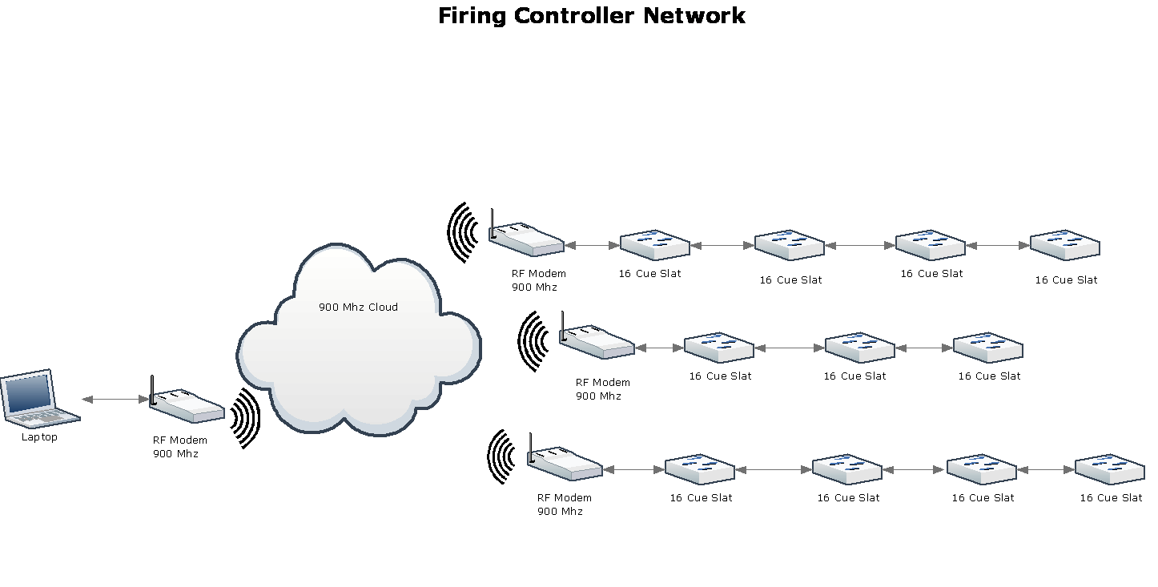

# Physical Connections

The RJ45 connections are shown here:

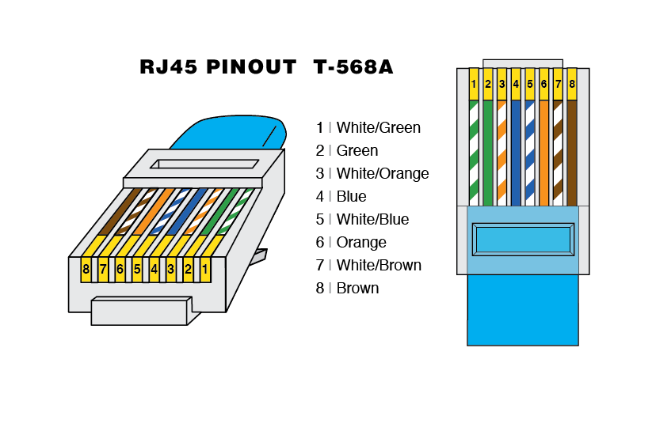

Pins 1,2 RS485 Balanced signal with 100 Ohm load.

Pins 3,5,7 +12 Volts (Striped)

Pins 4,6,8 0 Volts (Ground) (Solid)

The pin connections that parallel the power lines are made at the RJ45 connector at the clients.

The clients have two RJ45 jacks that are wired in parallel so that the clients may be daisy chained.

Notice, the power supply wires are run in parallel to provide minimum voltage drop over long distances.

This design uses all pins of the RJ45 connector because it may be desirable, under some extreme conditions, to run CAT5 cables up to 100 feet between units. In general, however, the head end radio/power supply units should be co-located with the clients they service to keep CAT5 cable distances to a minimum, usually less than 10 feet.

*In shows that I have designed, I typically use 3 modems and run ,at most, 50 feet of CAT5 between the modem and a group of clients.*

# Network Topology

A network consisting of multiple clients interconnected by CAT5 cabling should be *daisy chained* and not connected in a star arrangement. The RS485 transceivers used in the clients and radio modem are designed to operate only in a *daisy chained* configuration. It may be possible to operate short distances in a star configuration but long runs will cause communication to fail. Don’t ask me how I know!

The daisy chained clients connect to a radio modem/power source. This combination unit provides signals and power to the clients.

# Radio Modem

The radio modem is described in detail in document GBN002.

# Networking Protocols.

The communication protocols are described in a document titled “Network and networking protocols”.