**Name:** Waleed Akram

**Roll #** 20p-640

**Section :** BCS3-B

* ***Instructor SIR USMAN ABBASI***

**Reports #** 11-12

7-Segment Display Interfacing with AVR ATmega16/ATmega32

**Introduction:**

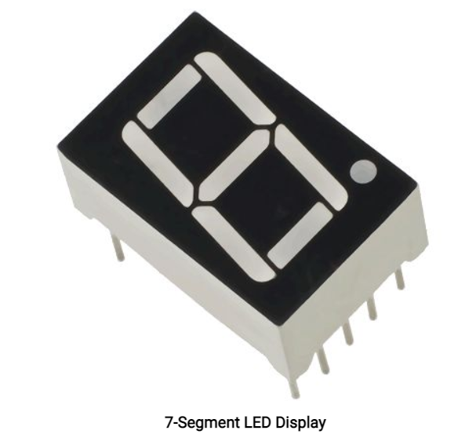

* *7-segment displays are made up of 8 LED segments. 7 of these LED segments are in the shape of a line, whereas 1 segment is circular.*
* *The 7 line-shaped LED segments are used for displaying numbers 0 to 9 and a few letters like A, c, d, e, F, H, L, O, P, U, etc. The circular segment is used for displaying a decimal point.*
* *Each of the 8 elements has a pin associated with it which can be driven HIGH or LOW according to the type of display and the number or alphabet to be displayed.*
* *The common anode and common cathode types are available in a 7-segment display. Depending on which type is used, the control signal required to light up a segment in the display changes. Common anode requires a LOW signal whereas common cathode requires a HIGH signal to light up a segment.*

**Circuit Diagram:**

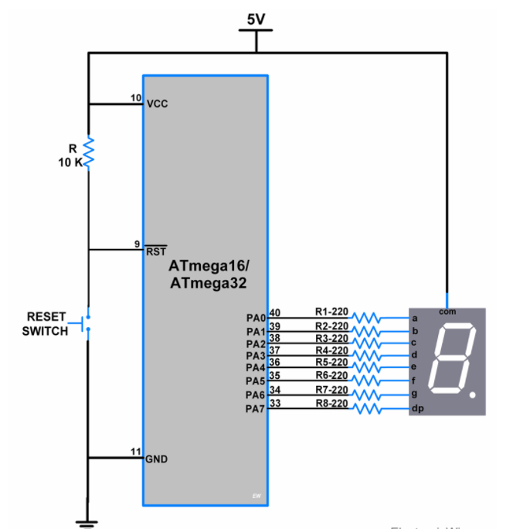

**Program:**

*.INCLUDE"m328pDEF.INC"*

*.ORG 0*

*LDI R16, HIGH(REMEND)*

*OUT SPH, R16*

*LDI R16, LOW(REMEND)*

*OUT SPL, R16*

*LDI R19,0XFF*

*OUT DDRB, R19*

*START:*

*LDI R20,0b010000000*

*OUT PORTB, R20*

*RECALL DELAY*

*LDI R20,0b01111001*

*OUT PORTB, R20*

*RECALL DELAY*

*LDI R21 ,0b0100100*

*OUT PORTB, R21*

*RECALL DELAY*

*LDI R21 ,0b0110000*

*OUT PORTB, R21*

*RECALL DELAY*

*LDI R21 ,0b0011001*

*OUT PORTB, R21*

*RECALL DELAY*

*LDI R21 ,0b0010010*

*OUT PORTB, R21*

*RECALL DELAY*

*LDI R21 ,0b0100010*

*OUT PORTB, R21*

*RECALL DELAY*

*LDI R21 , 0b0011001*

*OUT PORTB, R21*

*RECALL DELAY*

*LDI R21 , 0b0010010*

*OUT PORTB, R21*

*RECALL DELAY*

*LDI R21 , 0b0000010*

*OUT PORTB, R21*

*RECALL DELAY*

*LDI R21 , 0b1111000*

*OUT PORTB, R21*

*RECALL DELAY*

*LDI R21 ,0b0000000*

*OUT PORTB, R21*

*RECALL DELAY*

*LDI R21 ,0b010000*

*OUT PORTB , R21*

*RECALL DELAY*

*JMP START*

*DELAY:*

*LDI R16, 0XFF*

*AGAIN3: LDI R17,0XFF*

*AGAIN2: LDI R18,0X5*

*AGAIN1: DEC R18*

*BRNE AGAIN1*

*DEC R17*

*BRNE AGAIN2*