NAME: WALEED AKRAM

# ROLL # 20P-0640

# SECTION: 3-B

# REPORT # 13,14

*Hardware implementation:*

First we do these steps in computer:

We have already did a code in computer. Use .hex file in atml studio to do these steps

* Blank
* Erase
* Program
* Verified

To write a code.

We use microprocessor atmega32 to write a code in it last lab then in lab 13,14 we use microprocessor chip programmable to write a

code in it which will help us in we use breadboard to display a 7 seven segment display.

* + - requirement:
  + BreadBoard
  + 7 segment display light
  + Bundles of wires
  + Transistor
  + Register
  + Microprocessor chips

1. How to display 7 segment on breadboard.

Place the 7-segment display so that the top row of pins is separated from the bottom pin by the central gutter that splits the breadboard. Next, connect the jumper wire from the resistor to pin 1 of the display. The other wires are red and blue and are connected to 5V and ground respectively.

o Not exactly the same scenario I did in the lab, but it looks like this:

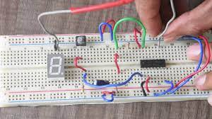

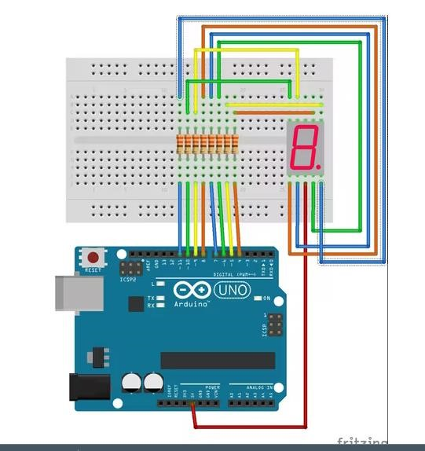

|  |  |  |
| --- | --- | --- |
| **Number** | **g f e d c b a** | **Hex Code** |
| 0 | 0111111 | 3F |
| 1 | 0000110 | 06 |
| 2 | 1011011 | 5B |
| 3 | 1001111 | 4F |
| 4 | 1100110 | 66 |
| 5 | 1101101 | 6D |
| 6 | 1111101 | 7D |
| 7 | 0000111 | 07 |
| 8 | 1111111 | 7F |
| 9 | 1001111 | 4F |

At the end we display all our 0 to 9 display on

7 segment light.

# -→End←