

Waleed Akram 20p-0640

­­­

Computer organization and assembly language lab

­

**Q # 1. Write an assembly language program (NASM) to find second largest and second smallest digit of your Roll No and store it in the memory.**

**• Store all the digits of Roll No in the memory.**

**• Use CMP to check digit is greater or not and move to next.**

**• Store the largest digit in memory.**

[org 0x0100]

mov bx , 0

mov cx , 6

loop1:

mov bx , 0

loop2:

mov ax , [RN +bx ]

cmp ax , [RN + bx+2]

jbe loop3

mov dx , [RN + bx+2]

mov [RN + bx+2] , ax

mov [RN + bx] , dx

loop3:

add bx , 2

cmp bx , 10

jne loop2

sub cx , 1

jnz loop1

xor cx , cx

mov bx , [RN + 2]

mov cx , [RN + 8]

mov dx , [RN + 10]

mov ax , 0x4c00

int 0x21

RN: dw 2, 0, 0, 6, 4, 0

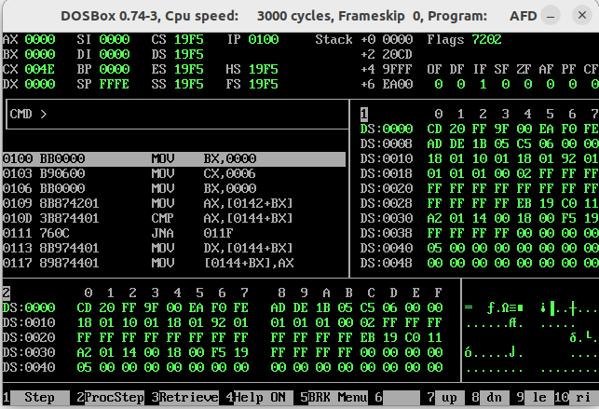

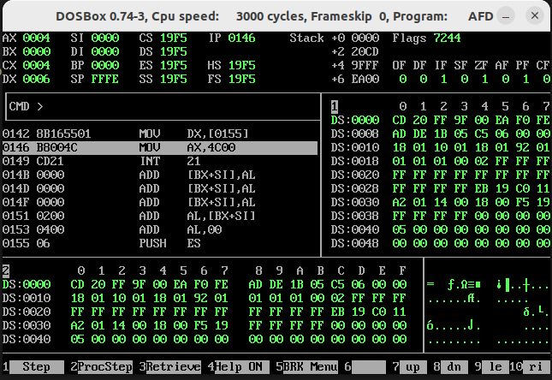

**Q2. Write an assembly language program (NASM) to sort your roll no in descending order**

**and store it in the memory.**

**• Store all the digits of Roll No in the memory.**

**• Use CMP to check digit is greater or not and move to next.**

**• Make use of loop etc.**

[org 0x0100]

mov bx,0

mov cx,6

loop1:

mov bx,10

loop2:

mov ax,[RN +bx ]

cmp ax, [RN + bx-2]

jbe loop3

mov dx , [RN + bx-2]

mov [RN + bx-2],ax

mov [RN + bx],dx

loop3:

sub bx,2

cmp bx,0

jne loop2

sub cx,1

jnz loop1

xor cx,cx

mov ax,[RN + 10]

mov [RN1],ax

mov ax,[RN + 8]

mov [RN1 + 2],ax

mov ax,[RN + 6]

mov [RN1 + 4],ax

mov ax,[RN + 4]

mov [RN1 + 6],ax

mov ax,[RN + 2]

mov [RN1 + 8],ax

mov ax,[RN ]

mov [RN1 + 10],ax

mov ax,0x4c00

int 0x21

RN: dw 2,0,0,6,4,0

RN1: dw 0, 0, 0, 0, 0

