**CH5020 Assignment 1**

**Instructions:**

1. Do in groups of 2
2. Submit as word document (Arial font, 11 font size, 1.5 line spacing)
3. Give Matlab code wherever appropriate
4. PLEASE do discuss within and outside your group if required but provide original answers
5. Due Date: 18th September 2020

**1.** A probability density function is given such that **[7]**

f(x) = Ax+b 0≤x≤1

= 0, elsewhere

P(0.25 < X < 0.5)=19/80

Find the constants A and B as well as the mean value.

**2.** Experiments are subject to measurement errors. Suppose the error is treated as a random variable X whose continuous probability density function is given by

f(x) = q(3-x2) -1≤x≤1

= 0, elsewhere

**a.** What are the minimum & maximum values of the error? **b.** Find q such that f(x) is valid. **c.** What is the probability that the random error in a measurement is less than 0.5? **d.** If the magnitude of the error does NOT exceed 0.8, what is the probability of this outcome? **[8]**

**3.** If X is a random variable described by a continuous probability density function

$f\left(x\right)=\frac{x^{2}}{3} -1<x<2$ and 0 elsewhere

Find the expected value of g(X) = 12X+5. **[4]**

**4.**

**a.** In the age of fast computers, modeling and simulation encompassing different length and timescales, why is it still necessary to do experiments?

**b.** Why do repeats of experiments carried out even with state of the art equipment and instruments give different results each time?

**[2+2]**

**5.** A government agency advertises in the newspaper inviting bids for some of its projects. It generally estimates what a reasonable bid would be and calls it as ‘b’. From experience, it has determined the probability density function of the winning (lowest) bids as follows

f(y) = 5/(8b) for 0.4 b ≤ y ≤ 2b

= 0, elsewhere

a. Prove this probability density function is correctly defined

b. Find the cumulative probability density function, F(y) and sketch it

c. Find the probability that the winning bid is less than the agency’s preliminary estimate ‘b’

**[5]**

**6.** In the annual book exhibition held in YMCA grounds, Chennai, over the past several years, during Pongal festival, there is a steady stream of visitors. They visit the various stalls and exit the exhibition at different times. Depending on the path they take – a few bored ones may bypass many stalls and exit practically instantaneously, some may follow the straight path, some may keep circling - unwilling to leave etc. Suppose the duration of their visit is described in terms of a random variable T and the associated continuous probability density function is given by

$$f\left(t\right)=\frac{1}{τ} exp(-\frac{t}{τ})$$

Here $τ$ is a parameter of the distribution with units of time.

1. What are the expected bounds of the probability distribution function?
2. Show that the above function is a legitimate probability distribution function.
3. What is the mean duration of the visit to the books exhibition?

**[5]**

1. The random variable X is described by the following probability density function, f(x) (-∞ <x< +∞)

$$f\left(x\right)=\frac{1}{\sqrt{18π}} e^{-\frac{x^{2}-10x+25}{18}}$$

What are the mean and variance of this distribution? What is the maximum value of this distribution?

**[4]**

**Problem 8**

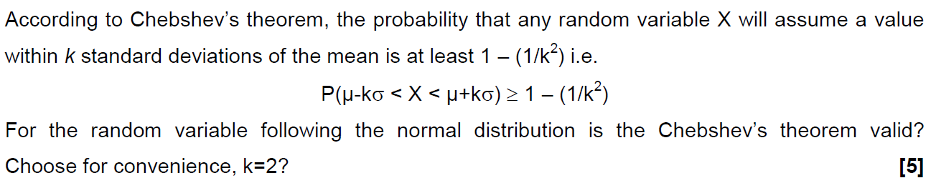

**Problem 9**

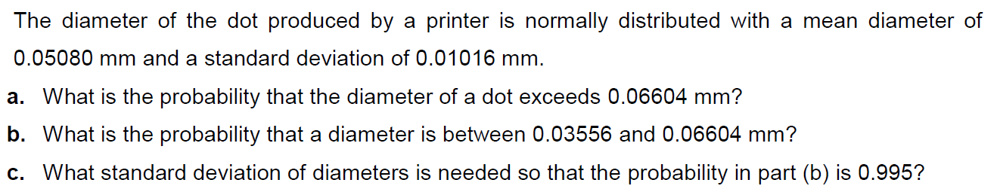

**[7]**

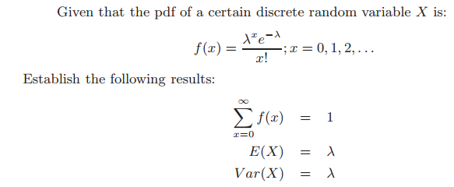**Problem 10**

**[8]**

**Problem 11 Covid (S)care**

It is known that a *healthy* human body has an average temperature of 98.6oF, with a standard deviation of 0.95oF. **Sixty** healthy humans are selected at random.

**a.** What can you say about the probability distribution of the population and about the sampling distribution? Justify your answers.

**b.** What is the probability that their temperatures average at least 99.1oF? If very low/high, explain.

**c.** As many sampled humans actually turned out to be suffering from fever, the sample size had to be reduced to only six, what condition has to be satisfied to re-estimate the probability required in part b? Find the new probability with the reduced sample size and again comment on the magnitude of the probability value now.

**[11]**

**Problem 12**

The Weibull probability distribution is a two parameter distribution defined for x>0 by

$$f\left(x\right)=\frac{β}{δ}{\left(\frac{x}{δ}\right)}^{β-1}exp[-{\left(\frac{x}{δ}\right)}^{β}]$$

1. If δ and β are both unity, what will be the general shape of the distribution?
2. when special case a holds, for what value of X, say q, will P(X>q) =P(X<q)?
3. What is the equation of the cumulative probability distribution, for the special case a and for the general case?

**[5]**

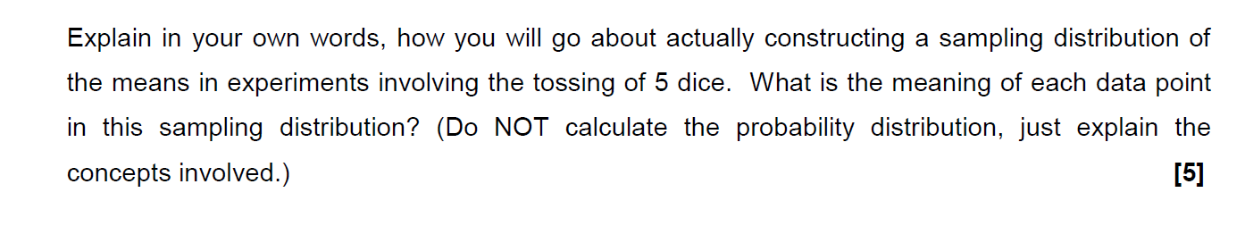**Problem 13**

**Problem 14**

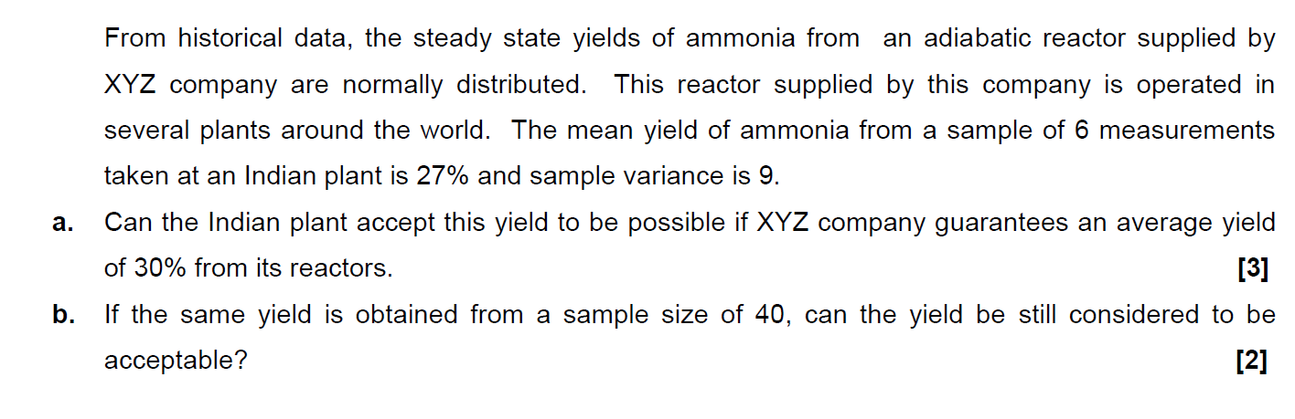**Problem 15**

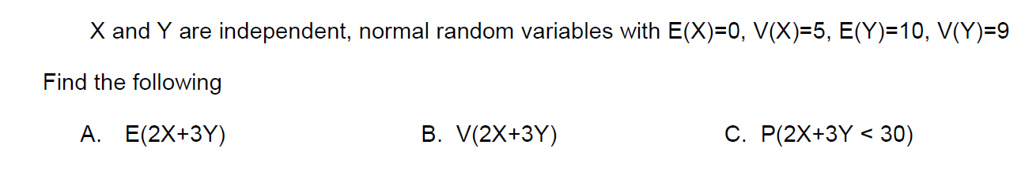

**[6]**

**Problem 16**

A tobacco company claims that the amount of nicotine in cigarettes is a random variable with mean 2.2 mg and standard deviation 0.3 mg. However, the sample mean nicotine content of 100 randomly chosen cigarettes was 3.1 mg. What is the approximate probability that the sample mean would have been as high or higher than 3.1 mg if the company’s claim was true?

**[6]**

**Problem 17**

A city installs 2000 electric lamps for street lighting. These lamps have a mean burning life of 1000 hours with a standard deviation of 200 hours. The normal distribution is a close approximation to this case.

1. What is the probability that a lamp will fail in the first 700 burning hours?
2. What is the probability that a lamp will fail between 900 and 1300 burning hours?
3. How many lamps are expected to fail between 900 and 1300 burning hours?
4. What is the probability that a lamp will burn for exactly 900 hours?

**[10]**

**Problem 18**

An engineer decides to buy four new snow tires for his car. He finds that Retailer A is offering a special cash rebate, which depends on how much snow falls during the first winter. If this snowfall is less than 50% of the mean annual snowfall for his city, his rebate will be 50% of the list price. If the snowfall that winter is more than 50% but less than 75% of the mean annual snowfall, his rebate will be 25% of the list price. If the snowfall is more than 75% of the mean annual snowfall, he will receive no rebate. The engineer finds from a reference book that the annual snowfall for his city has a mean of 80 cm and standard deviation of 20 cm and approximates a normal distribution. The list price for the brand and size of tires he wants is $80.00 per tire.

The engineer checks other retailers and finds that Retailer B sells the same brand and size of tires with the same warranty for the same list price but offers a discount of 5% of the list price regardless of snowfall that year.

1. Compare the expected costs of the two deals. Which expected cost is less?
2. How much is the difference for four new snow tires? Neglect the relative advantages of a cash rebate as compared to a discount.

**Problem 19**

An assembly plant has a bin full of steel rods, for which the diameters follow a normal distribution with a mean of 7.00 mm and a variance of 0.100 mm2, and a bin full of sleeve bearings, for which the diameters follow a normal distribution with a mean of 7.50 mm and a variance of 0.100 mm2 . What percentage of randomly selected rods and bearings will not fit together?

**Problem 20**

A certain dimension is measured on four successive items coming off a production line. This sample gives x̅ = 2.384 and s = 0.048.

(a) On the basis of this sample, what is the 95% confidence interval for the population mean?

(b) If instead of estimating the standard deviation from a sample, we knew the true standard deviation was 0.048, what then would be the 95% confidence interval for the population mean?

**Problem 21 [4]**

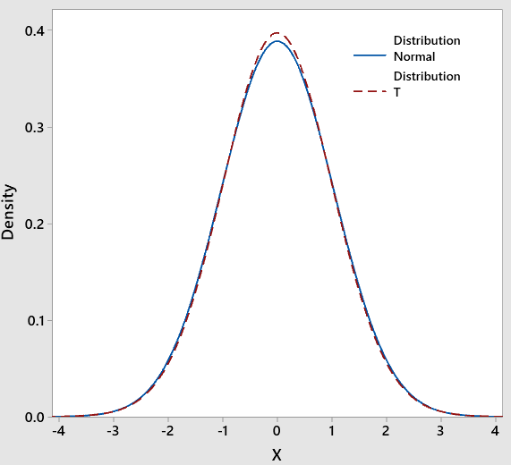.

The figure shows the t-distribution (dashed line) with 80 degrees of freedom overlaid on a normal distribution (solid line). The mean and variance of both these distributions are identical. Find these two parameters and explain the almost identical overlap between the two distributions.

**Problem 22 [7]**

A probability density function is given such that

f(x) = Ax+b 0≤x≤1

= 0, elsewhere

P(0.25 < X < 0.5)=19/80

Find the constants A and B as well as the mean value.

**Problem 23**

Thermo-mechanically treated iron (TMT) rods used in construction are to have area specific earthquake resistance. The rods prepared from a company have mean yield strength of 500 N/mm2 and standard deviation of 50 N/mm2. **[7]**

1. Will 95% of the bars chosen from this population have the required yield strength of at least 470 N/mm2?
2. If not, what process modification may be suggested (maintaining the same mean yield strength) to achieve the aim stated in part **a**?

**Problem 24**

A maker of a certain brand of low-fat cereal bars claims that their average saturated fat content is 0.5g. In a random sample of 8 cereal bars of this brand the saturated fat content was 0.6,0.7,0.7,0.3,0.4.0.5,0.4 and 0.2. Would you agree with the claim? Assume a normal distribution.

**[6]**

**Problem 25**

The chemical benzene is highly toxic to humans and it causes cancer. In any production process Involving benzene, the water in the output of the process must not exceed 7950 ppm because of Government Regulations. For a particular process, the water sample was collected by a manufacturer 25 times randomly and the sample average was 7960 ppm. It is known from historical data that the standard deviation σ is 100 ppm.

a. What is the probability that the sample average in this experiment would exceed the government limit if the population mean is equal to the limit? Use the central limit theorem.

*Assume the distribution of benzene concentrations to be normal.*

**[5]**

