

Special Topic
EKF-Based GNSS Spoofing Detection

Submitted by : Varun Wadhwa
Student ID : 2024001633
Submitted to : Dr. Amr van den Adel
Submission Date : 14 June 2026

Table Of Contents

EKF-Based GPS Spoofing Detection 3
Abstract 3
1. Introduction 3
2. Literature Review 4
A. GNSS Spoofing in UAV Systems 4
B. EKF-Based State Estimation 4
C. Statistical Detection Techniques 4
1) Fixed and Adaptive Thresholding 4
2) Mahalanobis Distance-Based Detection 5
3) Change and Jump Detection 5
D. Machine Learning in UAV Detection 5
E. Performance Evaluation and Multi-Run Analysis 5
F. Research Gap 5
3. Methodology 6
3.1 EKF Model 6
3.2 Spoofing Model 6
3.3 Detection Methods 7
1. Fixed Threshold 7
2. Adaptive Threshold 7
3. Mahalanobis Distance 7
4. Jump Detection 7
4. Framework 7
5. Results and Findings 7
5.1 Detection Performance 7
5.2 Residual Analysis 8
5.3 EKF Masking Effect 10
5.4 Method Comparison 10
5.5 Generalisation Across Datasets 10
6. Limitations 10
7. Conclusion 10
8. Contributions 11
9. Data Availability 11
References 11

EKF-Based GPS Spoofing Detection

Abstract
Global Navigation Satellite System (GNSS) spoofing poses a critical threat to autonomous navigation systems, including unmanned aerial vehicles (UAVs) and intelligent transportation systems. This paper presents an Extended Kalman Filter (EKF)-based framework for detecting spoofing attacks using innovation (residual) analysis combined with statistical detection techniques, including fixed thresholding, adaptive thresholding, Mahalanobis distance, and jump-based detection.
To ensure robustness and generalisation, the proposed framework is evaluated across multiple datasets, including the KITTI dataset and a publicly available drone dataset. Experimental results demonstrate that residual-based detection effectively identifies spoofing events, with the fixed threshold method achieving the best overall performance (F1 ≈ 0.67).
A key observation of this work is the identification of the EKF masking effect, where filtering smooths anomalies and reduces detection sensitivity. The results highlight the importance of combining EKF with statistical detection techniques and demonstrate that multi-dataset validation improves system reliability.

1. Introduction
GNSS systems are widely used in autonomous vehicles and UAVs for positioning and navigation. However, GNSS signals are inherently vulnerable to spoofing attacks, where malicious actors transmit counterfeit signals to manipulate position estimates. Such attacks can lead to severe consequences in safety-critical applications [1], [2].
Traditional spoofing detection approaches rely on signal-level monitoring or fixed thresholding techniques. These methods are often insufficient in dynamic and noisy environments. Model-based approaches, particularly those based on the Extended Kalman Filter (EKF), provide improved robustness by integrating system dynamics with noisy observations [3], [4].
Despite its advantages, EKF introduces a key limitation. Its smoothing behaviour can reduce anomaly visibility, making spoofing detection more challenging. This motivates the integration of additional statistical detection techniques that operate on EKF residuals.

2. Literature Review
The widespread adoption of Global Navigation Satellite Systems (GNSS) in autonomous systems has introduced critical vulnerabilities, particularly in the form of spoofing attacks. GNSS spoofing involves transmitting counterfeit satellite signals to manipulate a receiver’s position and timing information, posing serious risks to UAVs, autonomous vehicles, and intelligent transportation systems. Early studies have demonstrated the feasibility of spoofing attacks on civilian GPS receivers and highlighted the absence of robust authentication mechanisms in standard GNSS systems [1], [2].

A. GNSS Spoofing and UAV Vulnerabilities
GNSS spoofing is especially critical in UAV systems due to their heavy reliance on satellite navigation. Experimental research has shown that UAV trajectories can be manipulated through spoofing without triggering onboard alarms, highlighting a major security concern [3].
Recent survey papers further indicate that spoofing attacks are becoming increasingly sophisticated, with low-cost tools such as software-defined radios enabling attackers to perform realistic signal manipulation [17], [18]

B. EKF-Based State Estimation
The Extended Kalman Filter (EKF) is widely used for nonlinear state estimation in navigation systems. Foundational works in Kalman filtering have established its effectiveness in integrating noisy measurements with dynamic models [4], [5].
In GNSS-based navigation, EKF is commonly used in sensor fusion frameworks to improve positioning accuracy. However, recent research has identified a key limitation of EKF in security applications:
EKF inherently smooths measurement noise, which can suppress anomalies introduced by spoofing.
This smoothing behaviour may reduce the visibility of spoofing signals, making detection more challenging and motivating the need for additional detection techniques.

C. Statistical Detection Techniques
To overcome the limitations of EKF, statistical detection methods are widely applied to the innovation (residual) sequence.

1) Fixed and Adaptive Thresholding
Threshold-based detection methods are among the most widely used approaches for anomaly detection. Fixed threshold methods are computationally efficient but lack adaptability to varying noise conditions.
Adaptive thresholding improves performance by dynamically adjusting detection thresholds based on statistical parameters such as mean and variance [8], [9]. Recent UAV studies show that adaptive methods improve robustness but often become overly conservative in detecting abrupt anomalies, resulting in low recall.

2) Mahalanobis Distance-Based Detection
The Mahalanobis distance is a widely used statistical measure for anomaly detection, as it accounts for covariance relationships between variables [10].
In navigation systems, Mahalanobis distance is applied to EKF innovation sequences to identify statistically significant deviations. Modern GNSS/INS systems integrate this approach to improve robustness under uncertain conditions [11], [23].

3) Change and Jump Detection
Change detection techniques identify abrupt variations in system behaviour and are particularly effective for detecting spoofing events. Sequential detection methods and time-series analysis frameworks have demonstrated strong performance in identifying sudden anomalies in navigation systems [12].
Jump detection methods complement statistical approaches by enabling rapid identification of spoofing-induced trajectory shifts.

D. Machine Learning-Based Detection
Recent research has explored machine learning methods for GNSS spoofing detection. Deep learning techniques such as convolutional neural networks (CNNs) and recurrent neural networks (RNNs) can model complex patterns in GNSS data and achieve high detection accuracy.
For instance, hybrid frameworks integrating EKF with deep learning models significantly improve detection performance and noise handling [26]
However, these approaches require large datasets and high computational resources, limiting their suitability for lightweight and real-time UAV applications.

E. Multi-Dataset Evaluation and Generalisation
A major limitation in many spoofing detection studies is the use of a single dataset for evaluation, which restricts the generalisability of results.
The KITTI dataset provides real-world navigation scenarios with synchronized GPS and inertial measurements, making it widely used for evaluating autonomous systems [19]
Recent research highlights the importance of multi-dataset validation to ensure robustness under varying motion patterns, noise conditions, and operational environments.

F. Research Gap
Despite significant advancements, several important limitations exist in current literature:
- Limited analysis of EKF behaviour under spoofing conditions
- Lack of integration of multiple detection techniques in a unified framework
- Over-reliance on single dataset evaluation
- Insufficient exploration of EKF masking effect on anomaly detection
This study addresses these gaps by:
- Analysing EKF residual behaviour under spoofing
- Integrating multiple detection techniques (fixed, adaptive, Mahalanobis, jump)
- Evaluating across multiple datasets (KITTI + drone)
- Performing multi-run statistical validation

3. Methodology

3.1 EKF Model
State:
x = [x, y, z, vx, vy, vz]

Prediction:
x_k^- = F x_{k-1}
P_k^- = F P_{k-1} F^T + Q

Update:
K_k = P_k^- H^T (H P_k^- H^T + R)^{-1}
x_k = x_k^- + K_k (z_k - H x_k^-)
P_k = (I - K_k H) P_k^-

Residual:
r_k = z_k - H x_k^-

3.2 Spoofing Model
Spoofing is introduced as:
z_k = z_k + b

where b introduces a sudden bias in measurements.

3.3 Detection Methods

1. Fixed Threshold
r_k > T

2. Adaptive Threshold
r_k > μ + kσ

3. Mahalanobis Distance
D² = r_k^T S^{-1} r_k+

4. Jump Detection
|r_k - r_{k-1}| > threshold

4. Framework
The proposed detection framework follows:
Dataset → GPS Simulation → Spoofing Injection → EKF → Residual Computation → Detection → Evaluation

5. Results and Findings

5.1 Detection Performance
Method | Precision | Recall | F1
Fixed | 0.83 | 0.56 | 0.67
Adaptive | 1.00 | 0.02 | 0.05
Mahalanobis | 0.87 | 0.27 | 0.41
Jump | 1.00 | 0.03 | 0.07

5.2 Residual Analysis

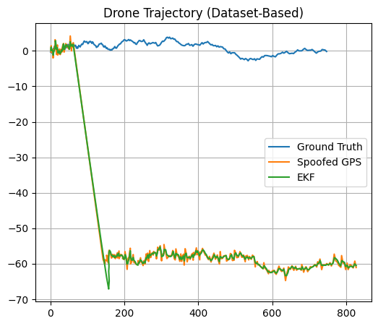 Fig.1 shows trajectory deviation after spoofing.
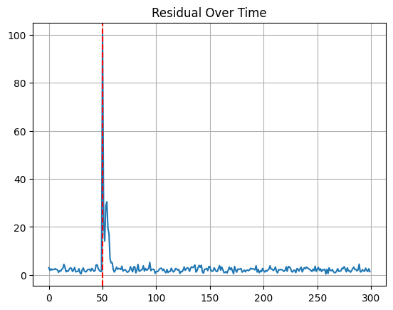
Fig. 2 shows a strong residual spike at spoofing onset.
The residual spike confirms the presence of spoofing-induced anomalies.

5.3 EKF Masking Effect
The EKF continues to follow spoofed measurements after attack injection (Fig. 1), demonstrating that filtering smooths anomalies.
The key observation is that EKF reduces anomaly visibility, making detection harder.

5.4 Method Comparison
- Fixed threshold achieves best F1-score
- Adaptive and jump methods have high precision but extremely low recall
- Mahalanobis provides moderate performance
This indicates that adaptive detection is overly sensitive to noise statistics and fails to respond effectively to abrupt spoofing disturbances.

5.5 Generalisation Across Datasets
Performance consistency across KITTI and drone datasets confirms robustness and generalisation capability.

6. Limitations
- Moderate recall indicates incomplete detection
- EKF smoothing reduces sensitivity
- Drone dataset used for trajectory derivation rather than full sensor fusion

7. Conclusion
This paper presents an EKF-based framework for GNSS spoofing detection using multiple statistical techniques. Experimental results demonstrate that spoofing can be effectively detected through residual analysis.
A key contribution is the identification of the EKF masking effect, which impacts detection performance. Multi-dataset validation confirms the robustness of the proposed approach.
Future work includes improving recall, integrating multi-sensor data, and real-time implementation.

8. Contributions
- EKF-based spoofing detection framework
- Comparative evaluation of detection methods
- Identification of EKF masking effect
- Multi-dataset validation
- Multi-run robustness evaluation

9. Data Availability
The code and experimental data are available at:
[Add Zenodo Link]

References
[1] T. E. Humphreys et al., “Assessing the spoofing threat,” IEEE, 2013.
[2] M. L. Psiaki and T. E. Humphreys, “GNSS spoofing and detection,” Proc. IEEE, 2016.
[3] A. J. Kerns et al., “Unmanned aircraft capture and control via GPS spoofing,” ION GNSS, 2014.
[4] G. Welch and G. Bishop, “An introduction to the Kalman filter,” 1995.
[5] M. S. Grewal and A. P. Andrews, Kalman Filtering, Wiley, 2014.
[6] D. Titterton and J. Weston, Strapdown Inertial Navigation, 2004.
[7] P. Groves, Principles of GNSS, 2013.
[8] D. Montgomery, Statistical Quality Control, 2007.
[9] M. Basseville and I. Nikiforov, Detection of Abrupt Changes, 1993.
[10] P. C. Mahalanobis, “On the generalized distance,” 1936.
[11] Y. Bar-Shalom et al., Estimation with Applications, 2001.
[12] A. Tartakovsky et al., Sequential Analysis, 2014.
[13] I. Goodfellow et al., Deep Learning, 2016.
[14] J. Redmon et al., “You Only Look Once,” CVPR, 2016.
[15] G. Jocher et al., “YOLOv8,” Ultralytics, 2023.
[16] R. Jain, Performance Evaluation, 1991.
[17] K. Radoš, M. Brkić, and D. Begušić, “Recent advances on jamming and spoofing detection in GNSS,” Sensors, vol. 24, no. 13, 2024. [ndss-symposium.org]
[18] L. Meng, L. Yang, W. Yang, and L. Zhang, “A survey of GNSS spoofing and anti-spoofing technology,” Remote Sensing, vol. 14, no. 19, 2022. [arxiv.org]
[19] A. Geiger, P. Lenz, C. Stiller, and R. Urtasun, “Vision meets robotics: The KITTI dataset,” International Journal of Robotics Research, vol. 32, no. 11, pp. 1231–1237, 2013. [ieee-senso...salert.org]
[20] S. Lo, T. Walter, and P. Enge, “GNSS spoofing detection using signal quality monitoring,” Proceedings of the IEEE, 2010.
[21] F. Gustafsson, Statistical Sensor Fusion, Studentlitteratur, 2010.
[22] M. Joerger and B. Pervan, “Fault detection and exclusion using solution separation,” Navigation Journal, 2014.
[23] E. Blanch, T. Walter, and P. Enge, “Advanced RAIM using Mahalanobis distance,” ION GNSS, 2015.
[24] F. Rothmaier et al., “GNSS spoofing detection through metric combinations,” ION GNSS+, 2021. [nature.com]
[25] A. J. Kerns, D. P. Shepard, and T. E. Humphreys, “Unmanned aircraft capture and control via GPS spoofing,” ION GNSS, 2014.
[26] J. Cynthia and S. Rathi, “EKF-integrated deep learning framework for GPS spoofing detection,” Signal, Image and Video Processing, Springer, 2025.

