PREVUMO
Preventive maintenance for makerspaces
PD B3: Customer discovery and prototype
GNG 4120
Group 10
Professor Oday Aswad
November 2026
Team members
No. | Name | Role
1
2
3
4
5

Table of contents
1. Summary 3
2. Problem and customer 3
3. What we learned before this round (evidence) 4
4. The prototype (this round) 5
4.1 System overview 5
4.2 Welder module 7
4.3 3D printer module 9
4.4 Enclosed printer module 11
4.5 Multimaker module 13
4.6 Laser cutter module 15
4.7 QR machine manual 17
4.8 Owner app 18
4.9 Shared rules 20
4.10 Safety and limits 20
5. Hypotheses to test in the interviews 21
6. Interview plan 22
7. Interview records 23
8. Results 34
9. Next steps (PD B4 validation) 35
10. References 36
Appendix A. Prototype pages 37
Appendix B. Interview script 38

1. Summary
PREVUMO is one module per machine type that protects the machine's health and the resources it uses: shielding gas and wire on a welder, filament on a 3D printer, tube time on a laser cutter. A member starts a session by tapping an NFC fob on the module. The owner sees every machine, alert and session in one owner app, and every machine carries a QR code that opens its manual.
What changed since PD B2: we left the café and restaurant tracker, because cafés were not interested. PREVUMO now focuses on makerspaces only, with preventive maintenance per machine and per energy source, including gas leaks on the welder.
This round we built eight prototype pages: five module drawings (welder, 3D printer, enclosed printer, multimaker, laser cutter), a system overview, a QR machine manual and an owner app. This report describes them, sets out seven hypotheses, and gives the interview plan and blank interview records for the team.
Concept only, not built or tested. Every chart, number and alert shown in the prototype is illustrative, not measured.

2. Problem and customer
Segment. Makerspaces and shared workshops with costly machines used by many members.
Problems we target, by machine:
- Welder: gas left open, gas leak, excessive wire, untrained user, abnormal load.
- FDM printer: heater stuck on, left heating, failed print, heavy filament use.
- Laser: fire unattended, no exhaust, no air assist, tube overheating.

3. What we learned before this round (evidence)
These are the only sources used in this round. Each one changed something in the prototype.
Source | What it says | What we changed
Yukonstruct (Rick Yorgason, Oct 27) | “we wouldn't want it to be a personal code, we would want it to be an NFC fob.” | Keypad replaced by an NFC fob reader on every module.
Grey Bruce Makers | Bills $0.10 per gram, and removes and weighs the spool by hand. | Wire counter on the welder and spool scale on the printers.
University of Regina | Charges $0.10 per gram. | Spool scale on the printers.
Alveo3D | Nozzles reach 250 °C and up; check prints every 30 minutes. | Heating timeout on the printers.
CMU EHS laser guideline | Ventilation must be on before operation; keep cutters always attended. | Exhaust interlock; pause when the operator taps out.
VanHack | A “zero tolerance” rule for leaving the laser. | Pause when the operator taps out.
HSE EIS45 | Listed as a source in the brief. | [Fill in: what we used from it]

4. The prototype (this round)
The prototype is a set of eight interactive web pages. Each module page is a drawing sheet: the module assembled, in pieces with a numbered parts table, on its machine, and then the steps of how it works as an animation. The names in the steps (Amira, Priya, Jonah and Lucas) are demo members on the pages, not real people. Every page is labelled as a concept, and every chart, number and alert on it is illustrative.

4.1 System overview
What each module watches, as on the System overview page:
Machine | Risks watched | Resource tracked | Automatic action
Welder | gas left open, gas leak, excessive wire, untrained user, abnormal load | gas, wire | valve closes, machine locks
FDM printer | heater stuck on, left heating, failed print, heavy filament use | filament, electricity | power cut, pause
Laser | fire unattended, no exhaust, no air assist, tube overheating | tube minutes | laser paused or locked
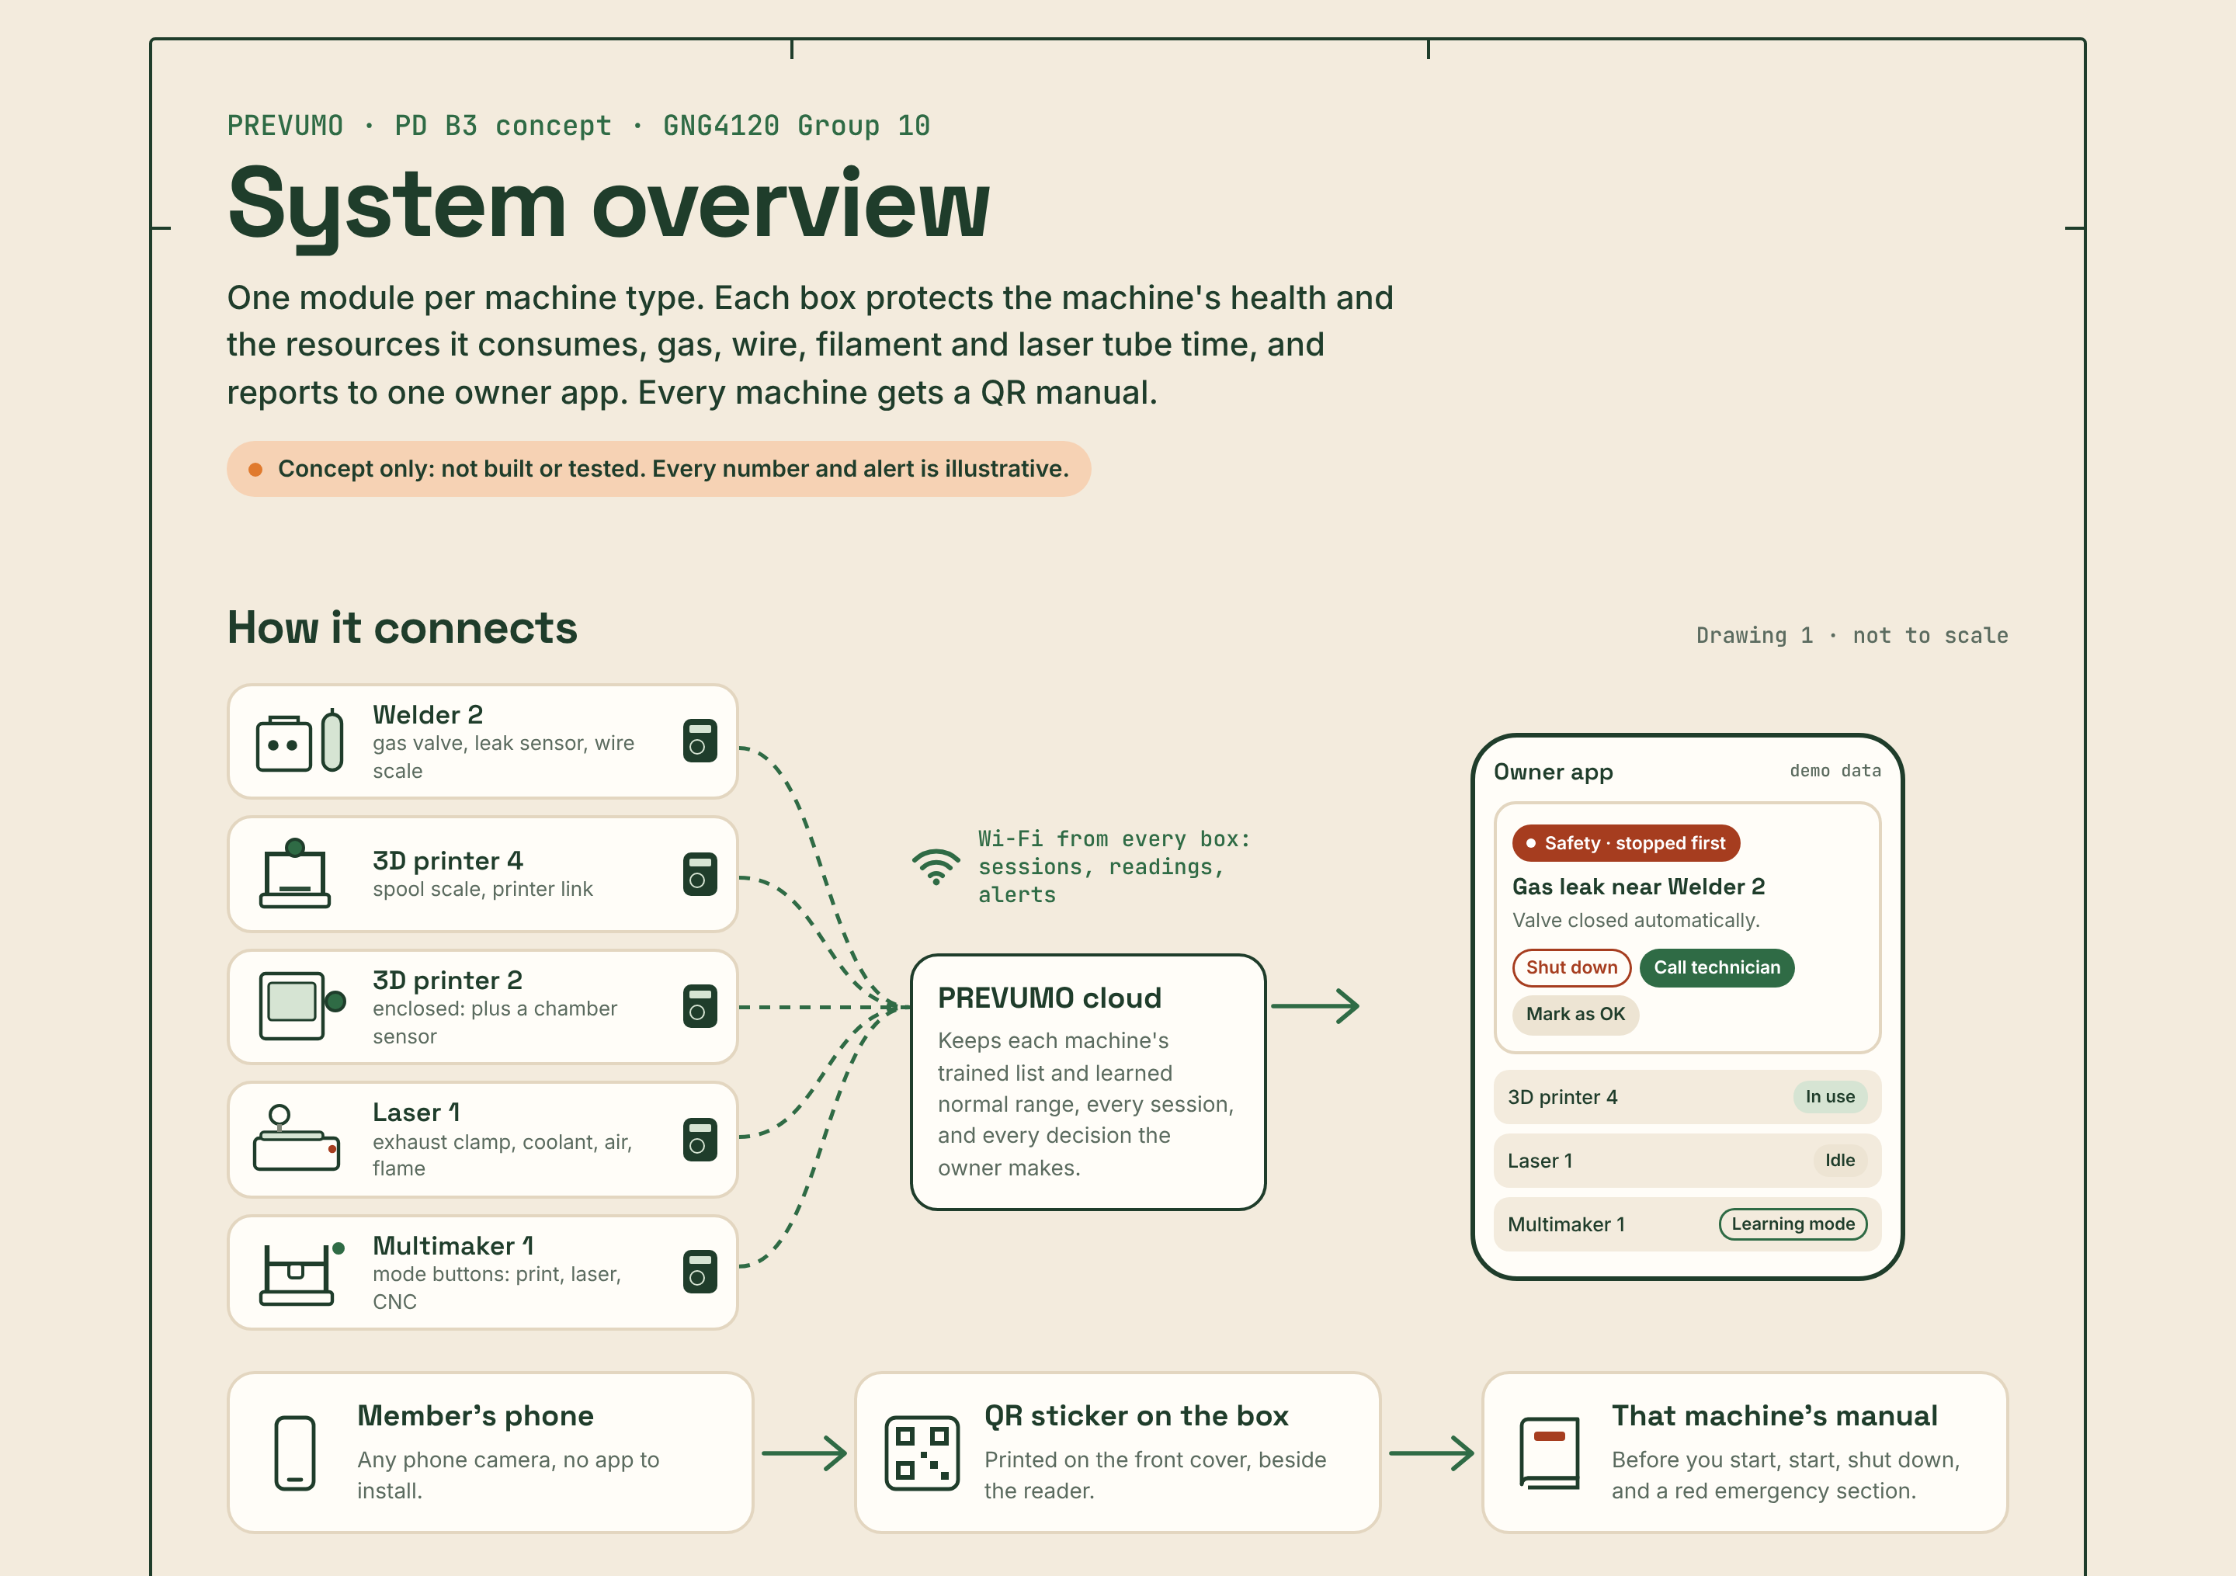
Figure 1. System overview page: modules on each machine report over Wi-Fi to the PREVUMO cloud and the owner app; a member's phone scans the QR sticker to open the manual. Illustrative.
One session takes five steps on every module:
- Tap fob. The box checks that machine's trained list.
- On. Power, gas or the laser's enable line switches on for this member.
- Watch. Current, sensors and resources are read against the learned normal range.
- Alert or act. Safety events stop the machine first, then alert the owner; anything else asks the owner to choose.
- Off and log. Tap out or idle timeout; who, how long and what was used go to the member's record.
Page: https://claude.ai/artifact/RAf322imEcX6BZJNPqsnQb

4.2 Welder module
A box on the wall beside a MIG welder. It unlocks with a member's fob, opens the shielding gas only during a session, weighs the wire used, and closes the gas valve when the leak sensor trips.
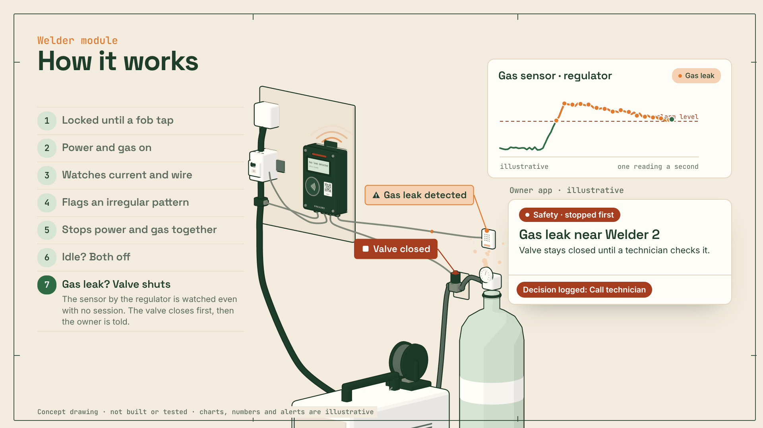
Figure 2. Welder module page at the gas leak step: the leak sensor trips, the valve closes and the owner app shows a safety alert. Charts, numbers and alerts are illustrative.
Parts (Where: in the box, or on the machine)
No. | Part | Where | Role
1 | NFC reader | Box | Members tap their fob; trained list per machine.
2 | Display and status light | Box | Who is on, and what the box is doing.
3 | QR sticker | Box | Opens the Welder 2 manual.
4 | Front cover | Box | Sealed, closed with four screws.
5 | Controller board | Box | ESP32 with Wi-Fi; drives the contactor and valve.
6 | Power supply | Box | Runs the box from the welder's line.
7 | Back housing | Box | Wall mount and four cable glands.
8 | Current clamp | Machine | Clips around one supply wire. Nothing is cut.
9 | Contactor, 240 V | Machine | Switches the welder. Licensed electrician installs.
10 | Gas valve | Machine | Closed without power: open only in a fob session.
11 | Gas leak sensor | Machine | On the wall by the regulator, watched day and night.
12 | Wire scale | Machine | Weighs the wire spool: grams per session.
Behaviour
- Locked until a fob tap Jonah's fob is not on Welder 2's trained list, so it stays locked. Amira is trained: it unlocks.
- Power and gas on The box closes the contactor and opens the gas valve. The session is logged to Amira.
- Watches current and wire The clamp reads the current every second and the scale weighs the spool. The first two weeks only learn the normal range.
- Flags an irregular pattern The owner gets one alert: Shut down, Call technician or Mark as OK.
- Stops power and gas together Nothing restarts on its own. Amira's session is logged with the wire she used.
- Idle? Both off If nobody welds for the idle time the owner sets, the box turns power and gas off.
- Gas leak? Valve shuts The sensor by the regulator is watched even with no session. The valve closes first, then the owner is told.
Evidence
- NFC fob: Yukonstruct (Rick Yorgason, Oct 27).
- Wire scale: Grey Bruce Makers bills $0.10 per gram and removes and weighs the spool by hand.
- Gas valve and leak sensor: HSE EIS45 [Fill in: what we used from it].
Page: https://claude.ai/artifact/KAUbvfq3DmXSjazq2fNP8Q

4.3 3D printer module
A box on the wall that an FDM printer plugs into. It powers the printer only for trained members, weighs the filament used, pauses a failed print over a USB link, and cuts power when the printer is left heating. The current spike during warm-up is normal and raises no alert.
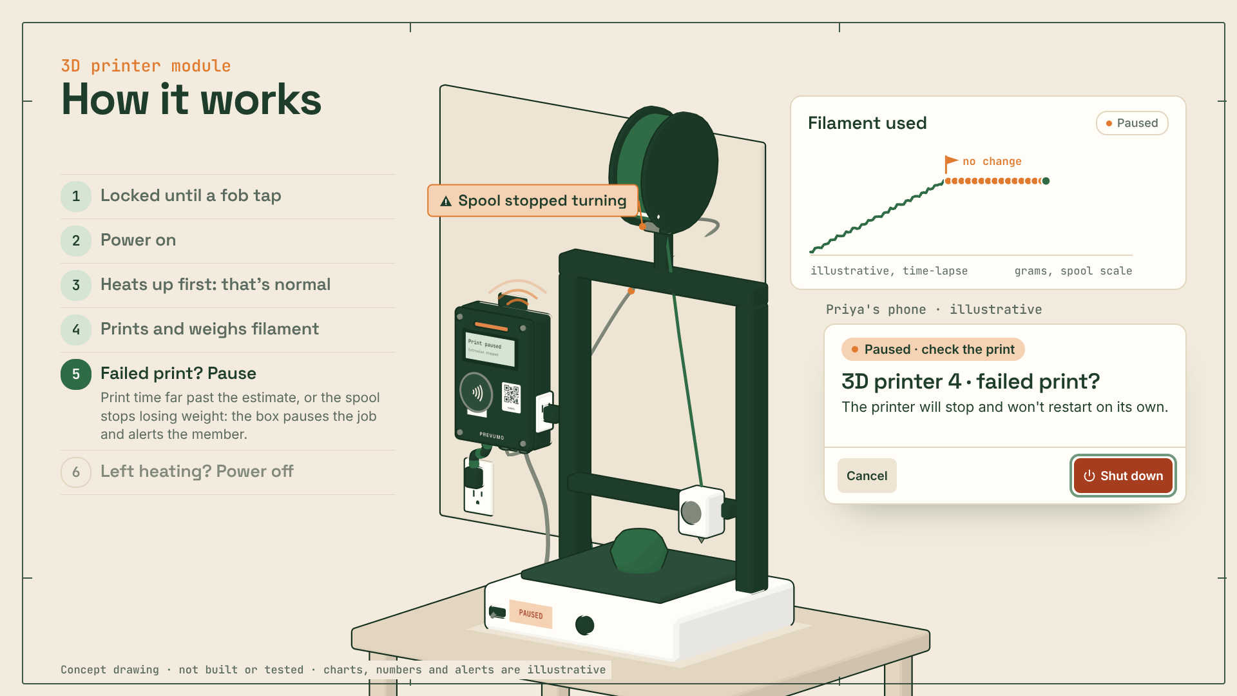
Figure 3. 3D printer module page at the failed print step: the spool stops losing weight, the job pauses and the member is alerted. Charts, numbers and alerts are illustrative.
Parts (Where: in the box, or on the machine)
No. | Part | Where | Role
1 | NFC reader | Box | Members tap their fob; trained list per machine.
2 | Display and status light | Box | Who is on, and what the box is doing.
3 | QR sticker | Box | Opens the 3D printer 4 manual.
4 | Front cover | Box | Sealed, closed with four screws.
5 | Controller board | Box | ESP32 with Wi-Fi and a current sensor.
6 | Relay | Box | Certified, 15 A at 120 V. Switches the printer.
7 | Power supply | Box | Runs the box from the same outlet.
8 | Back housing | Box | Wall mount, cord to the wall, outlet for the printer.
9 | Spool scale | Machine | Load cell under the spool: grams per session.
10 | Printer link | Machine | USB cable: reads the job, can pause it.
Behaviour
- Locked until a fob tap Amira's fob is not on this printer's trained list, so it stays locked. Priya is trained: it unlocks.
- Power on The box closes its relay and the printer turns on. The session is logged to Priya.
- Heats up first: that's normal A printer draws the most current while the bed and nozzle heat. PREVUMO knows this warm-up, so it raises no alert.
- Prints and weighs filament Once warm, the current settles into its normal range. The scale under the spool counts grams; the first two weeks only learn the normal range.
- Failed print? Pause Print time far past the estimate, or the spool stops losing weight: the box pauses the job and alerts the member.
- Left heating? Power off Heaters on and nothing moving for the time the owner sets, or a finished job still hot: the relay cuts power.
Evidence
- NFC fob: Yukonstruct (Rick Yorgason, Oct 27).
- Spool scale: University of Regina and Grey Bruce Makers charge $0.10 per gram.
- Heating timeout and failed print pause: Alveo3D, nozzles reach 250 °C and up and prints should be checked every 30 minutes.
Page: https://claude.ai/artifact/T8ZbrGETfFSC93hxXRPbfV

4.4 Enclosed printer module
The 3D printer box on an enclosed printer, with one more sensor for the air temperature inside the enclosure. If the chamber passes the owner's limit, the box cuts power first and then alerts the owner.
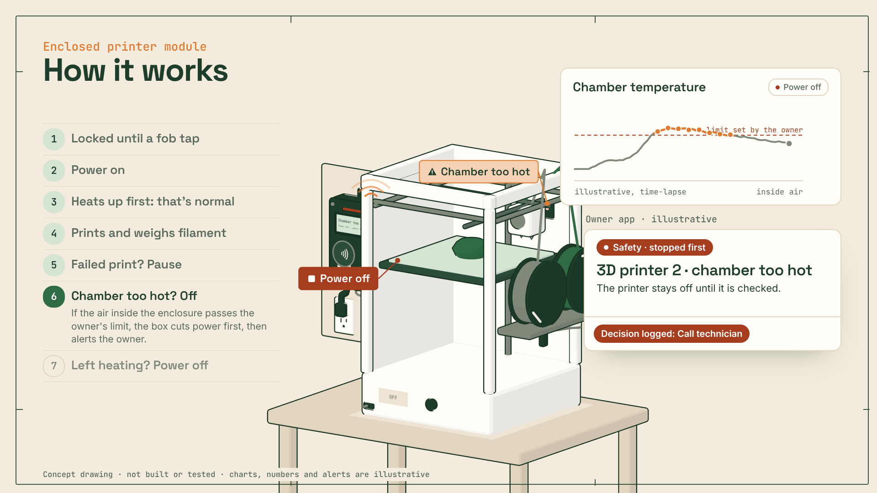
Figure 4. Enclosed printer module page at the chamber step: the air inside passes the owner's limit, power is cut and the owner is alerted. Charts, numbers and alerts are illustrative.
Parts (Where: in the box, or on the machine)
No. | Part | Where | Role
1 | NFC reader | Box | Members tap their fob; trained list per machine.
2 | Display and status light | Box | Who is on, and what the box is doing.
3 | QR sticker | Box | Opens the 3D printer 2 manual.
4 | Front cover | Box | Sealed, closed with four screws.
5 | Controller board | Box | ESP32 with Wi-Fi and a current sensor.
6 | Relay | Box | Certified, 15 A at 120 V. Switches the printer.
7 | Power supply | Box | Runs the box from the same outlet.
8 | Back housing | Box | Wall mount, cord to the wall, outlet for the printer.
9 | Spool scale | Machine | Load cells under both spools: grams per session.
10 | Printer link | Machine | USB cable: reads the job, can pause it.
11 | Chamber sensor | Machine | Air temperature inside the enclosure.
Behaviour
- Locked until a fob tap Lucas's fob is not on this printer's trained list, so it stays locked. Jonah is trained: it unlocks.
- Power on The box closes its relay and the printer turns on. The session is logged to Jonah.
- Heats up first: that's normal The bed and nozzles heat first, so the current is high. PREVUMO knows this warm-up and raises no alert.
- Prints and weighs filament The current settles into its normal range and the scale counts grams. The first two weeks only learn the normal range.
- Failed print? Pause Print time far past the estimate, or the spools stop losing weight: the box pauses the job and alerts the member.
- Chamber too hot? Off If the air inside the enclosure passes the owner's limit, the box cuts power first, then alerts the owner.
- Left heating? Power off Heaters on and nothing moving for the time the owner sets: the relay cuts power.
Evidence
- NFC fob, spool scale, heating timeout: as for the 3D printer module (Yukonstruct, University of Regina, Grey Bruce Makers, Alveo3D).
- Chamber sensor: no source yet. [Fill in: evidence or interview finding]
Page: https://claude.ai/artifact/75rKRdjDcEjJiDaA1jvsZ4

4.5 Multimaker module
One box for a 3-in-1 machine. After the fob tap the member picks print, laser or CNC on the box. Print mode weighs filament, laser mode stays locked until the exhaust fan draws current and logs laser minutes, and CNC mode logs spindle minutes.
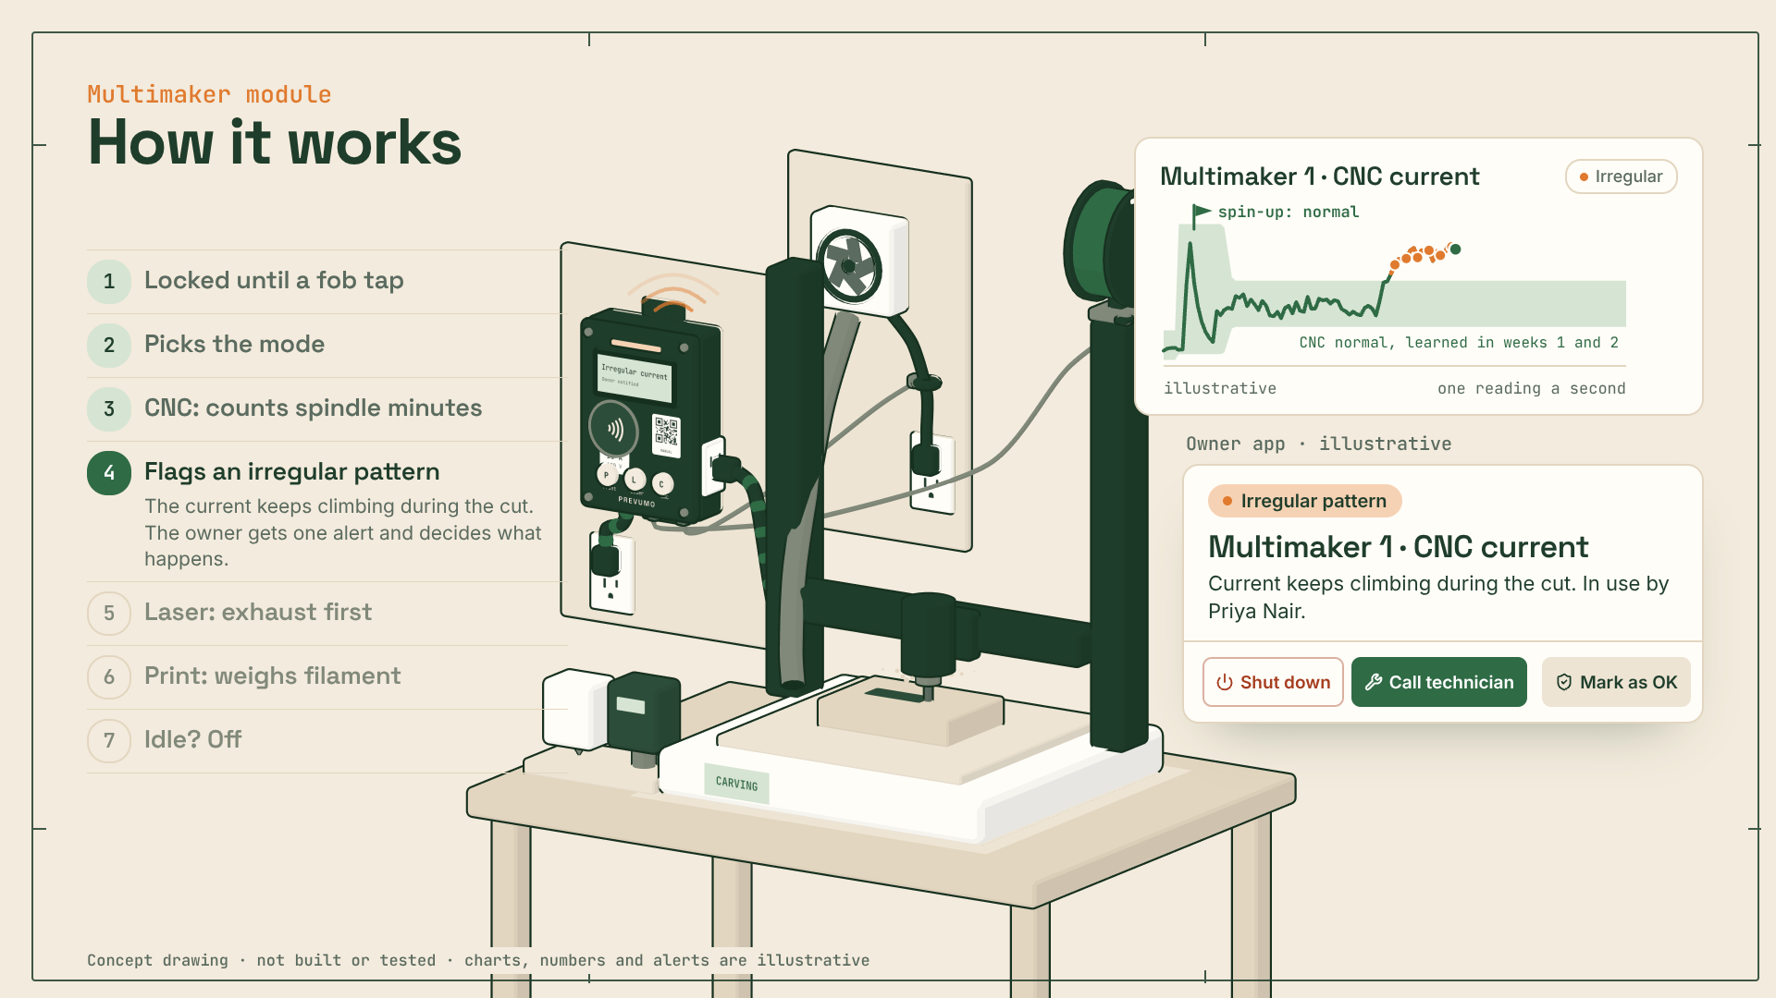
Figure 5. Multimaker module page at the CNC step: the current keeps climbing during the cut and the owner gets one alert. Charts, numbers and alerts are illustrative.
Parts (Where: in the box, or on the machine)
No. | Part | Where | Role
1 | NFC reader | Box | Members tap their fob; trained list per machine.
2 | Mode buttons | Box | Pick print, laser or CNC after the tap.
3 | Display and status light | Box | Who is on, the mode, and what the box is doing.
4 | QR sticker | Box | Opens the Multimaker 1 manual.
5 | Front cover | Box | Sealed, closed with four screws.
6 | Controller board | Box | ESP32 with Wi-Fi and a current sensor.
7 | Relay | Box | Certified, 15 A at 120 V. Switches the machine.
8 | Power supply | Box | Runs the box from the same outlet.
9 | Back housing | Box | Wall mount, cord to the wall, outlet for the machine.
10 | Spool scale | Machine | Print mode: grams of filament per session.
11 | Exhaust clamp | Machine | Laser mode: no exhaust current, no laser.
Behaviour
- Locked until a fob tap Jonah's fob is not on Multimaker 1's trained list, so it stays locked. Priya is trained: it unlocks.
- Picks the mode Priya presses CNC on the box. Each mode has its own trained list and its own normal range.
- CNC: counts spindle minutes The spin-up spike is normal for CNC, so no alert. The box logs the minutes the spindle runs.
- Flags an irregular pattern The current keeps climbing during the cut. The owner gets one alert and decides what happens.
- Laser: exhaust first Amira picks laser. The laser stays locked until the exhaust fan draws current, then laser-on minutes are logged.
- Print: weighs filament Lucas picks print. The scale under the spool counts the grams of his session.
- Idle? Off A finished job left switched on: the box turns it off after the idle time the owner sets.
Evidence
- NFC fob: Yukonstruct (Rick Yorgason, Oct 27).
- Exhaust interlock in laser mode: CMU EHS laser guideline, ventilation must be on before operation.
- Spool scale in print mode: University of Regina and Grey Bruce Makers.
- Spindle minutes: no source yet. [Fill in]
Page: https://claude.ai/artifact/C52M2y6pjY9HUNtT7dSVgp

4.6 Laser cutter module
A box beside a CO2 laser with its exhaust fan, chiller and air assist. An interlock relay on the laser's enable line lets it fire only when every check passes.
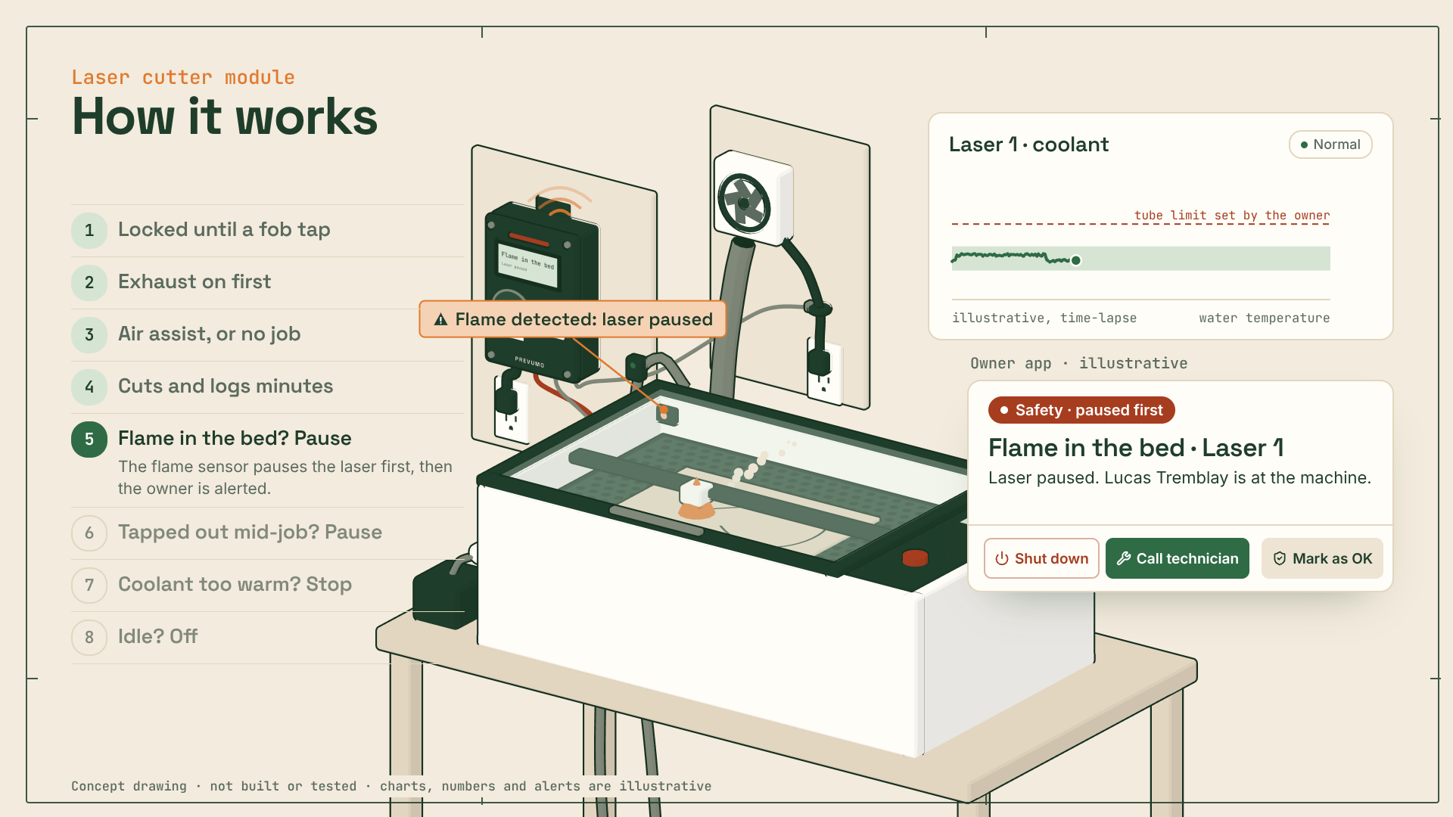
Figure 6. Laser cutter module page at the flame step: the flame sensor pauses the laser and the owner gets a safety alert. Charts, numbers and alerts are illustrative.
Parts (Where: in the box, or on the machine)
No. | Part | Where | Role
1 | NFC reader | Box | Members tap their fob; trained list per machine.
2 | Display and status light | Box | Who is on, and what the box is doing.
3 | QR sticker | Box | Opens the Laser 1 manual.
4 | Front cover | Box | Sealed, closed with four screws.
5 | Controller board | Box | ESP32 with Wi-Fi; reads every sensor.
6 | Interlock relay | Box | Opens the laser's enable line: no fob, no laser.
7 | Power supply | Box | Runs the box from a wall outlet.
8 | Back housing | Box | Wall mount and four cable glands.
9 | Exhaust clamp | Machine | Current clamp on the exhaust fan's cord.
10 | Coolant sensor | Machine | Water temperature on the chiller's return hose.
11 | Air pressure switch | Machine | On the air assist hose: no pressure, no job.
12 | Flame and smoke sensor | Machine | Looks at the bed from inside the laser.
Behaviour
- Locked until a fob tap Priya's fob is not on Laser 1's trained list, so it stays locked. Lucas is trained: it unlocks.
- Exhaust on first The laser stays locked until the clamp sees the exhaust fan draw current.
- Air assist, or no job No pressure at the air switch blocks the job.
- Cuts and logs minutes Laser-on minutes go to Lucas's record. The coolant temperature is read the whole time.
- Flame in the bed? Pause The flame sensor pauses the laser first, then the owner is alerted.
- Tapped out mid-job? Pause A running laser is never left alone: tapping out pauses the job and alerts the owner.
- Coolant too warm? Stop The laser stops before the tube is damaged, then the owner is alerted.
- Idle? Off Nothing running for the owner's idle time: the enable line opens and the session ends.
Evidence
- Exhaust interlock: CMU EHS laser guideline, ventilation must be on before operation.
- Pause when the operator taps out: CMU EHS (keep cutters always attended) and VanHack (“zero tolerance” rule for leaving the laser).
- NFC fob: Yukonstruct (Rick Yorgason, Oct 27).
- Air assist and coolant limits: no source yet. [Fill in]
Page: https://claude.ai/artifact/5e6JmpAoJxPuM4aq2bjoHg

4.7 QR machine manual
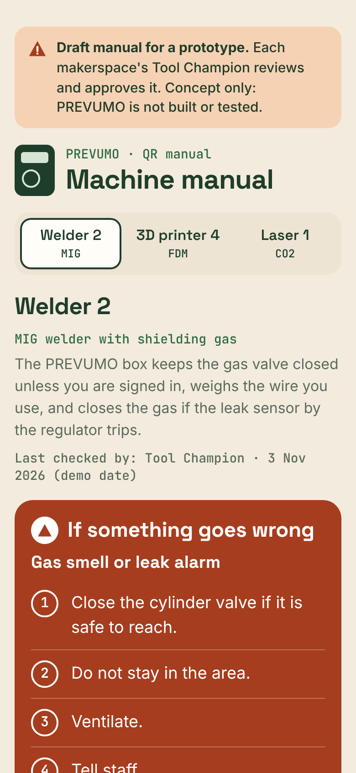
Figure 7. QR machine manual on a phone (Welder 2). Draft text for a prototype.
A member scans the QR sticker beside the reader on the box and the manual for that machine opens on their phone. They see:
- a banner: “Draft manual for a prototype. Each makerspace's Tool Champion reviews and approves it.”
- a switcher with large buttons for Welder 2, 3D printer 4 and Laser 1;
- a short note on what the PREVUMO box does on that machine, and a “Last checked by: Tool Champion” line;
- a large red section, “If something goes wrong”, with short and conservative emergency steps;
- Before you start (checks), Start (numbered) and Shut down (numbered).
The page works without a connection once it has opened. The review date shown on the page is a demo date.
Page: https://claude.ai/artifact/H3puTqjPPLrXovR8i2b6jk

4.8 Owner app
Demo data, illustrative. The owner app shows four machines (Welder 2, 3D printer 4, Laser 1, Multimaker 1) with their status (idle, in use, alert, learning mode), who is on and a live mini chart. Alerts use one format with three buttons, and pressing one logs the decision. Members shows sessions, minutes and resources per member, with a “flagged for review” badge. Resources shows monthly totals, and Manuals lists the QR manuals with their review dates.
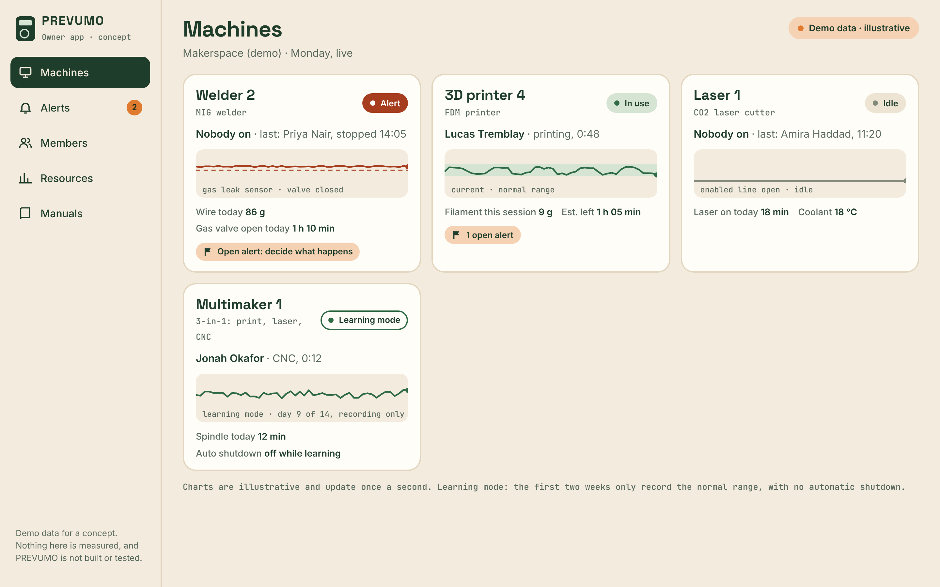
Figure 8. Owner app, Machines. Demo data, illustrative.
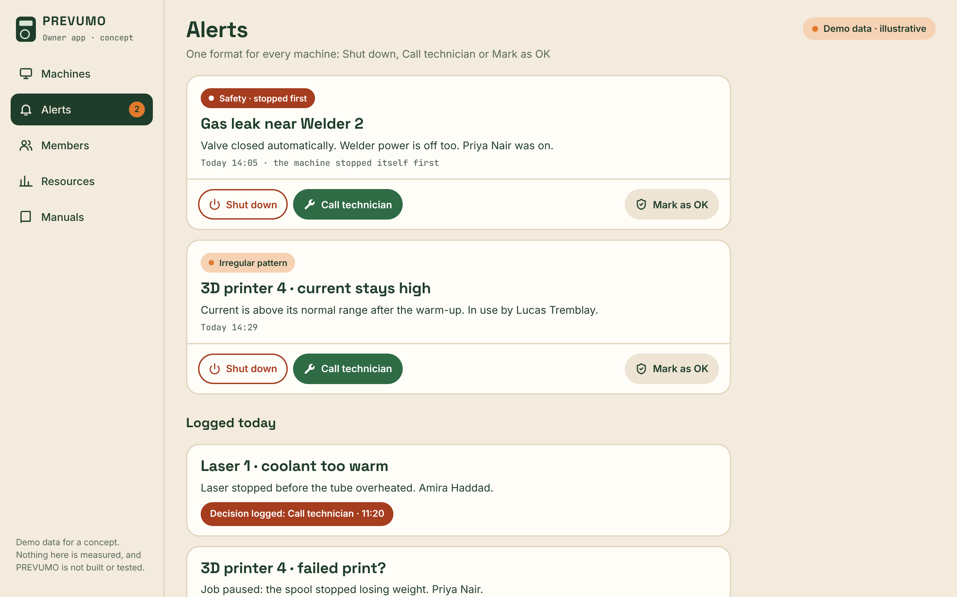
Figure 9. Owner app, Alerts, with the three buttons and the confirmation for Shut down. Demo data, illustrative.
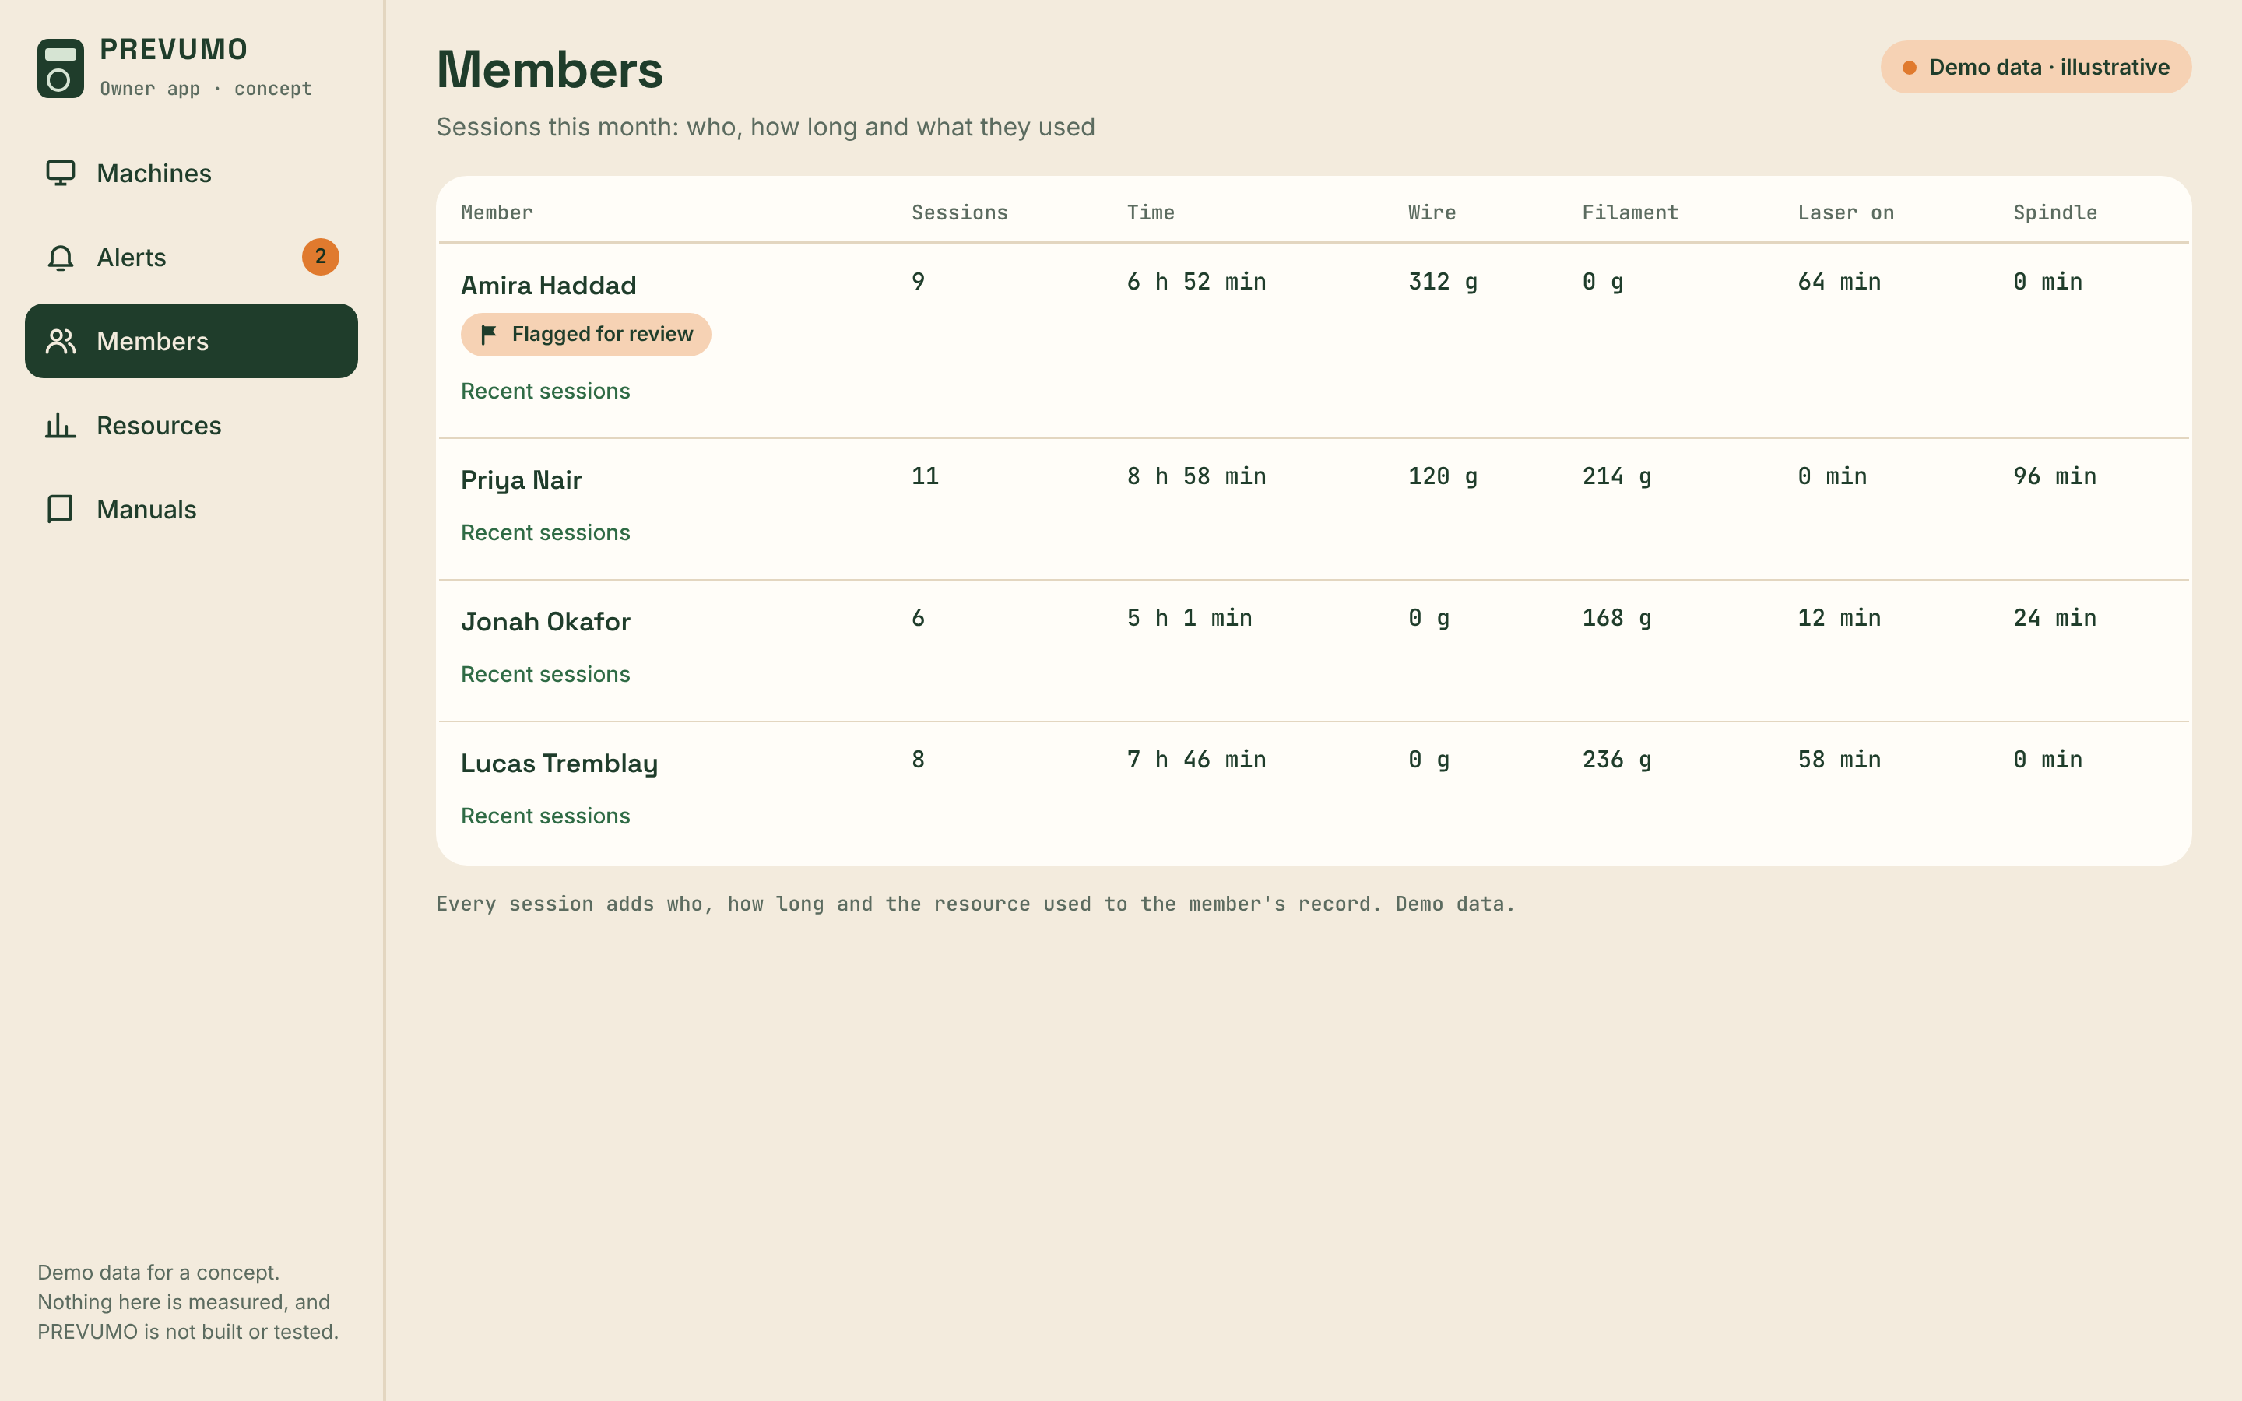
Figure 10. Owner app, Members, with the “flagged for review” badge. Demo data, illustrative.
Page: https://claude.ai/artifact/4h4W69hJd84m2PPxQsAU6n

4.9 Shared rules
The same rules apply on every module:
- NFC fob and trained list. A member taps a fob; the display shows “Tap your fob”, then “Checking fob”, then “Hi” and their name. A fob that is not on that machine's trained list sees “Not trained on this machine” and the machine stays locked.
- QR beside the reader. A printed sticker on the front cover opens that machine's manual.
- Two-week learning mode. The first two weeks only record the normal range, with no automatic shutdown.
- One alert format. Shut down, Call technician or Mark as OK. Safety events (gas leak, fire, no exhaust) stop the machine first, then alert.
- Idle timeout. If nothing happens for the time the owner sets, everything switches off.
- Resources logged per session. Each session logs who, how long and the resource used, and adds it to the member's record.

4.10 Safety and limits
Concept only, not built or tested. A licensed electrician installs switching parts; gas parts reviewed by a licensed gas fitter; CSA certification needed before sale.
Every chart, number and alert in the prototype pages is illustrative, not measured. The pages show how the system would behave; they are not test results.

5. Hypotheses to test in the interviews
No. | Hypothesis | How we test it | What would prove it wrong
H1 | Makerspace owners prefer an NFC fob to a personal code to unlock machines. | Ask how members unlock machines today, then show the fob step on the Welder page and ask how it would fit their space. | Owners say a code, key or sign-in sheet works better, or they would not issue fobs.
H2 | Owners want material used (grams of wire or filament, laser minutes) tracked per member automatically. | Ask how they track and bill material today, then show the wire scale and the Members tab of the owner app. | They do not track or bill material per member, or weighing by hand is good enough for them.
H3 | An automatic gas valve shut-off and leak alert on the welder is worth paying for. | Ask how gas is handled when the welder is idle and about past leaks, then show the gas leak step and ask what it would be worth to them. | They report no gas problems, already have a shut-off, or would not pay for it.
H4 | A heating timeout that cuts power on idle printers solves a real problem. | Ask what happens when a print ends or fails with nobody there, then show the heating timeout step. | Printers are always attended or switched off by staff, and they report no incidents.
H5 | A laser that stays locked until the exhaust runs, and pauses when the operator leaves, matches their safety rules. | Ask for their laser rules, then compare them with the steps on the Laser page. | Their rules differ, or they see the lock and the pause as getting in the way.
H6 | A QR manual on each machine would be used by members and kept up to date by a Tool Champion. | Ask where members find instructions now and who updates them, then show the QR manual on a phone. | Members would not scan it, or nobody would take charge of keeping it current.
H7 | A two-week learning mode before any automatic shutdown makes owners trust the system. | Ask how they would want a new system to behave in its first weeks, then show the learning mode note. | They want shutdown from day one, or the learning period does not change their trust.

6. Interview plan
We will interview makerspace owners, managers, Tool Champions and members, in person, by video or by phone. Each interview takes about 30 to 45 minutes. We ask about how things work today first, and only then show the prototype pages that match their machines, so the pages do not steer the answers.
Number of interviews planned | [Fill in]
Dates | [Fill in]
Organizations contacted | [Fill in]
Interview script
Open, neutral questions, grouped by hypothesis. Follow up with “Tell me more” or “What happened next?”.
H1, access to machines
- How do members unlock machines today?
- How do you know a member is trained on a machine before they use it?
- Tell me about a time access to a machine caused a problem.
H2, materials
- How do you track material used?
- How do you charge members for wire, filament or laser time today?
- What takes the most time in that process?
H3, welding gas
- What happens to the shielding gas when the welder is not in use?
- Tell me about the last time gas was left open or a leak was suspected.
- What do you do today when someone notices a gas smell?
H4, printers left heating
- What happens when a print ends or fails and nobody is at the printer?
- Tell me about the last time a machine was left on or misused.
H5, laser safety
- What are your rules for running the laser?
- How do you make sure the exhaust and air assist are on before a job?
- What happens when someone walks away from the laser while it runs?
H6, manuals
- Where do members find instructions for a machine today?
- Who keeps those instructions up to date, and how often?
H7, trust in automatic actions
- How would you want a new monitoring system to behave in its first weeks?
- What would make you trust, or not trust, a system that can switch a machine off?
Closing
- What would stop you from installing this?
- Who else should we talk to?

7. Interview records
Fill in one sheet per interview. Copy a sheet if you do more than 10.
Every grey cell is for the team to fill in. Write exact words in the quote row, and leave a row empty rather than guess.
Interview sheet 1
Interview number
Interviewer (team member)
Date
Method (in person / video / phone)
Organization
Interviewee name and role (or “anonymous”)
Machines they have
How they handle access today
How they track materials today
Safety incidents or close calls they mentioned
Reaction to the prototype pages shown (which pages)
Hypotheses supported (H1 to H7)
Hypotheses contradicted (H1 to H7)
Best quote (exact words)
Willingness to pay or pilot
Follow-up or next step
Interview sheet 2
Interview number
Interviewer (team member)
Date
Method (in person / video / phone)
Organization
Interviewee name and role (or “anonymous”)
Machines they have
How they handle access today
How they track materials today
Safety incidents or close calls they mentioned
Reaction to the prototype pages shown (which pages)
Hypotheses supported (H1 to H7)
Hypotheses contradicted (H1 to H7)
Best quote (exact words)
Willingness to pay or pilot
Follow-up or next step
Interview sheet 3
Interview number
Interviewer (team member)
Date
Method (in person / video / phone)
Organization
Interviewee name and role (or “anonymous”)
Machines they have
How they handle access today
How they track materials today
Safety incidents or close calls they mentioned
Reaction to the prototype pages shown (which pages)
Hypotheses supported (H1 to H7)
Hypotheses contradicted (H1 to H7)
Best quote (exact words)
Willingness to pay or pilot
Follow-up or next step
Interview sheet 4
Interview number
Interviewer (team member)
Date
Method (in person / video / phone)
Organization
Interviewee name and role (or “anonymous”)
Machines they have
How they handle access today
How they track materials today
Safety incidents or close calls they mentioned
Reaction to the prototype pages shown (which pages)
Hypotheses supported (H1 to H7)
Hypotheses contradicted (H1 to H7)
Best quote (exact words)
Willingness to pay or pilot
Follow-up or next step
Interview sheet 5
Interview number
Interviewer (team member)
Date
Method (in person / video / phone)
Organization
Interviewee name and role (or “anonymous”)
Machines they have
How they handle access today
How they track materials today
Safety incidents or close calls they mentioned
Reaction to the prototype pages shown (which pages)
Hypotheses supported (H1 to H7)
Hypotheses contradicted (H1 to H7)
Best quote (exact words)
Willingness to pay or pilot
Follow-up or next step
Interview sheet 6
Interview number
Interviewer (team member)
Date
Method (in person / video / phone)
Organization
Interviewee name and role (or “anonymous”)
Machines they have
How they handle access today
How they track materials today
Safety incidents or close calls they mentioned
Reaction to the prototype pages shown (which pages)
Hypotheses supported (H1 to H7)
Hypotheses contradicted (H1 to H7)
Best quote (exact words)
Willingness to pay or pilot
Follow-up or next step
Interview sheet 7
Interview number
Interviewer (team member)
Date
Method (in person / video / phone)
Organization
Interviewee name and role (or “anonymous”)
Machines they have
How they handle access today
How they track materials today
Safety incidents or close calls they mentioned
Reaction to the prototype pages shown (which pages)
Hypotheses supported (H1 to H7)
Hypotheses contradicted (H1 to H7)
Best quote (exact words)
Willingness to pay or pilot
Follow-up or next step
Interview sheet 8
Interview number
Interviewer (team member)
Date
Method (in person / video / phone)
Organization
Interviewee name and role (or “anonymous”)
Machines they have
How they handle access today
How they track materials today
Safety incidents or close calls they mentioned
Reaction to the prototype pages shown (which pages)
Hypotheses supported (H1 to H7)
Hypotheses contradicted (H1 to H7)
Best quote (exact words)
Willingness to pay or pilot
Follow-up or next step
Interview sheet 9
Interview number
Interviewer (team member)
Date
Method (in person / video / phone)
Organization
Interviewee name and role (or “anonymous”)
Machines they have
How they handle access today
How they track materials today
Safety incidents or close calls they mentioned
Reaction to the prototype pages shown (which pages)
Hypotheses supported (H1 to H7)
Hypotheses contradicted (H1 to H7)
Best quote (exact words)
Willingness to pay or pilot
Follow-up or next step
Interview sheet 10
Interview number
Interviewer (team member)
Date
Method (in person / video / phone)
Organization
Interviewee name and role (or “anonymous”)
Machines they have
How they handle access today
How they track materials today
Safety incidents or close calls they mentioned
Reaction to the prototype pages shown (which pages)
Hypotheses supported (H1 to H7)
Hypotheses contradicted (H1 to H7)
Best quote (exact words)
Willingness to pay or pilot
Follow-up or next step

8. Results
To be completed after the interviews.
Hypothesis scorecard
Hypothesis | Supported | Contradicted | Unclear | Number of interviews | Key evidence
H1
H2
H3
H4
H5
H6
H7
What we will change for PD B4
1.
2.
3.
4.
5.
Surprises and new questions
1.
2.
3.

9. Next steps (PD B4 validation)
1. | [Fill in]
2. | [Fill in]
3. | [Fill in]

10. References
Sources from section 3, as cited in the PREVUMO brief. Links and access dates are to be completed by the team.
[1] Alveo3D. Guidance on nozzle temperatures (250 °C and up) and checking prints every 30 minutes. [Fill in: link and date accessed]
[2] CMU EHS. Laser cutter guideline: ventilation on before operation, cutters always attended. [Fill in: link and date accessed]
[3] Grey Bruce Makers. Material billing at $0.10 per gram; spools removed and weighed by hand. [Fill in: link or contact and date]
[4] HSE. EIS45. [Fill in: title, link and date accessed]
[5] University of Regina. 3D printing charge of $0.10 per gram. [Fill in: link and date accessed]
[6] VanHack. “Zero tolerance” rule for leaving the laser. [Fill in: link and date accessed]
[7] Yorgason, R. (Yukonstruct). Conversation with Group 10, October 27. Personal communication.
Prototype pages (Group 10, PD B3, interactive web pages)
[8] PREVUMO, page 1: Welder module. https://claude.ai/artifact/KAUbvfq3DmXSjazq2fNP8Q
[9] PREVUMO, page 2: 3D printer module. https://claude.ai/artifact/T8ZbrGETfFSC93hxXRPbfV
[10] PREVUMO, page 3: Enclosed printer module. https://claude.ai/artifact/75rKRdjDcEjJiDaA1jvsZ4
[11] PREVUMO, page 4: Multimaker module. https://claude.ai/artifact/C52M2y6pjY9HUNtT7dSVgp
[12] PREVUMO, page 5: Laser cutter module. https://claude.ai/artifact/5e6JmpAoJxPuM4aq2bjoHg
[13] PREVUMO, page 6: System overview. https://claude.ai/artifact/RAf322imEcX6BZJNPqsnQb
[14] PREVUMO, page 7: QR machine manual. https://claude.ai/artifact/H3puTqjPPLrXovR8i2b6jk
[15] PREVUMO, page 8: Owner app. https://claude.ai/artifact/4h4W69hJd84m2PPxQsAU6n

Appendix A. Prototype pages
Page | Name | Description | URL
1 | Welder module | Box beside a MIG welder: NFC fob, gas valve, gas leak sensor, wire scale. | https://claude.ai/artifact/KAUbvfq3DmXSjazq2fNP8Q
2 | 3D printer module | Box for an FDM printer: spool scale, printer link, failed print pause, heating timeout. | https://claude.ai/artifact/T8ZbrGETfFSC93hxXRPbfV
3 | Enclosed printer module | The printer box on an enclosed printer, plus a chamber temperature sensor. | https://claude.ai/artifact/75rKRdjDcEjJiDaA1jvsZ4
4 | Multimaker module | Box for a 3-in-1 machine: mode buttons for print, laser and CNC. | https://claude.ai/artifact/C52M2y6pjY9HUNtT7dSVgp
5 | Laser cutter module | Box beside a CO2 laser: exhaust, air, flame and coolant checks, laser minutes. | https://claude.ai/artifact/5e6JmpAoJxPuM4aq2bjoHg
6 | System overview | Diagram of the whole system, the risks table, the session in five steps. | https://claude.ai/artifact/RAf322imEcX6BZJNPqsnQb
7 | QR machine manual | Phone-first manual for Welder 2, 3D printer 4 and Laser 1. | https://claude.ai/artifact/H3puTqjPPLrXovR8i2b6jk
8 | Owner app | Machines, alerts, members, resources and manuals, with demo data. | https://claude.ai/artifact/4h4W69hJd84m2PPxQsAU6n
Every chart, number and alert on these pages is illustrative. Concept only, not built or tested.

Appendix B. Interview script
Ask about today first. Show the prototype pages only after the questions for that topic. Do not suggest answers.
H1, access to machines
1. How do members unlock machines today?
2. How do you know a member is trained on a machine before they use it?
3. Tell me about a time access to a machine caused a problem.
H2, materials
4. How do you track material used?
5. How do you charge members for wire, filament or laser time today?
6. What takes the most time in that process?
H3, welding gas
7. What happens to the shielding gas when the welder is not in use?
8. Tell me about the last time gas was left open or a leak was suspected.
9. What do you do today when someone notices a gas smell?
H4, printers left heating
10. What happens when a print ends or fails and nobody is at the printer?
11. Tell me about the last time a machine was left on or misused.
H5, laser safety
12. What are your rules for running the laser?
13. How do you make sure the exhaust and air assist are on before a job?
14. What happens when someone walks away from the laser while it runs?
H6, manuals
15. Where do members find instructions for a machine today?
16. Who keeps those instructions up to date, and how often?
H7, trust in automatic actions
17. How would you want a new monitoring system to behave in its first weeks?
18. What would make you trust, or not trust, a system that can switch a machine off?
Closing
19. What would stop you from installing this?
20. Who else should we talk to?

