Second Year

2022 / 2023

Capstone Design Project

|  |  |
| --- | --- |
| Name | Section |
| Yousef Ellban | 4 |
| Nourhan Khaled | 4 |
| Nada AhmedAhmed | 4 |
| Wahid ali | 4 |

|  |  |
| --- | --- |
| **Issue** | **Mark** |
| Project Identification |  |
| System Request |  |
| Feasibility Study |  |
| Task Identification |  |
| Pert Chart |  |
| Gantt Chart |  |
| Interview |  |
| Questionnaire |  |
| Context Diagram -- DFD |  |
| Level-0 Diagram -- DFD |  |
| Level-1 Diagram – DFD |  |
| Process Specification |  |
| Data Dictionary |  |
| Normalization |  |
| Entity-Relationship Diagram |  |

**Project Identification**

Project Name:

Blue-lock

Short Description about project:

This project aims to develop express means of delivery to be available in a safe technological way for more than one person... The project aims to create a small community to help young people move around the city and its various streets in an organized, modern, safe way and organize traffic to reach the target destination quickly.

**System Request**

Project sponsor:

Blue-lock organization

Business needs:

1. Environmental pollution problems caused by car exhausts to increase overpopulation.
2. Because it is difficult to cross distances in some areas on foot.
3. Difficulty obtaining means of transportation.
4. The problem of petroleum products

Business requirement:

1. Provide a safe and easy way to moving.
2. Safe a lot of money.
3. Reliance on renewable energy

Business value

1. 10% increasing of Environmental pollution at lest
2. Saving a lot of time
3. Saving a lot of money

Special Issues or Constraints

1. Deadline before final exam
2. Provide security for customers information

**Feasibility Study**

Technical Feasibility

Can we build it or not ?

1. Familiarity with applications:

We have experiences and skills that make us to do it

1. Familiarity with technology:

We have :

1. Programmers
2. Designers
3. We can work with various databases
4. We can manage all TECH problems
5. Project size:

Our project size is medium

Economic Feasibility

1. System cost :
   1. Developer cost -> $5.000
   2. Designing system -> $2.000
2. Annual operating cost is :

For software company:

1. Developing cost -> $100.000

For organization:

1. Sentral data server -> $50.000
2. Technical fixing motors ->$10.000
3. Annual benefits:
   1. Annual benefits =(Total benefits in year)-(system cost + annual operating cost)

Annual benefits =( $500.000 )-($7.000 + $160.000)=$323.000

Organizational Feasibility

For sponsor :

1. Admins
2. Organization customers
3. Organization Technical support

For services :

1. Students
2. Normal people
3. Any one not have a mode of transport
4. For fun

**Methodology**

**Why we chosen this method?**

**Because we have been finished the planning and analysis phases**

**And in this method we can manage all debug one by one and over control at all system**

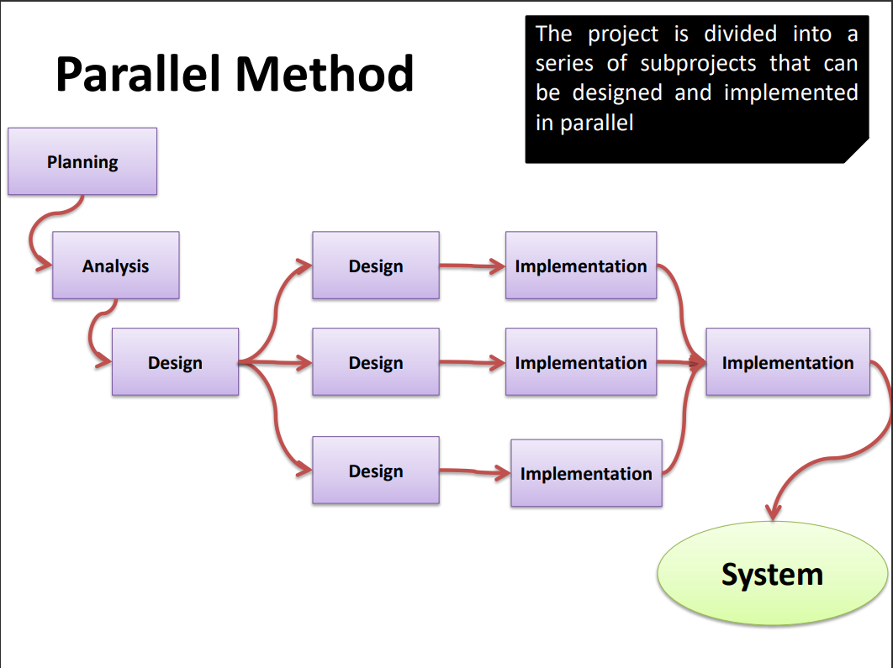

**Time Estimation**

**We may take around 100 days for finished**

**1-Planning 🡪 15% (15 Days)**

**2-Analysis 🡪35% (35 Days)**

**3-Desigen 🡪50% (50 days)**

|  |  |
| --- | --- |
| Project planning and description | Name of Task |
| ‏10‏/03‏/2023 | Start Date |
| ‏07‏/03‏/2023 | End Date |
| Yousef mohammed , Nada ahmed, Nourhan khaled , Wahid ali | Person assigned to task |
| High | Priority |
| MS word | Resources Needed |
| 7 Days | Estimated Time |
| 3 Days | Actual Time |

|  |  |
| --- | --- |
| System request | Name of Task |
| 2023/3/3 | Start Date |
| 2023/3/7 | End Date |
| Wahid ali , Nourhan khaled | Person assigned to task |
| High | Priority |
| MS word | Resources Needed |
| 5 Days | Estimated Time |
| 1 Day | Actual Time |

|  |  |
| --- | --- |
| Feasibility study | Name of Task |
| 2023/3/4 | Start Date |
| 2023/3/7 | End Date |
| Wahid ali | Person assigned to task |
| High | Priority |
| MS word | Resources Needed |
| 3 Days | Estimated Time |
| 3 Days | Actual Time |

|  |  |
| --- | --- |
| Methodology | Name of Task |
| 2023/3/1 | Start Date |
| 2023/3/6 | End Date |
| Nourhan Khaled | Person assigned to task |
| High | Priority |
| Methodology & MS word | Resources Needed |
| 6 Days | Estimated Time |
| 3 Days | Actual Time |

|  |  |
| --- | --- |
| Pert chart | Name of Task |
| 20230/3/5 | Start Date |
| 2023/3/7 | End Date |
| Nada ahmed | Person assigned to task |
| Medium | Priority |
| MS word | Resources Needed |
| 2 Days | Estimated Time |
| 2 Days | Actual Time |

|  |  |
| --- | --- |
| Gant chart | Name of Task |
| 2023/3/5 | Start Date |
| 2023/3/7 | End Date |
| Yousef mohammed | Person assigned to task |
| Medium | Priority |
| MS word & Gant chart maker | Resources Needed |
| 2 Days | Estimated Time |
| 2 Days | Actual Time |

|  |  |
| --- | --- |
| Interview | Name of Task |
| 2023/3/4 | Start Date |
| 2023/3/7 | End Date |
| Nourhan Khaled | Person assigned to task |
| High | Priority |
| Methodology & MS word | Resources Needed |
| 6 Days | Estimated Time |
| 3 Days | Actual Time |

**Pert Chart**

|  |  |  |  |
| --- | --- | --- | --- |
| **Activity** | **Description** | **Predecessors** | **Duration** |
| A | Project planning and description | _ | 3 |
| B | System request | _ | 1 |
| C | Feasibility study | B | 3 |
| D | Methodology | C | 3 |
| E | Time Estimation | _ | 1 |
| F | Scope Management | E | 2 |
| G | Interview | C | 1 |

**Gantt chart**

|  |  |  |  |  |  |  |  |  |  |  |  |  |  |  |  |  |
| --- | --- | --- | --- | --- | --- | --- | --- | --- | --- | --- | --- | --- | --- | --- | --- | --- |
| ID | Task Name | Start time | End time | 1 | 2 | 3 | 4 | 5 | 6 | 7 | 8 | 9 | 10 | 11 |  |  |
| A | Project planning &Description | 2023/3/1 | 2023/3/7 |  |  |  |  |  |  |  |  |  |  |  |  |  |
| B | System request | 2023/3/3 | 2023/3/7 |  |  |  |  |  |  |  |  |  |  |  |  |  |
| C | Feasibility study | 2023/3/4 | 2023/3/7 |  |  |  |  |  |  |  |  |  |  |  |  |  |
| D | Methodology | 2023/3/8 | 2023/3/10 |  |  |  |  |  |  |  |  |  |  |  |  |  |
| E | Time Estimation | 2023/3/1 | 2023/3/2 |  |  |  |  |  |  |  |  |  |  |  |  |  |
| F | Scope Management | 2023/3/2 | 2023/3/3 |  |  |  |  |  |  |  |  |  |  |  |  |  |
| G | Interview | 2023/3/10 | 2023/3/11 |  |  |  |  |  |  |  |  |  |  |  |  |  |

**Scope Management**

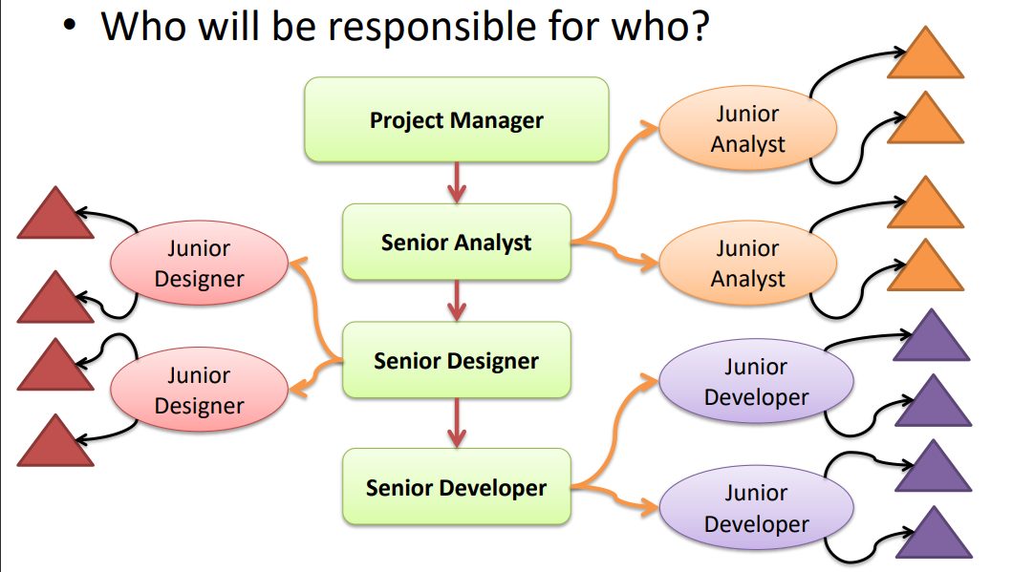

**Interview**

**Interview is a method uses to collection useful data and information**

**Planning interview**

1. **Reading background materials**
2. **Determine interview objectives**
3. **Deciding whom to interview**
4. **Preparing the interview**
5. **Deciding on question type and structure**
6. **Closing interview**
7. **Write interview report**

**close-end Questions :**

1. **Do you want users to be able to reserve bikes or scooters in advance, or only when they arrive at a pickup location?**

**=Yes, users will be able to reserve bikes or scooters in advance through the website.**

1. **Will users be able to rent bikes or scooters for a set amount of time, or can they keep them for as long as they want?**

**=Users will be able to rent bikes or scooters for a set amount of time, which will be specified on the website.**

1. **Do you want users to be able to pay for their rentals through the website, or will they need to pay at the pickup location?**

**=Yes, users will be able to pay for their rentals through the website.**

1. **Will users need to create an account to use the service, or can they rent bikes or scooters anonymously?**

**=Users will be able to rent bikes or scooters anonymously, but creating an account will offer additional benefits and features.**

1. **Will users need to provide a credit card or other form of payment information to use the service?**

**=Yes, users will need to provide payment information, such as a credit card or debit card, to use the service.**

1. **Will the website include a map or other visual aids to help users locate pickup and drop-off locations?**

**=Yes, the website will include a map and other visual aids to help users locate pickup and drop-off locations.**

1. **Will the website include information about available bikes and scooters, such as battery life, location, and availability?**

**=Yes, the website will provide users with information about available bikes and scooters, including battery life, location, and availability.**

1. **Will the website allow users to leave reviews or feedback about their rental experience?**

**=Yes, users will be able to leave reviews and feedback about their rental experience on the website.**

1. **Will the website include information about local laws and regulations regarding bike and scooter rentals?**

**=Yes, the website will include information about local laws and regulations regarding bike and scooter rentals to ensure compliance.**

1. **Will the website have a mobile app or other means of accessing the service on a smartphone or tablet?**

**=Yes, the website will have a mobile app and other means of accessing the service on a smartphone or tablet for user convenience.**

**(Probing Questions ):**

1. **Can you tell me more about your target audience for this service? What age ranges or demographics are you hoping to attract?**

**=Answer: Yes, we are targeting urban commuters aged 18-45 who are environmentally conscious and value convenience.**

1. **How do you see this service fitting into the existing bike and scooter rental market? What sets your service apart from others?**

**=Answer: Our service aims to provide a more convenient, eco-friendly, and cost-effective solution for urban transportation needs. Our focus on electric scooters and bikes sets us apart from other traditional bike and scooter rental companies.**

1. **What sort of user data do you hope to collect through the website, and how do you plan to use that data to improve the service?**

**=Answer: We plan to collect user data such as rental frequency, locations, and user preferences.**

**We will use this data to improve the availability of our service and tailor promotions and discounts to meet user needs.**

1. **Can you tell me more about the technology you'll be using to manage bike and scooter rentals, and how it will integrate with the website?**

**=Answer: We plan to use GPS-enabled technology to track rentals and manage inventory.**

**The technology will integrate with our website to allow users to easily locate and reserve bikes and scooters.**

1. **Have you considered any potential legal or regulatory issues that might arise with this service, such as liability concerns or insurance requirements?**

**=Answer: Yes, we have considered potential legal and regulatory issues, and plan to have proper insurance coverage and liability waivers in place to protect both our company and users.**

1. **How do you envision users discovering your service and the website, and what sort of marketing or advertising do you plan to use to promote it?**

**=Answer: We plan to utilize digital advertising and social media marketing to promote our service. We also plan to partner with local businesses to offer promotions and discounts to attract users.**

1. **Are there any additional features or functionality you're considering adding to the website, such as social media integration or gamification elements?**

**=Answer: Yes, we are considering social media integration to allow users to share their experiences and promote our service to their networks. We may also explore gamification elements to incentivize frequent rentals.**

1. **How do you plan to handle customer support and complaints through the website, and what sort of resources will be available to users who need help?**

**=Answer: We plan to have a customer support team available through the website, as well as an FAQ section and user guides to assist with common issues.**

**Can you tell me more about the payment processing system you plan to use on the website, and how you'll ensure user data remains secure?**

**Answer: We plan to use a secure payment processing system that is PCI compliant and will encrypt user data to ensure privacy and security. We will also have a privacy policy in place to outline our data handling practices.**

**(OPEN ENDED Questions )**

**1.What inspired you to create a bike and scooter rental website, and what do you hope to achieve with this service?**

**Answer: "As a cyclist and occasional scooter rider myself, I've often wished for a more convenient and affordable rental option in my city. With this website, I hope to provide a reliable, user-friendly platform that offers easy access to bikes and electric scooters for short-term rentals. Ultimately, I want to encourage more people to choose eco-friendly transportation options and reduce traffic congestion in urban areas."**

**2.How do you plan to ensure a positive user experience for renters, and what features or functionalities will be available on the website?**

**Answer: "Our main priority is to make renting a bike or scooter as easy and hassle-free as possible for users. To achieve this, we plan to offer features like advanced reservations, mobile app integration, and real-time inventory management. We'll also provide detailed information about each rental option, including bike or scooter specifications, pick-up and drop-off locations, and safety tips."**

**3.What challenges or obstacles do you anticipate facing with this service, and how do you plan to overcome them?**

**Answer: "One of our biggest challenges will be ensuring the safety and security of our users and their personal information. To address this, we'll be implementing strict security protocols for our website and payment processing system, as well as providing clear guidelines for safe riding and equipment handling. We also anticipate potential legal or regulatory issues, such as liability concerns or insurance requirements, and we'll work closely with legal experts to ensure compliance and minimize risk."**

**(BIBOLAR Questions )**

**1.Do you think users will be more likely to rent bikes or scooters if they can reserve them in advance, or only when they arrive at a pickup location?**

**Answer: Yes, some users may prefer reserving in advance, while others may prefer renting on the spot.**

**2.Would you prefer to limit the rental period for bikes and scooters to ensure availability for other users, or allow users to keep them for as long as they want for convenience?**

**Answer: It depends. Yes, limiting rental period may ensure availability, but allowing longer rentals can provide more convenience.**

**3.Do you think users will feel more comfortable providing payment information through the website, or prefer to pay at the pickup location for added security?**

**Answer: It depends. Yes, some users may feel comfortable providing payment info through the website, while others may prefer paying at pickup location for added security.**

**4.Is it more important to you to prioritize user convenience with anonymous rentals, or user accountability with required account creation?**

**Answer: It depends on the business's priorities. Yes, anonymous rentals can prioritize user convenience, while requiring account creation can prioritize user accountability.**

**5.Would users prefer a mobile app for the service for greater accessibility, or a mobile-optimized website for ease of use on different devices?**

**Answer: It depends on the user's preference. Yes, some users may prefer a mobile app for accessibility, while others may prefer a mobile-optimized website for ease of use on different devices.**

**Interview Report**

**Questionnaire**

**Context Diagram – Data Flow Diagram**

**Diagram 0 – Data Flow Diagram**

**Child Diagram – Data Flow Diagram**

**Process Specification (at least two processes)**

|  |
| --- |
| **Process Specification**  **Number:**  **Name:**  **Description:** |
| **Input Data Flow** |
| **Output Data Flow** |
| **Type of Process**  **Online Batch Manual** |
| **Process Logic:** |
| **Structured English Decision Table Decision Tree** |
| **Unresolved Issues:** |

**Data Dictionary**

**Data Flow (At least three Data Flows needed)**

|  |  |
| --- | --- |
|  | ID |
|  | Label |
|  | Description |
|  | Source |
|  | Destination |
|  | Type |
|  | Data Structure |
|  | Volume/Time |
|  | Comments |

**Normalization**

**Normal Tables**

**Tables after 1NF**

**Tables after 2NF**

**Tables after 3NF**

**Entity Relationship Diagram**