Chess Engine Project – Final Updated Report
This report documents the final implementation of the Chess Engine project, including the login system, time controls, gameplay mechanics, and end‑game handling. The document reflects the most recent version of the codebase and interface, supported by screenshots taken directly from the running application.

1. Login and User Management
A local login and registration system was implemented using a lightweight file‑based approach. This allows users to create multiple accounts and return to their saved practice environment without reconfiguration. The design choice avoids unnecessary complexity while still enforcing basic user separation.
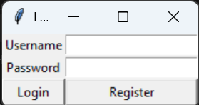

2. Game Settings and Time Control
Before each match, players can choose their side (White or Black) and select a time control. Supported modes include Bullet, Blitz, Rapid, and Classical formats. Increment‑based clocks are supported where applicable, ensuring accurate timing consistent with real tournament play.
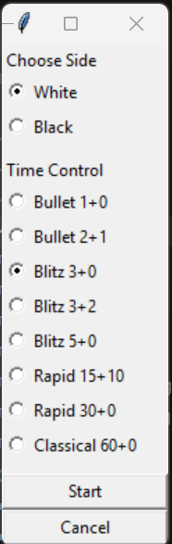

3. Chessboard Layout and Interaction
The chessboard is rendered using an 8×8 grid with alternating colors. Pieces are centered within each square and scale dynamically based on screen resolution. User interaction is mouse‑driven, allowing click‑to‑select and click‑to‑move behavior.
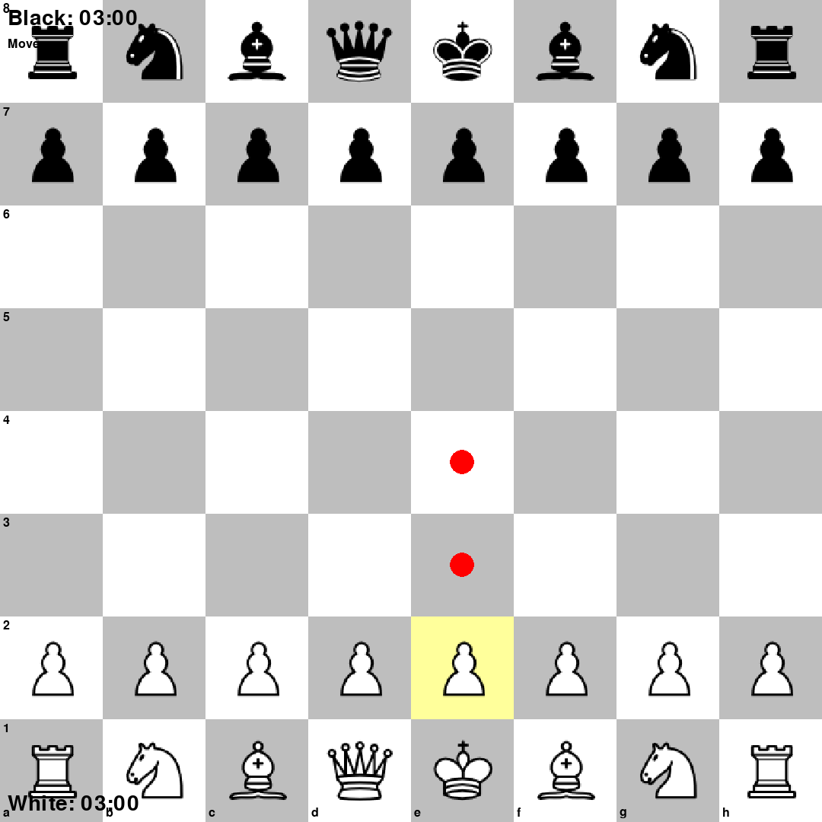

4. Legal Move Highlighting
When a piece is selected, all legal destination squares are visually indicated using highlight overlays. This feature improves usability by preventing illegal moves and guiding new players through valid move patterns.

5. Clock System
Each player is assigned an independent clock. The active player's timer decreases in real time and switches automatically after a valid move. Time increments are applied immediately after a move when enabled.
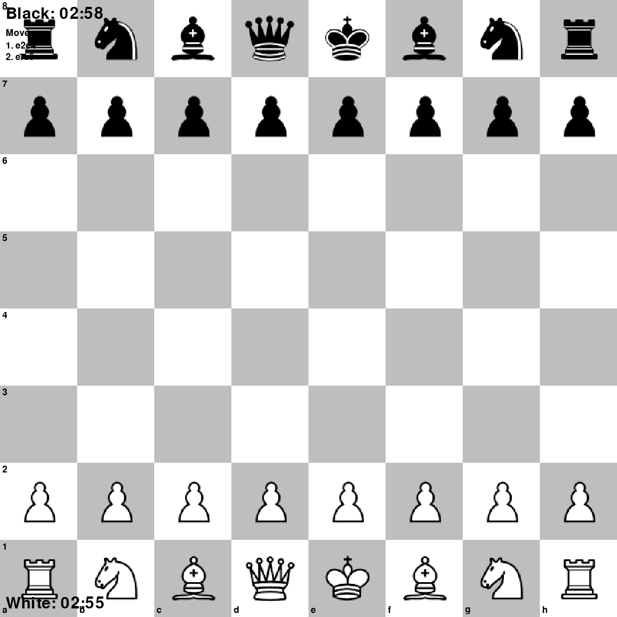

6. Check, Checkmate, and Stalemate Detection
The engine continuously evaluates king safety after every move. If the current player has no legal moves remaining, the system determines whether the state is checkmate or stalemate and displays the appropriate end‑game message.


7. Pawn Promotion
When a pawn reaches the final rank, gameplay pauses and a promotion menu is displayed. The user may choose between Queen, Rook, Bishop, or Knight. The board state updates immediately based on the selection.
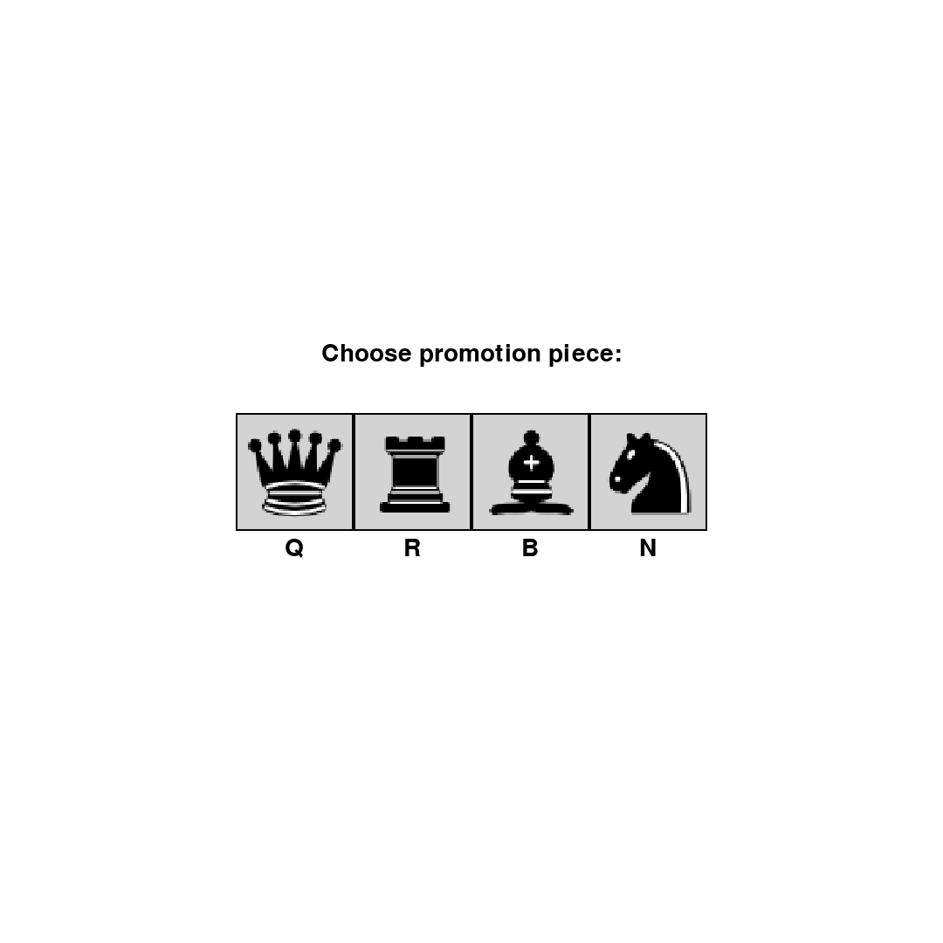

8. Restart and New Game Options
After a game concludes, players may either restart with the same settings or begin a new game. Keyboard shortcuts (R and N) are also supported for faster control.
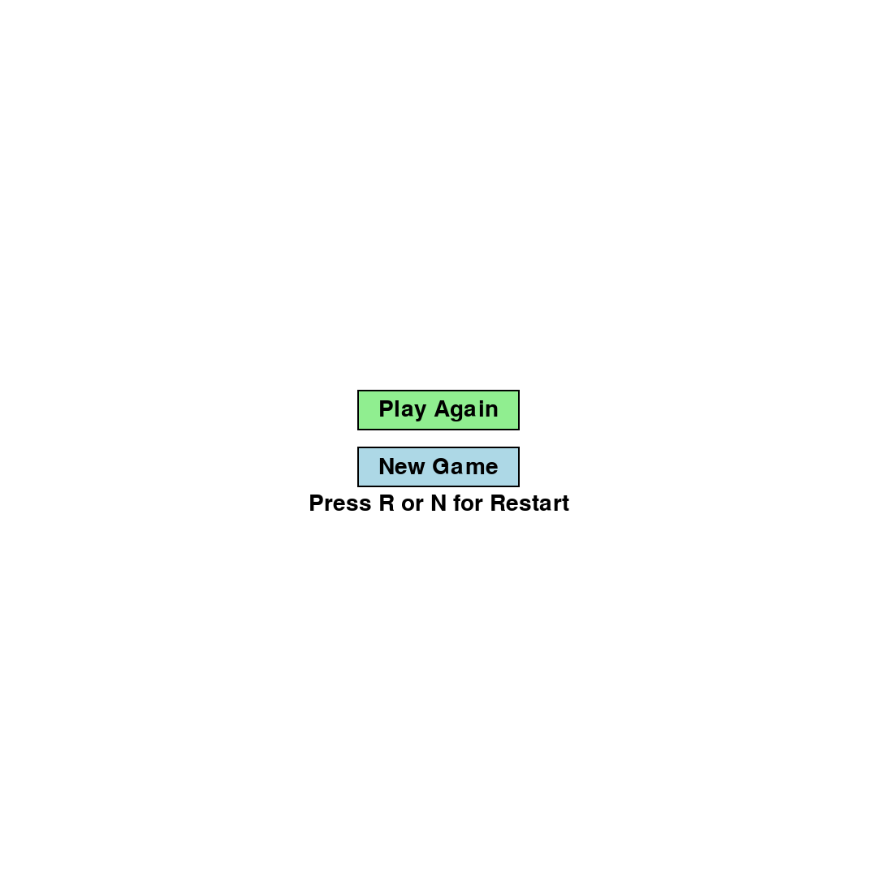

9. Conclusion
The final system meets all functional requirements of a complete offline chess game. It enforces official chess rules, provides clear visual feedback, and supports multiple time formats. The architecture allows future expansion, such as AI opponents or online play, without requiring major redesign.

