UIWebView的简单教程
——新浪微博 @WALL-E-ZZ
本教程分为3部分
1：实现webView，可以浏览网页
2：实现UIWebViewDelegate协议，跟踪webView加载内容的过程
3：实现UIActivityIndicatorView，系统等待时显示转动齿轮

实验环境：
- ProductName: Mac OS X 10.7.3
- Xcode： 4.3.2

（一）实现简单的浏览网页功能
1：创建工程UIWebViewDemo
①使用single-view模板
②不使用storyboard
③使用ARC
④不使用TestUtil

2：存储位置
①不使用版本控制系统

3：添加控件
textFiled，button，webView
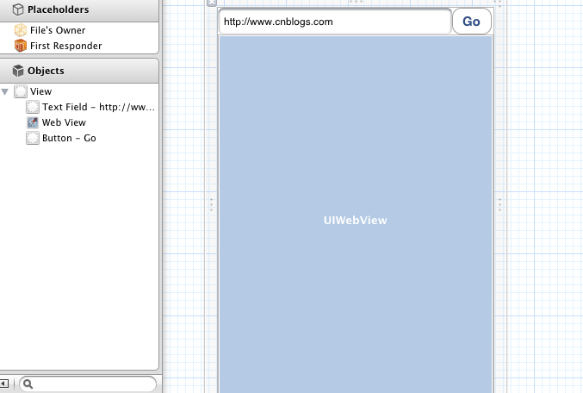

4：连接nib
两个IBOutlet（textFiled，webView），一个action（buttonPress）

5：UIWebViewDemoViewController.m中添加和修改方法

- (IBAction)buttonPress:(UIButton *)sender {
[textField resignFirstResponder];
[self loadWebPageWithString:textField.text];
}

- (void)loadWebPageWithString:(NSString*)urlString
{
NSURL *url =[NSURL URLWithString:urlString];
NSLog(@"%@", urlString);
NSURLRequest *request =[NSURLRequest requestWithURL:url];
[webView loadRequest:request];
}

- (void)viewDidLoad
{
[super viewDidLoad];
webView.scalesPageToFit =YES;
webView.delegate =self; //需要实现UIWebViewDelegate协议
[self.view addSubview : activityIndicatorView] ;

// Do any additional setup after loading the view, typically from a nib.
}

- (void)viewDidUnload
{
webView.delegate =nil;
[self setTextField:nil];
[self setWebView:nil];
[super viewDidUnload];
// Release any retained subviews of the main view.
}

到目前为止，就可以点击run，然后在自己的app里面浏览网页了。


（二）为了监控webView加载内容的过程，我们来实现UIWebViewDelegate协议。

//UIWebViewDelegate协议(总共4个可选方法，这里实现了3个)

需要修改UIWebViewDemoViewController.h
@interface UIWebViewDemoViewController : UIViewController<UIWebViewDelegate>
否则viewDidLoad函数中webView.delegate =self; 语句会有警告。

- (void)webViewDidStartLoad:(UIWebView *)webView
{
NSLog(@"startload");
}

- (void)webViewDidFinishLoad:(UIWebView *)webView
{
NSLog(@"stopload");
}

- (void)webView:(UIWebView *)webView didFailLoadWithError:(NSError *)error
{

UIAlertView *alterview = [[UIAlertView alloc] initWithTitle:@"" message:[error localizedDescription] delegate:nil cancelButtonTitle:nil otherButtonTitles:@"OK", nil];
[alterview show];
}

（三）为了又更好的用户体验，使用UIActivityIndicatorView，当webView加载数据时，显示等待标识

1：UIWebViewDemoViewController.h添加类成员变量
@interface UIWebViewDemoViewController : UIViewController<UIWebViewDelegate>
{
UIActivityIndicatorView *activityIndicatorView;
}

2：修改4个成员方法
- (void)viewDidLoad
{
[super viewDidLoad];
webView.scalesPageToFit =YES;
webView.delegate =self;
activityIndicatorView = [[UIActivityIndicatorView alloc]
initWithFrame : CGRectMake(0.0f, 0.0f, 32.0f, 32.0f)] ;
[activityIndicatorView setCenter: self.view.center] ;
[activityIndicatorView setActivityIndicatorViewStyle: UIActivityIndicatorViewStyleGray] ;
[self.view addSubview : activityIndicatorView] ;

// Do any additional setup after loading the view, typically from a nib.
}

- (void)webViewDidStartLoad:(UIWebView *)webView
{
[activityIndicatorView startAnimating] ;
NSLog(@"startload");
}

- (void)webViewDidFinishLoad:(UIWebView *)webView
{
[activityIndicatorView stopAnimating];
NSLog(@"stopload");
}

- (void)webView:(UIWebView *)webView didFailLoadWithError:(NSError *)error
{
[activityIndicatorView stopAnimating];
UIAlertView *alterview = [[UIAlertView alloc] initWithTitle:@"" message:[error localizedDescription] delegate:nil cancelButtonTitle:nil otherButtonTitles:@"OK", nil];
[alterview show];
}

