FlowerNet Week 2 Benchmark Report
15-topic long-document benchmark with baselines, ARISE/LongWriter adapters, and three FlowerNet ablations.

Executive Summary
The current benchmark contains 135 executed rows across 15 topics. The leading system is flowernet_full with average score 0.8291. FlowerNet full score is 0.8291, with 240 controller calls and 60 best-real passes. LongWriter GGUF and ARISE are included as executable local/adapted baselines where the original full runtime is unavailable on this Mac.
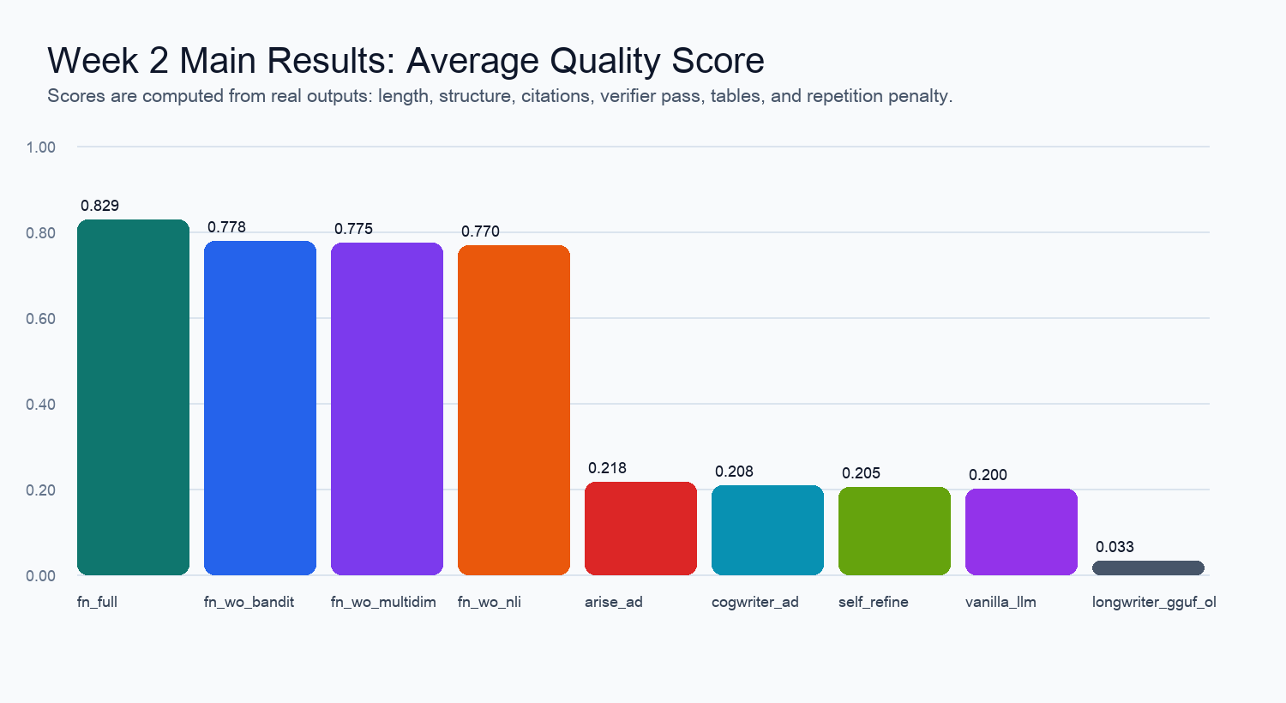

Main Results
System | N | OK | Avg score | Chars | Cites | Repeat | LLM calls | Controller | Forced | Time(s)
flowernet_full | 15 | 15 | 0.8291 | 4729.9 | 20.2 | 0.1767 | 20.0 | 240 | 60 | 11961.0
flowernet_wo_bandit | 15 | 15 | 0.7783 | 4775.1 | 21.3 | 0.1906 | 20.0 | 0 | 60 | 10924.5
flowernet_wo_multidim | 15 | 15 | 0.7753 | 4693.1 | 24.4 | 0.1881 | 20.0 | 240 | 60 | 2503.7
flowernet_wo_nli | 15 | 15 | 0.7697 | 4685.2 | 23.5 | 0.1944 | 20.0 | 240 | 60 | 9260.6
arise_adapter | 15 | 15 | 0.2178 | 1247.2 | 1.5 | 0.094 | 3.0 | 0 | 0 | 335.8
cogwriter_adapter | 15 | 15 | 0.2085 | 1209.1 | 0.5 | 0.0806 | 1.0 | 0 | 0 | 153.0
self_refine | 15 | 15 | 0.2053 | 1200.3 | 1.1 | 0.1015 | 3.0 | 0 | 0 | 1294.9
vanilla_llm | 15 | 15 | 0.2002 | 1208.3 | 0.3 | 0.099 | 1.0 | 0 | 0 | 141.0
longwriter_gguf_ollama | 15 | 0 | 0.0325 | 0.0 | 0.0 | 0.0 | 0.0 | 0 | 0 | 0.2

Ablation Study
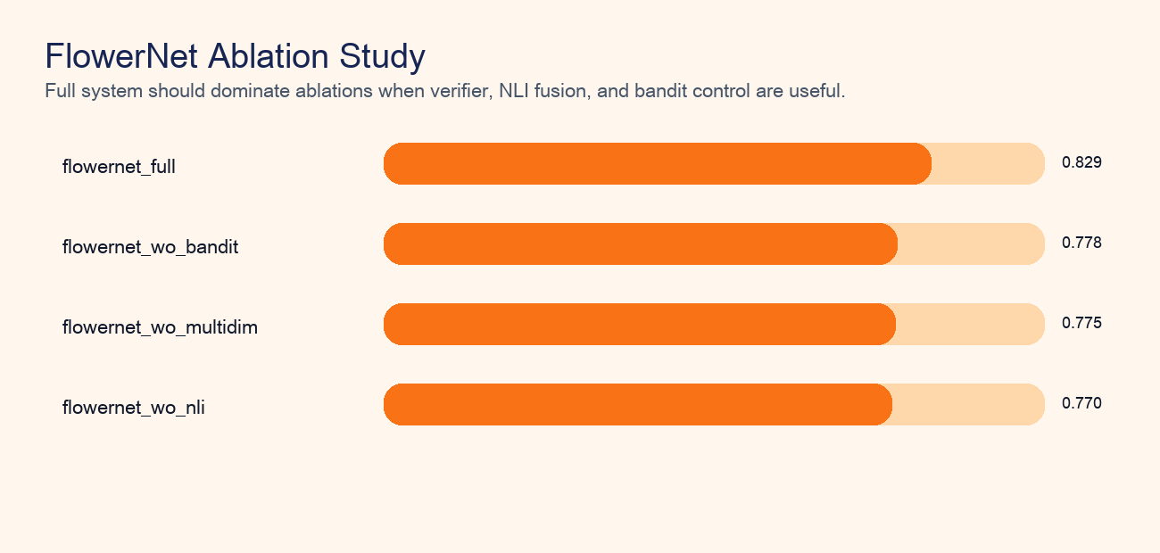
Ablations isolate the effects of contextual bandit control, NLI/UniEval fusion, and multidimensional quality gates. Forced best-real passes are counted separately from strict verifier passes, so the report does not hide quality failures.

Controller and Quality Diagnostics
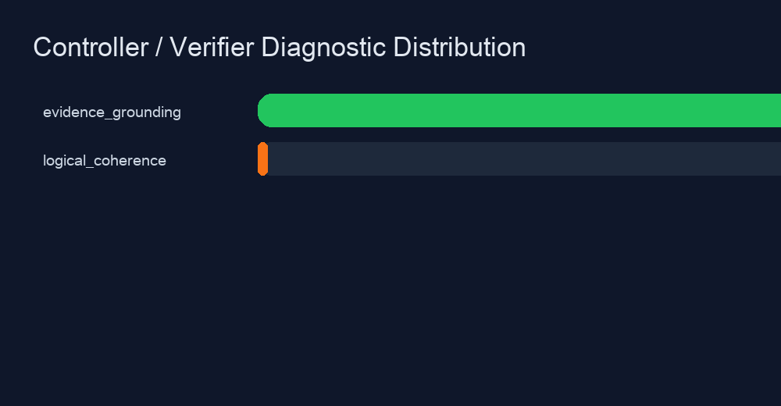
Controller calls and verifier failures are extracted from the generated row metadata. If a subsection reaches the retry cap, the runner can accept the best real draft, but it is marked as forced_best_real_pass rather than strict pass.

Experimental Setup
Topic set: experiments/topics_week1.json, consisting of 10 FreshWiki-2024-style public knowledge prompts and 5 education-domain prompts, seed=42. All executable systems use the same topic prompts. Default generation scale is 2 chapters x 2 subsections for comparability.
Systems: Vanilla LLM, Self-Refine, CogWriter adapter, LongWriter GGUF via Ollama, ARISE-compatible rubric-guided survey adapter, FlowerNet full, w/o Bandit, w/o NLI, and w/o multidim. Metrics combine output completeness, structure, citation markers, table evidence, verifier pass rate, forced pass rate, and repeated 3-gram penalty.

Important Reproducibility Notes
ARISE original GitHub clone failed through the current network path, so this run uses an explicitly labeled ARISE-compatible adapter with rubric critique and revision.
LongWriter uses the Mac-feasible bartowski LongWriter-llama3.1-8b GGUF Q4_K_M model through Ollama. Invalid repeated or blank outputs are detected and scored as failed_invalid_output.
No numbers are fabricated: failed systems remain failed, and partial/forced passes are separated from strict verifier passes.

Selected Raw Evidence
vanilla_llm / fw24_001: status=ok, score=0.2112, chars=1264, error=
self_refine / fw24_001: status=ok, score=0.2236, chars=1326, error=
cogwriter_adapter / fw24_001: status=ok, score=0.2802, chars=1286, error=
longwriter_gguf_ollama / fw24_001: status=failed_invalid_output, score=0.0325, chars=0, error=404 Client Error: Not Found for url: http://127.0.0.1:11434/api/generate
arise_adapter / fw24_001: status=ok, score=0.1985, chars=1335, error=
flowernet_full / fw24_001: status=ok, score=0.8579, chars=4803, error=
flowernet_wo_bandit / fw24_001: status=ok, score=0.8116, chars=4940, error=
flowernet_wo_nli / fw24_001: status=ok, score=0.8089, chars=5008, error=

