Topology:

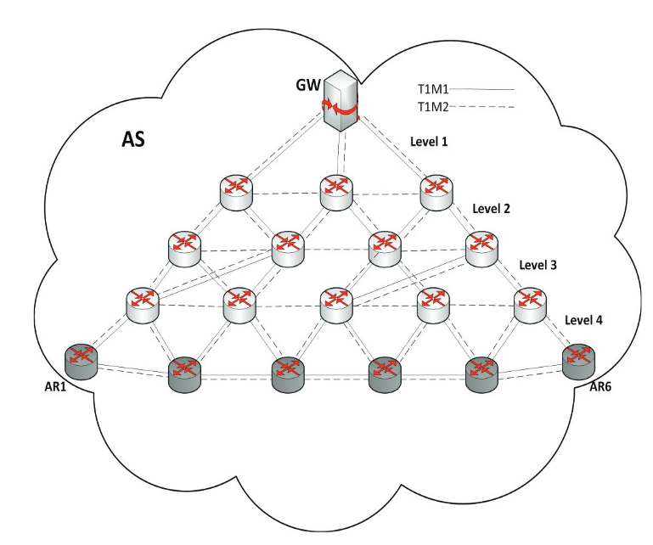

Link capacities:
Level 1: [360,400]Mbps,
Level 2: [200, 240]Mbps
Level 3: [140, 180]Mbps
Level 4: [60, 100]Mbps

Traffic types from every AR and GW:
Class 1 (tactile traffic): 150kbps
Class 2 (best effort): 500kbps

