Topology:

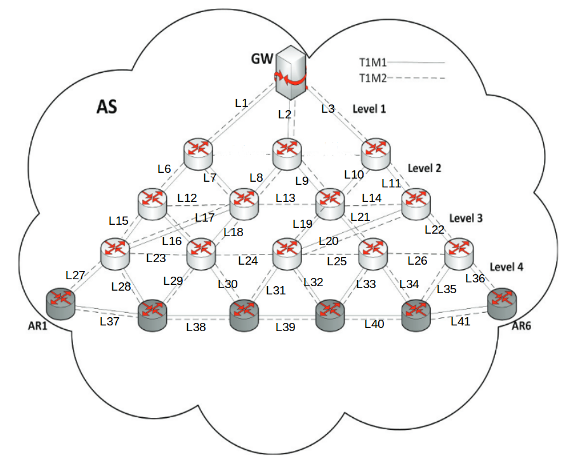

Link capacities: Randomly setup following a uniform distribution
Level 1: [360,400]Mbps,
Level 2: [200, 240]Mbps
Level 3: [140, 180]Mbps
Level 4: [60, 100]Mbps

Traffic types from every AR and GW:
Class 1 (tactile traffic): 150kbps
Class 2 (best effort): 500kbps

#link Cost

$L1 cost $n0 $n1 {3 222 295 308}
$L2 cost $n0 $n2 {3 150 199 472}
$L3 cost $n0 $n3 {3 78 463 492}
$L6 cost $n1 $n4 {3 222 295 308}
$L7 cost $n1 $n5 {3 6 7 8}
$L8 cost $n2 $n5 {3 6 7 272}
$L9 cost $n2 $n6 {3 150 199 208}
$L10 cost $n3 $n6 {3 6 367 392}
$L11 cost $n3 $n7 {3 78 103 108}
$L12 cost $n4 $n5 {6 12 15 17}
$L15 cost $n4 $n8 {6 156 207 217}
$L17 cost $n4 $n9 {6 84 111 117}
$L13 cost $n5 $n6 {6 12 135 145}
$L16 cost $n5 $n8 {6 12 15 281}
$L18 cost $n5 $n9 {6 12 135 145}
$L14 cost $n6 $n7 {6 12 255 273}
$L19 cost $n6 $n10 {6 84 111 117}
$L21 cost $n6 $n11 {6 84 111 117}
$L20 cost $n7 $n10 {6 12 255 273}
$L22 cost $n7 $n12 {6 84 111 117}
$L23 cost $n8 $n9 {6 12 15 193}
$L27 cost $n8 $n13 {6 84 111 161}
$L28 cost $n8 $n14 {6 84 111 161}
$L24 cost $n9 $n10 {6 12 15 193}
$L29 cost $n9 $n14 {6 12 135 145}
$L30 cost $n9 $n15 {6 84 111 117}
$L25 cost $n10 $n11 {6 12 195 209}
$L31 cost $n10 $n15 {6 12 75 257}
$L32 cost $n10 $n16 {6 84 111 117}
$L26 cost $n11 $n12 {6 12 135 145}
$L33 cost $n11 $n16 {6 12 75 81}
$L34 cost $n11 $n17 {6 84 111 117}
$L35 cost $n12 $n17 {6 12 135 145}
$L36 cost $n12 $n18 {6 84 111 117}
$L37 cost $n13 $n14 {6 12 75 81}
$L38 cost $n14 $n15 {6 12 15 17}
$L39 cost $n15 $n16 {6 12 15 149}
$L40 cost $n16 $n17 {6 12 15 105}
$L41 cost $n17 $n18 {6 12 75 125}

