1.Solution: Since  is a convex function with respect to variable , the linear combination of these convex functions with nonnegative coefficients leads to a new convex function, . It is easily seen that , so the whole objective function as well, is a convex function.

The implemented code by me is as follows:

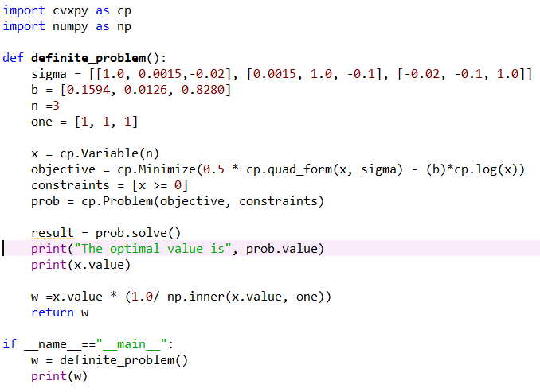

And the printed solution from the above code is

[0.2726693, 0.11152186, 0.61580883]

2.Solution: The objective function of this problem is so similar to the above one that it is easy to see that it is a convex function. Along with the affine equality and convex inequality constraints, it follows that this problem is a convex one.

The code to solve this problem is as follows:

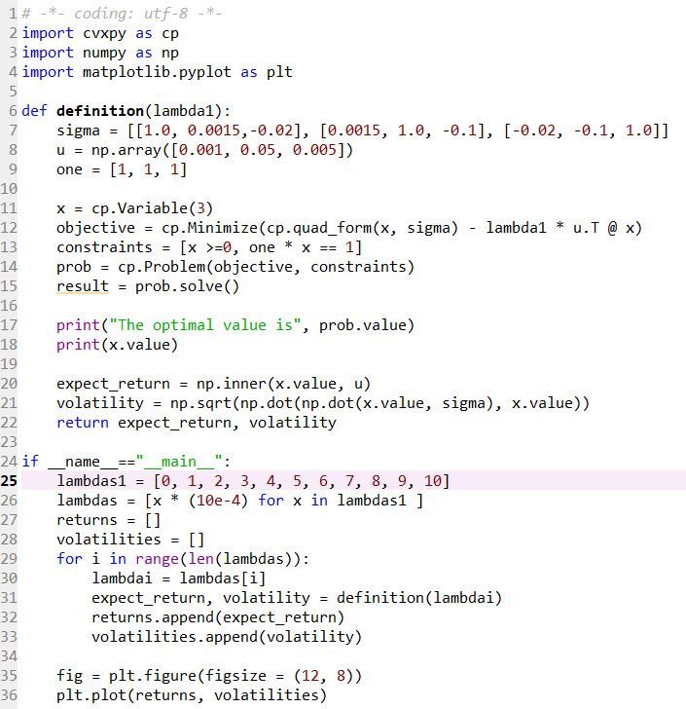

And the wanted figure is shown in figure 1:

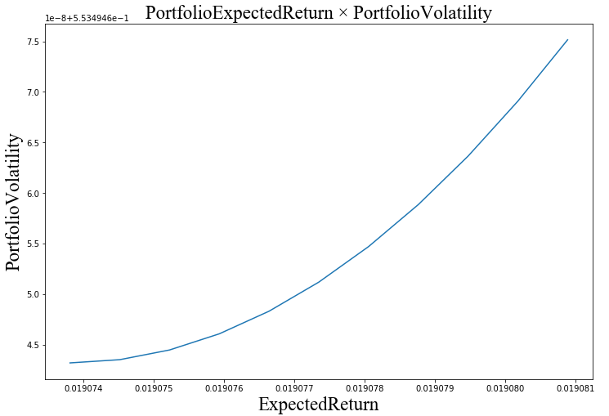

Figure 1. the curve of volatility with respect to expected return

3.Solution:

The piece of code to solve the problem is as follows:

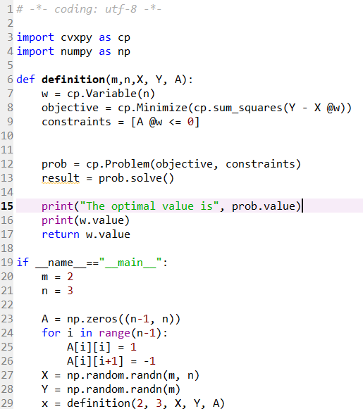

By taking m = 2 and n = 3, we obtain that the optimal value  derived from above code is [-0.31162825, -0.24432935, 0.10136403].

4.Solution: The code to solve the problem is as follows:

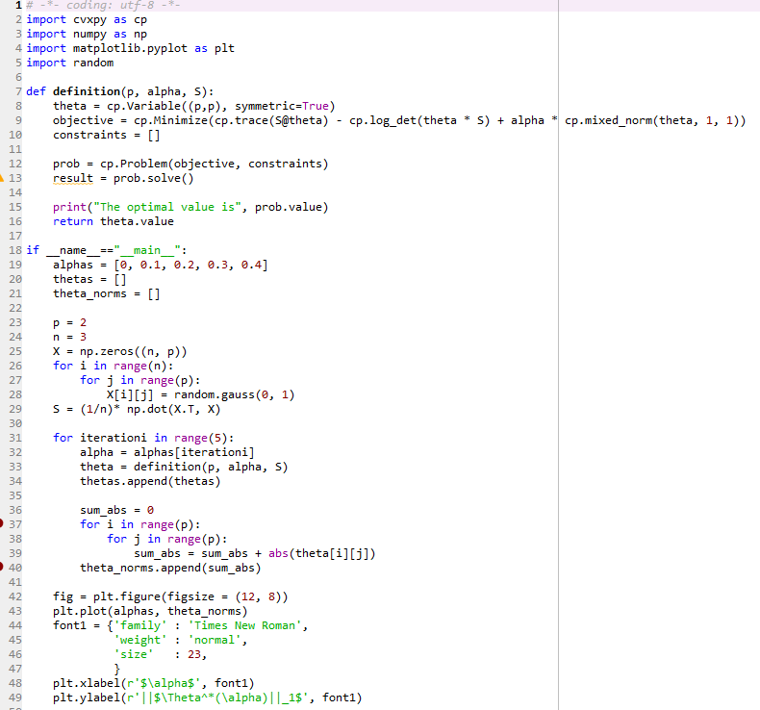

By taking p = 2, n = 3 and , we get the values of  as follows:

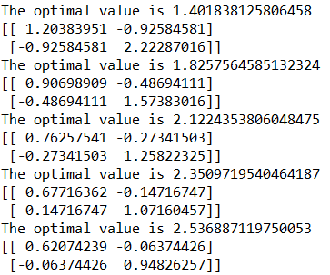

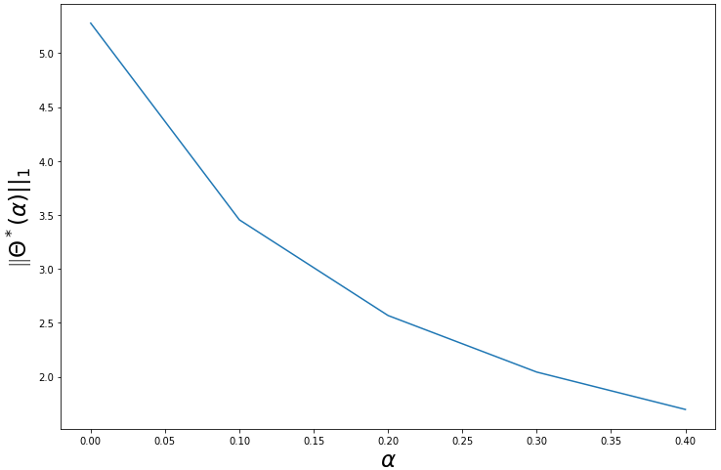

Figure 2. the value of  with respect to 