**Lab worksheet 02 Numerical Data**

**CT/2021/022**

1. **a**
2. package Q_01;  
   import java.sql.SQLOutput;  
   import java.util.*;  
     
     
   public class Q_01a {  
    public static void main(String[] args) {  
     
    System.*out*.print("Enter value for A:");  
    Scanner s;  
    s=new Scanner(System.*in*);  
    int A;  
    A=s.nextInt();  
     
    System.*out*.print("Enter value for B:");  
    int B;  
    B=s.nextInt();  
     
    System.*out*.print("Enter value for C:");  
    int C;  
    C=s.nextInt();  
     
    int Z=(B*B)+A*C;  
     
    float X=(float)Math.*sqrt*(Z);  
     
    System.*out*.println(X);  
     
     
    }  
   }

**output**

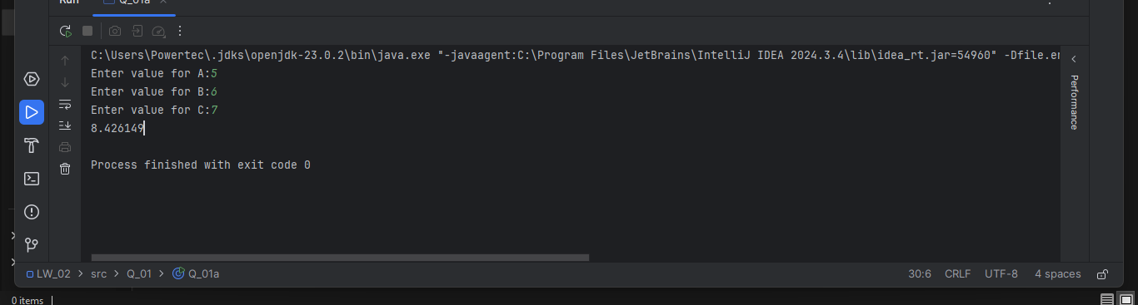

**B)**

package Q_01b;  
import java.util.*;  
public class Q_01b {  
 public static void main(String[] args) {  
  
  
 System.*out*.print("Enter value for X:");  
 Scanner s;  
 s=new Scanner(System.*in*);  
 int X=s.nextInt();  
  
 System.*out*.print("Enter value for Y:");  
 int Y;  
 Y=s.nextInt();  
  
  
 int W;  
 W=X+(4*(Y*Y*Y));  
  
 float Z=(float)Math.*sqrt*(W);  
  
 System.*out*.print(Z);  
  
 }  
  
}

**output**

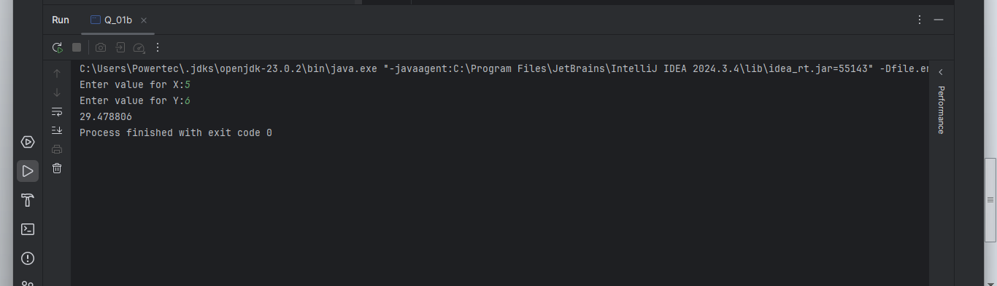

**c)** package Q_01c;  
import java.sql.SQLOutput;  
import java.util.*;  
  
public class Q_01c {  
 public static void main(String[] args) {  
  
 Scanner s;  
 s=new Scanner(System.*in*);  
  
 System.*out*.print("Enter value for X:");  
 int X;  
 X=s.nextInt();  
  
 System.*out*.print("Enter value for Y:");  
 int Y;  
 Y=s.nextInt();  
  
 int M=X*Y;  
  
 float C=(float)Math.*cbrt*(M);  
  
 System.*out*.println(C);  
  
 }  
  
}

**output**

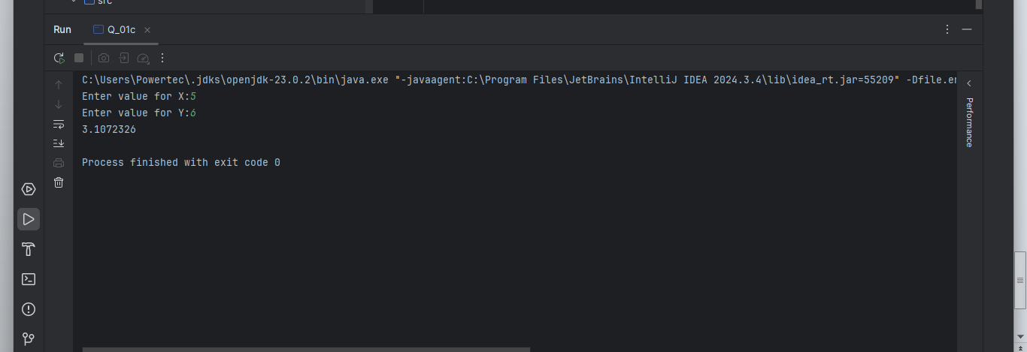

**d)**

package Q_01d;  
import java.util.*;  
public class Q_01d {  
  
 public static void main(String[] args) {  
  
 final double F=3.14;  
  
 System.*out*.print("Enter value for Radius:");  
 Scanner s;  
 s=new Scanner(System.*in*);  
 int r=s.nextInt();  
  
 double a=F*r*r;  
  
 System.*out*.print("Area of circul="+a);  
  
  
 }  
  
}

**output**

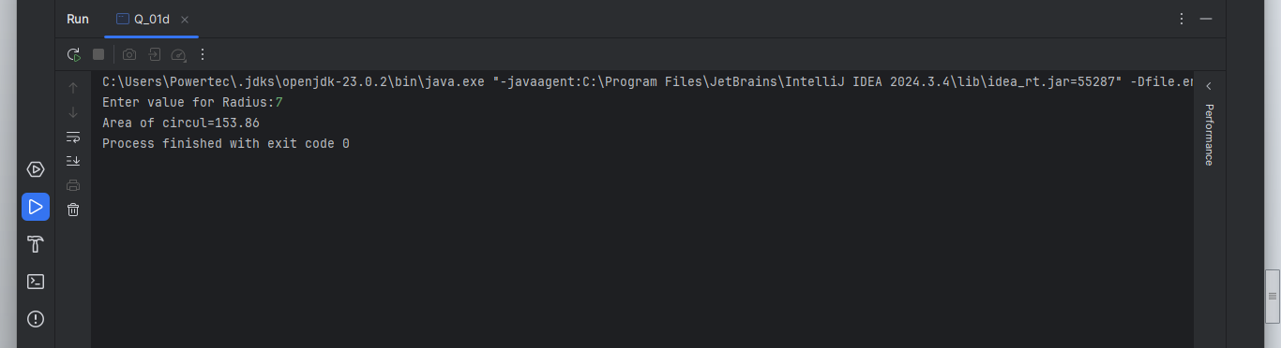

**2)**

package Q_02;  
import java.util.*;  
public class Q_02 {  
 public static void main(String[] args) {  
  
 System.*out*.print("Enter value of centimeter:");  
  
 Scanner S;  
 S=new Scanner(System.*in*);  
 int X=S.nextInt();  
  
 double I=(X/2.54);  
  
 double F=(X/30.48);  
  
 System.*out*.println("inches="+I);  
 System.*out*.print("feet="+F);  
  
  
 }  
  
}

**output**

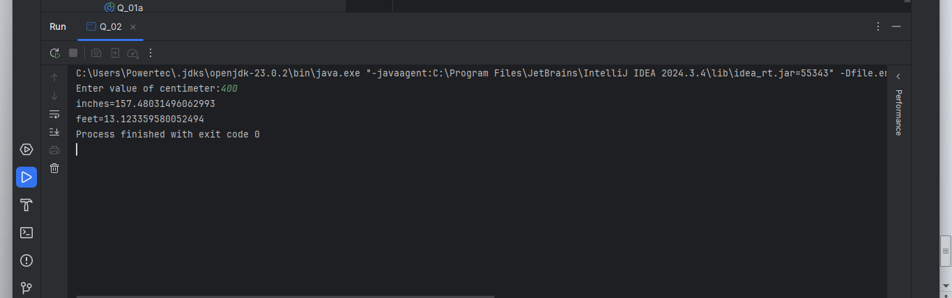

**3)**

package Q_03;  
import java.util.*;  
public class Q_03 {  
 public static void main(String[] args) {  
  
 System.*out*.print("input temperature of celsius:");  
  
 Scanner S;  
 S=new Scanner(System.*in*);  
 int C=S.nextInt();  
  
 double F;  
 F=(1.8*C)+32;  
  
 System.*out*.println(F);  
  
 }  
  
}

**output**

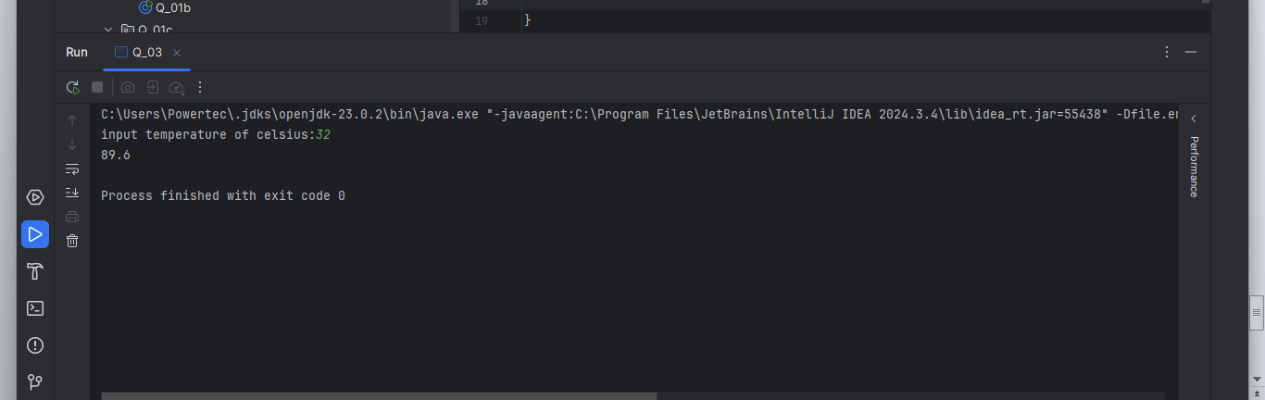

**4)**

package Q_04;  
import java.util.*;  
public class Q_04 {  
 public static void main(String[] args) {  
  
 System.*out*.print("Input weight of person:");  
  
 Scanner S;  
 S=new Scanner(System.*in*);  
  
 int W;  
 W=S.nextInt();  
  
 int C=W+19;  
  
 System.*out*.println(C);  
 }  
  
}

**output**

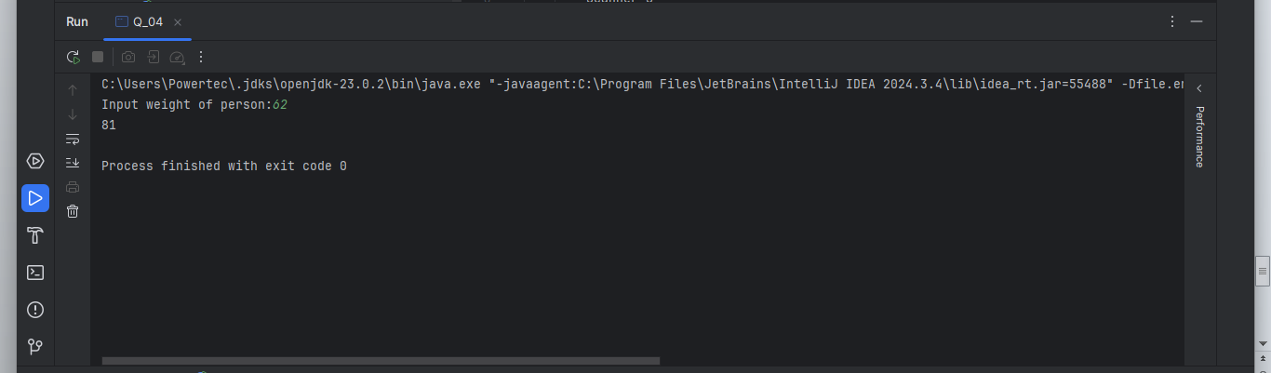

**5)**

package Q_05;  
import java.util.*;  
public class Q_05 {  
 public static void main(String[] args) {  
  
 System.*out*.print("input temperature of celsius:");  
 Scanner S;  
 S=new Scanner(System.*in*);  
 double F;  
 F=S.nextInt();  
  
 double C=0.56*(F-32);  
  
 System.*out*.println(C);  
  
 }  
  
}

**output**

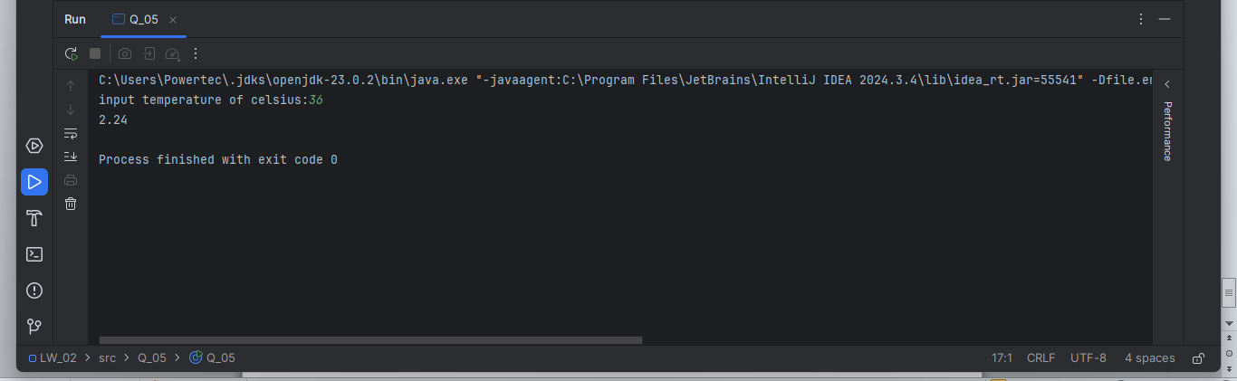

**6)**

package Q_06;  
import java.text.SimpleDateFormat;  
import java.util.*;  
  
public class Q_06 {  
 public static void main(String[] args) {  
 System.*out*.print("Input the year you were born:");  
  
 Scanner S=new Scanner(System.*in*);  
 int year=S.nextInt();  
  
 Calendar C;  
 C=Calendar.*getInstance*();  
 int CY=C.get(Calendar.*YEAR*);  
  
 int age =CY - year;  
  
 System.*out*.println("You were born in " + year + " and your age is " + age);  
 }  
  
}

**output**

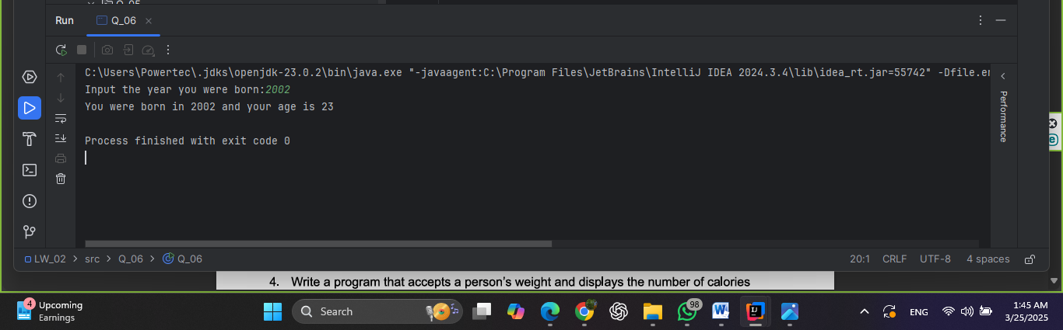

**7)**

package Q_07;  
import java.util.*;  
public class Q_07 {  
 public static void main(String[] args) {  
  
 Scanner S;  
 S = new Scanner(System.*in*);  
  
 System.*out*.print("input your weight of(kg):");  
 int W = S.nextInt();  
  
 System.*out*.print("input your height of(cm):");  
 int H = S.nextInt();  
  
 double BMI = W / ((H / 100.0) * (H / 100.0));  
  
 if (BMI >= 20 && BMI <= 25) {  
 System.*out*.println("BMI=" + BMI + "\nNormal");  
 } else {  
 System.*out*.println("BMI=" + BMI + "\n Not Normal");  
 }  
 }  
  
}

**output**

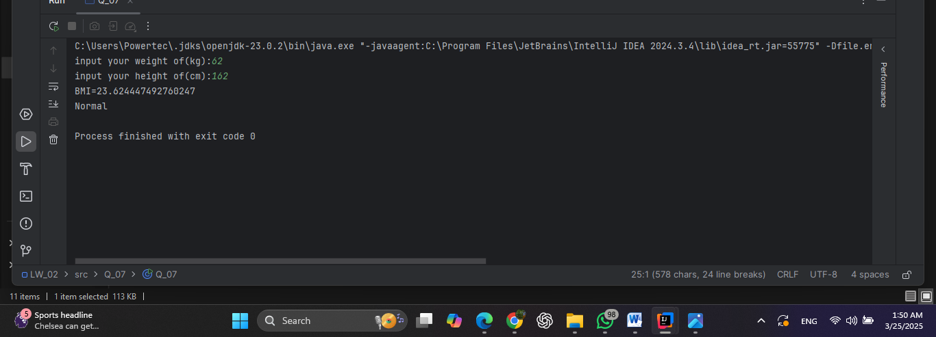

**8)**

package Q_08;  
import java.util.*;  
public class Q_08 {  
 public static void main(String[] args) {  
  
 final double PI=3.14;  
  
 System.*out*.print("input radius of sphere:");  
 Scanner S;  
 S=new Scanner(System.*in*);  
 int r=S.nextInt();  
  
 double V;  
 V=(4/3)*PI*r*r*r;  
  
 System.*out*.println("Volume of spere="+V);  
  
  
  
 }

**output**

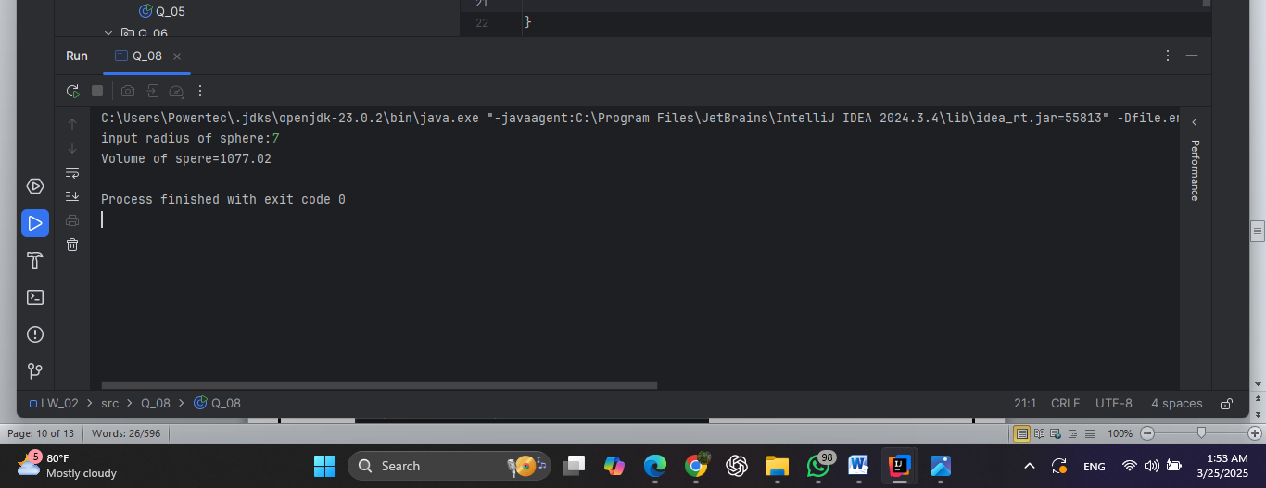

**9)**

package Q_09;  
import java.util.*;  
public class Q_09 { public static void main(String[] args) {  
  
 Scanner S=new Scanner(System.*in*);  
  
 System.*out*.print("Input amount of dollars:");  
 int P=S.nextInt();  
  
 System.*out*.print("Input percent:");  
 int R=S.nextInt();  
  
 System.*out*.print("Input amount of years:");  
 int N=S.nextInt();  
  
 double M=Math.*pow*(1+(R/100.0),N);  
  
 M=P*M;  
 System.*out*.print("The final amount after"+N+"years is:"+M);  
}  
  
}

**output**

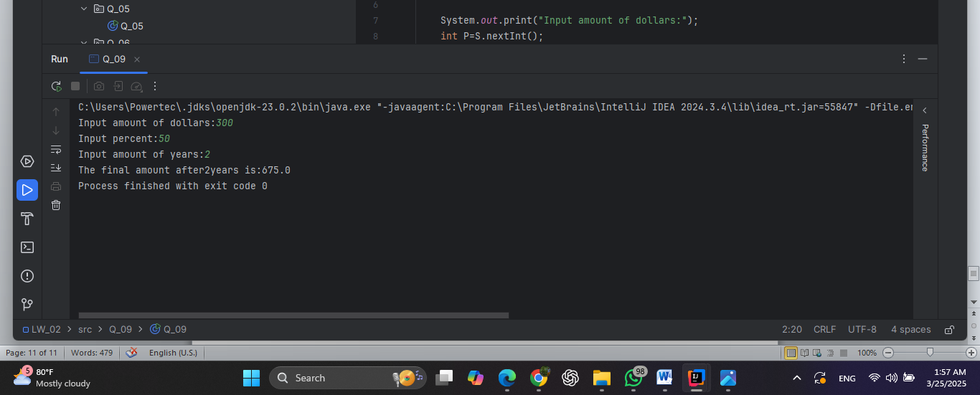

**10)**

package Q_10;  
import java.text.DecimalFormat;  
import java.util.Scanner;  
  
public class Q_10 {  
 public static void main(String[] args) {  
  
 Scanner s = new Scanner(System.*in*);  
 DecimalFormat df= new DecimalFormat("#.##");  
  
 double loanAmount;  
 double annualInterestRate;  
 double monthlyInterestRate;  
 double monthlyPayment;  
 double totalPayment;  
  
 int loanPeriod;  
 int numberOfPayments;  
  
 System.*out*.print("input loan amount:");  
 loanAmount = s.nextDouble();  
  
 System.*out*.print("input annual interest rate:");  
 annualInterestRate = s.nextDouble();  
  
 System.*out*.print("input loan period in months:");  
 loanPeriod = s.nextInt();  
  
 monthlyInterestRate=(annualInterestRate/100)/12;  
 numberOfPayments=loanPeriod;  
 monthlyPayment=(loanAmount*monthlyInterestRate)/(1-Math.*pow*((1/(1+monthlyInterestRate)),numberOfPayments));  
 totalPayment=monthlyPayment*numberOfPayments;  
  
 System.*out*.print("Monthly Payment:"+df.format(monthlyPayment));  
 System.*out*.print("Total Payment after"+loanPeriod+"months:"+ df.format(totalPayment));  
 }  
  
}

**output**

