**Deep Learning - Lab 6 – RL**

**Name = Wanni Arachchige P.N**

**IT Number = IT20617028**

**Answers**

1. Upload the attached Markov_Decision_Process (PolicyIteration) notebook and the GridWorld (QLearning) notebook to Google colab.
2. Understand the two codes.
3. Complete the incomplete parts in each notebook (these parts are mentioned by ‘#type your code here’).

**GridWorld.py**

import random

class Q_Agent():

# Initialize

def __init__(self, environment, epsilon=0.05, alpha=0.1, gamma=1):

self.environment = environment

self.q_table = dict() # Store all Q-values in a dictionary of dictionaries

for x in range(environment.height): # Loop through all possible grid spaces, create a sub-dictionary for each

for y in range(environment.width):

self.q_table[(x, y)] = {'UP': 0, 'DOWN': 0, 'LEFT': 0, 'RIGHT': 0} # Populate sub-dictionary with zero values for possible moves

self.epsilon = epsilon

self.alpha = alpha

self.gamma = gamma

def choose_action(self, available_actions):

"""Returns the optimal action from the Q-Value table. If multiple optimal actions exist, choose randomly.

Will make an exploratory random action dependent on epsilon."""

if random.uniform(0, 1) < self.epsilon:

# Choose a random action (exploration)

return random.choice(available_actions)

else:

# Choose the action with the highest Q-value (exploitation)

max_q_value = max(self.q_table[self.environment.current_state].values())

best_actions = [action for action in available_actions if self.q_table[self.environment.current_state][action] == max_q_value]

return random.choice(best_actions)

def learn(self, old_state, reward, new_state, action):

"""Updates the Q-value table using Q-learning"""

# Get the current Q-value for the old state-action pair

current_q_value = self.q_table[old_state][action]

# Calculate the maximum Q-value for the new state

max_next_q_value = max(self.q_table[new_state].values())

# Update the Q-value using the Q-learning update rule

new_q_value = current_q_value + self.alpha * (reward + self.gamma * max_next_q_value - current_q_value)

# Update the Q-value in the Q-table

self.q_table[old_state][action] = new_q_value

**Markov_Decision_Process .py**

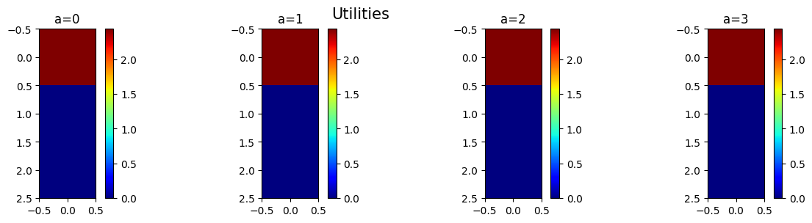

1. Run the notebooks.
2. In the GridWorld notebook, increase the grid size to a large value to see how the execution time and the time to converge changes.

**In the GridWorld notebook, increasing the grid size to a larger value will likely result in longer execution times and potentially longer time to converge for algorithms such as Q-learning or value iteration. The reason is that with a larger grid, there are more states to explore, and the agent needs to take more actions to learn the optimal policy. This can lead to increased computational complexity and longer training times.**

1. Add screenshots of the completed parts of two notebooks (in step 3) in a word file.

**Submission**

Download the final modified notebooks. Add these notebooks and the word file to a new zip file. Upload this zip file to the courseweb submission link. The file name should be your registration number.