Roll: 2420030512
Name: G.AKSHATH

Docker
- Install Docker Desktop.
- Open Command Prompt.
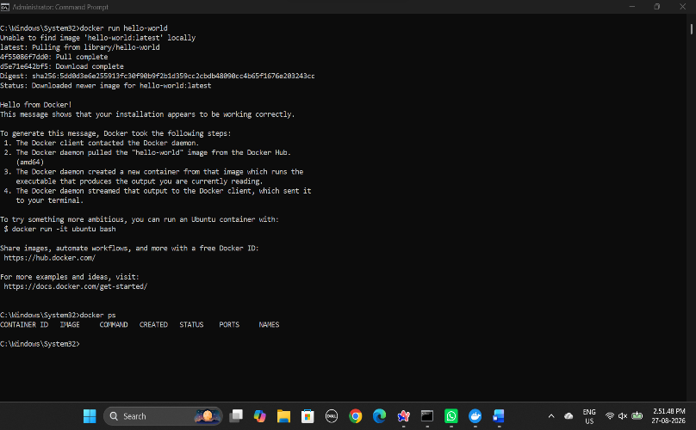
- Type docker to check Docker.
- Open Docker Desktop.
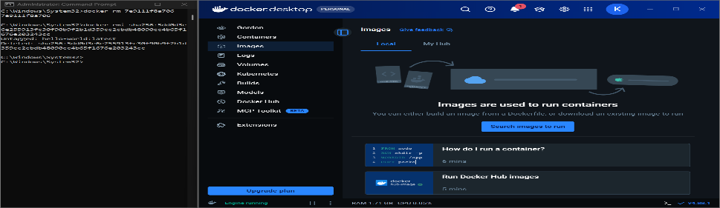
- Open Docker Hub and search for an image such as Hello World or Ubuntu.
- Pull the required image using the Docker command.
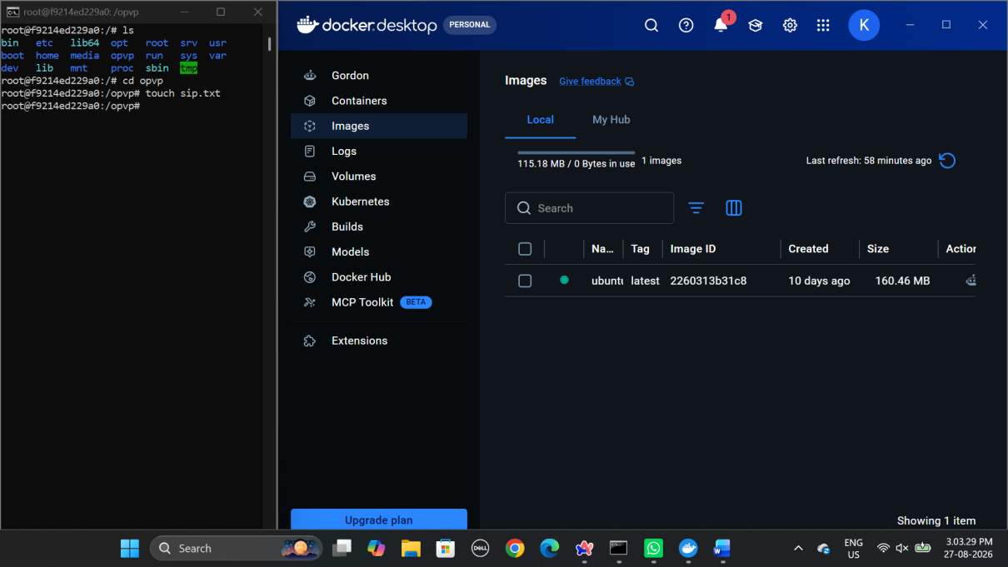
- Run the image using the docker run command.
- Stop the container using docker stop <container-id>.
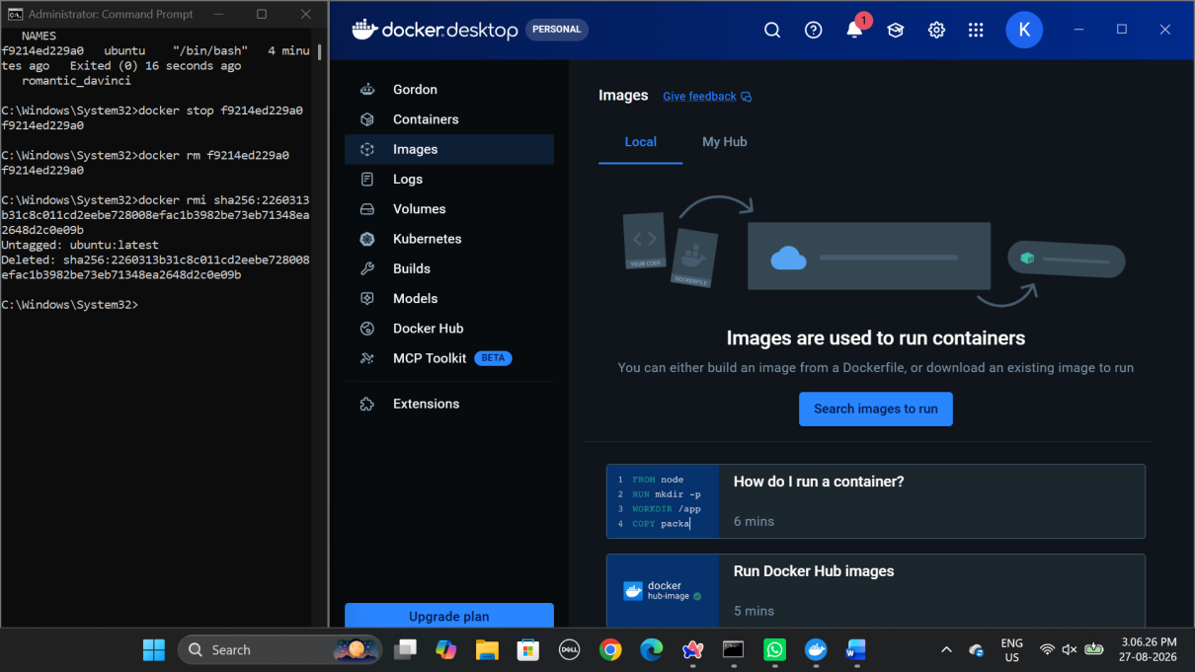
- Remove the container using docker rm <container-id>.
- For Ubuntu interactive mode, use docker run -it ubuntu.
