EXPERIMENT 2: Jira Scrum Board
QuickBite Food Delivery App
Project Setup • 5 User Stories • Story Points • Sprint Board
Student Name: Akshath
Roll Number: 2420030512
Course / Subject: Software Engineering
Academic Year: 2026–2027

1. Objective
The objective of Experiment 2 is to set up a Jira Scrum board, define five user stories for a software product, and assign appropriate story-point estimates. The activity demonstrates Agile backlog management, estimation and sprint planning.

1.1 Project Selected
QuickBite is a standalone food-delivery application in which customers can discover restaurants, select food items, place orders and track delivery. This project is used only for Experiment 2.

1.2 Why Scrum?
- Requirements can be divided into small, testable user stories.
- Stories can be prioritized in a product backlog.
- Work can be delivered in short sprints.
- The board provides visible progress from To Do to Done.
- Story points support relative estimation.

2. Jira Project Setup
A Scrum software project named QuickBite Food Delivery App was configured with project key QBA. The backlog is grouped under the Customer Ordering epic.
Configuration | Value
Project Name | QuickBite Food Delivery App
Project Key | QBA
Project Type | Software
Template | Scrum
Epic | Customer Ordering
Workflow | To Do → In Progress → Done
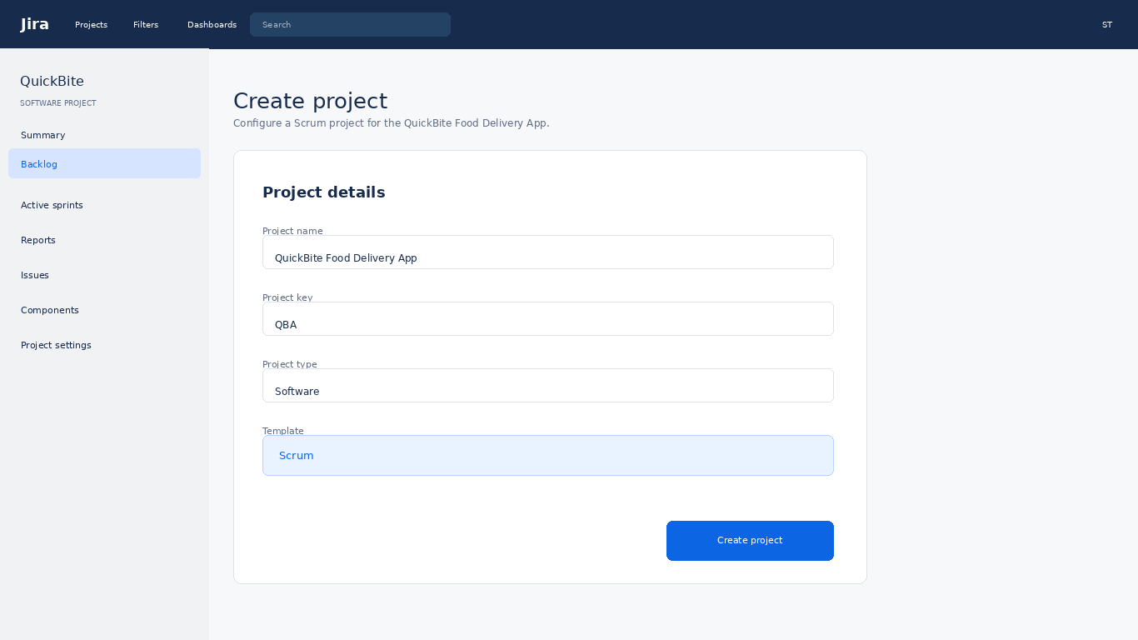
Figure 1. Jira project setup – original mockup for Experiment 2.
Note: This is an original academic mockup representing the intended Jira setup; it is not a screenshot from a live Jira Cloud account.

3. Five User Stories
The following five stories represent the main QuickBite customer ordering flow. Each follows the standard Agile user-story format and includes a relative story-point estimate.
ID | User Story | Priority | Points
QBA-1 | As a customer, I want to create an account so that I can place food orders. | High | 3
QBA-2 | As a customer, I want to browse restaurants and menus so that I can choose what to order. | High | 5
QBA-3 | As a customer, I want to add menu items to my cart so that I can review my order before checkout. | High | 5
QBA-4 | As a customer, I want to place and pay for my order so that the restaurant can prepare it. | High | 8
QBA-5 | As a customer, I want to track my order so that I know its delivery status. | Medium | 5

3.1 Story Point Scale
Story points are relative measures of effort, complexity and uncertainty. A Fibonacci-style scale is used here: 3, 5 and 8 points. A 3-point story is comparatively small, a 5-point story requires moderate effort, and an 8-point story has more complexity or uncertainty.

3.2 Estimation Rationale
Story | Points | Reason
Customer Sign Up | 3 | Basic account creation, validation and confirmation.
Browse Restaurants | 5 | Restaurant/menu retrieval, filtering and presentation.
Add Items to Cart | 5 | Cart state, quantities, price calculation and validation.
Place Order | 8 | Checkout, address validation, payment and order creation.
Track Delivery | 5 | Order-status retrieval and customer-facing progress information.
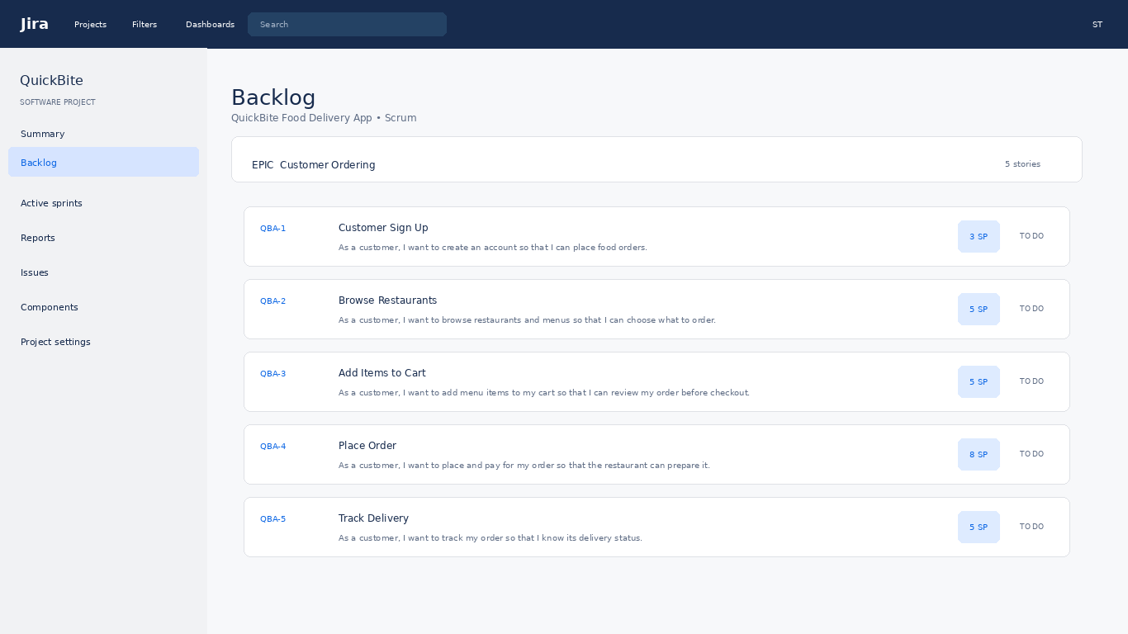
Figure 2. Jira-style backlog containing the five user stories and story points.

4. Detailed Story Example

QBA-4 – Place Order
As a customer, I want to place and pay for my order so that the restaurant can prepare it.

Acceptance Criteria
- Cart contains at least one valid item.
- Delivery address is available.
- Payment succeeds or a safe error message is displayed.
- Order receives a unique confirmation ID.
- The customer can view the newly created order.

Story Point Estimate
QBA-4 is estimated at 8 story points because it combines cart validation, delivery information, payment handling, order creation and confirmation.
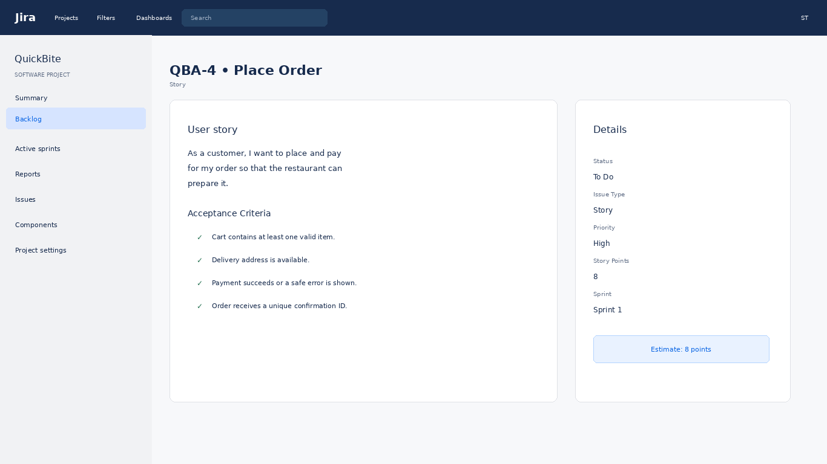
Figure 3. Detailed Jira-style story with an 8-point estimate.

5. Sprint Board
The five stories are placed on Sprint 1 to demonstrate how work moves through a Scrum workflow. The sprint goal is to establish the main customer ordering flow.
Status | Stories
To Do | QBA-1 Customer Sign Up; QBA-2 Browse Restaurants
In Progress | QBA-4 Place Order
Done | QBA-3 Add Items to Cart; QBA-5 Track Delivery
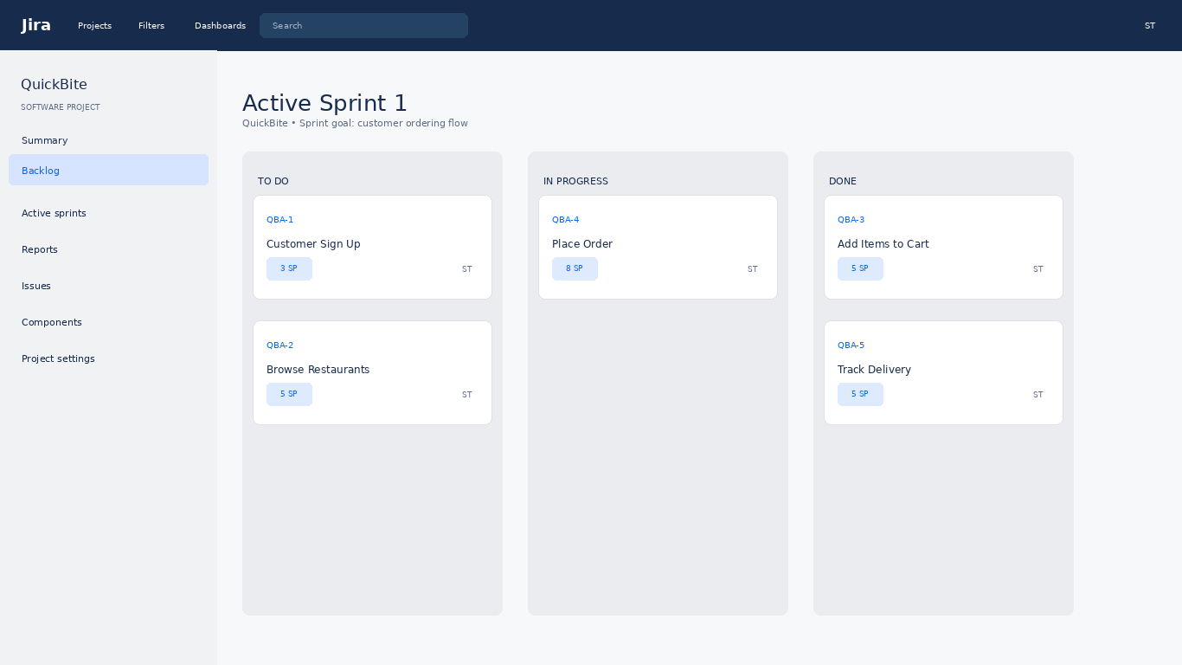
Figure 4. Jira-style Sprint 1 board showing workflow states and story points.

5.1 Total Story Points
Total estimated effort = 3 + 5 + 5 + 8 + 5 = 26 Story Points. Story points are not direct hours; they are relative estimates used for planning and velocity tracking.

6. Sprint Report and Evaluation
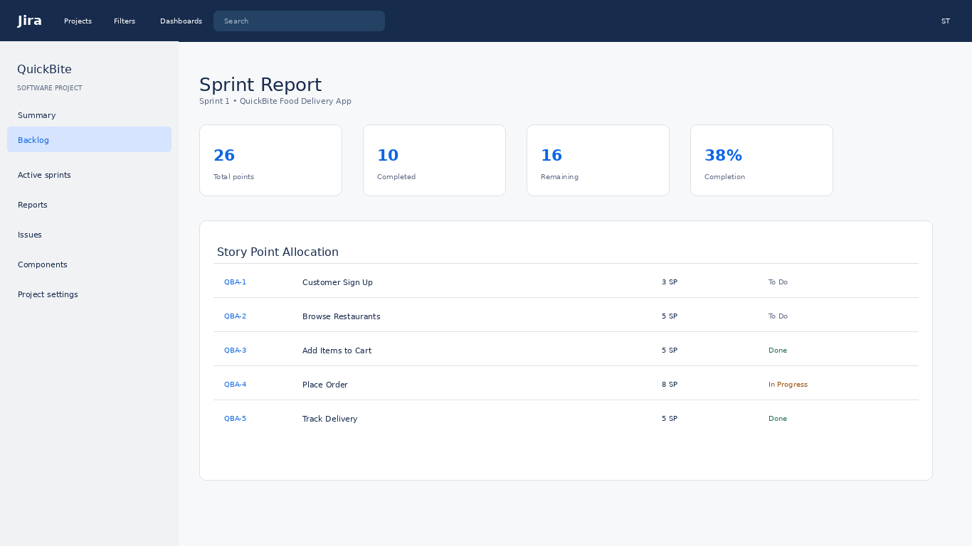
Figure 5. Jira-style Sprint Report for Experiment 2.
Evaluation Area | Expected Result
Project setup | Scrum project and board are configured.
User stories | Exactly five clear stories are defined.
Story points | Every story has a relative estimate.
Backlog | Stories are visible and prioritized.
Sprint workflow | Stories are distributed across To Do, In Progress and Done.
Progress tracking | Sprint report summarizes points and status.

7. Conclusion
Experiment 2 demonstrates Jira and Scrum concepts for software project planning. A standalone QuickBite project was configured, five user stories were created, story points were assigned, and the stories were represented on a sprint board. The exercise demonstrates backlog management, relative estimation and sprint progress tracking.

8. Independence of Experiment
This documentation is intentionally independent from every other experiment. The project name, screenshots, data, user stories and terminology belong only to Experiment 2.

