EXPERIMENT 3: Trello Agile Project Management
CampusConnect Event Management
Project Board • User Stories • Task Assignments • Sprint Workflow
Student Name: Akshath
Roll Number: 2420030512
Course / Subject: Software Engineering
Academic Year: 2026–2027

1. Objective
The objective of Experiment 3 is to implement a suitable case study using Trello by creating a project board, defining user stories, assigning tasks to team members, and demonstrating a sprint workflow for Agile project management and collaboration.

1.1 Case Study Selected
CampusConnect is an event-management application used as a standalone case study for this experiment. The system supports event discovery, attendee registration, event creation and attendee management.

1.2 Agile Approach
- Use a Trello board as a visual project-management workspace.
- Break requirements into user stories and tasks.
- Assign each task to a responsible team member.
- Organize work into a short Sprint 1.
- Move cards through Backlog, To Do, In Progress, Review and Done.
- Use the sprint summary to evaluate progress.

2. Trello Board Creation
A Trello-style board named CampusConnect Event Management was created for the case study. The board uses five workflow lists to demonstrate the movement of Agile work.
Board Setting | Value
Board Name | CampusConnect Event Management
Workspace | Software Engineering Team
Sprint | Sprint 1
Workflow | Backlog → To Do → In Progress → Review → Done
Team Members | AR, RM, SK
Case Study | CampusConnect Event Management
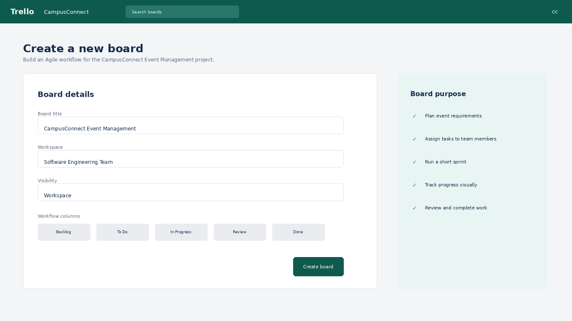
Figure 1. Trello-style project board creation screen – original academic mockup.
Note: The screenshots are original mockups prepared for academic documentation and are not screenshots from a live Trello account.

3. Project Board and Task Assignments
The board visually separates pending requirements, planned work, active development, review work and completed tasks. Cards are assigned to team members to demonstrate collaboration.
List | Example Cards | Purpose
Backlog | Define Event Requirements; Create User Stories | Capture and refine upcoming work.
To Do | Design Event Listing; Create Registration Form | Work selected for development.
In Progress | Implement Registration | Currently being developed.
Review | Test Registration Flow | Validate completed development work.
Done | Finalize Event Listing; Write User Stories | Completed and accepted work.
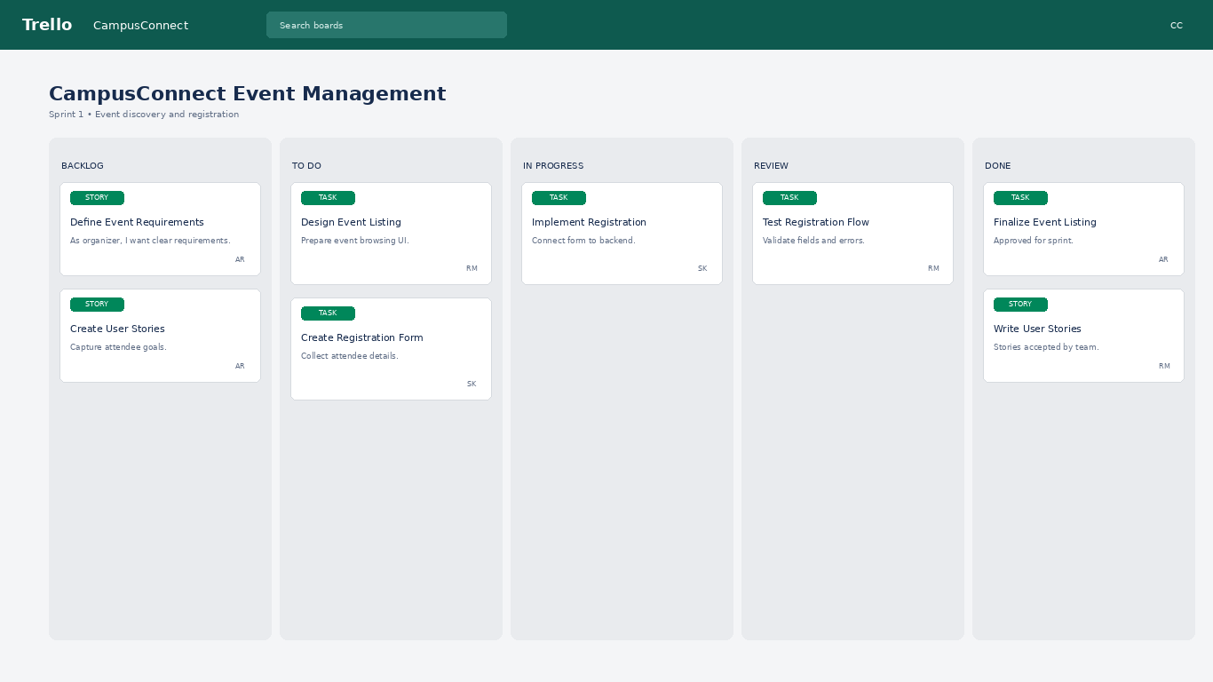
Figure 2. Trello-style Agile board showing project cards, lists, labels and assignments.

4. User Stories
Five user stories were created to represent important stakeholder goals for the CampusConnect application.
ID | User Story | Owner | Priority | Points
CC-01 | As an attendee, I want to register for an event so that my seat is reserved. | RM | High | 5
CC-02 | As an attendee, I want to browse events so that I can choose one to attend. | SK | High | 3
CC-03 | As an organizer, I want to create an event so that attendees can discover it. | AR | High | 5
CC-04 | As an organizer, I want to view registered attendees so that I can manage participation. | RM | Medium | 5
CC-05 | As an attendee, I want to see event status so that I know whether it is open or closed. | SK | Medium | 3
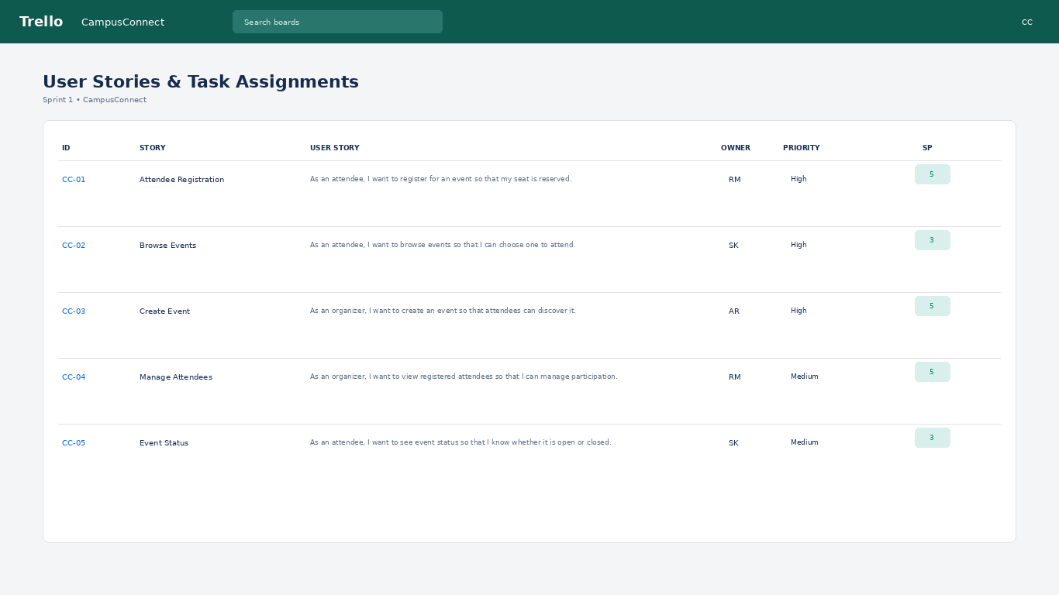
Figure 3. User stories with task ownership, priority and story-point estimates.

5. Task Assignment and Sprint Workflow
Tasks are assigned to team members using the initials AR, RM and SK. The board demonstrates collaboration by making responsibility visible and by moving cards through the sprint workflow.

5.1 Detailed Card
CC-01 – Attendee Registration is selected as the detailed example. It is assigned to RM and estimated at 5 story points.

Acceptance Checklist
- Validate attendee name and email.
- Select an available event.
- Submit registration.
- Display registration confirmation.
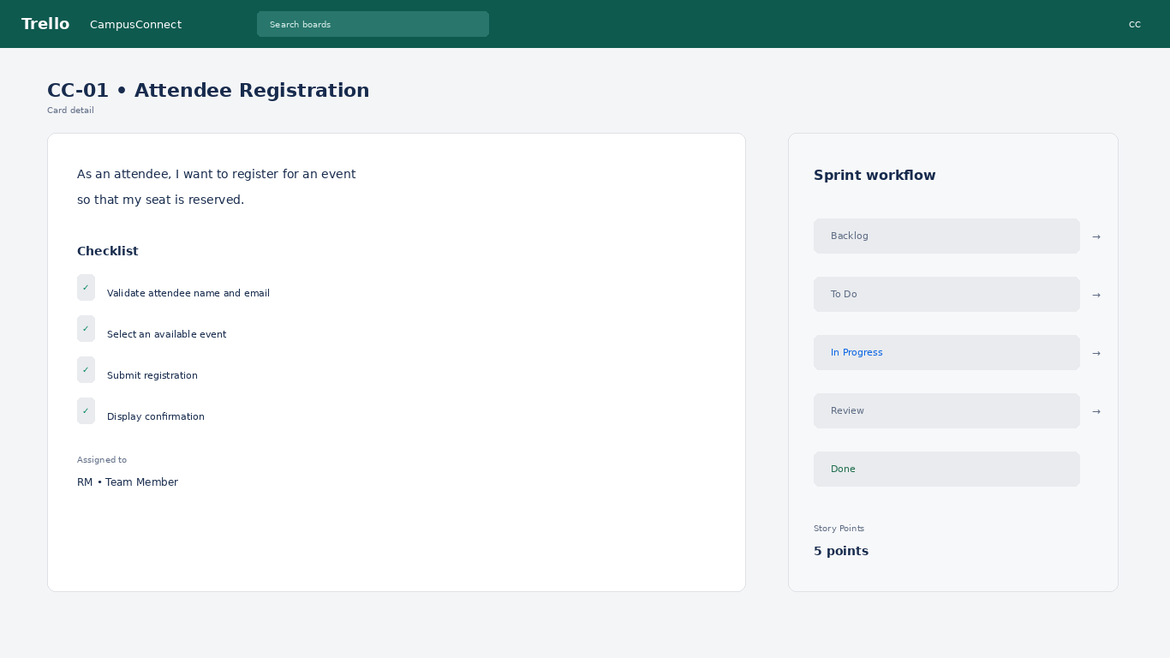
Figure 4. Detailed Trello-style card showing checklist, assignee, workflow and story points.

5.2 Workflow
Backlog is used for ideas and unplanned requirements. To Do contains sprint-ready work. In Progress contains active development. Review contains work waiting for validation. Done contains completed and accepted work.

6. Sprint Summary and Evaluation
Sprint 1 contains all five user stories with a combined estimate of 21 story points.
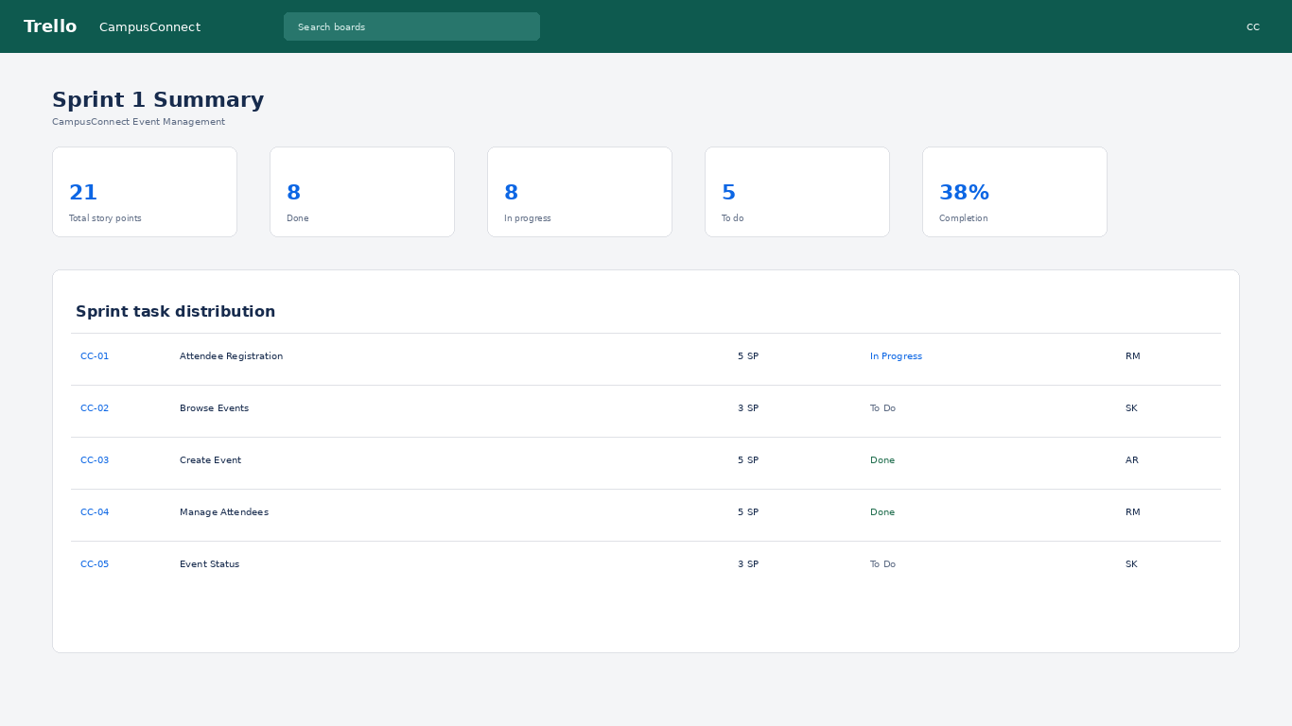
Figure 5. Sprint summary showing story-point distribution and team ownership.

6.1 Story Point Calculation
Total story points = 5 + 3 + 5 + 5 + 3 = 21 points.
Evaluation Area | Expected Result
Board setup | A dedicated Trello-style board is configured.
User stories | Five clear user stories are documented.
Task assignment | Cards have identifiable team owners.
Sprint workflow | Cards move through defined Agile stages.
Collaboration | Responsibilities and progress are visible to the team.
Progress tracking | Sprint summary shows points and current status.

7. Conclusion
Experiment 3 demonstrates how Trello can support Agile project management through visual boards, user stories, task assignments and sprint workflows. The CampusConnect case study shows how a team can organize work, assign responsibility, track progress and evaluate sprint completion using a collaborative board.

8. Independence of Experiment
This is a standalone Experiment 3. Its case study, project board, screenshots, users, tasks and terminology are independent of all previous experiments.

