**FINAL PROJECT DOCUMENTATION**

**Career Labs**



### Submitted By

|  |  |
| --- | --- |
| Usman Ali | 21-arid-3440 |
| M Hassan Mehmood | 21-arid-3424 |
| Muzammal Maqsood | 21-arid-3434 |

**Supervisor**

#### Ms. Marriam Ijaz

Lecturer

**2024**

**Gujrat Institute of Management Sciences**

**PMAS-Arid Agriculture University, Rawalpindi**

**‘‘Career Labs**

Project submitted to Department of Computer Science

Gujrat Institute of Management Sciences

### By

|  |  |
| --- | --- |
| Usman Ali | 21-arid-3440 |
| M Hassan Mehmood | 21-arid-3424 |
| Muzammal Maqsood | 21-arid-3434 |

#### In partial fulfillment of the requirements for the degree of (BSSE)

**Gujrat Institute of Management Sciences**

**PMAS-Arid Agriculture University, Rawalpindi**

## Members’ Detail

|  |  |
| --- | --- |
| **Project ID** | GIMS-BSSE-20214 |

|  |  |  |  |
| --- | --- | --- | --- |
| Career Labs | | | |
| **Group Leader:** Usman Ali  **Group Members:**3 | | | |
| Name | Registration # | Email Address | Class |
| Usman Ali | 21-Arid-3440 | uh.2029@gmail.com | BSSE |
| M Hassan Mehmood | 21-Arid-3424 | hm2257153@gmail.com | BSSE |
| Muzammal Maqsood | 21-Arid-3434 | minhasmuzammal@gmail.com | BSSE |

##### Mr. Awais Illyas

PMO, GIMS

**Dated:**

## Dedication

### To our Fathers,

“To My Guiding Light, My Source of Strength -My Beloved Father”

### To our Mothers,

“To the One Whose Unwavering Support And Kindness guided Me Through Life’s Melodies. Thank You Being My Rock, Mom”

### To our Loved Ones,

“For Their Understanding, Tenderness For Keeping Us Motivated To Our Dreams”

### To our Teacher,

“To Sir Bilal Mazhar, Who Kindled Wisdom's Flame Within Us, Guiding My Path With Unwavering Grace and Insight, I Dedicate My Deepest Gratitude and Eternal Appreciation”

~M Hassan Mehmoodl,Usman Ali, Muzammal Maqsood ~

## Project Summary

|  |  |
| --- | --- |
| **Project Title** | Career Labs |
| **Project ID** | GIMS-BSSE-F20214 |
| **Organization** | Gujrat Institute of Management Sciences |
| **Objective** | * Develop a User-Friendly Platform. * Implement Customized Data Collection Forms. * Integrate Location-Based Event Recommendations. * Develop an AI-Driven Career Recommendation System. * Integrate a Company Module for Job Alerts and Application Links. * Provide Real-Time Career Guidance and Notifications. * Ensure Data Security and Privacy. |
| **Undertaken By** | M Hassan Mehmood 21-arid-3424, Usman Ali 21-arid-3440and Muzammal Maqsood 21-arid-3434 |
| **Supervised By** | Ms. Marriam Ijaz |
| **Date started** | 10-November-2024 |
| **Date Completed** | June 10, 2024 |
| **Technologies Used** | Angular, HTML/CSS, JavaScript, Bootstrap,Node.js, Express.js, Python (for AI/ML), OAuth,MongoDB,Visual Studio Code |
| **System Used** | Window 10 |

**Proofreading Certificate**

##### This is to acknowledge that the project entitled

**Project Management System [**GIMS-BSSE-F20214**]**

**has been proofread By**

**Ms. Marriam Ijaz**

#### Lecturer(GIMS)

**Dated:**

## Declaration

We hereby declare that we developed this project and this report entirely on the basis of our personal efforts made under the sincere guidance of our project supervisor. We further declare that, the titled project and all associated documents, reports are submitted as partial requirements for the degree of “BS (Hons.) in Software Engineering’’

|  |  |  |
| --- | --- | --- |
| **Members’ Name** | **Registration #** | **Signature** |
| M Hassan Mehmood | 21-arid-3424 |  |
| Usman Ali | 20-arid-3440 |  |
| Muzammal Maqsood | 20-arid-3434 |  |

**Dated:**

## Acknowledgement

"In the name of guidance and unwavering support, I extend my heartfelt gratitude to the esteemed mentor, Ms. Marriam Ijaz, whose wisdom and encouragement steered this final project's completion. Dr. Amir Nabi Rana, the Director, deserves my sincere thanks for invaluable guidance. I am truly appreciative of the collective inspiration and unwavering encouragement received from the revered teachers of the Software Engineering Department throughout this enriching journey."

## Certificate

This is to certify that Muhammad Hassan Mehmood 21-arid-3424, Usman Ali 21-arid-3440 and Muzammal Maqsood 21-arid-3434 have successfully completed the final project titled: “Career Labs”, accepted by the Department of Software Engineering and find satisfactory for the requirement of:

**Gujrat Institute of Management Sciences PMAS-Arid Agriculture University Rawalpindi**

**For Award of the Degree**

**BSSE**

|  |  |
| --- | --- |
| Supervisor  Ms. Marriam Ijaz  Lecturer,GIMS | |
| Examiner 1 Sir Awais | |
| Examiner 2 Sir Sami-ullah | |
| Examiner 3 Sir Ashar | |
| HOD/CS-IT GIMS | Director General  GIMS |

**Dated:**

## Abstract

In today’s fast-paced and highly competitive world, students and young professionals often struggle to make well-informed decisions about their careers. Generic career guidance falls short in addressing the specific needs of individuals, as it fails to account for their unique backgrounds, interests, and aspirations. This project proposes the development of a Career Counseling Web Application, a data-driven platform designed to deliver personalized career recommendations tailored to each user’s educational history, personal preferences, and career goals.

This web application aims to support a diverse range of users by offering features that address specific needs, such as age-based career guidance, categorization based on educational background, and interest-based career recommendations. Users will be guided through custom forms to input their information, including age, education, and areas of interest. For those who may lack formal education or career experience, the application provides an alternative pathway, ensuring that all users can benefit from meaningful career guidance.

A core feature of this platform is the Company Module, which allows companies to interact directly with potential job candidates. Through this module, companies can connect with users via SMS, email, and audio/video calls, enabling streamlined communication for job openings, internships, or informational sessions. This module bridges the gap between job seekers and recruiters, fostering opportunities for users to explore career options and gain insights into industry expectations.

The Career Counseling Web Application utilizes artificial intelligence (AI) and machine learning (ML) algorithms to analyze user data and provide accurate career recommendations. Key algorithms include Support Vector Machines (SVM) for career path classification, and K-Nearest Neighbors (KNN) for recommending career paths based on similar user profiles. These algorithms work together to deliver dynamic, real-time recommendations that evolve as users update their profiles and as job market trends change.

To ensure privacy and security, the platform employs a privacy-centered design that safeguards user data, allowing only authorized personnel to access sensitive information. The application’s intuitive interface and user-friendly dashboard enable users to track their progress, update their information, and receive actionable insights on skill development and career advancement.

The goal of this project is to develop an inclusive and intelligent career counseling tool that empowers users to make well-informed career choices aligned with their strengths, interests, and the latest industry trends. By integrating AI-driven insights and personalized recommendations, the Career Counseling Web Application promises to enhance users’ career planning journeys, equipping them with the guidance needed to succeed in today’s dynamic job market.

## Table of Contents

[Dedication iii](#_bookmark0)

[Project Summary iv](#_bookmark1)

[Declaration vi](#_bookmark2)

[Acknowledgement vii](#_bookmark3)

[Abstract ix](#_bookmark4)

[Table of Contents x](#_bookmark5)

[List of Tables xvii](#_bookmark6)

[List of Figures xx](#_bookmark7)

[List of Abbreviations xxiii](#_bookmark8)

[Chapter 1 Introduction 2](#_bookmark9)

* 1. [Problem Statement 3](#_bookmark10)
  2. [Significance 3](#_bookmark11)
  3. [Objectives 4](#_bookmark12)
  4. [Limitations and Restrictions 4](#_bookmark13)
  5. [Overview 5](#_bookmark14)
  6. [System Architecture 7](#_bookmark15)
  7. [Software/Hardware Requirements 7](#_bookmark17)
  8. [Implementation Tools and Technology 7](#_bookmark18)
  9. [Implementation Plan 8](#_bookmark19)
     1. [Deliverable Items 8](#_bookmark20)
     2. [Milestone Chart 8](#_bookmark21)

[Chapter 2 Requirement Analysis 10](#_bookmark23)

* 1. [Functional Requirements 10](#_bookmark24)
     1. [For Admin 10](#_bookmark25)
     2. [For Advisor 12](#_bookmark26)
     3. [For User 13](#_bookmark27)
  2. [Non-Functional Requirement 15](#_bookmark28)
  3. [Use Cases 16](#_bookmark29)
     1. [Login Use Case 16](#_bookmark30)
     2. [Forget Password Usecase 17](#_bookmark32)
     3. [Add Students Use Case 18](#_bookmark34)
     4. [View Students Profile Use Case 19](#_bookmark36)
     5. [Update Students Insformation Use Case 20](#_bookmark38)
     6. [Delete Student Profile Use Case 21](#_bookmark40)
     7. [Activate/Deactivate Student Profile Use Case 22](#_bookmark42)
     8. [Add Mentor/Advisor Use Case 23](#_bookmark44)
     9. [View Profile Use Case 24](#_bookmark46)
     10. [Update Mentor Information Use Case 25](#_bookmark48)
     11. [Delete Mentor Profile Use Case 26](#_bookmark50)
     12. [Activate/Deactivate Mentor Account Use Case 27](#_bookmark52)
     13. [Add Career Resource Use Case 28](#_bookmark54)
     14. [View Career Resources Use Case 29](#_bookmark56)
     15. [Update Career Resources Detail Use Case. 30](#_bookmark58)
     16. [Delete Outddated Career Resources Use Case 31](#_bookmark60)
     17. [Approve/Reject Job Posting Use Case 32](#_bookmark62)
     18. [Add Job Posting Manually Use Case 33](#_bookmark64)
     19. [View,Update,Delete Job Posting Use Case.. 34](#_bookmark66)
     20. [Categorized Job Postings Use Case 35](#_bookmark68)
     21. [Generate Reports Use Case 36](#_bookmark70)
     22. [Generate Reports Use Case 37](#_bookmark72)
     23. [View Shared Files Use Case 38](#_bookmark74)
     24. [Delete Shared FilesUse Case 39](#_bookmark76)
     25. [SendNotifications Use Case 40](#_bookmark78)
     26. [View & Manage Notifications Use Case 41](#_bookmark80)
     27. [Mentor/Advisor Login Use Case 42](#_bookmark82)
     28. [Schedule Counselling Session Use Case 43](#_bookmark84)
     29. [View User Profile Assigning to Mentor Use Case.. 44](#_bookmark86)
     30. [Provide Feedback or SuggestionUse Case 45](#_bookmark88)
     31. [Review Career Roadmaps Use Case 46](#_bookmark90)
     32. [Accept Reject Feedback Use Case 47](#_bookmark92)
     33. [View Analytics Use Case. 48](#_bookmark94)
     34. [Share Files Use Case 49](#_bookmark96)
     35. [View Shared Files Use Case 50](#_bookmark98)
     36. [Delete Shared Files Use Case 51](#_bookmark100)
     37. [View Platform Notification Use Case.. 52](#_bookmark102)
     38. [Participate Group Discussion Use Case 53](#_bookmark104)
     39. [Student Login Use Case 54](#_bookmark106)
     40. [Create & Update Profile Use Case 55](#_bookmark108)
     41. [Take Career Assesment Test Use Case. 56](#_bookmark110)
     42. [View Career Suggestions Use Case 57](#_bookmark112)
     43. [Search Jobs Use Case....... 58](#_bookmark114)
     44. [Save Favourite Jobs Use Case 59](#_bookmark116)
     45. [Apply Jobs use case 60](#_bookmark118)
     46. [File Sharing Use Case 61](#_bookmark120)
     47. [View Shared Files Use Case 62](#_bookmark122)
     48. [Delete Shared Files Use Case 63](#_bookmark124)
     49. [Notification Use Case 61](#_bookmark120)
     50. [Chat Support Use Case 62](#_bookmark122)

[Chapter 3 DESIGN 65](#_bookmark126)

* 1. [UML Diagrams 65](#_bookmark127)
  2. [Use-Case Diagram 65](#_bookmark128)
     1. [Admin 65](#_bookmark129)
     2. [Student 66](#_bookmark131)
     3. [Complete System 68](#_bookmark135)
  3. [Class Diagram 69](#_bookmark137)
  4. [Sequence Diagram 70](#_bookmark139)
     1. [User Registration 70](#_bookmark140)
     2. [User login Authentication 71](#_bookmark142)
     3. [Career Assesment Completion 72](#_bookmark144)
     4. [Generating Guidance Report. 73](#_bookmark146)
     5. [Admin Posting Jobs 74](#_bookmark148)
     6. [User Applying For Jobsr 75](#_bookmark150)
     7. [Admin Uploading Career Resources 76](#_bookmark152)
     8. [System Sending Notifications 77](#_bookmark154)
  5. [ERD 87](#_bookmark174)

[Chapter 4 Testing 89](#_bookmark176)

* 1. [Signup Test Case for User, Mentor, and Admin 89](#_bookmark177)
  2. [Login – Admin, User, and Mentor 90](#_bookmark179)
  3. [Role-Based Redirection After Login 91](#_bookmark181)
  4. [Add Student/User Test Case 92](#_bookmark183)
  5. [View Student Profiles Test Case 93](#_bookmark185)
  6. [Update Student/User Information Test Case 94](#_bookmark187)
  7. [Delete Student/User Profile Test Case 95](#_bookmark189)
  8. [Add Mentor/Advisor Test Case 96](#_bookmark191)
  9. [View Mentor Profiles Test Case 97](#_bookmark193)
  10. [Update Mentor Profiles Test Case 98](#_bookmark195)
  11. [Delete Mentor Profile Test Case 99](#_bookmark197)
  12. [Add Career Resources Test Case 100](#_bookmark199)
  13. [View Career Resources Test Case 101](#_bookmark201)
  14. [Update Career Resources Details Test Case 102](#_bookmark203)
  15. [Generate Reports Test Case 103](#_bookmark205)
  16. [View Analytics Test Case 104](#_bookmark207)
  17. [Share Files with Users/Mentors Test Case 105](#_bookmark209)
  18. [View Shared Files Test Case 106](#_bookmark211)
  19. [Delete Shared Files Test Case 107](#_bookmark213)
  20. [Send Notifications/Announcements Test Case 108](#_bookmark215)
  21. [Create/Update Profile Test Case 109](#_bookmark217)
  22. [Career Assessment Test Submission Test Case 110](#_bookmark219)
  23. [View Career Suggestions Test Case 111](#_bookmark221)
  24. [Search Jobs Using Filters Test Case 112](#_bookmark223)
  25. [Save Job Postings Test Case 113](#_bookmark225)
  26. [Apply for Job Test Case 114](#_bookmark227)
  27. [Upload Resume/Files Test Case 115](#_bookmark229)
  28. [View Shared Files Test Case 116](#_bookmark231)
  29. [Delete Shared Files Test Case 117](#_bookmark233)
  30. [Receive Notifications Test Case 118](#_bookmark235)
  31. [Open Chat Support Test Case 119](#_bookmark237)
  32. [Send Message to Mentor/Admin Test Case 120](#_bookmark239)
  33. [Verify Mentor Dashboard Access Test Case 121](#_bookmark241)
  34. [Mentor Profile Update Test Case 122](#_bookmark243)
  35. [Add New Counseling Session Time Slot Test Case 123](#_bookmark245)
  36. [Update Existing Counseling Session Test Case 124](#_bookmark247)
  37. [Delete Counseling Session Test Case 125](#_bookmark249)
  38. [Prevent Session Time Conflict Test Case 126](#_bookmark251)
  39. [View All Scheduled Counseling Sessions Test Case 127](#_bookmark253)
  40. [Access Assigned User Profiles Test Case 128](#_bookmark255)
  41. [Provide Feedback on User Profile Test Case 129](#_bookmark257)
  42. [Review and Comment on Career Road-map Test Case 130](#_bookmark259)
  43. [Accept User Proposal Test Case 131](#_bookmark261)
  44. [Reject User Proposal Test Case 132](#_bookmark263)
  45. [Share Resource File with Individual User Test Case 133](#_bookmark265)
  46. [View Files Shared by Users Test Case 134](#_bookmark267)
  47. [Delete File Shared with User Test Case 135](#_bookmark269)
  48. [Receive and View Platform Notifications Test Case 136](#_bookmark271)

[Chapter 5 User Manual 140](#_bookmark277)

* 1. [PMO Login 140](#_bookmark278)
  2. [Dashboard 140](#_bookmark280)
  3. [Add group login 141](#_bookmark282)
  4. [Add Student 141](#_bookmark284)
  5. [Add Student by Excel Sheet 142](#_bookmark286)
  6. [View All Student 142](#_bookmark288)
  7. [Update Student 143](#_bookmark290)
  8. [Delete Student 143](#_bookmark292)
  9. [All Group Login 144](#_bookmark294)
  10. [Update Group Login 144](#_bookmark296)
  11. [Delete Group Login 145](#_bookmark298)
  12. [View all group 145](#_bookmark300)
  13. [Delete Group Member 146](#_bookmark302)
  14. [Update Proposal 146](#_bookmark304)
  15. [Download Form 147](#_bookmark306)
  16. [Submitted items 147](#_bookmark308)
  17. [Add Supervisor 148](#_bookmark310)
  18. [View all Supervisor 148](#_bookmark312)
  19. [Update Supervisor 149](#_bookmark314)
  20. [D-Activate supervisor 149](#_bookmark316)
  21. [Delete Supervisor 150](#_bookmark318)
  22. [PMO Share File 150](#_bookmark320)
  23. [View Share File 151](#_bookmark322)
  24. [Delete file 151](#_bookmark324)
  25. [Create Session 152](#_bookmark326)
  26. [Delete Session 152](#_bookmark328)
  27. [Add new PMO 153](#_bookmark330)
  28. [View All PMO 153](#_bookmark332)
  29. [Update PMO 154](#_bookmark334)
  30. [D-Activate PMO 154](#_bookmark336)
  31. [Delete PMO 155](#_bookmark338)
  32. [Supervisor Login 155](#_bookmark340)
  33. [View Proposal Forms 156](#_bookmark342)
  34. [Accept or Reject Proposal form 156](#_bookmark344)
  35. [Supervisor of Groups 157](#_bookmark346)
  36. [Assign Weightage 157](#_bookmark348)
  37. [Delete Weightage 158](#_bookmark350)
  38. [Add Progress 158](#_bookmark352)
  39. [View Group Details 159](#_bookmark354)
  40. [Download Uploaded Files 159](#_bookmark356)
  41. [Delete Group from Supervision 160](#_bookmark358)
  42. [Share File 160](#_bookmark360)
  43. [View My Share File 161](#_bookmark362)
  44. [Delete My Share File 161](#_bookmark364)
  45. [View Another Share File 162](#_bookmark366)
  46. [Set Meeting Time 162](#_bookmark368)
  47. [Student Login 163](#_bookmark370)
  48. [Student Dashboard 163](#_bookmark372)
  49. [Select Group Members 164](#_bookmark374)
  50. [Submitted Proposal Form 164](#_bookmark376)
  51. [Check Project Status 165](#_bookmark378)
  52. [Check Meeting Slots 165](#_bookmark380)
  53. [Chat Box 166](#_bookmark382)
  54. [Send Message 166](#_bookmark384)

[References 167](#_bookmark386)

Dedication ............................................................ iii

Project Summary ................................................. iv

Declaration ......................................................... vi

Acknowledgement ........................................... vii

Abstract ............................................................... ix

Table of Contents ............................................ x

List of Tables ..................................................... xvii

List of Figures ................................................... xx

List of Abbreviations ...................................... xxiii

Chapter 1: Introduction .................................................... 2

1.1 Problem Statement ........................................................................ 3

1.2 Significance .................................................................................. 3

1.3 Objectives ...................................................................................... 4

1.4 Limitations and Restrictions .......................................................... 4

1.5 Overview ........................................................................................ 5

1.6 System Architecture ................................................................... 7

1.7 Software/Hardware Requirements ............................................. 7

1.8 Implementation Tools and Technology ..................................... 7

1.9 Implementation Plan .................................................................... 8

1.10 Deliverable Items ........................................................................ 8

1.11 Milestone Chart .......................................................................... 8

Chapter 2: Requirement Analysis .................................... 10

2.1 Functional Requirements ....................................................... 10

 2.1.1 For Admin ............................................................................. 10

 2.1.2 For Advisor .......................................................................... 12

 2.1.3 For User ................................................................................ 13

2.2 Non-Functional Requirements .............................................. 15

2.3 Use Cases ...................................................................................... 16

Chapter 3: Design ................................................................ 65

3.1 UML Diagrams ............................................................................. 65

 3.1.1 Use Case Diagrams .............................................................. 65

  Admin ........................................................................................ 65

  Student ...................................................................................... 66

  Complete System .................................................................... 68

3.2 Class Diagram .............................................................................. 69

3.3 Sequence Diagrams .................................................................... 70

 User Registration ........................................................................ 70

 User Login Authentication ..................................................... 71

 Career Assessment Completion ............................................ 72

 Generating Guidance Report ................................................. 73

 Admin Posting Jobs ..................................................................... 74

 User Applying For Jobs ............................................................ 75

 Admin Uploading Career Resources .................................... 76

 System Sending Notifications ................................................ 77

3.4 ERD ................................................................................................. 87

Chapter 4: Testing ............................................................. 89

(Individual Test Cases for Modules)

Chapter 5: User Manual ................................................ 140

(Details about PMO, Supervisor, and Student Portals)

References .................................................................................. 167

## List of Tables

Table 2.1 login use case............................................................................................... 16

Table 2.2 Forget Password Use Case........................................................................... 17

Table 2.3 Add Students Use Case................................................................................ 18

Table 2.4 View Student Information Use Case............................................................19

Table 2.5 Update Student Profiles Use Case................................................................20

Table 2.6 Delete Student Profiles Use Case.................................................................21

Table 2.7 Activate/Deactivate Student Accounts Use Case.........................................22

Table 2.8 Add Mentors/Advisors Use Case................................................................. 23

Table 2.9 View Mentor Profiles Use Case...................................................................24

Table 2.10 Update Mentor Information Use Case....................................................... 25

Table 2.11 Delete Mentor Profiles Use Case............................................................... 26

Table 2.12Activate/Deactivate Mentor Accounts Use Case........................................ 27

Table 2.13 Add Career Resources Use Case................................................................28

Table 2.14 View Career Resources Use Case.............................................................. 29

Table 2.15 Update Career Resource Details Use Case................................................ 30

Table 2.16 Delete Outdated Career Resources Use Case........................................….31

Table 2.17 Approve/Reject Job Postings Use Case..................................................... 32

Table 2.18 Add Job Postings Manually Use Case....................................................... 33

Table 2.19 View, Update, or Delete Job Postings Use Case........................................34

Table 2.20 Categorize Jobs by Industry and Relevance Use Case...............................35

Table 2.21 Generate Reports Use Case........................................................................36

Table 2.22 View Analytics Use Case...........................................................................37

Table 2.23 Share Files Use Case..................................................................................38

Table 2.24 View Shared Files Use Case...................................................................... 39

Table 2.25 Delete Shared Files Use Case.................................................................... 40

Table 2.26 Send Platform-Wide Notifications Use Case.............................................41

Table 2.27 View and Manage Previously Sent Notifications Use Case...................... 42

Table 2.28 Mentor/Advisor Login Use Case............................................................... 43

Table 2.29 Mentor/Advisor Forget Password Use Case............................................ 44

Table 2.30Schedule Counseling Sessions Use Case.................................................... 45

Table 2.31 View User Profiles Assigned for Mentoring Use Case..............................46

Table 2.32 Provide Feedback or Suggestions Use Case.............................................. 47

Table 2.33 Review Career Roadmaps Submitted by Users......................................... 48

Table 2.34 Accept, Reject, or Provide Feedback on User Proposals........................... 49

Table 2.35 Share Files Use Case..................................................................................50

Table 2.36 View Shared Files Use Case...................................................................... 51

Table 2.37 Delete Shared Files Use Case.................................................................... 52

Table 2.38 View Platform Notifications Use Case...................................................... 53

Table 2.39 Host or Participate in Group Discussions Use Case.................................. 54

Table 2.40 Login Use Case.......................................................................................... 52

Table 2.41 Create and Update Profile Use Case.......................................................... 53

Table 2.42 Take Career Assessment Tests Use Case...................................................54

Table 2.43 View Personalized Career Suggestions Use Case......................................56

Table 2.44 Search for Job Opportunities Use Case......................................................57

Table 2.45 Save Favorite Job Postings Use Case.........................................................58

Table 2.46 Apply for Jobs Directly Through the Platform Use Case.......................... 59

Table 2.47 File Sharing Use Case................................................................................ 60

Table 2.48 View Shared Files Use Case...................................................................... 61

Table 2.49 Delete Shared Files Use Case.................................................................... 62

Table 2.50 Notifications Use Case...............................................................................63

Table 2.51 Chat Support Use Case...............................................................................60

##### List of Figures

Figure 1.1: Model-View-Controller............................................................................. 9

Figure 1.2: Gantt chart for milestones..........................................................................11

Figure 3.1 Use-Case Diagram For Admin Authentication...........................................70

Figure 3.2.2 Use-Case Diagram For Admin Manage Users........................................ 71

Figure 3.2.3 Use-Case Diagram for Admin Manage Job postings...............................72

Figure 3.2.4 Use-Case Diagram for Admin Report And Analytics............................ 72

Figure 3.2.5 Class Diagram For Admin File Sharing...................................................73

Figure 3.2.6 Use-Case Diagram For Admin Notifications...........................................73

Figure 3.2.7 Use-Case Diagram for User/Student........................................................74

Figure 3.2.8 Use-Case Diagram for Complete System................................................ 75

Figure 3.3 Class Diagram.............................................................................................76

Figure 3.4 Sequence Diagrams.....................................................................................78

Figure 3.4.1 Sequence Diagram For User Registration............................................... 78

Figure 3.4.2 Sequence Diagram For User Login Authentication.................................79

Figure 3.4.3 Sequence Diagram For Career Assesment Completion...........................80

Figure 3.4.4 Sequence Diagram For Generating Report .............................................81

Figure 3.4.5 Sequence Diagram For Admin Posting Jobs...........................................82

Figure 3.4.6 Sequence Diagram For User Applying For Jobs.....................................83

Figure 3.4.7 Sequence Diagram For Admin Uploading resources..............................84

Figure 3.4.8 Sequence Diagram For System Sending Notifications...........................84

## List of Abbreviations

|  |  |
| --- | --- |
| PMO | Project Management Office |
| PMS | Project Management System |

# Chapter 1 Introduction

## Chapter 1 Introduction

In today’s fast-paced and technology-driven world, individuals face numerous challenges when making career decisions and seeking job opportunities. The sheer volume of career options, rapidly changing job market trends, and competition for employment have made it increasingly difficult for individuals to navigate their career paths effectively. This challenge is especially pronounced for students, recent graduates, and young professionals who often lack access to reliable career guidance and job-seeking resources.

Career counseling plays a vital role in bridging this gap by helping individuals identify their strengths, interests, and opportunities in the job market. However, traditional career counseling methods often fall short due to limited accessibility, time constraints, and insufficient customization based on individual preferences. Similarly, job-seeking platforms, while abundant, often fail to offer personalized recommendations and actionable guidance tailored to specific skills or career aspirations.

To address these issues, Career Labs introduces an innovative solution in the form of a comprehensive career counseling and job-finding web application. The platform is designed to empower users by offering personalized career guidance, skills assessments, and job recommendations. Leveraging advanced technologies, including machine learning, Career Labs aims to provide data-driven insights and tailored career pathways that align with users’ individual profiles and market demands.

The Career Labs platform encompasses key functionalities to support users throughout their career journeys:

* **Career Assessments:** Users can take personalized assessments to discover their interests, strengths, and suitable career fields.
* **Skill Development Insights:** The system identifies skill gaps and suggests relevant courses, certifications, and resources for career growth.
* **Job Recommendations:** Using intelligent algorithms, the platform provides users with curated job opportunities that match their profiles.
* **Guided Career Pathways:** Users receive actionable career guidance through interactive dashboards and visualized pathways for achieving their goals.

### Problem Statement

Making informed career decisions and finding suitable job opportunities has become an increasingly difficult task in today’s dynamic job market. The overwhelming number of career options, combined with rapid technological advancements and evolving industry requirements, often leaves individuals confused and uncertain about their professional future. Students, graduates, and job seekers frequently struggle to align their aspirations and skills with available opportunities, resulting in frustration, underemployment, or career dissatisfaction. Despite their efforts, many fail to find a reliable source of guidance to navigate the complexities of career planning and job searching.

Traditional career counseling methods, while valuable, are often limited in scope and accessibility. These methods typically rely on face-to-face interactions, which are time-consuming and resource-intensive. Moreover, the advice provided is frequently generic and fails to address the unique needs, preferences, and abilities of each individual. For many, access to career counseling services is restricted by geographic, financial, or institutional barriers. As a result, students and job seekers are left without the necessary tools and information to make informed decisions about their futures.

On the other hand, existing online job portals and career-related platforms largely focus on providing job listings without offering meaningful insights into personal career growth. These platforms rarely incorporate advanced features like personalized assessments, skill gap analysis, or career guidance tailored to individual profiles. This lack of Personalization leaves users ill-equipped to address their weaknesses or identify opportunities for skill enhancement. Furthermore, the absence of actionable career pathways and progress tracking diminishes the effectiveness of these tools, making them insufficient for comprehensive career planning.

To address these critical issues, a comprehensive and innovative solution is required. The need for a platform that integrates career counseling, skill development, and job recommendations into a single, user-friendly application is paramount. Such a system would empower users with personalized guidance, help them identify their strengths and areas for improvement, and provide actionable steps toward achieving their professional goals. By leveraging modern technologies such as machine learning and user-centric design, this platform can revolutionize career planning and job searching, making it accessible, efficient, and impactful for users across diverse backgrounds and skill levels.

### Significance

This project aims to fill a crucial gap in the current career counseling landscape by offering personalized guidance that moves beyond standardized, one-size-fits-all advice. Leveraging AI, the application will analyze each user’s interests, educational background, and personal preferences to provide tailored career recommendations. This individualized approach enables students to identify and develop the skills most relevant to their goals, empowering them to make informed decisions about their future.

Additionally, this project enhances digital education by utilizing data-driven insights to support career exploration and skill development. By providing students with meaningful, real-time guidance, this application has the potential to improve their career success, helping them navigate the complexities of today’s job market with confidence and clarity. Furthermore, the platform addresses accessibility challenges, ensuring users from diverse backgrounds can benefit from advanced career counseling tools. This innovation not only supports individual growth but also contributes to creating a more skilled and future-ready workforce, aligned with global market demands.

### Objectives

The objectives are:

* **Develop a User-Friendly Platform:** Create an intuitive and accessible web application that caters to students, job seekers, and professionals for seamless career exploration and job finding.
* **Implement Customized Data Collection Forms:** Design dynamic forms to collect user data, such as skills, interests, educational background, and career goals, to enable personalized recommendations.
* **Integrate Location-Based Event Recommendations:** Provide users with tailored suggestions for nearby job fairs, networking events, and career workshops based on their geographical location.
* **Develop an AI-Driven Career Recommendation System:** Utilize machine learning algorithms to analyze user profiles and provide personalized career pathways and skill development suggestions.
* **Integrate a Company Module for Job Alerts and Application Links:** Enable businesses to post job opportunities, application links, and other relevant details, allowing users to directly connect with potential employers.
* **Provide Real-Time Career Guidance and Notifications:** Offer timely notifications about job openings, skill development opportunities, and market trends to keep users informed and proactive.
* **Ensure Data Security and Privacy:** Implement robust security measures to protect user data and maintain compliance with privacy regulations.

### Limitations and Restrictions:

There can be various limitations and restrictions that we need to consider. These limitations and restrictions can arise from different sources, including budget constraints, regulatory requirements, resource availability, and more.

* **Privacy Concerns**

Users may be hesitant to share personal information, such as location and career preferences, which could limit the platform's ability to deliver highly personalized recommendations.

* **Data Accuracy**

The effectiveness of career recommendations depends on the accuracy and completeness of the data provided by users. Incomplete or inaccurate data may lead to less reliable guidance.

* **AI/ML Model Limitations**

The machine learning algorithms used for career recommendations may require substantial training data to achieve high accuracy, and the quality of suggestions may vary based on the data available.

* **Age Limitations**

Some features may be restricted based on user age groups to ensure relevance and accuracy of recommendations.

* **Technical Constraints**

Factors such as limited processing power or storage on user devices, as well as internet connectivity, could affect the platform’s performance, particularly for real-time recommendations and notifications.

* **User Familiarity**

Some users may face challenges in understanding or interacting with AI-based career suggestions, which could reduce the platform’s effectiveness without additional guidance or support.

### Overview

##### Project Goal:

* To develop a platform that provides personalized career counseling based on user data, including educational background, skills, interests, and career aspirations.
* To integrate social media and location data to assess students' routines and offer dynamic career guidance.
* To utilize AI and ML algorithms for real-time data analysis, skill development suggestions, and job market analysis to identify relevant job opportunities and salary trends.
* To build a secure and privacy-focused platform that ensures the confidentiality of user data.
* To offer students a road-map of skills and courses required for their desired career paths, aligned with current job market demands.
* To provide access to a curated database of job openings, company profiles, and industry insights.



**Type of project:**

R&D

Development

##### Project Success criteria:

Accurately Provide career paths to the users by analyzing their data and give suitable suggestions for education & jobs.

##### Risks of the Project:

|  |  |  |  |  |  |
| --- | --- | --- | --- | --- | --- |
|  | **(Please mark ☑** **where applicable)** | **Low** | **Medium** | **High** |  |
| Technical risk |  | Checkmark |  |
| Timing risk |  | Checkmark |  |
| Budget risk | Checkmark |  |  |

##### Organization Details (if any):

N/A

|  |
| --- |
| **Target End users:**  The person that are involved in our system are:   * Students * Graduates * Admins * Professionals Seeking Career Change or Upskilling |
| **Development Technology/ Languages:**   * **Languages:** JavaScript, Python, HTML/CSS * **Frameworks:** React.js (Frontend), Node.js & Express.js (Backend) * **Database:** MongoDB * **AI/ML:** Python libraries |
| **Platform:**  CheckmarkWeb based Distributed Setup Configurations  Desktop based Android iOS  Other |
| **Project Supervisor:** Ms. Marriam Ijaz |

### System Architecture

### WhatsApp Image 2024-12-25 at 14.36.49_84a25da8

*Figure 1.1: Model-View-Controller*

### Software/Hardware Requirements

### Software Requirements:

* Windows 10 or higher / macOS / Linux (Ubuntu)
* JavaScript, Python, HTML/CSS
* React
* Node.js & Express.js
* MongoDB
* Python libraries (TensorFlow, scikit-learn)
* OAuth
* Git and GitHub
* Visual Studio Code / PyCharm
* Postman
* AWS
* Hardware Requirements:
* Intel i5 or higher processor
* 8GB RAM (16GB recommended)
* 256GB SSD or higher storage
* Cloud server (2 vCPUs, 4GB RAM - AWS EC2, Digital Ocean, or Heroku)
* GPU (optional for AI/ML tasks)

### Implementation Tools and Technology

* + - * **Frontend:** React.js, HTML, CSS, JavaScript, Bootstrap
      * **Back-end:** Node.js, Express.js, Python (for AI/ML), OAuth for authentication
      * **Database:** MongoDB (MongoDB Atlas – Cloud Hosted)
      * **AI/ML:** TensorFlow, scikit-learn, NLP
      * **Notifications:** Firebase Cloud Messaging, Twilio, SendGrid
      * **Version Control:** Git, GitHub
      * **Development IDEs:** Visual Studio Code, PyCharm
      * **Cloud Hosting:** AWS

### Implementation Plan

### Deliverable Items

* + - * User Authentication and Profile Module.
      * Company Module with Job Links.
      * AI/ML Data Processing and Recommendation Engine.
      * User Dashboard and Career Suggestions Interface.
      * Security and Privacy Protection Implementation.

### Milestone Chart

**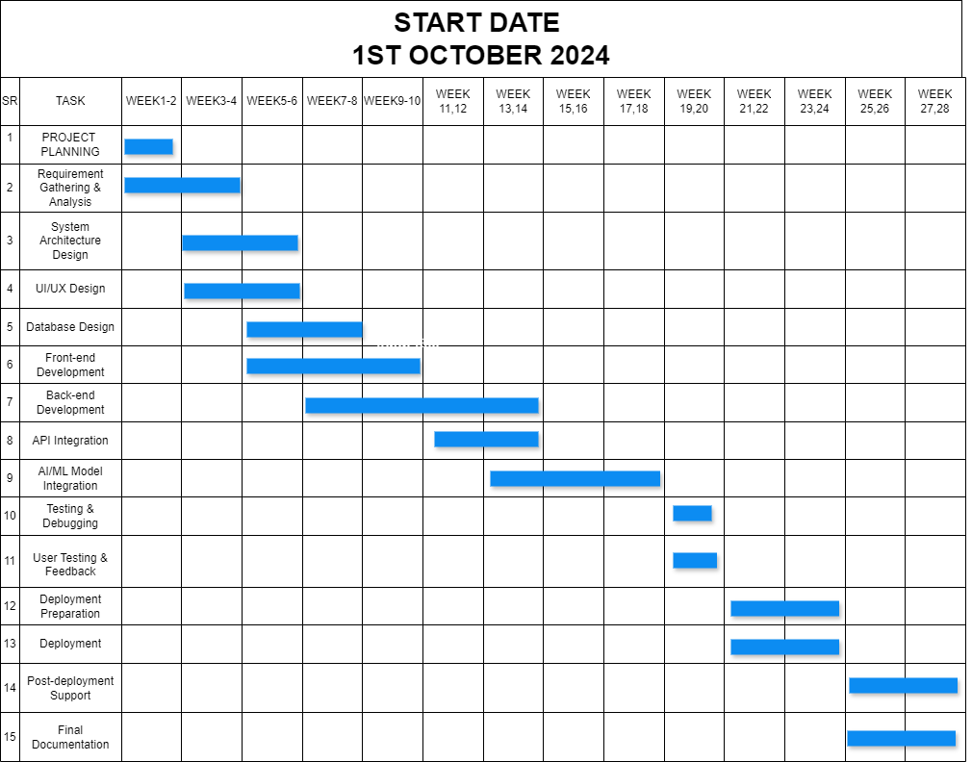**

*Figure 1.2: Gantt chart for milestones*

# Chapter 2 Requirement Analysis

## Chapter 2 Requirement Analysis

### Functional Requirements

### 2.1.1 For Admin

* **Authentication**
  + Signup(Name, Email, Password, Confirm password)
  + Login (Email, Password)
* **Manage Students**
  + Add students.
  + View student profiles.
  + Update student information.
  + Delete student profiles.
* **Manage Mentors/Advisors**
  + Add mentors/advisors.
  + View mentor profiles.
  + Update mentor information.
  + Delete mentor profiles.
* **Manage Career Resources**
  + Add career resources (e.g., eBooks, tutorials, and videos).
  + View available career resources.
  + Update resource details.
* **Reports and Analytics**
  + Generate reports on user engagement, platform activity, and success metrics.
  + View analytics for job postings, user activity, and system performance.
* **File Sharing**
  + Share files with users or mentors.
  + View shared files.
  + Delete shared files.
* **Notifications and Announcements**
  + Send platform-wide notifications or announcements to all users.
  + View and manage previously sent notifications.

### 2.1.2 For Mentor/Advisor

* **Authentication**
  + Login (Email, Password).
  + Forget Password.
* **Manage Career Guidance**
  + Schedule counseling sessions (Add, View, Update, Delete time slots).
  + View user profiles assigned for mentoring.
  + Provide feedback or suggestions for individual users.
* **View User Proposals**
  + Review career roadmaps submitted by users.
  + Accept, reject, or provide feedback on user proposals.
* **File Sharing**
  + Share files (e.g., resources or feedback) with specific users or groups.
  + View files shared by users.
  + Delete shared files.
* **Notifications**
  + View platform notifications and announcements shared by the Admin.
* **Group Discussions**
  + Host or participate in group discussions with assigned users.
  + Share insights and updates in a discussion forum.

### 2.1.3 For User/Student

* **Authentication**
  + Login (Email, Password).
  + Forget Password.
* **Profile Management**
  + Create and update profile, including educational background, skills, interests, and career aspirations.
* **Career Assessment and Counseling**
  + Take career assessment tests (e.g., skill tests, interest inventories).
  + View personalized career suggestions and road-maps.
* **Search and Apply for Jobs**
  + Search for job opportunities using filters (e.g., location, industry, salary).
  + Save favorite job postings.
  + Apply for jobs directly through the platform.
* **File Sharing**
  + Share resumes or documents with mentors or admins.
  + View shared files.
  + Delete shared files.
* **Notifications**
  + Receive notifications for job openings, session reminders, and platform updates.
* **Chat Support**
  + Engage in real-time chat with mentors for quick guidance or feedback.

### Non-Functional Requirement

All non-functional requirements of proposed system are as followed:

##### Performance

The system should be able to handle 1000+ concurrent users with minimal latency (response time < 2 seconds).

##### Scalability

The system should be scalable to support a growing user base by utilizing cloud-based infrastructure (e.g., AWS).

##### Security

All user data should be encrypted, and sensitive information like passwords must be stored using industry-standard hashing algorithms.

OAuth should be used for secure user authentication.

##### Availability:

The system should have 99.9% uptime, ensuring high availability for users.

##### Usability:

The user interface should be intuitive and user-friendly, enabling easy navigation for non-technical users.

##### Data Privacy:

The system should comply with data privacy regulations (e.g., GDPR) to protect user information.

##### Maintainability:

The system code should follow modular architecture to facilitate easy updates and maintenance.

##### Compatibility:

The application should be compatible across different web browsers (Chrome, Firefox, Safari) and mobile devices.

### Use Cases

### Login Use Case

*Table 2.1 login use case*

|  |  |
| --- | --- |
| **Use Case Number** | UC-1 |
| **Use Case Name** | UC-Login |
| **Goal** | User log into the system |
| **Primary actor** | Admin, Student, Mentor |
| **Level** | User, System |
| **Precondition** | User must have valid login credential/exist in the  system. |
| **Success end** | User successfully login into the system and is redirected to their dashboard. |
| **Failure and condition** | User fails to log in due to invalid credentials or inactive account. |
| **Main success scenario** | 1. **User** navigates to the login page.  2. **User** enters email and password.  3. System validates the credentials against the database.  4. **User** is redirected to their dashboard upon successful authentication. |
| **Extensions (error scenarios)** | 3.a Email or password is incorrect.  3.b System displays an error message.  3.c User retries login. |

### Forget Password Use Case

*Table 2.2 Forget Password Use Case*

|  |  |
| --- | --- |
| **Use Case Number** | UC-2 |
| **Use Case Name** | UC-Forget Password |
| **Goal** | User resets their password when they forget it. |
| **Primary actor** | Admin, Student, Mentor |
| **Level** | User, System |
| **Precondition** | User must have a registered email address. |
| **Success end** | User resets their password successfully and logs into the system. |
| **Failure and condition** | User fails to reset their password due to invalid email or link expiration. |
| **Main success scenario** | 1. **User** clicks on the **"Forgot Password"** link on the login page.  2. **User** enters their registered email address.  3. System verifies the email and sends a password reset link.  4. **User** clicks the link, enters a new password, and confirms.  5. System updates the password and redirects the user to the login page. |
| **Extensions (error scenarios)** | 2.a Email address is not registered.  2.b System displays an error message.  4.a Password reset link is expired or invalid.  4.b User requests a new link. |

### Add Students Use Case

*Table 2.3 Add Students Use Case*

|  |  |
| --- | --- |
| **Use Case Number** | UC-3 |
| **Use Case Name** | UC-Add Students |
| **Goal** | Admin adds new student profiles individually or via bulk upload using an Excel sheet. |
| **Primary actor** | Admin |
| **Level** | User, System |
| **Precondition** | Admin must be logged in. |
| **Success end** | Students are added successfully to the system. |
| **Failure and condition** | Student addition fails. |
| **Main success scenario** | 1. **Admin** navigates to the **"Manage Students"** section.  2. **Admin** selects **"Add Student"** or **"Bulk Upload."**  3. **Admin** enters details or uploads an Excel file.  4. System validates the data and adds the students.  5. System confirms successful addition. |
| **Extensions (error scenarios)** | 3.a Excel file has invalid or duplicate entries.  3.b Required fields are missing in the form.  4.a System displays an error and prompts for corrections. |

### View Student Profiles Use Case

*Table 2.4 View Student Profiles Use Case*

|  |  |
| --- | --- |
| **Use Case Number** | UC-4 |
| **Use Case Name** | UC-View Student Profiles |
| **Goal** | Admin views the profiles of individual students. |
| **Primary actor** | Admin |
| **Level** | User, System |
| **Precondition** | Admin must be logged in. |
| **Success end** | Student profiles are displayed successfully. |
| **Failure and condition** | Profiles fail to load. |
| **Main success scenario** | 1. **Admin** navigates to the **"Manage Students"** section.  2. **Admin** selects a specific student profile.  3. System retrieves and displays the student's information. |
| **Extensions (error scenarios)** | 2.a Profile data retrieval fails due to a system error.  2.b Admin is notified to retry. |

### Update Student Information Use Case

*Table 2.5 Update Student Information Use Case*

|  |  |
| --- | --- |
| **Use Case Number** | UC-5 |
| **Use Case Name** | UC- Update Student Information |
| **Goal** | Admin updates existing student details. |
| **Primary actor** | Admin |
| **Level** | User, System |
| **Precondition** | Admin must be logged in, and the student profile must exist. |
| **Success end** | Student information is updated successfully. |
| **Failure and condition** | Update operation fails. |
| **Main success scenario** | 1. **Admin** navigates to the **"Manage Students"** section.  2. **Admin** selects a student profile to edit.  3. **Admin** updates the required fields and submits.  4. System saves the updated information and confirms success. |
| **Extensions (error scenarios)** | 3.a Required fields are left blank.  3.b System displays an error message and prompts for correction. |

### Delete Student Profiles Use Case

*Table 2.6 Delete Student Profiles Use Case*

|  |  |
| --- | --- |
| **Use Case Number** | UC-6 |
| **Use Case Name** | UC- Delete Student Profiles |
| **Goal** | Admin deletes student profiles from the system. |
| **Primary actor** | Admin |
| **Level** | User, System |
| **Precondition** | Admin must be logged in, and the student profile must exist. |
| **Success end** | Student profile is deleted successfully. |
| **Failure and condition** | Deletion operation fails. |
| **Main success scenario** | 1. **Admin** navigates to the **"Manage Students"** section.  2. **Admin** selects a student profile to delete.  3. System prompts for confirmation.  4. **Admin** confirms the action.  5. System deletes the profile and confirms success. |
| **Extensions (error scenarios)** | 3.a Profile cannot be deleted due to dependencies (e.g., ongoing activities).  3.b System displays an error and suggests resolution steps. |

### Activate/Deactivate Student Accounts Use Case

*Table 2.7 Activate/Deactivate Student Accounts Use Case*

|  |  |
| --- | --- |
| **Use Case Number** | UC-7 |
| **Use Case Name** | UC- Activate/Deactivate Student Accounts |
| **Goal** | Admin activates or deactivates student accounts. |
| **Primary actor** | Admin |
| **Level** | User, System |
| **Precondition** | Admin must be logged in, and the student account must exist. |
| **Success end** | Student account status is updated successfully. |
| **Failure and condition** | Status update operation fails. |
| **Main success scenario** | 1. **Admin** navigates to the **"Manage Students"** section.  2. **Admin** selects a student account to activate or deactivate.  3. System updates the account status and confirms success. |
| **Extensions (error scenarios)** | 3.a System error occurs during the update.  3.b Admin is notified and prompted to retry. |

### Add Mentors/Advisors Use Case

*Table 2.8 Add Mentors/Advisors Use Case*

|  |  |
| --- | --- |
| **Use Case Number** | UC-8 |
| **Use Case Name** | UC- Add Mentors/Advisors |
| **Goal** | Admin adds new mentors or advisors to the system. |
| **Primary actor** | Admin |
| **Level** | User, System |
| **Precondition** | Admin must be logged in. |
| **Success end** | Mentors/advisors are added successfully to the system. |
| **Failure and condition** | Mentor/advisor addition fails. |
| **Main success scenario** | 1. **Admin** navigates to the **"Manage Mentors"** section.  2. **Admin** selects **"Add Mentor."**  3. **Admin** enters the mentor’s details and submits.  4. System validates the data and saves the **mentor’s profile.**  5. System confirms successful addition. |
| **Extensions (error**  **scenarios)** | 3.a Required fields are missing.  3.b System displays an error message and prompts for correction. |

### View Mentor Profiles Use Case

*Table 2.9 View Mentor Profiles Use Case*

|  |  |
| --- | --- |
| **Use Case Number** | UC-9 |
| **Use Case Name** | UC- View Mentor Profiles |
| **Goal** | Admin views detailed profiles of mentors/advisors. |
| **Primary actor** | Admin |
| **Level** | User, System |
| **Precondition** | Admin must be logged in. |
| **Success end** | Mentor profiles are displayed successfully. |
| **Failure and condition** | Profiles fail to load. |
| **Main success scenario** | 1. **Admin** navigates to the **"Manage Mentors"** section.  2. **Admin** selects a mentor’s profile.  3. System retrieves and displays the mentor’s details. |
| **Extensions (error scenarios)** | 2.a Profile data retrieval fails due to a system error.  2.b Admin is notified to retry. |

### Update Mentor Information Use Case

*Table 2.10 Update Mentor Information Use Case*

|  |  |
| --- | --- |
| **Use Case Number** | UC-10 |
| **Use Case Name** | UC- Update Mentor Information |
| **Goal** | Admin updates existing mentor details. |
| **Primary actor** | Admin |
| **Level** | User, System |
| **Precondition** | Admin must be logged in, and the mentor’s profile must exist. |
| **Success end** | Mentor information is updated successfully. |
| **Failure and condition** | Update operation fails. |
| **Main success scenario** | 1. **Admin** navigates to the **"Manage Mentors"** section.  2. **Admin** selects a **mentor’s profile** to edit.  3**. Admin** updates the required fields and submits.  4. System saves the updated information and confirms success. |
| **Extensions (error scenarios)** | 3.a Required fields are left blank.  3.b System displays an error message and prompts for correction. |

### Delete Mentor Profiles Use Case

*Table 2.11 Delete Mentor Profiles Use Case*

|  |  |
| --- | --- |
| **Use Case Number** | UC-11 |
| **Use Case Name** | UC- Delete Mentor Profiles |
| **Goal** | Admin deletes mentor profiles from the system. |
| **Primary actor** | Admin |
| **Level** | User, System |
| **Precondition** | Admin must be logged in, and the mentor’s profile must exist. |
| **Success end** | Mentor profile is deleted successfully. |
| **Failure and condition** | Deletion operation fails. |
| **Main success scenario** | 1. **Admin** navigates to the **"Manage Mentors"** section.  2. **Admin** selects a mentor’s profile to delete.  3. System prompts for confirmation.  4. **Admin** confirms the action.  5. System deletes the profile and confirms success. |
| **Extensions (error scenarios)** | 3.a Profile cannot be deleted due to dependencies (e.g., ongoing assignments).  3.b System displays an error and suggests resolution steps. |

### Activate/Deactivate Mentor Accounts Use Case

*Table 2.12 Activate/Deactivate Mentor Accounts Use Case*

|  |  |
| --- | --- |
| **Use Case Number** | UC-12 |
| **Use Case Name** | UC- Activate/Deactivate Mentor Accounts |
| **Goal** | Admin activates or deactivates mentor accounts. |
| **Primary actor** | Admin |
| **Level** | User, System |
| **Precondition** | Admin must be logged in, and the mentor’s account must exist. |
| **Success end** | Mentor account status is updated successfully. |
| **Failure and condition** | Status update operation fails. |
| **Main success scenario** | 1. **Admin** navigates to the **"Manage Mentors"** section.  2. **Admin** selects a mentor account to activate or deactivate.  3. System updates the account status and confirms success. |
| **Extensions (error scenarios)** | 3.a System error occurs during the update.  3.b Admin is notified and prompted to retry. |

### Add Career Resources Use Case

*Table 2.13 Add Career Resources Use Case*

|  |  |
| --- | --- |
| **Use Case Number** | UC-14 |
| **Use Case Name** | UC-Add Career Resources |
| **Goal** | Admin adds new career resources, such as eBooks, tutorials, or videos. |
| **Primary actor** | Admin |
| **Level** | User, System |
| **Precondition** | Admin must be logged in. |
| **Success end** | Career resource is added successfully to the system. |
| **Failure and condition** | Career resource addition fails. |
| **Main success scenario** | 1. **Admin** navigates to the **"Manage Career Resources"** section.  2. **Admin** selects **"Add Resource."**  3. **Admin** enters resource details, uploads the file, and submits.  4. System validates the data and uploads the resource.  5. System confirms successful addition. |
| **Extensions (error**  **scenarios)** | 3.a Required fields are missing.  3.b System displays an error message and prompts for correction.  4.a File upload fails due to size or format issues.  4.b System notifies the admin and suggests valid formats. |

### View Career Resources Use Case

*Table 2.14 View Career Resources Use Case*

|  |  |
| --- | --- |
| **Use Case Number** | UC-14 |
| **Use Case Name** | UCView Career Resources |
| **Goal** | Admin views the list of available career resources. |
| **Primary actor** | Admin |
| **Level** | User, System |
| **Precondition** | Admin must be logged in. |
| **Success end** | List of available resources is displayed successfully. |
| **Failure and condition** | Resource list fails to load. |
| **Main success scenario** | 1. **Admin** navigates to the **"Manage Career Resources"** section.  2. **Admin** selects **"View Resources."**  3. System retrieves and displays the list of resources. |
| **Extensions (error scenarios)** | 2.a System error occurs while fetching resources.  2.b Admin is notified to retry. |

### Update Career Resource Details Use Case

*Table 2.15 Update Career Resource Details Use Case*

|  |  |
| --- | --- |
| **Use Case Number** | UC-15 |
| **Use Case Name** | UC-Update Career Resource Details |
| **Goal** | Admin updates information for an existing career resource. |
| **Primary actor** | Admin |
| **Level** | User, System |
| **Precondition** | Admin must be logged in, and the resource must exist in the system. |
| **Success end** | Career resource details are updated successfully. |
| **Failure and condition** | Career resource details are not updated. |
| **Main success scenario** | 1. Admin navigates to the **"Manage Career Resources"** section.  2. **Admin** selects a resource to update.  3. **Admin** edits the required fields and submits.  4. System validates and saves the updated information.  5. System confirms success. |
| **Extensions (error**  **scenarios)** | 3.a Required fields are left blank.  3.b System displays an error message and prompts for correction. |

### Delete Outdated Career Resources Use Case

*Table 2.16 Delete Outdated Career Resources Use Case*

|  |  |
| --- | --- |
| **Use Case Number** | UC-16 |
| **Use Case Name** | UC- Delete Outdated Career Resources |
| **Goal** | Admin deletes outdated or irrelevant career resources. |
| **Primary actor** | Admin |
| **Level** | User, System |
| **Precondition** | Admin must be logged in, and the resource must exist in the system. |
| **Success end** | Career resource is deleted successfully. |
| **Failure and condition** | Deletion operation fails. |
| **Main success scenario** | 1. **Admin** navigates to the **"Manage Career Resources"** section.  2. **Admin** selects a resource to delete.  3. System prompts for confirmation.  4. **Admin** confirms the action.  5. System deletes the resource and confirms success. |
| **Extensions (error scenarios)** | 3.a Resource cannot be deleted due to dependencies.  3.b System displays an error and suggests resolution steps.  4.a System error occurs during deletion.  4.b Admin is notified and prompted to retry. |

### Approve/Reject Job Postings Use Case

*Table 2.17 Approve/Reject Job Postings Use Case*

|  |  |
| --- | --- |
| **Use Case Number** | UC-17 |
| **Use Case Name** | UC- Approve/Reject Job Postings |
| **Goal** | Admin reviews and either approves or rejects job postings submitted by employers. |
| **Primary actor** | Admin |
| **Level** | User, System |
| **Precondition** | Admin must be logged in, and job postings must exist in the pending approval list. |
| **Success end** | Job posting is approved or rejected successfully. |
| **Failure and condition** | Approval or rejection action fails. |
| **Main success scenario** | 1. **Admin** navigates to the **"Manage Job Postings"** section.  2. **Admin** selects a job posting from the pending approval list.  3. **Admin** reviews the job details.  4. Admin chooses to either approve or reject the posting.  5. System processes the decision and updates the posting status.  6. System notifies the employer of the decision. |
| **Extensions (error scenarios)** | 3.a Job details are incomplete or inaccessible.  4.a System error occurs while updating status.  4.b Admin is notified to retry. |

### Add Job Postings Manually Use Case

*Table 2.18 Add Job Postings Manually Use Case*

|  |  |
| --- | --- |
| **Use Case Number** | UC-18 |
| **Use Case Name** | UC-Add Job Postings Manually |
| **Goal** | Admin adds job postings directly to the system. |
| **Primary actor** | Admin |
| **Level** | User, System |
| **Precondition** | Admin must be logged in. |
| **Success end** | Job posting is added successfully to the system. |
| **Failure and condition** | Job posting addition fails. |
| **Main success scenario** | 1. **Admin** navigates to the **"Manage Job Postings"** section.  2. **Admin** selects **"Add Job Posting."**  3. **Admin** enters job details, such as title, description, requirements, and employer information.  4. **Admin** submits the form.  5. System validates and saves the job posting.  6. System confirms successful addition. |
| **Extensions (error scenarios)** | 3.a Required fields are left blank.  3.b System displays an error message and prompts for correction.  4.a Validation fails (e.g., unsupported formats).  4.b System notifies admin to correct the input. |

### View, Update, or Delete Job Postings Use Case

*Table 2.19 View, Update, or Delete Job Postings Use Case*

|  |  |
| --- | --- |
| **Use Case Number** | UC-19 |
| **Use Case Name** | UC- View, Update, or Delete Job Postings |
| **Goal** | Admin views, updates, or deletes job postings in the system. |
| **Primary actor** | Admin |
| **Level** | User, System |
| **Precondition** | Admin must be logged in, and job postings must exist in the system. |
| **Success end** | Admin successfully views, updates, or deletes job postings. |
| **Failure and condition** | Action to view, update, or delete fails. |
| **Main success scenario** | 1. **Admin** navigates to the **"Manage Job Postings"** section.  2. **Admin** selects a job posting from the list.  3. **Admin** performs one of the following:   3.a Views job details.   3.b Edits job details and saves the changes.   3.c Deletes the job posting.  4. System processes the action and updates the list. |
| **Extensions (error scenarios)** | 3.a Job details fail to load.  3.b Update fails due to validation errors.  3.c Deletion fails due to dependencies or system errors.  3.d System notifies admin to retry. |

### Categorize Jobs by Industry and Relevance Use Case

*Table 2.20 Categorize Jobs by Industry and Relevance Use Case*

|  |  |
| --- | --- |
| **Use Case Number** | UC-20 |
| **Use Case Name** | UC-Categorize Jobs by Industry and Relevance |
| **Goal** | Admin categorizes job postings for better organization and searchability. |
| **Primary actor** | Admin |
| **Level** | User, System |
| **Precondition** | Admin must be logged in, and job postings must exist in the system. |
| **Success end** | Jobs are categorized successfully by industry and relevance. |
| **Failure and condition** | Categorization action fails. |
| **Main success scenario** | 1. **Admin** navigates to the **"Manage Job Postings"** section.  2. **Admin** selects a job posting.  3. **Admin** assigns relevant categories (e.g., IT, healthcare) and relevance tags.  4. System validates and updates the job posting with the new categories.  5. System confirms successful categorization. |
| **Extensions (error scenarios)** | 3.a Invalid or duplicate categories are assigned.  3.b System displays an error and prompts for correction.  4.a System error occurs while saving categories.  4.b **Admin** is notified to retry. |

### Generate Reports Use Case

*Table 2.21 Generate Reports Use Case*

|  |  |
| --- | --- |
| **Use Case Number** | UC-21 |
| **Use Case Name** | UC-Generate Reports |
| **Goal** | Admin generates detailed reports for analysis of platform performance and user engagement. |
| **Primary actor** | Admin |
| **Level** | User, System |
| **Precondition** | Admin must be logged in, and data must exist in the system for report generation. |
| **Success end** | Reports are successfully generated and made available for download or viewing. |
| **Failure and condition** | Report generation fails. |
| **Main success scenario** | 1. **Admin** navigates to the **"Reports and Analytics"** section.  2. **Admin** selects **"Generate Report."**  3. **Admin** specifies the type of report (e.g., user engagement, platform activity).  4. **Admin** selects parameters (e.g., time period, user roles).  5. System processes the request and generates the report.  6. **Admin** views or downloads the report. |
| **Extensions (error**  **scenarios)** | 4.a **Admin** provides invalid or incomplete parameters.  4.b System displays an error message and prompts for correction.  5.a System encounters a processing error.  5.b **Admin** is notified to retry the action. |

### View Analytics Use Case

*Table 2.22 View Analytics Use Case*

|  |  |
| --- | --- |
| **Use Case Number** | UC-22 |
| **Use Case Name** | UC-View Analytics |
| **Goal** | Admin views detailed analytics to monitor the platform's key performance indicators. |
| **Primary actor** | Admin |
| **Level** | User, System |
| **Precondition** | Admin must be logged in, and data must exist in the system for analytics visualization. |
| **Success end** | Analytics are displayed successfully in a visual and comprehensible format. |
| **Failure and condition** | Analytics fail to load or display. |
| **Main success scenario** | 1. **Admin** navigates to the **"Reports and Analytics"** section.  2. **Admin** selects **"View Analytics."**  3. System displays analytics in visual formats (charts, graphs, tables).  4. **Admin** filters or customizes the analytics view by selecting parameters (e.g., time period, activity type).  5. System updates the analytics view based on selected filters. |
| **Extensions (error scenarios)** | 3.a Data is incomplete or unavailable.  3.b System notifies admin of the issue.  4.a Filters are invalid or incompatible.  4.b System displays an error message and prompts for correction. |

### Share Files Use Case

*Table 2.23 Share Files Use Case*

|  |  |
| --- | --- |
| **Use Case Number** | UC-23 |
| **Use Case Name** | UC- Share Files |
| **Goal** | Allow admin or users to share files with other users or mentors.. |
| **Primary actor** | Admin, Mentor, User |
| **Level** | User, System |
| **Precondition** | The primary actor must be logged in and have the file ready for upload. |
| **Success end** | File is successfully shared with the selected recipients. |
| **Failure and condition** | File sharing fails, and the file is not uploaded. |
| **Main success scenario** | 1. The **primary actor** navigates to the **"File Sharing"** section.  2. The **primary actor** selects **"Share File."**  3. The **primary actor** uploads the file and selects recipients.  4. The system validates the file format and size.  5. The system uploads and shares the file with the selected recipients.  6. Recipients receive a notification about the shared file. |
| **Extensions (error scenarios)** | 3.a File exceeds maximum allowable size.  3.b System displays an error message and prevents upload.  4.a System displays a format error and prompts for correction. |

### View Shared Files Use Case

*Table 2.24 View Shared Files Use Case*

|  |  |
| --- | --- |
| **Use Case Number** | UC-24 |
| **Use Case Name** | UC-View Shared Files |
| **Goal** | Allow users to view the files shared with them. |
| **Primary actor** | Admin, Mentor, User |
| **Level** | User, System |
| **Precondition** | The primary actor must be logged in, and shared files must exist. |
| **Success end** | Shared files are successfully displayed to the primary actor. |
| **Failure and condition** | Files fail to load or display. |
| **Main success scenario** | 1. The **primary actor** navigates to the **"Shared Files"** section.  2. The system fetches the list of files shared with the actor.  3. The **primary actor** selects a file to view.  4. The system opens or previews the selected file. |
| **Extensions (error scenarios)** | 2.a Files are not found or are inaccessible.  2.b System displays an error message.  3.a File format is not supported for preview.  3.b System prompts the actor to download instead. |

### Delete Shared Files Use Case

*Table 2.25 Delete Shared Files Use Case*

|  |  |
| --- | --- |
| **Use Case Number** | UC-25 |
| **Use Case Name** | UC-Delete Shared Files |
| **Goal** | Allow users to delete files they shared or received. |
| **Primary actor** | Admin, Mentor, User |
| **Level** | User, System |
| **Precondition** | The primary actor must be logged in, and the file must exist in the shared files section. |
| **Success end** | File is successfully deleted from the system. |
| **Failure and condition** | File deletion fails, and the file remains in the system. |
| **Main success scenario** | 1. The **primary actor** navigates to the **"Shared Files"** section.  2. The **primary actor** selects a file to delete.  3. The system asks for confirmation.  4. The **primary actor** confirms the deletion.  5. The system deletes the file and removes it from the shared files section. |
| **Extensions (error scenarios)** | 3.a The file is locked or in use.  3.b System notifies the actor that deletion is not possible.  4.a Confirmation is not received.  4.b System cancels the deletion process. |

### Send Platform-Wide Notifications Use Case

*Table 2.26 Send Platform-Wide Notifications Use Case*

|  |  |
| --- | --- |
| **Use Case Number** | UC-26 |
| **Use Case Name** | UC- Send Platform-Wide Notifications |
| **Goal** | Admin sends notifications or announcements to all platform users. |
| **Primary actor** | Admin |
| **Level** | User, System |
| **Precondition** | The admin must be logged in and have the announcement content ready. |
| **Success end** | Notifications or announcements are sent successfully to all users. |
| **Failure and condition** | Notification sending fails, and no users receive the announcement. |
| **Main success scenario** | 1. **Admin** navigates to the **"Notifications and Announcements"** section.  2. **Admin** selects **"Create Notification."**  3. **Admin** enters the notification content and selects recipients (e.g., all users, specific roles).  4. **Admin** confirms and sends the notification.  5. The system delivers the notification to the selected recipients.  6. **Users** receive the notification in their inbox or dashboard. |
| **Extensions (error scenarios)** | 3.a Notification content is incomplete.  3.b System prompts admin to complete the fields.  5.a System encounters a delivery error.  5.b Admin is notified to retry. |

### View and Manage Previously Sent Notifications Use Case

*Table 2.27 View and Manage Previously Sent Notifications Use Case*

|  |  |
| --- | --- |
| **Use Case Number** | UC-27 |
| **Use Case Name** | UC- View and Manage Previously Sent Notifications |
| **Goal** | Admin views or manages notifications previously sent to users. |
| **Primary actor** | Admin |
| **Level** | User, System |
| **Precondition** | The admin must be logged in, and notifications must already exist in the system. |
| **Success end** | Previously sent notifications are successfully displayed and managed. |
| **Failure and condition** | Notifications fail to load or cannot be managed. |
| **Main success scenario** | 1. **Admin** navigates to the **"Notifications and Announcements"** section.  2. **Admin** selects **"View Sent Notifications."**  3. The system displays a list of previously sent notifications.  4. **Admin** selects a notification to view details.  5. **Admin** optionally edits, resend, or deletes the notification. |
| **Extensions (error scenarios)** | 3.a Notifications fail to load.  3.b System notifies admin of the issue.  5.a Notification cannot be edited or deleted.  5.b System informs admin of the restriction. |

### Mentor/Advisor Login Use Case

*Table 2.28 Mentor/Advisor Login Use Case*

|  |  |
| --- | --- |
| **Use Case Number** | UC-28 |
| **Use Case Name** | UC- Mentor/Advisor Login |
| **Goal** | Mentor/Advisor logs into the system using valid credentials. |
| **Primary actor** | Mentor/Advisor |
| **Level** | User, System |
| **Precondition** | The mentor/advisor must be registered in the system and have valid login credentials. |
| **Success end** | Mentor/Advisor successfully logs into the system and accesses their dashboard. |
| **Failure and condition** | Login fails, and the mentor/advisor cannot access the system. |
| **Main success scenario** | 1. **Mentor/Advisor** navigates to the login page.  2. **Mentor/Advisor** enters their email and password.  3. System validates the credentials.  4. **Mentor/Advisor** is redirected to their dashboard. |
| **Extensions (error scenarios)** | 2.a Email or password is incorrect.  2.b System displays an error message and prompts for re-entry.  3.a Account is deactivated.  3.b System notifies the mentor/advisor of account status and advises contacting support. |

### Mentor/Advisor Forget Password Use Case

*Table 2.29 Mentor/Advisor Forget Password Use Case*

|  |  |
| --- | --- |
| **Use Case Number** | UC-29 |
| **Use Case Name** | UC- Mentor/Advisor Forget Password |
| **Goal** | Allow mentors/advisors to reset their password if forgotten. |
| **Primary actor** | Mentor/Advisor |
| **Level** | User, System |
| **Precondition** | Mentor/Advisor must have a registered email in the system. |
| **Success end** | Mentor/Advisor successfully resets their password and regains access. |
| **Failure and condition** | Password reset fails, and access is not restored. |
| **Main success scenario** | 1. **Mentor/Advisor** clicks on the **"Forgot Password"** link on the login page.  2. System prompts for the registered email.  3. **Mentor/Advisor** enters their email.  4. System sends a password reset link to the email.  5. **Mentor/Advisor** clicks the link and sets a new password.  6. System updates the password and confirms the change. |
| **Extensions (error**  **scenarios)** | 3.a Email does not exist in the system.  3.b System notifies the mentor/advisor.  4.a Email delivery fails.  4.b System prompts the mentor/advisor to retry later.  5.a New password does not meet criteria.  5.b System displays a validation error and prompts for correction. |

### Schedule Counseling Sessions Use Case

*Table 2.30 Schedule Counseling Sessions Use Case*

|  |  |
| --- | --- |
| **Use Case Number** | UC-30 |
| **Use Case Name** | UC- Schedule Counseling Sessions |
| **Goal** | Mentor/Advisor schedules counseling sessions by managing time slots. |
| **Primary actor** | Mentor/Advisor |
| **Level** | User, System |
| **Precondition** | Mentor/Advisor must be logged into the system. |
| **Success end** | Counseling sessions are successfully scheduled or managed. |
| **Failure and condition** | Sessions are not scheduled or managed due to errors. |
| **Main success scenario** | 1. **Mentor/Advisor** navigates to the **"Counseling Sessions"** section.  2. **Mentor/Advisor** selects **"Add Time Slot"** and inputs details (date, time, duration).  3. **Mentor/Advisor** confirms and saves the session.  4. System updates the calendar with the new session.  5. **Mentor/Advisor** can view, update, or delete existing time slots. |
| **Extensions (error scenarios)** | 2.a Time slot conflicts with an existing session.  2.b System displays an error message.  3.a Required details are missing or invalid.  3.b System prompts for corrections. |

### View User Profiles Assigned for Mentoring Use Case

*Table 2.31 View User Profiles Assigned for Mentoring Use Case*

|  |  |
| --- | --- |
| **Use Case Number** | UC-31 |
| **Use Case Name** | UC-View User Profiles Assigned for Mentoring |
| **Goal** | Mentor/Advisor views detailed profiles of users assigned to them. |
| **Primary actor** | Mentor/Advisor |
| **Level** | User, System |
| **Precondition** | Users must be assigned to the mentor/advisor, and profiles should exist in the system. |
| **Success end** | Mentor/Advisor successfully views the profiles of assigned users. |
| **Failure and condition** | Profiles are not displayed or accessible. |
| **Main success scenario** | 1. **Mentor/Advisor** navigates to the **"User Profiles"** section.  2. System displays a list of users assigned to the mentor/advisor.  3. **Mentor/Advisor** selects a user to view the profile.  4. System displays detailed information, including career preferences, goals, and activity history. |
| **Extensions (error scenarios)** | 2.a No users are assigned to the mentor/advisor.  2.b System displays a message indicating no profiles are available. |

### Provide Feedback or Suggestions Use Case

*Table 2.32 Provide Feedback or Suggestions Use Case*

|  |  |
| --- | --- |
| **Use Case Number** | UC-32 |
| **Use Case Name** | UC- Provide Feedback or Suggestions for Users |
| **Goal** | Mentor/Advisor provides personalized feedback or career suggestions for individual users. |
| **Primary actor** | Mentor/Advisor |
| **Level** | User, System |
| **Precondition** | Mentor/Advisor must have access to the user's profile and feedback functionality. |
| **Success end** | Feedback or suggestions are successfully recorded and sent to the user. |
| **Failure and condition** | Feedback is not recorded or delivered. |
| **Main success scenario** | 1. **Mentor/Advisor** opens the user's profile from the **"User Profiles"** section.  2. **Mentor/Advisor** selects **"Provide Feedback."**  3. **Mentor/Advisor** inputs feedback or suggestions and submits them.  4. System saves the feedback and notifies the user. |
| **Extensions (error scenarios)** | 3.a Feedback field is left blank.  3.b System prompts the mentor/advisor to input text.  4.a Feedback fails to save due to system error.  4.b System informs the mentor/advisor and prompts to retry. |

### Review Career Roadmaps Submitted by Users

*Table 2.33 Review Career Roadmaps Submitted by Users*

|  |  |
| --- | --- |
| **Use Case Number** | UC-33 |
| **Use Case Name** | UC- Review Career Roadmaps |
| **Goal** | Mentor/Advisor reviews career road-maps submitted by users. |
| **Primary actor** | Mentor/Advisor |
| **Level** | User, System |
| **Precondition** | Users must have submitted their career road-maps, and the mentor/advisor should have access to view them. |
| **Success end** | Mentor/Advisor successfully reviews the career road-maps. |
| **Failure and condition** | Career road-maps are not displayed or accessible for review. |
| **Main success scenario** | 1. **Mentor/Advisor** navigates to the **"Career Roadmaps"** section.  2. System displays a list of submitted roadmaps.  3. **Mentor/Advisor** selects a road-map to review.  4. System displays detailed content, including goals, timelines, and required skills. |
| **Extensions (error**  **scenarios)** | 2.a No road-maps are submitted.  2.b System displays a message indicating no submissions are available.  4.a Roadmap fails to load due to system error.  4.b System prompts to retry later. |

### Accept, Reject, or Provide Feedback on User Proposals

*Table 2.34 Accept, Reject, or Provide Feedback on User Proposals*

|  |  |
| --- | --- |
| **Use Case Number** | UC-34 |
| **Use Case Name** | UC- Accept, Reject, or Provide Feedback on User Proposals |
| **Goal** | Mentor/Advisor evaluates user proposals and takes appropriate action. |
| **Primary actor** | Mentor/Advisor |
| **Level** | User, System |
| **Precondition** | Career proposals must be submitted by users and available for action. |
| **Success end** | Mentor/Advisor successfully accepts, rejects, or provides feedback on a user proposal. |
| **Failure and condition** | Proposal evaluation is not completed due to errors or system failure. |
| **Main success scenario** | 1. **Mentor/Advisor** selects a user proposal from the **"Career Roadmaps"** section.  2. **Mentor/Advisor** reviews the details of the proposal.  3. **Mentor/Advisor** selects an action (Accept, Reject, or Provide Feedback).  4. System records the action and notifies the user.  5. For feedback, Mentor/Advisor inputs comments and submits them. |
| **Extensions (error scenarios)** | 3.a Proposal does not meet criteria for acceptance.  3.b Mentor/Advisor selects **"Reject"** and provides reasons.  4.b System prompts the mentor/advisor to input text.  4.c System error prevents action recording; retry is prompted. |

### Share Files Use Case

*Table 2.35 Share Files Use Case*

|  |  |
| --- | --- |
| **Use Case Number** | UC-35 |
| **Use Case Name** | UC- Share Files |
| **Goal** | Mentor/Advisor shares files, such as resources or feedback, with specific users or groups. |
| **Primary actor** | Mentor/Advisor |
| **Level** | User, System |
| **Precondition** | Mentor/Advisor must have a valid account and be logged into the system. |
| **Success end** | Files are successfully shared with the intended users or groups. |
| **Failure and condition** | Files are not shared due to errors or invalid inputs. |
| **Main success scenario** | 1. **Mentor/Advisor** navigates to the **"File Sharing"** section.  2. **Mentor/Advisor** selects **"Share File**" and uploads a file.  3. **Mentor/Advisor** chooses recipients (users or groups).  4. **Mentor/Advisor** confirms and submits.  5. System notifies recipients about the shared file. |
| **Extensions (error scenarios)** | 2.a File format or size is invalid.  2.b System prompts the user to correct the issue.  4.a System error prevents file sharing.  4.b Mentor/Advisor retries the action. |

### View Shared Files Use Case

*Table 2.36 View Shared Files Use Case*

|  |  |
| --- | --- |
| **Use Case Number** | UC-36 |
| **Use Case Name** | UC- View Shared Files |
| **Goal** | Mentor/Advisor views files shared by users. |
| **Primary actor** | Mentor/Advisor |
| **Level** | User, System |
| **Precondition** | Files must be shared by users and accessible to the mentor/advisor. |
| **Success end** | Files are successfully viewed by the mentor/advisor. |
| **Failure and condition** | Files are not displayed or accessible. |
| **Main success scenario** | 1. **Mentor/Advisor** navigates to the **"File Sharing"** section.  2. System displays a list of files shared by users.  3. **Mentor/Advisor** selects a file to view.  4. File opens or downloads for viewing. |
| **Extensions (error scenarios)** | 2.a No files are shared.  2.b System displays a message indicating no files available. |

### Delete Shared Files Use Case

*Table 2.37 Delete Shared Files Use Case*

|  |  |
| --- | --- |
| **Use Case Number** | UC-37 |
| **Use Case Name** | UC-Delete Shared Files |
| **Goal** | Mentor/Advisor deletes unnecessary shared files. |
| **Primary actor** | Mentor/Advisor |
| **Level** | User, System |
| **Precondition** | Files must be available and deleted. |
| **Success end** | Files are successfully deleted. |
| **Failure and condition** | Files are not deleted due to errors. |
| **Main success scenario** | 1. **Mentor/Advisor** navigates to the **"File Sharing"** section.  2. **Mentor/Advisor** selects a file to delete.  3. System prompts for confirmation.  4. **Mentor/Advisor** confirms, and the system deletes the file. |
| **Extensions (error**  **scenarios)** | 2.a File cannot be deleted due to restrictions.  2.b System notifies the mentor/advisor of the issue. |

### View Platform Notifications Use Case

*Table 2.38 View Platform Notifications Use Case*

|  |  |
| --- | --- |
| **Use Case Number** | UC-38 |
| **Use Case Name** | UC- View Platform Notifications |
| **Goal** | Goal is that Mentor/Advisor views notifications and announcements shared by the Admin.PMO create session. |
| **Primary actor** | Mentor/Advisor |
| **Level** | User, System |
| **Precondition** | Notifications must be created and shared by the Admin. |
| **Success end** | Notifications are successfully viewed. |
| **Failure and condition** | Notifications are not displayed. |
| **Main success scenario** | 1. **Mentor/Advisor** navigates to the **"Notifications"** section.  2. System displays a list of recent notifications.  3. **Mentor/Advisor** selects a notification to view details. |
| **Extensions (error scenarios)** | 2.a No notifications are available.  2.b System displays a message indicating no notifications. |

### Host or Participate in Group Discussions Use Case

*Table 2.39 Host or Participate in Group Discussions Use Case*

|  |  |
| --- | --- |
| **Use Case Number** | UC-39 |
| **Use Case Name** | UC- Host or Participate in Group Discussions |
| **Goal** | Mentor/Advisor hosts or participates in discussions with assigned users. |
| **Primary actor** | Mentor/Advisor |
| **Level** | User, System |
| **Precondition** | Group discussions must be enabled for the mentor/advisor and assigned users. |
| **Success end** | Mentor/Advisor successfully hosts or participates in discussions. |
| **Failure and condition** | Discussions are not accessible or functional. |
| **Main success scenario** | 1. **Mentor/Advisor** navigates to the **"Group Discussions"** section.  2. **Mentor/Advisor** selects a group discussion or starts a new one.  3. System opens a discussion forum where messages or updates can be shared.  4. Participants (users) can respond and engage in real time. |
| **Extensions (error scenarios)** | 2.a No assigned groups for discussion.  2.b System notifies the mentor/advisor.  3.a Technical error prevents hosting or participation.  3.b System suggests retrying later. |

### Login Use Case

*Table 2.40 Login Use Case*

|  |  |
| --- | --- |
| **Use Case Number** | UC-40 |
| **Use Case Name** | UC-Login |
| **Goal** | User/Student logs into the system. |
| **Primary actor** | User/Student |
| **Level** | User, System |
| **Precondition** | The User/Student must have a valid account and credentials (Email and Password). |
| **Success end** | The User/Student successfully logs into the system and accesses their dashboard. |
| **Failure end condition** | The User/Student cannot log in due to invalid credentials or system issues. |
| **Main success scenario** | 1. **User/Student** navigates to the login page.  2. **User/Student** enters their email and password.  3. **User/Student** clicks the **"Login"** button.  4. The system validates the credentials.  5. The system grants access to the user's dashboard. |
| **Extensions (error scenarios)** | 2.a Email or password is invalid.  2.b System displays an error message.  4.a System encounters a technical issue.  4.b User/Student retries or contacts support. |

### Use Case Forget Password Use Case

*Table 2.41 Forget Password Use Case*

|  |  |
| --- | --- |
| **Use Case Number** | UC-41 |
| **Use Case Name** | UC- Forget Password |
| **Goal** | User/Student resets their password when they forget it. |
| **Primary actor** | User/Student |
| **Level** | User, System |
| **Precondition** | User/Student must have an existing account with a registered email address. |
| **Success end** | User/Student successfully resets their password and can log in. |
| **Failure and condition** | Password is not reset due to errors or invalid inputs. |
| **Main success scenario** | 1. **User/Student** navigates to the login page.  2. **User/Student** clicks the **"Forget Password"** link.  3. **User/Student** enters their registered email address.  4. The system sends a password reset link to the email.  5. **User/Student** clicks the link, sets a new password, and confirms it.  6. The system updates the password and notifies the user. |
| **Extensions (error scenarios)** | 3.a Email is not registered.  3.b System displays an error message.  4.a Email fails to send due to technical issues.  4.b System suggests retrying later. |

### Create and Update Profile Use Case

*Table 2.42 Create and Update Profile Use Case*

|  |  |
| --- | --- |
| **Use Case Number** | UC-42 |
| **Use Case Name** | UC-Create and Update Profile |
| **Goal** | User/Student creates or updates their profile with personal and career-related information. |
| **Primary actor** | User/Student |
| **Level** | User, System |
| **Precondition** | User/Student must be logged into the system. |
| **Success end** | The profile is successfully created or updated with accurate information. |
| **Failure and condition** | Profile creation or update fails due to invalid or missing inputs. |
| **Main success scenario** | 1. **User** navigates to the profile management page.  2. **User** inputs or edits personal details, such as **educational background, skills, interests, and career aspirations.**  3. **User** submits the changes.  4. The system validates the inputs.  5. The system saves the profile information and confirms success. |
| **Extensions (error scenarios)** | 2.a Required fields are left blank.  2.b System displays an error message.  4.a Input validation fails for certain fields (e.g., incorrect format).  4.b System requests corrections and resubmission. |

### Take Career Assessment Tests Use Case

*Table 2.43 Take Career Assessment Tests Use Case*

|  |  |
| --- | --- |
| **Use Case Number** | UC-43 |
| **Use Case Name** | UC- Take Career Assessment Tests |
| **Goal** | User/Student completes career assessment tests to evaluate skills, interests, and preferences. |
| **Primary actor** | User/Student |
| **Level** | User, System |
| **Precondition** | User/Student must be logged into the system. |
| **Success end** | Career assessment test is completed, and results are saved in the user's profile. |
| **Failure and condition** | Test completion fails due to system errors or user not finishing the test. |
| **Main success scenario** | 1. **User** navigates to the **"Career Assessment"** section.  2. **User** selects an available test (e.g., skill test, interest inventory).  3. **User** answers the questions.  4. The system validates and submits the responses.  5. The system calculates results and updates the user’s profile.  6. **User** views the assessment summary. |
| **Extensions (error scenarios)** | 3.a User skips mandatory questions.  3.b System prompts to complete unanswered questions.  4.a System experiences a technical issue.  4.b User is notified and advised to retry later. |

### View Personalized Career Suggestions and Roadmaps Use Case

*Table 2.44 View Personalized Career Suggestions and Roadmaps Use Case*

|  |  |
| --- | --- |
| **Use Case Number** | UC-44 |
| **Use Case Name** | UC- View Personalized Career Suggestions and Roadmaps |
| **Goal** | User/Student views tailored career guidance and pathways based on their assessment results and profile data. |
| **Primary actor** | User/Student |
| **Level** | User, System |
| **Precondition** | User/Student must have completed at least one career assessment test. |
| **Success end** | User successfully views career suggestions and detailed roadmaps for their career goals. |
| **Failure and condition** | Career suggestions and roadmaps fail to load due to missing data or system issues. |
| **Main success scenario** | 1. **User** navigates to the **"Career Suggestions"** section.  2. System analyzes user profile and assessment results.  3. System generates personalized career suggestions.  4. **User** selects a suggested career to view its detailed road-map.  5. System displays required skills, courses, and steps for achieving the career goal. |
| **Extensions (error scenarios)** | 2.a Profile or assessment data is incomplete.  2.b System prompts the user to complete missing data.  3.a System encounters technical issues.  3.b User is notified and advised to retry later. |

### Search for Job Opportunities Use Case

*Table 2.45 Search for Job Opportunities Use Case*

|  |  |
| --- | --- |
| **Use Case Number** | UC-45 |
| **Use Case Name** | UC-Search for Job Opportunities |
| **Goal** | User/Student searches for job opportunities using various filters. |
| **Primary actor** | User/Student |
| **Level** | User, System |
| **Precondition** | User/Student must be logged into the system. |
| **Success end** | User successfully views a list of job opportunities based on the applied filters. |
| **Failure and condition** | Search fails due to missing input or system errors. |
| **Main success scenario** | 1. **User** navigates to the **"Job Search"** section.  2. **User** selects search filters (e.g., location, industry, salary).  3. **User** clicks the **"Search"** button.  4. The system retrieves and displays job postings that match the criteria.  5. **User** browses the search results. |
| **Extensions (error scenarios)** | 2.a User leaves required fields blank.  2.b System displays an error message.  4.a No job postings match the criteria.  4.b System informs the user and suggests adjusting filters. |

### Save Favorite Job Postings Use Case

*Table 2.46 Save Favorite Job Postings Use Case*

|  |  |
| --- | --- |
| **Use Case Number** | UC-46 |
| **Use Case Name** | UC-Save Favorite Job Postings |
| **Goal** | User/Student saves job postings to their favorites for later review. |
| **Primary actor** | User/Studen |
| **Level** | User, System |
| **Precondition** | User/Student must be logged into the system and viewing job postings. |
| **Success end** | Job posting is successfully saved to the user's favorites list. |
| **Failure and condition** | Job posting fails to save due to system errors or lack of user action. |
| **Main success scenario** | 1. **User** finds a job posting of interest in the search results.  2. **User** clicks the **"Save"** or **"Add to Favorites"** button.  3. The system saves the job posting to the user's favorites list.  4. **User** receives a confirmation message. |
| **Extensions (error scenarios)** | 2.a System experiences a technical issue.  2.b User is notified and advised to try again.  3.a User attempts to save a posting that is already saved.  3.b System alerts the user that the posting is already in favorites. |

### Apply for Jobs Directly Through the Platform Use Case

*Table 2.47 Apply for Jobs Directly Through the Platform Use Case*

|  |  |
| --- | --- |
| **Use Case Number** | UC-47 |
| **Use Case Name** | UC-Apply for Jobs Directly Through the Platform |
| **Goal** | User/Student applies for jobs using the application platform. |
| **Primary actor** | User/Student |
| **Level** | User, System |
| **Precondition** | User/Student must be logged into the system and viewing a job posting. |
| **Success end** | User successfully submits their job application through the platform. |
| **Failure and condition** | Job application fails to submit due to missing information or system errors. |
| **Main success scenario** | 1. **User** navigates to a specific job posting.  2. **User** clicks the **"Apply"** button.  3. **User** reviews application requirements and uploads necessary documents (e.g., resume, cover letter).  4. **User** submits the application.  5. The system confirms successful submission and informs the user of the next steps. |
| **Extensions (error scenarios)** | 3.a Required fields are left blank or files are not uploaded.  3.b System prompts the user to fill out the missing information.  4.a System encounters a technical issue during submission. |

### File Sharing Use Case

*Table 2.48 Share Resumes or Documents with Mentors or Admins Use Case*

|  |  |
| --- | --- |
| **Use Case Number** | UC-48 |
| **Use Case Name** | UC-Share Resumes or Documents |
| **Goal** | User/Student shares resumes or documents with mentors or admins. |
| **Primary actor** | User/Student |
| **Level** | User, System |
| **Precondition** | User/Student must be logged into the system and have documents ready for sharing. |
| **Success end** | Document is successfully shared with the selected mentor or admin. |
| **Failure and condition** | Document fails to share due to missing information or system errors. |
| **Main success scenario** | 1. **User** navigates to the **"File Sharing"** section.  2. **User** selects the document (e.g., resume) to share.  3. **User** selects a mentor or admin from the list.  4. **User** clicks the **"Share"** button.  5. The system confirms that the document has been successfully shared. |
| **Extensions (error scenarios)** | 2.a User attempts to share a document that exceeds size limits.  2.b System alerts the user about the file size limit.  3.a Selected mentor or admin does not exist.  3.b System prompts the user to select a valid recipient. |

### View Shared Files Use Case

*Table 2.48 View Shared Files Use Case*

|  |  |
| --- | --- |
| **Use Case Number** | UC-48 |
| **Use Case Name** | UC- View Shared Files |
| **Goal** | User/Student views files that have been shared with them or by them. |
| **Primary actor** | User/Student |
| **Level** | User, System |
| **Precondition** | User/Student must be logged into the system. |
| **Success end** | User successfully views the list of shared files. |
| **Failure and condition** | User fails to view shared files due to system errors or lack of files. |
| **Main success scenario** | 1. **User** navigates to the **"My Shared Files"** section.  2. The system retrieves and displays all files shared with the user.  3. **User** selects a specific file to view details or download.  4. The system confirms that the document has been successfully viewed. |
| **Extensions (error scenarios)** | 2.a No files are available for the user.  2.b System displays a message indicating no shared files are found.  3.a System encounters a technical issue.  3.b User is notified and advised to retry later. |

### Delete Shared Files Use Case

*Table 2.48 Delete Shared Files Use Case*

|  |  |
| --- | --- |
| **Use Case Number** | UC-48 |
| **Use Case Name** | UC- Delete Shared Files |
| **Goal** | User/Student deletes previously shared files from the platform. |
| **Primary actor** | User/Student |
| **Level** | User, System |
| **Precondition** | User/Student must be logged into the system and have shared files available. |
| **Success end** | Selected file is successfully deleted from the user's shared files. |
| **Failure and condition** | File fails to delete due to system errors or invalid selection. |
| **Main success scenario** | 1. **User** navigates to the **"My Shared Files"** section.  2. **User** selects the file to be deleted.  3. **Use**r clicks the **"Delete"** button.  4. The system prompts for confirmation.  5. **User** confirms deletion.  6. The system successfully deletes the file and confirms the action. |
| **Extensions (error scenarios)** | 2.a User selects a file that has already been deleted.  2.b System displays an error message indicating the file cannot be found.  3.a System encounters a technical issue during deletion.  3.b User is notified and advised to retry later. |

### Notifications Use Case

*Table 2.48 Notifications Use Case*

|  |  |
| --- | --- |
| **Use Case Number** | UC-48 |
| **Use Case Name** | UC- Receive Notifications |
| **Goal** | User/Student receives notifications for job openings, session reminders, and platform updates. |
| **Primary actor** | User/Student |
| **Level** | User, System |
| **Precondition** | User/Student must be logged into the system and have notifications enabled. |
| **Success end** | User successfully receives and views notifications. |
| **Failure and condition** | User fails to receive notifications due to system errors or disabled notifications. |
| **Main success scenario** | 1. **User** logs into the system.  2. The system checks for new notifications.  3. **User** receives a notification alert for job openings, session reminders, or platform updates.  4. **User** clicks on the notification to view details. |
| **Extensions (error scenarios)** | 2.a User does not receive notifications due to a system issue.  2.b System alerts the user to check notification settings.  3.a User clicks on a notification, but the details fail to load.  3.b System displays an error message regarding the loading issue. |

### Chat Support Use Case

*Table 2.48 Chat Support Use Case*

|  |  |
| --- | --- |
| **Use Case Number** | UC-48 |
| **Use Case Name** | UC- Engage in Chat Support |
| **Goal** | User/Student engages in real-time chat with mentors for quick guidance or feedback. |
| **Primary actor** | User/Student |
| **Level** | User, System |
| **Precondition** | User/Student must be logged into the system and have a mentor available for chat. |
| **Success end** | User successfully engages in a chat session with a mentor. |
| **Failure and condition** | User fails to initiate or maintain a chat session due to system errors or unavailability of mentors. |
| **Main success scenario** | 1. **User** navigates to the **"Chat Support"** section.  2. **User** selects a mentor from the list.  3. **User** clicks on the **"Start Chat"** button.  4. The system opens a chat window.  5. **User** sends a message, and the mentor responds.  6. **User** and mentor engage in a conversation. |
| **Extensions (error scenarios)** | 2.a Mentor is unavailable for chat.  2.b System displays a message indicating the mentor's status.  3.a Connection issues prevent messages from sending.  3.b User is notified about connection problems and advised to retry. |

# Chapter 3 Design

## Chapter 3 DESIGN

### UML Diagrams

### Use-Case Diagrams

***3.2.1 Use-Case Diagram For Admin Authentication***

**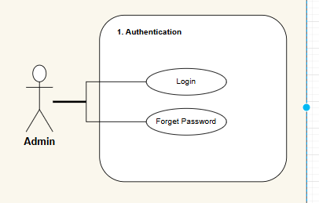**

*Figure 3.2.1 Use-Case Diagram For Admin Authentication*

***3.2.2 Use-Case Diagram For Admin Manage Users***

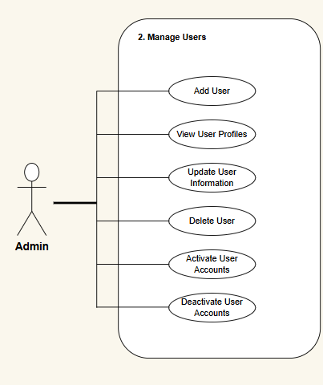

*Use-Case Diagram For Admin Manage Users*

***3.2.3 Use-Case Diagram For Admin Manage Job Postings***

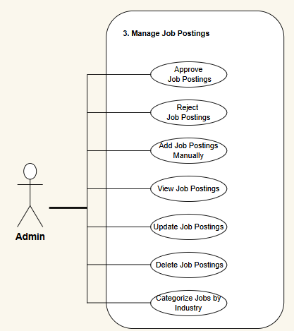

*Use-Case Diagram For Admin Manage Job Postings*

***3.2.5 Use-Case Diagram For Admin For Reports and Analytics***

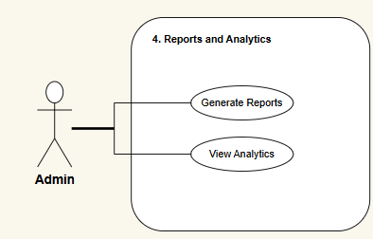

*Use-Case Diagram For Admin For Reports and Analytics*

***3.2.6 Use-Case Diagram For Admin For File Sharing***

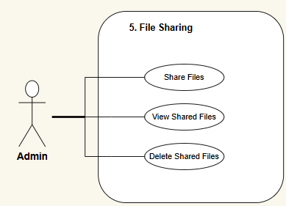

*Use-Case Diagram For Admin For File Sharing*

***3.2.7 Use-Case Diagram For Admin For Notifications and Announcements***

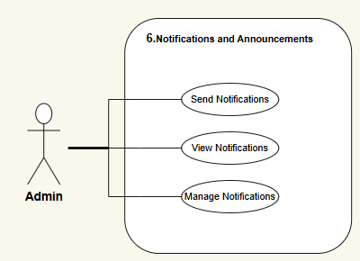

*Use-Case Diagram For Admin For Notifications and Announcement**s*

***3.2.8 Use-Case Diagram For User/Student***

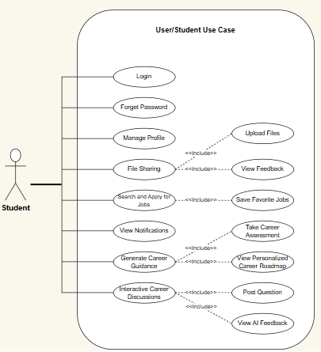

*Use-Case Diagram For User/Student*

### 3.2.9 Complete System

**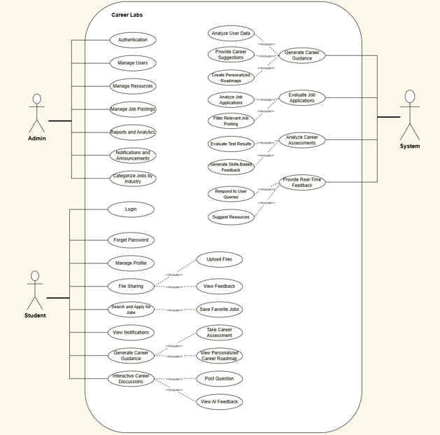**

*Figure 3.4 Use-Case Diagram for complete system*

### Class Diagram

**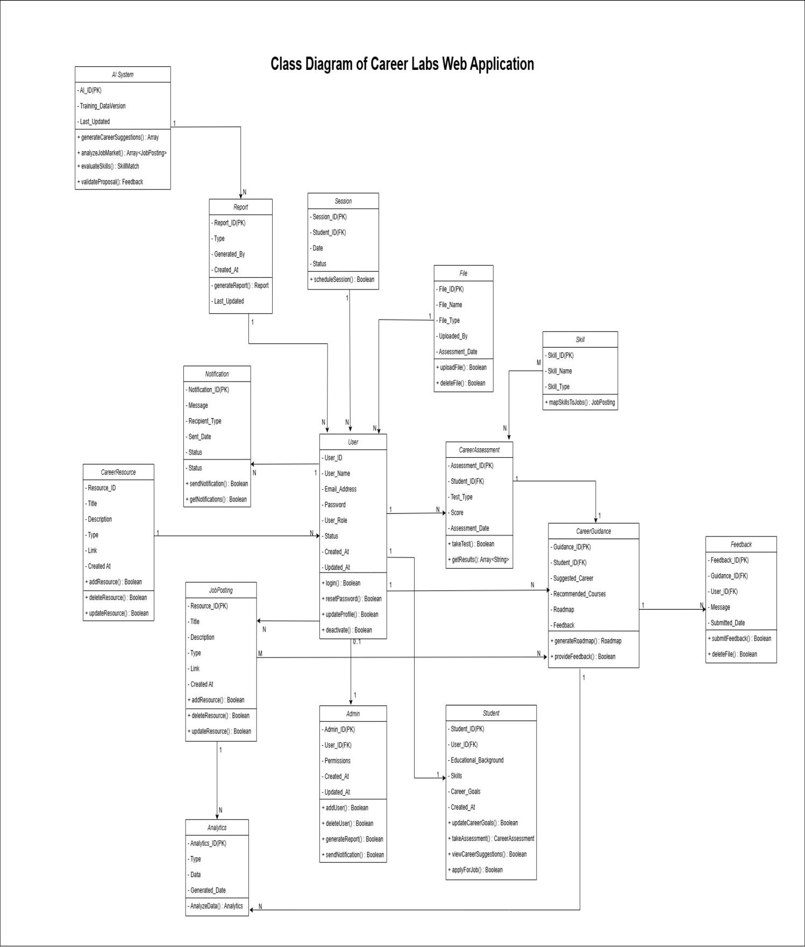**

*Figure 3.5 Class Diagram*

### 

### 3.4 Sequence Diagram

### Login for PMO, Supervisor, Groups

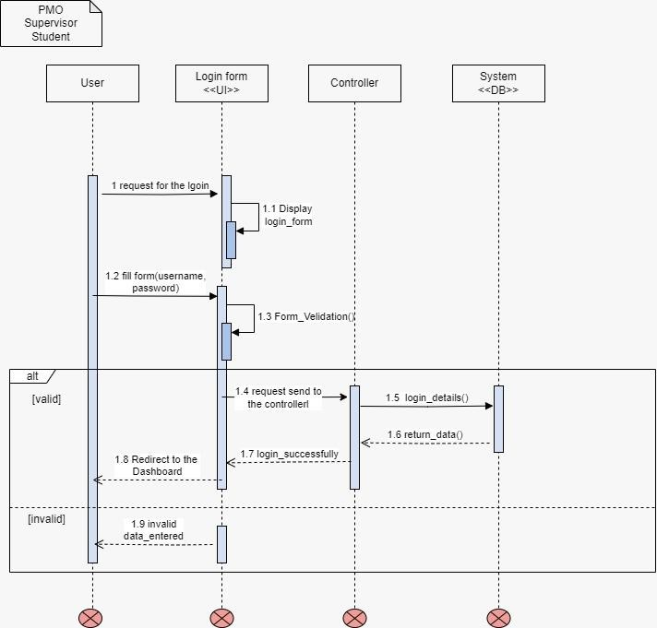

*Figure 3.6 Login for PMO, Supervisor, Students*

### Add group logins

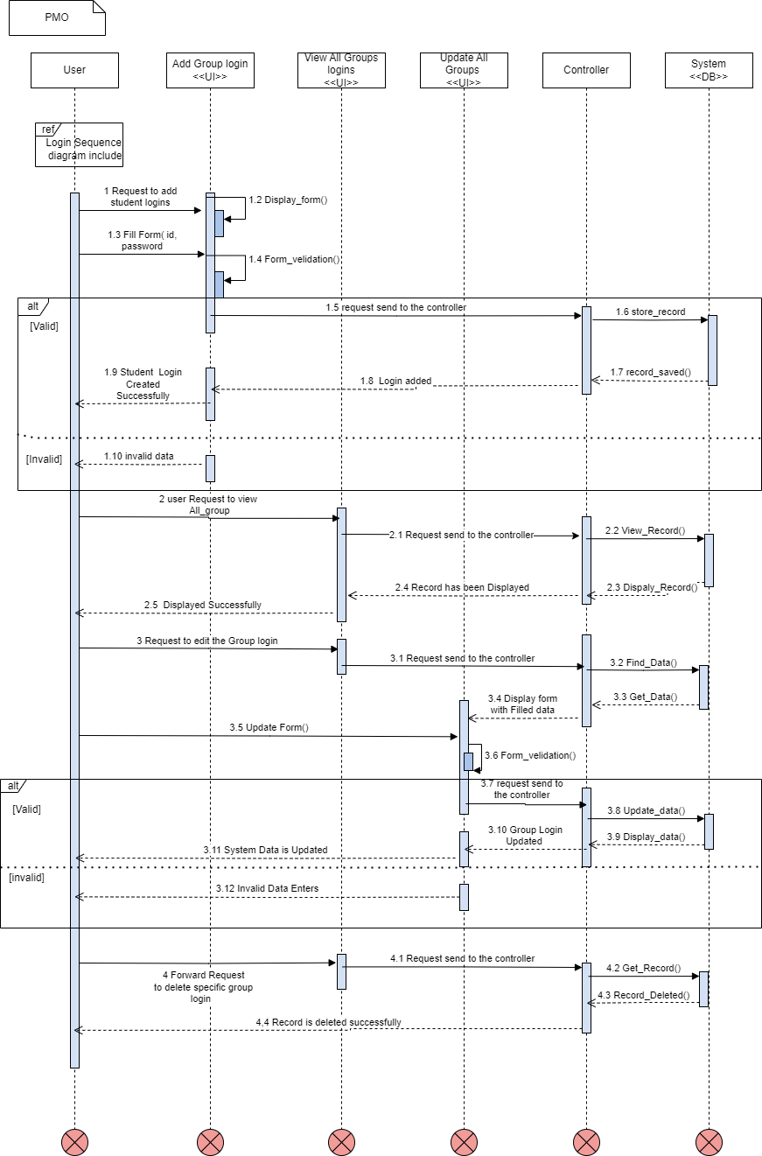

*Figure 3.7 Add groups logins*

### All group details

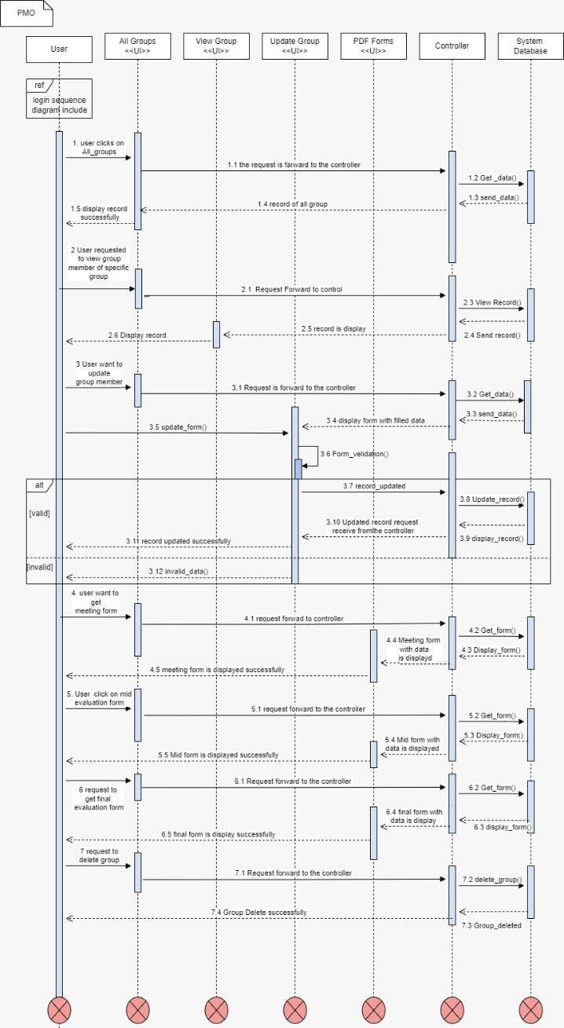

*Figure 3.8 All groups details*

### Add PMO

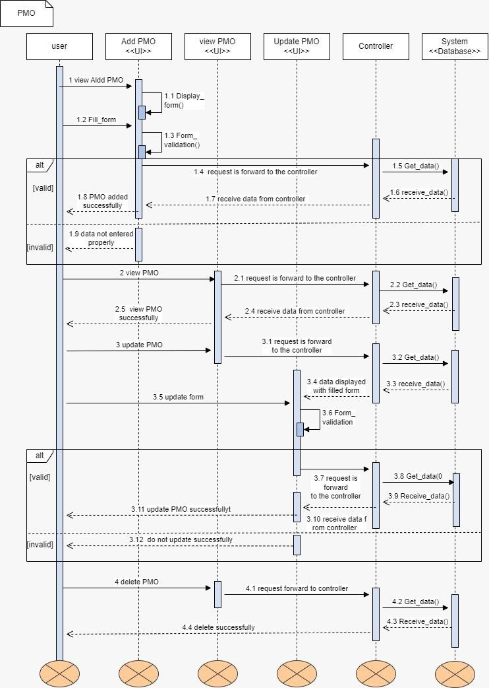

*Figure 3.9 Add PMO*

### Add Student

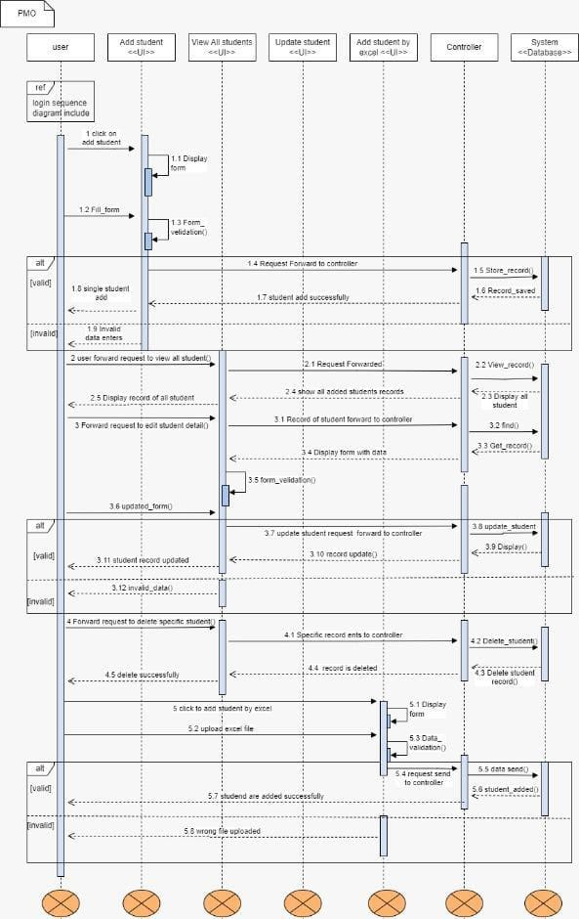

*Figure 3.10 Add Student*

### Add supervisor

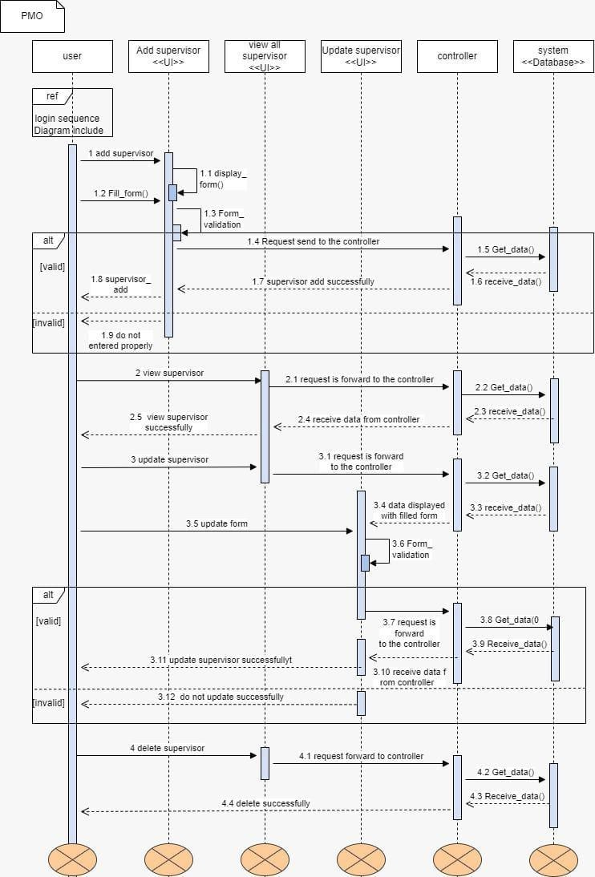

*Figure 3.11 Add Supervisor*

### PMO Session

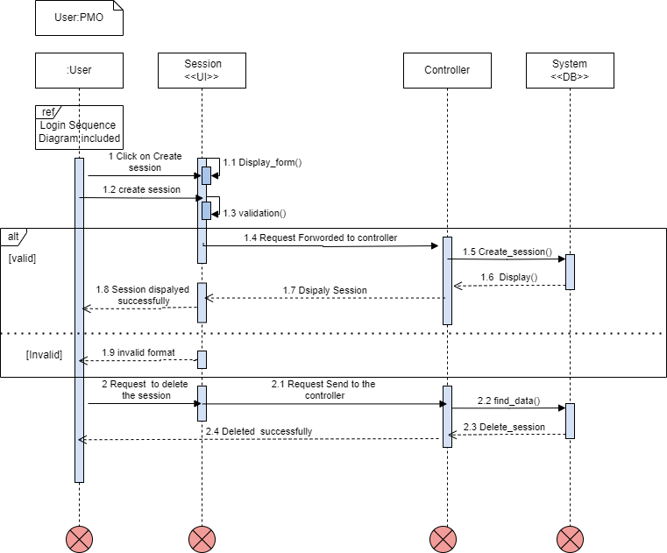

*Figure 3.12 PMO Session*

### Share file

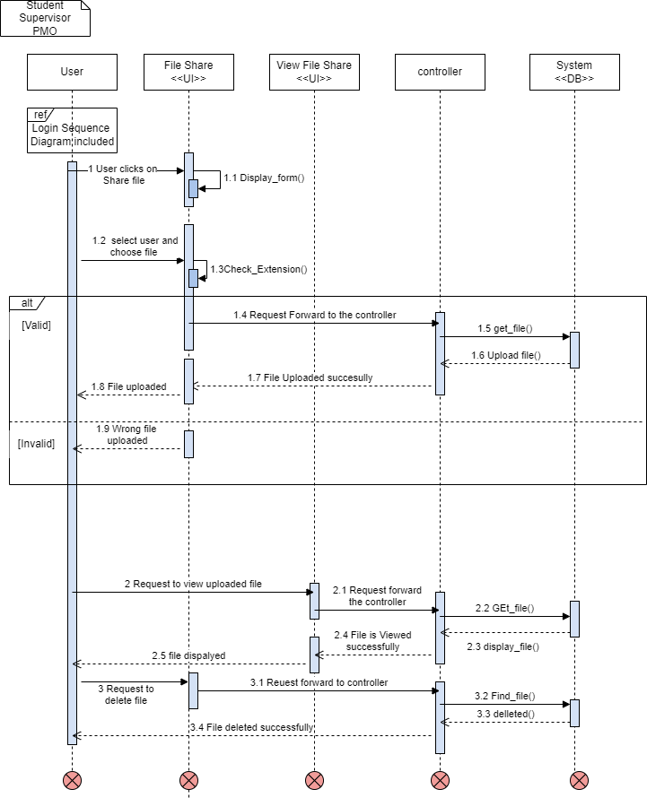

*Figure 3.13 Share File*

### Preliminary Proposal form

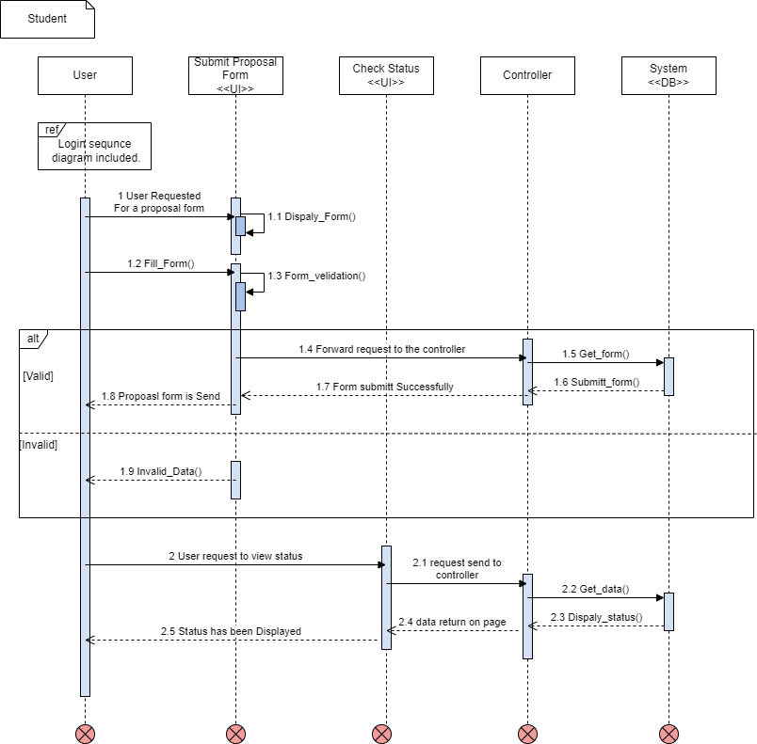

*Figure 3.14 Preliminary proposal form*

### Check status

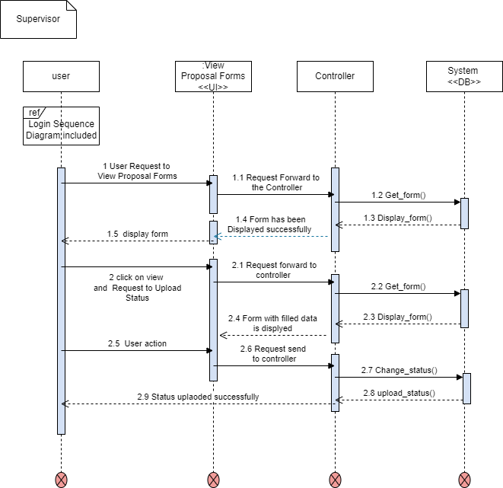

*Figure 3.15 Check status*

### Select Group Member

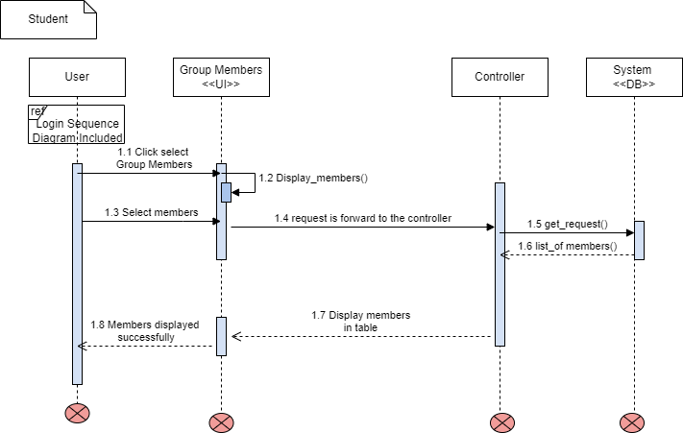

*Figure 3.16 Select Group Members*

### Meting Time table

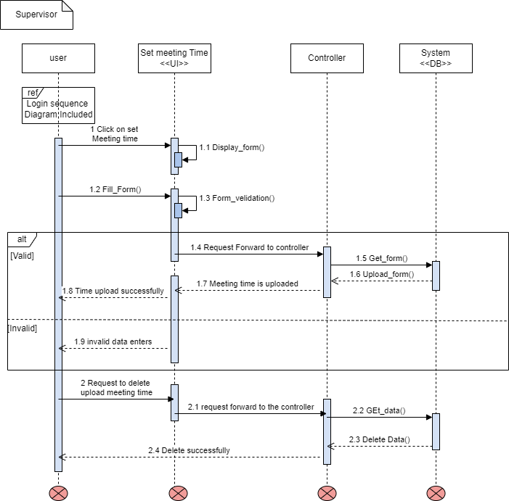

*Figure 3.17 Meeting Time Table*

### View Meeting Timetable

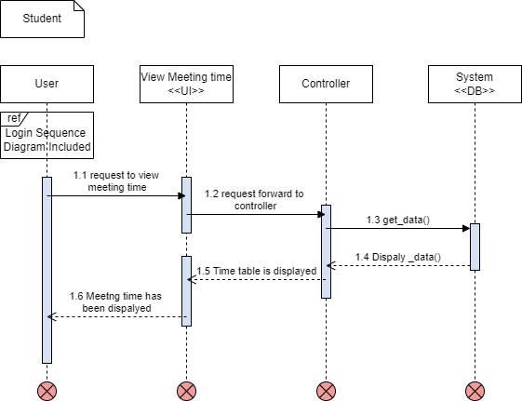

*Figure 3.18 View Meeting Timetable*

### Send Message in Chat Box



*Figure 3.19 Send Message in Chat Box*

### View chat

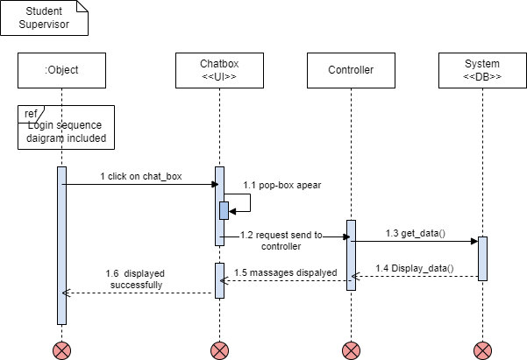

*Figure 3.20 View Chat*

### Upload Marks

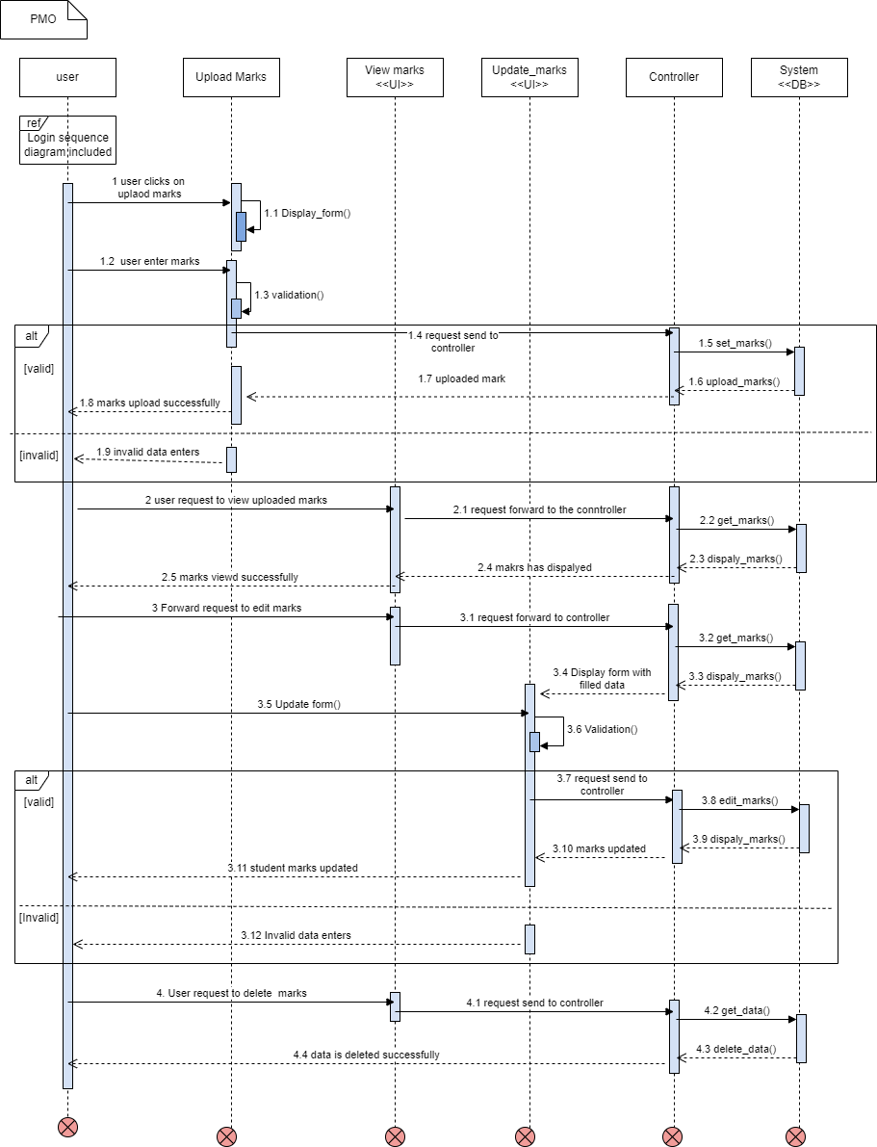

*Figure 3.21 Upload Marks*

### View marks

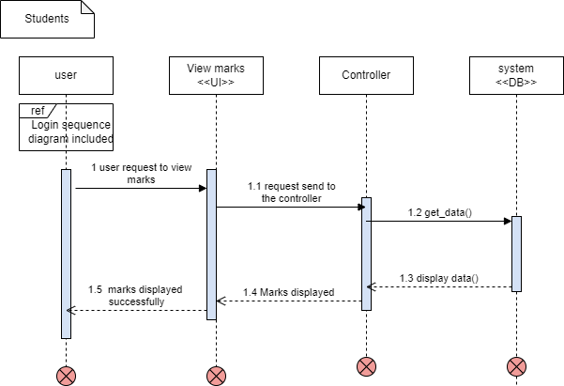

*Figure 3.22 View Marks*

### ERD

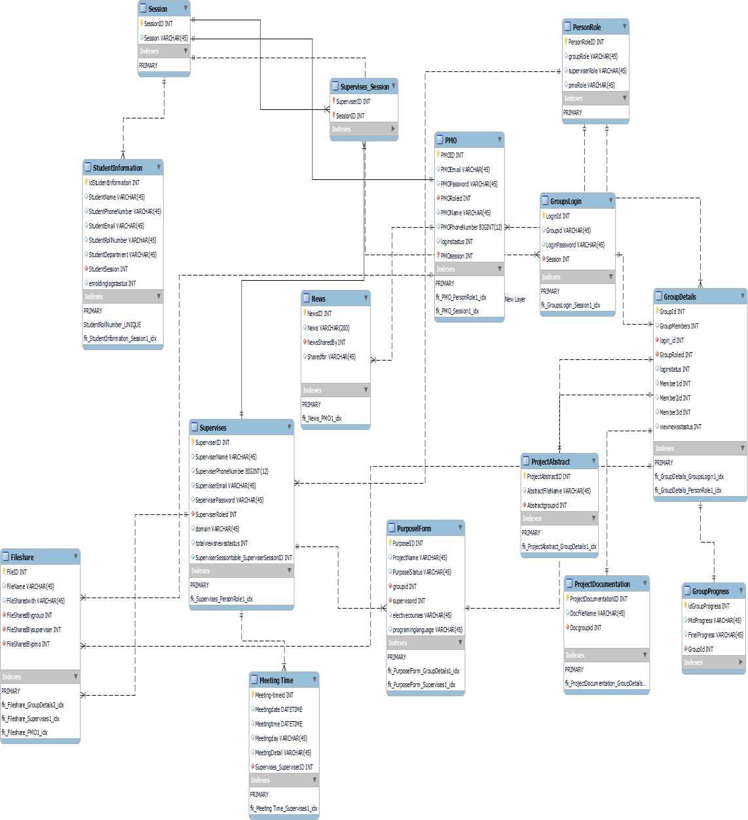

*Figure 3.23 ERD of PM*

# Chapter 4 Testing

## Chapter 4 Testing

This chapter explains all the possible test cases of our web application Career Labs. We have conducted test cases based on functional requirements that cover the complete functionality of the system. All test cases were successfully executed.

### Signup Test Case for User, Mentor, and Admin

*Table 4.1 Signup Test Case*

|  |  |
| --- | --- |
| **Signup Test Case for User,Mentor and Admin** | |
| Test Engineer | Hassan Mehmood |
| Test Case ID | TC-1 |
| Date | January 01,2025 |
| Purpose | Register new User, Mentor, or Admin. |
| Pre-Req | Email must not already be registered |
| Test Data | Name, Email, Password, Confirm Password, Role |
| Steps | **Case 1:**   * Admin User/Mentor/Admin fills valid info in the sign-up form * Selects role from dropdown * Clicks signup button * System validates data and creates account * Redirects to login page with success message   **Case 2:**   * Fields are empty / mismatched passwords / existing email * System shows:   “All fields are required”  “Passwords do not match”  “Email is already registered” |
| **Status** | Pass |

### ****4.2 Login – Admin, User, and Mentor****

*Table 4.2 LoginTest Case*

|  |  |
| --- | --- |
| **Login Test Case for User,Mentor and Admin** | |
| Test Engineer | Hassan Mehmood |
| Test Case ID | TC-2 |
| Date | January 01,2025 |
| Purpose | Login into the system for all roles. |
| Pre-Req | Must already have an account as Admin, User, or Mentor |
| Test Data | Email & Password |
| Steps | **Case 1:**   * User enters valid email and password. * Clicks login button. * System redirects to **User Dashboard.**   **Case 2:**   * Mentor enters valid email and password. * Clicks login button. * System redirects to **Mentor Dashboard.**   **Case 3:**   * Admin enters valid email and password. * Clicks login button. * System redirects to **Admin Dashboard**.   **Case 4:**   * Any role enters invalid email or password. * Clicks login button. * System shows messages: – “Please enter valid information” – “Email is not registered” – “Password is incorrect” |
| **Status** | Pass |

### 4.3 Role-Based Redirection After Login

*Table 4.3: Role-Based Redirection Test Case*

|  |  |
| --- | --- |
| **Role-Based Login Redirection Test Case** | |
| Test Engineer | Hassan Mehmood |
| Test Case ID | TC-3 |
| Date | January 02,2025 |
| Purpose | Ensure all roles are redirected correctly after login |
| Pre-Req | Must have valid credentials and assigned role |
| Test Data | Email, Password and Role. |
| Steps | **Case 1:**   * User logs in with valid credentials * System redirects to **User Dashboard.**   **Case 2:**   * Mentor logs in with valid credentials. * System redirects to **Mentor Dashboard.**   **Case 3:**   * Admin logs in with valid credentials. * System redirects to **Admin Dashboard.**   **Case 4:**   * If role is unassigned or manipulated System shows: – “Unauthorized role” – “Access denied” |
| **Status** | Pass |

**ADMIN FUNCTIONALITY TEST CASES**

**4.4 Add Student/User Test Case**

*Table 4.4: Add Student Test Case*

|  |  |
| --- | --- |
| **Add Student Test Case** | |
| Test Engineer | Yasir Rafiq |
| Test Case ID | TC-4 |
| Date | January 021,2025 |
| Purpose | To verify that Admin can add a student to the system with valid data. |
| Pre-Req | Admin is logged in, and the "Add Student" form is accessible. |
| Test Data | Name, Email, Password. |
| Steps | **Case 1:**   * Admin opens "Add Student/User" form. * Enters valid data and clicks "Add". * System stores student info and displays success message.   **Case 2:**   * Admin leaves a field empty or uses duplicate email. * System shows appropriate validation messages. * Admin is prompted to fill the required fields.   **Case 2:**   * Admin tries to add a student with invalid data (e.g., wrong email format). * System shows validation error messages: "Invalid email format." |
| **Status** | Pass |

**4.5 View Student Profiles Test Case**

*Table 4.5: View Student/User Profiles Test Case*

|  |  |
| --- | --- |
| **View Student/User Test Case** | |
| Test Engineer | Yasir Rafiq |
| Test Case ID | TC-5 |
| Date | April 20,2025 |
| Purpose | To verify that Admin can view the profiles of students in the system. |
| Pre-Req | Admin is logged in, and students exist in the system. |
| Test Data | UserId or Name. |
| Steps | **Case 1:**   * Admin navigates to the "Student Profiles" section. * System displays all students with relevant details.   **Case 2:**   * Admin searches for a specific student by name or email. * System filters and displays the relevant student profile.   **Case 3:**   * Admin tries to view a student profile that doesn't exist. * System displays an error message: "Student not found." |
| **Status** | Pass |

### ****4.6 Update Student/User Information Test Case****

### *Table 4.6: Update Student/User Information Test Case*

|  |  |
| --- | --- |
| **Update Student/User Test Case** | |
| Test Engineer | Yasir Rafiq |
| Test Case ID | TC-6 |
| Date | April 20,2025 |
| Purpose | To verify that Admin can update student information in the system. |
| Pre-Req | Admin is logged in, and student profiles are available. |
| Test Data | User-id or Name and Updated information. |
| Steps | **Case 1:**   * Admin navigates to the "Student Profiles" section. * Admin opens the "Edit Student" form and updates the student's data. * Admin clicks "Save". * System updates the student profile successfully and displays a success message.   **Case 2:**   * Admin enters invalid data (e.g., non-numeric values in a numeric field). * System shows an error: "Invalid data entered."   **Case 3:**   * Admin leaves required fields empty (e.g., email). * System displays validation error: "This field is required."   **Case 4:**   * Admin tries to update a student profile that does not exist. * System displays: "Student not found." |
| **Status** | Pass |

### ****4.7 Delete Student/User Profile Test Case****

### *Table 4.7: Delete Student/User Information Test Case*

|  |  |
| --- | --- |
| **Delete Student/User Test Case** | |
| Test Engineer | Yasir Rafiq |
| Test Case ID | TC-7 |
| Date | April 20,2025 |
| Purpose | To verify that Admin can delete a student profile from the system. |
| Pre-Req | Admin is logged in, and student profiles are available. |
| Test Data | User-id |
| Steps | **Case 1:**   * Admin selects a student and clicks "Delete". * System confirms deletion and removes the student profile from the database.   **Case 2:**   * Admin tries to delete a student that does not exist * .System shows: "Student not found."   **Case 3:**   * Admin clicks "Delete" but then cancels the action. * System keeps the student profile intact.   **Case 4:**   * Admin selects multiple students for deletion. * System deletes all selected profiles and updates the list accordingly. |
| **Status** | Pass |

**4.8 Add Mentor/Advisor Test Case**

*Table 4.8: Add* *Mentor/Advisor Test Case*

|  |  |
| --- | --- |
| **Add Mentor/AdvisorTest Case** | |
| Test Engineer | Yasir Rafiq |
| Test Case ID | TC-8 |
| Date | April 20,2025 |
| Purpose | To verify that Admin can add a mentor/advisor to the system with valid data. |
| Pre-Req | Admin is logged in, and the "Add Mentor" form is accessible. |
| Test Data | Name, Email, Password. |
| Steps | **Case 1:**   * Admin opens "Add Mentor" form. * Enters valid data and clicks "Add". * System sores Mentors info and displays success message.   **Case 2:**   * Admin leaves a field empty or uses duplicate email. * System shows appropriate validation messages. * Admin is prompted to fill the required fields.   **Case 2:**   * Admin tries to add a mentor with invalid data (e.g., wrong email format). * System shows validation error messages: "Invalid email format." |
| **Status** | Pass |

**4.9 View Mentor Profiles Test Case**

*Table 4.9: View Mentor Profiles Test Case*

|  |  |
| --- | --- |
| **View Mentor Test Case** | |
| Test Engineer | Yasir Rafiq |
| Test Case ID | TC-9 |
| Date | April 20,2025 |
| Purpose | To verify that Admin can view the profiles of mentors/advisors in the system. |
| Pre-Req | Admin is logged in, and mentors exist in the system. |
| Test Data | Mentor-id or Mentor Name. |
| Steps | **Case 1:**   * Admin searches for a mentor by ID or name. * System displays the mentor’s full profile (name, email, skills, etc.).   **Case 2:**   * Admin selects multiple mentors for viewing * System displays the profile details for all selected mentors.   **Case 3:**   * Admin views a mentor profile with missing information (e.g., no phone number) * System shows "Data not available" in the missing fields.   **Case 4:**   * Admin views a profile of a mentor marked as inactive. * System displays: "This mentor is inactive." |
| **Status** | Pass |

**4.10 Update Mentor Profiles Test Case**

### *Table 4.10: Update Mentors/Advisors Information Test Case*

|  |  |
| --- | --- |
| **Update Mentors/Advisors Test Case** | |
| Test Engineer | Yasir Rafiq |
| Test Case ID | TC-10 |
| Date | April 20,2025 |
| Purpose | To verify that Admin can update mentor/advisor information in the system. |
| Pre-Req | Admin is logged in, and mentor profiles exist. |
| Test Data | Mentorr-id, Updated Details (e.g., phone number, skills). |
| Steps | **Case 1:**   * Admin edits a mentor’s profile and updates the necessary fields (e.g., phone number). * Admin clicks "Save". * System updates the mentor’s information and confirms the changes   **Case 2:**   * Admin enters invalid data (e.g., non-numeric phone number). * System shows an error: "Invalid data entered." * Admin is prompted to fix the error.   **Case 3:**   * Admin leaves any required fields empty (e.g., skills or department). * System displays an error: "This field is required.   **Case 4:**   * Admin tries to update a mentor profile that is no longer in the system. * System shows: "Mentor profile not found." |
| **Status** | Pass |

### ****4.11 Delete Mentor Profile Test Case****

### *Table 4.11: Delete Mentor Information Test Case*

|  |  |
| --- | --- |
| **Delete Student/User Test Case** | |
| Test Engineer | Yasir Rafiq |
| Test Case ID | TC-11 |
| Date | April 20,2025 |
| Purpose | To verify that Admin can delete a mentor/advisor profile from the system. |
| Pre-Req | Admin is logged in, and mentor profiles are available. |
| Test Data | Mentor ID |
| Steps | **Case 1:**   * Admin selects a mentor and clicks "Delete". * System confirms deletion and removes the mentor profile from the database.   **Case 2:**   * Admin tries to delete a mentor that does not exist * .System shows: "Mentor not found."   **Case 3:**   * Admin clicks "Delete" but then cancels the action. * System keeps the mentor profile intact.   **Case 4:**   * Admin selects multiple mentors for deletion. * System deletes all selected profiles and updates the list accordingly. |
| **Status** | Pass |

### ****4.12 Add Career Resources Test Case****

### *Table 4.12: Add Career Resources Test Case*

|  |  |
| --- | --- |
| **Add Career Resources Test Case** | |
| Test Engineer | Yasir Rafiq |
| Test Case ID | TC-12 |
| Date | April 20,2025 |
| Purpose | To verify that Admin can add a career resource (e.g., a job guide or resource link) to the system. |
| Pre-Req | Admin is logged in, and the "Add Resource" form is accessible. |
| Test Data | Resource Title, Description, URL or File Attachment |
| Steps | **Case 1:**   * Admin enters valid details (title, description, URL/file). * Admin clicks "Add Resource". * System adds the resource successfully and confirms.   **Case 2:**   * Admin leaves one or more fields empty. * System shows validation error: "This field is required." * Admin is prompted to fill in all fields.   **Case 3:**   * Admin enters an invalid URL (e.g., no "http://"). * System shows: "Invalid URL format." * Admin is asked to correct the URL.   **Case 4:**   * Admin tries to add a resource with a title already used. * System shows: "Resource title already exists. * Admin is asked to choose a different title. |
| **Status** | Pass |

### ****4.13 View Career Resources Test Case****

### *Table 4.13: View Career Resources Test Case*

|  |  |
| --- | --- |
| **View Career Resources Test Case** | |
| Test Engineer | Yasir Rafiq |
| Test Case ID | TC-13 |
| Date | April 20,2025 |
| Purpose | To verify that Admin can view the available career resources in the system. |
| Pre-Req | Admin is logged in, and resources are available in the system. |
| Test Data | Resource ID, Resource Name |
| Steps | **Case 1:**   * Admin selects a resource by ID or title. * System displays the resource details (e.g., description, URL).   **Case 2:**   * Admin views the list of all available career resources. * System displays resources with titles, descriptions, and links.   **Case 3:**   * Admin clicks on a resource link. * System opens the resource (URL or attachment).   **Case 4:**   * Admin tries to view resources when no resources have been added. * System shows: "No resources available." |
| **Status** | Pass |

### ****4.14 Update Career Resources Details Test Case****

### *Table 4.14: Update Career Resources Details Test Case*

|  |  |
| --- | --- |
| **Update Career Resources Details Test Case** | |
| Test Engineer | Yasir Rafiq |
| Test Case ID | TC-14 |
| Date | April 20,2025 |
| Purpose | To verify that Admin can update the details of a career resource (e.g., title, description, URL). |
| Pre-Req | Admin is logged in, and a career resource exists in the system. |
| Test Data | Resource ID, Updated Title, Updated Description, Updated URL |
| Steps | **Case 1:**   * Admin selects an existing resource and clicks "Edit". * Admin updates the resource details (title, description, URL). * Admin clicks "Save". * System updates the resource and shows a success message.   **Case 2:**   * Admin enters invalid data (e.g., malformed URL). * System shows an error: "Invalid URL format". * Admin is prompted to correct the data.   **Case 3:**   * Admin leaves one or more required fields empty. * System shows validation errors. * Admin is asked to fill in the missing information.   **Case 4:**   * Admin tries to update the resource with a title already used. * System shows an error: "Title already exists." * Admin is prompted to choose a different title. |
| **Status** | Pass |

### ****4.15 Generate Reports Test Case****

### *Table 4.15: Generate Reports Test Case*

|  |  |
| --- | --- |
| **Generate Reports Test Case** | |
| Test Engineer | Yasir Rafiq |
| Test Case ID | TC-15 |
| Date | April 20,2025 |
| Purpose | To verify that Admin can generate reports from the system (e.g., student reports, mentor reports). |
| Pre-Req | Admin is logged in, and data (students, mentors) is available in the system. |
| Test Data | Report Type (e.g., Student Report, Mentor Report), Date Range |
| Steps | **Case 1:**   * Admin selects a report type (e.g., student report). * Admin selects a date range and clicks "Generate Report". * System generates the report and displays it.   **Case 2:**   * Admin tries to generate a report without any available data for the selected parameters. * System displays: "No data available for the selected criteria."   **Case 3:**   * Admin selects multiple categories (e.g., both student and mentor reports). * System generates a combined report and displays it.   **Case 4:**   * Admin selects an invalid date range (e.g., start date after end date). * System shows an error: "Invalid date range." * Admin is prompted to adjust the dates. |
| **Status** | Pass |

### ****4.16 View Analytics Test Case****

### *Table 4.16: View Analytics Test Case*

|  |  |
| --- | --- |
| **View Analytics Test Case** | |
| Test Engineer | Yasir Rafiq |
| Test Case ID | TC-16 |
| Date | April 20,2025 |
| Purpose | To verify that Admin can view analytics of the system (e.g., student engagement, resource usage). |
| Pre-Req | Admin is logged in, and analytics data is available in the system. |
| Test Data | Analytics Type (e.g., Student Engagement, Resource Usage), Time Period |
| Steps | **Case 1:**   * Admin selects an analytics type (e.g., student engagement). * Admin selects a time period (e.g., last 30 days). * System displays the relevant analytics for that time period.   **Case 2:**   * Admin tries to view analytics for a period with no data. * System displays: "No data available for the selected time period."   **Case 3:**   * Admin selects real-time analytics. * System displays live data (e.g., current active students, current active resources).   **Case 4:**   * Admin selects multiple analytics categories (e.g., student engagement and resource usage). * System displays combined analytics data for both categories. |
| **Status** | Pass |

### ****4.17 Share Files with Users/Mentors Test Case****

### *Table 4.17: Share Files with Users/Mentors Test Case*

|  |  |
| --- | --- |
| **Share Files with Users/Mentors Test Case** | |
| Test Engineer | Yasir Rafiq |
| Test Case ID | TC-17 |
| Date | April 20,2025 |
| Purpose | To verify that Admin can share files with users or mentors. |
| Pre-Req | Admin is logged in, and files are available for sharing. |
| Test Data | File(s), Recipient (e.g., student or mentor) |
| Steps | **Case 1:**   * Admin selects a file to share. * Admin selects a recipient (student/mentor). * Admin clicks "Share". * System confirms that the file has been shared successfully.   **Case 2:**   * Admin selects multiple recipients. * Admin clicks "Share". * System confirms that the file has been shared with all selected recipients.   **Case 3:**   * Admin tries to share a file with a non-existent user/mentor. * System shows: "Recipient not found." * Admin is prompted to choose a valid recipient.   **Case 4:**   * Admin tries to share a file without selecting a recipient. * System displays an error: "Please select a recipient." |
| **Status** | Pass |

### ****4.18 View Shared Files Test Case****

### *Table 4.18: View Shared Files Test Case*

|  |  |
| --- | --- |
| **View Shared Files Test Case** | |
| Test Engineer | Yasir Rafiq |
| Test Case ID | TC-18 |
| Date | April 20,2025 |
| Purpose | To verify that Admin can view files that have been shared with users/mentors. |
| Pre-Req | Admin is logged in, and files have been shared. |
| Test Data | File(s) Name, Recipient Name |
| Steps | **Case 1:**   * Admin selects a user/mentor. * System displays the files shared with that user/mentor.   **Case 2:**   * Admin selects "View All Shared Files". * System displays a list of all files shared with users and mentors.   **Case 3:**   * Admin views a file with missing information (e.g., no description). * System shows "Data not available" for the missing field.   **Case 4:**   * Admin views shared files for a user or mentor who has been deleted. * System shows: "User/Mentor no longer exists." |
| **Status** | Pass |

### ****4.19 Delete Shared Files Test Case****

### *Table 4.19: Delete Shared Files Test Case*

|  |  |
| --- | --- |
| **Delete Shared Files Test Case** | |
| Test Engineer | Yasir Rafiq |
| Test Case ID | TC-19 |
| Date | April 20,2025 |
| Purpose | To verify that Admin can delete shared files from the system. |
| Pre-Req | Admin is logged in, and files have been shared. |
| Test Data | File(s) Name, User/Mentor |
| Steps | **Case 1:**   * Admin selects a shared file and clicks "Delete". * System confirms the deletion and removes the file.   **Case 2:**   * Admin tries to delete a file that is no longer in the system. * System shows: "File not found."   **Case 3:**   * Admin selects a file but cancels the deletion. * System keeps the file in the database.   **Case 4:**   * Admin selects multiple shared files for deletion. * System deletes all selected files successfully. |
| **Status** | Pass |

### ****4.20 Send Notifications/Announcements Test Case****

### *Table 4.20: Send Notifications/Announcements Test Case*

|  |  |
| --- | --- |
| **Send Notifications/Announcements Test Case** | |
| Test Engineer | Yasir Rafiq |
| Test Case ID | TC-20 |
| Date | April 20,2025 |
| Purpose | To verify that Admin can send notifications or announcements to users/mentors. |
| Pre-Req | Admin is logged in. |
| Test Data | Notification Title, Message Content, Recipients (e.g., All Users, Specific Group) |
| Steps | **Case 1:**   * Admin writes a notification and selects "All Users" as recipients. * Admin clicks "Send". * System sends the notification to all users and shows a success message.   **Case 2:**   * Admin writes a notification and selects a specific group (e.g., mentors). * Admin clicks "Send". * System sends the notification to the selected group.   **Case 3:**   * Admin attempts to send a notification with no message content. * System shows: "Please enter a message."   **Case 4:**   * Admin enters an invalid title or message. * System shows: "Invalid notification format." |
| **Status** | Pass |

**USER FUNCTIONALITY TEST CASES**

### 4.21 Create/Update Profile Test Case

### *Table 4.21: Create/Update Profile Test Case*

|  |  |
| --- | --- |
| **Create/Update Profile Test Case** | |
| Test Engineer | Usman Ali |
| Test Case ID | TC-21 |
| Date | May 05,2025 |
| Purpose | To verify that a user can create and update their profile details accurately. |
| Pre-Req | User must be logged into the system. |
| Test Data | Full Name, Email, Phone, Skills, Education, Experience, Resume |
| Steps | **Case 1:**   * User navigates to the profile section from the dashboard. * Enters valid data for all fields and uploads resume. * Clicks on "Save Changes" button. * The system saves the information and shows a confirmation message.   **Case 2:**   * User updates the profile and submits incomplete or invalid data. * System identifies errors (e.g., missing phone number or invalid email). * Displays appropriate validation messages. * User must correct the information before submission.   **Case 3:**   * User attempts to upload a file in an unsupported format as resume. * System detects invalid format (e.g., .exe or large size file). * Displays an error: "Unsupported file type." * Resume upload is blocked until a valid file is uploaded. |
| **Status** | Pass |

### 4.22 Career Assessment Test Submission Test Case

### *Table 4.22: Career Assessment Test Submission Test Case*

|  |  |
| --- | --- |
| **Career Assessment Test Submission Test Case** | |
| Test Engineer | Usman Ali |
| Test Case ID | TC-22 |
| Date | May 05,2025 |
| Purpose | To verify the user can submit a career assessment test and the results are stored accurately. |
| Pre-Req | User is logged in and test is available. |
| Test Data | Test ID, Questions, Selected Options |
| Steps | **Case 1:**   * User starts the career assessment test. * Selects answers for all questions. * Clicks on "Submit Test". * System stores responses and shows confirmation.   **Case 2:**   * User submits the test with some unanswered questions. * System highlights incomplete answers. * Prompts user to complete all questions. * Prevents submission until complete.   **Case 3:**   * User tries to submit after session timeout. * System invalidates submission. * User is redirected to test start page. * Prompt appears: "Session expired. Please restart the test."   **Case 4:**   * User selects invalid input values using inspect element. * System validates inputs on back end. * Rejects invalid values. * Shows error: "Invalid selection detected." |
| **Status** | Pass |

### 4.23 View Career Suggestions Test Case

### *Table 4.23: View Career Suggestions Test Case*

|  |  |
| --- | --- |
| View Career Suggestions Test Case | |
| Test Engineer | Usman Ali |
| Test Case ID | TC-23 |
| Date | May 05,2025 |
| Purpose | To verify that users can view career recommendations after test submission. |
| Pre-Req | Career test is completed and evaluated. |
| Test Data | AI-generated career fields |
| Steps | **Case 1:**   * User visits "Career Suggestions" section. * System fetches data based on test results. * Career fields like IT, Medicine, Business are displayed. * User can click to view more about each career.   **Case 2:**   * User clicks on a recommended career (e.g., Software Engineer). * System shows job scope, future demand, study paths. * Related universities and skill requirements are listed. * Links to apply or learn more are included.   **Case 3:**   * User receives message: "Your suggestions are being generated" if processing is still ongoing. * Page auto-refreshes or user is notified via email once ready. * Smooth user experience ensured.   **Case 4:**   * User feedback option available for suggested fields. * User selects "Not interested in this career". * System learns preferences for future recommendations. * Feedback saved to profile. |
| **Status** | Pass |

### 4.24 Search Jobs Using Filters Test Case

### *Table 4.24: Search Jobs Using Filters Test Case*

|  |  |
| --- | --- |
| Search Jobs Using Filters Test Case | |
| Test Engineer | Usman Ali |
| Test Case ID | TC-24 |
| Date | May 05,2025 |
| Purpose | To ensure users can filter and search job listings based on multiple criteria. |
| Pre-Req | User is logged in. Job listings available. |
| Test Data | Filter fields - Location, Job Title, Type, Experience |
| Steps | **Case 1:**   * User enters keyword "Frontend Developer". * Sets location to "Lahore" and experience "0-2 years". * Clicks "Search". * System shows matching jobs.   **Case 2:**   * User applies "Remote only" and "Part-time" filters. * System fetches updated results dynamically. * Matching remote jobs shown. * Pagination maintained.   **Case 3:**   * User tries searching with invalid keyword (e.g., "/////"). * System shows: "No results found". * Suggestions to broaden search are given. * Previous results cleared.   **Case 4:**   * User clears all filters using "Reset" button. * System refreshes to show all active job listings. * Search box also cleared. * UX is smooth and intuitive.. |
| **Status** | Pass |

### 4.25 Save Job Postings Test Case

### *4.25: Save Job Postings Test Case*

|  |  |
| --- | --- |
| Save Job Postings Test Case | |
| Test Engineer | Usman Ali |
| Test Case ID | TC-25 |
| Date | May 05,2025 |
| Purpose | To confirm that users can save job postings for later review. |
| Pre-Req | User is logged in. Job listings are displayed. |
| Test Data | Job IDs |
| Steps | **Case 1:**   * User clicks "Save" icon on a job card. * System marks job as saved. * Toast message: "Job saved successfully." * Job added to "Saved Jobs" list.   **Case 2:**   * User tries saving the same job twice. * System prevents duplication. * Message: "Job already saved." * Only one entry shown.   **Case 3:**   * User navigates to saved jobs list. * System displays all saved jobs with title, company, and expiry. * User can click to apply or delete. * Data persists across sessions.   **Case 4:**   * Saved job is no longer available (deleted by employer). * System flags it as "Expired/Unavailable". * User receives a notification. * Option to remove from list is available. |
| **Status** | Pass |

### 4.26 Apply for Job Test Case

### *4.26: Apply for Jobs Test Case*

|  |  |
| --- | --- |
| Apply for Job Test Case | |
| Test Engineer | Usman Ali |
| Test Case ID | TC-26 |
| Date | May 05,2025 |
| Purpose | To verify that users can apply for jobs successfully. |
| Pre-Req | User is logged in. Resume uploaded. Job listings available. |
| Test Data | Job ID, Resume |
| Steps | **Case 1:**   * User opens job detail page. * Clicks “Apply Now”. * System submits application with attached resume. * Success message: “Application submitted successfully.”   **Case 2:**   * User clicks “Apply” without uploading a resume. * System prompts: “Please upload your resume before applying.” * Submission blocked. * Redirects to upload section.   **Case 3:**   * User applies for same job again. * System prevents duplicate application. * Message: “You have already applied to this job.” * Application count not incremented.   **Case 4:**   * User applies to multiple jobs in a session. * System tracks and confirms each application. * All jobs show “Applied” tag. * Application history updated. |
| **Status** | Pass |

### 4.27 Upload Resume/Files Test Case

### *4.27: Upload Resume/Files Test Case*

|  |  |
| --- | --- |
| Upload Resume/Files Test Case | |
| Test Engineer | Usman Ali |
| Test Case ID | TC-27 |
| Date | May 05,2025 |
| Purpose | To verify that users can upload resumes or relevant documents. |
| Pre-Req | User is logged in. Upload section enabled. |
| Test Data | PDF, DOCX files |
| Steps | **Case 1:**   * User clicks “Upload Resume”. * Selects PDF file under 5MB. * File is uploaded. * System confirms: “Resume uploaded successfully.”   **Case 2:**   * User tries uploading an unsupported format (e.g., .exe). * System rejects file. * Message: “Invalid file type. Only PDF or DOCX allowed.” * Upload not processed.   **Case 3:**   * User uploads large file (10MB+). * System blocks upload. * Message: “File exceeds max size limit (5MB).” * Upload aborted.   **Case 4:**   * User uploads a new resume, replacing the old one. * System asks for confirmation. * File is replaced successfully. * Old file removed from server. |
| **Status** | Pass |

### 4.28 View Shared Files Test Case

### *4.28: View Shared Files Test Case*

|  |  |
| --- | --- |
| View Shared Files Test Case | |
| Test Engineer | Usman Ali |
| Test Case ID | TC-28 |
| Date | May 05,2025 |
| Purpose | To ensure users can view files they’ve uploaded/shared. |
| Pre-Req | User has uploaded files. |
| Test Data | File metadata |
| Steps | **Case 1:**   * User opens “My Files” section. * Uploaded files are listed with name, date, type. * User can click to download or preview. * Interface is user-friendly.   **Case 2:**   * No files uploaded. * System shows: “You haven’t uploaded any files yet.” * Button to “Upload Now” shown. * Empty state is handled gracefully.   **Case 3:**   * File list includes upload date and file size * User can sort by date or name. * Files are listed correctly. * UX consistency verified.   **Case 4:**   * User previews file (PDF). * System opens in modal or new tab. * PDF viewer loads correctly. * Navigation back to dashboard works.   **Case 5:**   * User tries to open a corrupted file. * System handles error. * Message: “File can’t be opened. It may be corrupted.” |
| **Status** | Pass |

### 4.29 Delete Shared Files Test Case

### *4.29: Delete Shared Files Test Case*

|  |  |
| --- | --- |
| Delete Shared Files Test Case | |
| Test Engineer | Usman Ali |
| Test Case ID | TC-28 |
| Date | May 05,2025 |
| Purpose | To verify that users can delete uploaded files. |
| Pre-Req | User is logged in and has uploaded files. |
| Test Data | File ID |
| Steps | **Case 1:**   * User clicks “Delete” on a file. * System asks for confirmation. * File is removed from storage. * Sccess message displayed.   **Case 2:**   * User cancels delete confirmation. * File remains in list. * No changes made. * Cancel action functions correctly.   **Case 3:**   * User deletes all files in “My Files”. * List becomes empty. * Empty state message shown. * System updates immediately.   **Case 4:**   * User deletes from mobile browser. * Deletion successful. * File list refreshes without full reload. * Mobile UX validated..   **Case 5:**   * User tries to delete non-existing file via direct link. * System responds: “File not found.” * No action performed. * Secure back end validation. |
| **Status** | Pass |

### 4.30 Receive Notifications Test Case

### *4.30: Receive Notifications Test Case*

|  |  |
| --- | --- |
| Receive Notifications Test Case | |
| Test Engineer | Usman Ali |
| Test Case ID | TC-28 |
| Date | May 05,2025 |
| Purpose | To ensure users receive system notifications. |
| Pre-Req | User is logged in. |
| Test Data | Notification payloads |
| Steps | **Case 1:**   * User logs in. * System shows unread notifications badge (e.g., "3"). * Dropdown displays titles. * Click to view each in detail.   **Case 2:**   * System pushes notification for new job posting. * User receives toast: “New job posted: Web Developer.” * Notification stored in notification center.   **Case 3:**  User marks notifications as “Read”.   * Badge disappears. * Read status saved in DB. * System behaves as expected.   **Case 4:**   * User receives file shared notification. * Message: “Your mentor shared a file with you.” * File link included. * Notification opens file viewer. |
| **Status** | Pass |

### 4.31 Open Chat Support Test Case

### *4.31: Open Chat Support Test Case*

|  |  |
| --- | --- |
| Open Chat Support Test Case | |
| Test Engineer | Usman Ali |
| Test Case ID | TC-28 |
| Date | May 05,2025 |
| Purpose | To confirm that users can open chat support panel. |
| Pre-Req | Chat service is active. |
| Test Data | UI element |
| Steps | **Case 1:**   * User clicks “Chat with Support” button. * Chat panel opens. * Welcome message shown. * Input box ready for message.   **Case 2:**   * Chat box opens in mobile view. * Responsive layout adapts. * Chat is usable on small screens. * No overflow issues.   **Case 3:**   * Chat icon shows notification dot on new message. * User clicks and views unread message. * Dot disappears. * Real-time update working.   **Case 4:**   * User closes and reopens chat. * Previous conversation retained. * Messages not lost. * Local/session storage handled.   **Case 5:**   * System is offline. * User tries to open chat. * Message: “Support is currently unavailable.” * Option to leave message shown. |
| **Status** | Pass |

### 4.32 Send Message to Mentor/Admin Test Case

### *4.32: Send Message to Mentor/Admin Test Case*

|  |  |
| --- | --- |
| Send Message to Mentor/Admin Test Case | |
| Test Engineer | Usman Ali |
| Test Case ID | TC-28 |
| Date | May 05,2025 |
| Purpose | To verify users can send messages to mentors/admins via chat. |
| Pre-Req | Mentor/Admin assigned and chat active. |
| Test Data | Text messages |
| Steps | **Case 1:**   * User selects “Chat with Mentor”. * Types message: “I need guidance for career path.” * Clicks send. * Message appears in chat with timestamp.   **Case 2:**   * User sends message with emoji/special characters. * Message accepted and formatted correctly. * No encoding issues. * Clean chat display.   **Case 3:**   * Mentor replies. * System shows real-time response. * User notified by sound or badge. * 2-way chat verified.   **Case 4:**   * User sends very long message (500+ chars). * Message sent in full. * Text wraps correctly. * Scrollable chat window. |
| **Status** | Pass |

**MENTOR FUNCTIONALITY TEST CASES**

### 4.33 Verify Mentor Dashboard Access Test Case

### *4.33: Verify Mentor Dashboard Access Test Case*

|  |  |
| --- | --- |
| Verify Mentor Dashboard Access Test Case | |
| Test Engineer | Usman Ali |
| Test Case ID | TC-33 |
| Date | April 2, 2025 |
| Purpose | To ensure that only mentors can access the mentor dashboard. |
| Pre-Req | Mentor is logged in. |
| Test Data | Mentor credentials |
| Steps | **Case 1:**   * Mentor logs in with valid credentials. * System redirects the mentor to the mentor dashboard. * Dashboard loads all available features for the mentor role (e.g., counseling sessions, feedback, user proposals).   **Case 2:**   * Non-mentor user logs in with valid credentials. * System redirects the non-mentor user to the user dashboard. * Non-mentor is unable to access the mentor dashboard.   **Case 3:**   * User attempts to access the mentor dashboard by entering the URL directly. * System redirects the user to the login page or user dashboard with a message: "Access Denied."   **Case 4:**   * Mentor logs in after being assigned a new user but no sessions or proposals are available. * System loads the dashboard but displays a message: "No data available yet." |
| **Status** | Pass |

### 4.34 Mentor Profile Update Test Case

### *4.34: Mentor Profile Update Test Case*

|  |  |
| --- | --- |
| Mentor Profile Update Test Case | |
| Test Engineer | Usman Ali |
| Test Case ID | TC-34 |
| Date | April 2, 2025 |
| Purpose | To verify that mentors can update their profile information. |
| Pre-Req | Mentor is logged in. |
| Test Data | Mentor profile data |
| Steps | **Case 1:**   * Mentor navigates to their profile. * Mentor updates their profile details (e.g., name, contact information, biography). * Mentor clicks the "Save" button. * System confirms: "Profile updated successfully."   **Case 2:**   * Mentor attempts to update profile with invalid data (e.g., invalid phone number or email format). * System displays an error message: "Please enter valid information." * Profile is not updated.   **Case 3:**   * Mentor attempts to leave required fields empty (e.g., name or email). * System displays a warning message: "This field is required." * Mentor cannot save the profile until all required fields are filled. |
| **Status** | Pass |

### 4.35 Add New Counseling Session Time Slot Test Case

### *4.35: Add New Counseling Session Time Slot Test Case*

|  |  |
| --- | --- |
| Add New Counseling Session Time Slot Test Case | |
| Test Engineer | Usman Ali |
| Test Case ID | TC-35 |
| Date | April 2, 2025 |
| Purpose | To verify mentor can add new counseling session. |
| Pre-Req | Mentor is logged in and on the session scheduling page. |
| Test Data | Date, Time, Session Title |
| Steps | **Case 1:**   * Mentor navigates to scheduling section. * Selects date, time, description. * Clicks save. * Session added.   **Case 2:**   * Mentor enters an invalid date (e.g., past date). * System displays an error message: "Date must be in the future." * Session is not added.   **Case 3:**   * Mentor leaves the "Title" field empty. * Clicks "Save". * System displays a validation message: "Title cannot be empty." * Session is not saved.   **Case 4:**   * Mentor tries to schedule a session at a time that overlaps with an existing session. * System displays a conflict error: "This time slot is already booked." * Session is not added. |
| **Status** | Pass |

### 4.36 Update Existing Counseling Session Test Case

### *4.36: Update Existing Counseling Session Test Case*

|  |  |
| --- | --- |
| Update Existing Counseling Session Test Case | |
| Test Engineer | Usman Ali |
| Test Case ID | TC-35 |
| Date | April 2, 2025 |
| Purpose | To ensure mentors can successfully update existing counseling sessions. |
| Pre-Req | Mentor is logged in, and there is at least one session scheduled. |
| Test Data | New Date, Time, Title |
| Steps | **Case 1:**   * Mentor selects an existing session. * Changes the date, time, and title. * Clicks "Save". * System updates the session and shows the new details in the session list. * A success message is displayed: "Session updated successfully."   **Case 2:**   * Mentor tries to select a past date. * System shows an error: "Date must be in the future." * Session is not updated.   **Case 3:**   * Mentor selects a valid date and time without any conflict. * The system successfully saves the updated session. * A confirmation message appears: "Session updated." |
| **Status** | Pass |

### 4.37 Delete Counseling Session Test Case

### *4.37: Delete Counseling Session Test Case*

|  |  |
| --- | --- |
| Delete Counseling Session Test Case | |
| Test Engineer | Usman Ali |
| Test Case ID | TC-37 |
| Date | April 2, 2025 |
| Purpose | To ensure mentors can successfully delete counseling sessions. |
| Pre-Req | Mentor is logged in, and at least one session is scheduled. |
| Test Data | Session ID |
| Steps | **Case 1:**   * Mentor selects an existing session. * Clicks on the "Delete" button. * Confirms the deletion. * The session is removed from the calendar and the session list. * A success message appears: "Session deleted successfully."   **Case 2:**   * Mentor tries to delete a session that has already been deleted or doesn't exist. * System shows an error message: "Session not found." * No changes occur.   **Case 3:**   * Mentor attempts to delete a session after the session has started. * System shows an error message: "Session cannot be deleted once it has started." * The session is not deleted."   **Case 4:**   * Mentor deletes a session scheduled for later. * The session is removed from the calendar. * A confirmation message is shown: "Session successfully deleted." |
| **Status** | Pass |

### 4.38 Prevent Session Time Conflict Test Case

### *4.38: Prevent Session Time Conflict Test Case*

|  |  |
| --- | --- |
| Prevent Session Time Conflict Test Case | |
| Test Engineer | Usman Ali |
| Test Case ID | TC-38 |
| Date | April 2, 2025 |
| Purpose | To ensure the system prevents scheduling sessions that conflict with existing sessions. |
| Pre-Req | Mentor is logged in, and at least one session is scheduled. |
| Test Data | Session Date, Session Time |
| Steps | **Case 1:**   * Mentor tries to schedule a new session that overlaps with an existing one. * System displays an error: "This time slot is already booked." * Session is not scheduled.   **Case 2:**   * Mentor schedules a new session at a time when no other session exists. * The session is added to the calendar. * Confirmation message: "Session scheduled successfully."   **Case 3:**   * Mentor attempts to select a conflicting time slot. * System displays a clear warning: "Time conflict with another session." * Mentor can adjust the session time.   **Case 4:**   * Mentor schedules sessions across different time zones. * System automatically adjusts for time zone conflicts and prevents overlapping sessions. * The session is added successfully. |
| **Status** | Pass |

### 4.39 View All Scheduled Counseling Sessions Test Case

### *4.39: View All Scheduled Counseling Sessions Test Case*

|  |  |
| --- | --- |
| View All Scheduled Counseling Sessions Test Case | |
| Test Engineer | Usman Ali |
| Test Case ID | TC-39 |
| Date | April 2, 2025 |
| Purpose | To verify that mentors can view all of their scheduled counseling sessions. |
| Pre-Req | Mentor is logged in and has at least one scheduled session. |
| Test Data | Scheduled session data |
| Steps | **Case 1:**   * Mentor navigates to the "My Sessions" page. * All scheduled sessions are displayed with session details (date, time, title). * Mentor can view past and future sessions.   **Case 2:**   * Mentor adds a new session. * Refreshes the session list. * New session appears in the list of scheduled sessions."   **Case 3:**   * Mentor filters the list to show sessions only for a specific date. * Only sessions scheduled for that date are shown. * System displays the correct session list.   **Case 4:**   * Mentor has no scheduled sessions. * System shows: "You have no upcoming sessions." * A prompt is displayed to schedule a new session.   **Case 5:**   * Mentor views the session list in a calendar format. * Sessions are correctly displayed on the corresponding dates. * Mentor can click on a date to view the sessions for that day. |
| **Status** | Pass |

### 4.40 Access Assigned User Profiles Test Case

### *4.40: Access Assigned User Profiles Test Case*

|  |  |
| --- | --- |
| Access Assigned User Profiles Test Case | |
| Test Engineer | Usman Ali |
| Test Case ID | TC-40 |
| Date | April 2, 2025 |
| Purpose | To ensure that mentors can access only the profiles of users assigned to them. |
| Pre-Req | Mentor is logged in and assigned at least one user for mentoring. |
| Test Data | Assigned user data |
| Steps | **Case 1:**   * Mentor selects a user from the "Assigned Users" list. * Mentor is able to view detailed user profile information (name, skills, interests, etc.). * Mentor can view and update the profile if permitted.   **Case 2:**   * Mentor tries to access the profile of a user who is not assigned to them. * System shows an error: "You do not have permission to view this profile." * Access is denied.   **Case 3:**   * Mentor accesses the profile of an assigned user. * All the information (education, skills, interests) is accurate and updated. * Mentor can view all relevant details for providing guidance.   **Case 4:**   * Mentor edits the user profile (e.g., adds a new skill). * Mentor saves the changes. * System successfully updates the user profile.   **Case 5:**   * Mentor tries to access the profile of a user who has been deleted. * System shows an error message: "Profile not found." * No access is granted. |
| **Status** | Pass |

### 4.41 Provide Feedback on User Profile Test Case

### *4.41: Provide Feedback on User Profile Test Case*

|  |  |
| --- | --- |
| Provide Feedback on User Profile Test Case | |
| Test Engineer | Usman Ali |
| Test Case ID | TC-41 |
| Date | April 2, 2025 |
| Purpose | To verify that mentors can successfully provide feedback on assigned user profiles. |
| Pre-Req | Mentor is logged in, and there is at least one user profile assigned to the mentor. |
| Test Data | Feedback text, rating |
| Steps | **Case 1:**   * Mentor selects a user profile. * Enters feedback in the provided text box. * Submits the feedback. * System successfully saves the feedback and displays it on the user’s profile.   **Case 2:**   * Mentor tries to submit feedback without entering any text. * System displays an error message: "Feedback cannot be empty." * Feedback is not submitted.   **Case 3:**   * Mentor enters feedback with special characters or emojis. * System successfully saves the feedback without issues. * Feedback is displayed correctly on the user’s profile.   **Case 4:**   * Mentor provides a rating (e.g., 1 to 5 stars) along with feedback. * Feedback is submitted and displayed along with the rating on the user profile. * System confirms: "Feedback submitted successfully." |
| **Status** | Pass |

### 4.42 Review and Comment on Career Road-map Test Case

### *4.42: Review and Comment on Career Road-map Test Case*

|  |  |
| --- | --- |
| Review and Comment on Career Road-map Test Case | |
| Test Engineer | Usman Ali |
| Test Case ID | TC-42 |
| Date | April 2, 2025 |
| Purpose | To verify that mentors can review and comment on career roadmaps submitted by users. |
| Pre-Req | Mentor is logged in, and the user has submitted a career roadmap. |
| Test Data | Roadmap details, Comment text |
| Steps | **Case 1:**   * Mentor selects a user’s career road-map from the list. * Reads through the road-map and provides a comment in the provided text box. * Comments are saved successfully and displayed below the road-map.   **Case 2:**   * Mentor tries to submit a comment without entering text. * System displays an error message: "Comment cannot be empty. * No comment is submitted.   **Case 3:**   * Mentor provides positive feedback on the career road-map (e.g., "Great roadmap!"). * Feedback is successfully submitted and displayed under the road-map. |
| **Status** | Pass |

### 4.43 Accept User Proposal Test Case

### *4.43: Accept User Proposal Test Case*

|  |  |
| --- | --- |
| Accept User Proposal Test Case | |
| Test Engineer | Usman Ali |
| Test Case ID | TC-43 |
| Date | April 2, 2025 |
| Purpose | To verify that mentors can accept user proposals for career guidance. |
| Pre-Req | Mentor is logged in, and the user has submitted a proposal. |
| Test Data | Proposal details |
| Steps | **Case 1:**   * Mentor views a user proposal. * Clicks the "Accept" button. * System displays a success message: "Proposal accepted." * The proposal status changes to "Accepted."   **Case 2:**   * Mentor accepts a proposal that contains incomplete or invalid information. * System shows a warning: "Proposal has invalid information. Are you sure you want to accept?" * Mentor confirms, and the proposal is accepted.   **Case 3:**   * Mentor attempts to accept a proposal that is past the submission deadline. * System shows an error message: "This proposal is no longer valid." * Proposal is not accepted.   **Case 4:**   * Mentor accepts a proposal and adds a note: "This looks great. Let's start working on it." * System successfully saves the feedback along with the acceptance. |
| **Status** | Pass |

### 4.44 Reject User Proposal Test Case

### *4.44: Reject User Proposal Test Case*

|  |  |
| --- | --- |
| Reject User Proposal Test Case | |
| Test Engineer | Usman Ali |
| Test Case ID | TC-44 |
| Date | April 2, 2025 |
| Purpose | To verify that mentors can reject user proposals for career guidance. |
| Pre-Req | Mentor is logged in, and the user has submitted a proposal. |
| Test Data | Proposal details |
| Steps | **Case 1:**   * Mentor views a user proposal. * Clicks the "Reject" button. * System displays a rejection message: "Proposal rejected." * The proposal status changes to "Rejected."   **Case 2:**   * Mentor provides a feedback message while rejecting the proposal: "This proposal needs more work." * System saves the feedback and updates the proposal status to "Rejected.”   **Case 3:**   * Mentor attempts to reject a proposal that has already been accepted. * System shows an error message: "This proposal has already been accepted." * Proposal is not rejected.   **Case 4:**   * Mentor attempts to reject a proposal past the submission deadline. * System shows an error message: "Proposal is no longer valid for rejection." * Proposal is not rejected. |
| **Status** | Pass |

### 4.45 Share Resource File with Individual User Test Case

### *4.45: Share Resource File with Individual User Test Case*

|  |  |
| --- | --- |
| Share Resource File with Individual User Test Case | |
| Test Engineer | Usman Ali |
| Test Case ID | TC-45 |
| Date | April 2, 2025 |
| Purpose | To verify that mentors can share resource files with individual users. |
| Pre-Req | Mentor is logged in, and the user is assigned to the mentor. |
| Test Data | Resource file (e.g., PDF, image, or document), user profile |
| Steps | **Case 1:**   * Mentor selects a user from the list. * Uploads the resource file to be shared. * System successfully uploads and associates the file with the selected user. * Confirmation message: "File shared successfully."   **Case 2:**   * Mentor selects multiple users to share a file. * System successfully uploads the file and associates it with each user. * Confirmation message: "File shared with multiple users successfully."   **Case 3:**   * Mentor tries to share a file but doesn’t upload any file. * System displays an error message: "Please upload a file to share." * File is not shared. |
| **Status** | Pass |

### 4.46 View Files Shared by Users Test Case

### *4.46: View Files Shared by Users Test Case*

|  |  |
| --- | --- |
| View Files Shared by Users Test Case | |
| Test Engineer | Usman Ali |
| Test Case ID | TC-46 |
| Date | April 2, 2025 |
| Purpose | To verify that mentors can view files shared by users. |
| Pre-Req | Mentor is logged in, and the user has shared at least one file. |
| Test Data | User shared file |
| Steps | **Case 1:**   * Mentor selects a user and navigates to the "Shared Files" section. * Mentor views the list of files shared by the user. * Files are displayed with names and formats (e.g., PDF, DOCX). * Mentor can open and view the files.   **Case 2:**   * Mentor selects a user who has not shared any files. * System displays a message: "No files shared by the user." * No files are shown.   **Case 3:**   * Mentor tries to view files shared by a user not assigned to them. * System shows an error message: "You are not authorized to view files for this user." * No files are displayed. |
| **Status** | Pass |

### 4.47 Delete File Shared with User Test Case

### *4.47: Delete File Shared with User Test Case*

|  |  |
| --- | --- |
| Delete File Shared with User Test Case | |
| Test Engineer | Usman Ali |
| Test Case ID | TC-47 |
| Date | April 2, 2025 |
| Purpose | To ensure that mentors can delete files they have shared with users. |
| Pre-Req | Mentor is logged in, and there is at least one file shared with a user. |
| Test Data | Shared file |
| Steps | **Case 1:**   * Mentor navigates to the "Shared Files" section for a user. * Mentor selects a file to delete. * Mentor clicks the "Delete" button. * System deletes the file and shows a confirmation message: "File deleted successfully."   **Case 2:**   * Mentor attempts to delete a file that they did not share. * System displays an error message: "You cannot delete a file that you did not share." * File is not deleted.   **Case 3:**   * Mentor selects multiple files to delete. * System processes the deletion for each file. * Confirmation message: "Selected files deleted successfully.   **Case 4:**   * User revokes access to the shared file. * Mentor tries to delete the file. * System shows an error message: "Access to file revoked. You cannot delete it." * File is not deleted. |
| **Status** | Pass |

### 4.48 Receive and View Platform Notifications Test Case

### *4.48: Receive and View Platform Notifications Test Case*

|  |  |
| --- | --- |
| Receive and View Platform Notifications Test Case | |
| Test Engineer | Usman Ali |
| Test Case ID | TC-48 |
| Date | April 2, 2025 |
| Purpose | To verify that mentors receive and can view platform notifications. |
| Pre-Req | Mentor is logged in. |
| Test Data | Notification payloads |
| Steps | **Case 1:**   * Mentor receives a platform notification about a new event or announcement. * System displays a notification in the "Notification Center." * Mentor clicks the notification to view details.   **Case 2:**   * Mentor clicks on the notification icon in the header. * A dropdown displays unread notifications. * Mentor clicks to view detailed notifications.   **Case 3:**   * Mentor clicks the "Mark as Read" button. * Unread notification count reduces. * System updates the notification status in the database.   **Case 4:**   * Mentor receives a notification about a new job posting on the platform. * Notification reads: "New job posted: Web Developer." * Mentor clicks to view more details about the job. |
| **Status** | Pass |

Chapter 5

User Manual

**Chapter 5 User Manual**

**5.1 Home Page**

This is the homepage of our website. Here all the options are available you can go anywhere

from this page

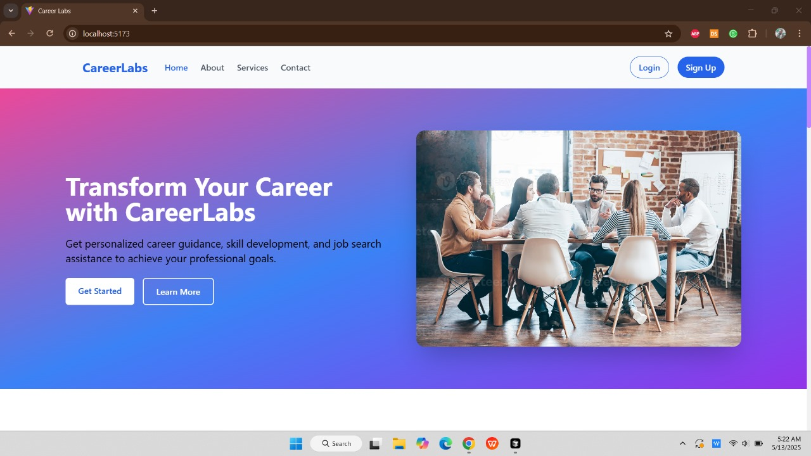

**5.2 Signup Page**

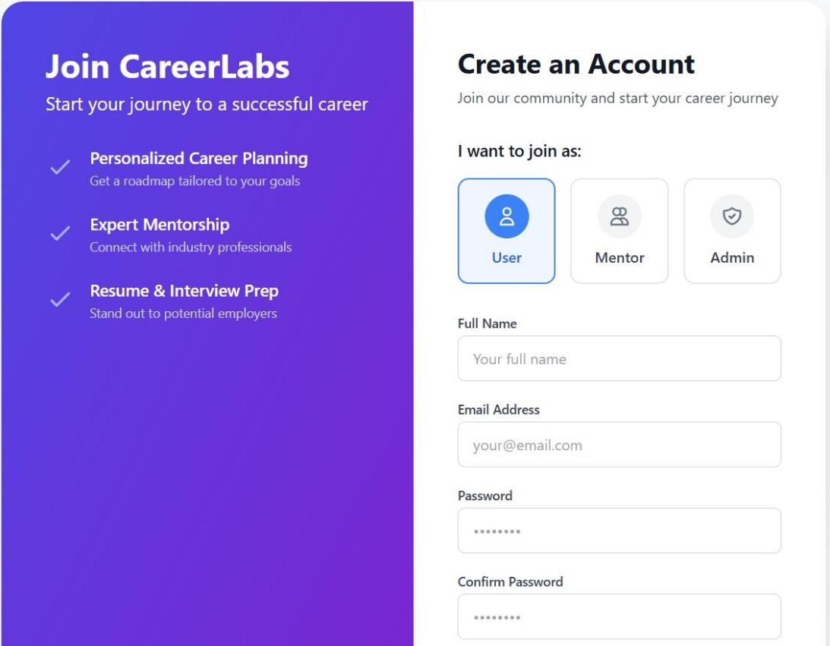

**5.3 Login Page**

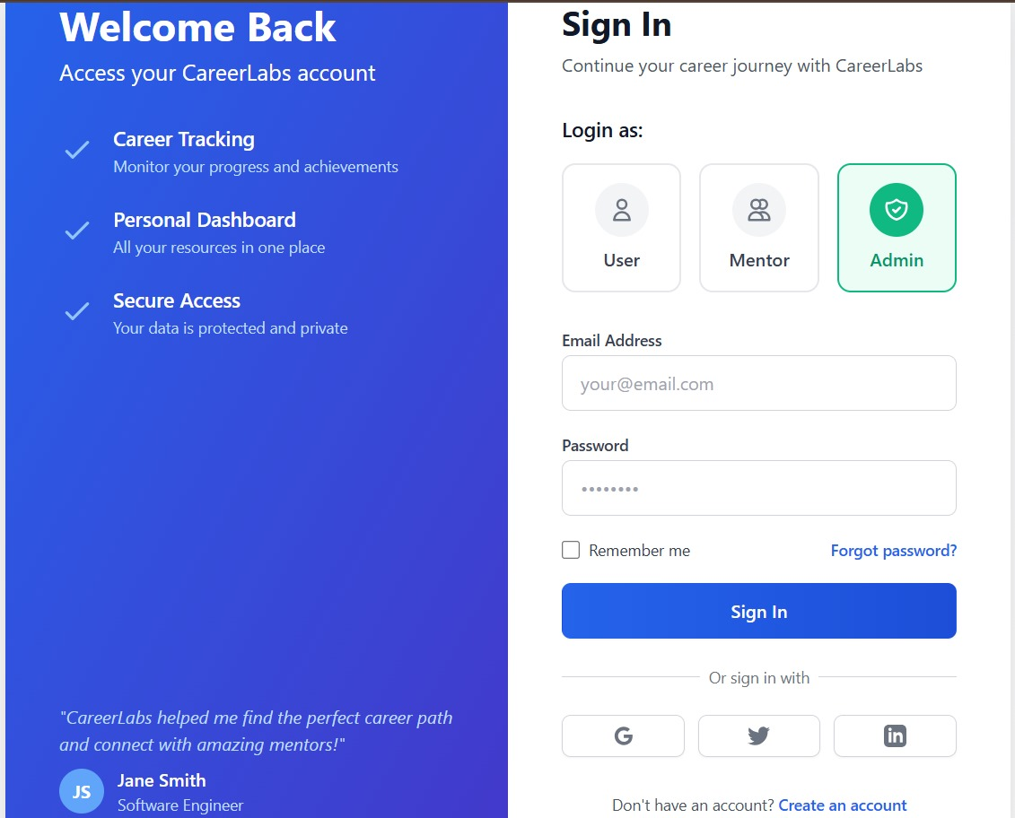

**5.3 Admin Dashboard**

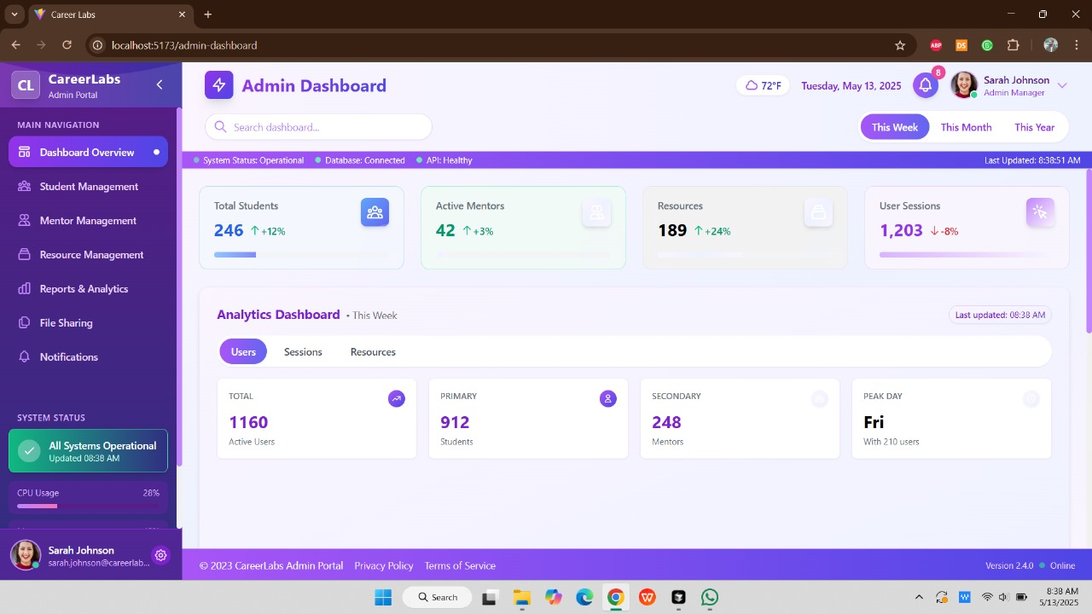

**5.4 Mentor Dashboard**

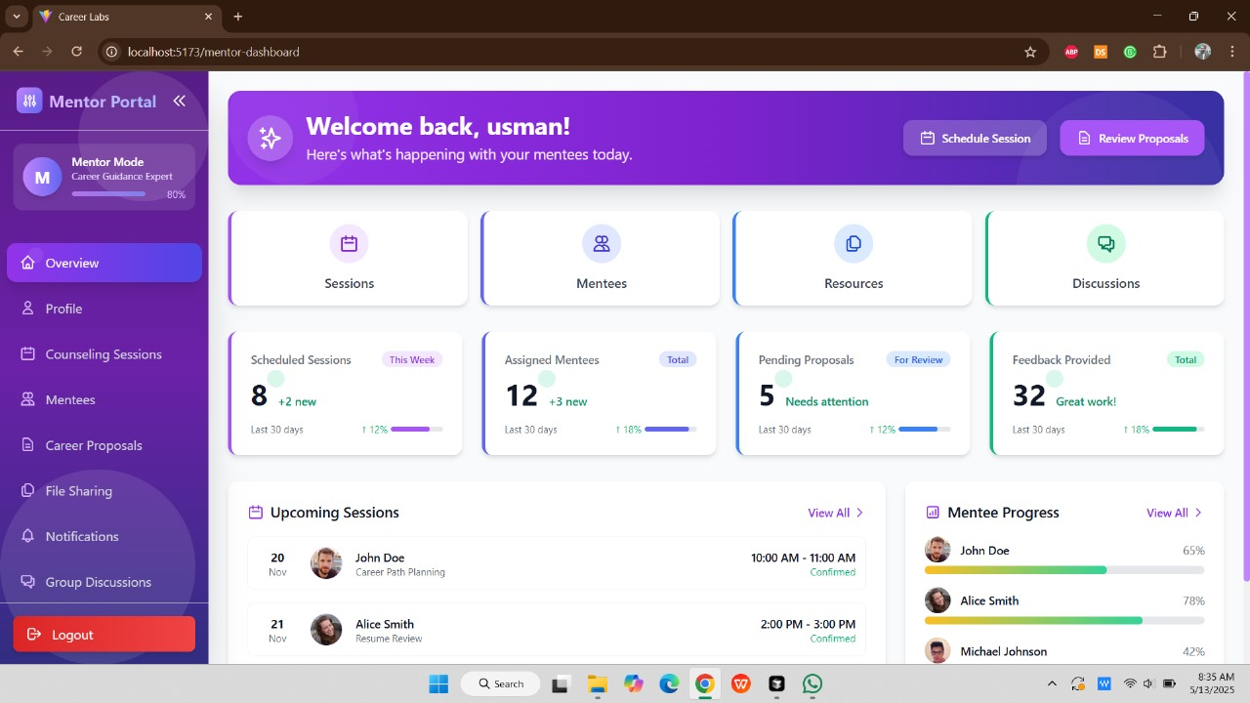

**5.5 User Dashboard**

