KR MANGALAM UNIVERSITY
SCHOOL OF ENGINEERING & TECHNOLOGY

DEVOPS LAB RECORD
PRACTICAL FILE
Subject: DevOps
Submitted To:
Dr. Saurabh Jain
Submitted By:
Om Prajapati
Roll No. 2301010337

Course: B.Tech – Computer Science & Engineering
Section: 5
University: K.R. Mangalam University
Academic Session: 2026–2027
LAB EXPERIMENTS
- Lab 2 – Containerization & Kubernetes
Department of Computer Science & Engineering
K.R. Mangalam University, Gurugram, Haryana

LAB 2 — CONTAINERIZATION & KUBERNETES ORCHESTRATION
2.1 Docker image and container lifecycle
Aim
Manage container images and containers using Docker CLI.
Requirements
Docker Engine and Ubuntu terminal.
Procedure and Commands
docker pull nginx:alpine
docker images
docker run -d --name nginx-lab -p 8081:80 nginx:alpine
docker ps
docker logs nginx-lab
curl -I http://localhost:8081
docker stop nginx-lab
docker ps -a
docker rm nginx-lab
Explanation / Notes
pull downloads an image; images lists local images; run starts a container; ps lists running containers; logs shows logs; stop halts; rm removes a stopped container.
Expected Output — Reference Only
Expected: nginx:alpine appears in images; container is Up; curl returns HTTP response; after stop it appears Exited; rm removes it.
Screenshot Evidence
Capture docker images, docker ps, docker logs, and curl output; optionally capture Nginx welcome page.
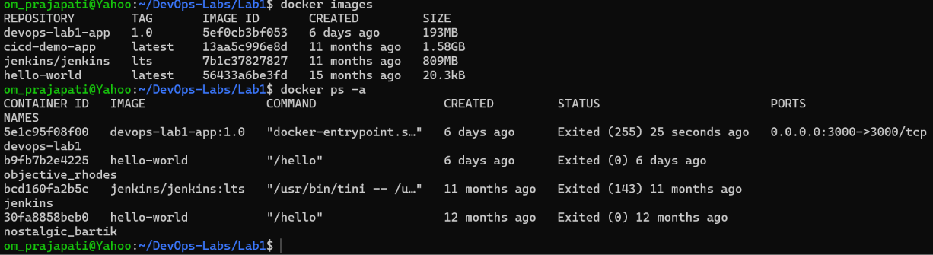Result and Conclusion
Record the actual result after execution. State the observed status, relevant version, and any errors resolved. Do not claim success without evidence.
Viva Questions
What is docker pull? Downloads an image. What is docker logs? Displays container logs. Difference between stop and rm? Stop halts; rm removes.
2.2 Docker Compose
Aim
Define and run an application using Docker Compose.
Requirements
Docker Engine and Docker Compose plugin.
Procedure and Commands
mkdir -p ~/DevOps-Labs/Lab2-compose && cd ~/DevOps-Labs/Lab2-compose
cat > compose.yaml <<'EOF'
services:
web:
image: nginx:alpine
ports:
- "8082:80"
restart: unless-stopped
EOF
docker compose version
docker compose up -d
docker compose ps
curl -I http://localhost:8082
docker compose logs
docker compose down
Explanation / Notes
Compose uses YAML to define services. up -d starts them in the background; down removes Compose-managed containers and network.
Expected Output — Reference Only
Expected: docker compose ps lists web as running; curl returns an HTTP response.
Screenshot Evidence
Capture compose.yaml, docker compose ps, and curl output.
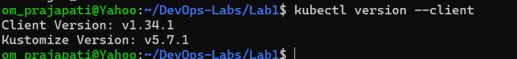Result and Conclusion
Record the actual result after execution. State the observed status, relevant version, and any errors resolved. Do not claim success without evidence.
Viva Questions
What is Docker Compose? Tool for defining/running multi-container applications. What is up -d? Starts services detached.
2.3 Minikube and Kubernetes deployment
Aim
Deploy and expose a containerized application on a local Kubernetes cluster.
Requirements
Minikube, kubectl, Docker driver, sufficient CPU/RAM.
Procedure and Commands
# Install Minikube and kubectl using their official Ubuntu instructions.
minikube version
kubectl version --client
minikube start --driver=docker
kubectl get nodes
mkdir -p ~/DevOps-Labs/Lab2 && cd ~/DevOps-Labs/Lab2
cat > deployment.yaml <<'EOF'
apiVersion: apps/v1
kind: Deployment
metadata:
name: lab-web
spec:
replicas: 2
selector:
matchLabels:
app: lab-web
template:
metadata:
labels:
app: lab-web
spec:
containers:
- name: web
image: nginx:alpine
ports:
- containerPort: 80
EOF
kubectl apply -f deployment.yaml
kubectl rollout status deployment/lab-web
kubectl get deployments
kubectl get pods -o wide
kubectl expose deployment lab-web --type=NodePort --port=80
kubectl get services
minikube service lab-web --url
Explanation / Notes
Apply creates the Deployment; rollout status waits for readiness; expose creates a Service; minikube service prints a reachable URL.
Expected Output — Reference Only
Expected: node Ready; deployment shows 2/2 available replicas; pods reach Running; Service exists. Verify the printed URL in a browser.
Screenshot Evidence
Capture minikube status, kubectl get nodes/deployments/pods/services, and the app opened via Minikube URL.
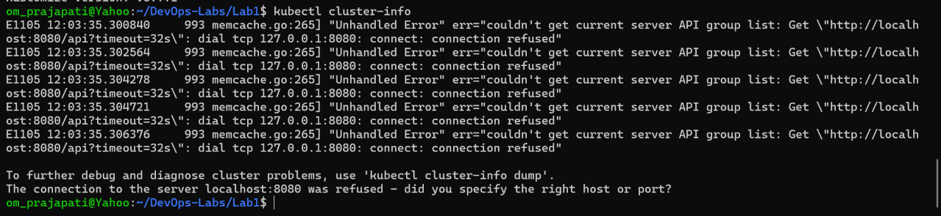Result and Conclusion
Record the actual result after execution. State the observed status, relevant version, and any errors resolved. Do not claim success without evidence.
Viva Questions
What is a Pod? Smallest deployable unit. What is a Deployment? Manages replicas and updates. What is a Service? Stable network access to pods.
2.4 Scaling, rollout, rollback and ConfigMap
Aim
Scale a deployment, update and roll back an image, and create a ConfigMap.
Requirements
Working Minikube cluster and Lab 2 deployment.
Procedure and Commands
cd ~/DevOps-Labs/Lab2
kubectl scale deployment/lab-web --replicas=3
kubectl get pods
kubectl set image deployment/lab-web web=nginx:1.27-alpine
kubectl rollout status deployment/lab-web
kubectl rollout history deployment/lab-web
kubectl rollout undo deployment/lab-web
kubectl rollout status deployment/lab-web
kubectl create configmap app-settings --from-literal=APP_MODE=lab
kubectl get configmap app-settings -o yaml
kubectl delete configmap app-settings
# Cleanup after evidence is captured:
kubectl delete service lab-web
kubectl delete deployment lab-web
Explanation / Notes
Scaling changes replica count; set image triggers a rollout; rollout undo restores a prior revision; ConfigMap stores non-secret configuration.
Expected Output — Reference Only
Expected: 3 replicas after scale; rollout completes; history lists revisions; ConfigMap contains APP_MODE=lab.
Screenshot Evidence
Capture 3-replica state, rollout history/undo, and ConfigMap YAML.
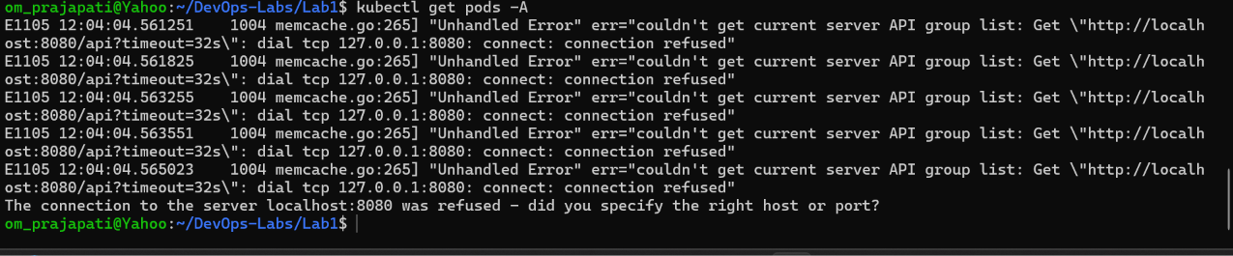
Result and Conclusion
Record the actual result after execution. State the observed status, relevant version, and any errors resolved. Do not claim success without evidence.
Viva Questions
What is scaling? Changing replicas. What is rollback? Returning to a previous revision. What is ConfigMap? Non-secret configuration data.

