KR MANGALAM UNIVERSITY
SCHOOL OF ENGINEERING & TECHNOLOGY

DEVOPS LAB RECORD
PRACTICAL FILE
Subject: DevOps
Submitted To:
Dr. Saurabh Jain
Submitted By:
Om Prajapati
Roll No. 2301010337

Course: B.Tech – Computer Science & Engineering
Section: 5
University: K.R. Mangalam University
Academic Session: 2026–2027
LAB EXPERIMENTS
- Lab 3 – Automation, Monitoring & DevSecOps

Department of Computer Science & Engineering
K.R. Mangalam University, Gurugram, Haryana

LAB 3 — MONITORING, LOGGING & DEVSECOPS
3.1 Ansible inventory and playbook
Aim
Automate a configuration task on the local Ubuntu host.
Requirements
Ubuntu, Python 3, Ansible.
Procedure and Commands
sudo apt update
sudo apt install -y python3 python3-venv
python3 -m venv ~/ansible-venv
source ~/ansible-venv/bin/activate
pip install ansible
ansible --version
mkdir -p ~/DevOps-Labs/Lab3/ansible && cd ~/DevOps-Labs/Lab3/ansible
cat > inventory.ini <<'EOF'
[local]
localhost ansible_connection=local
EOF
cat > setup.yml <<'EOF'
- name: Configure local lab host
hosts: local
become: false
tasks:
- name: Ensure lab directory exists
ansible.builtin.file:
path: /tmp/devops-ansible-lab
state: directory
mode: '0755'
- name: Write marker file
ansible.builtin.copy:
dest: /tmp/devops-ansible-lab/status.txt
content: "Configured by Ansible\n"
mode: '0644'
EOF
ansible-inventory -i inventory.ini --list
ansible-playbook -i inventory.ini setup.yml
cat /tmp/devops-ansible-lab/status.txt
Explanation / Notes
Inventory lists hosts; playbook describes tasks. This example operates locally and does not change system services.
Expected Output — Reference Only
Expected: play recap shows failed=0; marker file contains “Configured by Ansible”.
Screenshot Evidence
Capture ansible --version, inventory output, play recap, and marker file.
Result and Conclusion
Record the actual result after execution. State the observed status, relevant version, and any errors resolved. Do not claim success without evidence.
Viva Questions
What is Ansible? Automation/configuration tool. What is inventory? Managed host list. What is playbook? YAML automation instructions.
3.2 Terraform with a local resource
Aim
Learn init, validate, plan, apply, and destroy using a local file resource (no cloud resources).
Requirements
Terraform CLI and Ubuntu terminal.
Procedure and Commands
mkdir -p ~/DevOps-Labs/Lab3/terraform && cd ~/DevOps-Labs/Lab3/terraform
cat > main.tf <<'EOF'
terraform {
required_providers {
local = {
source = "hashicorp/local"
version = "~> 2.5"
}
}
}
provider "local" {}
resource "local_file" "lab_note" {
filename = "${path.module}/terraform-output.txt"
content = "Infrastructure as Code lab completed after apply.\n"
}
output "created_file" {
value = local_file.lab_note.filename
}
EOF
terraform version
terraform init
terraform fmt
terraform validate
terraform plan
terraform apply
cat terraform-output.txt
terraform destroy
Explanation / Notes
init downloads providers; fmt formats files; validate checks configuration; plan previews changes; apply creates the file; destroy removes the managed resource.
Expected Output — Reference Only
Expected: validate succeeds; plan shows one file to add; apply creates terraform-output.txt; destroy removes it. Review the plan before approving.
Screenshot Evidence
Capture init, validate, plan, apply, file content, and destroy outputs.
Result and Conclusion
Record the actual result after execution. State the observed status, relevant version, and any errors resolved. Do not claim success without evidence.
Viva Questions
What is Terraform? Infrastructure as Code tool. What does init do? Initializes providers. What is plan? Preview of changes.
3.3 Prometheus monitoring
Aim
Run Prometheus and inspect its scrape target and built-in metrics.
Requirements
Docker Engine and browser.
Procedure and Commands
mkdir -p ~/DevOps-Labs/Lab3/prometheus && cd ~/DevOps-Labs/Lab3/prometheus
cat > prometheus.yml <<'EOF'
global:
scrape_interval: 15s
scrape_configs:
- job_name: prometheus
static_configs:
- targets: ['localhost:9090']
EOF
docker run -d --name prometheus-lab -p 9090:9090 \
-v "$PWD/prometheus.yml:/etc/prometheus/prometheus.yml:ro" prom/prometheus
docker ps
docker logs prometheus-lab
# Open http://localhost:9090; Status > Targets; query: up
docker rm -f prometheus-lab
Explanation / Notes
Prometheus scrapes configured targets. This minimal example monitors Prometheus itself; it is not host-level monitoring.
Expected Output — Reference Only
Expected: UI loads at port 9090; target is listed; query up returns a value for the scrape target.
Screenshot Evidence
Capture Prometheus Targets page, query up result, and running container.
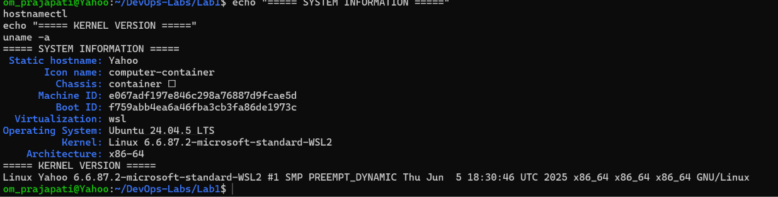
Result and Conclusion
Record the actual result after execution. State the observed status, relevant version, and any errors resolved. Do not claim success without evidence.
Viva Questions
What is Prometheus? Metrics monitoring/alerting system. What is scrape interval? Frequency of metric collection. What does up mean? Target scrape health.
3.4 Grafana dashboard
Aim
Run Grafana and connect it to Prometheus.
Requirements
Docker Engine, browser, Prometheus container/network.
Procedure and Commands
docker run -d --name grafana-lab -p 3000:3000 grafana/grafana
docker ps
# Open http://localhost:3000
# Initial login: admin / admin; change the password when prompted.
# Connections > Data sources > Add data source > Prometheus
# For container-to-container access, put both containers on the same
# user-defined Docker network and use http://prometheus-lab:9090.
docker rm -f grafana-lab
Explanation / Notes
Important: localhost inside the Grafana container refers to Grafana itself, not the Prometheus container. Use a shared Docker network and Prometheus container name. Port 3000 may already be used by the Lab 1 app; choose another host port such as 3001:3000 if needed.
Expected Output — Reference Only
Expected: Grafana UI loads; Prometheus data source connection succeeds; a dashboard panel displays a real metric.
Screenshot Evidence
Capture Grafana home page, data source connection test, and a dashboard panel with live data.
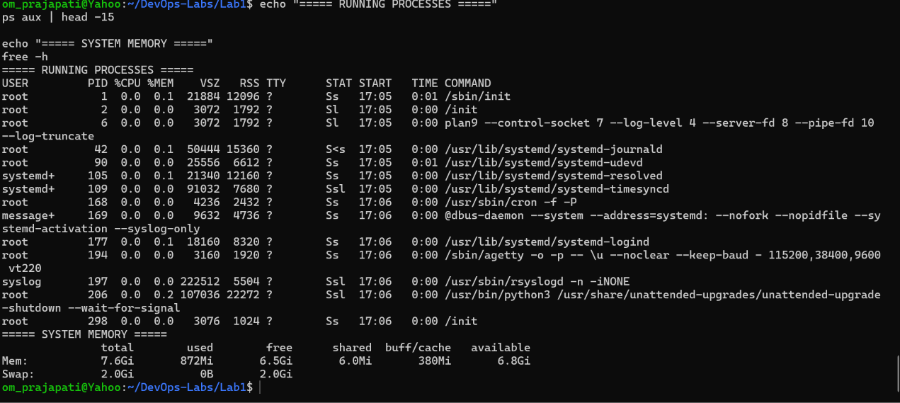
Result and Conclusion
Record the actual result after execution. State the observed status, relevant version, and any errors resolved. Do not claim success without evidence.
Viva Questions
What is Grafana? Dashboard/visualization platform. What is a data source? Backend Grafana queries.
3.5 ELK Stack and Logstash sample
Aim
Understand centralized logging with Elasticsearch, Logstash, and Kibana; validate a basic Logstash pipeline.
Requirements
ELK components; Docker Compose recommended; adequate RAM.
Procedure and Commands
mkdir -p ~/DevOps-Labs/Lab3/elk && cd ~/DevOps-Labs/Lab3/elk
cat > logstash.conf <<'EOF'
input {
stdin { }
}
filter {
mutate { add_field => { "lab" => "devops-lab3" } }
}
output {
stdout { codec => rubydebug }
}
EOF
# Run Logstash using an approved installation/container with this file mounted:
# logstash -f logstash.conf
# Enter a sample line and inspect the structured output.
# For a full ELK stack, use a version-matched official Elastic Compose setup.
Explanation / Notes
Elasticsearch stores/searches events; Logstash ingests and transforms data; Kibana explores and visualizes it. A full stack is resource-intensive and component versions must match.
Expected Output — Reference Only
Expected: Logstash starts with pipeline loaded and prints structured event output. Full ELK additionally needs Elasticsearch health and Kibana connectivity.
Screenshot Evidence
Capture Logstash pipeline startup and test event output; for full ELK capture Elasticsearch health and Kibana UI.
Result and Conclusion
Record the actual result after execution. State the observed status, relevant version, and any errors resolved. Do not claim success without evidence.
Viva Questions
What is Elasticsearch? Search/analytics engine. What is Logstash? Data processing pipeline. What is Kibana? UI for exploring Elasticsearch.
3.6 Selenium browser automation
Aim
Automate a simple browser test using Selenium WebDriver.
Requirements
Python 3, Selenium, Chrome or Firefox; graphical browser or headless setup.
Procedure and Commands
python3 -m venv ~/selenium-venv
source ~/selenium-venv/bin/activate
pip install selenium
mkdir -p ~/DevOps-Labs/Lab3/selenium && cd ~/DevOps-Labs/Lab3/selenium
cat > test_title.py <<'EOF'
from selenium import webdriver
from selenium.webdriver.common.by import By
driver = webdriver.Chrome()
try:
driver.get("https://example.com")
heading = driver.find_element(By.TAG_NAME, "h1").text
assert heading == "Example Domain", f"Unexpected heading: {heading}"
print("PASS: Example Domain heading found")
finally:
driver.quit()
EOF
python test_title.py
Explanation / Notes
Selenium Manager can locate/download a compatible driver in supported environments. A graphical browser may require a desktop session; configure headless mode for servers.
Expected Output — Reference Only
Expected: browser opens example.com, assertion passes, terminal prints PASS, and browser closes.
Screenshot Evidence
Capture terminal PASS output and browser page if using headed mode.
Result and Conclusion
Record the actual result after execution. State the observed status, relevant version, and any errors resolved. Do not claim success without evidence.
Viva Questions
What is Selenium? Browser automation framework. What is WebDriver? Interface for controlling browsers. Why use assertions? To verify expected behavior.
3.7 DevSecOps security checks
Aim
Introduce security checks into the development workflow.
Requirements
Git, Node.js project, npm; optional approved image scanner.
Procedure and Commands
cd ~/DevOps-Labs/Lab1
npm audit
git status
git diff --check
# Optional, if Trivy is installed:
trivy image devops-lab1-app:1.0
Explanation / Notes
Review dependency and image findings; do not blindly apply fixes. Scan output depends on database/tool versions. A completed scan is not a guarantee that software is secure.
Expected Output — Reference Only
Expected: npm audit reports dependency status; git diff --check reports whitespace errors if present; optional scanner lists findings.
Screenshot Evidence
Capture npm audit, git diff --check, and optional image scan output. Mask secrets/tokens.
Result and Conclusion
Record the actual result after execution. State the observed status, relevant version, and any errors resolved. Do not claim success without evidence.
Viva Questions
What is DevSecOps? Security integrated throughout DevOps. What is dependency scanning? Checking packages for known vulnerabilities. Why avoid committing secrets? Prevents credential exposure.
DevOps Practical Lab Record | Om Prajapati
Final Completion Checklist
☐ Lab 1 — Git repository created, commits recorded, and GitHub push verified.
☐ Lab 1 — Node.js application tested locally using curl or browser.
☐ Lab 1 — Docker image built and container verified running.
☐ Lab 1 — Jenkins pipeline actually executed; Console Output ends with Finished: SUCCESS.
☐ Lab 2 — Docker image/container lifecycle commands executed.
☐ Lab 2 — Docker Compose service started and tested.
☐ Lab 2 — Minikube node Ready; Deployment, Pods, and Service verified.
☐ Lab 2 — Scaling, rollout, rollback, and ConfigMap verified.
☐ Lab 3 — Ansible playbook executed with failed=0.
☐ Lab 3 — Terraform init, validate, plan, apply, and destroy executed.
☐ Lab 3 — Prometheus target verified UP.
☐ Lab 3 — Grafana connected to Prometheus and displays a real metric.
☐ Lab 3 — Logstash pipeline executed; ELK health/UI verified if deployed.
☐ Lab 3 — Selenium test passed.
☐ Lab 3 — Security/dependency scan reviewed and findings documented.
☐ All screenshots are genuine, readable, and inserted under the correct experiment.
☐ GitHub repository contains lab artifacts and no credentials or secrets.
Submission Integrity Note
This record separates expected/reference outputs from actual execution evidence. A screenshot placeholder is not evidence of completion. Execute each experiment in the authorized lab environment, insert genuine screenshots, and update the result with observed facts.

