KR MANGALAM UNIVERSITY
SCHOOL OF ENGINEERING & TECHNOLOGY

DEVOPS LAB RECORD
PRACTICAL FILE
Subject: DevOps
Submitted To:
Dr. Saurabh Jain
Submitted By:
Om Prajapati

Roll No. 2301010337

Course: B.Tech – Computer Science & Engineering
Section: 5
University: K.R. Mangalam University
Academic Session: 2026–2027
LAB EXPERIMENTS
- Lab 1 – Git, Docker & Jenkins
Department of Computer Science & Engineering
K.R. Mangalam University, Gurugram, Haryana

LAB 1 — DEVOPS FOUNDATIONS & CONTINUOUS INTEGRATION
1.1 Git and GitHub version control
Aim
Create a Git repository, track source files, maintain commit history, and publish the project to GitHub.
Requirements
Ubuntu 24.04 terminal, Git, GitHub account.
Procedure and Commands
sudo apt update
sudo apt install -y git
git --version
git config --global user.name "Om Prajapati"
git config --global user.email "YOUR_GITHUB_EMAIL"
mkdir -p ~/DevOps-Labs/Lab1 && cd ~/DevOps-Labs/Lab1
git init
git status
# After creating project files:
git add .
git commit -m "Initial DevOps Lab 1 project"
git branch -M main
git remote add origin https://github.com/YOUR_USERNAME/YOUR_REPOSITORY.git
git push -u origin main
git log --oneline
git pull origin main
Explanation / Notes
git init creates a local repository; add stages files; commit records a snapshot; remote links GitHub; push uploads commits; pull integrates remote changes. Replace placeholders. If the repository already exists, inspect git remote -v and do not add a duplicate remote.
Expected Output — Reference Only
git status should show a clean working tree after committing; git log displays commits; git remote -v displays the repository URL.
Screenshot Evidence
Capture terminal output for git status, git log, and git remote -v. Capture GitHub Code tab showing repository name and files.
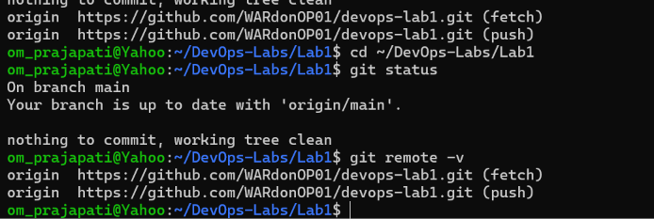Result and Conclusion
Record the actual result after execution. State the observed status, relevant version, and any errors resolved. Do not claim success without evidence.
Viva Questions
What is version control? A system that tracks changes. What is a commit? A saved snapshot. Difference between fetch and pull? Fetch downloads updates; pull also integrates them.
1.2 Create and test a Node.js application
Aim
Create a small HTTP application that returns a page for the DevOps lab.
Requirements
Ubuntu 24.04, Node.js LTS, npm, text editor.
Procedure and Commands
mkdir -p ~/DevOps-Labs/Lab1 && cd ~/DevOps-Labs/Lab1
node --version
npm --version
cat > package.json <<'EOF'
{
"name": "devops-lab1-app",
"version": "1.0.0",
"private": true,
"scripts": { "start": "node index.js", "test": "node --check index.js" }
}
EOF
cat > index.js <<'EOF'
const http = require('http');
const server = http.createServer((req, res) => {
res.writeHead(200, { 'Content-Type': 'text/html; charset=utf-8' });
res.end('<h1>DevOps Lab 1</h1><h2>CI/CD Pipeline Working Successfully!</h2><p>Student: Om Prajapati</p>');
});
server.listen(3000, '0.0.0.0', () => console.log('Application listening on port 3000'));
EOF
npm test
npm start
# In a second terminal:
curl http://localhost:3000
Explanation / Notes
npm test checks JavaScript syntax. npm start runs the server. Stop it with Ctrl+C after testing.
Expected Output — Reference Only
Expected: server prints “Application listening on port 3000”; curl returns the HTML page. This is expected output, not proof of execution.
Screenshot Evidence
Capture terminal showing npm test and npm start; capture browser at http://localhost:3000.
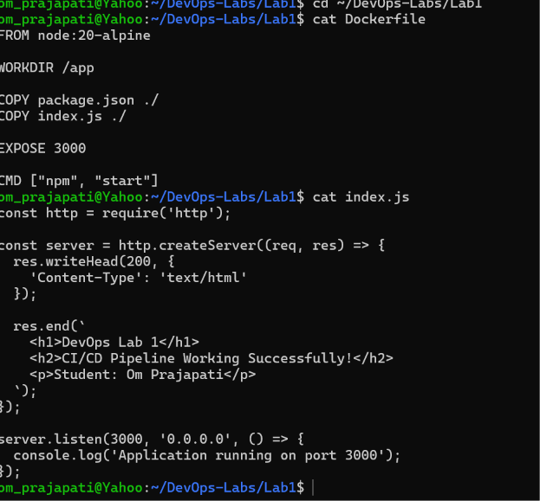Result and Conclusion
Record the actual result after execution. State the observed status, relevant version, and any errors resolved. Do not claim success without evidence.
Viva Questions
What is Node.js? A JavaScript runtime. What is npm? Node package manager. What does HTTP 200 mean? Request succeeded.
1.3 Dockerize the application
Aim
Build a Docker image and run the Node.js application in a container.
Requirements
Docker Engine or Docker Desktop with WSL integration; Ubuntu terminal.
Procedure and Commands
cd ~/DevOps-Labs/Lab1
cat > Dockerfile <<'EOF'
FROM node:20-alpine
WORKDIR /app
COPY package.json ./
COPY index.js ./
EXPOSE 3000
CMD ["npm", "start"]
EOF
cat > .dockerignore <<'EOF'
.git
node_modules
.env
EOF
docker version
docker build -t devops-lab1-app:1.0 .
docker images devops-lab1-app
docker run -d --name devops-lab1 -p 3000:3000 devops-lab1-app:1.0
docker ps
curl http://localhost:3000
docker logs devops-lab1
Explanation / Notes
docker build creates the image; docker run starts a container; -p maps host port 3000 to container port 3000. If the name is already in use, inspect it before removing it.
Expected Output — Reference Only
Expected: image devops-lab1-app:1.0 exists; docker ps shows container Up; curl returns the sample HTML.
Screenshot Evidence
Capture docker images, docker ps, curl output, and browser page. Use genuine output from your machine.
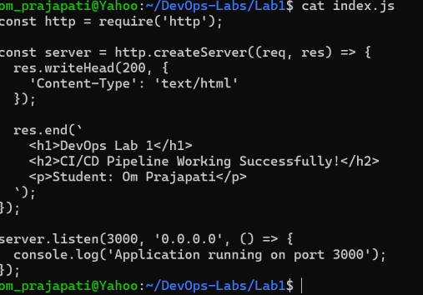
Result and Conclusion
Record the actual result after execution. State the observed status, relevant version, and any errors resolved. Do not claim success without evidence.
Viva Questions
What is an image? A packaged template. What is a container? A running image. What does -p do? Publishes/maps a port.
1.4 Jenkins CI/CD pipeline
Aim
Configure Jenkins to check out code, build and test a Docker image, deploy the app, and verify it.
Requirements
Jenkins with Git and Pipeline plugins; Jenkins agent must have Git, Node.js, Docker CLI, and Docker daemon access.
Procedure and Commands
// Jenkinsfile for a Linux Jenkins agent
pipeline {
agent any
stages {
stage('Checkout') {
steps { checkout scm }
}
stage('Build') {
steps { sh 'docker build -t devops-lab1-app:latest .' }
}
stage('Test') {
steps { sh 'node --check index.js' }
}
stage('Deploy') {
steps {
sh 'docker rm -f devops-lab1 || true'
sh 'docker run -d --name devops-lab1 -p 3000:3000 devops-lab1-app:latest'
}
}
stage('Verify') {
steps { sh 'docker inspect --format={{.State.Running}} devops-lab1' }
}
}
}
Explanation / Notes
Procedure: Install/enable Git and Pipeline plugins; create a Pipeline job; configure repository URL and branch main; select Pipeline script from SCM; set Script Path to Jenkinsfile; Save and Build Now. Linux uses sh. Windows agents require bat commands and a Windows-accessible workspace. Do not mix sh and bat.
Expected Output — Reference Only
Expected: Console Output shows each stage and ends with Finished: SUCCESS. If plugins cannot download, troubleshoot DNS/proxy. A Jenkinsfile alone does not prove a successful pipeline.
Screenshot Evidence
Capture job configuration and Stage View/Console Output showing green stages and Finished: SUCCESS. If not executed, mark this evidence Pending.
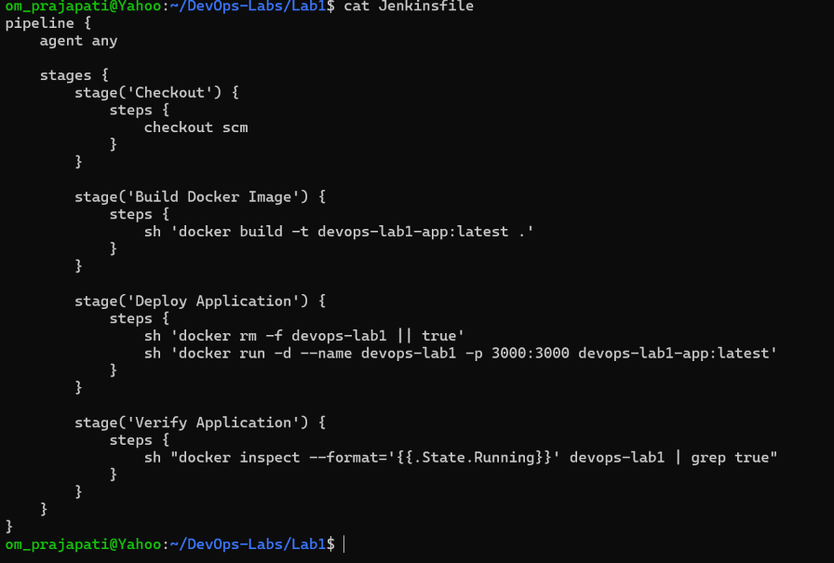
Result and Conclusion
Record the actual result after execution. State the observed status, relevant version, and any errors resolved. Do not claim success without evidence.
Viva Questions
What is CI? Automated integration and validation. What is CD? Automated delivery/deployment. What is Jenkinsfile? Text definition of a pipeline.

