**Power BI Assignment 2**

1. Explain the advantages of Natural Queries in PowerBi with an example?

The advantages of Natural Queries in PowerBi is that it gives suggestions about our data and we can get automated result based on it and we can get some important insights and it is very easy to use.

For Eg :- The Q&A visual we drag and it show suggestion about our data and we can select the appropriate based on our data insights.

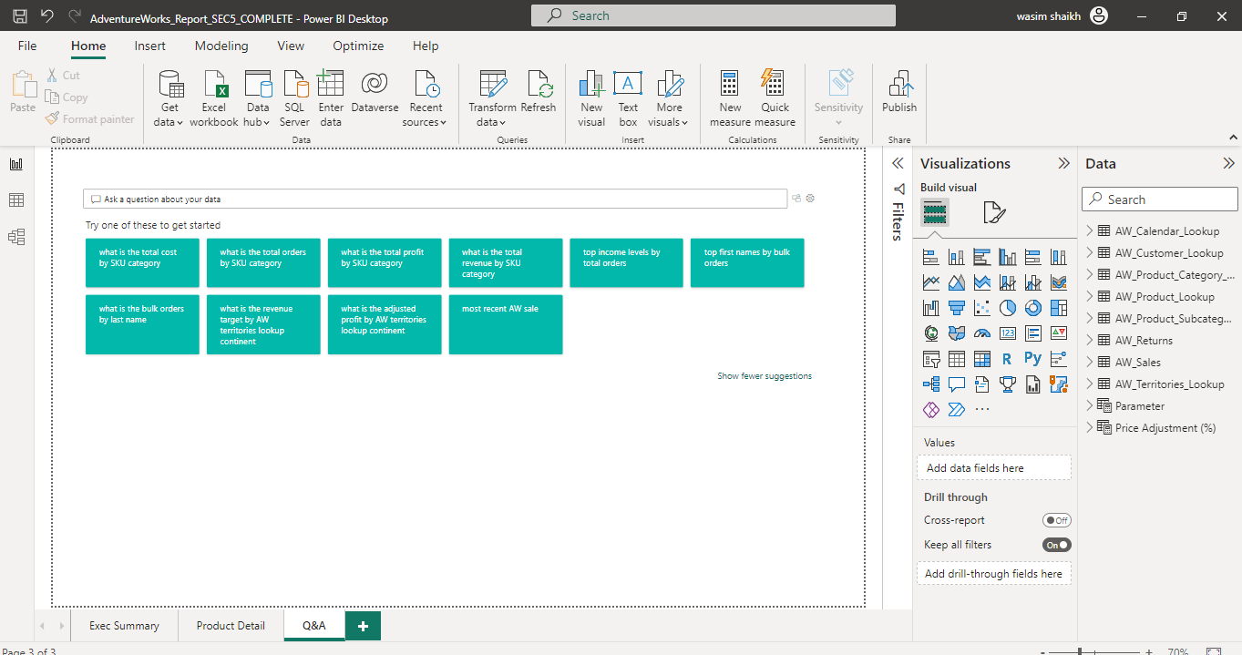

1. Explain Web Front End(WFE) cluster from Power BI Service Architecture?

Power BI service Architecture contains two clusters.

* Web Front End cluster (WFE)
* Back end cluster

Web Front End(WFE) cluster manages two important components.

* Initial connection
* User Autentication

Frond end cluster acts as intermediary between client and back end.

It uses **Azure Traffic Manager (ATM)** to make efficient and quick authentication. It attemps to send user traffic to nearest data center to reduce connection time. The nearest location is found by the DNS record of client attempting to connect.

Once user is connected, he/she can access static content & files. To share these files, Power BI uses another technology called **Azure Content Delivery(ACD)** to efficiently distribute the respective user file contents based on geographic locale.

Power BI uses **Azure Active Directory (AAD)** to authenticate users who sign in to the Power BI service, and in turn, uses the Power BI login credentials whenever a user attempts to access resources that require authentication

[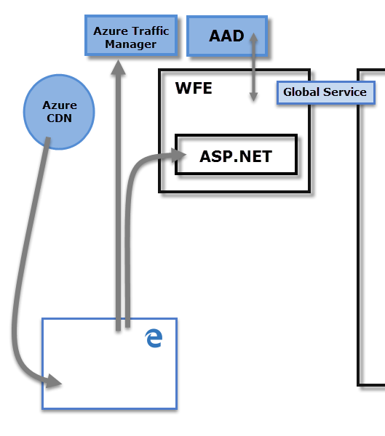](https://user-images.githubusercontent.com/89411580/149663992-184dafb2-638e-4758-a78e-9f18bc047f67.png)

1. Explain Back End cluster from Power BI Service Architecture?

The Power BI services at the back end take care of

* visualizations
* datasets
* storage
* reports
* data connections
* data refreshing and other interactions with Power BI.

At the back-end, a web client has only two direct points of interaction

* Azure API Management
* Gateway Role.

The Gateway Role acts as a gateway between user requests and the Power BI service. Users do not interact directly with any roles other than the Gateway Role. Azure API Management will eventually handle the Gateway Role. Azure API Management will eventually handle the Gateway Role.

These two components are responsible for load balancing, authentication, authorization, routing, etc.

[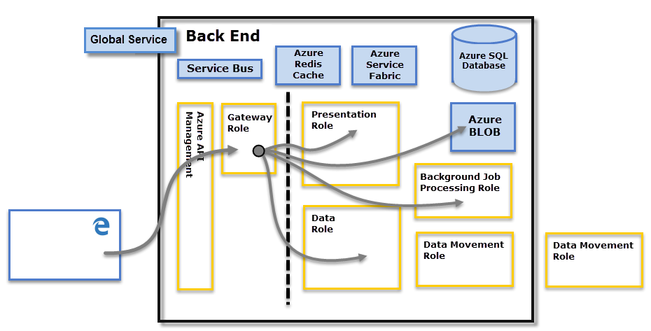](https://user-images.githubusercontent.com/89411580/149664526-7354aad7-f11b-426b-a382-3455c9a3ee53.png)

1. What ASP.NET component does in Power BI Service Architecture?

ASP.NET is a web development platform provided by microsoft.

* ASP ==> Active Server Page
* NET ==> Network Enabled Technologies

ASP.NET component plays a major role while publishing reports and dashboards to workspace where stakeholder interact with it in front end provided by Power BI service. Not only that, BI dashboards can also be accessed through other apps like Microsoft teams which embeds BI Applicaiton through ASP.NET framework

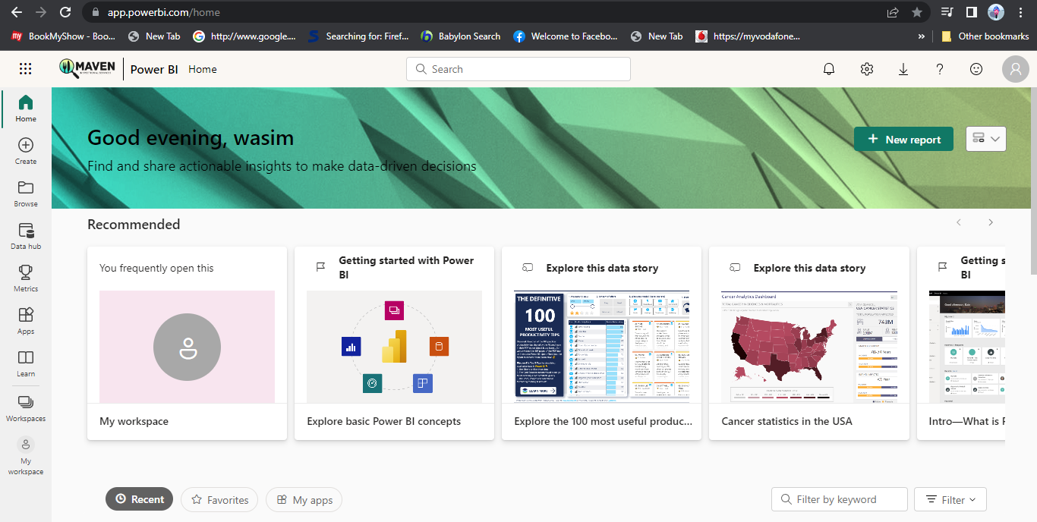

1. Compare Microsoft Excel and PowerBi Desktop on the following features:

|  |  |  |
| --- | --- | --- |
|  | **Microsoft Excel** | **Power Bi** |
| Data Import | Microsoft Excel can get data from everywhere with Power Query. | Power Bi can use Power Query to fetch data from everywhere. |
|  |
|  |
|  |
| Data Transformation | Microsoft Excel is all about the simplicity of organizing, analysing and transforming data sets. | Power Bi is fine tuned to handle data from different sources  while allowing the creation of complex models. |  |
|  |
|  |
|  |
| Modelling | Microsoft Excel is based on the MDX (Multi  Dimensional Expressions) language, which is used to query and manipulate multidimensional databases. | Power Bi is based on a functional language called DAX, which stands for Data Analysis Expressions. |  |
|  |
|  |
|  |
| Server Deployment | In addition to viewing Power BI reports in the web portal, Power BI Report Server can host Excel workbooks by using Office Online Server (OOS). Your report server becomes a  single location to publish and view self-service Microsoft BI content. | Power Bi Report Server is the on-premises solution for reporting today, with the flexibility to move to the cloud tomorrow. It's included with Power Bi Premium so you have the ability to move to the cloud on your terms. |  |
|  |
|  |
|  |
| Convert Models | In excel you cannot create model like | In Power Bi you can create one to one, one to many and many  to many relationships and show relationship in between the tables which is called as models. |  |
|  |
|  |
|  |
| Cost | Microsoft 365 Family - Rs 6199 | Power Bi Pro $9.99 Power Bi Premium $4995 |  |
|  |
|  |
|  |

1. List 20 data sources supported by Power Bi desktop.

Below is the list of 20 data sources supported by Power Bi desktop.

1. Excel Workbook
2. Text/CSV
3. XML
4. JSON
5. Folder
6. PDF
7. Parquet
8. SQL Server Database
9. Access Database
10. MySQL Database
11. Oracle Database
12. Postgre Database
13. SAP HANA Database
14. Amazon Redshift
15. Google BigQuery
16. Snowflake
17. Google Analytics
18. Smartsheet
19. Spark
20. R Script

