CDC-RFA-JG-26-0056 - Strengthening Global Health Security by improving public health capacity to detect, notify, and respond to disease outbreaks globally
Win-ready project narrative pack (submission companion)
FairBanks Medical Centre · FCHIP component
Your health, our mission.

Table of critical details
Item | Detail
Opportunity number | CDC-RFA-JG-26-0056
Applicant | FAIRBANKS MEDICAL CENTRE LIMITED
Company No. / TIN / NSSF | 80020003843337 · 1053370026 · NS043295
Countries Year 1 | Uganda (primary); East Africa corridor learning (CONFIRM LOIs)
Funding instrument | Cooperative agreement
Assistance listing | 93.318
Period of performance | 5 years (five 12-month budget periods)
Year 1 NOFO pool / awards | About $24M · expected 4-8 awards
Year 1 total federal ask (draft) | $3,200,000 (CONFIRM; components 1-4)
Year 1 Component 1 ask (draft) | $2,200,000 (CONFIRM; ceiling $3,000,000)
Cost share | None proposed
Local partner preference | Yes - Uganda-incorporated entity (+10 points; document before submit)
Merit scoring focus | Approach 35 · EPMP 30 · Capacity 35
Deadline | 14 August 2026, 11:59 p.m. ET
Contact | Racheal Nabukeera · info@fairbanksmedicalcentre.org · +256 772 849 258

Shared win
Who | What they gain
CDC / United States | Earlier containment at source - Safer, Stronger, More Prosperous
Uganda / MoH | Last-mile signals into NISS pathways; trained CHWs; 7-1-7 practice
FairBanks | Local partner with live clinic, Community Reach, and FCHIP that feeds government
Communities | Earlier alerts and clearer referral paths when something looks wrong

CDC needs outbreaks stopped closer to where people live. FairBanks already runs a Uganda clinic, CHW/VHT outreach, and working FCHIP tools - ready to feed MoH/NISS pathways under government leadership.
Project abstract summary
FAIRBANKS MEDICAL CENTRE LIMITED (FairBanks Medical Centre) is a Uganda-registered health organisation in Kampala. We run a licensed medical centre and FairBanks Community Reach with CHWs and VHTs in Bukoto, Kyebando, Kisaasi, Kamwokya, Kikaaya and nearby communities. Slogan: Your health, our mission. This NOFO strengthens countries' capacity to independently detect, notify, and respond to disease threats of international significance. Uganda's last-mile gap remains clear: community and facility signals that reach decision-makers too late; limited surge-ready workforce at subnational level; and incomplete links into national surveillance such as NISS pathways. Under Ministry of Health leadership, Year 1 Component 1 will (1) strengthen community and facility surveillance that contributes to MoH/NISS channels using FairBanks FCHIP tools, (2) speed community-to-district detection and response using 7-1-7 style timing, (3) train CHWs/VHTs and frontline workers for One Health-aware surveillance and surge readiness, and (4) tighten community-facility links for priority diseases. Laboratory and surge modules will be delivered with MoH-aligned partners. Components 2-5 are contingency surge plans that may be approved but unfunded until CDC activates emergency funding. Year 1 country of performance: Uganda (primary), with East Africa corridor learning under MoH Uganda. Shared result: threats found and acted on closer to source - safer for Uganda and for the United States.
1. Background and approach — problem
Uganda faces repeated infectious disease threats shaped by geography, rapid urban growth, and high population movement across East Africa corridors. Outbreaks that start in peri-urban communities can grow before national systems see them. Americans and Ugandans are safer when threats are found and contained close to source.
In FairBanks catchments, CHWs and VHTs already visit homes and schools, and the Medical Centre sees patients every day. Too often, community reports, clinic records, and lab referrals still sit apart. The 2023 JEE praised progress and still named gaps in information sharing, subnational surge capacity, and use of data for early action - including the need for stronger integrated surveillance such as NISS.
FairBanks proposes to close the last-mile gap under MoH leadership: structured community and facility signals, faster notify-respond loops with districts, trained frontline workers, and tools that feed government systems rather than create a parallel silo.
2. Approach and FairBanks model
CDC needs outbreaks stopped closer to where people live. FairBanks already runs a Uganda clinic, CHW/VHT outreach, and working FCHIP tools - ready to feed MoH/NISS pathways under government leadership.
FairBanks Community Reach cascade stays the operating model: community members -> CHWs/VHTs -> Community Reach programmes -> Medical Centre -> research and skills -> economic empowerment. FCHIP is the intelligence component on the Data & Feedback loop.
Award funds will support surveillance systems, training, emergency readiness, data linkages, and public health programme coordination. Routine clinical care continues on FairBanks' own operations and is not the purpose of this cooperative agreement.
We will collaborate with MoH, district/KCCA teams, other CDC partners, and community structures. Software, SOPs, and training materials developed under the award will be available to MoH and CDC for appropriate use. Multi-country claims beyond Uganda require registration or partner LOIs (CONFIRM before naming additional countries).
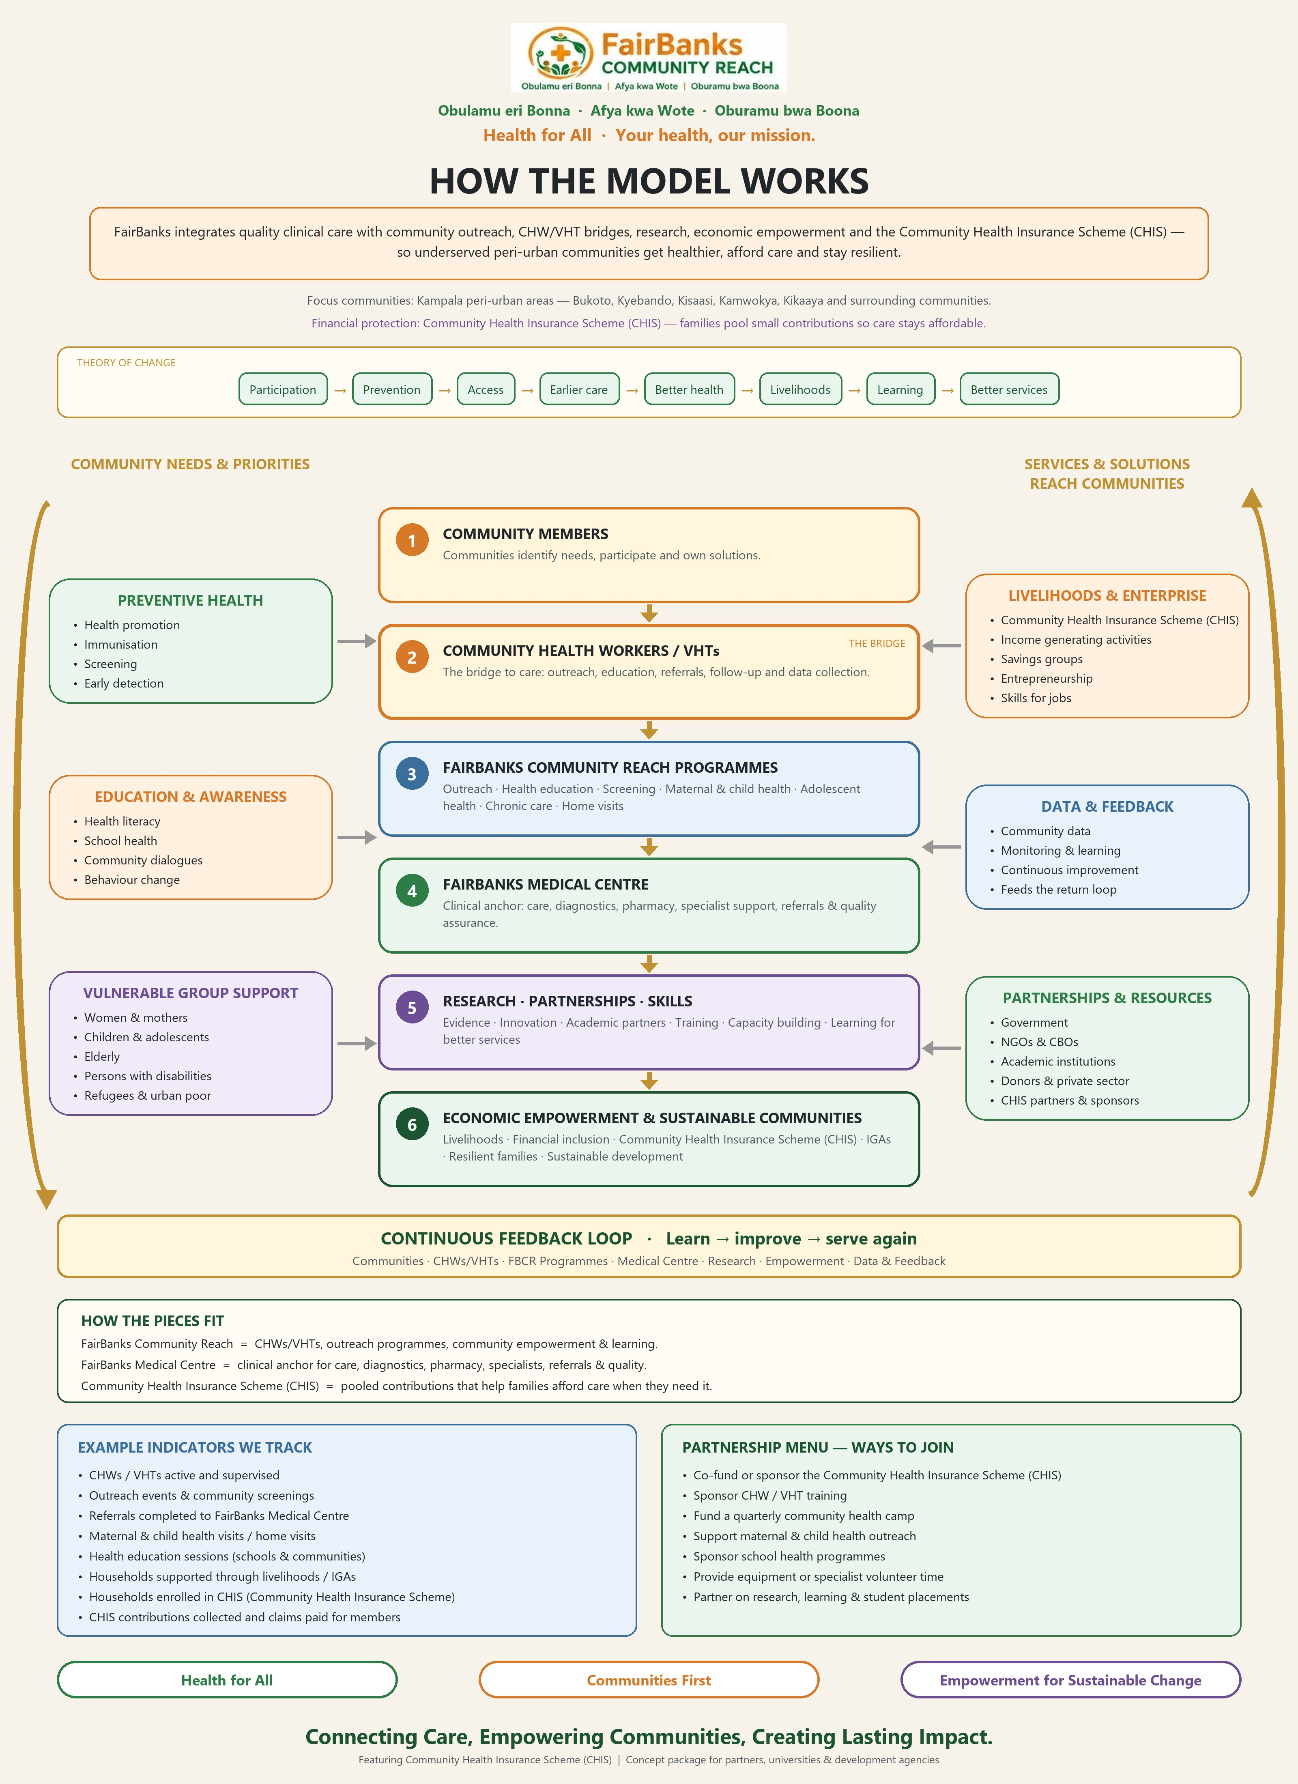
Figure: FairBanks Community Reach operating model
3. Year 1 strategies and activities (Component 1)
Strategy | FairBanks Year 1 focus
1 Surveillance systems with governments | FCHIP capture -> MoH/NISS-aligned exports; data quality; simple GIS early warning
2 Interoperable public health data | Community-facility-lab signal integration; weekly reports; district dashboards
3 Public health programmes / service links | Community-facility links for HIV, TB, malaria, VHFs, mpox, immunisation
4 Assessment and corrective action | Joint district reviews; AARs after drills; continuous improvement
5 Workforce | CHW/VHT and facility training; surge roster; One Health-aware sessions
6 Networks and surge connect | Partner coordination; MoH/CDC sharing; surge activation pathways
7 Outbreak response (C2-C5) | Contingency playbooks for moderate/substantial PHEs when CDC activates funds

4. Anticipated outcomes
Outcome | What success looks like
Faster detection & response | Shorter time from community signal to district notification (7-1-7 style)
Stronger surveillance | Weekly community reports and successful MoH/NISS-aligned data tests
Ready workforce | Trained CHWs/VHTs and surge roster exercised in drills
Better community-facility links | Documented referral outcomes for priority disease flags
Government use | Tools, SOPs, and data access handed for MoH/CDC use

5. Evaluation and performance measurement (summary)
- DGHP partner-level indicators from the FY26 list (surveillance, community mitigation, emergency ops, IPC, lab support) - final set agreed with CDC after award.
- Project measures with Year 1 targets: median days signal-to-notify (toward 7-1-7); at least 80% active CHWs with complete weekly reports by Q4; at least 70% priority referrals documented; at least 2 successful MoH export tests; at least 2 AARs.
- About 5-10% of funds for M&E; detailed EPMP and DMP within six months of award.
Full EPMP and DMP text for Grants.gov paste is in application_answers.md (sections D and D7).
6. Organizational capacity
- FAIRBANKS MEDICAL CENTRE LIMITED (No. 80020003843337; TIN 1053370026; NSSF NS043295) - Uganda company with principal place of business in Kampala.
- Live Medical Centre and Pharmacy; Community Reach with CHWs/VHTs; working FCHIP MVP.
- Public community base: Kyebando-Kisalosalo, Northern Bypass, Kampala. Catchments include Bukoto, Kyebando, Kisaasi, Kamwokya, Kikaaya.
- Lead: Racheal Nabukeera, Managing Director and Co-founder - 15+ years in Uganda private health leadership; MA Social Sector Planning (Makerere); PhD in progress; Uganda Healthcare Federation links.
- Company evidence pack available (incorporation, TIN, NSSF, licences, insurance) - see company-docs/.
- Honest note: we have not yet been prime on a multi-million CDC GHS award; financial controls and staffing for federal compliance will be strengthened as described in attachments (CONFIRM). Year 1 stays Uganda-primary; multi-country growth via registered partners.
Website: https://www.fairbanksmedicalcentre.org/
Registered address: Plot 1423 and 1425 Tirupati Road, Fairbanks Medical Centre, Kampala Central Division, Kololo IV, Lugogo, Kampala, Uganda
7. Draft Year 1 component budgets (CONFIRM before submit)
Component | Draft ask | Ceiling | Notes
1 Core GHS | $2,200,000 | $3,000,000 | Expected initial funding
2 Small-scale response | $350,000 | $5,000,000 | Contingency ABU
3 Large-scale response | $400,000 | $10,000,000 | Contingency ABU
4 Small emerging threats | $250,000 | $15,000,000 | Contingency ABU
5 Large emerging threats | ABU playbook | $20,000,000 | Narrative + CONFIRM SF-424A
TOTAL Year 1 (draft C1-C4) | $3,200,000 |  | Equals Box 18a when final

Indirect: foreign organisation 8% of MTDC (CONFIRM). Separate SF-424A lines per component. Itemised budget narrative categories: salaries, fringe, travel, equipment, supplies, contractual, other, indirect.
8. Pre-submit checklist
- SAM.gov active + UEI for physical location receiving funds (start now)
- Grants.gov / Login.gov active; AOR ready to Sign and Submit
- Follow applicant quick start: https://grants.gov/quick-start-guide/applicants
- Local partner letter + ownership/staff/board citizenship evidence from company-docs/
- Project narrative PDF ≤60 pages; attachments ≤50 pages; English; USD only
- All five components included; no research; clinical care not the award purpose
- Submit by 14 August 2026, 11:59 p.m. ET via Grants.gov
- Official listing: https://www.grants.gov
- Alt listing: https://simpler.grants.gov/opportunity/8454e463-cd43-4d0d-97a2-8a4310e0ce6b
Full copy-paste bank: application_answers.md. Generated 2026-08-10.
Your health, our mission.

