FRAVENT LIMITED
COMPANY PROFILE 2026
"Your toolkit for real solutions"
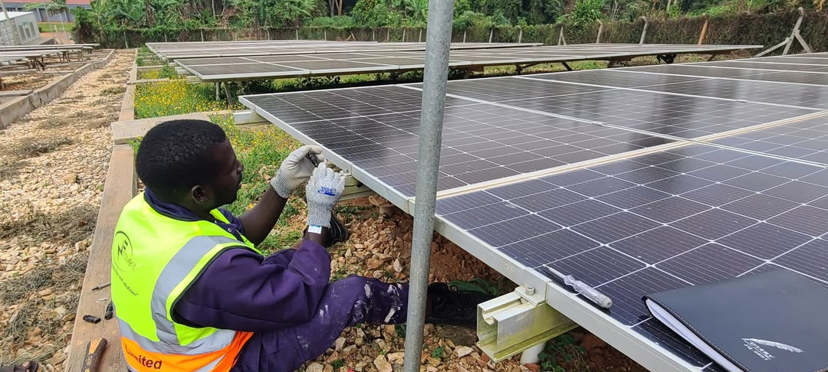
Cover photo: Solar Hybrid System installation for UGAFODE at Nakivale Refugee Settlement.
Electrical & Solar Solutions · Safe. Smart. Sustainable.
www.fraventlimited.com · fraventlimited@gmail.com · +256 778 455 042

About Us
Our Story
Fravent Limited is a fully registered company with the Registrar of Companies (Registration Number: 80020003614101). We help clients realise their goals in electrical engineering, solar and renewable energy, property management, consultancy and advisory services, import and export, logistics and transport, land brokerage, and business intelligence.
We employ experienced professional staff for every project. Our clients include private individuals, schools, private and public companies, organisations, local and international investors, and government ministries.
A steady flow of orders reflects trust in Fravent management's heritage and diversified experience, built on successful project delivery year after year.

Purpose
Mission · Vision · Values
Mission: Establish a strong and reliable working bond with clients, delivering quality, affordable and up-to-standard services for all stakeholders.
Vision: Evolve into the leading company providing unsurpassed services to participants across the globe.
- Reliable
- Efficient
- Sustainable
- Client-first

Featured Project
Solar Hybrid System — OFF Grid
Description: Procurement, Delivery, Installation, Testing and Commissioning of a Solar Hybrid System.
Client: UGAFODE Microfinance Limited - MDI
Location: Nakivale Refugee Settlement - Isingiro District, Western Uganda
System Size: 5.58 kWh
Status: Completed and Commissioned
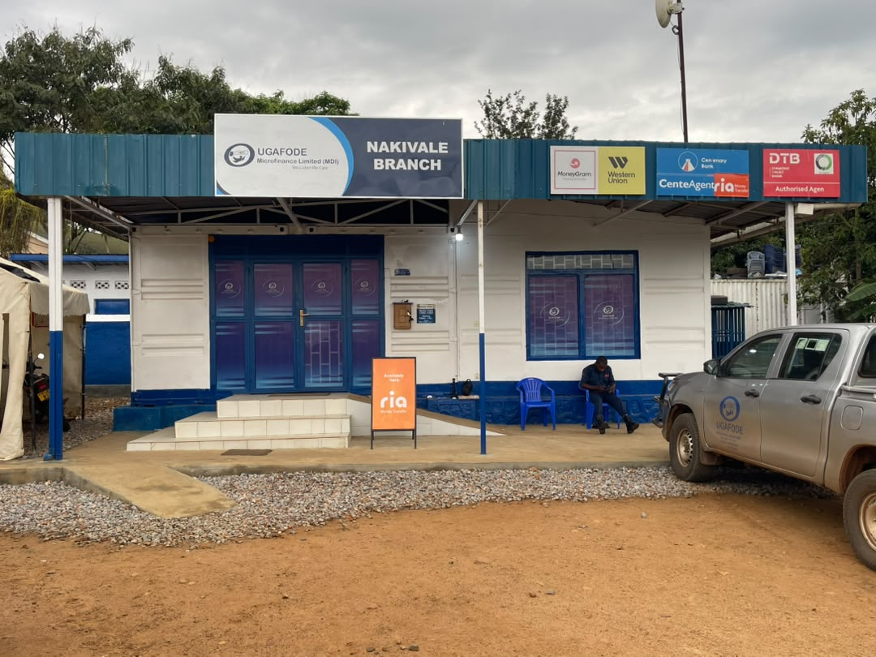
UGAFODE Microfinance Limited (MDI) Nakivale Branch — project site.
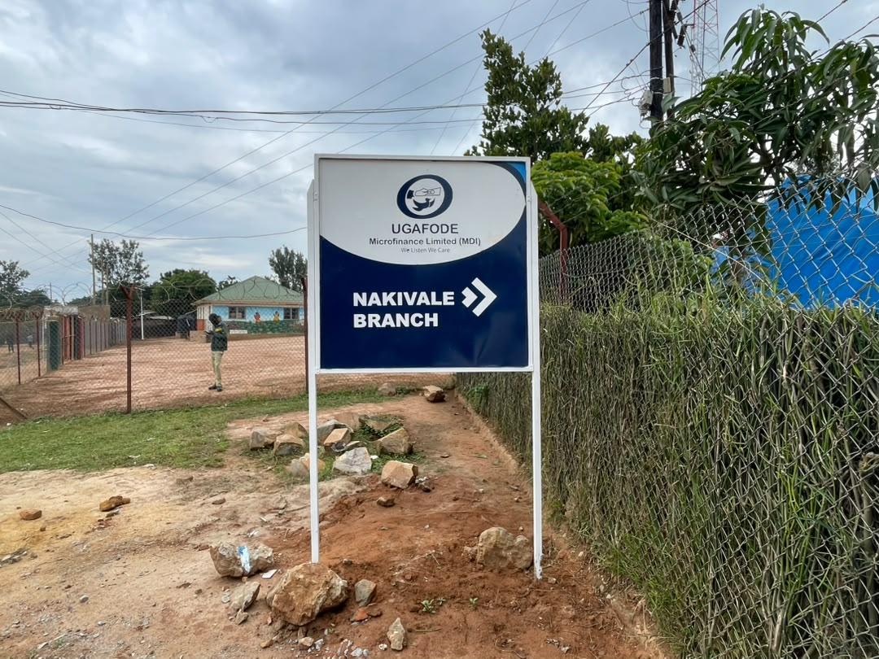
UGAFODE Nakivale Branch directional signage.

Ground-mounted solar array installation at Nakivale.
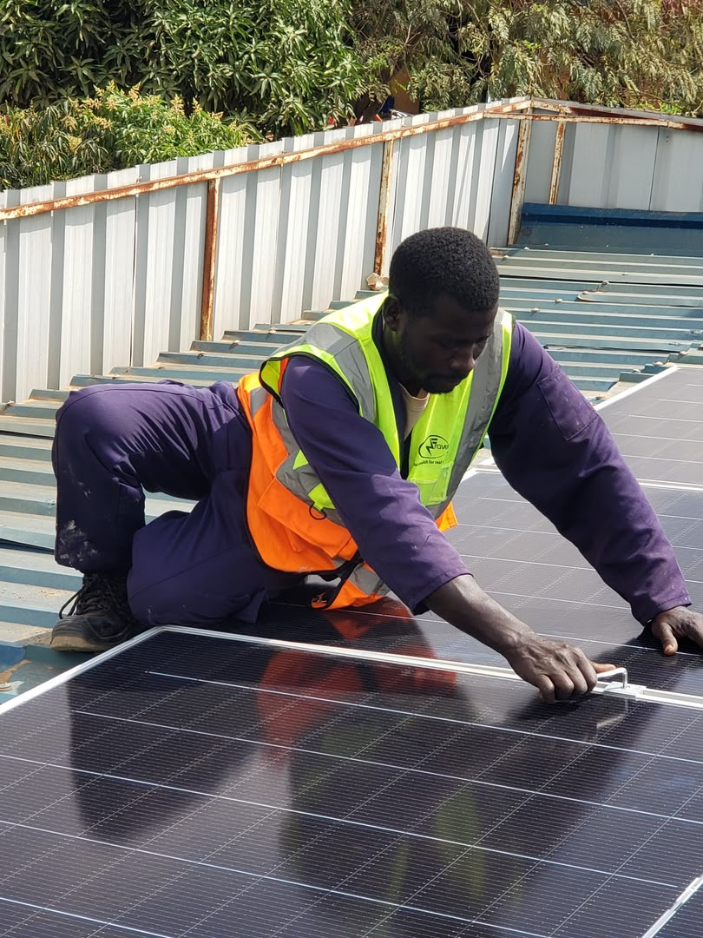
Rooftop solar panel mounting by Fravent technicians.
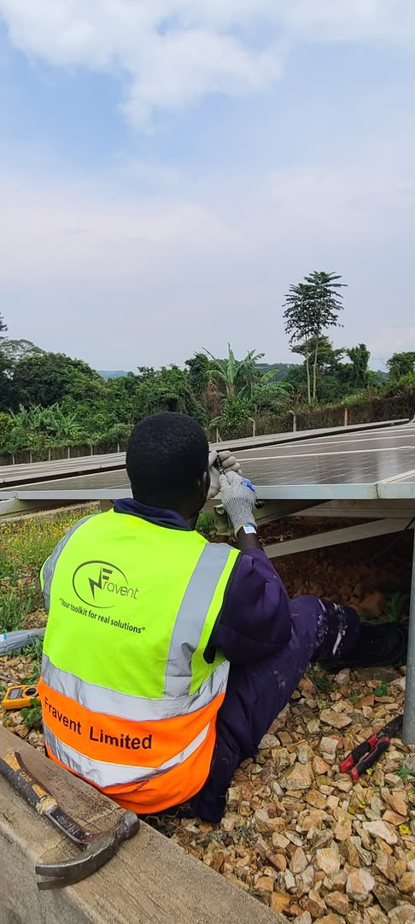
Fravent branded PPE during array works.
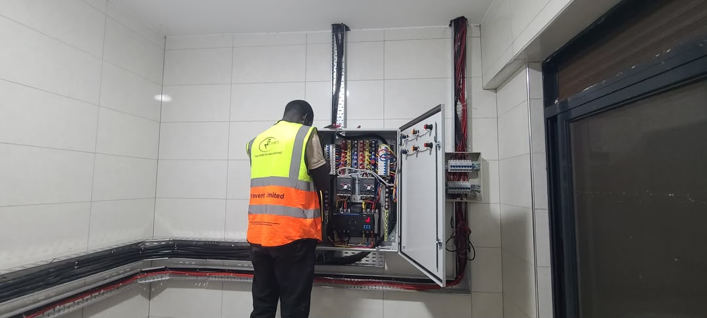
Indoor electrical panel integration.
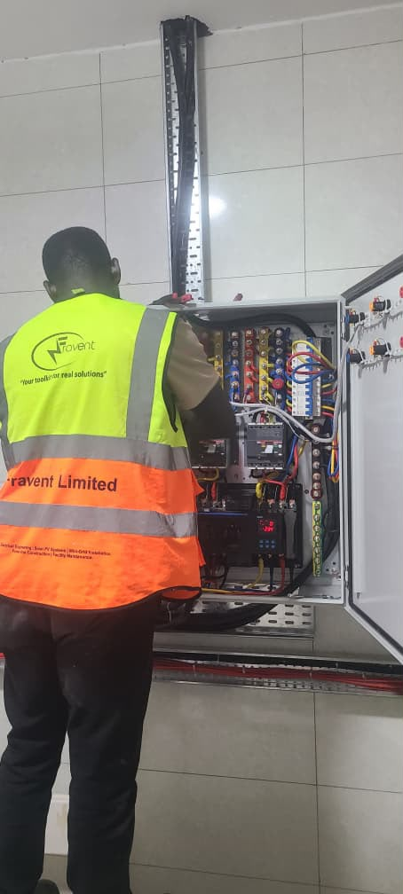
Control panel wiring and commissioning.
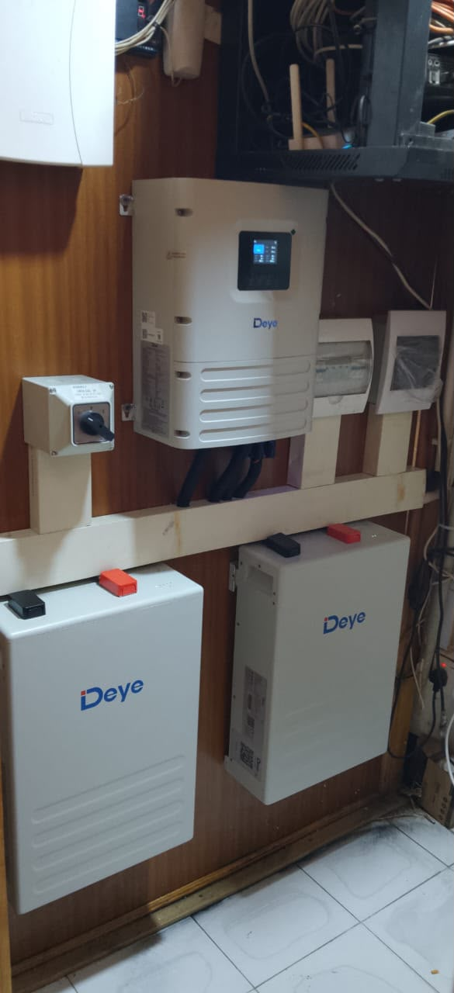
Completed Deye hybrid inverter and battery installation.
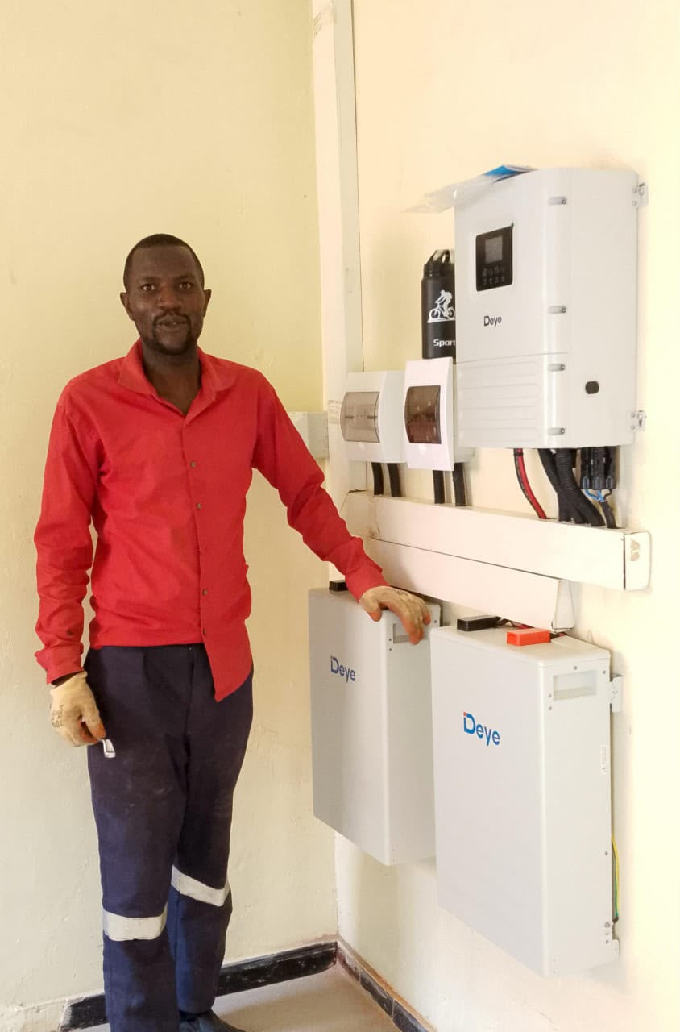
Commissioned wall-mounted inverter and battery bank.
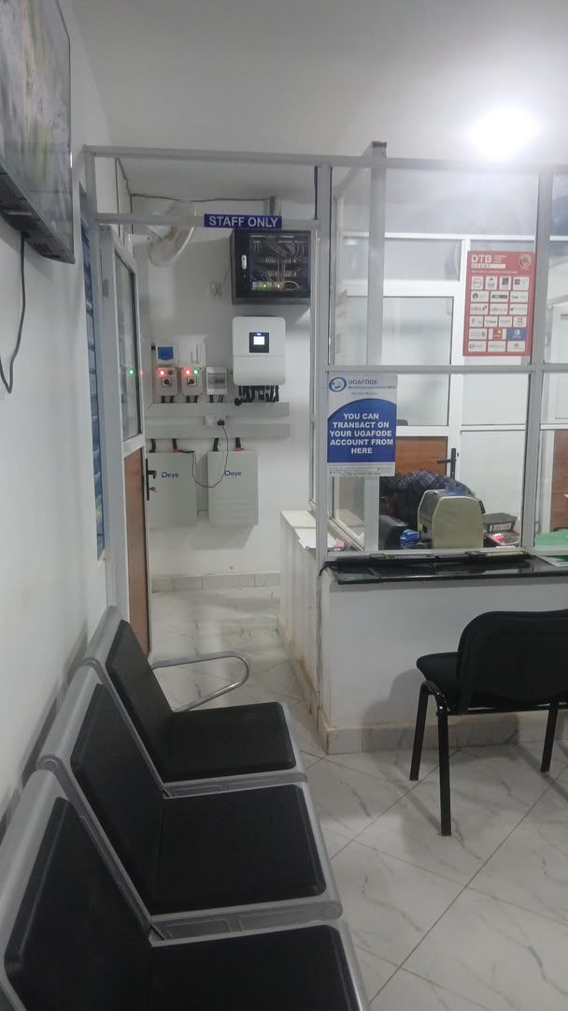
Completed system viewed from the UGAFODE customer area.
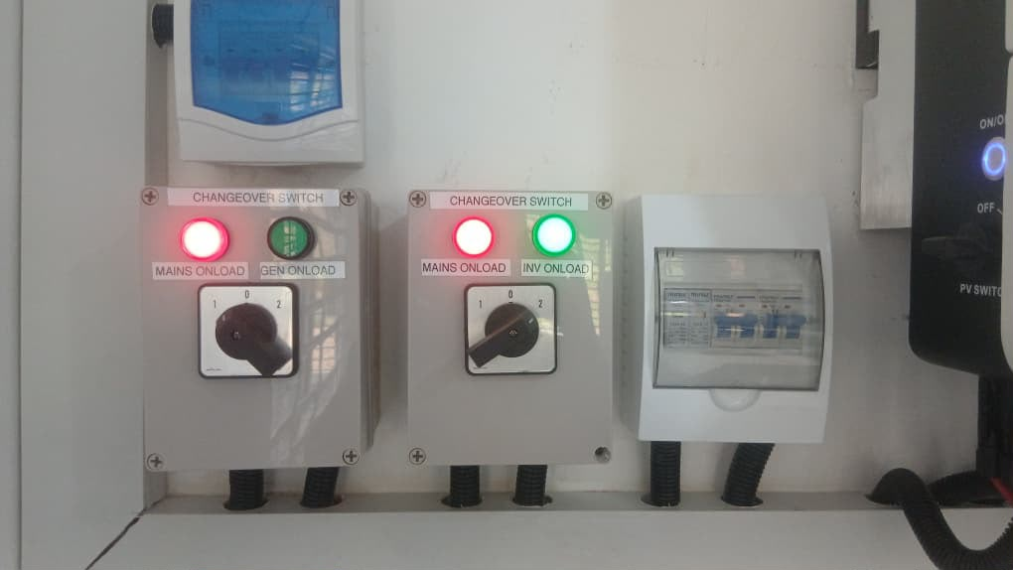
Changeover panel — mains, generator, and inverter paths.

More Projects
UGAFODE Solar Hybrid Sites
Rushere — Western Uganda
Description: Procurement, Delivery, Installation, Testing and Commissioning of a Solar Hybrid System.
Client: UGAFODE Microfinance Limited - MDI
System Size: 6.0 kWh
Status: Completed and Commissioned

Ntungamo — Western Uganda
Description: Procurement, Delivery, Installation, Testing and Commissioning of a Solar Hybrid System.
Client: UGAFODE Microfinance Limited - MDI
System Size: 6.0 kWh
Status: Completed and Commissioned

Nakivale Refugee Settlement — Isingiro District
Description: Procurement, Delivery, Installation, Testing and Commissioning of a Solar Hybrid System.
Client: UGAFODE Microfinance Limited - MDI
System Size: 5.58 kWh
Status: Completed and Commissioned

Kyaka Sales Branch
Description: Procurement, Delivery, Installation, Testing and Commissioning of a Solar Hybrid System.
Client: UGAFODE Microfinance Limited - MDI
System Size: 5.0 kWp DC
Status: Completed

Rwamwanja Sales Branch
Description: Procurement, Delivery, Installation, Testing and Commissioning of a Solar Hybrid System.
Client: UGAFODE Microfinance Limited - MDI
System Size: 6.25 kWp DC
Status: Completed

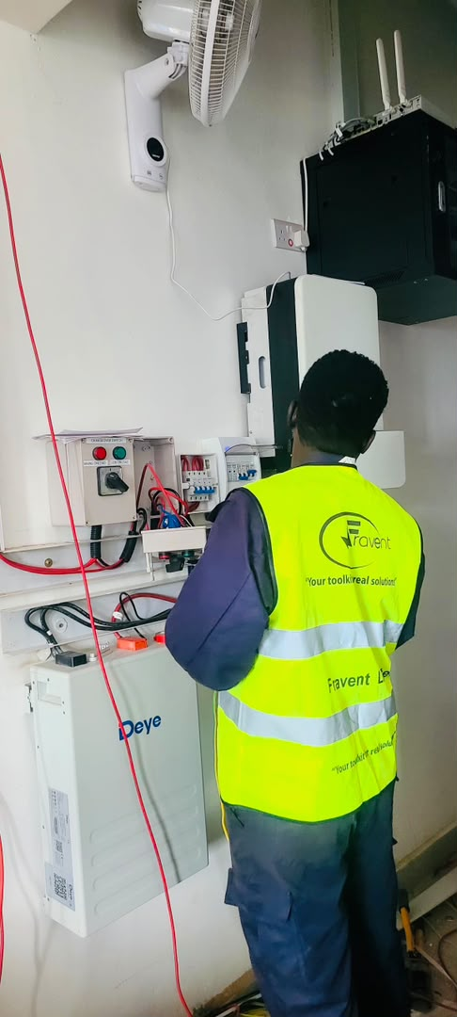
Transfer switch and Deye battery works at a UGAFODE branch.
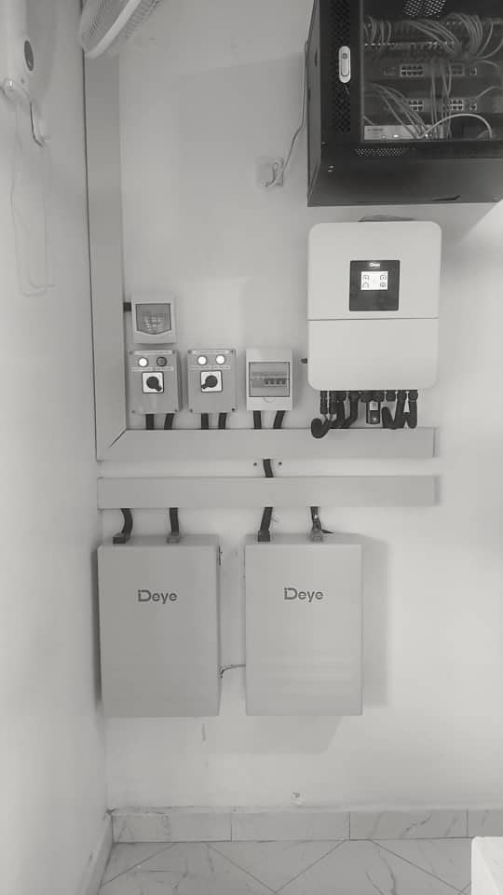
Completed Deye hybrid inverter and battery wall mount.

Manual changeover controls for mains, generator, and inverter.

On-going Project
Kiwoko Hospital — Adara Group
Description: Procurement, Delivery, Installation, Testing and Commissioning of a Solar Hybrid System.
Location: Kiwoko Hospital - Nakaseke District
System Size: 10 kWh
Client: Adara Group
Status: On-going
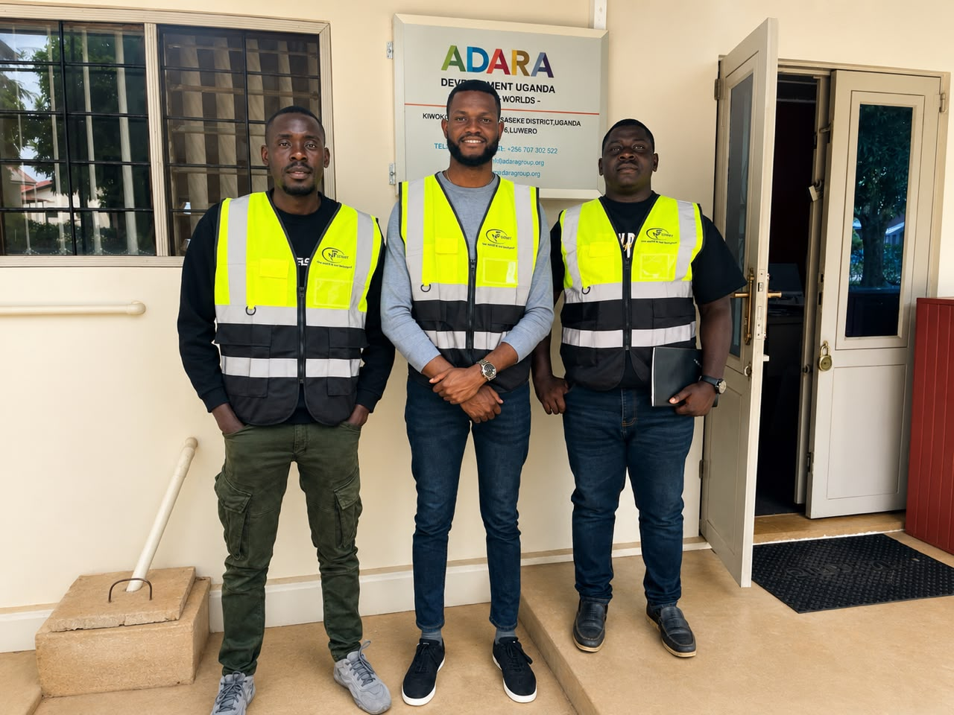
Fravent team on site at Adara Development Uganda — Kiwoko, Nakaseke District.
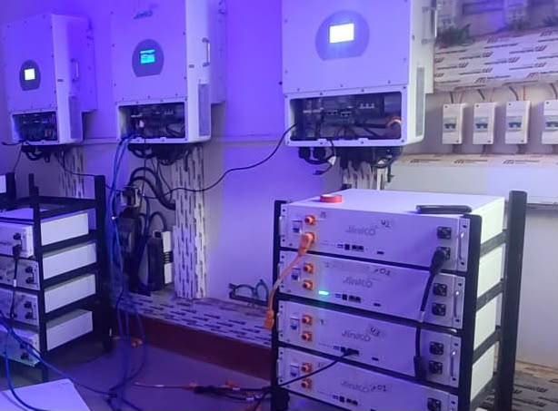
Jinko hybrid inverters and battery racks during installation.
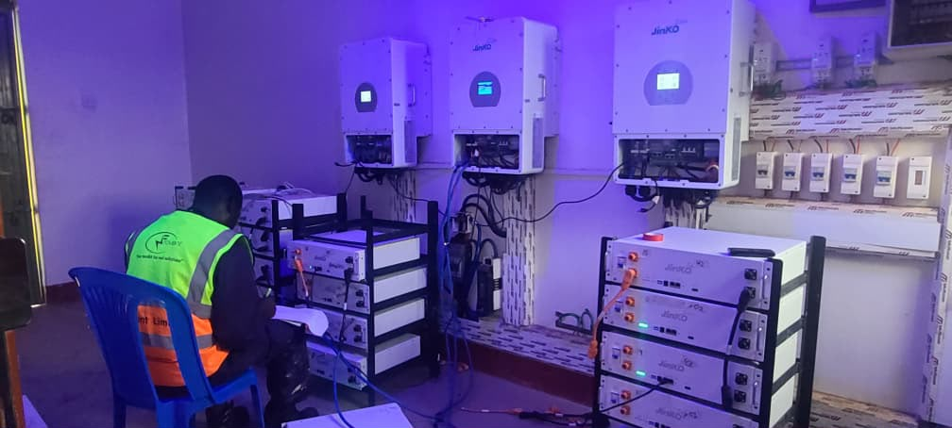
Commissioning checks on the 10 kWh hybrid storage system.

Earlier Portfolio
Community Solar & Mini-Grids
Pro Mini Grids — Lamwo District (WINCH Energy / Sagemcom / GIZ, REA, Government of Uganda).
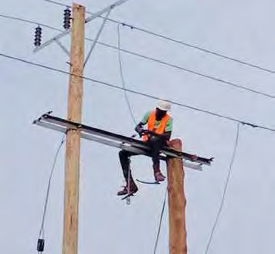
Pro Mini Grids field works — Lamwo District (1/4).
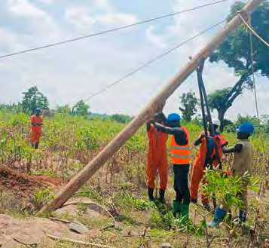
Pro Mini Grids field works — Lamwo District (2/4).
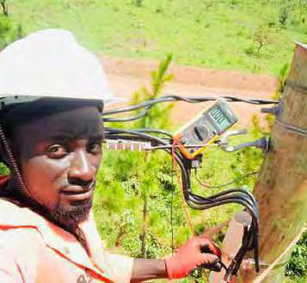
Pro Mini Grids field works — Lamwo District (3/4).
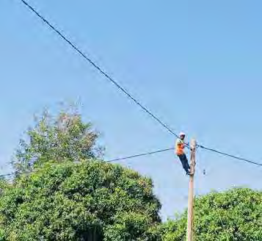
Pro Mini Grids field works — Lamwo District (4/4).
Shared Community Solar — Gomba District (Ministry of Local Government).
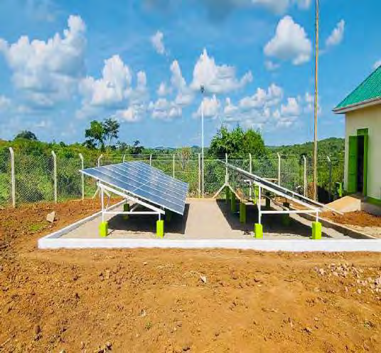
Shared community solar project — Gomba District (1/4).
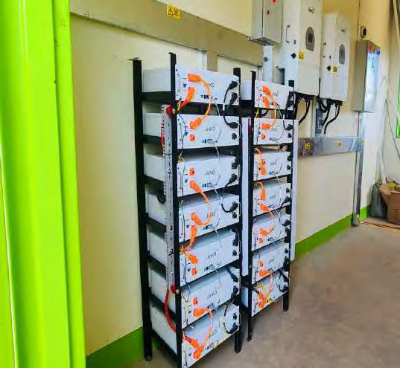
Shared community solar project — Gomba District (2/4).
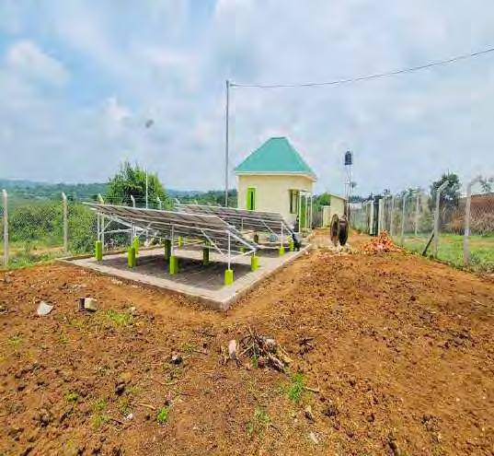
Shared community solar project — Gomba District (3/4).
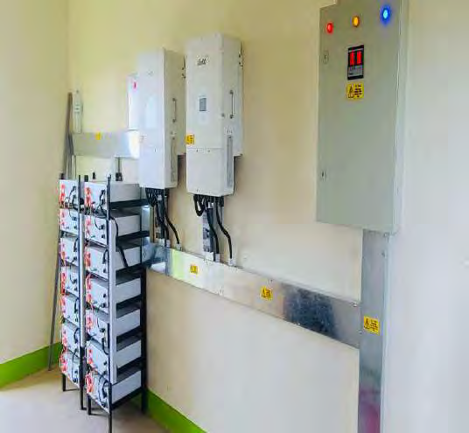
Shared community solar project — Gomba District (4/4).
Mazima Community Solar System — Buwenge, Jinja District.
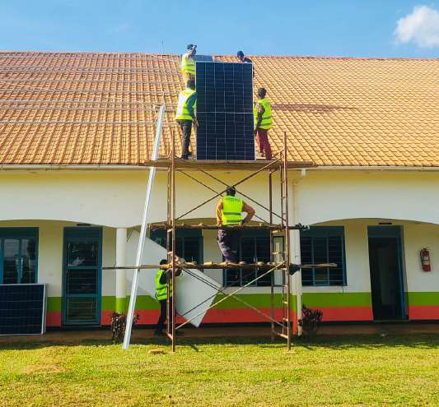
Mazima Community Solar System — Jinja District (1/4).
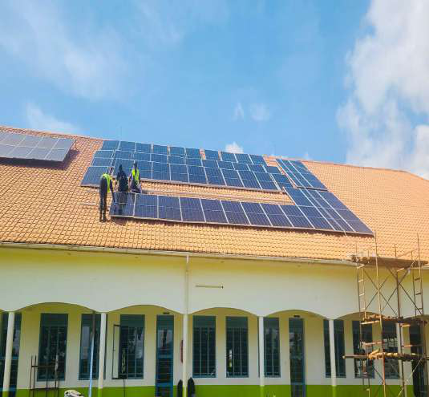
Mazima Community Solar System — Jinja District (2/4).
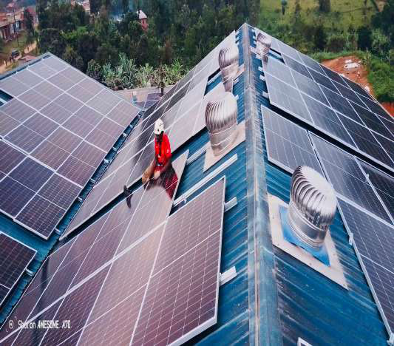
Mazima Community Solar System — Jinja District (3/4).
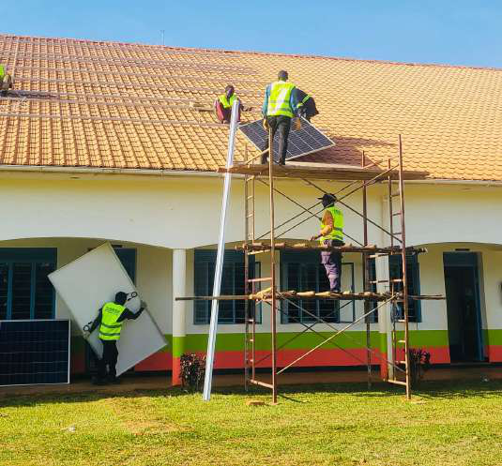
Mazima Community Solar System — Jinja District (4/4).

Other Projects
Ernest Cook University — Balintuma Road, Mengo
Hybrid Solar System. Status: Completed.
Uganda Museum
Electrical Upgrade and Automatic Change Over — Equatorial Power. Status: Complete.
Sentema Road, Mengo
Residential Apartment Wiring. Status: Complete.
Luthuli Avenue, Bugolobi
Maintenance of Lighting System — Madam Ivy. Status: Complete.

Contact
Address: P. O. Box 108053, Kampala (U), Rofra House, 04th Floor, Kansanga - Ggaba Road
Phone: +256 778 455 042 · +256 703 305 262
Email: fraventlimited@gmail.com
Website: www.fraventlimited.com
Safe. Smart. Sustainable.

