RACHEAL NABUKEERA  Senior Human Resource Executive | Human Capital Strategist | Organisational Development & Executive Leadership  Kampala, Uganda  Mobile: +256 772 849258 | +256 701 849258  Email: info@fairbanksmedicalcentre.org  Website: www.fairbanksmedicalcentre.org | 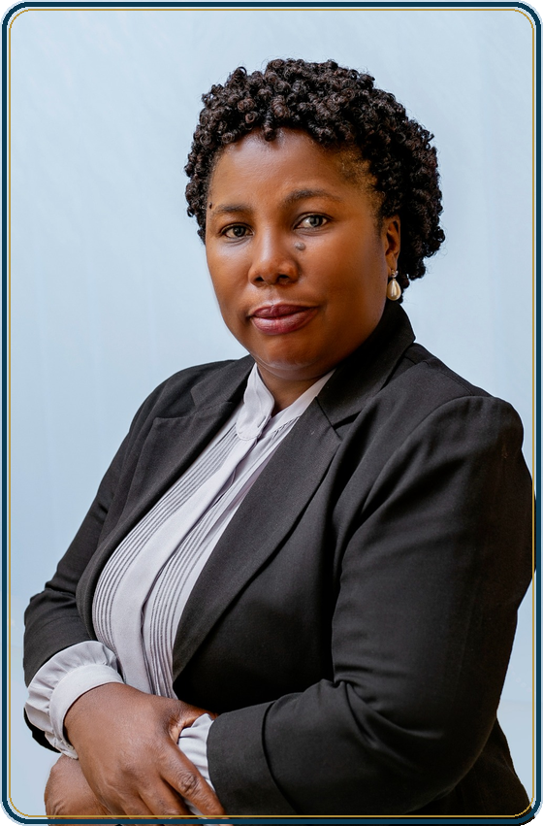
EXECUTIVE PROFILE
Strategic Human Resource Executive with nearly 30 years of progressive professional experience and over 18 years of executive Human Resource leadership, driving organisational transformation, workforce excellence and sustainable business performance across complex organisations.
Recognised for developing and implementing innovative Human Capital strategies that align people, performance and organisational objectives. Demonstrated expertise in Human Resource Strategy, Organisational Development, Talent Management, Workforce Planning, Leadership Development, Performance Management, Employee Relations, Change Management, Corporate Governance and Executive Administration.
Successfully provided strategic Human Resource leadership supporting more than 2,000 employees across over 50 operational departments and business units, partnering with executive leadership to strengthen organisational capability, improve workforce productivity and deliver measurable business results.
Currently serving as Founder and Managing Director of FairBanks Medical Centre Ltd, providing executive leadership in organisational strategy, corporate governance, institutional development, stakeholder engagement and business sustainability.
A PhD Candidate in Management at Uganda Christian University with research focusing on the application of Artificial Intelligence and Machine Learning in predicting occupational burnout among medical practitioners, reflecting a passion for innovation, evidence-based leadership and organisational excellence.
KEY CAREER HIGHLIGHTS
- Nearly 30 years of progressive Human Resource and Executive Management experience.
- More than 18 years in Executive Human Resource Leadership.
- Strategic Human Resource leadership supporting 2,000+ employees.
- Oversight of Human Resource functions across 50+ operational departments and business units.
- Extensive experience in Human Capital Strategy, Organisational Development and Business Transformation.
- Successfully led organisation-wide workforce planning, recruitment, employee relations and performance management initiatives.
- Executive advisor to senior leadership on Human Capital Strategy, organisational effectiveness and change management.
- Founder and Managing Director of FairBanks Medical Centre Ltd.
- Successfully established the FairBanks Social Enterprise Initiative, reaching over 10,000 community beneficiaries.
- Member of the Federation of Uganda Employers (FUE).
- PhD Candidate in Management specialising in Human Resource Analytics, Artificial Intelligence and Organisational Behaviour.
EXECUTIVE CORE COMPETENCIES
Human Capital Leadership
- Human Resource Strategy
- Human Capital Management
- Workforce Planning
- Talent Acquisition
- Talent Management
- Succession Planning
Organisational Effectiveness
- Organisational Development
- Change Management
- Business Transformation
- Leadership Development
- Employee Engagement
- Organisational Culture
Human Resource Operations
- Employee Relations
- Industrial Relations
- Labour Law Compliance
- Performance Management
- HR Policy Development
- Compensation & Benefits
- Staff Welfare
Corporate Leadership
- Executive Leadership
- Corporate Governance
- Strategic Planning
- Risk Management
- Stakeholder Engagement
- Corporate Administration
Digital & Analytical Capability
- Human Resource Information Systems (HRIS)
- Human Resource Analytics
- Management Reporting
- Data Analysis
- Digital Transformation
- Artificial Intelligence in Human Resource Management
PROFESSIONAL EXPERIENCE
Founder, Managing Director & Executive Human Resource Leader
FairBanks Medical Centre Ltd | 2025 - Present
Provide executive leadership for a growing healthcare organisation, overseeing strategic planning, Human Resource management, governance, organisational development, institutional sustainability and business growth.
Major Responsibilities
- Provide strategic leadership and institutional direction.
- Lead organisational development and workforce planning.
- Develop Human Resource policies and organisational structures.
- Oversee performance management and staff development.
- Champion organisational culture and employee engagement.
- Direct corporate governance and compliance.
- Build strategic partnerships with government, insurers and development partners.
- Lead resource mobilisation and organisational sustainability initiatives.
Key Achievements
- Founded FairBanks Medical Centre Ltd.
- Established the FairBanks Social Enterprise Initiative.
- Expanded specialist healthcare services.
- Led community health programmes benefiting over 10,000 people.
- Built strategic partnerships supporting institutional growth.
- Strengthened governance systems and organisational performance.
Group Human Resource & Administration Manager
Norvik Group | July 2016 - February 2026
Provided strategic leadership for Human Resource and Administration functions across the Group, supporting executive management in driving organisational performance, workforce effectiveness and business transformation.
Major Responsibilities
- Developed and implemented Group Human Resource Strategy.
- Led workforce planning and organisational restructuring.
- Directed leadership development and succession planning initiatives.
- Managed organisational development and change management programmes.
- Oversaw recruitment and talent management.
- Strengthened employee engagement and staff retention.
- Developed Human Resource policies and governance frameworks.
- Ensured compliance with labour legislation and organisational policies.
- Supervised Human Resource teams across multiple operational units.
- Advised Executive Management on Human Capital Strategy.
Key Achievements
- Provided strategic Human Resource leadership supporting more than 2,000 employees.
- Oversaw Human Resource operations across 50+ operational departments and business units.
- Led major organisational development and transformation initiatives.
- Improved Human Resource governance and organisational effectiveness.
- Strengthened performance management and leadership development systems.
- Enhanced workforce productivity through strategic Human Resource initiatives.
Human Resource & Administration Manager
Norvik Hospital Ltd | September 2013 - 2016
Provided leadership for the Human Resource and Administration Department while strengthening Human Resource systems, employee engagement and organisational performance.
Major Responsibilities
- Managed recruitment and selection.
- Coordinated employee relations and disciplinary processes.
- Supervised performance appraisal systems.
- Developed and implemented Human Resource policies.
- Managed staff welfare initiatives.
- Oversaw administration and facilities management.
- Ensured compliance with labour legislation.
Key Achievements
- Improved Human Resource operational efficiency.
- Strengthened organisational policy implementation.
- Enhanced staff performance management systems.
- Improved recruitment and retention practices.
Health Management Systems Administrator
St. Catherine's Hospital | 2010 - June 2013
Managed Hospital Information Systems while improving organisational reporting, digital information management and operational efficiency.
Major Responsibilities
- Managed Hospital Information Systems.
- Produced executive management reports.
- Improved administrative reporting processes.
- Coordinated user training.
- Strengthened information management.
- Supported digital transformation initiatives.
Key Achievements
- Improved operational reporting.
- Enhanced information management systems.
- Increased administrative efficiency.
Human Resource Manager
St. Catherine's Hospital | 2007 - 2010
Managed Human Resource functions while supporting organisational growth through effective people management, policy implementation and employee development.
Major Responsibilities
- Led recruitment and selection.
- Managed employee relations.
- Coordinated performance management.
- Developed and implemented Human Resource policies.
- Managed employee welfare programmes.
- Ensured labour law compliance.
- Supervised Human Resource administration.
Key Achievements
- Improved Human Resource systems and processes.
- Strengthened employee engagement.
- Enhanced recruitment and staff retention.
- Improved Human Resource service delivery.
Human Resource Assistant
E Power Limited | 1997 - 2000
Provided administrative and operational support to the Human Resource Department while contributing to efficient Human Resource service delivery.
Major Responsibilities
- Assisted with recruitment and onboarding.
- Maintained personnel records and employee files.
- Supported payroll administration.
- Coordinated leave administration.
- Assisted in organising staff training.
- Supported employee welfare initiatives.
- Prepared Human Resource reports and documentation.
Key Achievements
- Maintained accurate Human Resource records.
- Supported efficient recruitment processes.
- Improved Human Resource administration.
EDUCATION
Doctor of Philosophy (PhD) in Management (Ongoing)
Uganda Christian University
Research Topic:
Machine Learning-Based Prediction of Occupational Burnout Among Medical Practitioners in Uganda
Master of Social Sector Planning and Management
Makerere University
Bachelor of Arts in Social Sciences
Makerere University
PROFESSIONAL MEMBERSHIP
- Member, Federation of Uganda Employers (FUE)
TECHNICAL COMPETENCIES
- Microsoft Office Suite
- Human Resource Information Systems (HRIS)
- Enterprise Resource Planning (ERP) Systems
- Human Resource Analytics
- Performance Management Systems
- Payroll Administration Systems
- Data Analysis & Executive Reporting
- Artificial Intelligence Applications in Human Resource Management
ACADEMIC RESEARCH
Doctoral Research
Machine Learning-Based Prediction of Occupational Burnout Among Medical Practitioners in Uganda
Research Interests
- Human Resource Analytics
- Artificial Intelligence
- Machine Learning
- Organisational Behaviour
- Occupational Burnout
- Leadership
- Employee Wellbeing
- Healthcare Management
- Organisational Development
LANGUAGES
- English - Fluent
- Luganda - Fluent
REFERENCES
Available upon request.

