 | FAIRBANKS MEDICAL CENTRE  Your Health, Our Mission
Plot 1423 and 1425, Tirupati Road, Fairbanks Medical Centre, Lugogo, Kololo IV, Kampala Central Division, Kampala, Uganda
Tel: 0777 462 398 | 0748 319 052 Email: info@fairbanksmedicalcentre.org Website: www.fairbanksmedicalcentre.org

INVOICE  Medical / Occupational Health Services | Invoice No.: FBMC/INV/2026/0911/001  Invoice Date: 11th September 2026  Payment Terms: Within Seven (7) Days

Bill To  Palm Hotel  Attention: Management | Description of Services  Provision of Medical Examination Services for Food Handlers

Description | Quantity | Unit Price (UGX) | Amount (UGX)
Medical Examination and Certification for Food Handlers | 21 Persons | 20,000 | 420,000

Total Amount Payable | UGX 420,000

Amount in Words
Uganda Shillings Four Hundred and Twenty Thousand Only (UGX 420,000/=).

Payment Instructions
Kindly make payment to the account details provided by FairBanks Medical Centre and quote Invoice No. FBMC/INV/2026/0911/001 as the payment reference.
Note: FairBanks Medical Centre is not registered for Value Added Tax (VAT). Therefore, no VAT has been charged on this invoice.
We thank Palm Hotel for choosing FairBanks Medical Centre as your occupational health partner. We appreciate your trust and look forward to serving your team in the future.
Yours faithfully,
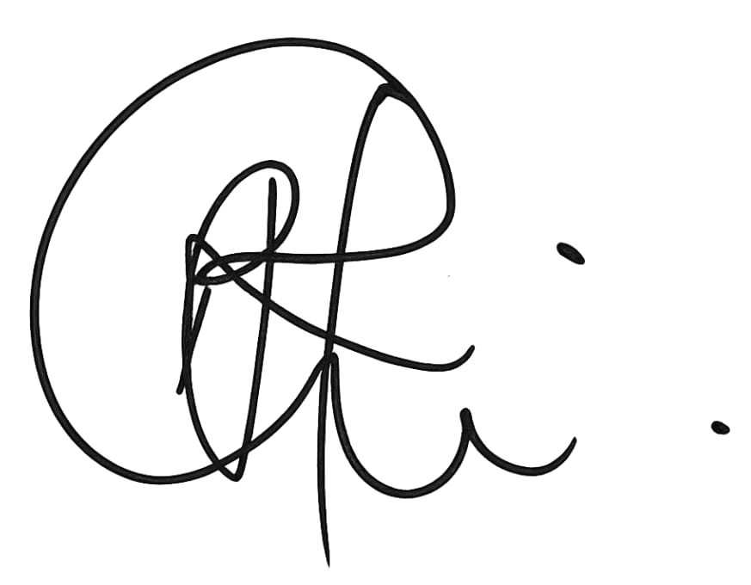
Brian Ssonko
Accountant
FairBanks Medical Centre
FairBanks Medical Centre - Your health, our mission. - Kampala, Uganda

