Africa CDC African Epidemic Services (AES) Epidemiology Fellowship 2026–2028
Win-Win Application Pack
Epidemiology & Informatics Talent for FCHIP
Fully funded fellowship strengthening outbreak intelligence capacity
Your health, our mission.
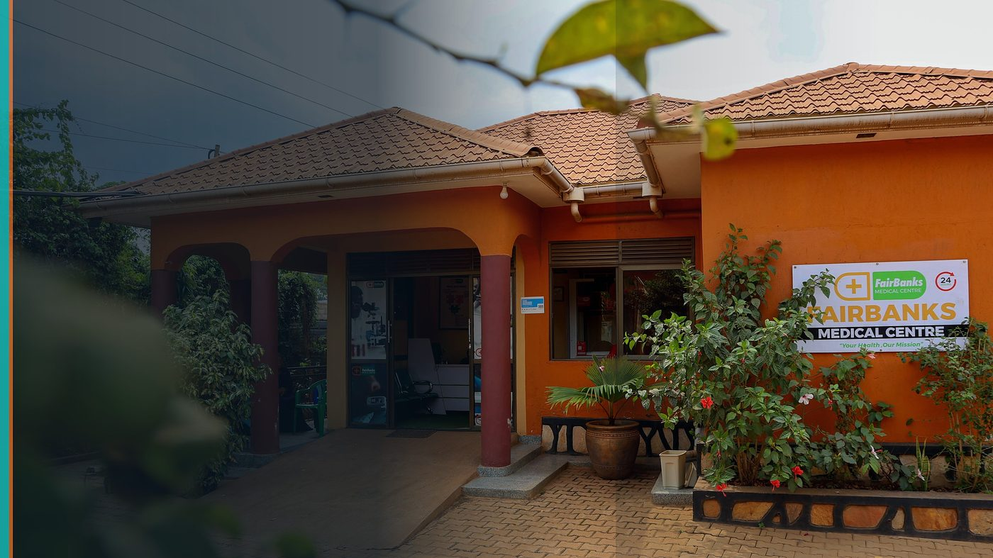
FairBanks Community Reach — Health for All — Obulamu eri Bonna · Afya kwa Wote · Oburamu bwa Boona
Item | Detail
Applicant | Eligible FairBanks public-health staff (AU citizen, under 35, employed)
Programme | Africa CDC African Epidemic Services (AES) Epidemiology Fellowship 2026–2028
Deadline | 26 August 2026
Geography | Addis Ababa training + field placement · Uganda employer
The ask | Select a FairBanks public-health professional for the AES Epidemiology (or Informatics) track.

https://opportunitiesforyouth.org/2026/07/16/africa-cdc-african-epidemic-services-aes-epidemiology-fellowship-2026-2028-fully-funded-apply-by-26-august-2026/

1. Executive Summary
Africa CDC's AES fellowship builds outbreak investigation, surveillance, and data-analysis skills over two years — including a Public Health Informatics pathway.
FairBanks needs this depth to make FCHIP's surveillance claims scientifically sound and operationally useful.
Africa CDC gains a fellow employed in a live community health setting who will apply skills immediately.
2. Win-Win Value
This application is designed as a true partnership: FairBanks grows capacity and reach; the programme advances its own mission with a grounded African health-tech partner.
2.1 What FairBanks / FCHIP gains
- World-class epidemiology / informatics training for staff
- Stronger outbreak and surveillance modules inside FCHIP
- Stipend, travel, insurance, hardware, and software covered
- Continental network across African Epidemic Services
2.2 What the programme / partners gain
- Fellow already employed in public-facing community health work
- Field placement potential linked to real CHW and facility data flows
- Contribution to Africa's epidemic readiness from Uganda
- Informatics track alignment with digital community health tools
3. The Problem We Address
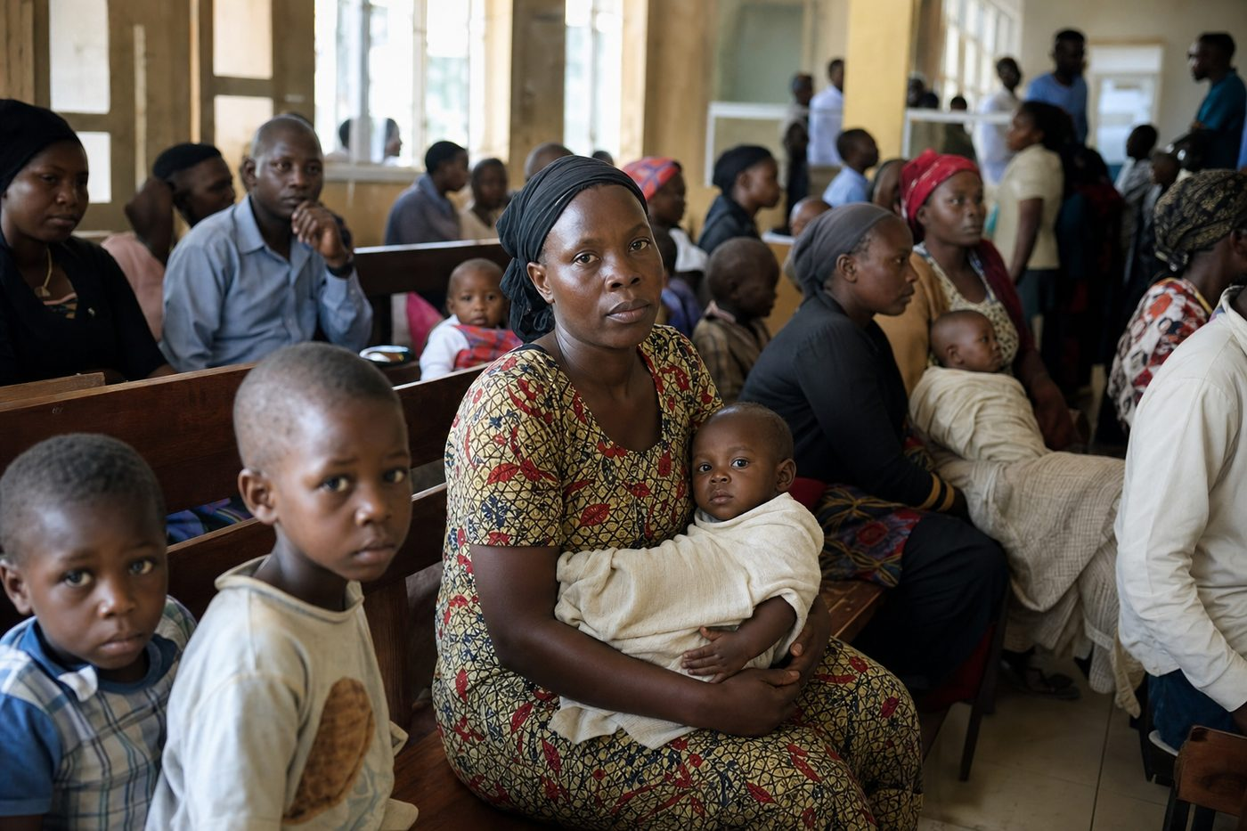
Reactive care waits for sickness before it responds
Predictive community platforms fail without trained people who understand surveillance science, not only software.
Africa needs more young epidemiologists and informaticians grounded in primary care realities.
4. Our Solution: FCHIP & Community Reach
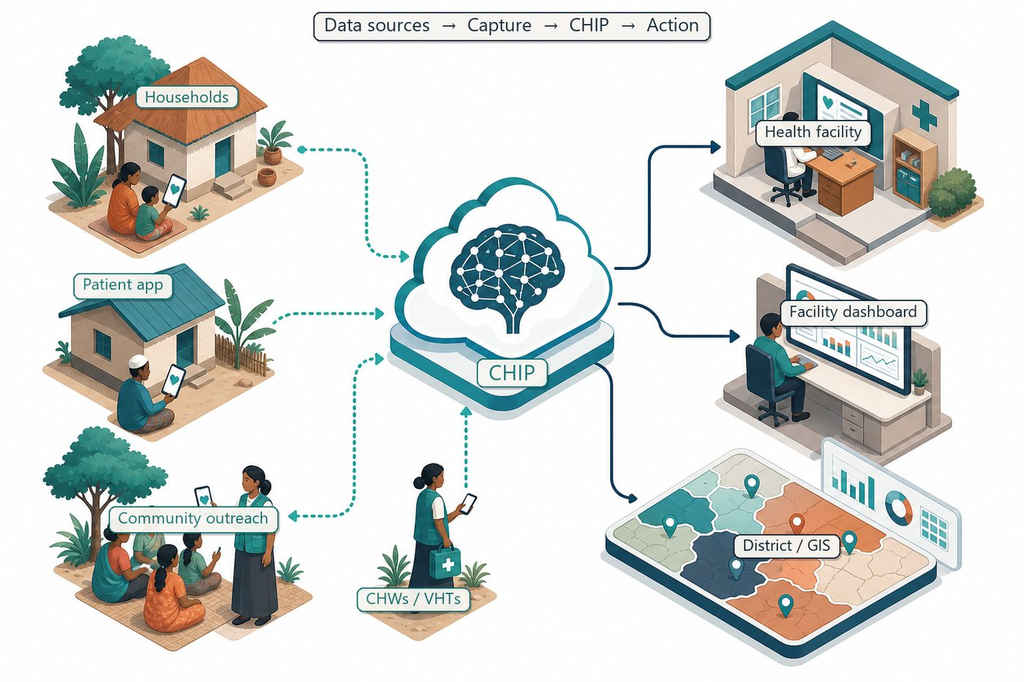
Community signals → capture → FCHIP intelligence → action
A FairBanks fellow will complete AES training and bring methods home: case investigation discipline, surveillance analysis, and informatics design for FCHIP alerts.
Employer support ensures learning returns to community programmes and partner districts.
4.1 Deep technology core
Technology | Role
Artificial Intelligence | Outbreak early warning; maternal and NCD risk scoring
Machine Learning | Learn from community patterns, seasons, and outreach outcomes
GIS Mapping | Disease distribution, hotspots, and resource gaps
Mobile Data Collection | Offline-capable CHW/VHT capture at household level
Cloud Computing | Secure sync across facilities and partners
Analytics Dashboards | Real-time views for clinics, districts, and NGOs

4.2 Priority use cases for this call
Outbreak workflows: Standardise community signal → investigation → response.
Informatics: Improve data quality pipelines for CHW capture.
Training cascade: Teach CHW supervisors better data use.
5. Fit to Programme Criteria
Criterion / theme | How we respond
AU citizen under 35 | Ugandan staff candidate in range
Employed in public health | FairBanks clinical / community health employment
Degree + 3 years' experience | Candidate will meet stated requirements
Epidemiology / Informatics tracks | Direct fit to FCHIP surveillance goals

6. Why FairBanks Is Ready
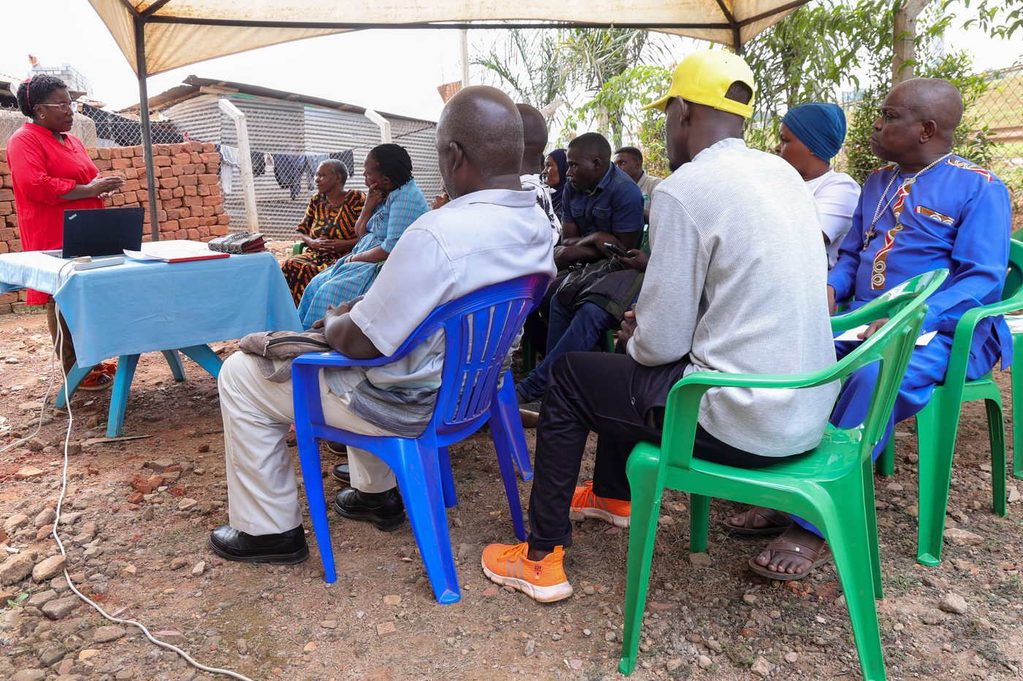
Live outreach in Kampala-area communities
- Functioning FairBanks Medical Centre with clinic, pharmacy, and diagnostics
- Active Community Reach outreach in Bukoto, Kyebando, Kisaasi, Kamwokya, Kikaaya
- Trusted CHW and VHT relationships for household visits and referrals
- Live programmes: maternal & child health, Gericare, chronic-disease screening
- Digital health records and outreach data ready to feed FCHIP
- Research and partnership mindset for ethical, evidence-based scale
7. Proposed Plan
Phase / step | Detail
Months 1–3 | Core training in Addis Ababa
Months 4–24 | Field placement with FairBanks / partner public health sites
Throughout | Apply methods to FCHIP surveillance and quality improvement

8. Risks & Safeguards
Risk | Mitigation
Data quality in the field | Structured forms, validation, CHW training and supervision
Low digital literacy | Simple offline UX, local-language support, supervised rollout
Privacy and consent | Ethical governance aligned with Uganda data protection rules
Adoption by partners | Co-design with CHWs, clinics, and district users from day one

9. Closing Ask
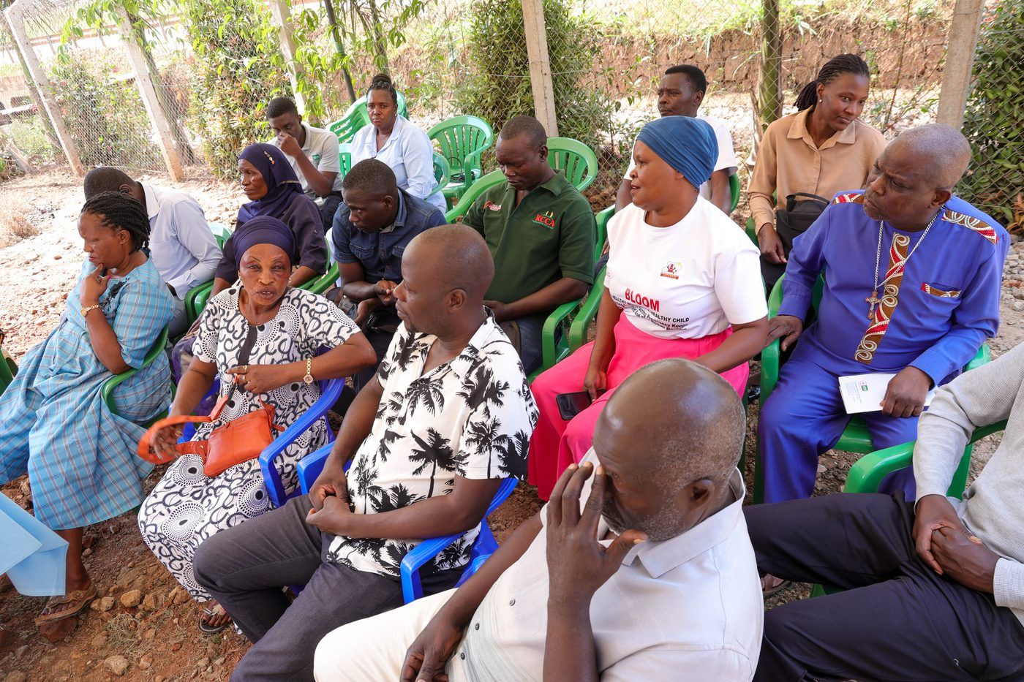
From community needs to lasting health impact
Epidemics are fought with skilled people. FairBanks will back our fellow completely so Africa CDC's investment returns to communities.
We ask for selection into the 2026–2028 AES cohort.
Your health, our mission.
Aligned with: https://opportunitiesforyouth.org/2026/07/16/africa-cdc-african-epidemic-services-aes-epidemiology-fellowship-2026-2028-fully-funded-apply-by-26-august-2026/

