AUC Venture Lab Women Innovation Fellowship 2026
Win-Win Application Pack
FairBanks Community Health Intelligence Platform (FCHIP)
Women-led HealthTech ready for leadership, networks, and investment readiness
Your health, our mission.
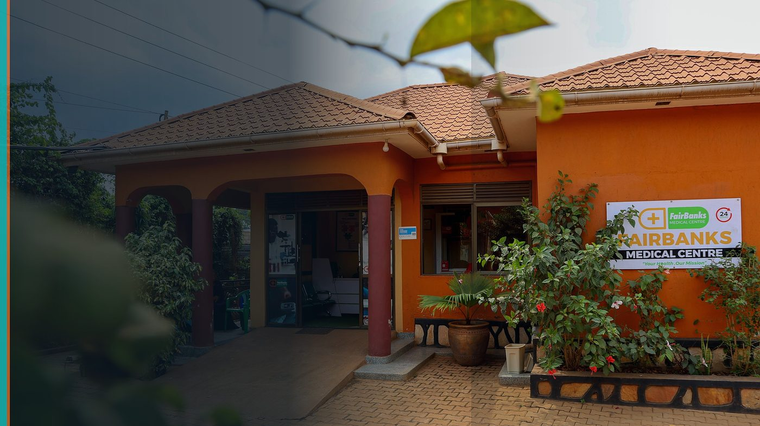
FairBanks Community Reach — Health for All — Obulamu eri Bonna · Afya kwa Wote · Oburamu bwa Boona
Item | Detail
Applicant | FairBanks / FCHIP — woman-led community health venture, Uganda
Programme | AUC Venture Lab Women Innovation Fellowship 2026
Deadline | 25 July 2026
Geography | Uganda base · Fellowship in Cairo (Egypt–Denmark ecosystem)
The ask | Select our founder/team for the Women Innovation Fellowship cohort (1 Sep–31 Oct 2026).

https://opportunitiesforyouth.org/2026/07/16/auc-venture-lab-women-innovation-fellowship-empowering-women-entrepreneurs-in-egypt-and-beyond/

1. Executive Summary
FairBanks is building FCHIP — a community health intelligence platform that helps African communities move from reactive treatment to proactive prevention.
A woman-led HealthTech venture rooted in a live medical centre and CHW outreach needs exactly what this fellowship offers: leadership training, mentorship, ecosystem access, and cross-regional exposure.
Selecting FairBanks gives AUC Venture Lab a grounded African case study in deep-tech HealthTech — and gives our team the networks to grow responsibly across East Africa.
2. Win-Win Value
This application is designed as a true partnership: FairBanks grows capacity and reach; the programme advances its own mission with a grounded African health-tech partner.
2.1 What FairBanks / FCHIP gains
- Leadership and investment-readiness coaching for a woman founder
- Access to Egypt–Denmark innovation networks and mentors
- Visibility that opens follow-on partners and capital conversations
- Peer learning with other women innovators across sectors
2.2 What the programme / partners gain
- A real HealthTech / AI venture already serving communities in Uganda
- Storytelling power: deep tech rooted in African primary care, not imported soft services
- Contribution to gender-inclusive innovation across Africa and beyond Egypt
- Alumni potential that can mentor future women founders in HealthTech
3. The Problem We Address
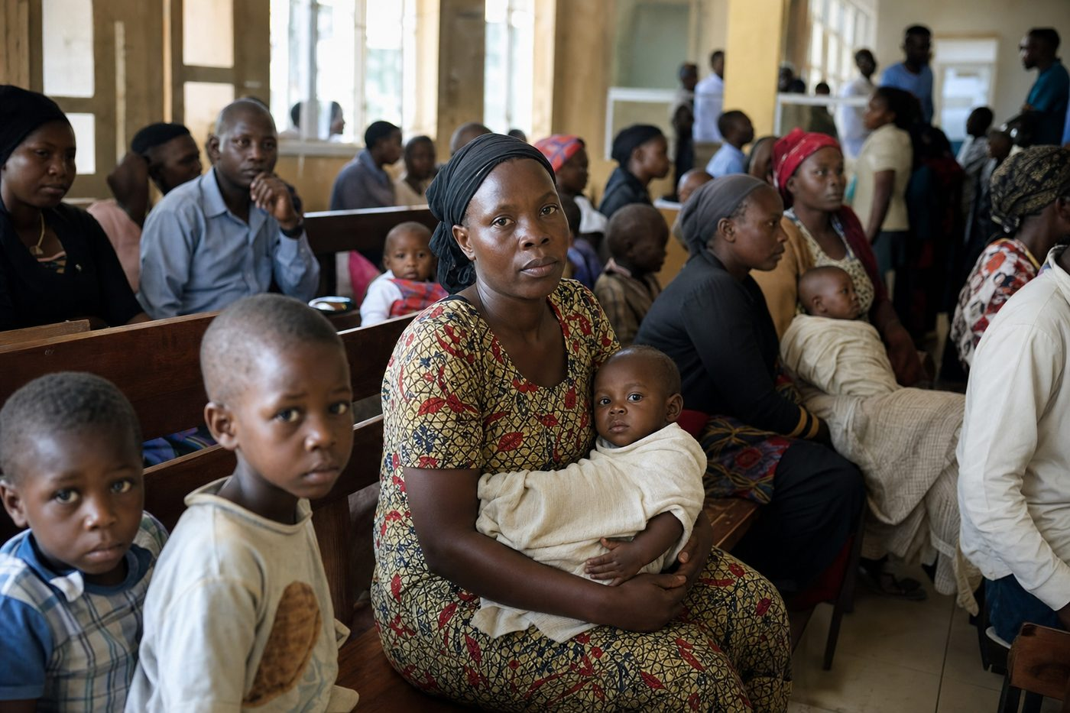
Reactive care waits for sickness before it responds
Women founders in African HealthTech face a double gap: building hard technology while also accessing leadership networks that are still uneven.
Without structured mentorship and regional exposure, promising community-health platforms stay local and underfunded — even when the need is urgent.
4. Our Solution: FCHIP & Community Reach
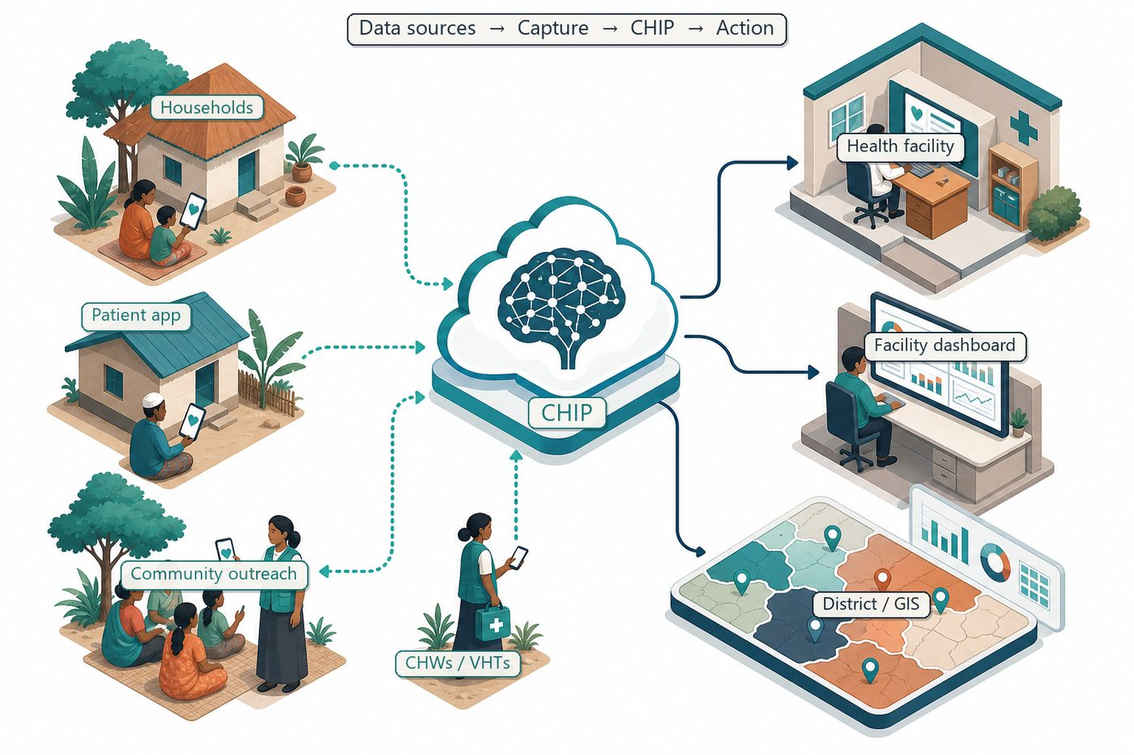
Community signals → capture → FCHIP intelligence → action
FCHIP connects CHWs, clinics, and partners through mobile capture, AI prediction, and GIS dashboards.
The fellowship will sharpen how we pitch, partner, and scale this women-led deep-tech story without losing our community-first roots.
4.1 Deep technology core
Technology | Role
Artificial Intelligence | Outbreak early warning; maternal and NCD risk scoring
Machine Learning | Learn from community patterns, seasons, and outreach outcomes
GIS Mapping | Disease distribution, hotspots, and resource gaps
Mobile Data Collection | Offline-capable CHW/VHT capture at household level
Cloud Computing | Secure sync across facilities and partners
Analytics Dashboards | Real-time views for clinics, districts, and NGOs

4.2 Priority use cases for this call
Maternal health: Home-visit signals flag high-risk pregnancies before complications.
Disease surveillance: Fever clusters trigger early malaria / outbreak response.
NCD hotspots: Community BP and glucose data guide targeted screening.
5. Fit to Programme Criteria
Criterion / theme | How we respond
Women entrepreneurs & innovators | Woman-led HealthTech venture with a clear founder growth need
HealthTech / AI / sustainability | FCHIP is AI + community data for preventive primary care
Leadership & ecosystem access | We seek coaching, mentors, and Egypt–Denmark exposure
Beyond Egypt eligibility | Ugandan women innovators are eligible; we bring East Africa context

6. Why FairBanks Is Ready
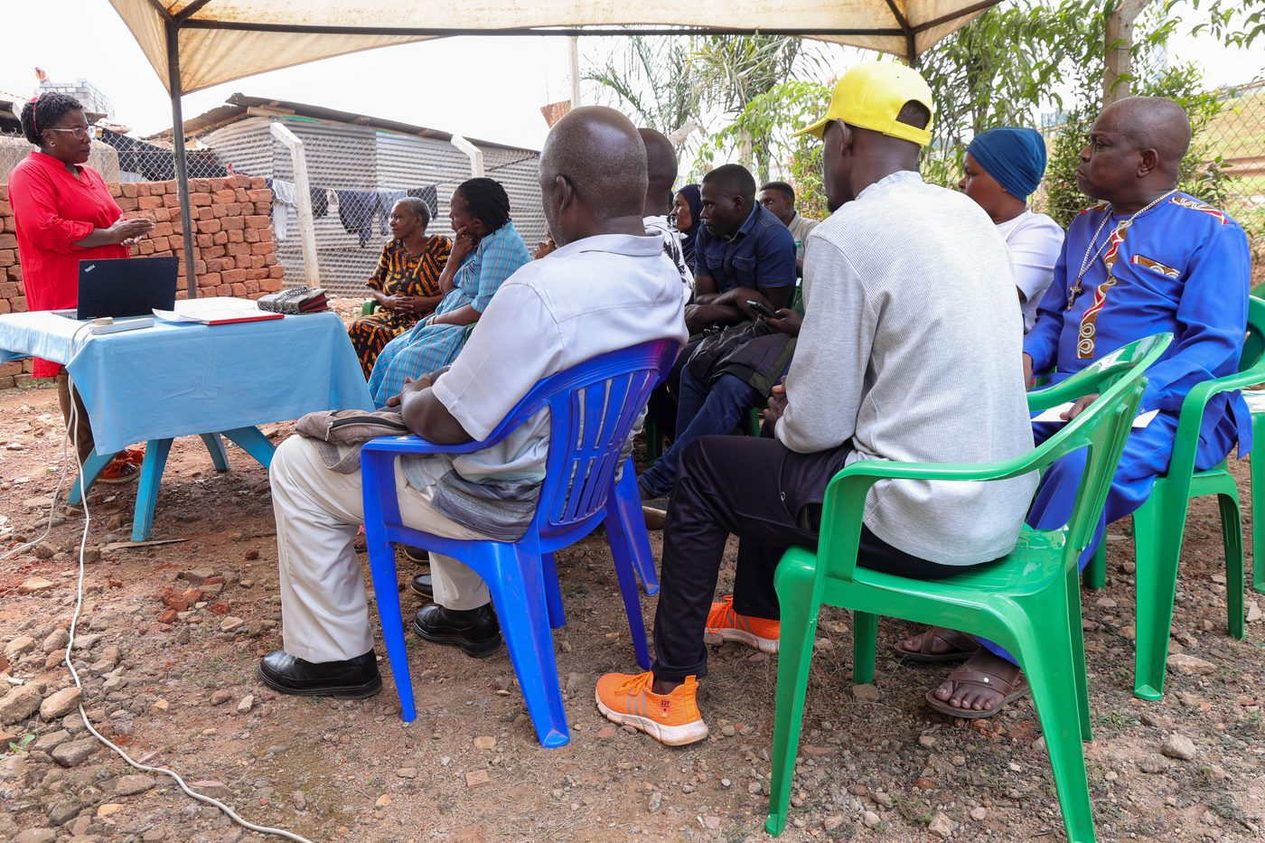
Live outreach in Kampala-area communities
- Functioning FairBanks Medical Centre with clinic, pharmacy, and diagnostics
- Active Community Reach outreach in Bukoto, Kyebando, Kisaasi, Kamwokya, Kikaaya
- Trusted CHW and VHT relationships for household visits and referrals
- Live programmes: maternal & child health, Gericare, chronic-disease screening
- Digital health records and outreach data ready to feed FCHIP
- Research and partnership mindset for ethical, evidence-based scale
7. Proposed Plan
- Attend the full Cairo fellowship (1 Sep–31 Oct 2026) with focus on leadership and fundraising readiness
- Translate FairBanks Community Reach cascade into investor-ready narrative and metrics
- Map partnership opportunities with mentors and peers for CHW tools and district pilots
- Return with a 90-day execution plan for FCHIP MVP milestones in Kampala catchments
8. Risks & Safeguards
Risk | Mitigation
Data quality in the field | Structured forms, validation, CHW training and supervision
Low digital literacy | Simple offline UX, local-language support, supervised rollout
Privacy and consent | Ethical governance aligned with Uganda data protection rules
Adoption by partners | Co-design with CHWs, clinics, and district users from day one

9. Closing Ask
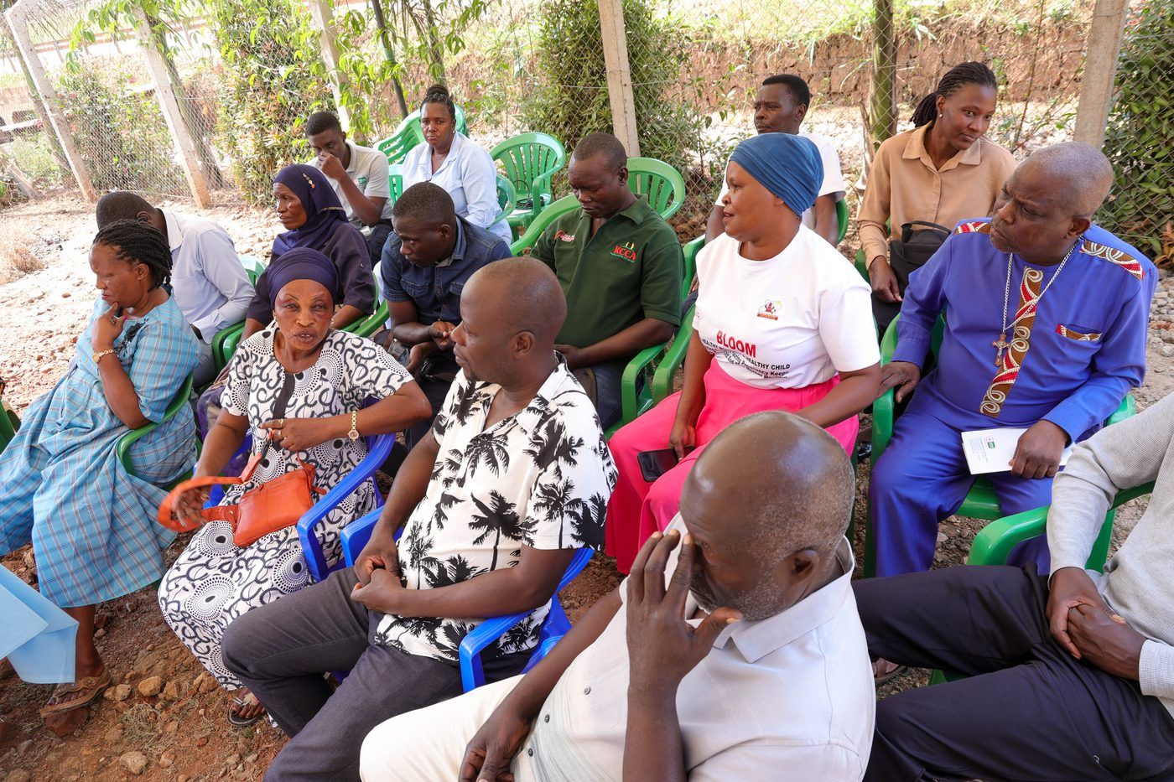
From community needs to lasting health impact
AUC Venture Lab invests in women who will shape Africa's innovation future. FairBanks offers a live HealthTech platform and a community to prove impact.
We ask to join the 2026 Women Innovation Fellowship so we can grow as leaders while advancing health for all.
Your health, our mission.
Aligned with: https://opportunitiesforyouth.org/2026/07/16/auc-venture-lab-women-innovation-fellowship-empowering-women-entrepreneurs-in-egypt-and-beyond/

