AUDA-NEPAD Youth SRH Ambassadors Initiative 2026
Win-Win Application Pack
Youth SRH Ambassadors for Community Health Intelligence
Advocacy and mobilisation powered by FairBanks community reach
Your health, our mission.
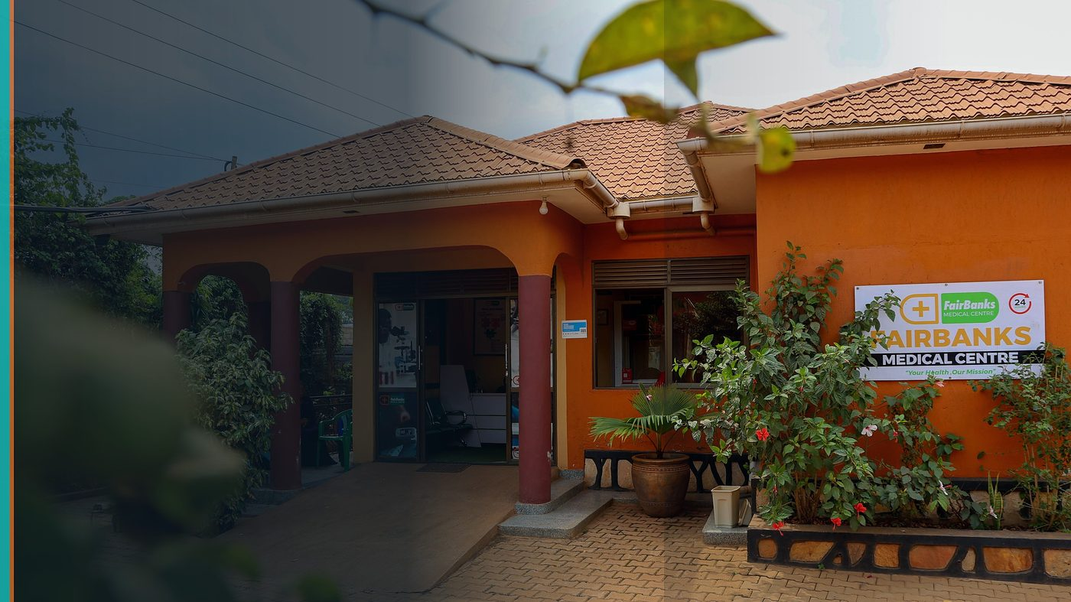
FairBanks Community Reach — Health for All — Obulamu eri Bonna · Afya kwa Wote · Oburamu bwa Boona
Item | Detail
Applicant | Eligible FairBanks youth (18–35) — Uganda · voluntary ambassador role
Programme | AUDA-NEPAD Youth SRH Ambassadors Initiative 2026
Deadline | 17 July 2026 (closing)
Geography | Uganda · African Union youth SRH network
The ask | Appoint FairBanks youth as AUDA-NEPAD Youth SRH Ambassadors.

https://opportunitiesforyouth.org/2026/06/13/african-union-youth-srh-ambassadors-initiative-2026-apply-to-become-an-auda-nepad-youth-srh-ambassador/

1. Executive Summary
AUDA-NEPAD is recruiting young Africans as voluntary Sexual and Reproductive Health ambassadors for advocacy, awareness, and community mobilisation.
FairBanks already runs community outreach that touches adolescent and maternal health — so our youth can amplify AU messages with real community channels.
This is a win-win: ambassadors gain recognition and training; AUDA-NEPAD gains Uganda-based advocates with digital presence and field access.
2. Win-Win Value
This application is designed as a true partnership: FairBanks grows capacity and reach; the programme advances its own mission with a grounded African health-tech partner.
2.1 What FairBanks / FCHIP gains
- Continental recognition and mentorship for FairBanks youth
- Training that strengthens our adolescent and maternal health messaging
- Network access across African Union youth health spaces
- Sponsored participation opportunities in selected events
2.2 What the programme / partners gain
- Ambassadors embedded in a live community health organisation
- Channels to CHWs, schools, and outreach events in Kampala communities
- Digital storytelling grounded in real SRH service pathways
- Diverse regional representation from East Africa / Uganda
3. The Problem We Address
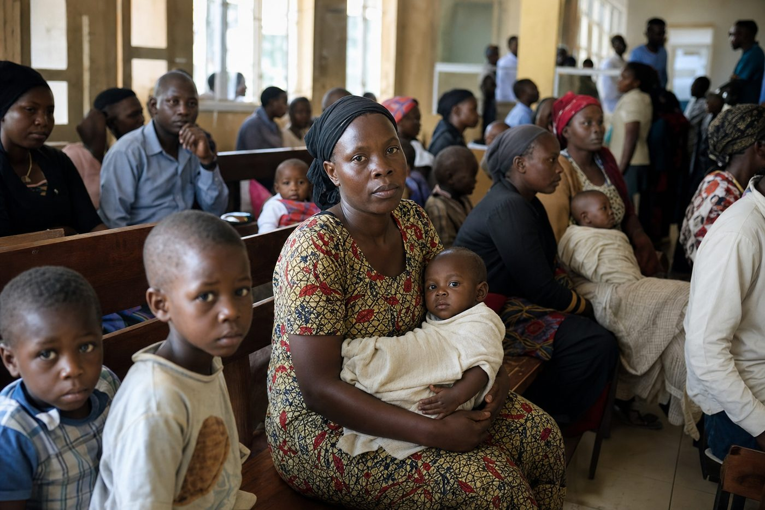
Reactive care waits for sickness before it responds
SRH information often fails to reach young people where they live — or arrives without a trusted referral path to care.
Ambassadors need more than slogans: they need community platforms and health partners.
4. Our Solution: FCHIP & Community Reach
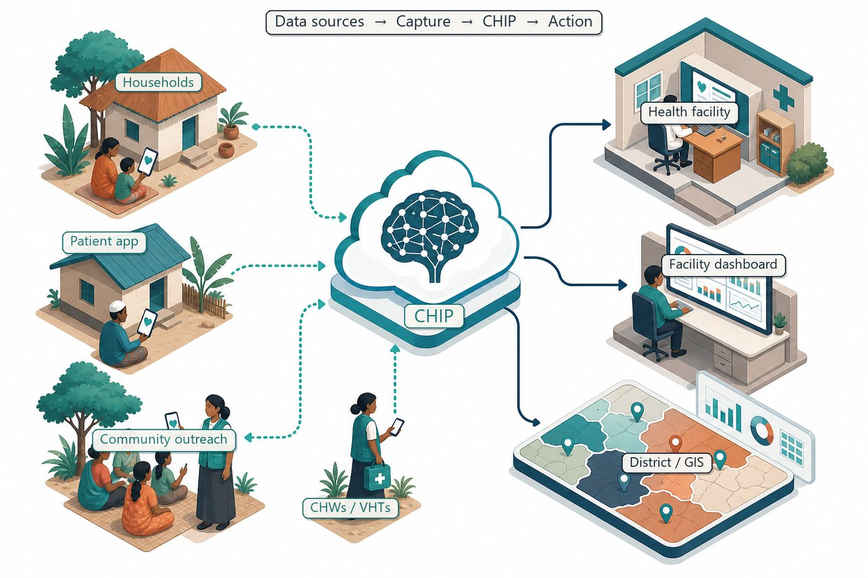
Community signals → capture → FCHIP intelligence → action
FairBanks youth ambassadors will pair AUDA-NEPAD advocacy with Community Reach dialogues, school health touchpoints, and clear referral to clinical care.
Where appropriate, FCHIP data (with privacy safeguards) can show where adolescent health gaps are rising — so advocacy targets the right places.
4.1 Deep technology core
Technology | Role
Artificial Intelligence | Outbreak early warning; maternal and NCD risk scoring
Machine Learning | Learn from community patterns, seasons, and outreach outcomes
GIS Mapping | Disease distribution, hotspots, and resource gaps
Mobile Data Collection | Offline-capable CHW/VHT capture at household level
Cloud Computing | Secure sync across facilities and partners
Analytics Dashboards | Real-time views for clinics, districts, and NGOs

4.2 Priority use cases for this call
Community dialogues: Youth-led SRH sessions linked to FairBanks outreach.
Digital advocacy: Responsible content that drives people to care, not panic.
Referral bridge: Ambassadors connect peers to CHWs and clinic services.
5. Fit to Programme Criteria
Criterion / theme | How we respond
Ages 18–35, AU citizens | Ugandan youth applicants in range
SRH commitment | Active in maternal / adolescent community health work
Digital presence | Team can maintain responsible advocacy channels
Voluntary service | Clear understanding: recognition and training, not a salary

6. Why FairBanks Is Ready
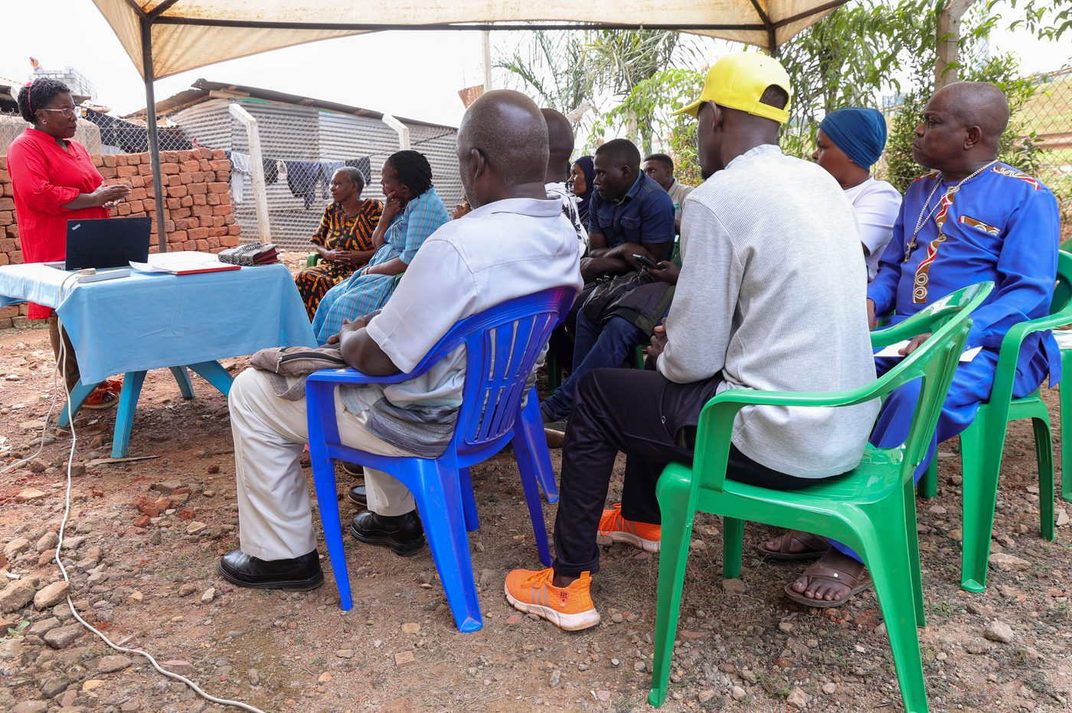
Live outreach in Kampala-area communities
- Functioning FairBanks Medical Centre with clinic, pharmacy, and diagnostics
- Active Community Reach outreach in Bukoto, Kyebando, Kisaasi, Kamwokya, Kikaaya
- Trusted CHW and VHT relationships for household visits and referrals
- Live programmes: maternal & child health, Gericare, chronic-disease screening
- Digital health records and outreach data ready to feed FCHIP
- Research and partnership mindset for ethical, evidence-based scale
7. Proposed Plan
- Complete ambassador onboarding and training requirements
- Run quarterly SRH awareness moments inside FairBanks outreach calendars
- Report activity and learning back to AUDA-NEPAD as required
- Protect privacy and avoid sharing identifiable patient data in advocacy
8. Risks & Safeguards
Risk | Mitigation
Data quality in the field | Structured forms, validation, CHW training and supervision
Low digital literacy | Simple offline UX, local-language support, supervised rollout
Privacy and consent | Ethical governance aligned with Uganda data protection rules
Adoption by partners | Co-design with CHWs, clinics, and district users from day one

9. Closing Ask
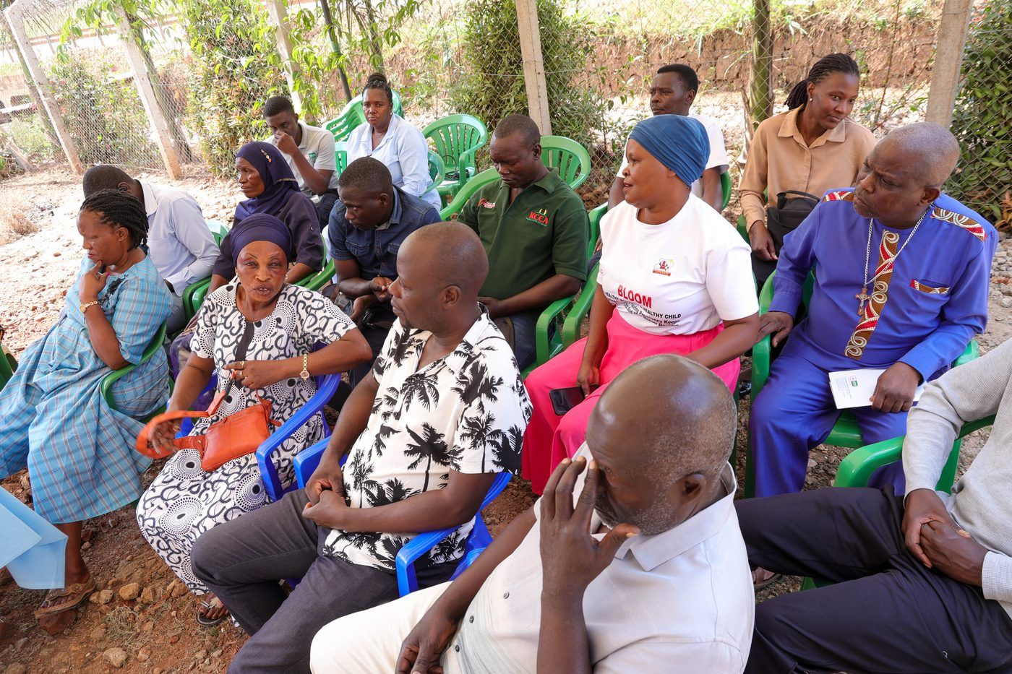
From community needs to lasting health impact
AUDA-NEPAD needs youth who can move communities. FairBanks youth already work inside those communities.
We ask for appointment as Youth SRH Ambassadors so continental goals meet local action.
Your health, our mission.
Aligned with: https://opportunitiesforyouth.org/2026/06/13/african-union-youth-srh-ambassadors-initiative-2026-apply-to-become-an-auda-nepad-youth-srh-ambassador/

