U.S. Dept of State — Uganda Health System MOU (DFOP0017890)
Win-Win Application Pack
Scaling Community Health Intelligence for Uganda
Statement of Interest: digital health, community systems, and accountable care
Your health, our mission.
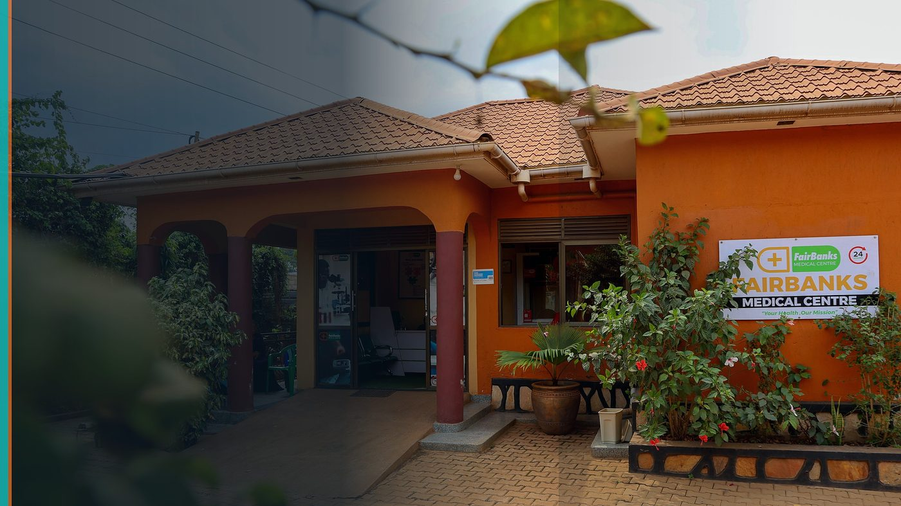
FairBanks Community Reach — Health for All — Obulamu eri Bonna · Afya kwa Wote · Oburamu bwa Boona
Item | Detail
Applicant | FairBanks Medical Centre / FairBanks Community Reach — Uganda
Programme | U.S. Dept of State — Uganda Health System MOU (DFOP0017890)
Deadline | 31 July 2026 (Statement of Interest, 5:00 PM EDT)
Geography | Uganda (national digital health & community health alignment)
The ask | Invite FairBanks to submit a full application under Objective 4 (digital health) and related community tracks.

https://opportunitiesforyouth.org/2026/06/15/u-s-department-of-state-launches-up-to-60-million-funding-opportunity-to-strengthen-ugandas-health-system-through-the-health-foreign-assistance-mou-implementation-plan/

1. Executive Summary
The U.S.–Uganda Health MOU opens up to $60M across ~15 awards to strengthen Uganda's health system. Objective 4 funds scaling digital health systems including EMRs, DHIS2, eCHIS, iHRIS, and the national data warehouse.
FCHIP is designed as a community intelligence layer that can complement national systems — feeding cleaner CHW data, early warnings, and facility decision support.
A Statement of Interest from FairBanks offers the U.S. and Uganda a private-sector community partner with live operations — not a slide-deck-only vendor.
2. Win-Win Value
This application is designed as a true partnership: FairBanks grows capacity and reach; the programme advances its own mission with a grounded African health-tech partner.
2.1 What FairBanks / FCHIP gains
- Pathway to multi-year partnership funding for digital community health
- Alignment with national systems (eCHIS / DHIS2 / data warehouse)
- Capacity to scale beyond Kampala catchments
- Stronger governance, M&E, and compliance muscle
2.2 What the programme / partners gain
- Ugandan implementer with clinic + CHW footprint already in motion
- Contribution to Objective 4 digital health scaling goals
- Community-based complementary data that improves facility and district action
- Potential links to community financing, faith/community facilities, and supply accountability tracks
3. The Problem We Address
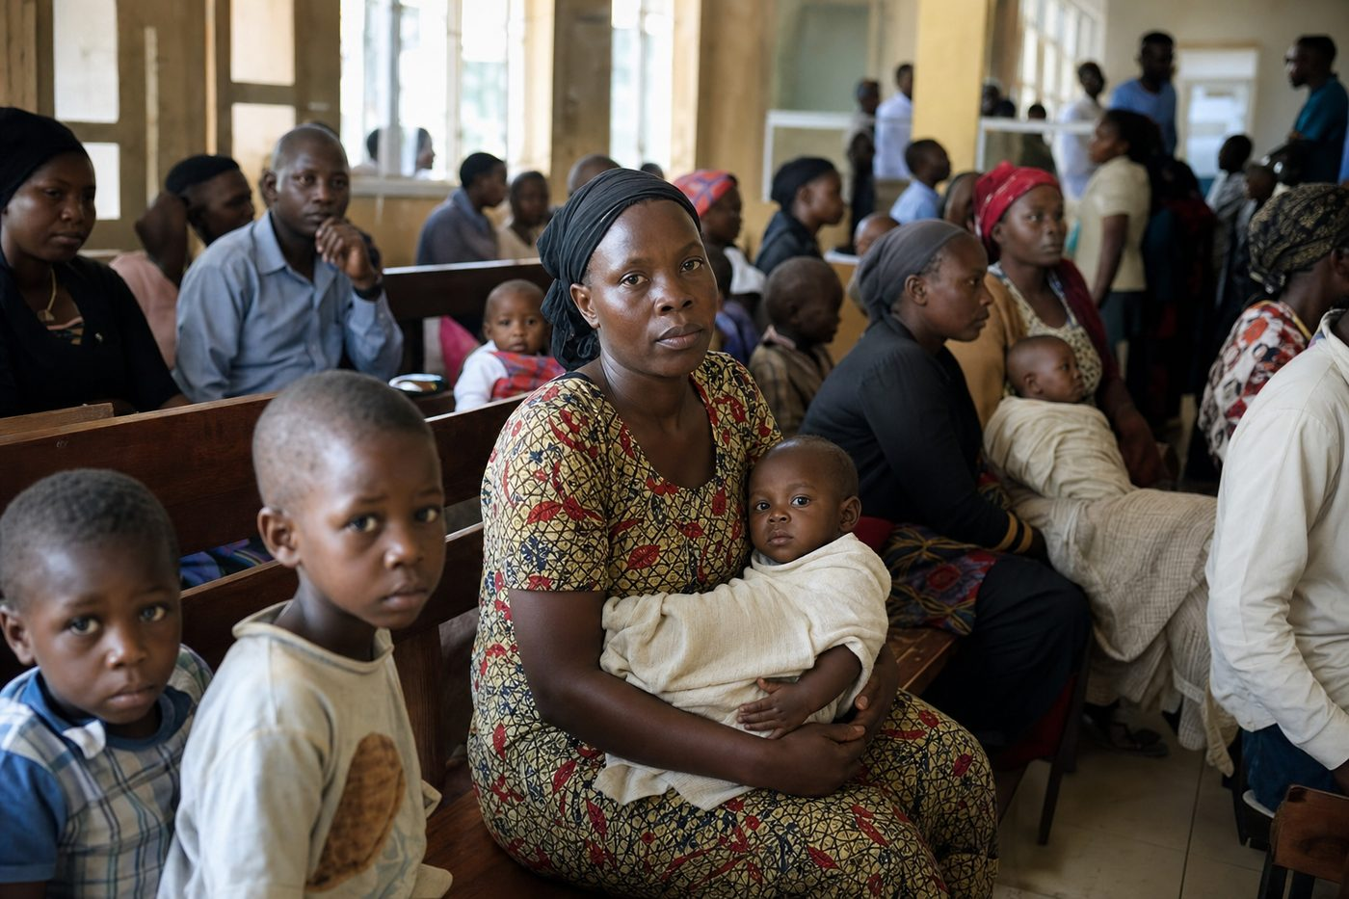
Reactive care waits for sickness before it responds
Uganda's digital health stack is advancing, but community-generated signals still arrive late or incompletely — limiting outbreak response, maternal risk management, and medicine planning.
Scaling digital tools without trusted community partners leaves last-mile gaps.
4. Our Solution: FCHIP & Community Reach
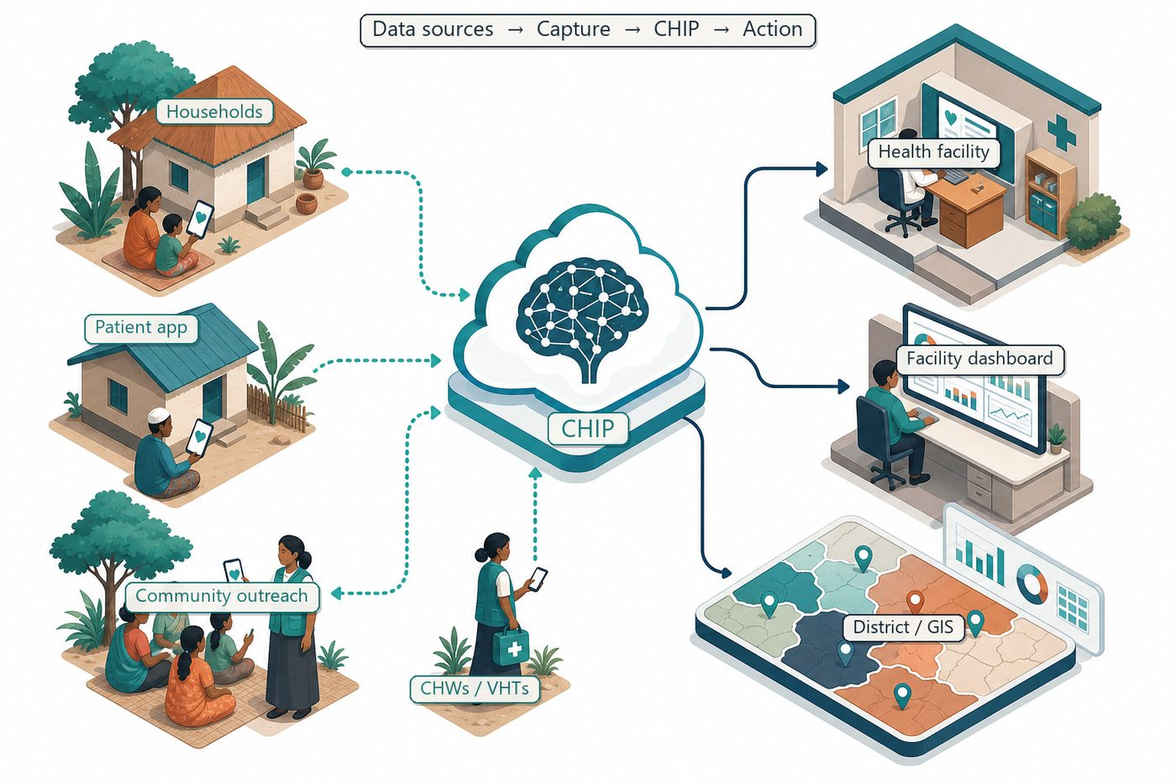
Community signals → capture → FCHIP intelligence → action
FairBanks proposes FCHIP as a community intelligence complement: mobile CHW capture interoperable with national reporting where permitted, predictive alerts, GIS views, and facility dashboards.
We start from live FairBanks operations, then partner outward with districts and public programmes under MOU priorities.
4.1 Deep technology core
Technology | Role
Artificial Intelligence | Outbreak early warning; maternal and NCD risk scoring
Machine Learning | Learn from community patterns, seasons, and outreach outcomes
GIS Mapping | Disease distribution, hotspots, and resource gaps
Mobile Data Collection | Offline-capable CHW/VHT capture at household level
Cloud Computing | Secure sync across facilities and partners
Analytics Dashboards | Real-time views for clinics, districts, and NGOs

4.2 Priority use cases for this call
eCHIS-aligned capture: Structured community forms that reduce double entry.
Surveillance support: Fever and maternal risk signals for earlier action.
Supply awareness: Demand signals that reduce avoidable stock-outs.
5. Fit to Programme Criteria
Criterion / theme | How we respond
Objective 4 — digital health | EMR/community data, analytics, interoperability intent
Ugandan organisations | Local medical centre and community programmes
Two-step process | This pack supports a strong Statement of Interest
Five-year systems strengthening | Roadmap from pilot catchment to district partnership

6. Why FairBanks Is Ready
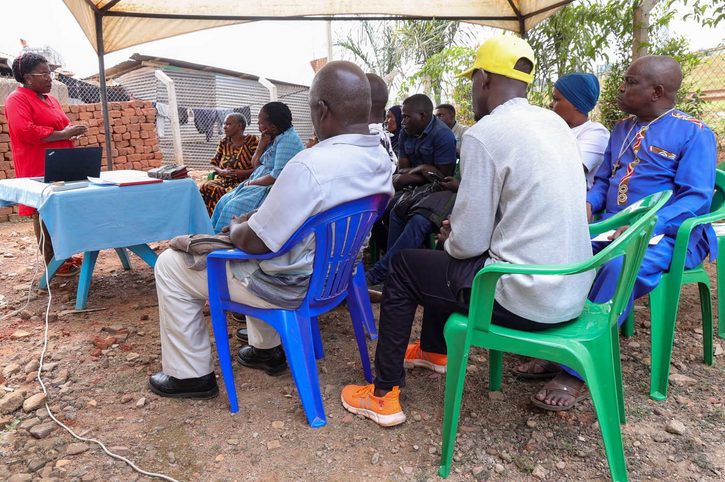
Live outreach in Kampala-area communities
- Functioning FairBanks Medical Centre with clinic, pharmacy, and diagnostics
- Active Community Reach outreach in Bukoto, Kyebando, Kisaasi, Kamwokya, Kikaaya
- Trusted CHW and VHT relationships for household visits and referrals
- Live programmes: maternal & child health, Gericare, chronic-disease screening
- Digital health records and outreach data ready to feed FCHIP
- Research and partnership mindset for ethical, evidence-based scale
7. Proposed Plan
Phase / step | Detail
SOI (by 31 Jul 2026) | Submit concise Statement of Interest aligned to Objective 4
Full proposal (if invited) | Technical approach, consortium, budget, M&E, safeguarding
Year 1–2 | Pilot interoperability + predictive modules in FairBanks catchment
Year 3–5 | District partnerships and national reporting alignment

8. Indicative Resources
Item | Detail | Amount
Digital platform & interoperability | Capture, APIs, analytics, GIS | TBD in full proposal
CHW capacity & supervision | Training, devices, quality assurance | TBD
M&E and learning | Baselines, dashboards, reporting | TBD
Total | Within award band if selected among ~15 awards | Up to programme ceilings

9. Risks & Safeguards
Risk | Mitigation
Data quality in the field | Structured forms, validation, CHW training and supervision
Low digital literacy | Simple offline UX, local-language support, supervised rollout
Privacy and consent | Ethical governance aligned with Uganda data protection rules
Adoption by partners | Co-design with CHWs, clinics, and district users from day one

10. Closing Ask
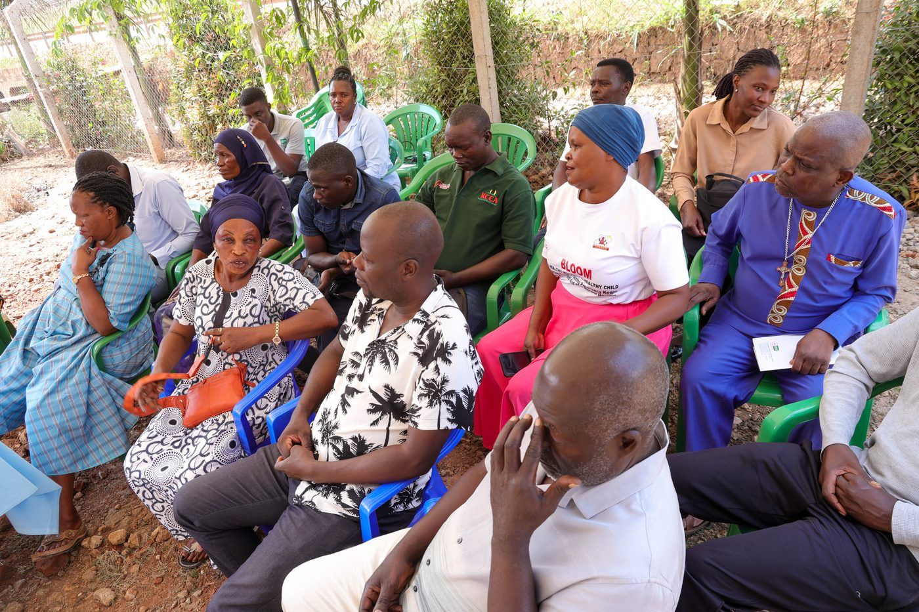
From community needs to lasting health impact
The MOU succeeds when digital health reaches communities, not only servers. FairBanks is ready to help close that gap.
We request consideration of our Statement of Interest for full application invitation.
Your health, our mission.
Aligned with: https://opportunitiesforyouth.org/2026/06/15/u-s-department-of-state-launches-up-to-60-million-funding-opportunity-to-strengthen-ugandas-health-system-through-the-health-foreign-assistance-mou-implementation-plan/

