Young Feminist AI School 2026 (UN Women)
Win-Win Application Pack
Gender-Responsive AI for Community Health
Practical AI skills that put women, girls, and mothers at the centre of FCHIP
Your health, our mission.
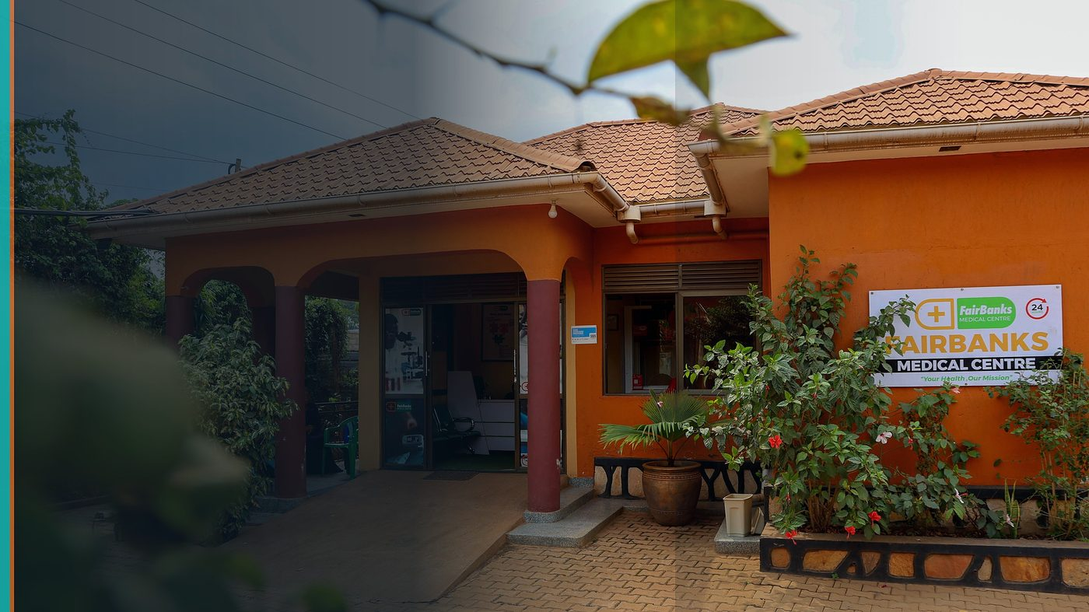
FairBanks Community Reach — Health for All — Obulamu eri Bonna · Afya kwa Wote · Oburamu bwa Boona
Item | Detail
Applicant | FairBanks team member(s) aged 18–30 — Uganda
Programme | Young Feminist AI School 2026 (UN Women)
Deadline | 28 July 2026
Geography | Fully online · Uganda participants eligible worldwide
The ask | Admit FairBanks youth / women team members to the 12-week AI School cohort.

https://opportunitiesforyouth.org/2026/07/16/ai-for-gender-equality-un-women-ai-school-opens-for-changemakers/

1. Executive Summary
UN Women's Young Feminist AI School builds practical, no-code AI skills for advocacy, policy, and civic tech — with most places reserved for young women and girls.
FairBanks needs exactly this capacity: gender-responsive AI applied to maternal health, adolescent health, and community data that too often ignores women's realities.
Selecting our team strengthens FCHIP's responsible AI practice and gives UN Women a live health use case from Uganda.
2. Win-Win Value
This application is designed as a true partnership: FairBanks grows capacity and reach; the programme advances its own mission with a grounded African health-tech partner.
2.1 What FairBanks / FCHIP gains
- Hands-on AI skills for young women on the FairBanks team
- Gender lens for FCHIP features (maternal risk, adolescent SRH, consent)
- A real project deliverable that can plug into community outreach
- Global peer network on feminist and responsible AI
2.2 What the programme / partners gain
- Participants who will apply skills immediately in community health
- A Uganda case study linking AI for gender equality to primary care
- Amplification through FairBanks Community Reach programmes
- Contribution to the 70%+ young women participation goal with serious applicants
3. The Problem We Address
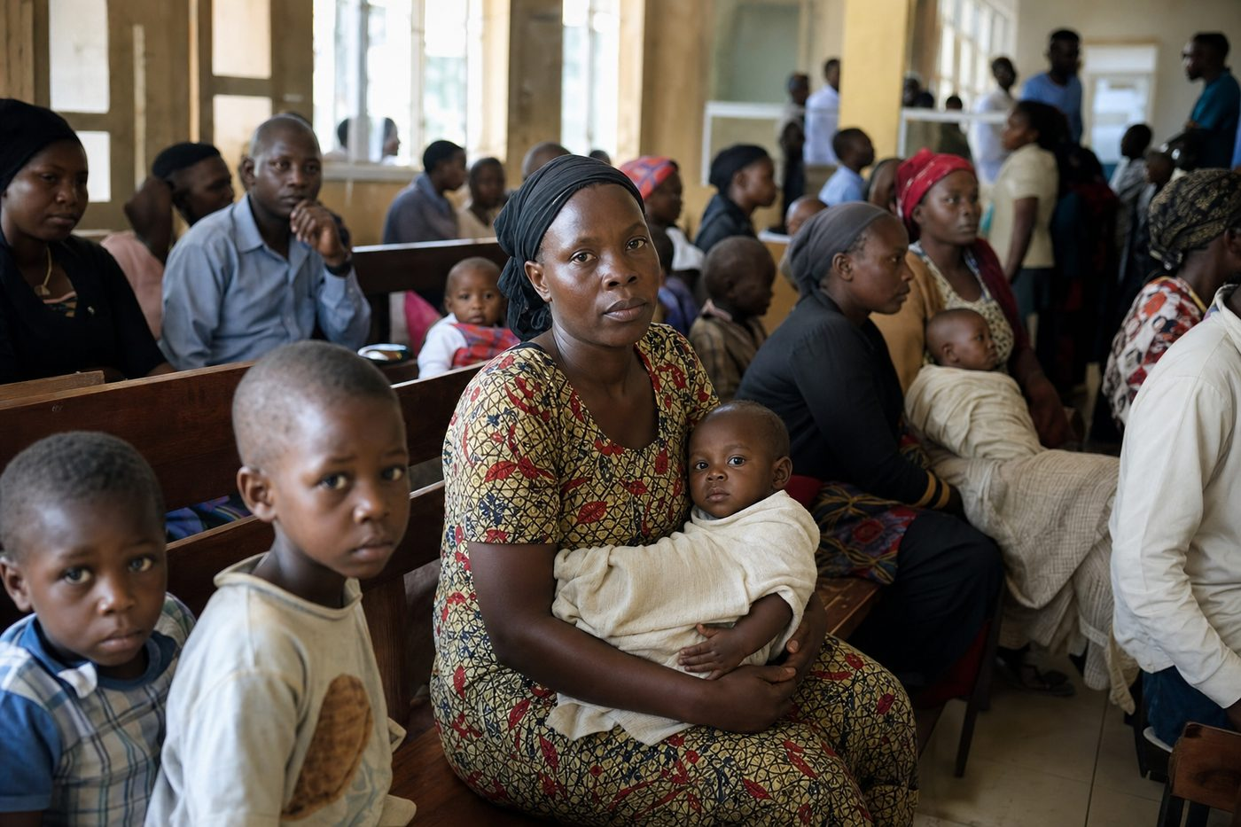
Reactive care waits for sickness before it responds
AI tools in health can deepen inequality if they ignore how women and girls experience care, consent, and unpaid caregiving.
Young changemakers need practical skills — not theory alone — to build gender-responsive systems.
4. Our Solution: FCHIP & Community Reach
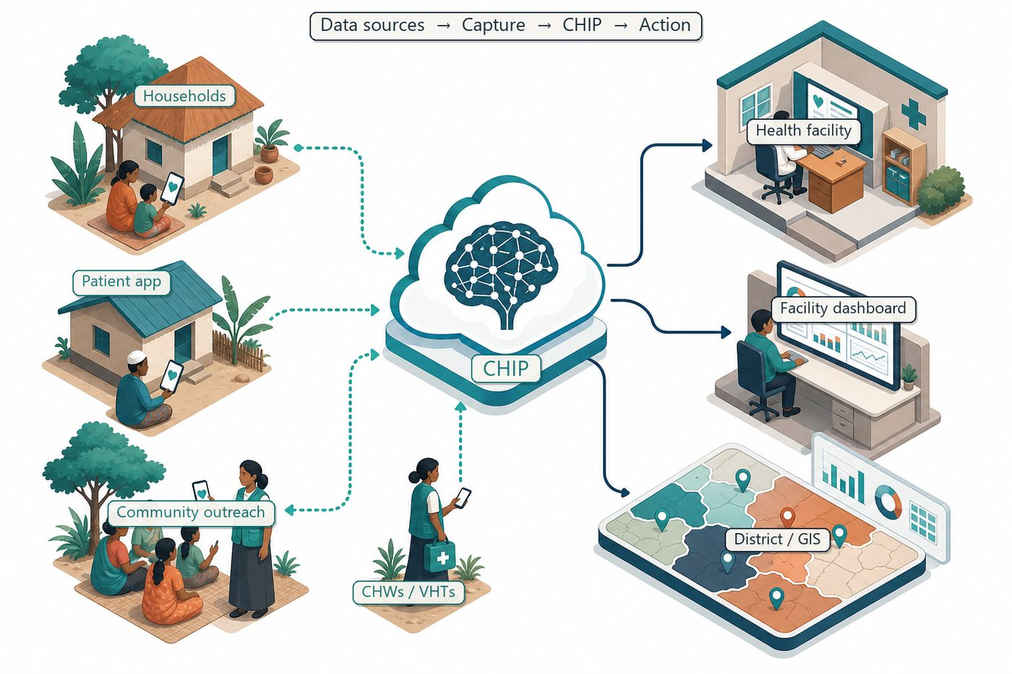
Community signals → capture → FCHIP intelligence → action
We will use the School's project track to design a gender-responsive AI workflow for FairBanks: safer maternal risk flags, clearer consent language, and community feedback loops.
Skills return to CHW training and FCHIP product decisions, not a one-off certificate.
4.1 Deep technology core
Technology | Role
Artificial Intelligence | Outbreak early warning; maternal and NCD risk scoring
Machine Learning | Learn from community patterns, seasons, and outreach outcomes
GIS Mapping | Disease distribution, hotspots, and resource gaps
Mobile Data Collection | Offline-capable CHW/VHT capture at household level
Cloud Computing | Secure sync across facilities and partners
Analytics Dashboards | Real-time views for clinics, districts, and NGOs

4.2 Priority use cases for this call
Maternal alerts: Risk scores explained in plain language for CHWs and mothers.
Adolescent health: Privacy-aware pathways for youth SRH education and referral.
Data dignity: Consent and feedback designed with women users, not about them.
5. Fit to Programme Criteria
Criterion / theme | How we respond
Ages 18–30 worldwide | Ugandan team members in range; women prioritised
No-code practical AI | We will ship a usable project for community health
Advocacy / civic / responsible AI | Health equity and gender-responsive product design
~4 hours weekly | Team can commit alongside FairBanks outreach duties

6. Why FairBanks Is Ready
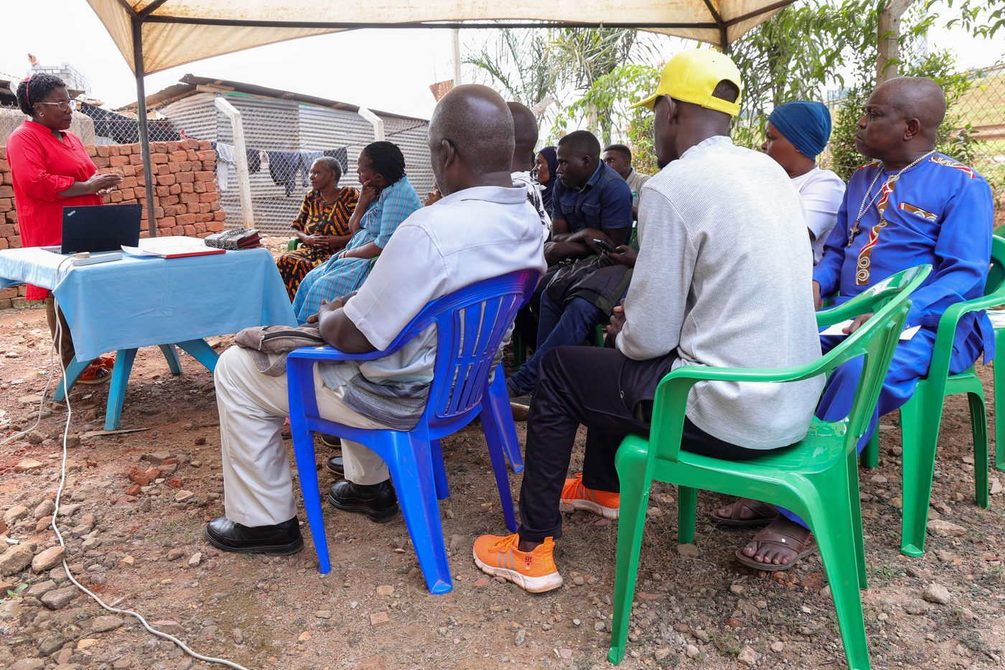
Live outreach in Kampala-area communities
- Functioning FairBanks Medical Centre with clinic, pharmacy, and diagnostics
- Active Community Reach outreach in Bukoto, Kyebando, Kisaasi, Kamwokya, Kikaaya
- Trusted CHW and VHT relationships for household visits and referrals
- Live programmes: maternal & child health, Gericare, chronic-disease screening
- Digital health records and outreach data ready to feed FCHIP
- Research and partnership mindset for ethical, evidence-based scale
7. Proposed Plan
- Complete all 12 weeks (Aug–Oct 2026) with full attendance
- Build a gender-responsive AI project tied to maternal / adolescent use cases
- Present findings to FairBanks clinical and CHW leads for adoption
- Share learnings back with UN Women alumni channels where useful
8. Risks & Safeguards
Risk | Mitigation
Data quality in the field | Structured forms, validation, CHW training and supervision
Low digital literacy | Simple offline UX, local-language support, supervised rollout
Privacy and consent | Ethical governance aligned with Uganda data protection rules
Adoption by partners | Co-design with CHWs, clinics, and district users from day one

9. Closing Ask
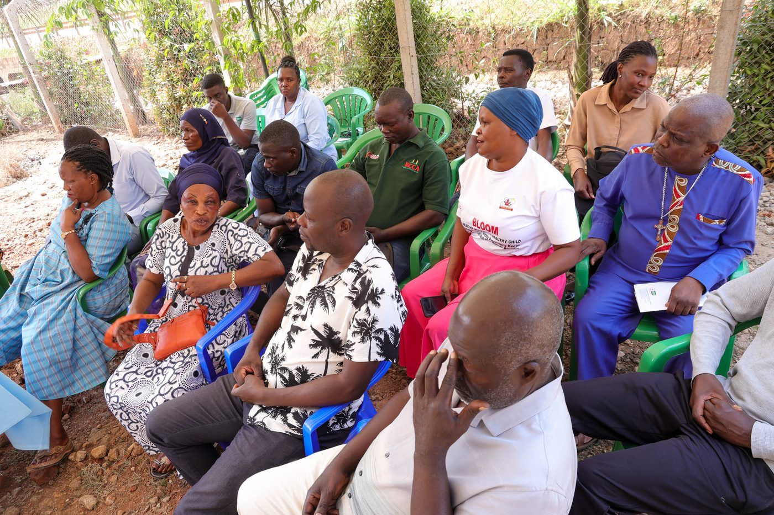
From community needs to lasting health impact
This School turns AI skill into justice. FairBanks will turn those skills into safer care for women and girls in our communities.
We respectfully request places for our eligible young women team members.
Your health, our mission.
Aligned with: https://opportunitiesforyouth.org/2026/07/16/ai-for-gender-equality-un-women-ai-school-opens-for-changemakers/

