The Gadfly Project Custom Web Application Grant 2026
Win-Win Application Pack
Build FCHIP Community Capture & Partner Dashboards
In-kind software development that expands community health impact
Your health, our mission.
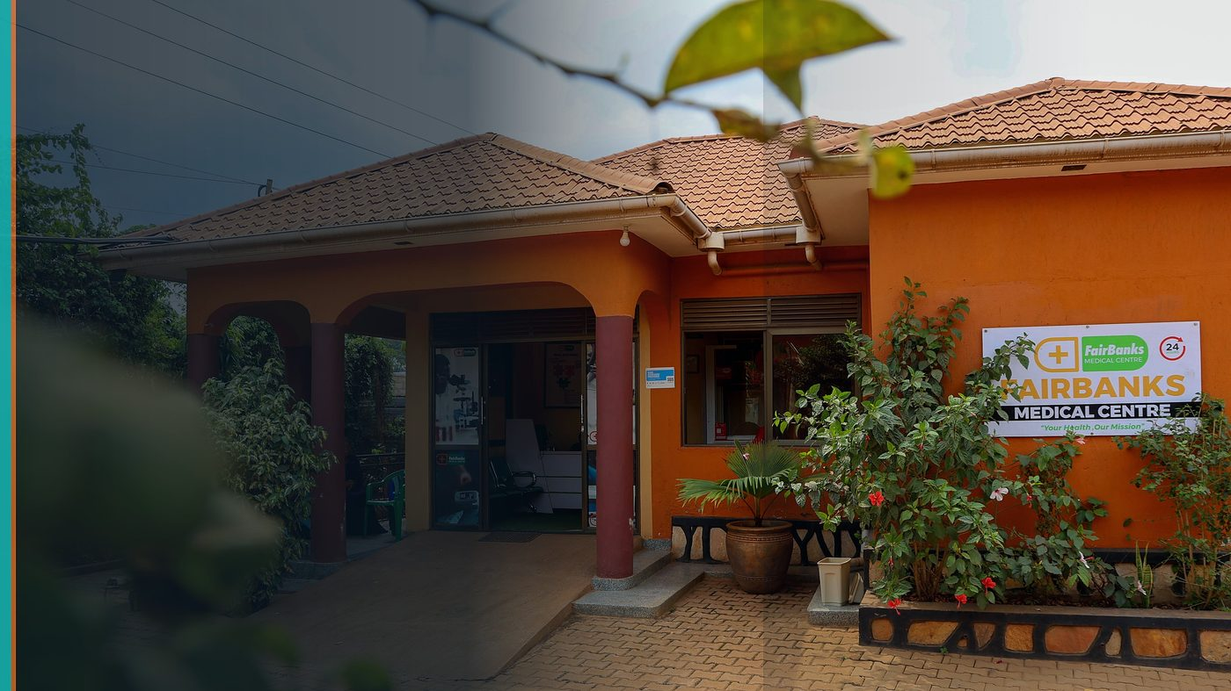
FairBanks Community Reach — Health for All — Obulamu eri Bonna · Afya kwa Wote · Oburamu bwa Boona
Item | Detail
Applicant | FairBanks Medical Centre / FairBanks Community Reach (social enterprise, Uganda)
Programme | The Gadfly Project Custom Web Application Grant 2026
Deadline | 24 July 2026 (next cycle 23 October 2026)
Geography | Uganda communities · web/cloud tools usable worldwide
The ask | Award in-kind engineering (valued toward US$5,000–100,000) to build FCHIP web and data tools.

https://opportunitiesforyouth.org/2026/07/16/the-gadfly-project-custom-web-application-grant-2026-apply-for-in-kind-software-development-support-worth-up-to-us100000/

1. Executive Summary
Gadfly funds impact through professional software development — not cash. That matches FairBanks: we have users, field workflows, and a clear product need.
We request in-kind build support for offline-friendly community capture, secure sync, and partner dashboards that turn CHW data into action.
Gadfly's engineers get a high-user, high-mission build; FairBanks communities get tools that prevent illness and hardship.
2. Win-Win Value
This application is designed as a true partnership: FairBanks grows capacity and reach; the programme advances its own mission with a grounded African health-tech partner.
2.1 What FairBanks / FCHIP gains
- Professional engineering capacity we cannot yet fund at full strength
- Faster delivery of CHW capture and partner dashboard MVP
- Cleaner architecture for later AI and GIS modules
- Reduced risk of brittle custom code built under field pressure
2.2 What the programme / partners gain
- Measurable users: CHWs, clinicians, and outreach teams already active
- Clear community impact story — prevention, referrals, stock awareness
- A social enterprise that will actually deploy and maintain the product
- Portfolio proof that in-kind software can change primary care access
3. The Problem We Address
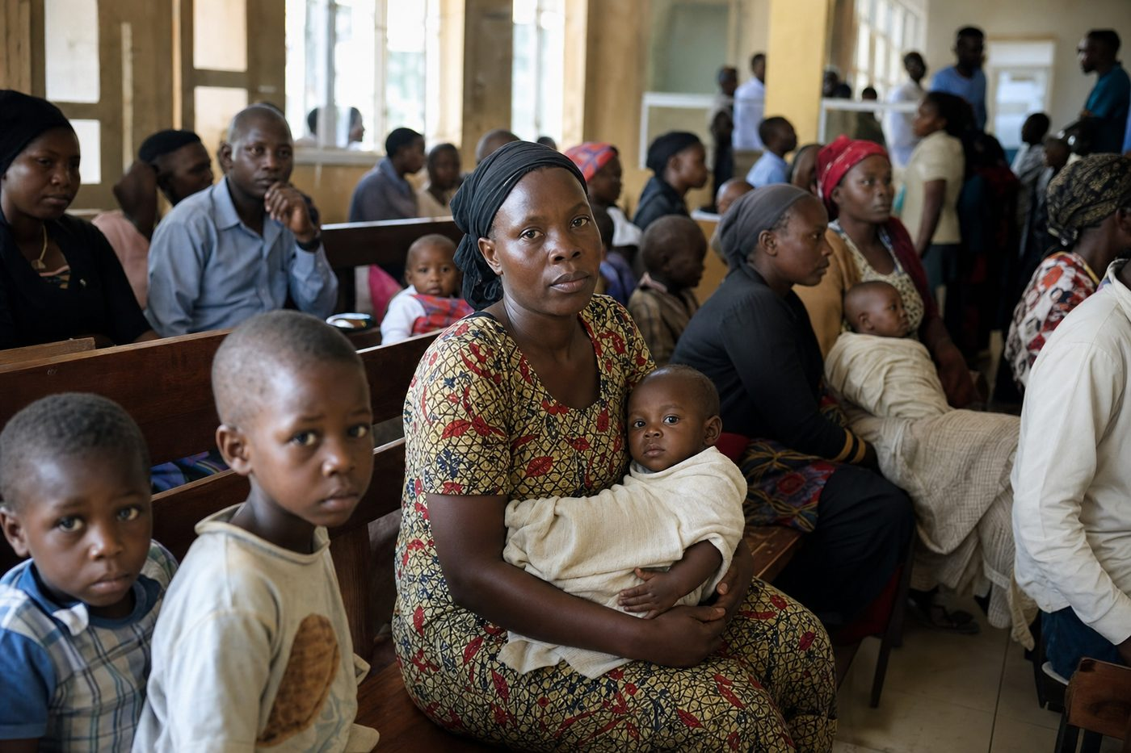
Reactive care waits for sickness before it responds
Our outreach still depends too much on paper and fragmented sheets. That slows referrals and hides emerging hotspots.
We do not need another brochure website — we need durable web/app infrastructure for community health workflows.
4. Our Solution: FCHIP & Community Reach
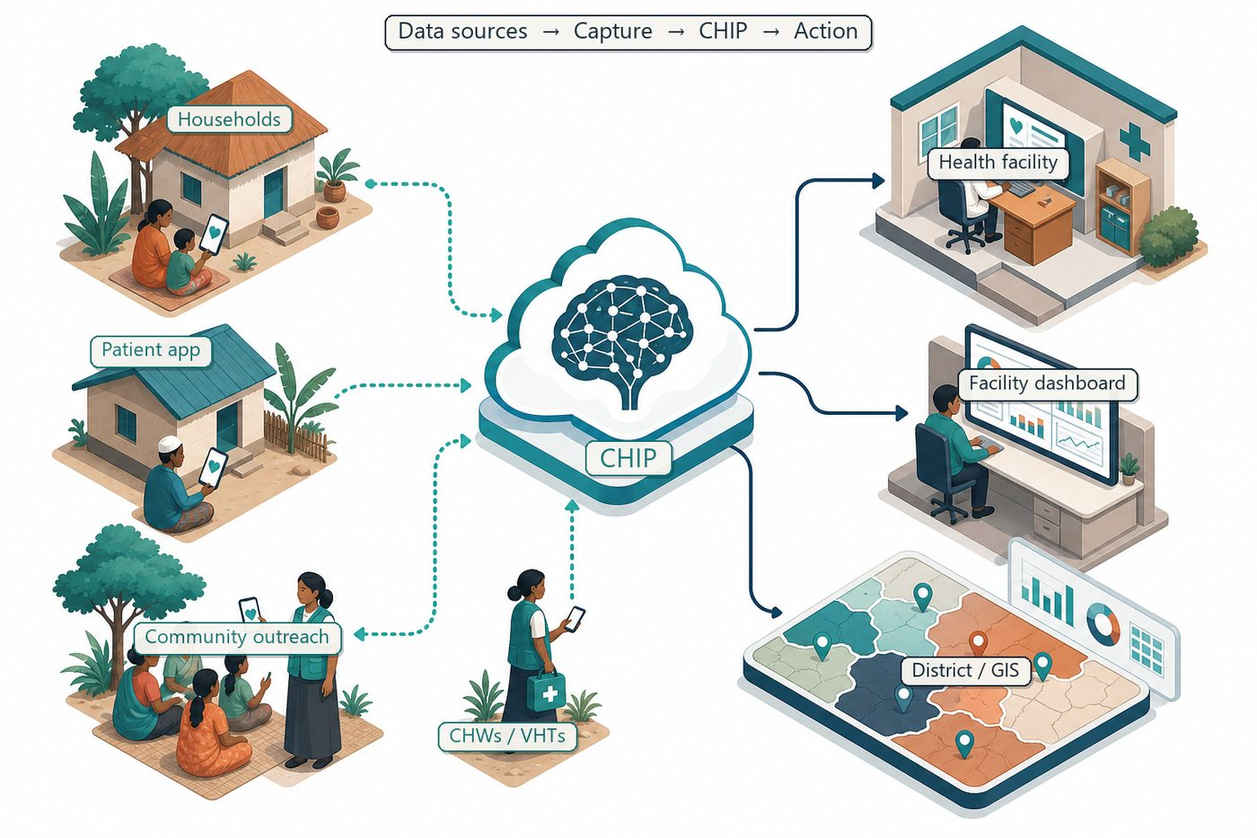
Community signals → capture → FCHIP intelligence → action
Scope for Gadfly: (1) CHW/VHT web/mobile-friendly capture with offline tolerance, (2) secure cloud sync, (3) role-based dashboards for clinic and programme managers, (4) export hooks for later AI models.
FairBanks provides clinical workflows, user testing with CHWs, and hosting/ops ownership after delivery.
4.1 Deep technology core
Technology | Role
Artificial Intelligence | Outbreak early warning; maternal and NCD risk scoring
Machine Learning | Learn from community patterns, seasons, and outreach outcomes
GIS Mapping | Disease distribution, hotspots, and resource gaps
Mobile Data Collection | Offline-capable CHW/VHT capture at household level
Cloud Computing | Secure sync across facilities and partners
Analytics Dashboards | Real-time views for clinics, districts, and NGOs

4.2 Priority use cases for this call
Household visit forms: Structured maternal, child, and NCD screening capture.
Referral tracker: See who was referred and who completed care.
Programme dashboard: Managers see coverage gaps by community.
5. Fit to Programme Criteria
Criterion / theme | How we respond
Mission-driven org | Community health social enterprise serving underserved areas
Custom web / databases | Capture + sync + dashboards are core Gadfly territory
Users served over complexity | Priority is CHW usability and community impact
Worldwide eligibility | Ugandan organisation qualifies

6. Why FairBanks Is Ready
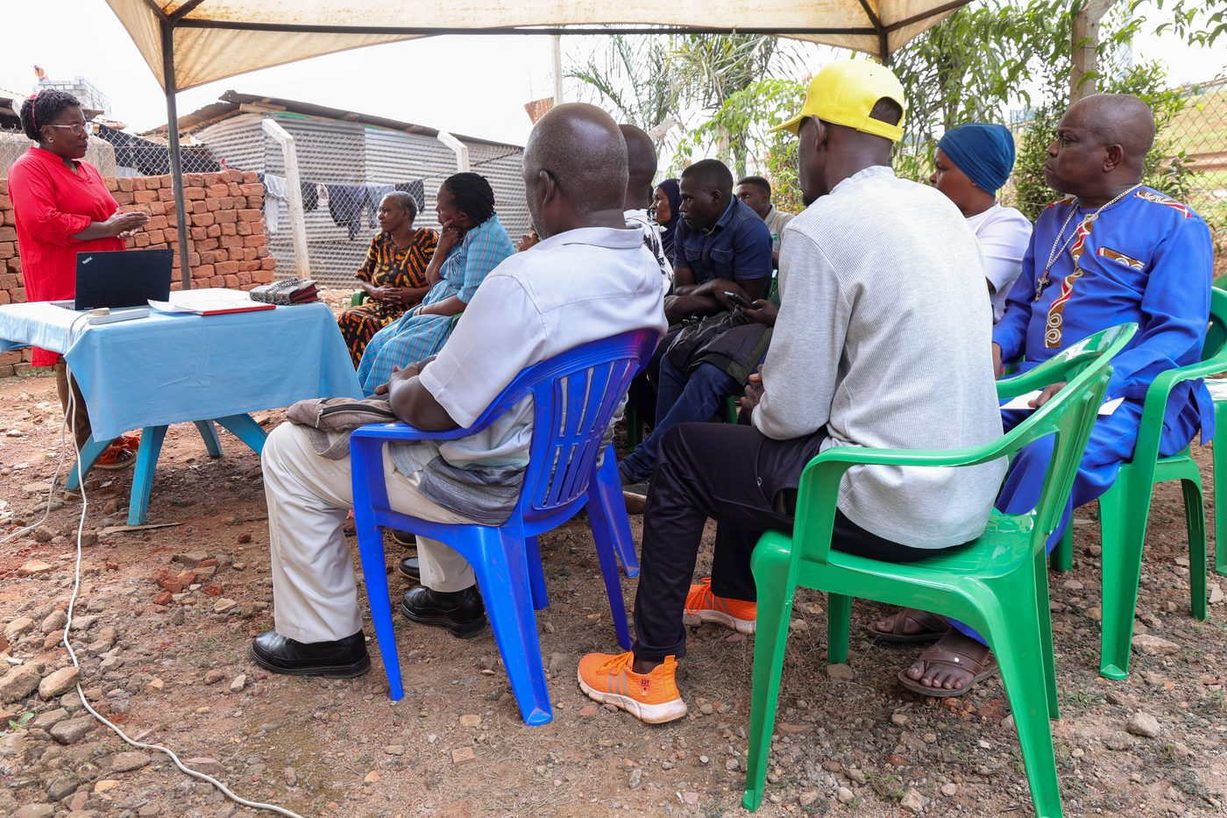
Live outreach in Kampala-area communities
- Functioning FairBanks Medical Centre with clinic, pharmacy, and diagnostics
- Active Community Reach outreach in Bukoto, Kyebando, Kisaasi, Kamwokya, Kikaaya
- Trusted CHW and VHT relationships for household visits and referrals
- Live programmes: maternal & child health, Gericare, chronic-disease screening
- Digital health records and outreach data ready to feed FCHIP
- Research and partnership mindset for ethical, evidence-based scale
7. Proposed Plan
Phase / step | Detail
Discovery (weeks 1–3) | Workflow mapping with CHWs and clinicians; prioritise MVP screens
Build (weeks 4–14) | Capture, sync, auth, dashboards; iterative field tests
Handover (weeks 15–18) | Docs, training, hosting handover, maintenance plan

8. Indicative Resources
Item | Detail | Amount
In-kind engineering | Gadfly team time for MVP build | In-kind
FairBanks counterpart | Clinical/product time, devices, hosting, training | In-kind + ops
Total cash ask | None — this is an in-kind grant | US$0

9. Risks & Safeguards
Risk | Mitigation
Data quality in the field | Structured forms, validation, CHW training and supervision
Low digital literacy | Simple offline UX, local-language support, supervised rollout
Privacy and consent | Ethical governance aligned with Uganda data protection rules
Adoption by partners | Co-design with CHWs, clinics, and district users from day one

10. Closing Ask
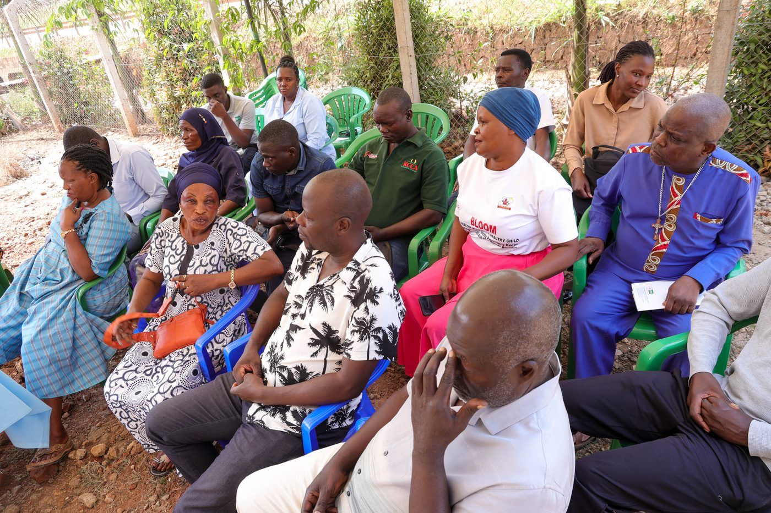
From community needs to lasting health impact
Gadfly multiplies mission through code. FairBanks will put that code in the hands of CHWs who already walk our communities.
We ask for selection in the current review cycle so communities benefit sooner.
Your health, our mission.
Aligned with: https://opportunitiesforyouth.org/2026/07/16/the-gadfly-project-custom-web-application-grant-2026-apply-for-in-kind-software-development-support-worth-up-to-us100000/

