GirlCode Hackathon 2026 — Kampala
Win-Win Application Pack
FCHIP Hack Challenge: AI for Community Health
Women builders prototype tools that help CHWs act before crises
Your health, our mission.
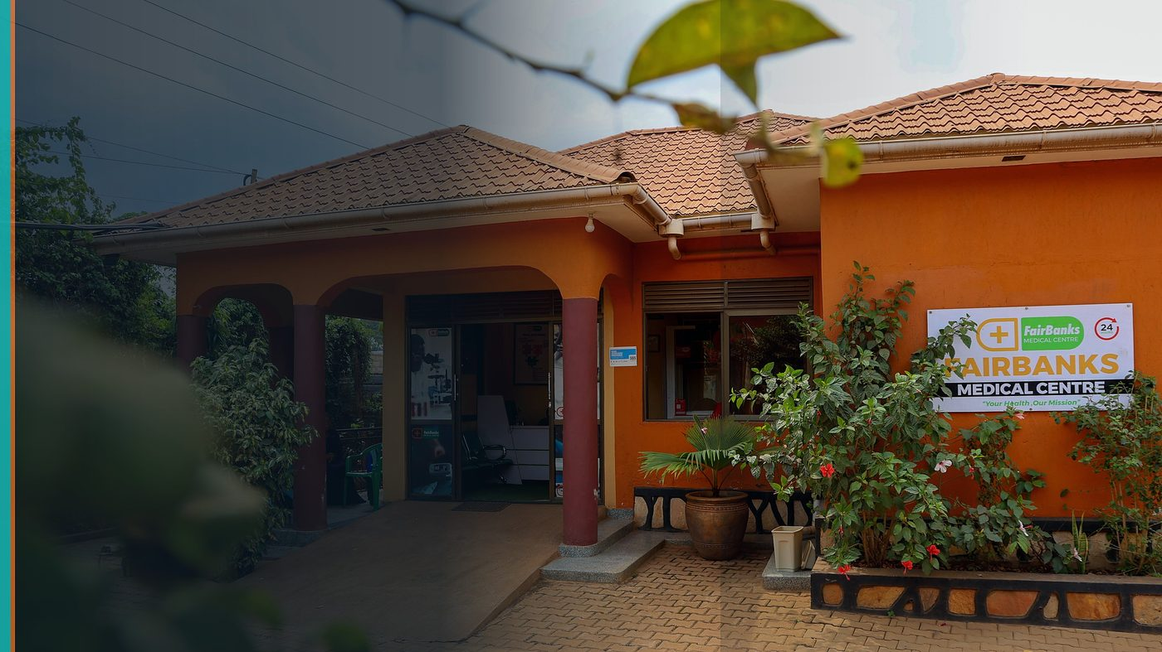
FairBanks Community Reach — Health for All — Obulamu eri Bonna · Afya kwa Wote · Oburamu bwa Boona
Item | Detail
Applicant | FairBanks-linked women innovators / team — Kampala, Uganda
Programme | GirlCode Hackathon 2026 — Kampala
Deadline | Register before Kampala event 5–6 September 2026
Geography | Kampala (UICT Nakawa) · Uganda chapter
The ask | Register / host FairBanks women builders at the Kampala GirlCode Hackathon.

https://opportunitiesforyouth.org/2026/07/15/building-africas-next-generation-of-ai-powered-female-innovators-apply-for-the-2026-girlcode-hackathon-across-six-african-countries/

1. Executive Summary
GirlCode is growing Africa's next generation of AI-powered women innovators — and Kampala is one of the host cities.
FairBanks brings a real problem set: offline CHW capture, maternal risk flags, and hotspot maps that communities need now.
Together we create a win-win: women builders get a meaningful HealthTech challenge; FairBanks meets talent and prototypes that can feed FCHIP.
2. Win-Win Value
This application is designed as a true partnership: FairBanks grows capacity and reach; the programme advances its own mission with a grounded African health-tech partner.
2.1 What FairBanks / FCHIP gains
- Visibility among Uganda's women-in-tech community
- Prototype ideas for FCHIP mobile and alert features
- Recruitment pipeline for women technologists
- Local proof that deep tech can be built with and for communities
2.2 What the programme / partners gain
- A concrete HealthTech / AI challenge grounded in real CHW work
- Mentorship access from a live medical centre and outreach team
- Strong Kampala story aligned with GirlCode's six-country mission
- Path from hackathon demo to community impact, not shelfware
3. The Problem We Address
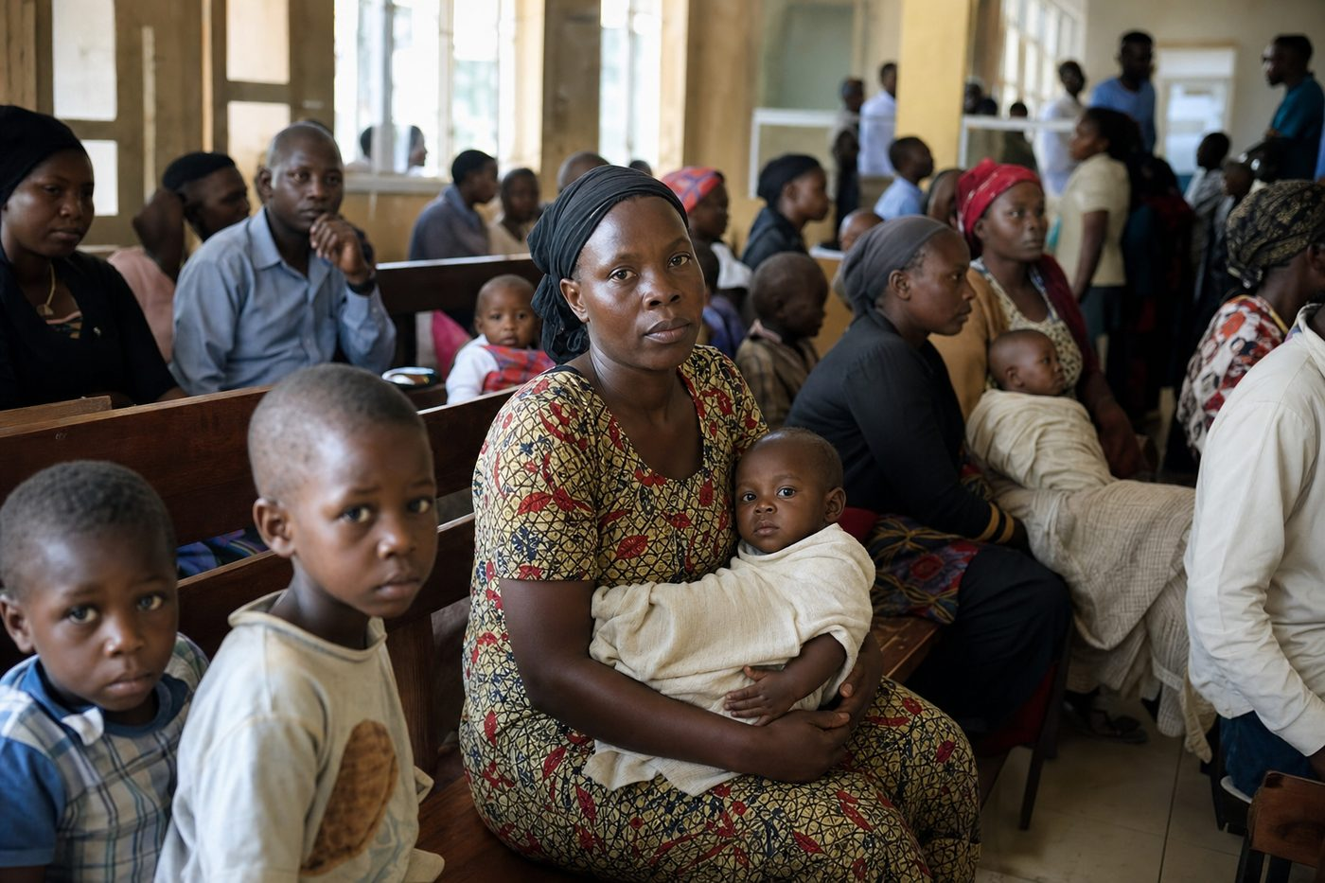
Reactive care waits for sickness before it responds
Hackathons often invent problems. Community health already has them: paper registers, late referrals, and invisible hotspots.
Women builders deserve challenges that matter — and partners who can take good ideas into the field.
4. Our Solution: FCHIP & Community Reach
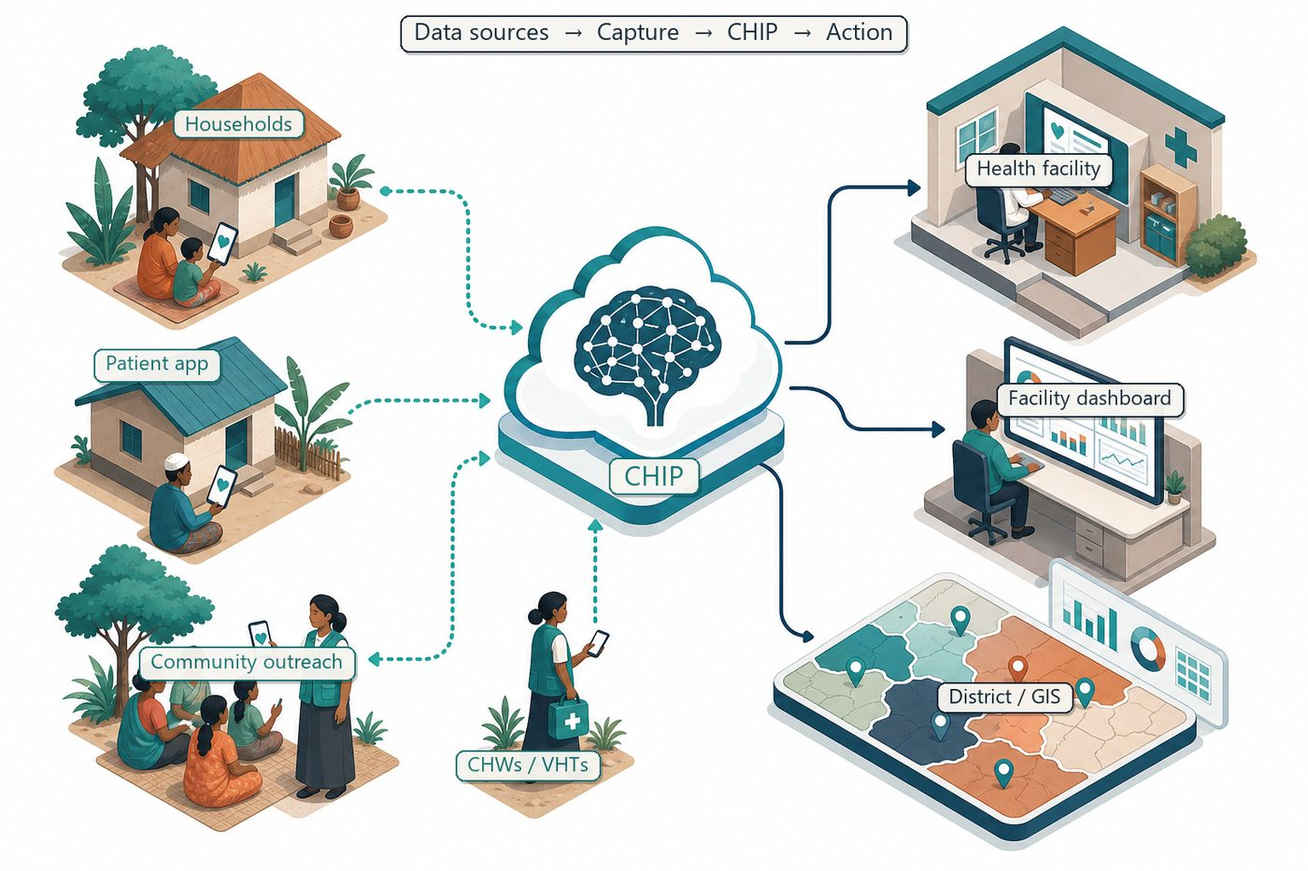
Community signals → capture → FCHIP intelligence → action
We propose an FCHIP challenge track: build lightweight AI-assisted tools for CHWs — symptom triage helpers, risk dashboards, or local-language education bots — designed for low connectivity.
FairBanks mentors provide clinical and community context during the Kampala weekend.
4.1 Deep technology core
Technology | Role
Artificial Intelligence | Outbreak early warning; maternal and NCD risk scoring
Machine Learning | Learn from community patterns, seasons, and outreach outcomes
GIS Mapping | Disease distribution, hotspots, and resource gaps
Mobile Data Collection | Offline-capable CHW/VHT capture at household level
Cloud Computing | Secure sync across facilities and partners
Analytics Dashboards | Real-time views for clinics, districts, and NGOs

4.2 Priority use cases for this call
CHW co-pilot: Simple decision support for home visits.
Hotspot sketch: Map fever or missed ANC clusters from sample data.
Mother messages: Local-language tips linked to referral pathways.
5. Fit to Programme Criteria
Criterion / theme | How we respond
Women innovators in AI | Team and challenge designed for women builders
Kampala event 5–6 Sep 2026 | Local presence at UICT Nakawa
Africa-wide GirlCode mission | Uganda chapter contributes a HealthTech flagship challenge
Talent & visibility | FairBanks offers mentorship and follow-up pathways

6. Why FairBanks Is Ready
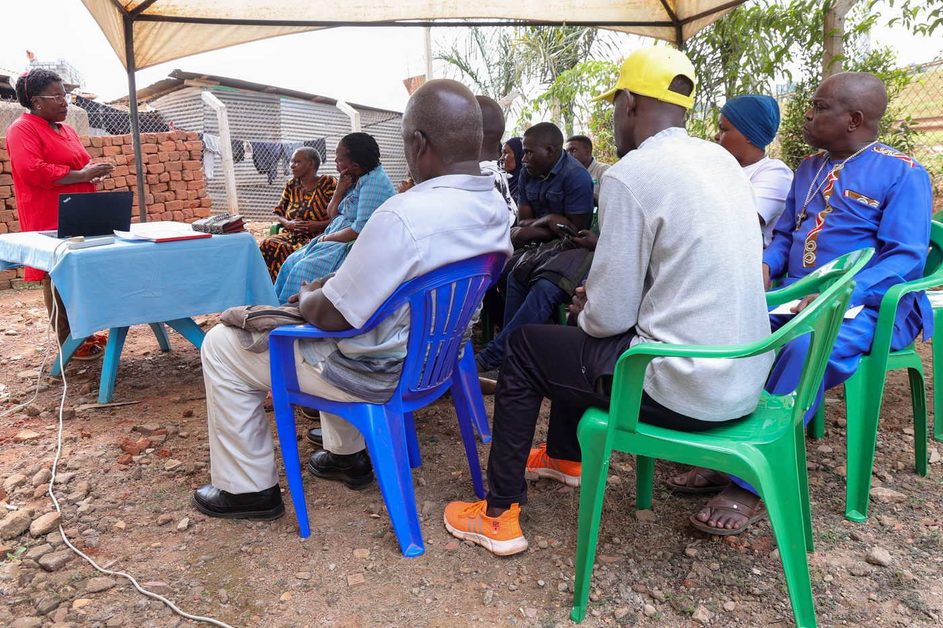
Live outreach in Kampala-area communities
- Functioning FairBanks Medical Centre with clinic, pharmacy, and diagnostics
- Active Community Reach outreach in Bukoto, Kyebando, Kisaasi, Kamwokya, Kikaaya
- Trusted CHW and VHT relationships for household visits and referrals
- Live programmes: maternal & child health, Gericare, chronic-disease screening
- Digital health records and outreach data ready to feed FCHIP
- Research and partnership mindset for ethical, evidence-based scale
7. Proposed Plan
- Register Kampala team before the event weekend
- Publish a one-page FCHIP challenge brief for participants
- Provide on-site / virtual mentorship from FairBanks clinical and product leads
- Shortlist prototypes for post-hack follow-up and possible internship
8. Risks & Safeguards
Risk | Mitigation
Data quality in the field | Structured forms, validation, CHW training and supervision
Low digital literacy | Simple offline UX, local-language support, supervised rollout
Privacy and consent | Ethical governance aligned with Uganda data protection rules
Adoption by partners | Co-design with CHWs, clinics, and district users from day one

9. Closing Ask
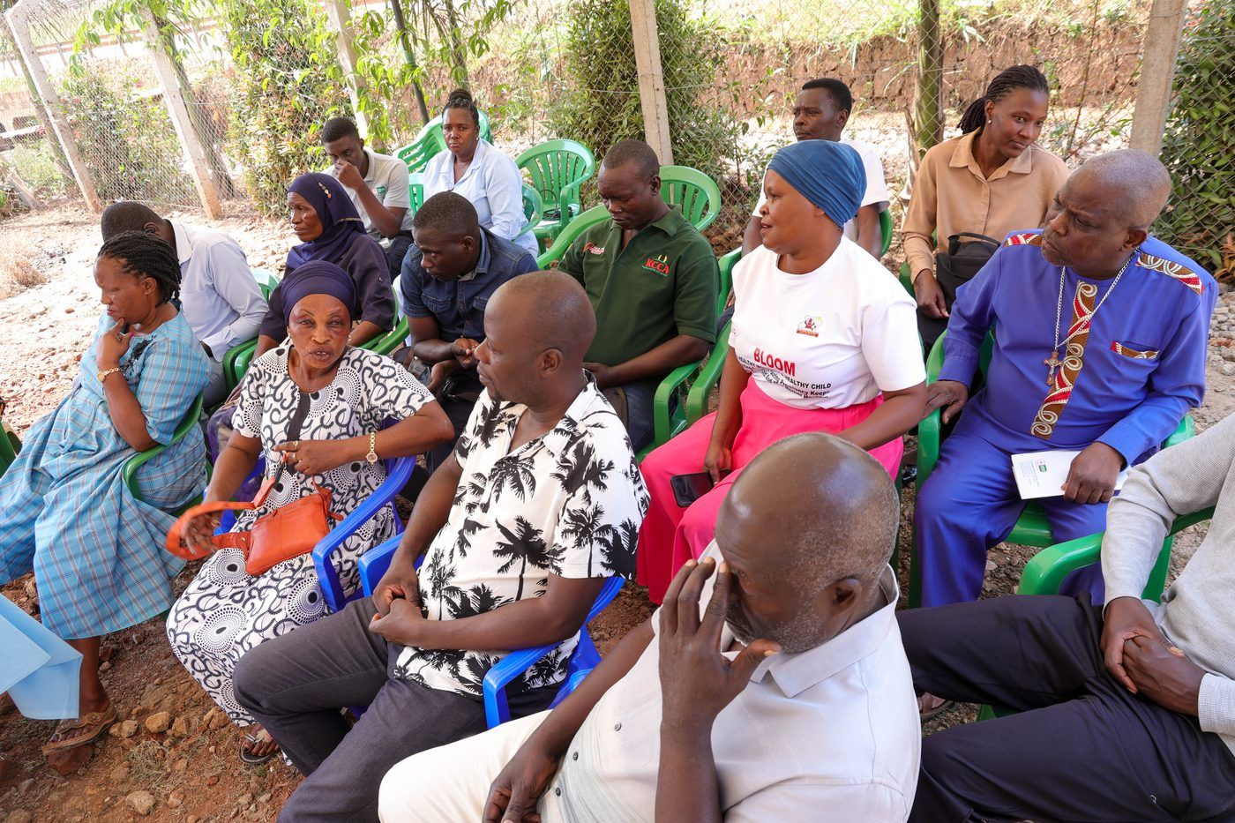
From community needs to lasting health impact
GirlCode builds women who build Africa's future. FairBanks offers a health problem worth solving.
We ask to participate fully in the Kampala 2026 hackathon with an FCHIP challenge and mentoring support.
Your health, our mission.
Aligned with: https://opportunitiesforyouth.org/2026/07/15/building-africas-next-generation-of-ai-powered-female-innovators-apply-for-the-2026-girlcode-hackathon-across-six-african-countries/

