World Bank GovTech Innovation Challenge 2026
Win-Win Application Pack
District Health Intelligence for Government Partners
Watching for health / Africa challenges — ready proof-of-concept partner
Your health, our mission.
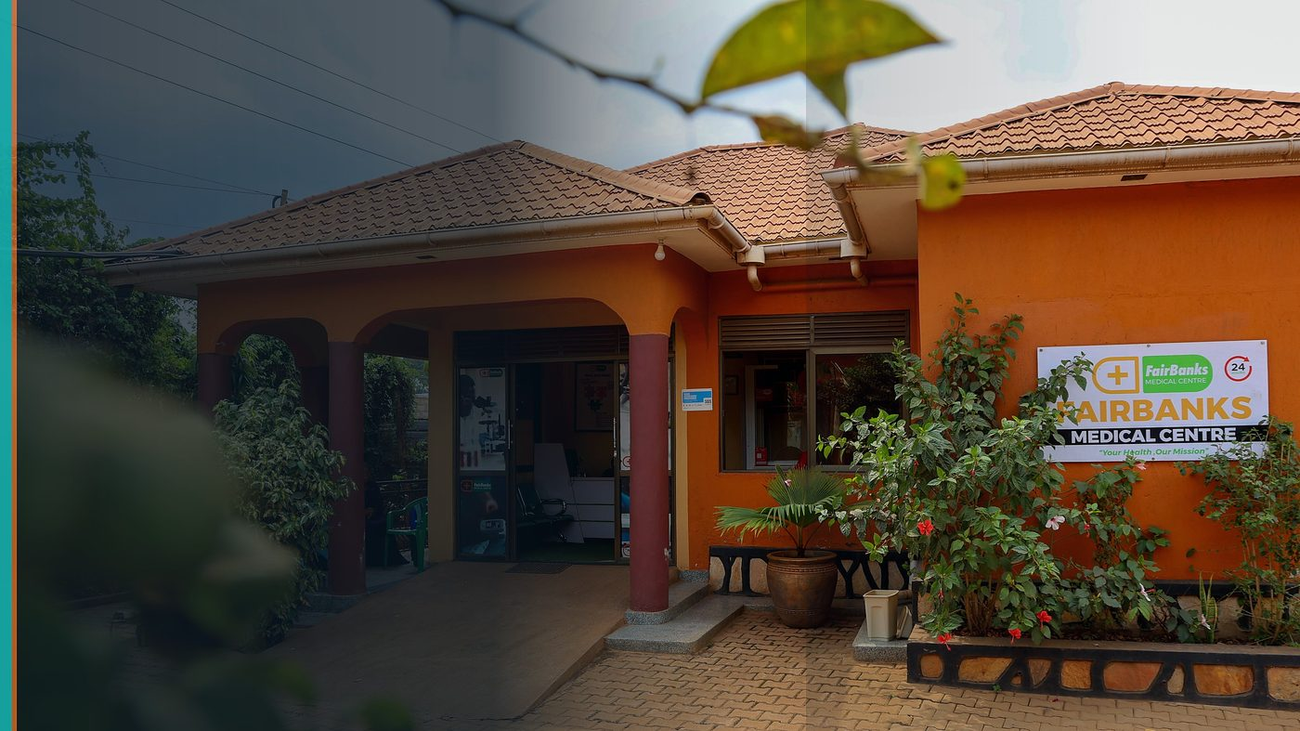
FairBanks Community Reach — Health for All — Obulamu eri Bonna · Afya kwa Wote · Oburamu bwa Boona
Item | Detail
Applicant | FairBanks / FCHIP — technology company & health operator, Uganda
Programme | World Bank GovTech Innovation Challenge 2026
Deadline | Varies by challenge — monitor specific challenge pages
Geography | Global challenge platform · Uganda / Africa health use cases
The ask | Shortlist FairBanks when health or Africa digital-government challenges open; engage on relevant PoCs.

https://opportunitiesforyouth.org/2026/07/10/world-bank-govtech-innovation-challenge-2026-global-call-for-proposals-to-build-digital-solutions-for-governments/

1. Executive Summary
The World Bank GovTech Innovation Challenge connects technology companies with government digitalisation needs — offering capacity building, a Switzerland bootcamp, and proof-of-concept work with government partners.
Current open challenges may focus elsewhere (e.g. public-finance audit), but FairBanks maintains a ready response pack for health and Africa-aligned calls.
When a matching challenge appears, we can move fast with a district health intelligence PoC concept rooted in live operations.
2. Win-Win Value
This application is designed as a true partnership: FairBanks grows capacity and reach; the programme advances its own mission with a grounded African health-tech partner.
2.1 What FairBanks / FCHIP gains
- Access to government PoC pathways and Trust Valley capacity building
- Credibility from World Bank / SECO ecosystem visibility
- Learning that hardens FCHIP for public-sector deployment
- Potential Switzerland bootcamp for selected innovators
2.2 What the programme / partners gain
- A vendor that already runs clinic and community operations — not only software
- Health intelligence use cases governments actually need (surveillance, CHW data, dashboards)
- African implementer ready for public-sector co-design
- Reusable PoC patterns for district health offices
3. The Problem We Address
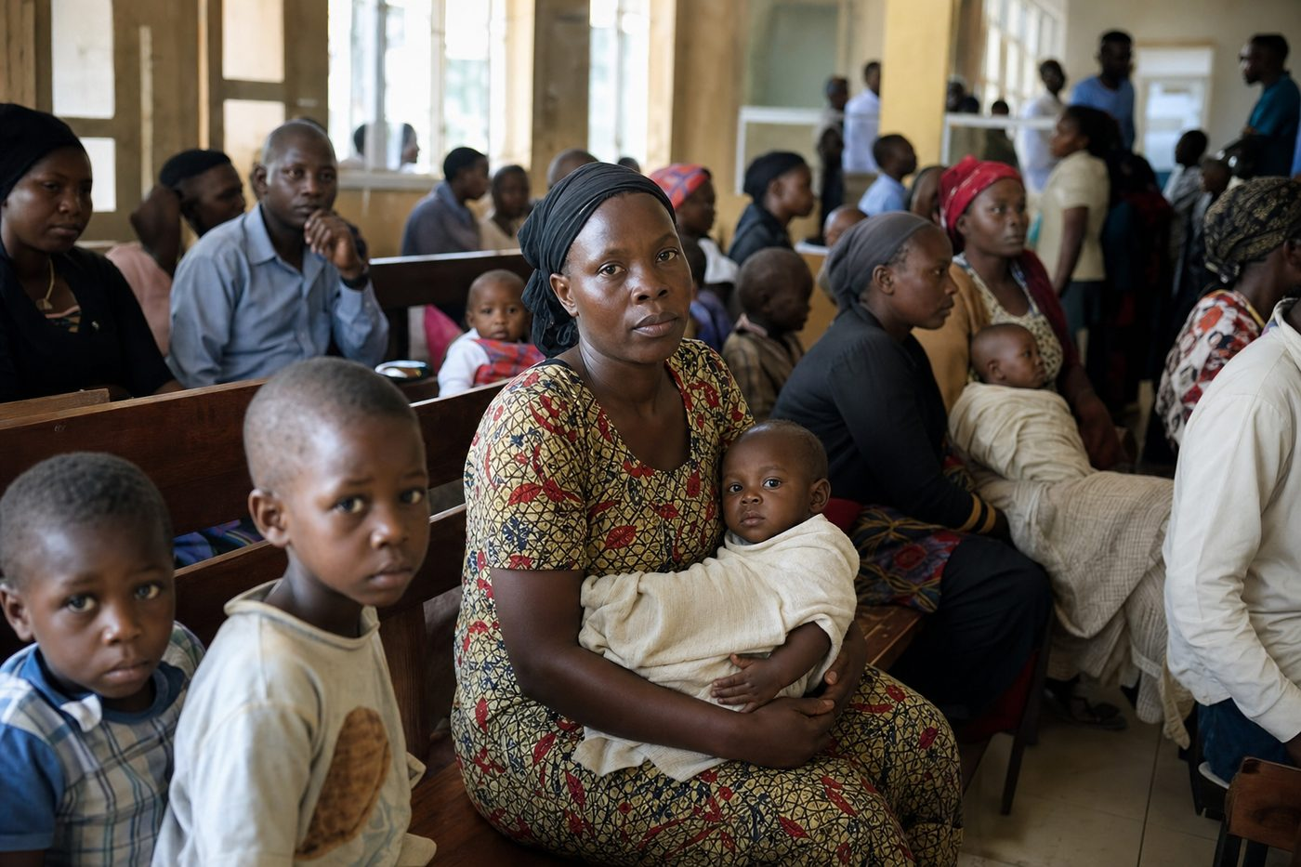
Reactive care waits for sickness before it responds
Governments struggle to turn scattered community health data into timely decisions. Vendors without field roots deliver brittle pilots.
4. Our Solution: FCHIP & Community Reach
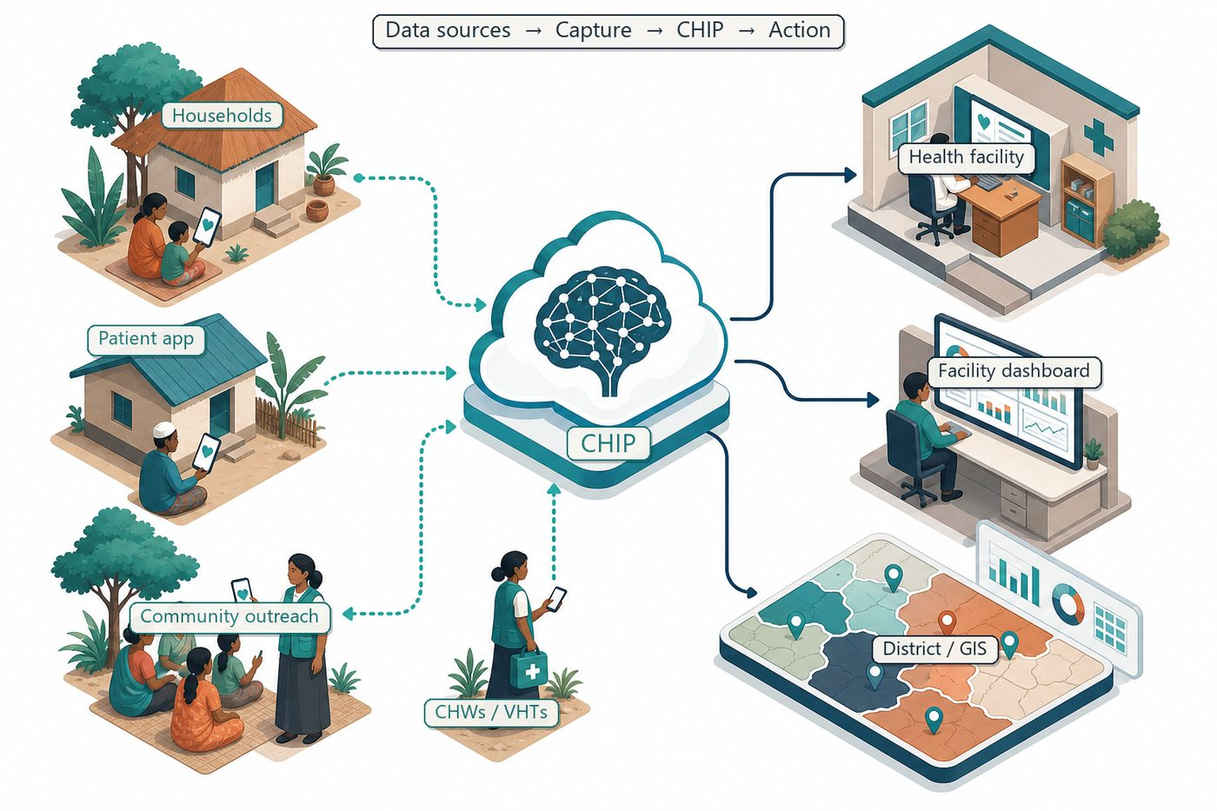
Community signals → capture → FCHIP intelligence → action
FCHIP offers a GovTech-ready pattern: secure community capture, analytics, GIS, and role-based dashboards co-designed with district users.
We monitor challenge pages and submit only when the use case matches — protecting evaluator time and our own.
4.1 Deep technology core
Technology | Role
Artificial Intelligence | Outbreak early warning; maternal and NCD risk scoring
Machine Learning | Learn from community patterns, seasons, and outreach outcomes
GIS Mapping | Disease distribution, hotspots, and resource gaps
Mobile Data Collection | Offline-capable CHW/VHT capture at household level
Cloud Computing | Secure sync across facilities and partners
Analytics Dashboards | Real-time views for clinics, districts, and NGOs

4.2 Priority use cases for this call
District dashboard: Population risk and coverage views for managers.
CHW data quality: Validation that improves government reporting.
Early warning: Configurable alerts aligned to local protocols.
5. Fit to Programme Criteria
Criterion / theme | How we respond
Tech companies worldwide | Ugandan HealthTech operator eligible
Government digitalisation | District health intelligence PoC ready
Capacity building + bootcamp | Team prepared to attend if selected
Challenge-specific deadlines | Active monitoring; no blind submissions

6. Why FairBanks Is Ready
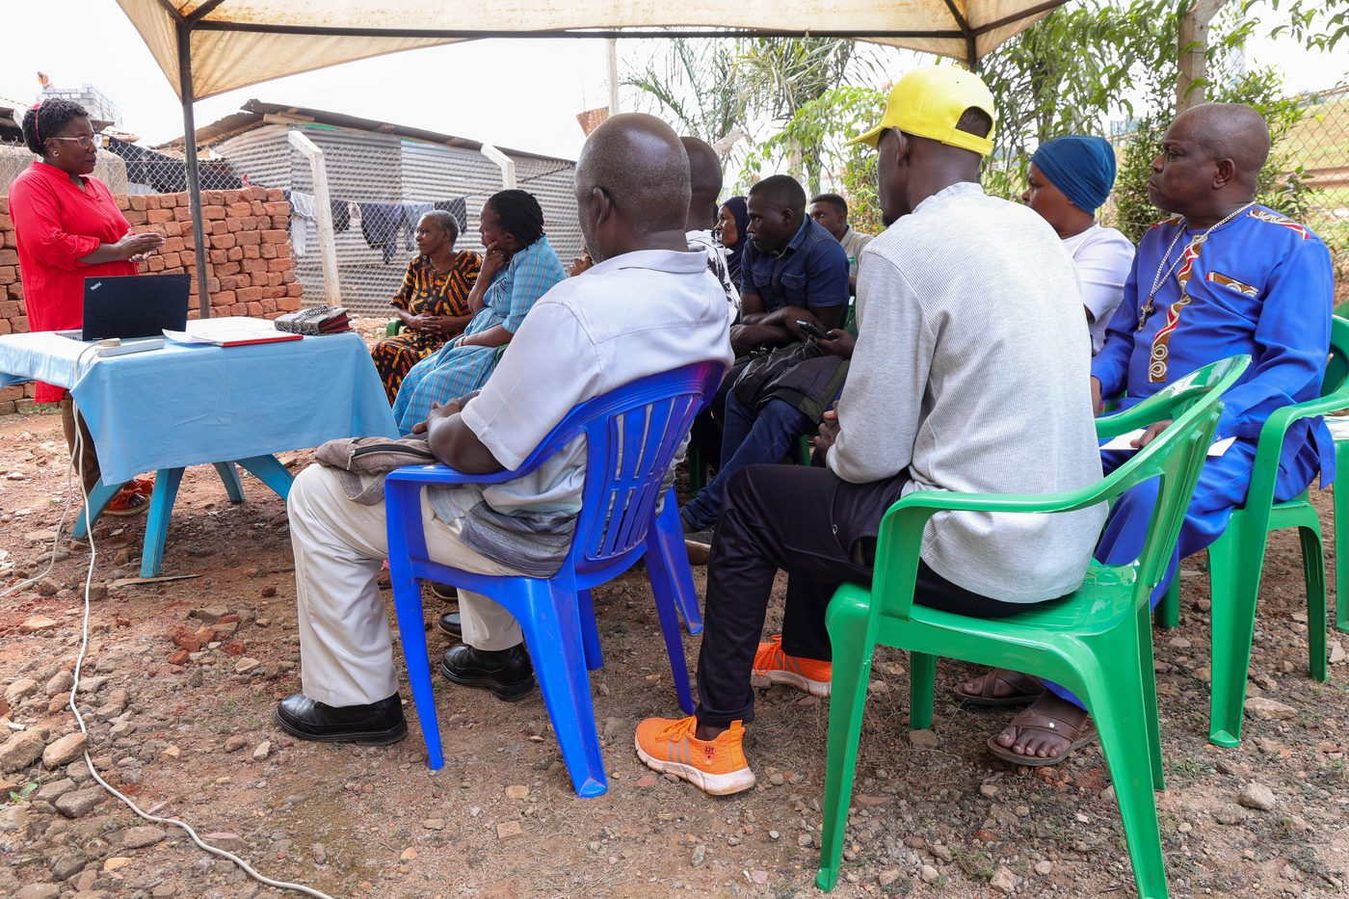
Live outreach in Kampala-area communities
- Functioning FairBanks Medical Centre with clinic, pharmacy, and diagnostics
- Active Community Reach outreach in Bukoto, Kyebando, Kisaasi, Kamwokya, Kikaaya
- Trusted CHW and VHT relationships for household visits and referrals
- Live programmes: maternal & child health, Gericare, chronic-disease screening
- Digital health records and outreach data ready to feed FCHIP
- Research and partnership mindset for ethical, evidence-based scale
7. Proposed Plan
- Maintain this application pack as a ready response baseline
- Monitor World Bank GovTech challenge pages weekly
- Submit tailored proposals only for health / Africa-aligned challenges
- If selected: co-design PoC with government partner and measure decision-cycle gains
8. Risks & Safeguards
Risk | Mitigation
Data quality in the field | Structured forms, validation, CHW training and supervision
Low digital literacy | Simple offline UX, local-language support, supervised rollout
Privacy and consent | Ethical governance aligned with Uganda data protection rules
Adoption by partners | Co-design with CHWs, clinics, and district users from day one

9. Closing Ask
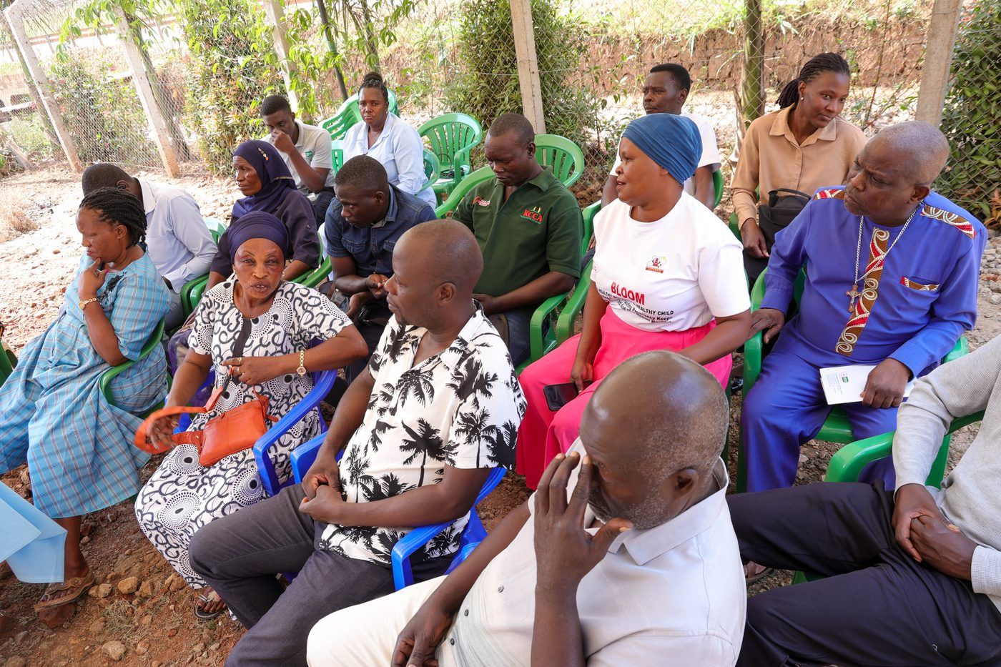
From community needs to lasting health impact
GovTech works when government problems meet operators who already serve people. FairBanks is ready when the right challenge opens.
We ask to be considered for matching health and Africa digital-government challenges as they appear.
Your health, our mission.
Aligned with: https://opportunitiesforyouth.org/2026/07/10/world-bank-govtech-innovation-challenge-2026-global-call-for-proposals-to-build-digital-solutions-for-governments/

