IFAD Grant — Rural Sector Performance Assessment (up to US$1.2M)
Win-Win Application Pack
Health–Livelihood Intelligence for Rural Policy
Linking community health data to rural development performance
Your health, our mission.
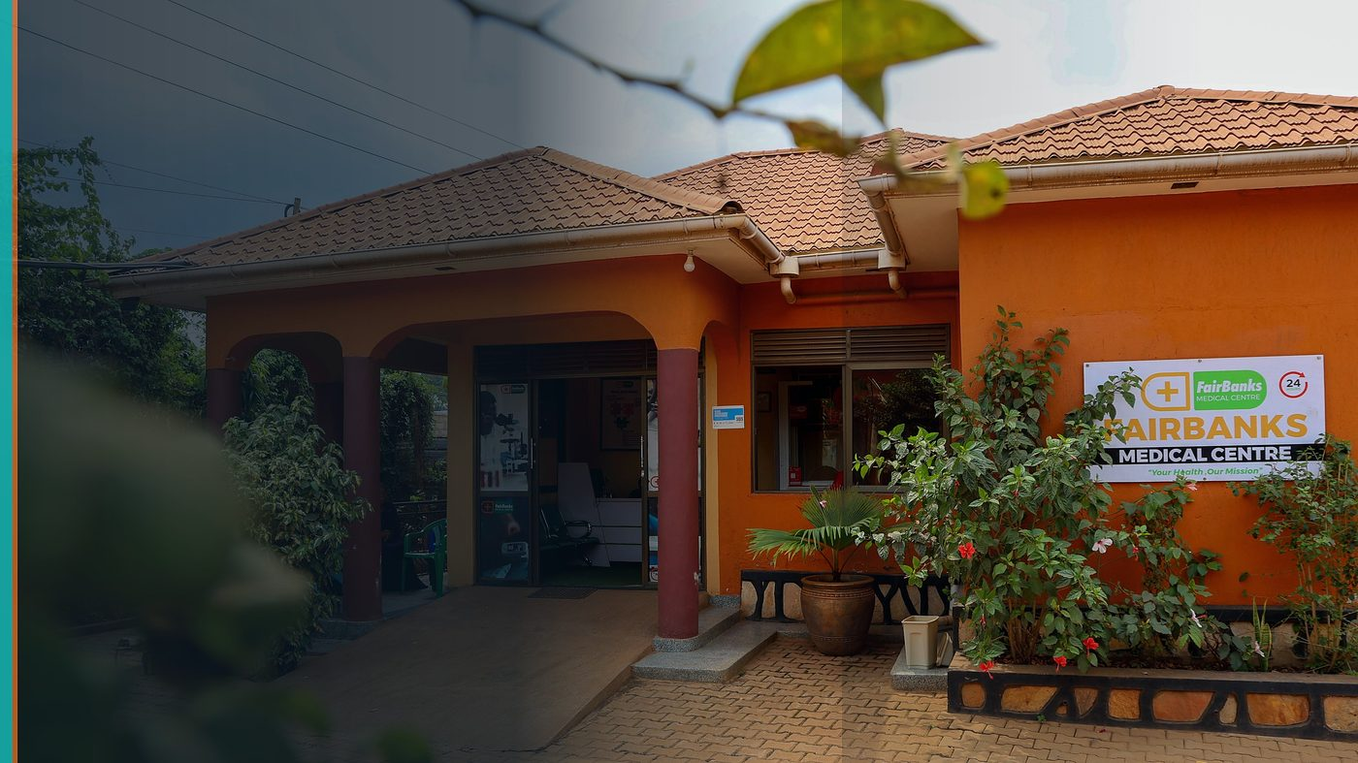
FairBanks Community Reach — Health for All — Obulamu eri Bonna · Afya kwa Wote · Oburamu bwa Boona
Item | Detail
Applicant | FairBanks (with research / policy partners as required) — Uganda
Programme | IFAD Grant — Rural Sector Performance Assessment (up to US$1.2M)
Deadline | 4 September 2026 (12:00 CET); optional EOI 31 July 2026
Geography | Uganda rural / peri-urban catchments · policy learning global
The ask | Consider FairBanks (and partners) for EOI and full proposal on health–livelihood policy intelligence.

https://opportunitiesforyouth.org/2026/07/14/ifad-announces-us1-2-million-grant-call-for-proposals-to-strengthen-rural-development-policies-worldwide/

1. Executive Summary
IFAD seeks proposals up to US$1.2M to leverage the Rural Sector Performance Assessment for better policy and investment — open to non-profits, private firms, universities, and think tanks.
FairBanks' cascade already links health to livelihoods and resilient families. FCHIP can contribute community health and vulnerability signals that make rural performance assessment more human-centred.
This pack frames a careful, partnership-ready fit — to be confirmed against IFAD's detailed thematic guidance before full proposal effort.
2. Win-Win Value
This application is designed as a true partnership: FairBanks grows capacity and reach; the programme advances its own mission with a grounded African health-tech partner.
2.1 What FairBanks / FCHIP gains
- Resources to connect health intelligence with rural livelihood policy
- Partnerships with universities / think tanks on rigorous assessment
- Evidence that prevention protects income and food security
- Optional EOI path to test fit early (31 July 2026)
2.2 What the programme / partners gain
- Ground-level health and vulnerability data from community programmes
- Private-sector / social enterprise implementer with field access
- SDG-aligned story: health shocks as rural poverty drivers
- Counterpart contribution potential via FairBanks operations (20–25%)
3. The Problem We Address
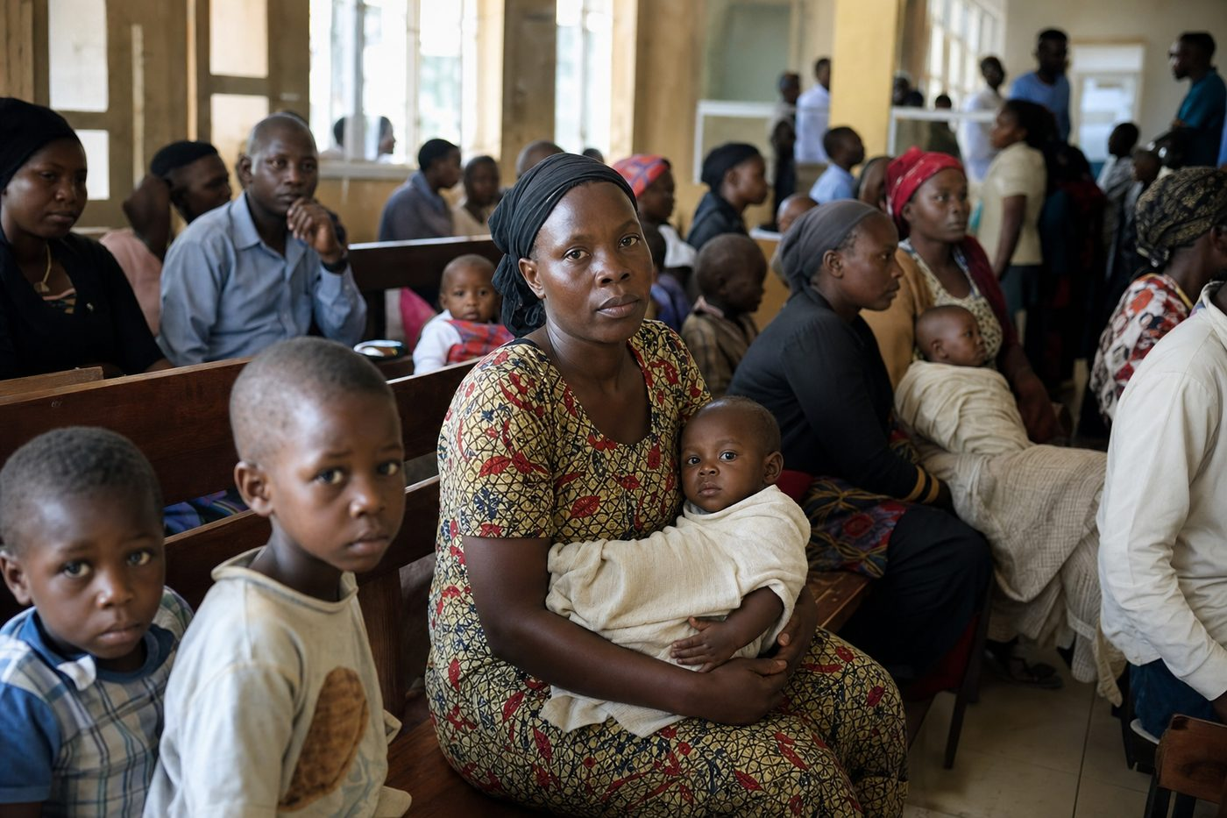
Reactive care waits for sickness before it responds
Rural policy often tracks production and infrastructure while under-weighting health shocks that wipe out household gains.
Without community health intelligence, rural performance assessments miss a core driver of poverty.
4. Our Solution: FCHIP & Community Reach
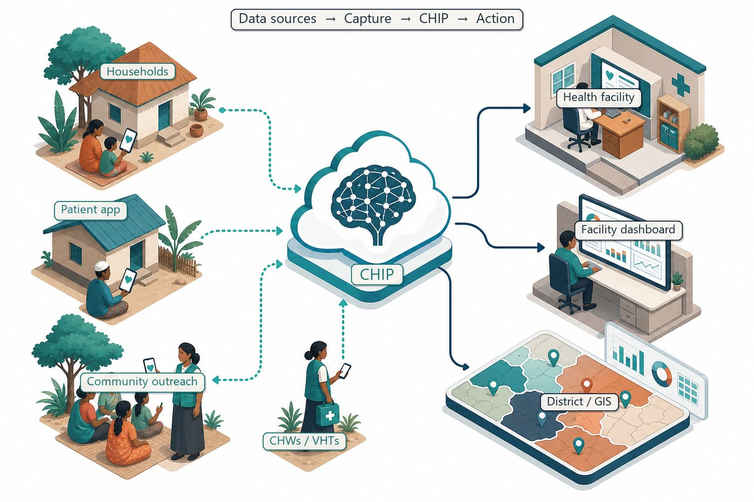
Community signals → capture → FCHIP intelligence → action
Propose a workstream where FCHIP community indicators (illness clusters, maternal risk, missed care) inform rural performance dashboards and policy briefs, in partnership with research institutes.
Counterpart effort includes FairBanks field operations, CHW networks, and data stewardship.
4.1 Deep technology core
Technology | Role
Artificial Intelligence | Outbreak early warning; maternal and NCD risk scoring
Machine Learning | Learn from community patterns, seasons, and outreach outcomes
GIS Mapping | Disease distribution, hotspots, and resource gaps
Mobile Data Collection | Offline-capable CHW/VHT capture at household level
Cloud Computing | Secure sync across facilities and partners
Analytics Dashboards | Real-time views for clinics, districts, and NGOs

4.2 Priority use cases for this call
Health-shock markers: Link disease surges to livelihood stress signals.
Policy briefs: Translate community data into investment priorities.
Partner research: Co-design methods with academic / think-tank partners.
5. Fit to Programme Criteria
Criterion / theme | How we respond
Rural Sector Performance Assessment | Add health–livelihood intelligence layer
Eligible entity types | Social enterprise + research partners
Counterpart 20–25% | In-kind operations and staff time
Verify thematic match | EOI first; full proposal only if guidance confirms fit

6. Why FairBanks Is Ready
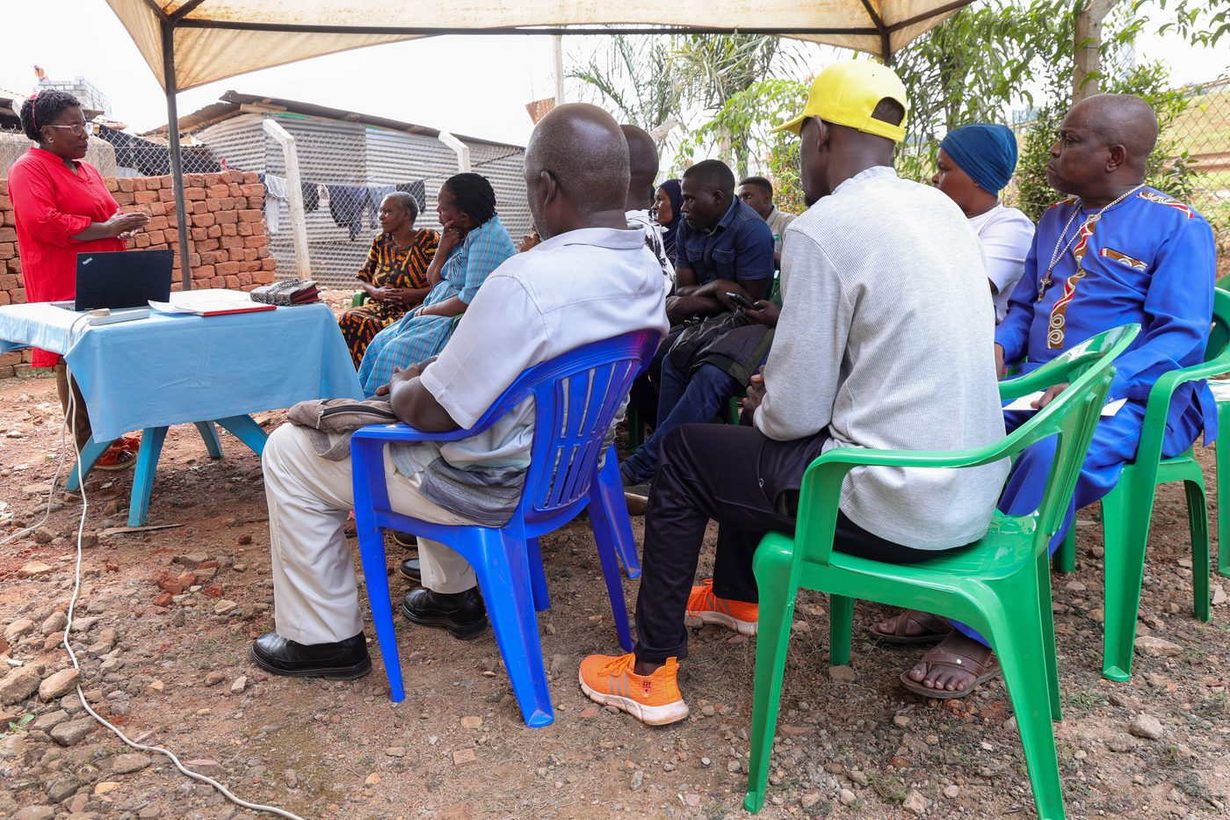
Live outreach in Kampala-area communities
- Functioning FairBanks Medical Centre with clinic, pharmacy, and diagnostics
- Active Community Reach outreach in Bukoto, Kyebando, Kisaasi, Kamwokya, Kikaaya
- Trusted CHW and VHT relationships for household visits and referrals
- Live programmes: maternal & child health, Gericare, chronic-disease screening
- Digital health records and outreach data ready to feed FCHIP
- Research and partnership mindset for ethical, evidence-based scale
7. Proposed Plan
Phase / step | Detail
By 31 Jul 2026 | Optional non-binding Expression of Interest
By 4 Sep 2026 | Full proposal if thematic fit confirmed
Year 1–2 | Pilot indicators in FairBanks / partner rural catchments
Learning | Policy notes for IFAD and national stakeholders

8. Indicative Resources
Item | Detail | Amount
Research & assessment design | Methods, partners, ethics | Share of grant
Community data & FCHIP modules | Indicators, dashboards, quality | Share of grant
FairBanks counterpart | Field ops, staff, outreach | 20–25% in-kind
Ceiling | Per call | Up to US$1.2M

9. Risks & Safeguards
Risk | Mitigation
Data quality in the field | Structured forms, validation, CHW training and supervision
Low digital literacy | Simple offline UX, local-language support, supervised rollout
Privacy and consent | Ethical governance aligned with Uganda data protection rules
Adoption by partners | Co-design with CHWs, clinics, and district users from day one

10. Closing Ask
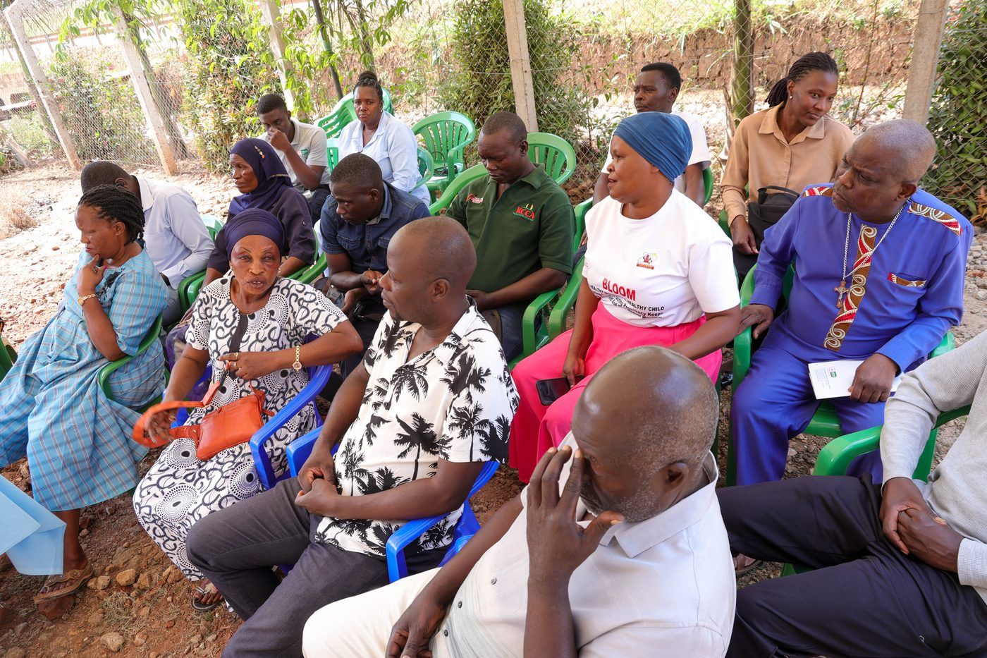
From community needs to lasting health impact
Rural development succeeds when families stay healthy enough to work and thrive. FairBanks can help IFAD see that link clearly.
We will submit an EOI and proceed to full proposal only where official guidance confirms thematic fit.
Your health, our mission.
Aligned with: https://opportunitiesforyouth.org/2026/07/14/ifad-announces-us1-2-million-grant-call-for-proposals-to-strengthen-rural-development-policies-worldwide/

