Brandtech Group AI for Good Scholarship 2026 (One Young World)
Win-Win Application Pack
AI for Community Health — Cape Town Summit
Fully funded seat for a young African leader using AI for health impact
Your health, our mission.
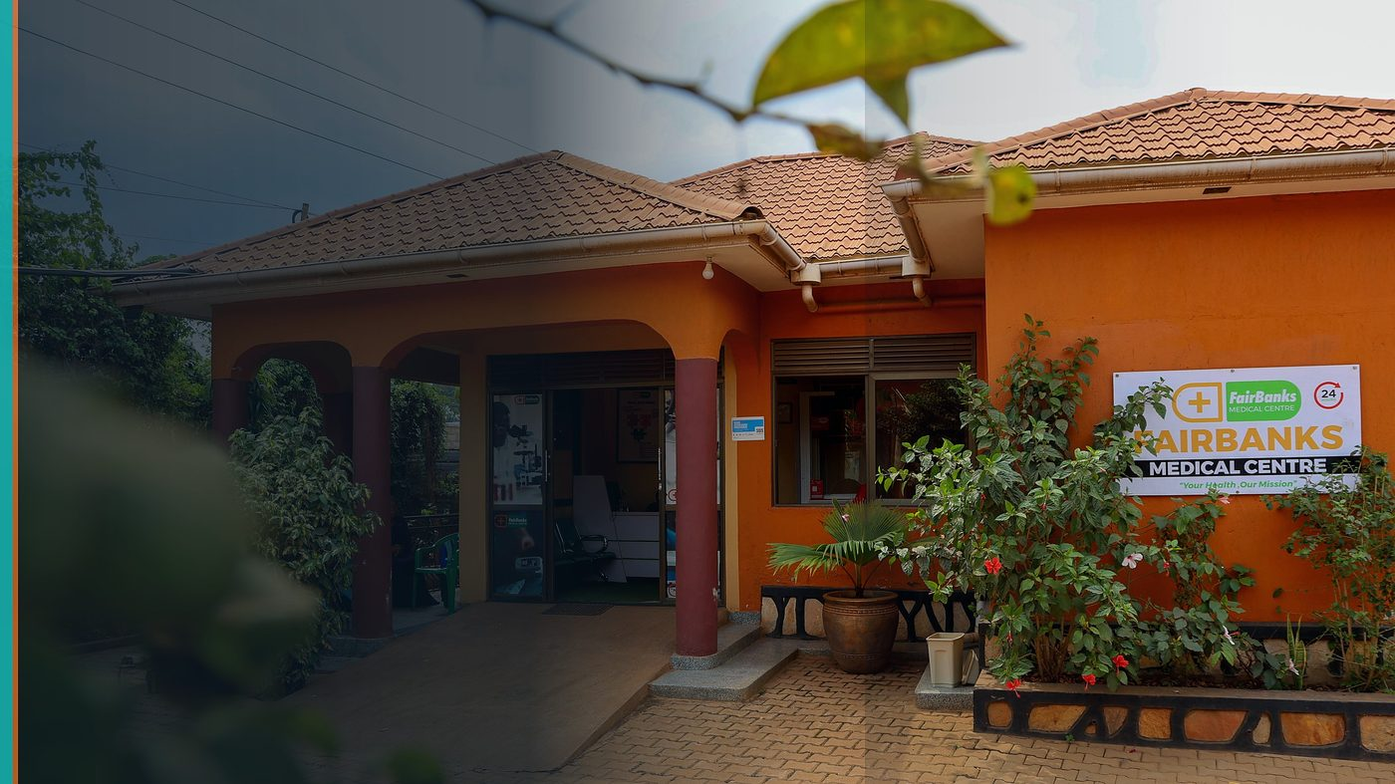
FairBanks Community Reach — Health for All — Obulamu eri Bonna · Afya kwa Wote · Oburamu bwa Boona
Item | Detail
Applicant | Eligible FairBanks young leader (18–30), Ugandan national & resident
Programme | Brandtech Group AI for Good Scholarship 2026 (One Young World)
Deadline | 2 August 2026
Geography | One Young World Summit 2026 — Cape Town
The ask | Award one of five AI for Good scholarships to a FairBanks young leader.

https://opportunitiesforyouth.org/2026/07/15/ai-for-good-scholarship-2025-empowering-young-innovators-to-address-global-challenges/

1. Executive Summary
Brandtech's AI for Good scholarship sends five young African leaders using AI for social impact to One Young World 2026 in Cape Town. Healthcare is a named priority.
A FairBanks nominee can show responsible AI for community health — CHW data, maternal risk, and outbreak early warning — rooted in Uganda.
The scholarship amplifies an African HealthTech practitioner; FairBanks returns with global alliances for FCHIP.
2. Win-Win Value
This application is designed as a true partnership: FairBanks grows capacity and reach; the programme advances its own mission with a grounded African health-tech partner.
2.1 What FairBanks / FCHIP gains
- Fully funded summit access for a young AI-for-health leader
- Global network across One Young World delegates
- Platform to share FCHIP's responsible AI story
- Inspiration and partnerships for product and policy pathways
2.2 What the programme / partners gain
- A scholar with proven community health AI intent, not abstract interest
- Healthcare priority area represented with African field credibility
- Nationality and residency eligibility met (Uganda)
- Alumni who will keep building after the summit lights fade
3. The Problem We Address
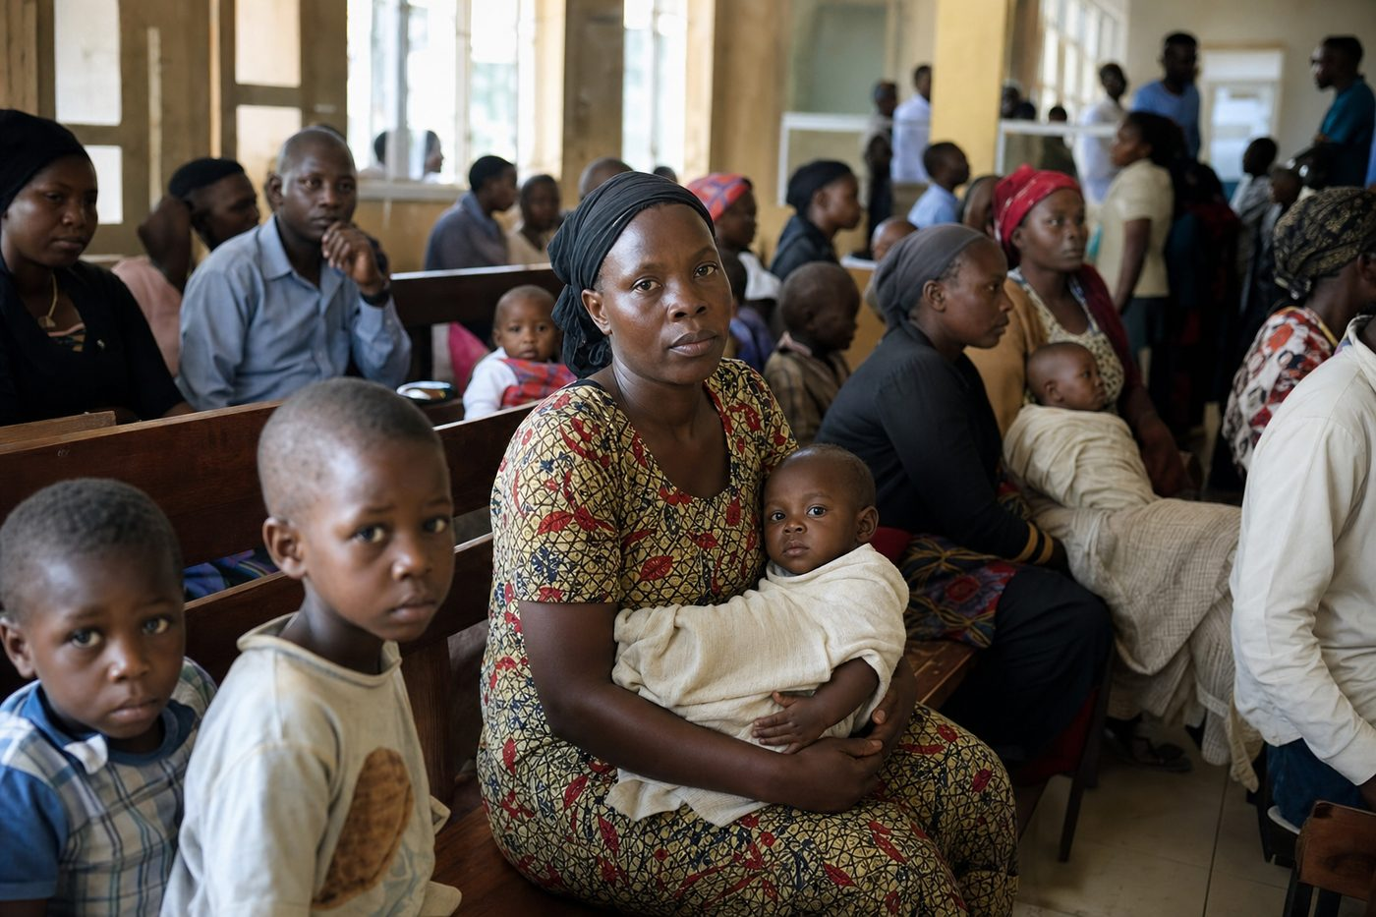
Reactive care waits for sickness before it responds
AI for good needs builders who already serve communities — not only pitch decks. Too few young African health practitioners get summit access.
4. Our Solution: FCHIP & Community Reach
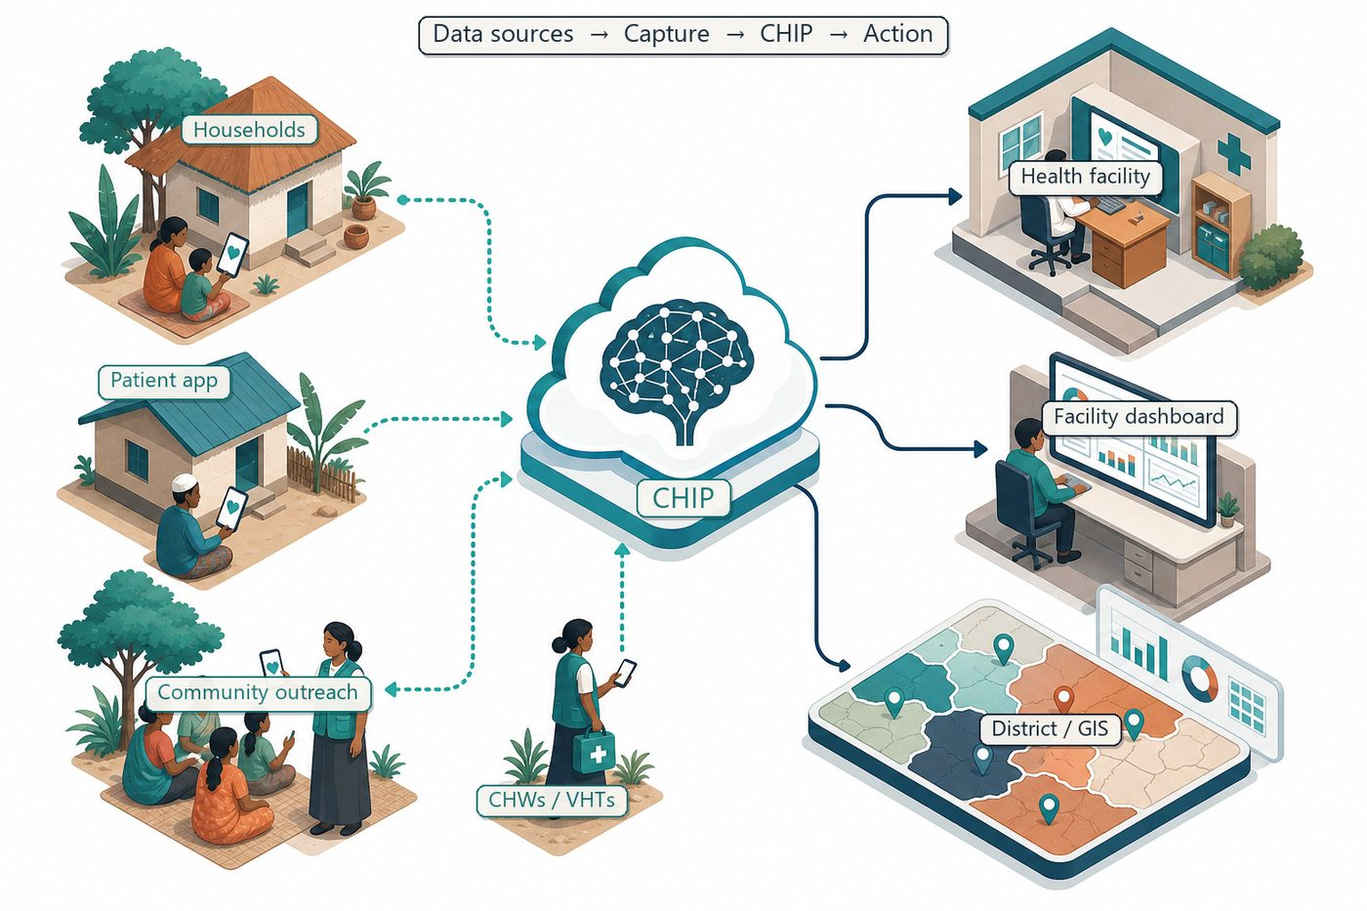
Community signals → capture → FCHIP intelligence → action
Our nominee will present FCHIP's approach: community-generated data + predictive analytics for prevention, with ethics and gender awareness at the centre.
Post-summit, learnings feed FairBanks product and partnership plans.
4.1 Deep technology core
Technology | Role
Artificial Intelligence | Outbreak early warning; maternal and NCD risk scoring
Machine Learning | Learn from community patterns, seasons, and outreach outcomes
GIS Mapping | Disease distribution, hotspots, and resource gaps
Mobile Data Collection | Offline-capable CHW/VHT capture at household level
Cloud Computing | Secure sync across facilities and partners
Analytics Dashboards | Real-time views for clinics, districts, and NGOs

4.2 Priority use cases for this call
Responsible AI: Explainable alerts for CHWs and clinicians.
Health for all: Prioritise underserved communities in model design.
Youth leadership: Carry summit commitments into Uganda programmes.
5. Fit to Programme Criteria
Criterion / theme | How we respond
Ages 18–30 | Nominee within range
African nationality & residency | Ugandan national living in Uganda
AI for social / health impact | FCHIP predictive community health
Five scholarships | Strong healthcare priority alignment

6. Why FairBanks Is Ready
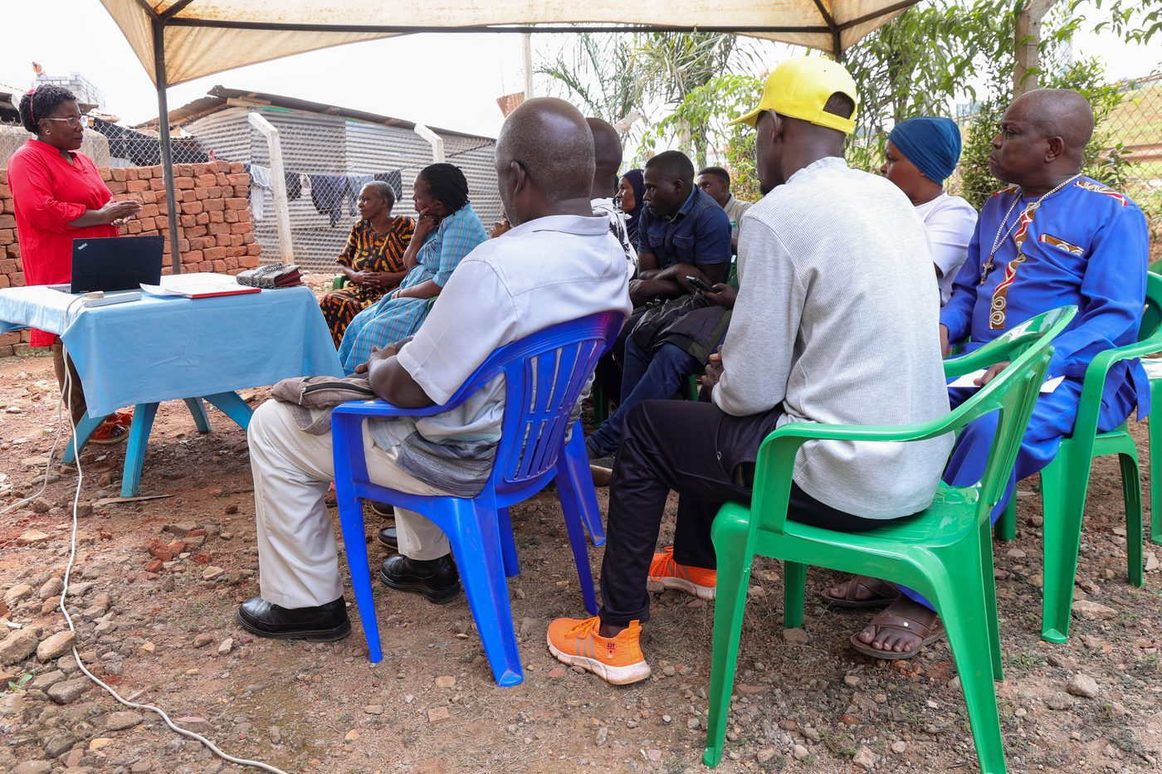
Live outreach in Kampala-area communities
- Functioning FairBanks Medical Centre with clinic, pharmacy, and diagnostics
- Active Community Reach outreach in Bukoto, Kyebando, Kisaasi, Kamwokya, Kikaaya
- Trusted CHW and VHT relationships for household visits and referrals
- Live programmes: maternal & child health, Gericare, chronic-disease screening
- Digital health records and outreach data ready to feed FCHIP
- Research and partnership mindset for ethical, evidence-based scale
7. Proposed Plan
- Submit nominee profile with AI-for-health evidence and references
- Prepare summit talking points on FCHIP and FairBanks cascade
- Engage Brandtech / OYW sessions on responsible AI
- Publish a public learning note for FairBanks community partners
8. Risks & Safeguards
Risk | Mitigation
Data quality in the field | Structured forms, validation, CHW training and supervision
Low digital literacy | Simple offline UX, local-language support, supervised rollout
Privacy and consent | Ethical governance aligned with Uganda data protection rules
Adoption by partners | Co-design with CHWs, clinics, and district users from day one

9. Closing Ask
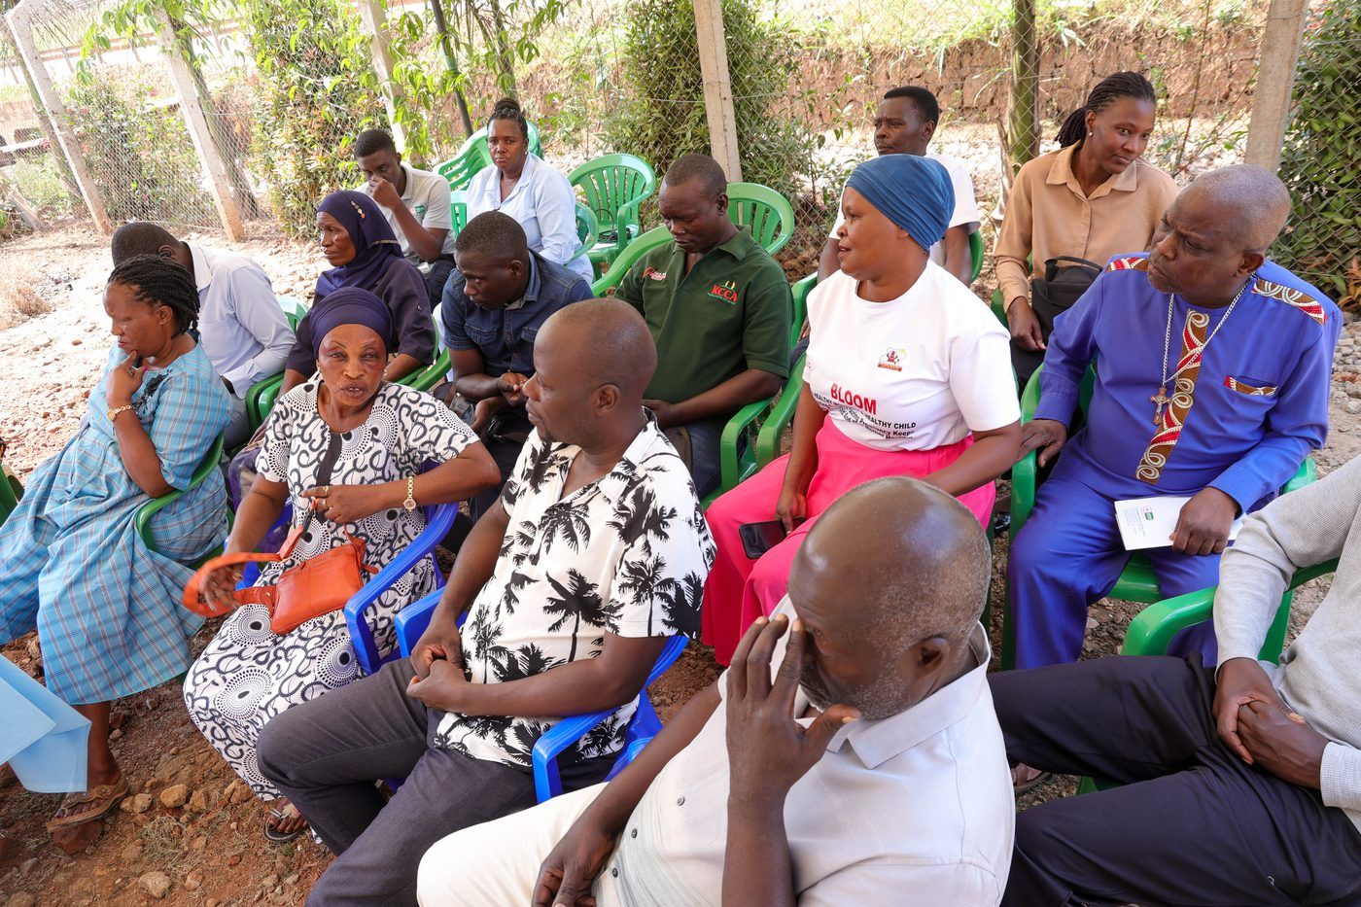
From community needs to lasting health impact
AI for Good is measured by lives improved. FairBanks is already walking that path in Uganda.
We ask for a Brandtech AI for Good scholarship for our eligible young leader.
Your health, our mission.
Aligned with: https://opportunitiesforyouth.org/2026/07/15/ai-for-good-scholarship-2025-empowering-young-innovators-to-address-global-challenges/

