World Health Summit 2026 Youth Group Opportunity (Berlin)
Win-Win Application Pack
FairBanks Youth Delegation to WHS 2026
Complimentary group tickets for youth-led community health voices
Your health, our mission.
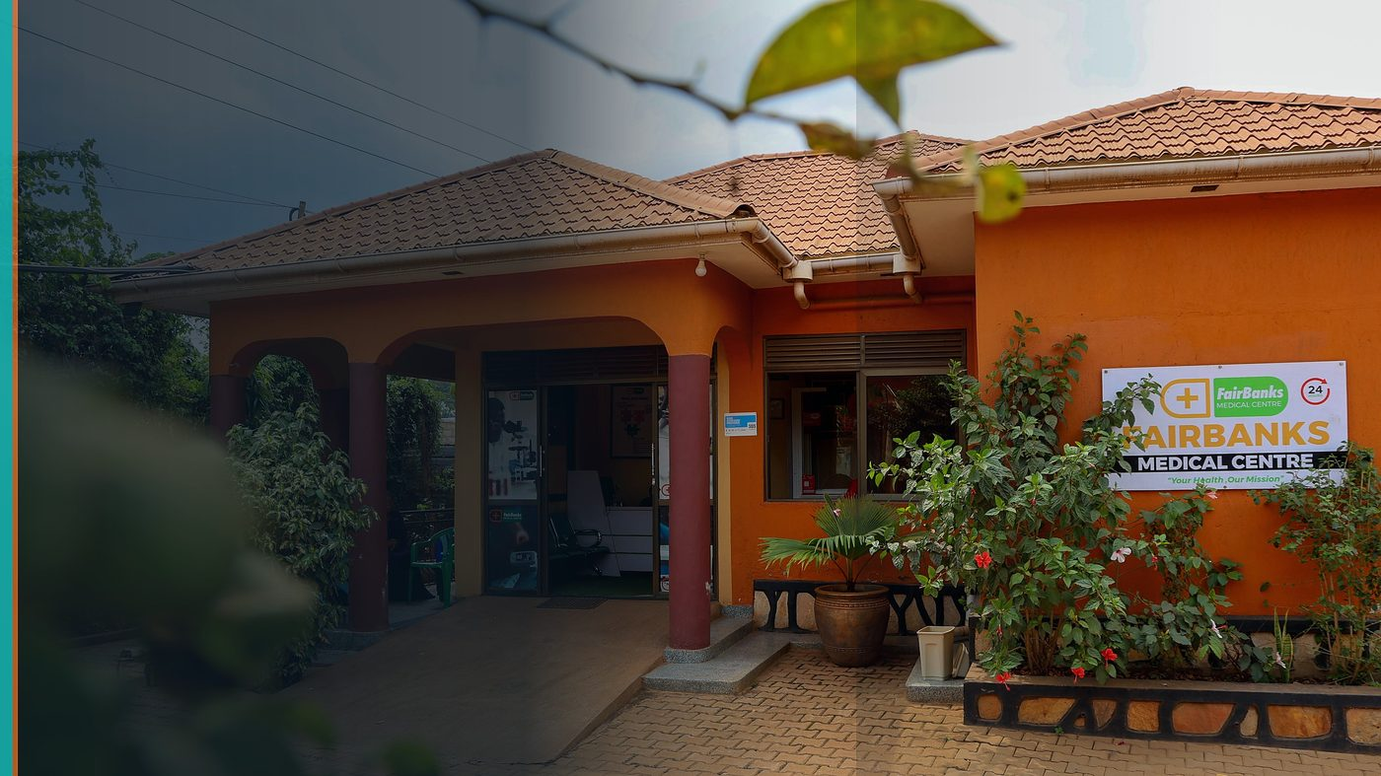
FairBanks Community Reach — Health for All — Obulamu eri Bonna · Afya kwa Wote · Oburamu bwa Boona
Item | Detail
Applicant | FairBanks youth-led cohort (nominees aged 28 or under) — Uganda
Programme | World Health Summit 2026 Youth Group Opportunity (Berlin)
Deadline | 31 July 2026
Geography | Berlin summit · Uganda organisation · self-funded travel
The ask | Award complimentary group tickets (3–15) for FairBanks youth delegates.

https://opportunitiesforyouth.org/2026/06/26/apply-now-world-health-summit-2025-stipend-program-for-global-health-changemakers/

1. Executive Summary
The World Health Summit offers complimentary group tickets for youth-led organisations working in health and social impact.
FairBanks youth can bring an authentic African community-health intelligence story to Berlin — and return with partnerships that strengthen FCHIP.
WHS gains underrepresented regional voices; FairBanks gains global learning without ticket barriers (travel remains self-funded).
2. Win-Win Value
This application is designed as a true partnership: FairBanks grows capacity and reach; the programme advances its own mission with a grounded African health-tech partner.
2.1 What FairBanks / FCHIP gains
- Access to three days of global health agenda-setting in Berlin
- Networking with ministries, NGOs, and innovators
- Visibility for FCHIP and FairBanks Community Reach
- Learning that feeds Uganda programme design
2.2 What the programme / partners gain
- Youth delegates from an underrepresented region with real field work
- Concrete community health intelligence narrative for summit sessions
- Organisation that will share learnings back home, not only attend
- Diverse group size (3–15) ready to engage seriously
3. The Problem We Address
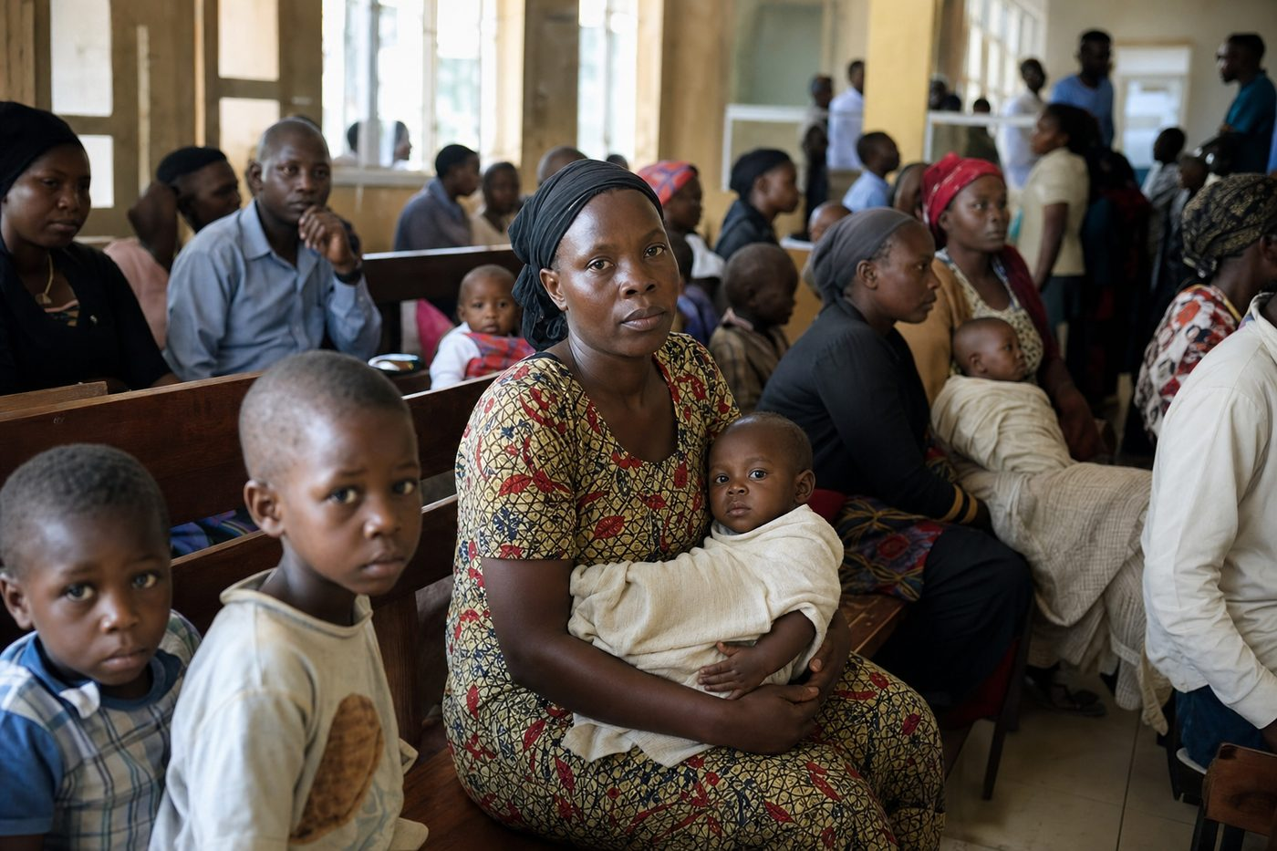
Reactive care waits for sickness before it responds
Global health forums can miss the voices of community-level African implementers — especially youth who already do the work.
Ticket costs block participation even when travel can be self-organised.
4. Our Solution: FCHIP & Community Reach
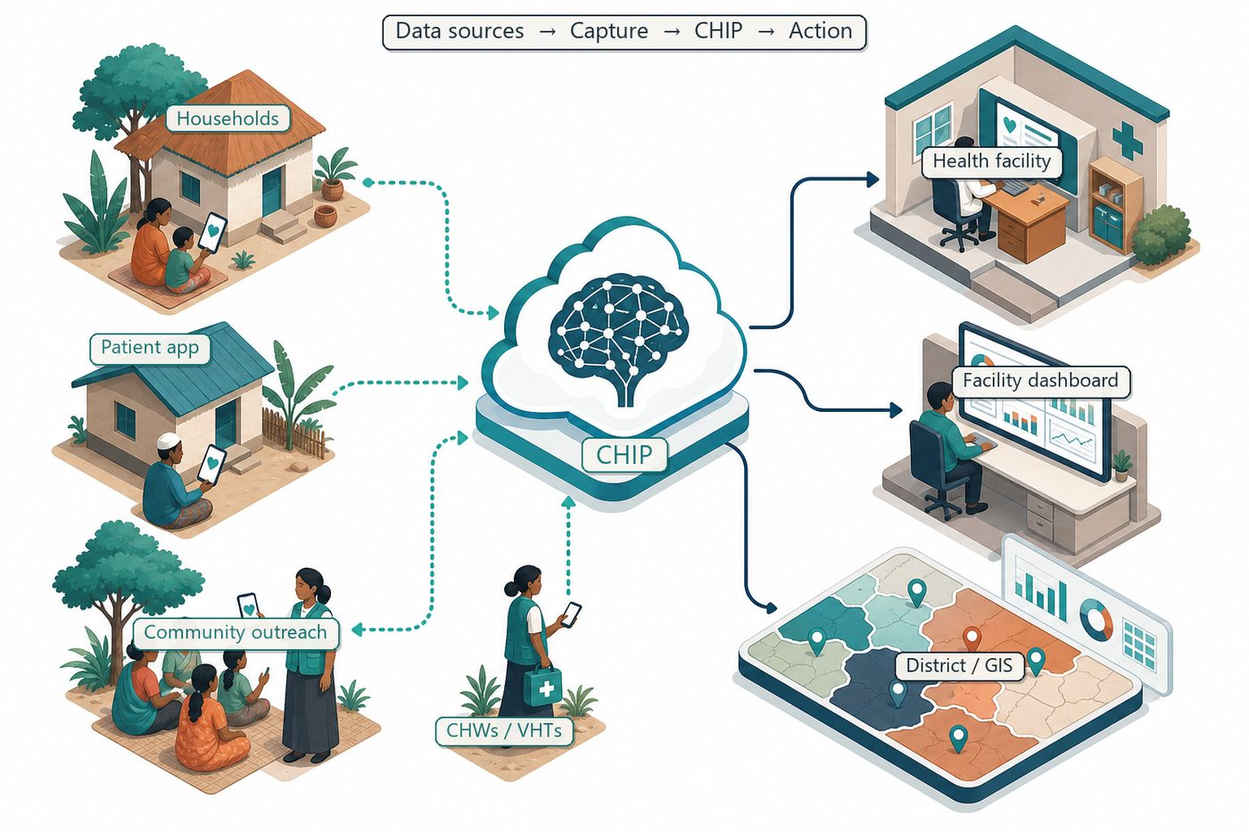
Community signals → capture → FCHIP intelligence → action
A FairBanks youth group will attend WHS 2026, document key sessions, and run a post-summit learning clinic for CHWs and clinic staff in Kampala.
We will focus on digital health, community systems, and partnership pathways relevant to FCHIP.
4.1 Deep technology core
Technology | Role
Artificial Intelligence | Outbreak early warning; maternal and NCD risk scoring
Machine Learning | Learn from community patterns, seasons, and outreach outcomes
GIS Mapping | Disease distribution, hotspots, and resource gaps
Mobile Data Collection | Offline-capable CHW/VHT capture at household level
Cloud Computing | Secure sync across facilities and partners
Analytics Dashboards | Real-time views for clinics, districts, and NGOs

4.2 Priority use cases for this call
Summit learning: Capture transferable practices for CHW digital tools.
Partnership mapping: Identify research and NGO collaborators.
Homeward briefing: Share insights with FairBanks and community partners.
5. Fit to Programme Criteria
Criterion / theme | How we respond
Youth-led health / impact org | FairBanks youth cohort within community health ecosystem
Nominees aged 28 or under | Delegation will meet age rules
Group tickets 3–15 | We request a mid-size learning group
Self-funded travel | Understood and planned separately from ticket request

6. Why FairBanks Is Ready
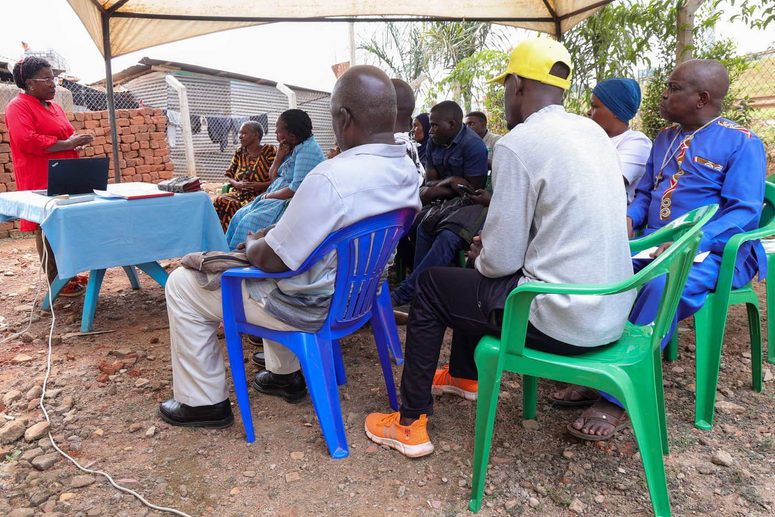
Live outreach in Kampala-area communities
- Functioning FairBanks Medical Centre with clinic, pharmacy, and diagnostics
- Active Community Reach outreach in Bukoto, Kyebando, Kisaasi, Kamwokya, Kikaaya
- Trusted CHW and VHT relationships for household visits and referrals
- Live programmes: maternal & child health, Gericare, chronic-disease screening
- Digital health records and outreach data ready to feed FCHIP
- Research and partnership mindset for ethical, evidence-based scale
7. Proposed Plan
- Select diverse youth nominees (clinical, community, digital) under 28
- Prepare a one-page FairBanks brief for networking
- Attend all three summit days with a session tracking plan
- Host a post-summit community briefing within 30 days of return
8. Risks & Safeguards
Risk | Mitigation
Data quality in the field | Structured forms, validation, CHW training and supervision
Low digital literacy | Simple offline UX, local-language support, supervised rollout
Privacy and consent | Ethical governance aligned with Uganda data protection rules
Adoption by partners | Co-design with CHWs, clinics, and district users from day one

9. Closing Ask
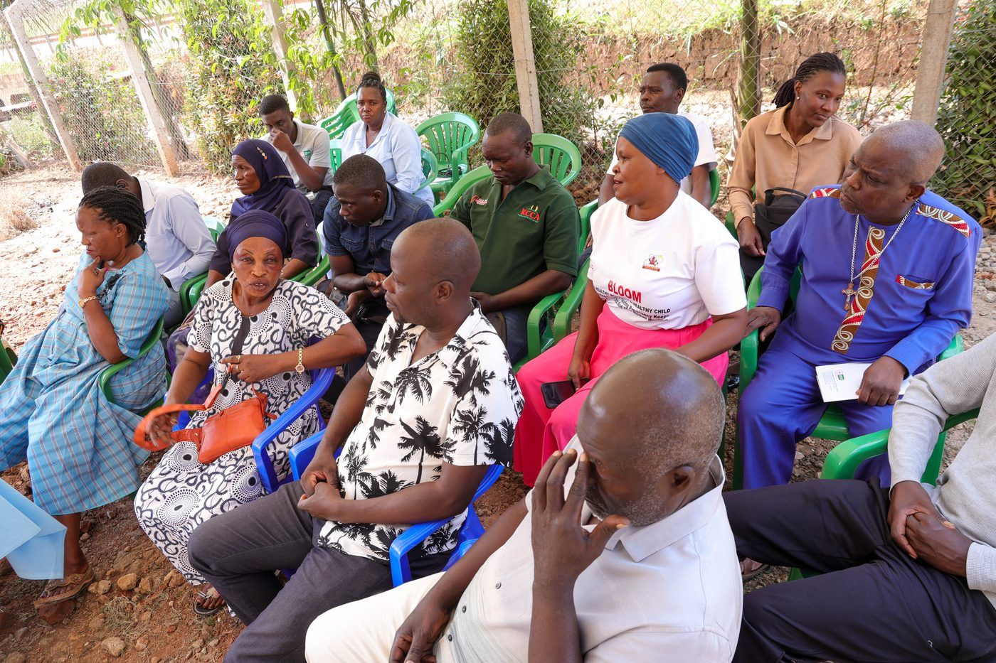
From community needs to lasting health impact
WHS is stronger when community practitioners are in the room. FairBanks youth are ready to listen, contribute, and bring lessons home.
We request complimentary group tickets for our eligible delegation.
Your health, our mission.
Aligned with: https://opportunitiesforyouth.org/2026/06/26/apply-now-world-health-summit-2025-stipend-program-for-global-health-changemakers/

