CDC-RFA-JG-26-0054 — Strengthening global health security through local partnerships in Uganda
Project Narrative Pack (submission companion)
FairBanks Medical Centre · FCHIP component
Your health, our mission.

Table of critical details
Item | Detail
Opportunity number | CDC-RFA-JG-26-0054
Applicant | FAIRBANKS MEDICAL CENTRE LIMITED
Country of performance | Uganda
Funding instrument | Cooperative agreement
Assistance listing | 93.318
Period of performance | 5 years (five 12-month budget periods)
Year 1 Component 1 ask (draft) | $2,450,000 (CONFIRM; ceiling $5,000,000)
Cost share | None proposed
Local partner preference | Yes — Uganda-incorporated entity (document before submit)
Deadline | 14 August 2026, 11:59 p.m. ET
Contact | Racheal Nabukeera · info@fairbanksmedicalcentre.org · +256 772 849 258

Project abstract summary
FAIRBANKS MEDICAL CENTRE LIMITED (FairBanks Medical Centre) is a Uganda-registered health organisation in Kampala. We run a licensed medical centre and FairBanks Community Reach with CHWs and VHTs in Bukoto, Kyebando, Kisaasi, Kamwokya, Kikaaya and nearby communities. Slogan: Your health, our mission. This project helps Uganda close last-mile Global Health Security gaps flagged by the 2023 Joint External Evaluation: community and facility signals that reach decision-makers too late; limited surge-ready workforce at subnational level; and incomplete links into national surveillance and emergency structures, including National Integrated Surveillance System (NISS) pathways. Under Ministry of Health leadership, Year 1 Component 1 will (1) strengthen community and facility surveillance that contributes to MoH/NISS channels using FairBanks FCHIP tools, (2) speed community-to-district detection and response using 7-1-7 style timing, (3) train CHWs/VHTs and frontline workers for One Health–aware surveillance and surge readiness, and (4) tighten community–facility links for priority diseases during routine work and outbreaks. Laboratory and border-health modules will be delivered with MoH-aligned partners. Components 2–5 are contingency surge plans that may be approved but unfunded until CDC activates emergency funding.
1. Background and approach — problem
Uganda faces repeated infectious disease threats shaped by geography, rapid urban growth, and high population movement. Outbreaks that start in peri-urban communities can grow before national systems see them. Americans and Ugandans are safer when threats are found and contained close to source.
In FairBanks catchments, CHWs and VHTs already visit homes and schools, and the Medical Centre sees patients every day. Too often, community reports, clinic records, and lab referrals still sit apart. The 2023 JEE praised progress and still named gaps in information sharing, subnational surge capacity, and use of data for early action — including the need for stronger integrated surveillance such as NISS.
FairBanks proposes to close the last-mile gap under MoH leadership: structured community and facility signals, faster notify–respond loops with districts, trained frontline workers, and tools that feed government systems rather than create a parallel silo.
2. Approach and FairBanks model
FairBanks Community Reach cascade stays the operating model: community members → CHWs/VHTs → Community Reach programmes → Medical Centre → research and skills → economic empowerment. FCHIP is the intelligence component on the Data & Feedback loop.
Award funds will support surveillance systems, training, emergency readiness, data linkages, and public health programme coordination. Routine clinical care continues on FairBanks’ own operations and is not the purpose of this cooperative agreement.
We will collaborate with MoH, district/KCCA teams, other CDC partners, and community structures. Software, SOPs, and training materials developed under the award will be available to MoH and CDC for appropriate use.
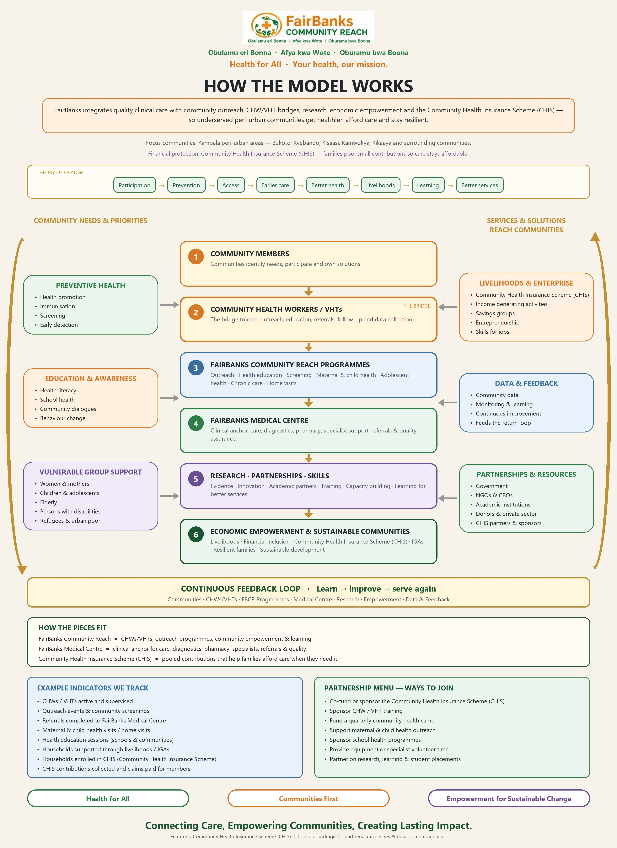
Figure: FairBanks Community Reach operating model
3. Year 1 strategies and activities (Component 1)
Strategy | FairBanks Year 1 focus
1 Emergency management | District notification SOPs, 7-1-7 drills, catchment IMS practice, AARs
2 Workforce | CHW/VHT and facility training; surge roster; One Health–aware sessions with districts
3 Laboratory (support) | Sample referral pathways; private-facility incident reporting support; biosafety basics
4 Surveillance | FCHIP capture → MoH/NISS-aligned exports; data quality; simple GIS early warning
5 Border health (support) | RCCE and signal sharing for high-mobility corridors with MoH partners
6 Public health programmes | Community–facility links for HIV, TB, malaria, VHFs, mpox, immunisation campaigns

4. Anticipated outcomes
Outcome | What success looks like
Faster detection & response | Shorter time from community signal to district notification (7-1-7 style)
Stronger surveillance | Weekly community reports and successful MoH/NISS-aligned data tests
Ready workforce | Trained CHWs/VHTs and surge roster exercised in drills
Better community–facility links | Documented referral outcomes for priority disease flags
Government use | Tools, SOPs, and data access handed for MoH/CDC use

5. Evaluation and performance measurement (summary)
- DGHP partner-level indicators from the FY26 list (surveillance, community mitigation, emergency ops, IPC, lab support) — final set agreed with CDC after award.
- Project measures: median days signal→notify; CHWs submitting complete weekly reports; completed priority referrals; successful MoH export tests; AARs after drills/events.
- About 5–10% of funds for M&E; detailed EPMP and DMP within six months of award.
Full EPMP and DMP text for Grants.gov paste is in application_answers.md (sections D and D7).
6. Organizational capacity
- FAIRBANKS MEDICAL CENTRE LIMITED (No. 80020003843337; TIN 1053370026) — Uganda company with principal place of business in Kampala.
- Live Medical Centre and Pharmacy; Community Reach with CHWs/VHTs; working FCHIP MVP.
- Public community base: Kyebando–Kisalosalo, Northern Bypass, Kampala. Catchments include Bukoto, Kyebando, Kisaasi, Kamwokya, Kikaaya.
- Lead: Racheal Nabukeera, Managing Director and Co-founder — 15+ years in Uganda private health leadership.
- Honest note: we have not yet been prime on a multi-million CDC GHS award; financial controls and staffing for federal compliance will be strengthened as described in attachments (CONFIRM).
Website: https://www.fairbanksmedicalcentre.org/
Registered address: Plot 1423 and 1425 Tirupati Road, Fairbanks Medical Centre, Kampala Central Division, Kololo IV, Lugogo, Kampala, Uganda
7. Draft Year 1 component budgets (CONFIRM before submit)
Component | Draft ask | Ceiling | Notes
1 Core GHS | $2,450,000 | $5,000,000 | Expected initial funding
2 Small-scale response | $1,800,000 | $10,000,000 | Contingency
3 Large-scale response | $2,750,000 | $15,000,000 | Contingency
4 Emerging threats | $1,500,000 | $15,000,000 | Contingency
5 Humanitarian | $1,500,000 | $20,000,000 | Contingency

Indirect: foreign organisation 8% of MTDC (CONFIRM). Separate SF-424A lines per component. Itemised budget narrative categories: salaries, fringe, travel, equipment, supplies, contractual, other, indirect.
8. Pre-submit checklist
- SAM.gov active + UEI for physical location receiving funds
- Grants.gov / Login.gov active; authorised official ready to certify
- Local partner letter + ownership/staff/board citizenship evidence
- Project narrative PDF ≤60 pages; attachments ≤50 pages; English; USD only
- All five components included; no research; clinical care not the award purpose
- Submit by 14 August 2026, 11:59 p.m. ET via Grants.gov
- Official listing: https://simpler.grants.gov/opportunity/264249e6-fdbb-4b1c-ac90-23b7d9b07b1b
Full copy-paste bank: application_answers.md. Generated 2026-07-30.
Your health, our mission.

