RACHEAL NABUKEERA SEKAGIRI  Senior Human Resource Executive | Human Capital Strategist  Kampala, Uganda  Mobile: +256 772 849258 | +256 701 849258  Email: info@fairbanksmedicalcentre.org  Web: www.fairbanksmedicalcentre.org | 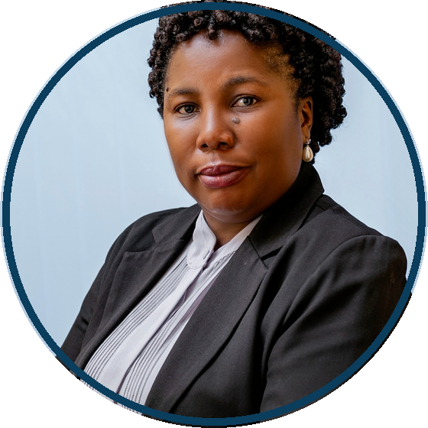
PROFILE
Strategic HR executive with nearly 30 years of experience and over 18 years in executive HR leadership. Aligns people strategy with organisational performance across complex institutions.
Founder and Managing Director, FairBanks Medical Centre Ltd. Formerly led Group HR for 2,000+ employees across 50+ departments. PhD Candidate (Management) researching AI prediction of occupational burnout.
CORE COMPETENCIES
HR Strategy · Organisational Development · Talent Management · Workforce Planning · Change Management · Performance Management · Employee Relations · Corporate Governance · Leadership Development · HR Analytics / HRIS
EXPERIENCE
Founder, Managing Director & Executive HR Leader
FairBanks Medical Centre Ltd | 2025 - Present
- Lead strategy, governance, HR and institutional growth.
- Founded social enterprise initiative (10,000+ beneficiaries).
Group Human Resource & Administration Manager
Norvik Group | Jul 2016 - Feb 2026
- Directed Group HR for 2,000+ employees across 50+ units.
- Led workforce planning, restructuring and leadership development.
Human Resource & Administration Manager
Norvik Hospital Ltd | Sep 2013 - 2016
- Led recruitment, employee relations and performance systems.
Human Resource Manager
St. Catherine's Hospital | 2007 - 2010
- Managed HR operations, welfare and labour compliance.
Earlier: Health Systems Administrator, St. Catherine's (2010-2013); HR Assistant, E Power Limited (1997-2000).
EDUCATION
PhD in Management (Ongoing)
Uganda Christian University - AI/ML research on occupational burnout in medical practice
Master of Social Sector Planning and Management
Makerere University
Bachelor of Arts in Social Sciences
Makerere University
ADDITIONAL
Member, FUE · English & Luganda (Fluent) · References on request

