RACHEAL NABUKEERA SEKAGIRI  Senior Human Resource Executive | Human Capital Strategist  Kampala, Uganda · +256 772 849258 | +256 701 849258 · info@fairbanksmedicalcentre.org | 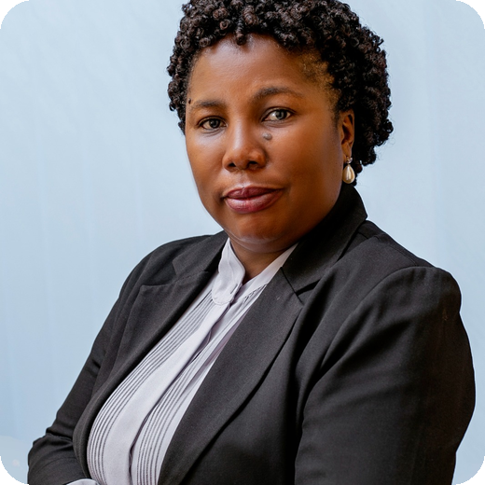
PROFILE
Strategic HR executive with nearly 30 years of experience and over 18 years in executive HR leadership. Aligns people strategy with organisational performance across complex institutions. Founder and Managing Director, FairBanks Medical Centre Ltd. Formerly led Group HR for 2,000+ employees across 50+ departments. PhD Candidate (Management) researching AI prediction of occupational burnout.
HIGHLIGHTS
- 30 years HR and executive management experience
- 18+ years executive Human Resource leadership
- HR leadership for 2,000+ employees across 50+ units
- Founder & MD, FairBanks Medical Centre Ltd
- Social enterprise reach: 10,000+ beneficiaries
SKILLS
HR Strategy · Organisational Development · Talent Management · Workforce Planning · Change Management · Performance Management · Employee Relations · Corporate Governance · Leadership Development · HR Analytics / HRIS
EXPERIENCE
Founder, Managing Director & Executive HR Leader
FairBanks Medical Centre Ltd | 2025 - Present
- Lead strategy, governance, HR and institutional growth.
- Founded social enterprise initiative (10,000+ beneficiaries).
Group Human Resource & Administration Manager
Norvik Group | Jul 2016 - Feb 2026
- Directed Group HR for 2,000+ employees across 50+ units.
- Led workforce planning, restructuring and leadership development.
Human Resource & Administration Manager
Norvik Hospital Ltd | Sep 2013 - 2016
- Led recruitment, employee relations and performance systems.
Earlier: HR Manager & Systems Administrator, St. Catherine's (2007-2013); HR Assistant, E Power Limited (1997-2000).
EDUCATION & MORE
PhD Management (Ongoing), Uganda Christian University · MSSPM, Makerere · BA Social Sciences, Makerere
FUE Member · English & Luganda (Fluent) · References on request

