RACHEAL NABUKEERA SEKAGIRI
Senior Human Resource Executive | Human Capital Strategist
Kampala, Uganda · +256 772 849258 | +256 701 849258 · info@fairbanksmedicalcentre.org
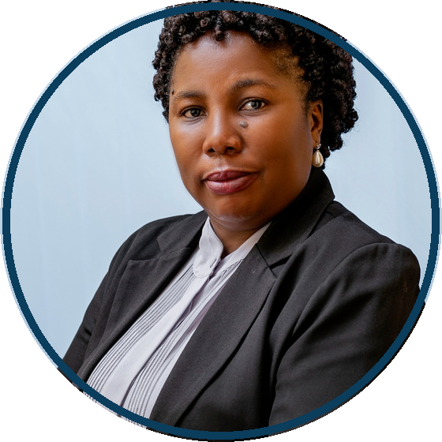
PROFILE
Strategic HR executive with nearly 30 years of experience and over 18 years in executive HR leadership. Aligns people strategy with organisational performance across complex institutions.
Founder and Managing Director, FairBanks Medical Centre Ltd. Formerly led Group HR for 2,000+ employees across 50+ departments. PhD Candidate (Management) researching AI prediction of occupational burnout.
CAREER TIMELINE
2025 - Present | Founder, Managing Director & Executive HR Leader  FairBanks Medical Centre Ltd  - Lead strategy, governance, HR and institutional growth.  - Founded social enterprise initiative (10,000+ beneficiaries).

Jul 2016 - Feb 2026 | Group Human Resource & Administration Manager  Norvik Group  - Directed Group HR for 2,000+ employees across 50+ units.  - Led workforce planning, restructuring and leadership development.

Sep 2013 - 2016 | Human Resource & Administration Manager  Norvik Hospital Ltd  - Led recruitment, employee relations and performance systems.

2007 - 2010 | Human Resource Manager  St. Catherine's Hospital  - Managed HR operations, welfare and labour compliance.

EDUCATION
PhD in Management (Ongoing) - Uganda Christian University
Master of Social Sector Planning and Management - Makerere University
Bachelor of Arts in Social Sciences - Makerere University
FUE Member · English & Luganda (Fluent) · References on request

