
Africa Health-Tech Accelerator 2026

FairBanks Community Health Intelligence Platform (FCHIP)
From community health signals to timely action across Africa
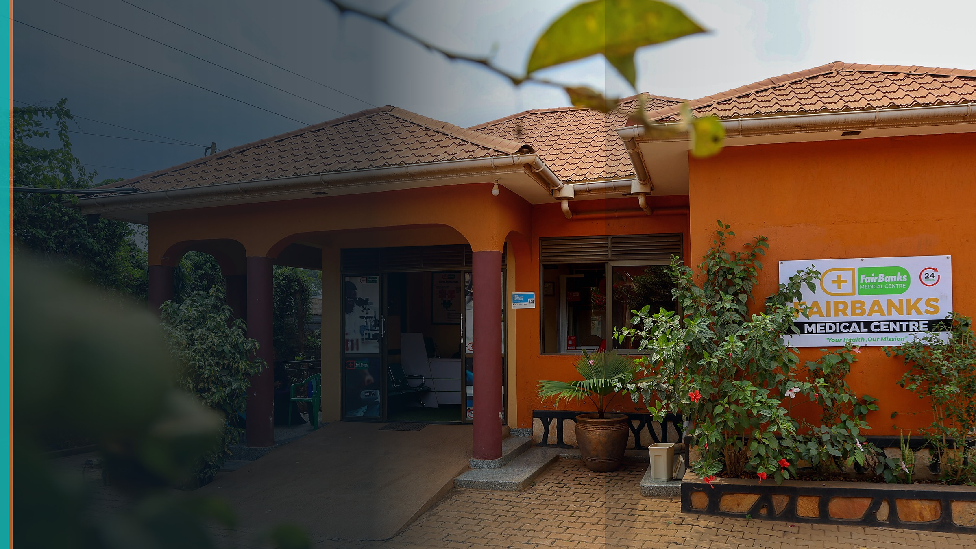
Your health, our mission.
Application detail | Working position
Deadline | 20 July 2026 (extended deadline - recheck before submission)
Headquarters | Uganda
Recommended stage | MVP - only if demonstrable
Document status | Application draft - identity and commercial fields require confirmation

Prepared from the live official programme site and all six sections of the application portal on 19 July 2026.

Submission readiness gate
The portal requires at least two founders and a minimum viable product. The repository confirms strong field operations, but it does not verify the founder, commercial, or FCHIP MVP facts below. Complete these items before submission.
- Confirm at least two founders and list every founder with a role.
- Confirm that a working FCHIP MVP exists and provide a demo or evidence.
- Confirm the presenting founder can attend at least 80% of sessions.
- Replace every CONFIRM BEFORE SUBMISSION field with verified information.
- Upload the pitch deck to a public-access link and test it while signed out.
Critical field | Current status
Founder identity and contacts | CONFIRM BEFORE SUBMISSION
Co-founders and roles | CONFIRM BEFORE SUBMISSION
Working FCHIP MVP evidence | CONFIRM BEFORE SUBMISSION
Revenue and paying customers | CONFIRM BEFORE SUBMISSION
Funding raised and partner list | CONFIRM BEFORE SUBMISSION
Website and public pitch-deck link | CONFIRM BEFORE SUBMISSION

1. Official programme brief
Item | Verified call information
Programme | Six-month pan-African health-tech accelerator
Delivery | Primarily online, with one in-person milestone event
Applicant | Africa-based early-stage health-tech startup or SME
Eligibility | At least two founders; minimum MVP; 80% session commitment
Benefits | Training, one-to-one mentorship, seed-funding opportunity, investor access, Demo Day exposure, and continental visibility
Deadline | 20 July 2026 (extended deadline - recheck before submission)

1.1 Strong fit with FCHIP
- Digital health platform with health data and analytics at its core.
- AI-assisted risk insight, used only after validation and clinical oversight.
- Preventive health, remote monitoring, EHR integration, and supply planning.
- Africa-based product with a clear Uganda-to-East-Africa scale path.
- A live care and outreach environment for real-world product validation.

1.2 Programme journey
Stage | Official programme description
Open call | Application and screening; deadline extended to 20 July 2026
Bootcamp and selection | Intensive virtual bootcamp; up to 50 startups targeted
Accelerator | Weekly sessions, office hours, and Demo Day preparation
Closing event | Pitching, winner announcement, and funding pathway

2. Portal answer bank
Copy only verified answers into the live portal. The wording below is submission-ready where facts are known; orange/red fields require the applicant.

Section 1 of 6 - Startup and founding team
Portal question | Draft answer / action
Startup Name* | FairBanks Community Health Intelligence Platform (FCHIP)
Founder Name* | [CONFIRM BEFORE SUBMISSION]
Founder Gender* | [CONFIRM BEFORE SUBMISSION: Male or Female]
Founder Mobile* | [CONFIRM BEFORE SUBMISSION]
Founder Email* | [CONFIRM BEFORE SUBMISSION]
Founder LinkedIn | [CONFIRM BEFORE SUBMISSION]
Startup Website* | [CONFIRM BEFORE SUBMISSION]
Startup Stage* | [CONFIRM BEFORE SUBMISSION: select MVP only if a working product can be demonstrated; the programme requires an MVP]
Country Headquarter* | Uganda
Primary African office if headquarters is outside Africa | Not applicable

Section 2 of 6 - Startup overview
Portal question | Draft answer / action
What Problem Are You Solving?* | Primary healthcare in underserved African communities is still reactive. Facilities often see people only after illness has worsened, while useful signals from CHW and VHT visits, outreach screenings, maternal care, pharmacy activity, and facility records remain fragmented. This delays outbreak detection, high-risk pregnancy referral, NCD follow-up, and medicine planning. Clinics and district teams therefore lack a timely, community-level view of who is at risk, where health threats are growing, and what action should happen next.
What is Your Solution?* | FCHIP is an offline-capable community health intelligence platform. CHWs and VHTs capture structured household and outreach data through mobile tools; approved facility and programme data are synchronized securely; and an analytics layer produces risk flags, GIS hotspot maps, referrals, and dashboards. The first release focuses on three practical use cases: maternal risk and missed-care alerts, hypertension and diabetes hotspot detection, and community disease surveillance. FairBanks will validate the product in its existing medical centre and Community Reach network before expanding to partner clinics and districts.
Who Are Your Target Customers?* | Private and faith-based clinics, district health offices, NGOs and development programmes, research partners, and health insurers that need better community-level data, follow-up, early warning, and programme monitoring. CHWs and VHTs are the core frontline users.
Startup Innovation Area* | Select: Digital Health Platforms; Health Data & Analytics; Artificial Intelligence in Healthcare; Electronic Health Records; Remote Patient Monitoring; Preventive Health & Wellness Technologies. Add Pharmaceutical Supply Chain Solutions only if medicine forecasting is in the MVP.
Other areas | Community health intelligence and CHW/VHT decision support
What Makes Your Solution Unique?* | FairBanks combines what many health-tech startups and facilities lack: a live medical centre, active outreach programmes, CHW and VHT links, digital health workflows, and a product designed from real community care. This gives FCHIP a direct test environment and a trusted route to users. The platform is not only an electronic register; it closes the loop from community signal to risk insight, referral, targeted outreach, and follow-up.
Which Countries Are You Operating In?* | Uganda
Pitch Deck (upload link)* | [CONFIRM BEFORE SUBMISSION: upload the generated PPT/PDF to Google Drive or another public link; test access while signed out]

Section 3 of 6 - Eligibility screening
Portal question | Draft answer / action
Is your startup based in Africa?* | Yes - Uganda
Does your startup provide a Health-Tech product/service?* | Yes
Co-Founder Names and Roles* | [CONFIRM BEFORE SUBMISSION]
Total Founders (including yourself)* | [CONFIRM BEFORE SUBMISSION: minimum 2]
Can you commit to 80%+ of programme sessions?* | [CONFIRM BEFORE SUBMISSION: select Yes only if true]

Section 4 of 6 - Traction and readiness
Portal question | Draft answer / action
Monthly Revenue Range* | [CONFIRM BEFORE SUBMISSION: Less than $5,000 / $5,000-$20,000 / $20,000-$50,000 / $50,000+]
Number of Paying Customers* | [CONFIRM BEFORE SUBMISSION: 0 / 1-10 / 11-50 / 51-200 / 200+]
Fundraising in the next 6 months?* | [CONFIRM BEFORE SUBMISSION: Yes or No]
Raised funding before?* | [CONFIRM BEFORE SUBMISSION: Yes or No]
If yes, amount raised (USD) | [CONFIRM BEFORE SUBMISSION]
Current Partners* | [CONFIRM BEFORE SUBMISSION. Do not count a prospective partner. Portal options: Hospitals/Clinics; Pharma; Insurers; NGOs; Government; Corporates; Universities; None Yet.]
Other Partners | [CONFIRM BEFORE SUBMISSION]
Next 6-Month Milestone* | Recommended if MVP is verified: Validate product-market fit. Otherwise FairBanks is not yet eligible under the stated MVP rule.

Section 5 of 6 - Expected support
Portal question | Draft answer / action
Top 3 Priorities* | 1. Validation & Market Research; 2. Product Development (MVP, UX, iteration); 3. Partnerships & Ecosystem Access.
Alternative priority | Replace Product Development with Investment Readiness & Fundraising if the MVP is already stable and validated.

Section 6 of 6 - Final notes
Portal question | Draft answer / action
What is your biggest bottleneck right now?* | Our biggest bottleneck is converting a strong real-world health delivery foundation into a validated, investment-ready product. We need disciplined MVP validation, user testing with CHWs and facility teams, a clear product-market fit case, and partnerships that can support deployment beyond one FairBanks catchment. We also need to strengthen our evidence, data-governance, and fundraising package without overbuilding before the highest-value workflows are proven.
Why do you want to join Africa Health-Tech Accelerator?* | The accelerator directly matches FCHIP's next milestone: validate an Africa-built digital health platform and prepare it for cross-border scale. Mentorship can sharpen our product choices and business model; healthcare and public-sector networks can open credible pilot and integration pathways; and investor-readiness support can turn field evidence into a financeable growth plan. We will contribute a practical Ugandan perspective grounded in community outreach, primary care, CHW and VHT workflows, and the daily realities of underserved urban communities.
How did you hear about the programme?* | [CONFIRM BEFORE SUBMISSION: choose the truthful portal option. Use Other if discovered through an opportunity listing.]

3. Venture narrative
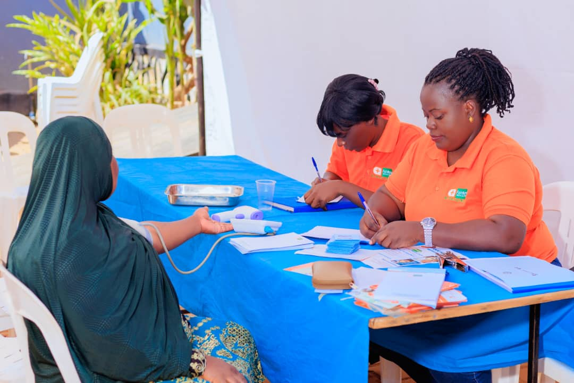
FairBanks outreach provides a real environment for FCHIP product validation.

3.1 Problem
Primary healthcare in underserved African communities is still reactive. Facilities often see people only after illness has worsened, while useful signals from CHW and VHT visits, outreach screenings, maternal care, pharmacy activity, and facility records remain fragmented. This delays outbreak detection, high-risk pregnancy referral, NCD follow-up, and medicine planning. Clinics and district teams therefore lack a timely, community-level view of who is at risk, where health threats are growing, and what action should happen next.

3.2 Solution
FCHIP is an offline-capable community health intelligence platform. CHWs and VHTs capture structured household and outreach data through mobile tools; approved facility and programme data are synchronized securely; and an analytics layer produces risk flags, GIS hotspot maps, referrals, and dashboards. The first release focuses on three practical use cases: maternal risk and missed-care alerts, hypertension and diabetes hotspot detection, and community disease surveillance. FairBanks will validate the product in its existing medical centre and Community Reach network before expanding to partner clinics and districts.

3.3 Competitive advantage
FairBanks combines what many health-tech startups and facilities lack: a live medical centre, active outreach programmes, CHW and VHT links, digital health workflows, and a product designed from real community care. This gives FCHIP a direct test environment and a trusted route to users. The platform is not only an electronic register; it closes the loop from community signal to risk insight, referral, targeted outreach, and follow-up.

4. Product and technology
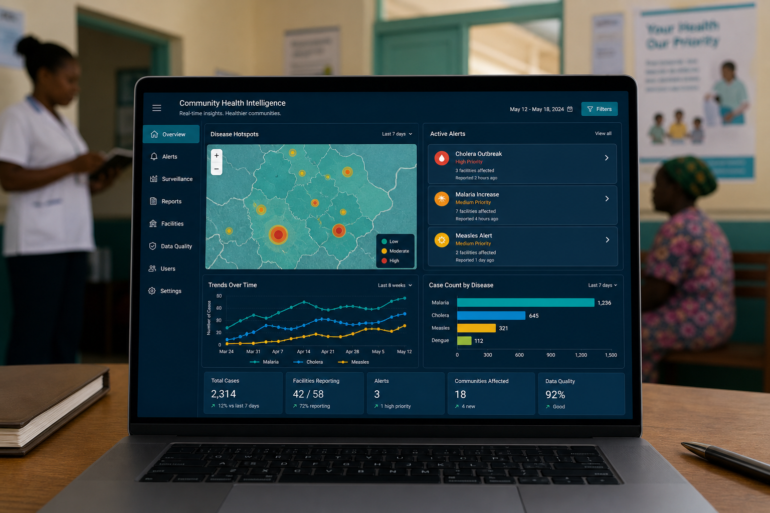
FCHIP dashboard concept - illustrative, not evidence of a deployed product.
Product layer | Role
Offline mobile capture | Structured CHW/VHT visits, vitals, referrals, and follow-up
Secure data pipeline | Validation, consent, role-based access, and approved integrations
Analytics and AI | Start with interpretable rules; add validated ML as data quality grows
GIS risk layer | Community hotspots, coverage gaps, and outreach priorities
Action dashboard | Alerts, referrals, trends, data quality, and medicine planning

Responsible AI position: begin with simple, explainable rules and clinician review. Add machine-learning models only when the training data, bias checks, monitoring, and clinical validation are adequate.

5. Target customers and business model
Private and faith-based clinics, district health offices, NGOs and development programmes, research partners, and health insurers that need better community-level data, follow-up, early warning, and programme monitoring. CHWs and VHTs are the core frontline users.
Customer | Revenue path
Clinics and hospitals | Subscription plus onboarding and support
Districts and ministries | Deployment, implementation, and analytics contracts
NGOs and programmes | Monitoring, evaluation, workflow, and reporting contracts
Research partners | Ethical study tools and approved anonymised analytics
Digital health partners | API and integration services
CHW organisations | Training and implementation support

5.1 Market-entry logic
- Beachhead: FairBanks catchment and Kampala-area outreach workflows.
- First external buyers: clinics and health programmes needing follow-up and reporting.
- Institutional scale: district, NGO, research, insurer, and ministry deployments.
- Regional scale: adapt to countries with established CHW systems and similar care gaps.

6. Traction and honest evidence
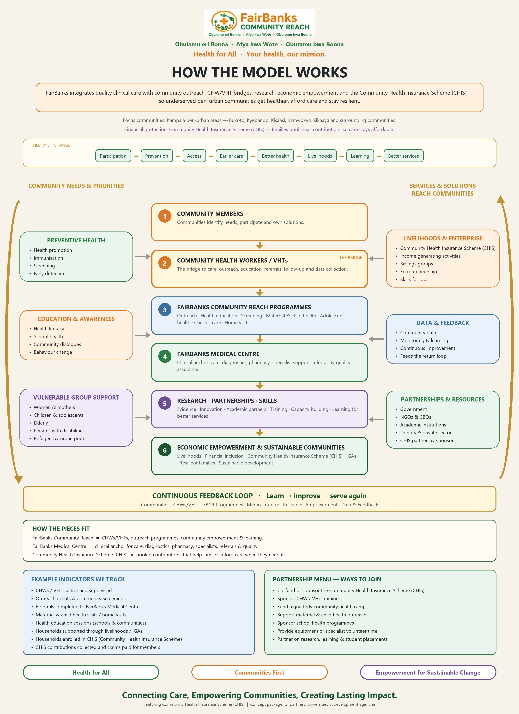
FairBanks Community Reach operating model - FCHIP is the intelligence layer.
- Functioning FairBanks Medical Centre with direct access to care workflows.
- Community Reach activity in Bukoto, Kyebando, Kisaasi, Kamwokya, Kikaaya, and nearby areas.
- CHW and VHT links for outreach, referral, follow-up, and community data collection.
- Existing maternal and child health, Gericare, NCD screening, school, and corporate health work.
- Digital health records and pharmacy workflows that can inform product integration.
These points prove delivery access and validation readiness. They do not by themselves prove FCHIP product traction, paying customers, or model performance. Those claims must be supported separately.

7. Six-month milestone plan
Recommended portal milestone: Validate product-market fit, provided a working MVP already exists.
Timing | Milestone
Month 1 | Confirm users, workflows, MVP evidence, governance, and baseline indicators.
Months 2-3 | Run CHW/facility usability testing; improve offline capture and dashboards.
Months 3-4 | Validate maternal, NCD, and surveillance workflows in FairBanks catchment.
Months 4-5 | Test willingness to pay and partnership model with clinics, NGOs, and districts.
Month 6 | Publish pilot evidence, investor data room, partnership pipeline, and scale plan.

7.1 Suggested pilot indicators
- CHW/VHT weekly active use and form-completion rate.
- Referral completion and time from risk flag to clinical review.
- Maternal, NCD, and surveillance alerts reviewed and acted upon.
- Data completeness, duplicate rate, and correction time.
- Facility/partner willingness to pay and signed pilot commitments.

8. Accelerator support requested
Priority | Why it matters now
Validation & Market Research | Prove user need, buying pathway, and measurable outcomes.
Product Development | Improve offline UX, workflow fit, dashboards, and interoperability.
Partnerships & Ecosystem Access | Secure clinics, districts, programmes, and scale partners.

The accelerator directly matches FCHIP's next milestone: validate an Africa-built digital health platform and prepare it for cross-border scale. Mentorship can sharpen our product choices and business model; healthcare and public-sector networks can open credible pilot and integration pathways; and investor-readiness support can turn field evidence into a financeable growth plan. We will contribute a practical Ugandan perspective grounded in community outreach, primary care, CHW and VHT workflows, and the daily realities of underserved urban communities.

9. Risk and governance
Risk | Mitigation
Eligibility | Confirm two founders and demonstrable MVP before submission.
Data quality | Use simple forms, validation rules, supervision, and data-quality dashboards.
Privacy | Consent, minimisation, role-based access, audit logs, and Uganda compliance.
AI accuracy | Begin with interpretable rules and clinician review; validate before automation.
Adoption | Co-design with CHWs, facilities, districts, and programme partners.
Commercial proof | Test willingness to pay and buying pathways during the pilot.

10. Submission checklist
[ ] Recheck the live deadline and portal availability.
[ ] Verify the legal/startup name used in the form.
[ ] Complete founder identity, contacts, gender, LinkedIn, and website.
[ ] List at least one co-founder and verify total founders is two or more.
[ ] Attach evidence of a working FCHIP MVP.
[ ] Choose only innovation areas included in the current product.
[ ] Enter exact revenue, customer, fundraising, and funding figures.
[ ] Name only confirmed current partners.
[ ] Confirm 80% session attendance and in-person milestone availability.
[ ] Upload the pitch deck; enable public link access; test while signed out.
[ ] Proofread all answers against this pack and the official portal.
[ ] Submit before the deadline and save the confirmation.

11. Official sources
Source | URL
Programme home | https://accelerator.africahealthexcon.com/
Application portal | https://accelerator.africahealthexcon.com/apply
Official programme article | https://accelerator.africahealthexcon.com/publications
Official deadline-extension post | https://www.linkedin.com/posts/africa-health-tech-accelerator_healthtechstartup-healthtech-digitalhealth-activity-7477401395688574976-TAof

Source check date: 19 July 2026. The official portal wins if any detail changes.

