Fund for Innovation in Development (FID) — Call for Proposals 2026
Innovation Proposal
FairBanks Community Health Intelligence Platform (FCHIP)
Predictive community health that keeps families out of poverty
Your health, our mission.
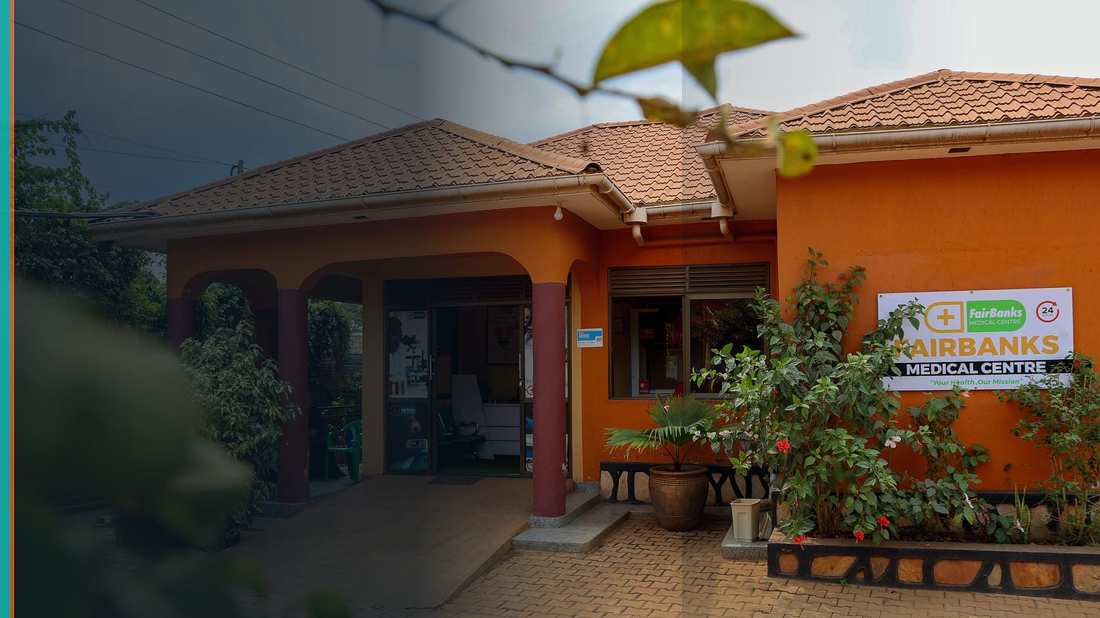
FairBanks Community Reach — Health for All — Obulamu eri Bonna · Afya kwa Wote · Oburamu bwa Boona
Item | Detail
Applicant | FairBanks Medical Centre / FairBanks Community Reach (social enterprise, Uganda)
Sectors | Health · Technology & Innovation · Economic Inclusion
Geography | Uganda (pilot) → East Africa → broader ODA-eligible markets
Funding stage | Requested stage: Pilot Grant (up to €200,000) — pathway to Impact Evaluation & Scale-Up

Aligned with the Fund for Innovation in Development Call for Proposals 2026.
https://opportunitiesforyouth.org/2026/06/12/fid-call-for-proposals-2026-apply-for-up-to-e4-million-to-scale-innovative-solutions-tackling-poverty-and-inequality-worldwide/

1. Executive Summary
In underserved African communities, illness is not only a health problem — it is one of the fastest routes into poverty. When an outbreak, a high-risk pregnancy, or an untreated chronic condition is caught late, families face catastrophic out-of-pocket costs, lost income, and deepening inequality. Today most primary healthcare is reactive: facilities treat patients only after they arrive sick, while the data that could warn everyone earlier sits scattered across community health workers' notebooks, outreach registers, and siloed systems.
FairBanks Community Health Intelligence Platform (FCHIP) is a deep-technology innovation that turns community-generated health data into early warnings and decision support. Community Health Workers (CHWs) and Village Health Teams (VHTs) capture structured data on offline-capable mobile tools; the platform applies artificial intelligence, machine learning, and GIS mapping to predict disease outbreaks, maternal complications, chronic-disease hotspots, child-health threats, and medicine stock-outs — then routes actionable alerts to CHWs, clinics, districts, insurers, and partners before crises escalate.
FairBanks is uniquely positioned to test this innovation. We already operate a functioning medical centre and active community outreach across Kampala-area communities (Bukoto, Kyebando, Kisaasi, Kamwokya, and Kikaaya), working with CHWs and VHTs on maternal and child health, geriatric care (Gericare), and chronic-disease screening. This gives us a live, real-world environment to pilot, evaluate, and refine FCHIP — exactly the evidence-first pathway FID is built to fund.
We are applying for a Pilot Grant to validate FCHIP under real-world conditions and generate the early evidence needed to progress toward a rigorous impact evaluation and, ultimately, scale-up across ODA-eligible markets.
2. The Problem: When Illness Deepens Poverty
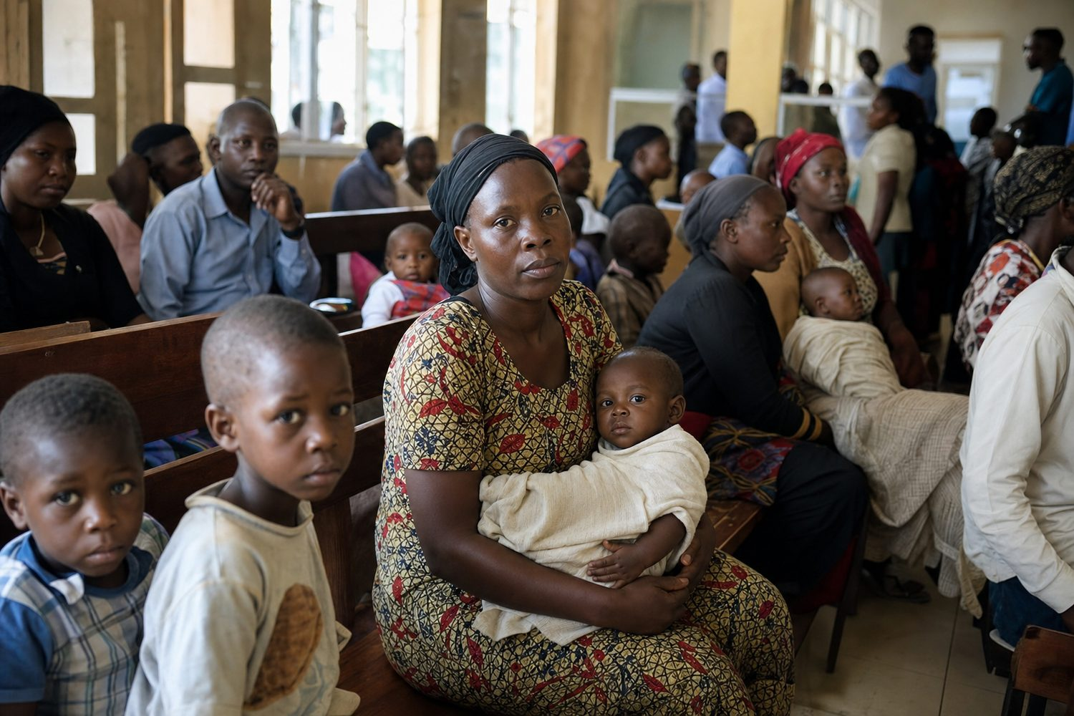
Reactive care: the system waits for sickness before it responds
Across underserved African communities, a structural information gap keeps health systems reactive — and that gap has a direct poverty and inequality cost.
Current reality | Consequence
Care starts only after people fall sick | Late detection of outbreaks and complications; higher treatment costs
Community data sits in paper registers and silos | Districts, NGOs, and insurers lack real-time intelligence
High-risk pregnancies and NCDs found late | Preventable maternal deaths and stroke/diabetes burden
Medicine ordered on guesswork | Stock-outs during seasonal disease surges
Health shocks hit poor households hardest | Catastrophic spending pushes families deeper into poverty

Existing digital tools — appointment booking, EMR digitisation, SMS reminders — rarely combine multi-source community data, predictive modelling, geospatial mapping, and real-time decision support. The result is fragmented data, delayed response, and missed prevention.
3. The Innovation: FCHIP
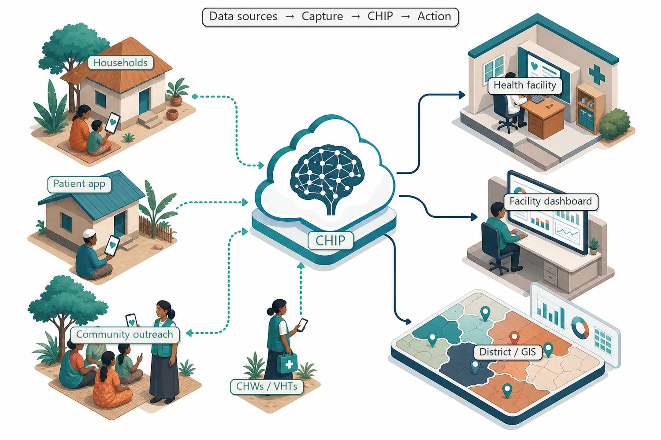
Community signals → mobile capture → FCHIP intelligence → action
FCHIP is a deep-technology platform that turns community-generated health data into predictions and decision support. It sits between last-mile data capture and the people who can act — CHWs, clinics, districts, insurers, and partners.
3.1 Deep technology core
Technology | Function in FCHIP
Artificial Intelligence | Outbreak early warning; maternal and NCD risk scoring
Machine Learning | Pattern learning from community data, seasonal trends, outreach outcomes
GIS Mapping | Disease distribution, hotspots, and resource-gap visualisation
Mobile Data Collection | Offline-capable CHW/VHT capture at household level
Cloud Computing | Secure sync across facilities, partners, administrative levels
Analytics & NLP | Live dashboards; local-language symptom capture where useful

3.2 Predictive use cases
Disease surveillance: Rising fever reports across neighbouring villages → predicted malaria surge → targeted testing, bed-nets, and pharmacy pre-stocking.
Maternal health: Home-visit BP, anaemia proxies, and ANC adherence → high-risk pregnancy flags → early CHW alerts and referral.
Non-communicable diseases: Community and workplace BP/glucose screening → hypertension and diabetes hotspots → targeted campaigns.
Child health: Growth, immunisation, and diarrhoea data → malnutrition and coverage-gap alerts → nutrition and immunisation drives.
Medicine demand: Disease trends, rainfall, and consumption → demand forecasts → replenishment before stock-outs.
4. Theory of Change
FID funds innovations with a clear, testable theory of change. Ours links a health innovation directly to poverty and inequality reduction:
Stage | Detail
Inputs | FID Pilot Grant; FairBanks live operations; CHW/VHT networks; mobile + cloud + AI stack.
Activities | Build offline capture app, cloud pipeline, AI risk models, GIS layer, and dashboards; train CHWs; run pilot.
Outputs | Structured community health data; predictive alerts; facility/district dashboards; referrals triggered.
Outcomes | Earlier detection and referral; fewer missed high-risk cases; fewer stock-outs; better-targeted outreach.
Impact | Reduced preventable illness and health-driven poverty; lower inequality for underserved communities.

5. Evidence of Impact & Evaluation
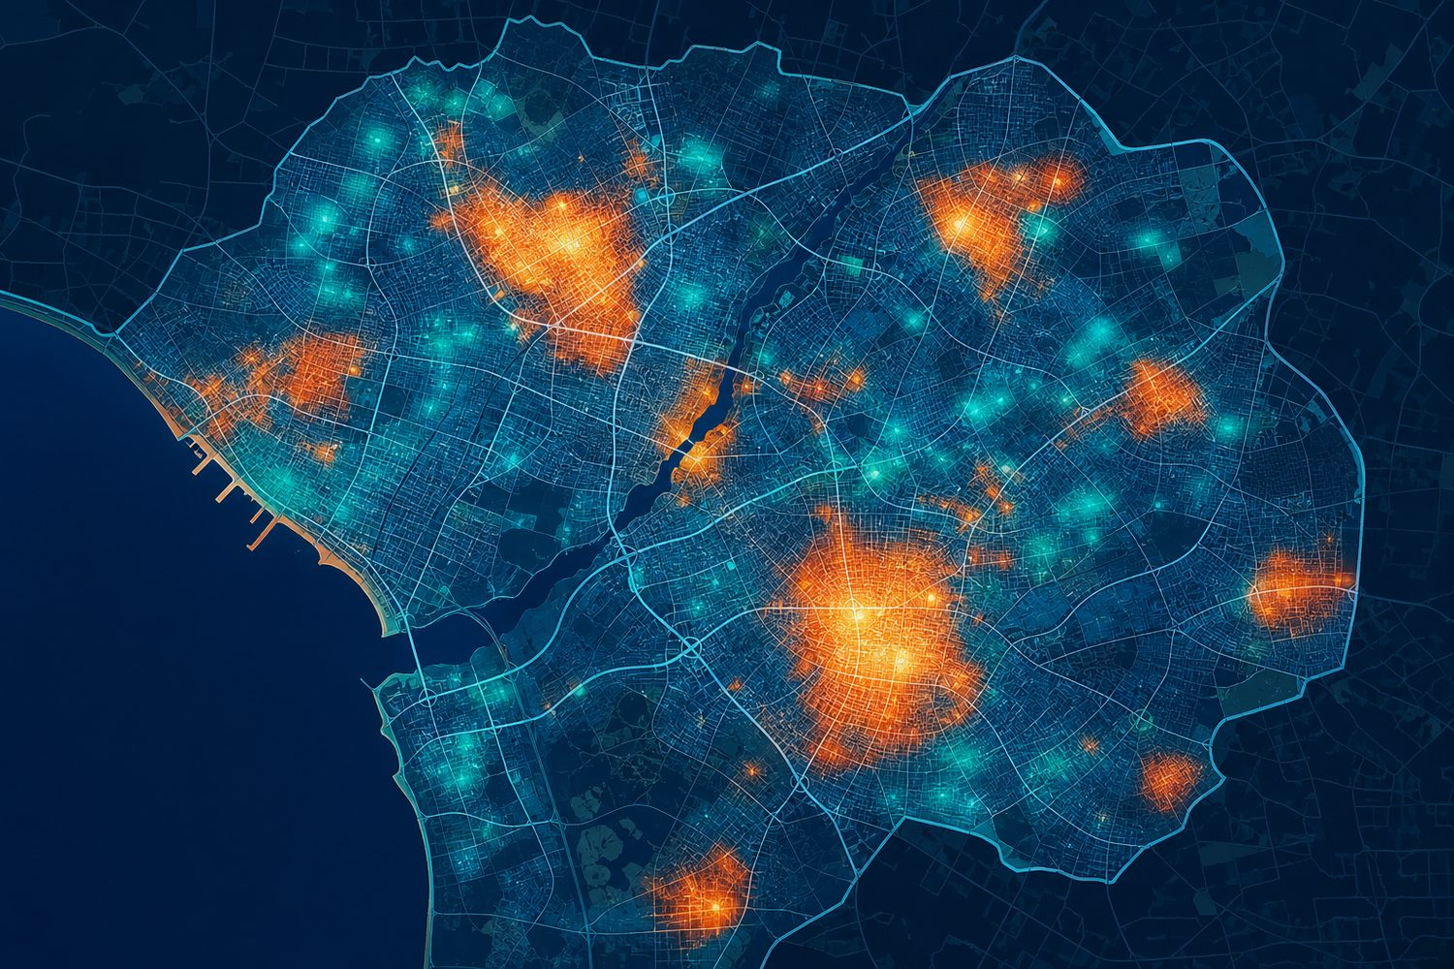
GIS hotspot mapping — measurable, testable early-warning outputs
- Existing evidence: CHW/mHealth programmes and community-based early warning have documented gains in maternal, child, and communicable-disease outcomes across sub-Saharan Africa; FCHIP builds on this base by adding predictive intelligence across multiple data sources.
- Baseline data: FairBanks outreach screening, maternal programmes, pharmacy dispensing, and facility encounters already generate the signals needed to establish a credible pre-intervention baseline.
- Measurable outcomes: alert accuracy, time-to-referral, proportion of high-risk pregnancies identified early, immunisation and screening coverage, and stock-out frequency.
- Evaluation pathway: the pilot is designed so that a subsequent counterfactual impact evaluation (comparison communities) can rigorously test effect sizes — the qualifying step toward FID's Impact Evaluation and Scale-Up stages.
6. Cost & Cost-Effectiveness
- Builds on assets that already exist — a live medical centre, trained CHW/VHT networks, and outreach programmes — so the pilot avoids the cost of standing up field operations from scratch.
- Offline-first, mobile-based capture keeps hardware and connectivity costs low and works in low-bandwidth settings.
- Prevention is cheaper than late treatment: early detection of outbreaks, maternal risk, and NCDs reduces costly emergency care and lost livelihoods.
- A shared platform serves many users (CHWs, clinics, districts, insurers), spreading cost and improving cost per beneficiary as coverage grows.
7. Scale & Financial Sustainability
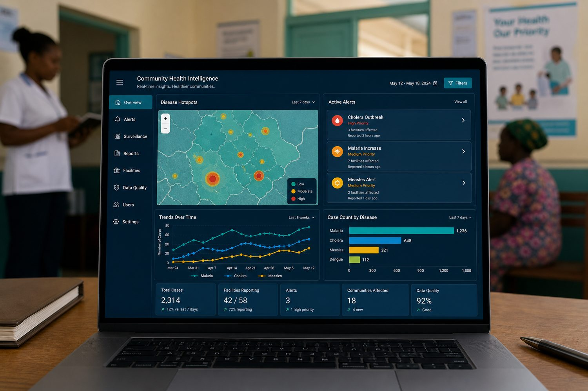
A shared intelligence layer that scales across many users and districts
- Technical scalability: cloud architecture and standard mobile tools extend from one catchment to many districts without redesign.
- Model portability: CHW/VHT systems exist across Uganda and much of Africa, so the approach transfers to other ODA-eligible markets.
- Financial sustainability: diversified revenue — clinic/hospital subscriptions, district and Ministry of Health deployments, NGO programme monitoring, insurer analytics, and partner APIs — reduces reliance on grants over time.
- Policy pathway: evidence generated in the pilot supports integration into public health planning and district decision-making, aligning with FID's public-policy funding streams.
8. Why FairBanks — Traction & Foundation
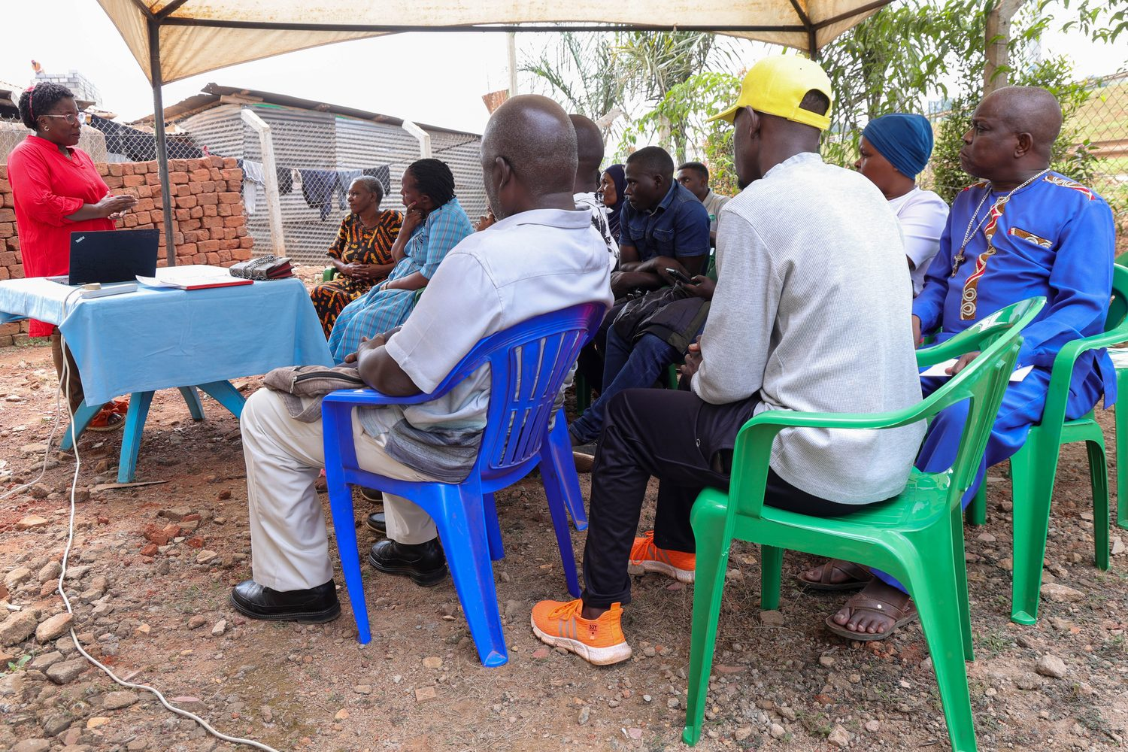
Live FairBanks Community Reach outreach in Kampala communities
- Functioning FairBanks Medical Centre with direct patient and community access
- Active Community Reach outreach in Bukoto, Kyebando, Kisaasi, Kamwokya, Kikaaya, and surrounding areas
- Established CHW and VHT relationships and trust in target communities
- Live programmes: maternal & child health, Gericare, chronic-disease screening, corporate & school health
- Digital health records foundation and pharmacy operations already generating data signals
- Research and community partnerships that support ethical data use and evaluation
9. Implementation Plan & Budget
9.1 Roadmap
Phase | Timeline | Milestones
Phase 1 — Pilot | 0–12 mo | MVP live with FairBanks CHWs/VHTs; validate 3 use cases; establish baseline
Phase 2 — Impact evaluation prep | 12–18 mo | Counterfactual design; comparison communities; measurement framework
Phase 3 — District scale | 18–36 mo | Partner clinics and district structures; NGO/insurer modules; APIs
Phase 4 — Scale-up | Year 3+ | Multi-district Uganda; East Africa entry; policy integration

9.2 Indicative pilot budget
Budget line | Detail | Amount
Product & engineering | Mobile capture app, cloud pipeline, AI/GIS modules, dashboards | €70,000
Field pilot & CHW training | CHW/VHT onboarding, devices, supervision, community engagement | €45,000
Data, evaluation & M&E | Baseline, monitoring, evaluation design toward counterfactual study | €35,000
Data governance & compliance | Consent, anonymisation, Uganda Data Protection alignment | €15,000
Project management & operations | Coordination, reporting, partnerships, contingency | €35,000
Total (indicative Pilot Grant) |  | €200,000

10. Alignment with FID & the SDGs
10.1 FID evaluation criteria
FID criterion | How FCHIP responds
Evidence of impact | Clear theory of change, baseline data, and a pathway to counterfactual evaluation
Cost & cost-effectiveness | Builds on existing assets; prevention reduces costly late treatment
Scale & sustainability | Portable model; diversified revenue; policy-integration pathway
Poverty & inequality focus | Targets underserved communities where health shocks drive poverty

10.2 Sustainable Development Goals
SDG | FCHIP contribution
SDG 1 — No Poverty | Prevents health-shock-driven catastrophic spending and lost income
SDG 3 — Good Health & Well-Being | Predictive community health; maternal/child/NCD focus
SDG 5 — Gender Equality | Women-led venture; maternal health intelligence
SDG 10 — Reduced Inequalities | Intelligence and care for underserved communities
SDG 17 — Partnerships | Government, NGO, insurer, and academic collaboration

11. Risks & Mitigation
Risk | Mitigation
Data quality from field capture | Structured forms, validation rules, CHW training and supervision
Low CHW digital literacy | Simple offline UX, local-language support, supervised rollout via VHTs
Privacy and consent | Ethical governance, anonymisation, Uganda Data Protection compliance
Early model accuracy | Start rule-based + limited ML; validate against FairBanks clinical outcomes
Public-sector adoption | Pilot evidence; district co-design; alignment with MoH community health strategy

12. Conclusion
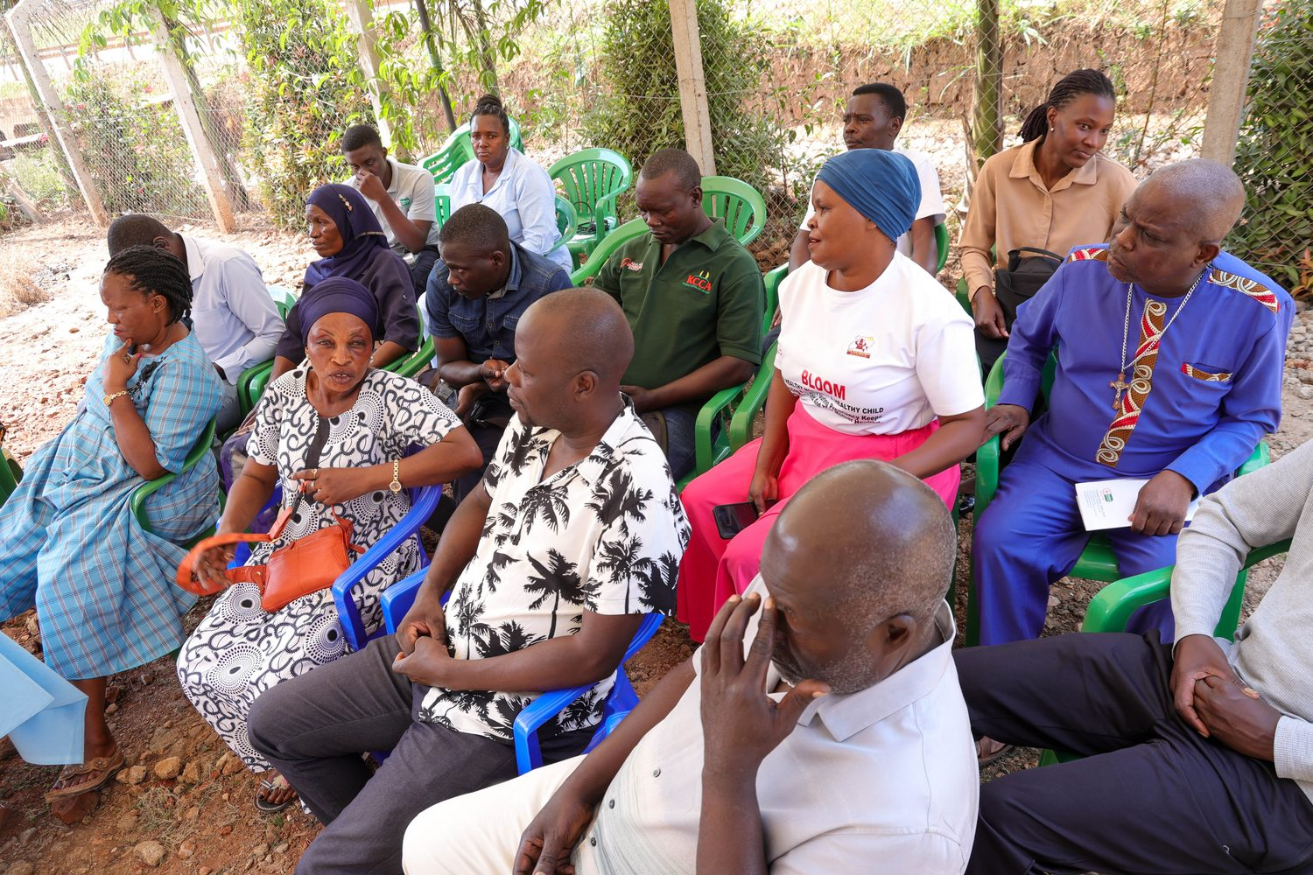
From community signals to life-saving, poverty-reducing predictions
FCHIP is an evidence-first innovation that fits the FID model precisely: a promising solution, ready to be tested in a real-world setting, with a clear pathway from pilot to rigorous evaluation and scale. By catching health risks before they become crises, FairBanks helps underserved families avoid the catastrophic costs that trap them in poverty — a genuine win for communities and for development.
Your health, our mission.
Proposal aligned with the FID Call for Proposals 2026. Source: https://opportunitiesforyouth.org/2026/06/12/fid-call-for-proposals-2026-apply-for-up-to-e4-million-to-scale-innovative-solutions-tackling-poverty-and-inequality-worldwide/

