
CONSULTANCY SERVICES TO VERIFY AND RECORD ASSETS UNDER THE UGIFT PROGRAMME
REF: MOFPED/UGIFT/CONS/25/26/00015

ASSET VERIFICATION REPORT
SUBMITTED BY:

Plot 31, Bukoto Street
P.O Box 7657, Kampala, Uganda
+256 (0) 39 2000216/0772525235
email: cpa@cpa.ug
www.cpa.com
6 October 2026
Financial reporting date 30 September 2026

Table of Contents
Executive summary 5
Priority actions 6
1 Introduction and background 7
1.1 Introduction 7
1.2 Background to the verification 7
1.3 Justification 8
1.4 Objectives of the assignment 9
1.5 Scope of Work 9
1.6 Expected deliverables 9
2 Approach and methodology 10
2.1 Preparation 10
2.2 Pilot Test 10
2.3 Data collection 10
2.4 Quality assurance 11
2.5 Asset categories, condition, use and identification 11
2.6 Financial analysis and Valuation 11
2.6.1 Review of service dates 12
2.7 Analysis and reporting 13
2.8 Challenges and Limitations to the assignment 13
3 Findings 14
3.1 Overall results 14
3.2 National level Ministries and Agencies results 22
3.3 MDA specific results 24
3.3.1 Ministry of Finance, Planning and Economic Development 24
3.3.2 Ministry of Works and Transport 25
3.3.3 Ministry of Education and Sports 26
3.3.4 Ministry of Agriculture, Animal Industry and Fisheries 27
3.3.5 Ministry of Health 28
3.3.6 Office of the Prime Minister 30
3.3.7 Ministry of Water and Environment 30
3.3.8 Ministry of Gender, Labour and Social Development 31
3.3.9 National Environment Management Authority 32
3.3.10 Public Procurement and Disposal of Public Assets Authority 33
3.3.11 Office of the Auditor General (OAG) 34
3.3.12 Ministry of Local Government 34
3.3.13 Ministry of Lands, Housing and Urban Development 35
3.4 Results from blood banks 37
3.4.1 Arua Regional Blood Bank 37
3.4.2 Hoima Regional Blood Bank 38
3.4.3 Soroti Regional Blood Bank 39
3.5 Local Government level results 41
3.6 Health Centres 41
3.6.1 Availability of the assets 41
3.6.2 Asset condition and functionality 42
3.6.3 Asset marking and Identification 44
3.7 Schools 47
3.7.1 Availability of the assets 47
3.7.2 Asset condition and functionality 48
3.7.3 Asset marking and Identification 48
3.8 Financial value of school assets 49
3.9 Completion Status of Facilities 50
3.10 Field Observations 52
3.11 Location and Name changes 52
3.12 UgIFT support to service delivery 53
3.12.1 Gaps and Challenges 54
4 Asset management 55
4.1 Maintenance and repairs 55
4.2 Obsolete and Unserviceable Assets 56
4.3 Missing and Unrecorded Assets 56
5 Recommendations 58
5.1 Actions to address the reported service gaps 59
Appendices 60
Appendix A Financial reconciliation and valuation limitations 60
Extent of existing cost estimates 60
Appendix B Service date exceptions and supporting evidence 61
Rules for an approved register correction 62
Appendix C Definitions used in the analysis 62
Principal references 63
Appendix D Programme list exception roster 63
Appendix E Documented outstanding works and handover 65
Appendix F Facility interview scope and denominators 70
Appendix G Asset reconciliation examples 70
Appendix H Photographic schedule 71
Appendix I Land records and ownership evidence 74
Appendix J Additional assets and classification checks 75
Appendix K Financial analysis by asset type 76
MoFPED 76
MoWT 77
MoES 78
MAAIF 78
MoH 79
OPM 80
MoWE 80
MoGLSD 81
NEMA 81
PPDA 81
OAG 81
MoLG 82
MoLHUD 82
Arua Regional Blood Bank 82
Hoima Regional Blood Bank 84
Soroti Regional Blood Bank 85
Health centres 86
Schools 88

List of acronyms
GOU Government of Uganda
HC Health centre
ICT Information and communications technology
IFMIS Integrated Financial Management Information System
KCCA Kampala Capital City Authority
LGFC Local Government Finance Commission
MAAIF Ministry of Agriculture, Animal Industry and Fisheries
MDA Ministry, department or agency
MoDVA Ministry of Defence and Veteran Affairs
MoES Ministry of Education and Sports
MOES Ministry of Education and Sports (as engraved)
MoFPED Ministry of Finance, Planning and Economic Development
MoGLSD Ministry of Gender, Labour and Social Development
MoH Ministry of Health
MOH Ministry of Health (as engraved)
MoLG Ministry of Local Government
MoLHUD Ministry of Lands, Housing and Urban Development
MoPS Ministry of Public Service
MoWE Ministry of Water and Environment
MoWT Ministry of Works and Transport
NEMA National Environment Management Authority
OAG Office of the Auditor General
OPM Office of the Prime Minister
PforR Program-for-Results
PPDA Public Procurement and Disposal of Public Assets Authority
RCU Reform Coordination Unit
TELA Teacher Effectiveness and Learner Assessment
UBTS Uganda Blood Transfusion Services
UgIFT Uganda Intergovernmental Fiscal Transfer
UGX Uganda shillings
UPS Uninterruptible power supply

Executive summary
The findings show a substantial stock of UgIFT assets supporting health care and secondary education, alongside equipment and buildings requiring attention. Facilities reported improvements in their services, but unfinished works, equipment out of use and weaknesses in asset identification limit the benefits. The report sets out the action needed to maintain the assets, complete outstanding works and resolve errors in the financial and custody records.
A total of 229,024 asset records were identified. Schools account for 145,256 and health centres for 63,432. A further 16,663 relate to ministries and agencies, 602 to regional blood banks, 3,067 to hospitals under local governments and four to other local-government locations. The total includes items whose receipt, classification or programme assignment still requires confirmation. These cases must be resolved before the full population can be certified as physically verified UgIFT assets.
Overall, 215,504 items (94.1%) are classified Functional and 13,520 (5.9%) Faulty, with the same numbers recorded as in use and out of use, respectively. Reasons for non-use include lack of power, unfinished buildings, missing parts and insufficient training. These require different responses. Usable tag details are unavailable for 178,695 items, making identification and custody checks a substantial task.
Facilities reported improvements in services following UgIFT support. Of 284 health-centre respondents, 238 (83.8%) reported at least one benefit, including improved maternity services, access to care and use of equipment. Of 193 school respondents, 144 (74.6%) reported benefits such as better learning conditions and access to secondary education. These are the facilities’ accounts of changes in their services; the exercise did not measure how much of each change was caused by the programme.
The programme list contains 629 distinct facility entries. Supporting returns account for 590, while 39 have discrepancies requiring reconciliation. The reviewed evidence identifies at least 70 facilities with incomplete works and 13 others awaiting handover or commissioning. Some facilities were operating while particular buildings or supporting structures remained unfinished. Completion, handover and readiness for use therefore need to be confirmed separately.

Priority actions
MoFPED and the responsible institutions should first confirm when assets were placed in service. Of 201,066 full service dates, 3,345 precede programme approval on 27 June 2017. A further 27,958 entries contain partial dates or text, which cannot be accepted as exact service dates. The review also found 787 purchase dates later than the recorded service date. These findings overlap. Each affected date should be checked against receipt, acceptance or commissioning records, together with the asset’s ownership and programme assignment.
Where a full service date cannot be supported, retain the reported period or status in the supporting records and leave the exact-date field blank until it is confirmed. A purchase date or the programme start date should not be used to fill the gap. Approve supported corrections before migration to IFMIS and recalculate depreciation and net book value where the corrected dates affect them.
Available recorded costs total UGX 996.813 billion, with costs missing for 1,086 records. Net book value remains unresolved for 23,016 records. For the 180,730 recognized records with complete accounting figures, cost of UGX 760.987 billion less accumulated depreciation of UGX 165.185 billion gives a net book value of UGX 595.802 billion at 30 September 2026. Net book value is the recorded cost remaining after depreciation; it does not measure the asset’s market value or physical condition.
Cost evidence also needs review. Costs for 166,593 items were estimated by comparison with similar assets. These account for 82.44% of available recorded cost. Of 298 construction-in-progress entries, 275 have zero cost and four have no cost recorded. The recorded amounts therefore cannot establish the full value of unfinished works. Obtain the supporting expenditure or valuation records, resolve missing amounts and approve changes before treating the balances as a verified programme valuation.
Facility managers, local governments and the responsible ministries should give priority to essential equipment, reliable power and water, user training and outstanding buildings. Keep an action list naming the item or facility, the responsible officer and the agreed completion date. Assess faulty items for repair, replacement or disposal, and review the 22,161 fully depreciated records still marked in use. Reconcile delivery, transfer and custody records before concluding that an asset is missing. The recommendations and appendices provide the specific cases and follow-up required.

1 Introduction and background

1.1 Introduction
This report presents the findings of the UgIFT asset verification undertaken by the Ministry of Finance, Planning and Economic Development as part of programme closure activities. It sets out the status of the assets provided by the programme to the targeted national institutions responsible for supporting the implementation of the programme, Blood Banks and local governments specifically targeting seed secondary schools and health facilities upgraded from Health Centre II to Health Centre III.

1.2 Background to the verification
The Uganda Intergovernmental Fiscal Transfers (UgIFT) Programme is a government programme implemented through a Programme-for-Results (PforR) launched and aligned with the broader IGFT Reform Programme (2015). UgIFT 1.0 began with US$200 million in FY2017/18, supporting Education and Health. This was later expanded through additional financing of US$300 million, including US$240 million in credit and US$60 million in grants, with US$50 million from the IDA Refugee Support Window, expanding beyond Education and Health to water and Environment and Agriculture (micro-scale irrigation) making the overall funding total of US$500 million.
The Intergovernmental Fiscal Transfer Reform Programme (IGFT RP) was revised in 2020 to align with the Third National Development Plan (NDP III 2020/21 - 2024/25), and to directly contribute to Four (04) Programmes i.e. Human Capital Development; Public Sector Transformation; Natural Resources, Environment, Climate change, Land and Water Management; and Development Plan Implementation.
Overall, the development objective of the UgIFT Programme was to: “Improve the adequacy, equity, and effectiveness of financing and the oversight, management, and delivery of Local Government services in Education, Health, Water and Environment, and Agriculture (micro-scale irrigation), including refugees and their host communities”.
Specifically, the Programme sought to:
- Increase the adequacy and predictability of fiscal transfers to Local Governments for service delivery;
- Improve the equity and transparency of allocation mechanisms through the introduction of formula-based transfers;
- Strengthen performance incentives and accountability systems for Local Governments; and
- Expand access to quality education and health infrastructure, particularly in under-served areas.
The UgIFT Programme had four components aimed at strengthening the intergovernmental fiscal transfer system while supporting investments in service delivery infrastructure. These included;
Component 1: Reform of the Intergovernmental Fiscal Transfer System
This supported the design and implementation of a reformed fiscal transfer framework based on objective and transparent allocation criteria. This resulted into introduction of formula-based grants - Revised allocation formulas reflecting population, infrastructure gaps, and service delivery needs.
Component 2: Education Infrastructure Development
This component financed the construction and upgrading of education facilities, particularly government secondary schools in under-served sub-counties. This involved construction and equipping of new secondary schools - classrooms, laboratories, administration blocks, sanitation facilities, teachers’ houses, furniture and ICT equipment in the different local governments.
Component 3: Health Infrastructure Development
This supported investments in health facilities to improve access to primary health care services at the local level. The major outputs under the component were construction and upgrading of health centers - Staff accommodation, sanitation facilities and provision of medical equipment.
Component 4: Local Government Performance and Institutional Strengthening
This aimed at Strengthening strengthening local government capacity in planning, budgeting, procurement, and infrastructure management. Under this component, Annual annual local government performance assessments have been undertaken across the 176 Local governments, assessments, capacity building and technical support strengthened monitoring and reporting systems across the Local local governments.
The Programme was implemented through a clearly defined results framework that connected actions and incentives across three levels of government to strengthen service delivery outcomes. The programme came to an end in on 31 December 2025 2025. and The had following accomplished areas of support describe the following outputs activities under the different components; current asset and facility findings are presented later in this report.
- Budget Support
- Education: 196 construction and equipping of 259 seed Seed secondary Schools schools are in complete underserved of which 189 are operational. areas.
- Health: 354 upgrading and equipping of 373 health facility facilities, upgrades/new including constructions improvements (HC from Health Centre II to HC Health III) Centre are complete. III.
- Water and Environment: 758 - piped water systems, 5,398- point water sources, 7,082 rehabilitation of water supply systems rehabilitated, 325 systems, designs completed, and 256 sanitation facilities in the targeted service units.
- Agriculture (Micro-scale Irrigation): Over installation 6,235 of irrigation systems were and installed establishment (4,843 hectares under irrigation), 632 of irrigation demonstration sites in 135 local LGs set up. governments.
- Refugee intervention: 51 integration of primary schools and 35 health facilities in refugee hosting districts (RHD) were transitioned and integrated into the local LG government service.
- Blood Banks: banks: construction and equipping of Arua and Hoima Regional Blood Banks in Arua and Hoima rehabilitation were completed and commissioned while of Soroti Regional Blood Bank was rehabilitated. Bank.
2. Grant management
Assets for institutional strengthening and retooling including ICT equipment and vehicles were provided. The Ministry of Finance, Planning and Economic Development (MoFPED) through PFM Coordination Unit (RCU) manages the Government of Uganda counterpart funding of the programme to support the grant management component of the UgIFT programme. The grant management supports in financing of Central Government actions intended to achieve programme objectives and Disbursement Linked Indicators (DLIs). To this end, MoFPED through RCU supported MDAs to acquire different assets meant to support programme implementation.

1.3 Justification
The UgIFT programme came to an end on 31st December 2025. As part of the programme’s closure activities, MoFPED, through RCU, commissioned an end-of-programme asset verification exercise to take stock of the assets procured under the programme and to establish where those assets were, how they were being used as part of the processes to hand them over to government for sustainability purposes.

1.4 Objectives of the assignment
The objective of the assignment was to undertake verification and recording of all assets acquired under the UgIFT Programme. Specifically, the assignment intended to;
- Identify and verify the existence of the assets
- Verify the assets condition and status: specifically, the condition on functionality, usage/performance and location among others
- Assess financial management aspects: residual value of the investments/hardware/tools for purposes of financial reporting for project closure
- List the assets that are obsolete, unserviceable and require disposal
- Develop a computerized database of the investment/hardware/tools to facilitate recording of new deployed assets/investments.
- Undertake PFM Assessment on Asset Management practices (including sustainability, Operations and Maintenance) of the UgIFT implementing LGs

1.5 Scope of Work
The assignment all covered institutions at National national and local government level that directly implemented the UgIFT program programme from through coordination, support and implementation across the country. implementation. At the local government level, the study focused on upgradedimproved upgraded health facilities and seed secondary schools only as these had that received assets upgraded under the programs programme. as Hospital a and result. other local-government assets are also reported separately.
Specifically, the assignment involved the following tasks;
- Verification of the Asset’s Records of targeted ministries departments and agencies and local governments
- Physical and Functional Verification of assests assets
- Data Consolidation for generation of a single data base of assets provided by the program
- Generation of an IFMIS ready Asset Register for Integration, and Migration into IFMIS
- Review of the UgIFT Asset Management Practices

1.6 Expected deliverables
Key expected outputs of the consultant include:
(i) Report with the list and current status of assets acquired under the programmes;
(ii) An automated up-to-date assets data base of UgIFT Investments across MDALGs;
(iii) Report on the estimated value of assets under the programme as well as operations and maintenance arrangements;
(iv) IFMS-Ready IFMIS-Ready Asset Register and Data Migration Report
(v) Report on functionality of assets relating to systems investments;
(vi) Report on Assessment of Asset Management Practices, Risks and recommendations.

2 Approach and methodology
The verification exercise was conducted using a participatory and consultative process and implemented in three interlinked phases: Preparatory and inception phase, Data collection phase and the report writing phase.

2.1 Preparation
After signing of the contract, the assignment commenced with an entry meeting on 28th May 2026. During this meeting, the Client specified target MDAs to be visited, the LG stakeholders to be reached as well as the documents to be reviewed. The Inception phase was completed and the inception report submitted on 18th June, 2026 which provided an agreed scope, approach and work plan for the exercise.

2.2 2.1.1 Pilot Test
The team also undertook a pilot test in Wakiso District Local Government, with verification carried out at Buloba Health Centre III and Sumbwe Seed Secondary School. During the pilot test, it was found out that, among others, there are cases of mismatches of facility names, that UgIFT assets can be integrated into the general LG asset register. This facilitated improving the design of the data collection process including; design of data collection tools, determining the timeline for data collection and estimated costs.

2.3 Data collection
This exercise was undertaken in two phases first at National level and later at the Local government level.
National level: Physical visits to verify assets provided by the programme at the national-level was completed on the 19th of August 2026. This covered 15 MDAs including; Ministry of Works and Transport (MoWT); Ministry of Education and Sports (MoES); Ministry of Agriculture, Animal Industries and Fisheries (MAAIF); Ministry of Health (MoH); Office of the Prime Minister (OPM); Ministry of Water and Environment (MoWE); Ministry of Gender, Labour and Social Development (MoGLSD); Local Government Finance Commission; National Environment Management Authority (NEMA); Public Procurement and Disposal of Assets Authority (PPDA); Office of the Auditor General (OAG); Ministry of Public Service (MoPs); Ministry of Lands, Housing and Urban Development (MoLHUD); Ministry of Local Government (MoLG) and Ministry of Finance, Planning and Economic Development (MoFPED). Additionally, three Blood Banks of Hoima, Arua and Soroti were covered.
Local government level: The local government verification covered all targeted UgIFT upgraded/ upgraded or constructed Health Centres and Seed Secondary Schools Schools. in The all programme reconciliation list contains 629 distinct entries: 371 health centres and 258 schools under 160 recorded local-government names. This is the 176 intended LGs. facility frame, rather than a count of sites visited. The process began with a training of field teams prior to the actual field verification.
Training of field teams: A total of 85 Research Assistants (RAs) and 7 Regional Supervisors were trained. The training took place from 21st to 23rd August 2026 and physical verification started on the 24th of August 2026 across all the 176 Local governments. 2026. During the Asset asset verification, the RAs visited Seed Secondary Schools, Health Centres and Blood Banks.
Physical verification: This exercise commenced on the 24th of August 2026 and was completed on 17th September 2026. The local government physical verification involved entry meetings with the LG leadership at the LG headquarters for authorization and review of reports relating to UgiFT assets, key informant interviews with the technical teams especially the Chief Administrative Officers, Finance Officers, District Health Officers and District Education Officers. Thereafter, the RAs proceeded to the facilities for physical verification of the assets.
The fieldwork dates above describe the main exercise reported by the original team. This revision also considers supplementary returns and photographs received later, including blood-bank photographs dated 28–29 September 2026. The date a file was created or received does not establish when the site was visited.
At local government level, the programme list had 629 facilities: 371 health centres and 258 seed secondary schools. The list recorded 547 facilities (87.0%) as complete and 82 (13.0%) as ongoing. The ongoing works were more common among seed secondary schools (63, or 24.4%) than among health centres (19, or 5.1%). These are programme-list baseline labels, not findings of physical completion, handover or operation at the verification date.

2.4 Quality assurance
Regional supervisors checked daily field activity and reviewed the completed tools. The central technical team carried out spot checks and helped resolve operational questions. Teams compared institutional asset information with the items and explanations provided during visits, while supervisors referred matters requiring clarification to the team leader and field coordinator.

2.5 Asset categories, condition, use and identification
Asset categories. Each asset entry was represents counted one once recorded unit. The analysis covers buildings and assigned structures, to one report category. Health centre assets were grouped as clinical equipment, clinical furniture, maternity ward equipment and health centre ICT equipment. On the other hand, seed secondary school assets were grouped as school furniture, school computers and related equipment and school support equipment. Another category included other land, ICT equipment, other transport furniture, equipment, vehicles, motorcycles furniture and buildings, fittings, medical, laboratory and research appliances, other classified assets, items outside fixed-asset classification and unclassified entries. Assets are grouped by the institution or beneficiary to which apply they to are MDAs, attributed. Blood Uncertain Banks school and LGs programme alike. assignments require reconciliation.
Condition and use. Condition Assets are classified as Functional or Faulty and use were reported as recorded in use or out of use. These classes do not distinguish broken equipment from stored items, items not received, incomplete installations and other reasons for each non-use. asset Further during the verification. A working asset assessment is one needed recorded before as deciding functional whether and an in item use. requires An installation, asset repair, recorded as faulty was reported as not working and not in use. This included assets that were broken down replacement or damaged. An asset that was new and in store was recorded as functional but not in use. Additionally, an asset that was held elsewhere, not yet delivered or awaiting power installation, completion of buildings or trained users, was also recorded as functional but not in use. disposal.
Identification. An The asset analysis is properly identified when carried a distinguishes UgIFT programme or marking. UGFT However, there were markings, other assets identifiers that and had items no without UgIFT usable marking identification but details. the Vehicle officers registrations on and ground other identified identifiers them are as distinguished UgIFT from assets. physical engraving. Buildings and land require site and ownership records. Lack of an identifier alone does not establish loss or non-delivery.

2.6 Financial analysis and Valuation
The Government of Uganda Asset Accounting Policies and Guidelines 2023 was used to determine as the policy basis for determining recorded values, depreciation and net book values. Financial values are reported at 30 September 2026, with year-to-date depreciation covering 1 July to 30 September 2026. Straight-line monthly depreciation is applied where the required information is available. Some costs are estimates rather than invoice amounts. Missing costs and pending calculations are reported separately. The underlying purchase, service date, useful life, classification and ownership require supporting evidence.

2.6.1 Review of service dates
Service dates were checked against 27 June 2017, when the World Bank approved UgIFT. The programme became effective on 29 May 2019, although implementation had begun after approval. The approval date helps identify entries needing investigation; it should not be entered as an asset’s service date. An earlier date may be incorrect, may relate to an asset acquired before UgIFT, or may indicate that the asset has been assigned to the wrong programme. Each case requires supporting evidence.
Source: World Bank UgIFT Additional Financing programme paper, section I, paragraph 1, printed page 1.
Service-date entry | Records | Share
Full date from 27 June 2017 to 30 September 2026 | 197,721 | 86.3%
Full date before 27 June 2017 | 3,345 | 1.5%
Month and year only | 2,987 | 1.3%
Year only | 7,701 | 3.4%
Year or financial-year period | 455 | 0.2%
Commissioning status or other text | 16,815 | 7.3%
Total asset records | 229,024 | 100.0%
Categories are mutually exclusive; rounded percentages may not total 100.0%.
The 201,066 full calendar dates contain a day, month and year, but still require supporting evidence. The remaining 27,958 entries comprise 2,987 month-only values, 7,701 years, 455 periods and 16,815 status or other text entries. Of the latter, 15,630 say Unconfirmed, 859 Not applicable - not received, 298 Not yet in service, 24 Commissioning status unresolved and four Service date unconfirmed. Two month-only values state April 2014 and one year-only value states 2013, giving three further entries that may predate the programme, in addition to the 3,345 full dates already identified.
A separate check found 787 records where the purchase date is later than the service date. These records may also appear among the date exceptions above, so the counts must not be added together. The comparison covers only records with full purchase and service dates. Original receipt, commissioning and acquisition records are needed to establish which date requires correction.
Non-date text and incomplete dates are not acceptable in a field that requires an exact date. When the register is corrected, keep any reported month, year or commissioning status in a separate supporting field and leave the service date blank until a full date is supported. Preserve the original entry in the audit record. Do not assume 1 January, 1 July, the first day of a month or the programme start date. Where the source supports an earlier date, check whether the asset belongs to UgIFT before approving any change.
The date 1 January 2014 has been assigned to 1,032 wooden-chair entries at Labongo Amida, Makokoto, Nyamarwa and Namungo, although the original returns did not provide service dates. A Sikuda desk entry dated 13 July 2012 relates to Sikuda Primary School but is attributed to Sikuda Seed Secondary School. Confirm the service date, beneficiary and funding before approving any correction.
The financial tables distinguish available amounts from pending calculations. Correcting service dates may change depreciation and net book value. After date and accounting-treatment corrections are approved, recalculate the linked service dates and financial amounts, including any recoverable-cost field that is based on net book value.

2.7 Analysis and reporting
Analysis and reporting was done through triangulation of the literature from different policy, Planning and Financial documents including: the Government of Uganda Asset Accounting Policies and Guidelines 2023; asset registers; asset records at national and local government levels; physical inspections; discussions with facility managers; photographs and asset counts for each institution.

2.8 Challenges and Limitations to the assignment
Difficult terrain and poor physical accessibility of facilities: Physical accessibility presented a significant operational challenge especially for facilities located in areas characterised by difficult terrain and limited transport accessibility such as Bwesumbu HC III, Bwesumbu Seed School, Buhuhira and Kabingo in Kasese District. In addition, accessing facilities within the Island was difficult, time consuming and expensive. This led the teams to overshoot the anticipated time for data collection.
High transportation cost: Given the national wide coverage, the rising fuel prices led to high field costs. The field teams spent more money than was anticipated. The costs were extra ordinarily higher for island facilities like Kalangala, Buvuma, Mayuge among others. For instance, Kalangala had 3 facilities with long distance on water that required hiring a private boat since it was not a common route to the transporters and outside the ferry schedules. A similar situation was encountered in Buvuma and Namayingo districts.
Poor record keeping: In many LGs and facilities, there were no clear records about the assets delivered under UgIFT. The LGs and the facilities had incomplete or missing UgIFT asset registers which delayed data collection. Subsequently, the teams took longer in such facilities identifying the assets as most of these were not engraved with the UgIFT identifiers while others were not engraved at all. In addition, the field teams encountered situations where some Assets could not be physically accessed especially for schools since it was holiday time.

3 Findings
This section presents results of the verification exercise based on the specific objectives. The results are presented in different results levels indicating availability of assets, asset condition and functionality, asset marking and identification and the financial analysis in each of the subsections.

3.1 Overall results
This section provides an overall view of the UgFT asset status combining both National level agencies and schools and health centres.
- Overall asset availability
Physical A verification total of all UgFT 229,024 assets are recorded across the targeted MDAs, beneficiary Blood blood Banks, banks, Upgraded health Health centres, Centres schools and Seed other Secondary local-government Schools locations. indicated These a include total vehicles, of laptops, 226,280 printers, assets desktop of computers, different projectors, categories including Vehicles, Laptops, Printers, Desktop Computers, Projectors, Furniture furniture (desks, chairs, chairs and stools), UPS Systems, systems, Digital digital Phones, phones, Paper paper Shredders, shredders, Mobile tablets Tablets, and clinical equipment’s equipment, among others. The total includes non-capitalized and unresolved entries; receipt, ownership and classification exceptions require confirmation before the full population can be certified as physically verified UgIFT assets.
Overall, the Seed Secondary Schools schools hold the majority of assets asset 64.2% records, (145,376) 63.4% (145,256), followed by the health Health Centres centres with 28.1% 27.7% (63,606), the (63,432), MDAs hold with 7.4% 7.3% (16,668) (16,663) while and the regional Blood blood Banks banks held with the 0.3% least (602). number A of further assets 3,067 records are at 0.3% hospital-named (626) locations on local-government books and four at other local-government locations, as indicated in Figure the 1. figure below.
Figure 1: Overall distribution Distribution of recorded assets UgFT by Assets institution
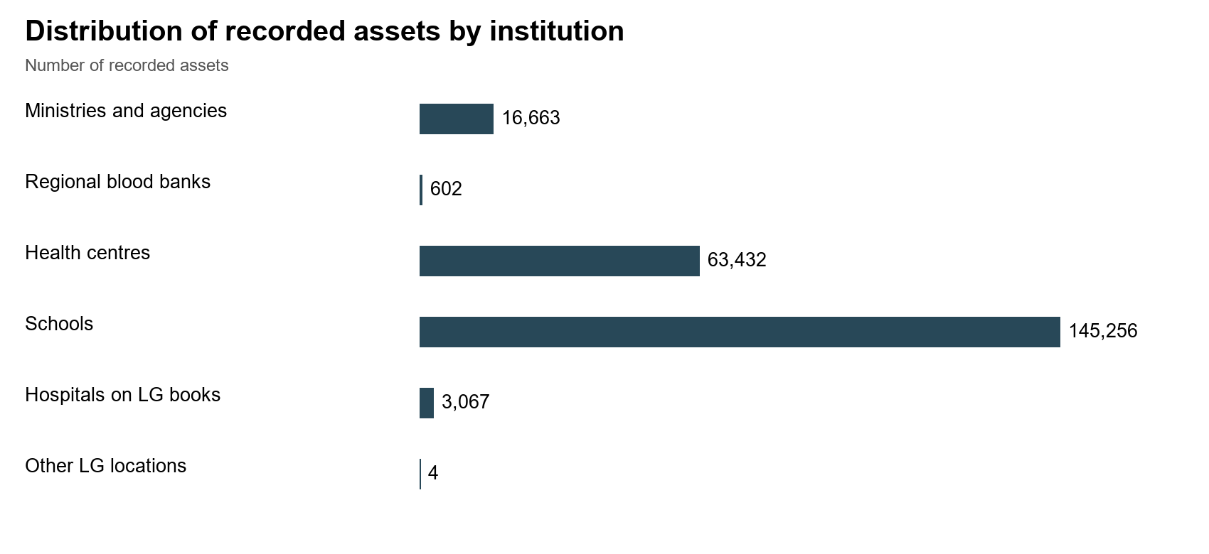
Source: Primary data analysis
- Overall asset Condition and functionality
Overall, 215,879 215,504 assets items, constituting 95.4% 94.1%, were are in classified good as condition, functional 3,392 assets (1.5%) were broken, while 7,009 (3.1%) were not in use. Of all assets in good condition, 94% were and in use, while 1.4% 13,520 were (5.9%) in are store classified not as yet faulty used. and out of use. The detailed analysis of the overall asset condition is indicated in the table 1. below. The two condition classes do not establish separate counts of broken items, items in store or items beyond repair.
Table 1: Overall condition of UgFT assets and functionality
Institution group | Records | Functional | Faulty | In use YES
Ministries and agencies | 16,663 | 16,643 | 20 | 16,643
Regional blood banks | 602 | 578 | 24 | 578
Health centres | 63,432 | 57,759 | 5,673 | 57,759
Schools | 145,256 | 137,465 | 7,791 | 137,465
Hospitals on LG books | 3,067 | 3,055 | 12 | 3,055
Other LG locations | 4 | 4 | 0 | 4
Total | 229,024 | 215,504 | 13,520 | 215,504
Source: Primary data analysis
As indicated in the table 1 above, most of the deployed recorded assets were already marked as in service use, while some the were field returns also described assets in store and still in good condition but not in use. This was attributed mainly to some localized challenges such as power, incomplete structures, structures and untrained staff, among others. Some assets were broken mainly furniture in Seed Secondary Schools and require required repair. Verification The also two noted condition that classes over do 7000 not assets distinguish mainly items in seed store, secondary broken schools equipment and health centres had not been used requiring installation or the facility itself was not yet ready. Figure 2 shows the other reasons for non-deployment non-use. of The some figure of below the shows assets reported even reasons when for they non-use were at found facilities; to it be does in not good count condition. individual idle assets.
Figure 2: Reasons Facilities reporting reasons for idle or unused assets and equipment non-use
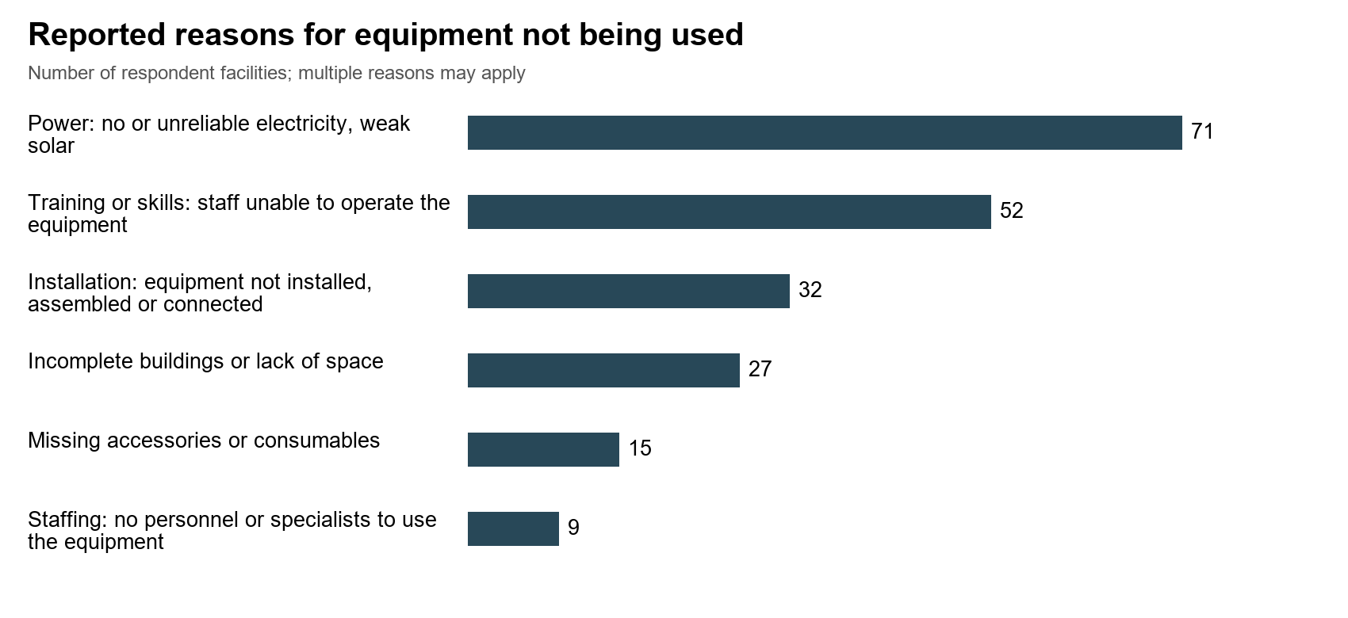
Source: Primary data analysis
This figure counts facilities reporting a reason, not individual idle assets. Responses can include more than one reason; the categories must not be added into an asset total. The interview-source and denominator appendix gives the reporting bases.
Notable among the facilities include Lungulu Seed Secondary School in Nwoya District where desktop computers, a printer and UPS units were still boxed because the school was waiting for power connection. At Nansanga Seed Secondary School in Budaka, 27 of 28 desktop computers remained packed for lack of reliable power. Broken desks and stools were in classrooms and stores at Seed schools in Namisindwa and Napak. At Arua Regional Blood Bank, six blood pressure machines were recorded as damaged or not functional. The information above is depicted in some of the photos presented below.
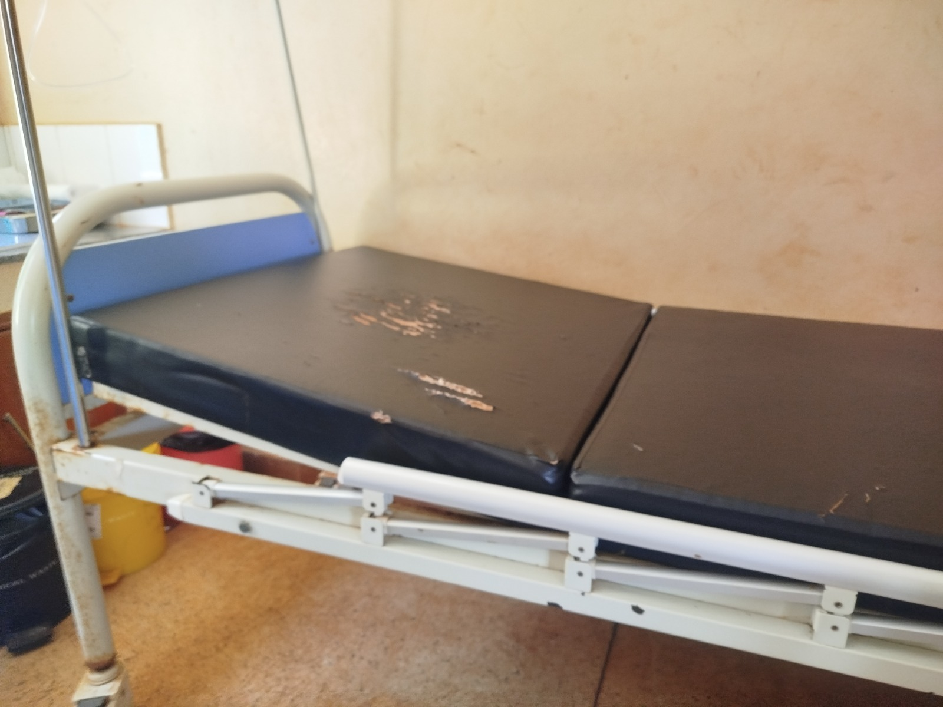 | 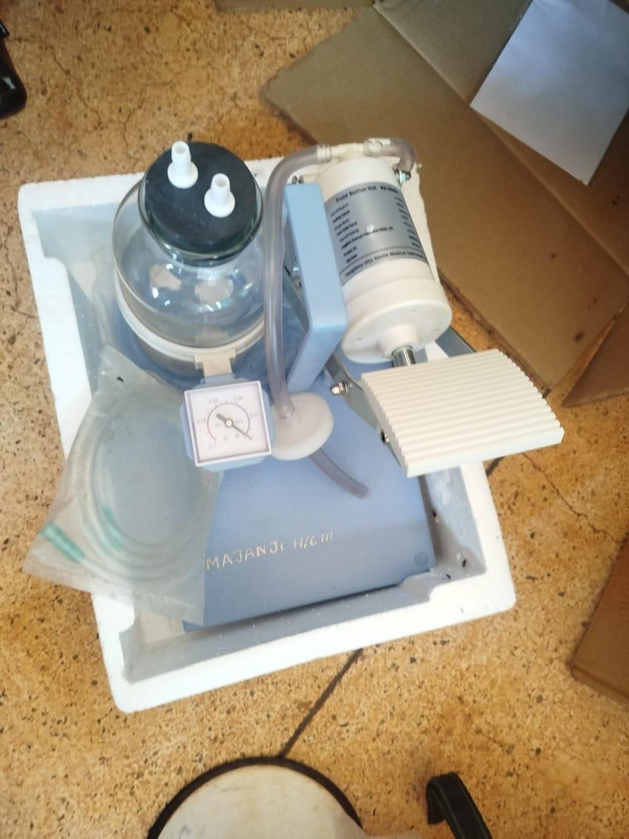
Delivery bed with a torn mattress cover at a health centre, Busia District (Bukedi) | Pedal suction unit marked MAJANJI H/C III still in its packing, recorded as not in use for lack of technical knowledge, Majanji Health Centre III, Busia District (Bukedi)
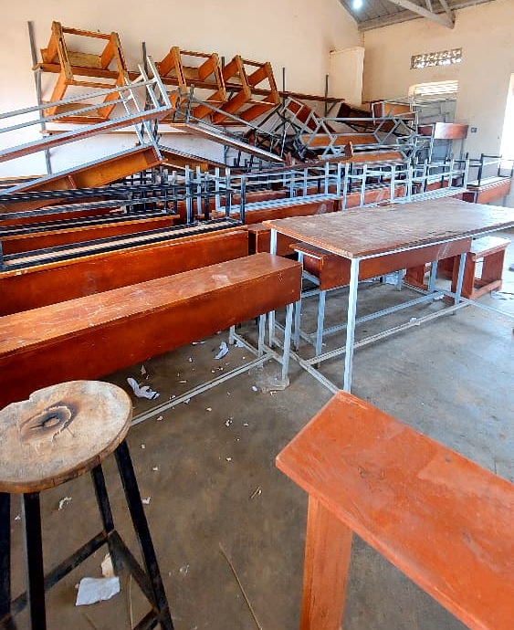 | 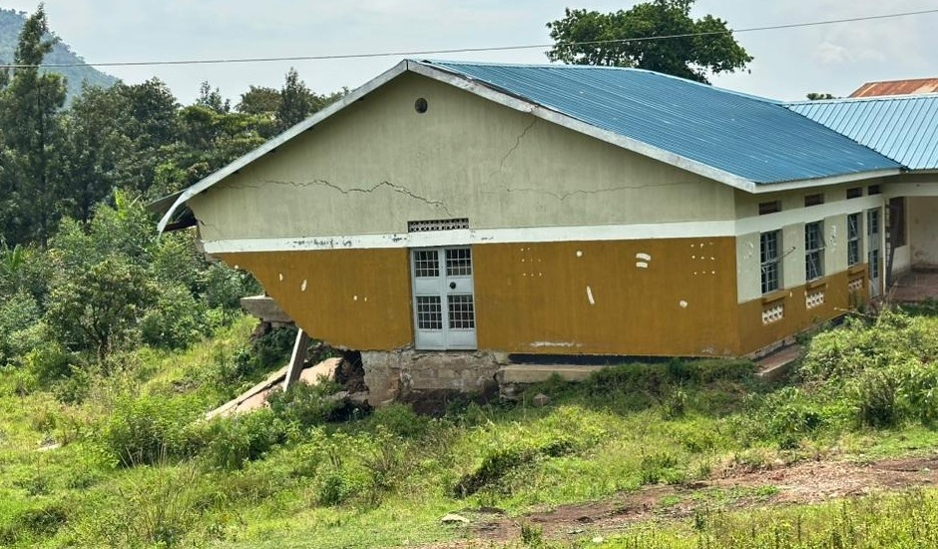
Stacked desks, chairs and stools, some recorded as broken and none engraved, at Napak Seed Secondary School, Napak District (Karamoja) | Cracked health centre block above collapsed ground, Bulambuli District (Bugisu)
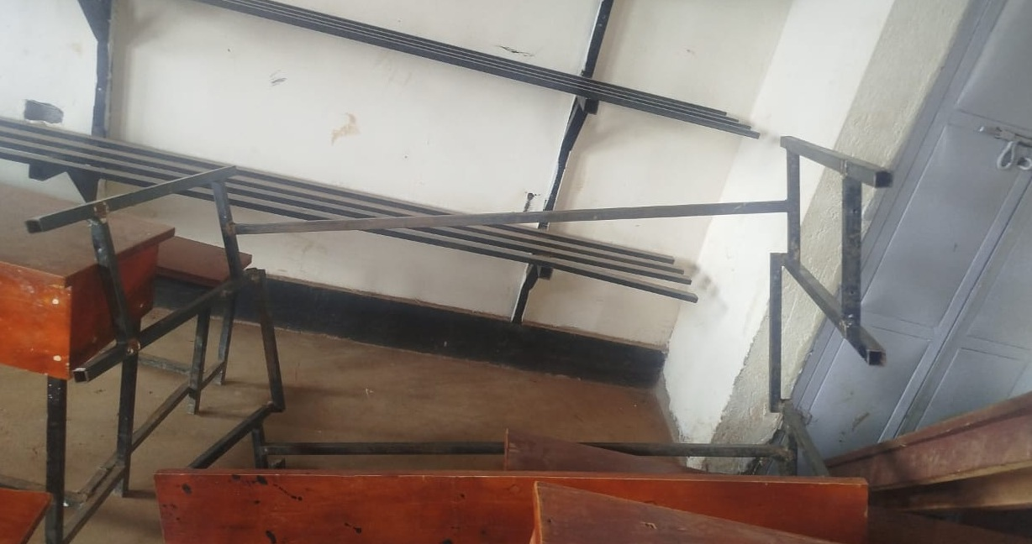 | 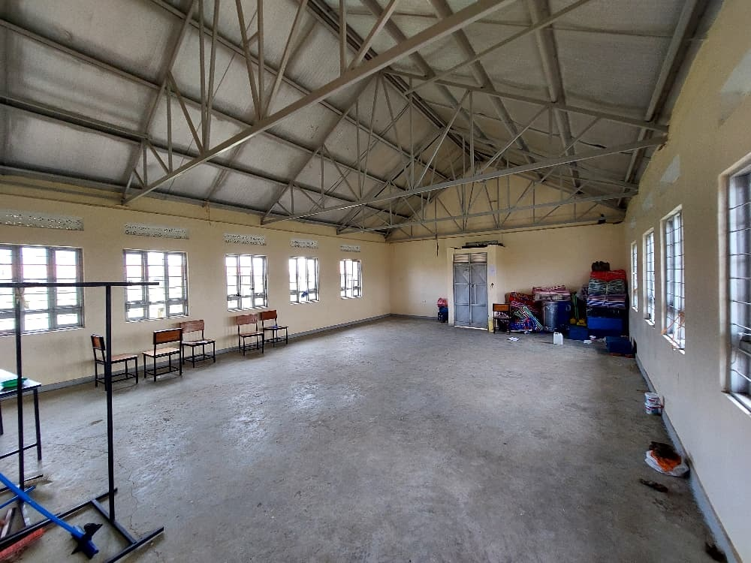
Broken desk frame at a seed secondary school, Namisindwa District (Bugisu) | Empty ICT and library block with a few chairs and items kept in one corner at Iriiri Seed Secondary School, Napak District (Karamoja), not yet in use while the school remained with the contractor
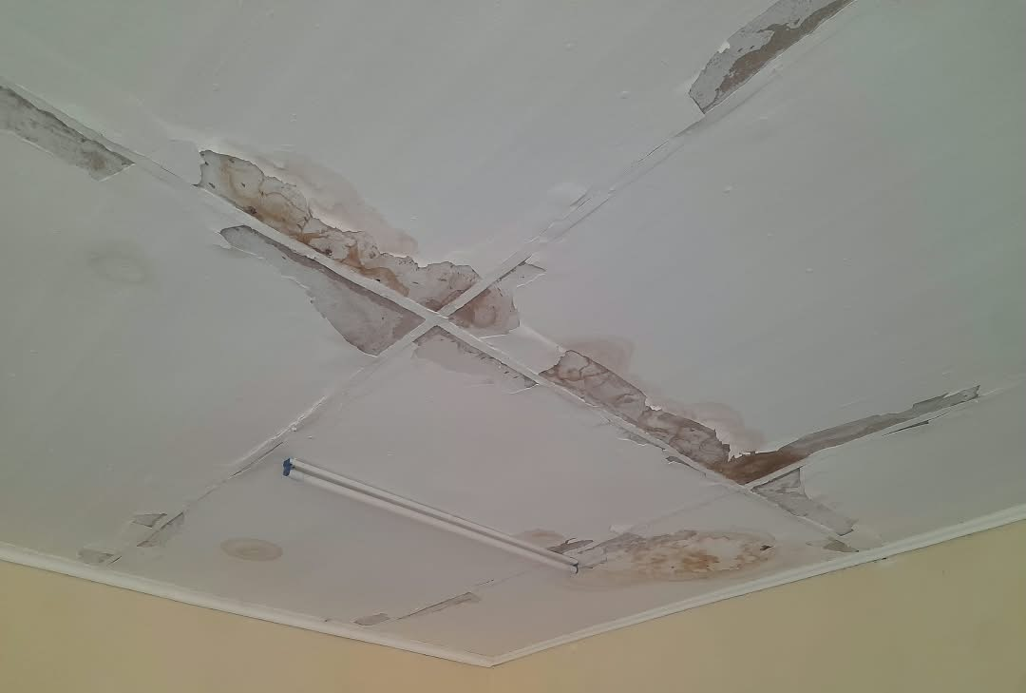 | 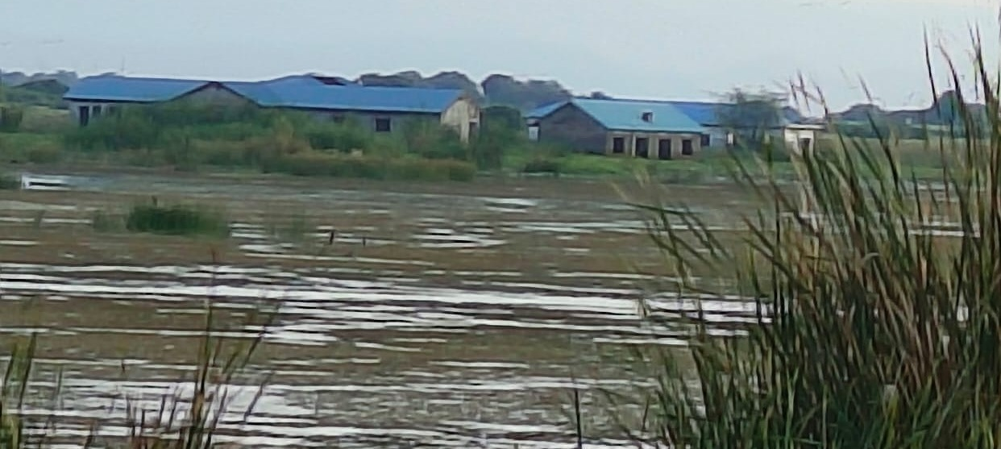
Stained and peeling ceiling at a health centre, Sironko District (Bugisu) | Flood-affected older health facility at Butiaba, Buliisa District (Bunyoro)
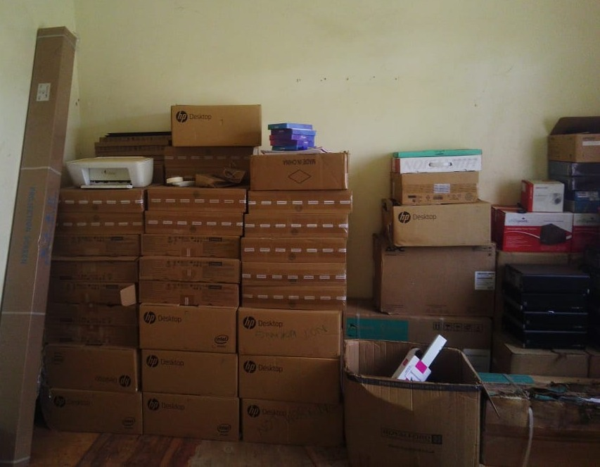 | 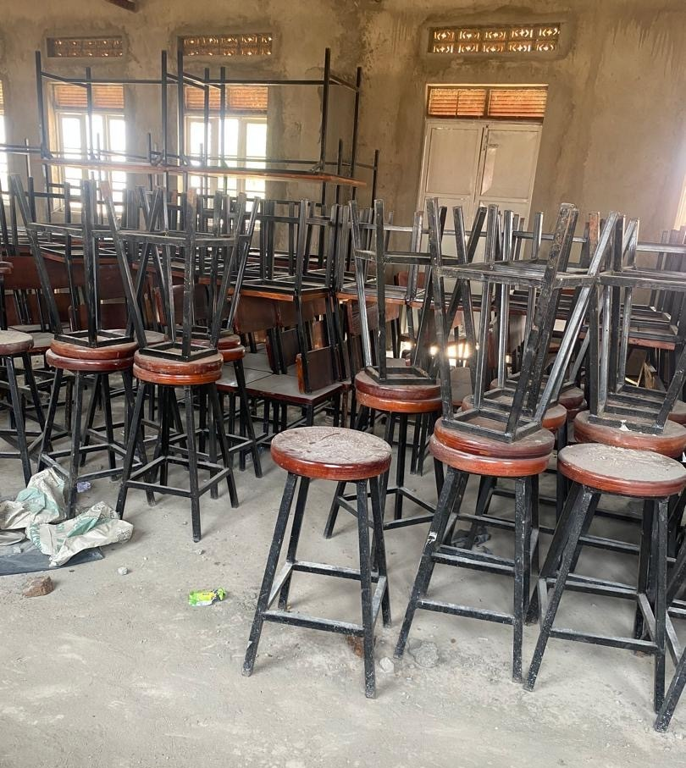
Desktop computers, a printer and UPS units still boxed in the store at Lungulu Seed Secondary School, Nwoya District (Acholi), awaiting a power connection for installation | Laboratory stools and desks stored and not yet in use at Butungama Seed Secondary School, Ntoroko District (Tooro), where the school buildings were still under construction
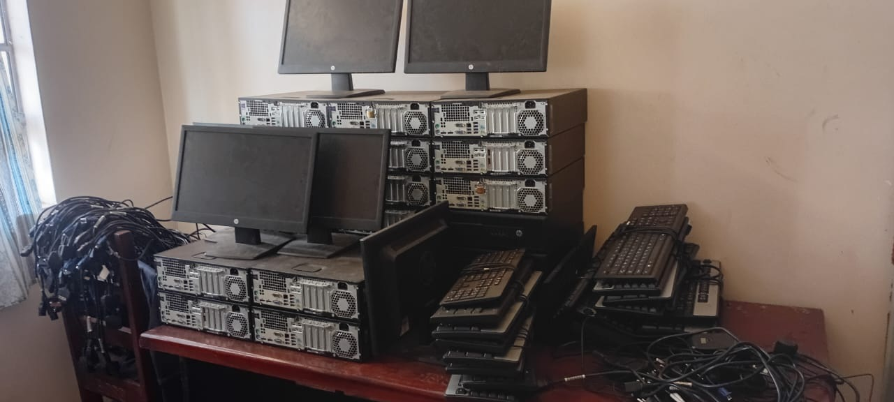 | 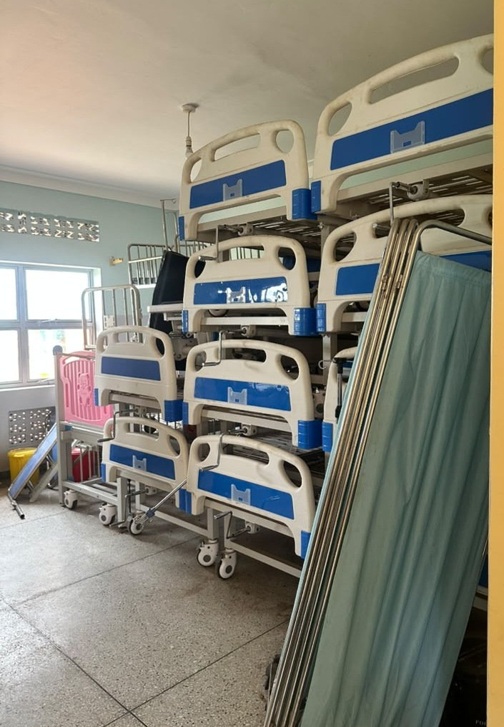
HP computer sets stacked in store with cables still bundled and not installed at Bumufuni Seed Secondary School, Bulambuli District (Bugisu) | beds and screens stacked in storage at a health centre, Kagadi District (Bunyoro)
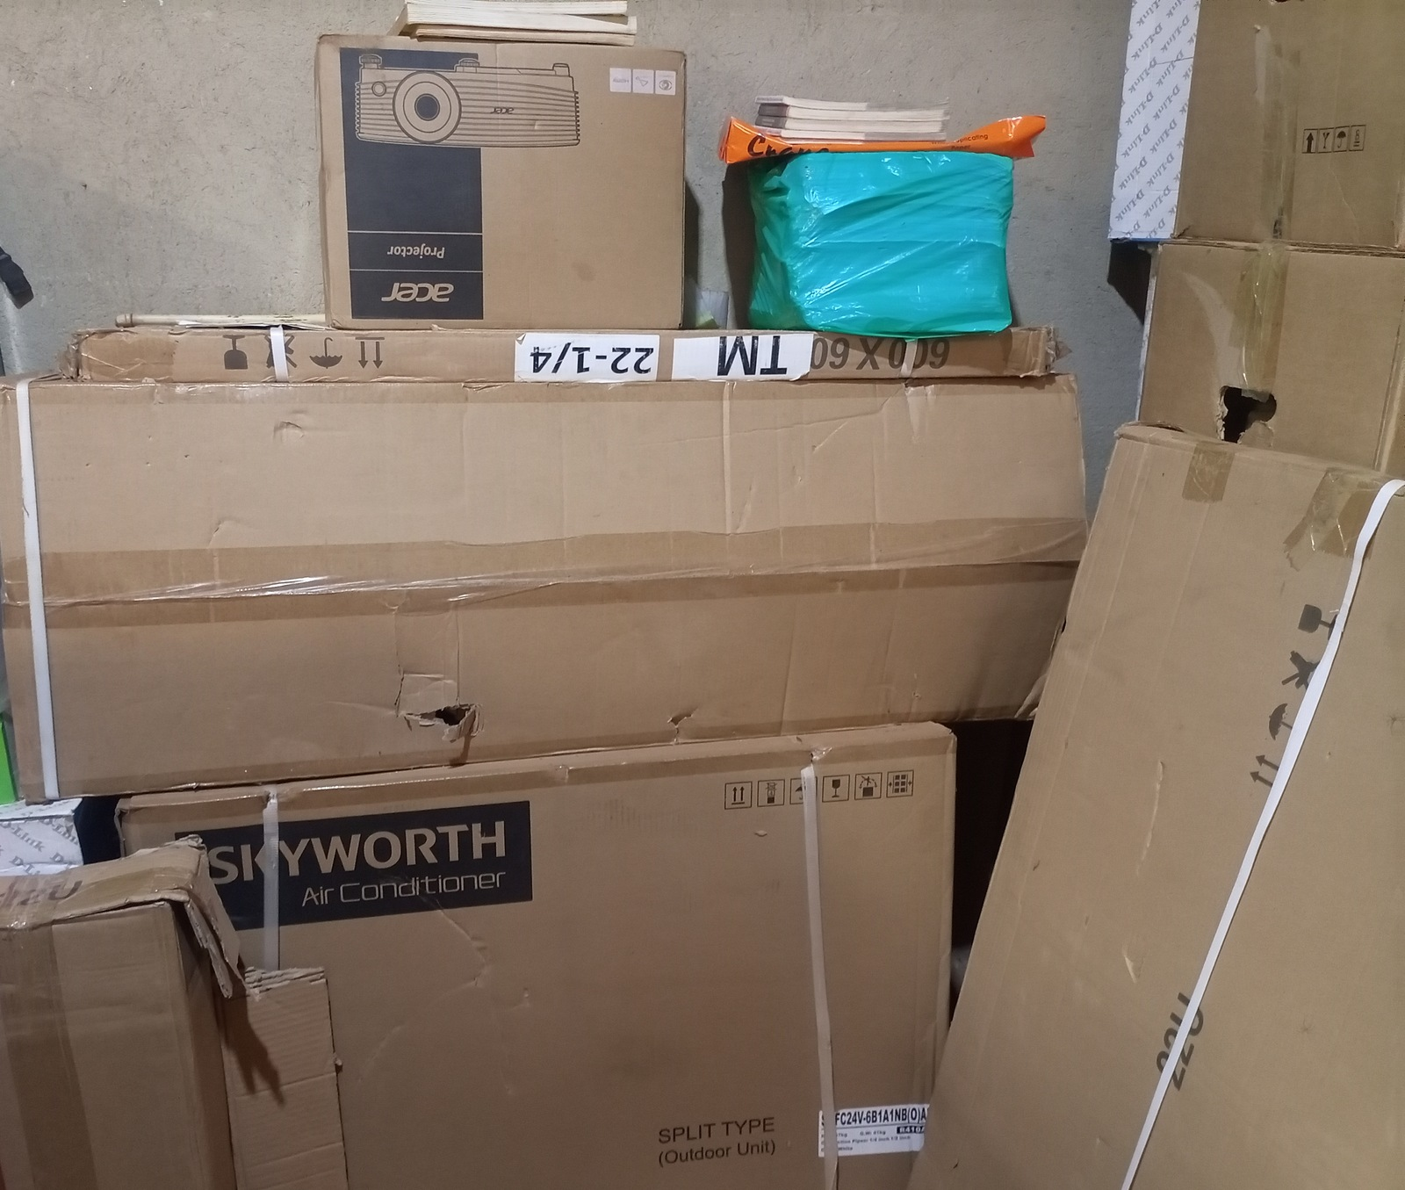 | 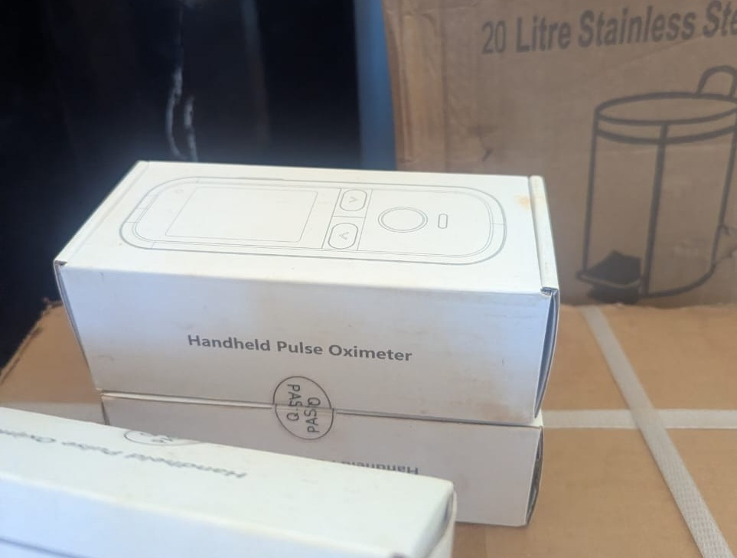
Boxed projector, air conditioner and other equipment in store at King Solomon Seed Secondary School, Kagadi District (Bunyoro), kept boxed because the school was still under construction | Boxed handheld pulse oximeters at Kibiri Health Centre III, Makindye-Ssabagabo Municipal Council (Buganda), where equipment was still being arranged after the facility opened on 31 August 2026
- Asset Marking and Identification
The verification revealed that only 49,457 (22.8%) of the movable assets were engraved Marking and 167,279 identification: (77.2%) 22,253 were records not (9.7%) engraved. have Out tag of text the engraved assets, 23,434 (10.8%) carried the containing UgIFT or UGFT, 28,076 (12.3%) have another identifier and 178,695 (78.0%) have no usable tag recorded. Physical marking on requires them confirmation as during a custody form of identification. checks.
Identification and engraving varied at the different asset locations. The Usable level identifiers are recorded for 30.3% of engravement MDA stood records, at 24.5% 31.5%, of 25.3% school records and 15.2% 15.0% for of MDAs, health-centre Seed Secondary Schools and Health Centers respectively. records. Among the MDAs, the Ministry of Education and Sports accounts for most of records the without ministry a assets usable that were not engraved, and these were tag, mainly the TELA handsets and tablets. The details of asset identification are provided in the figure 3. below. These are recorded tag fields, not independently confirmed engraving rates.

Figure 3: Asset marking and Identification
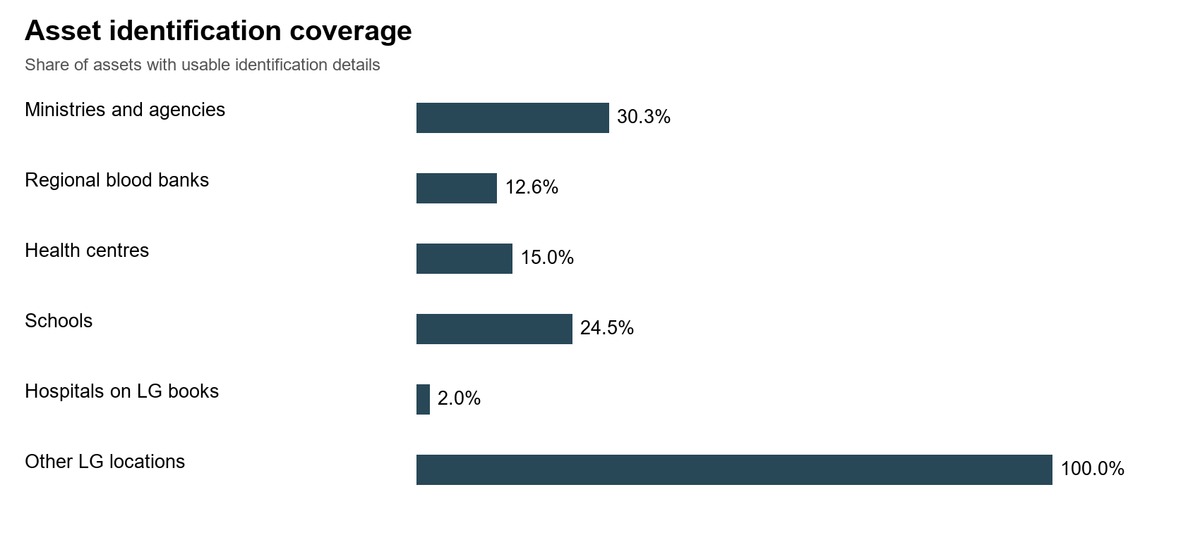
Below are some of the photos depicting the different markings and identification engravements of assets across the institutions
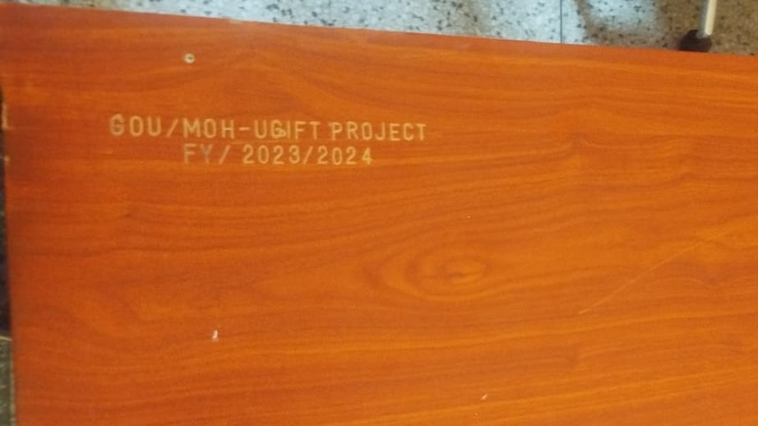 | 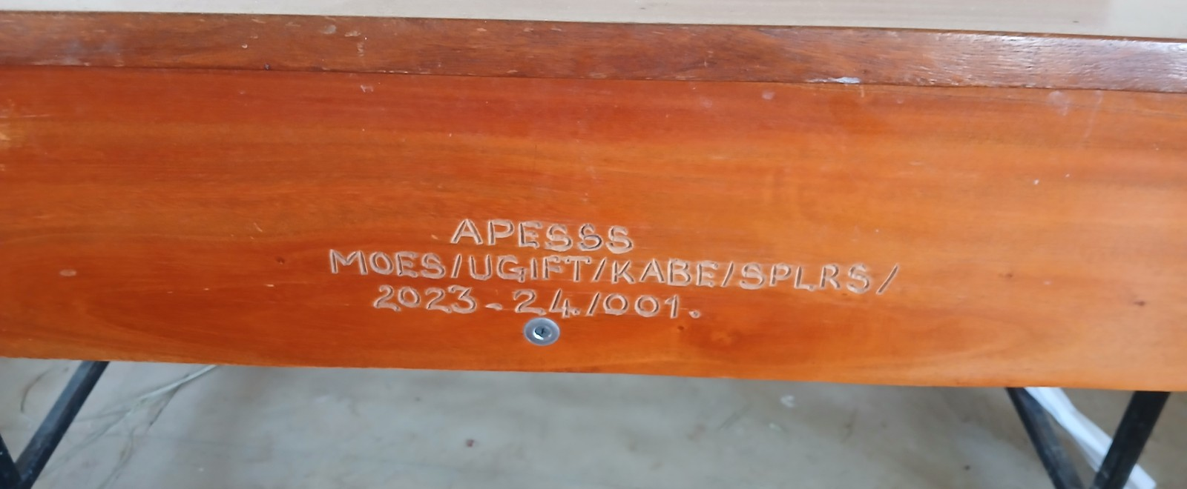
Engraving reading GOU/MOH-UGIFT PROJECT FY/2023/2024 on a desk at Namwaya Health Centre III, Tororo District | Engraving reading APESSS MOES/UGIFT/KABE/SPLRS/2023-24/001 on a desk at Aperikira Seed Secondary School, Kaberamaido District
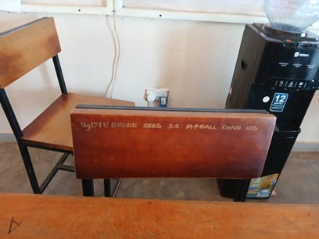 | 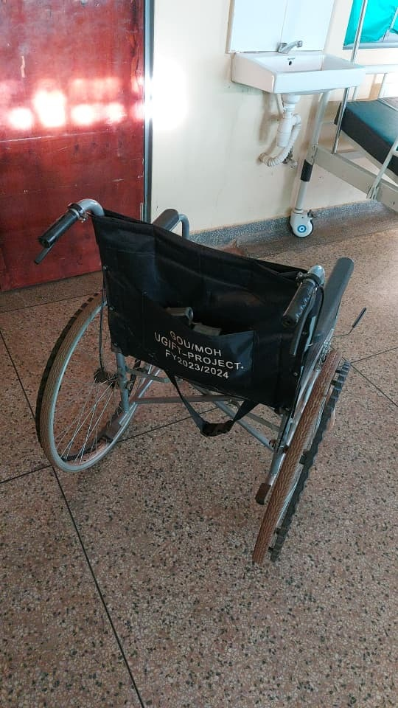
Chair engraved UgIFT/ BUDDE SEED S.S M-PHALL CHAIR with a serial number at Budde Seed Secondary School, Butambala District | Wheelchair backrest marked GOU/MOH UGIFT-PROJECT. FY2023/2024 at Kalemungole Health Centre III, Moroto District
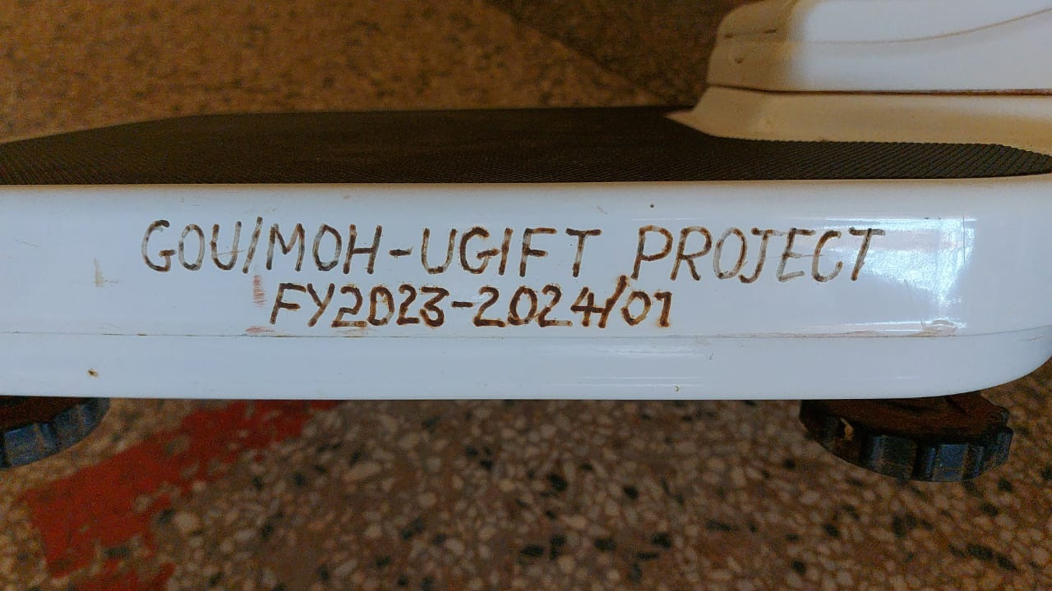 | 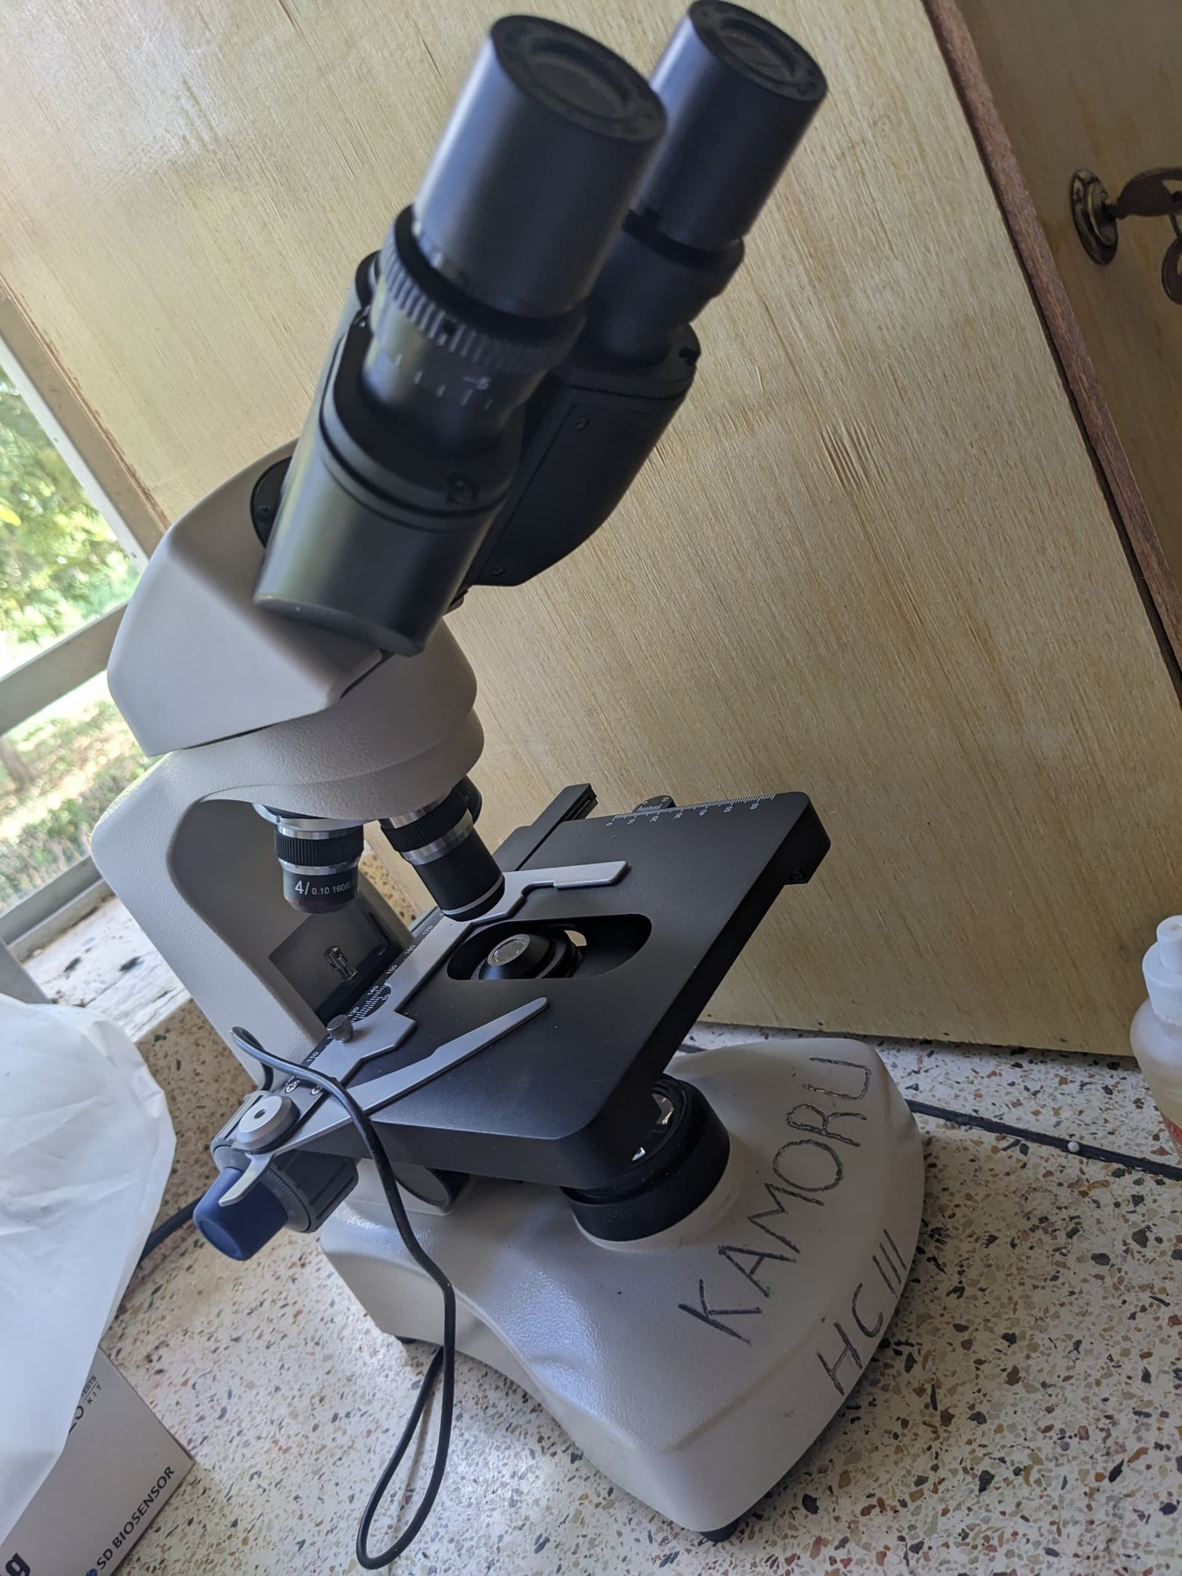
Engraving reading GOU/MOH-UGIFT PROJECT FY2023-2024/01 on a weighing scale at Kalemungole Health Centre III, Moroto District | Microscope marked KAMORU HC III by hand at Kamoru Health Centre III, Kotido Distric
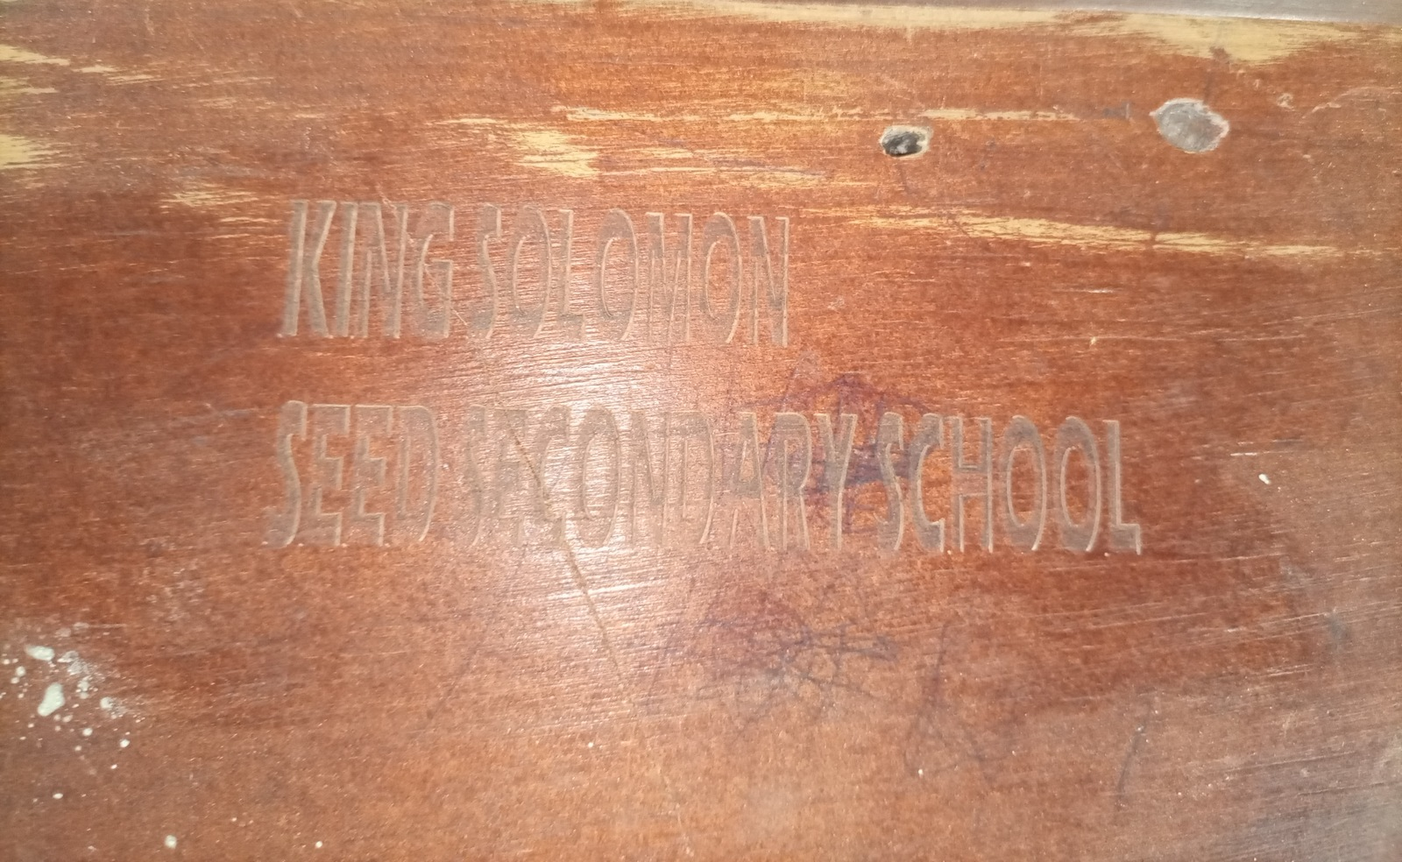 | 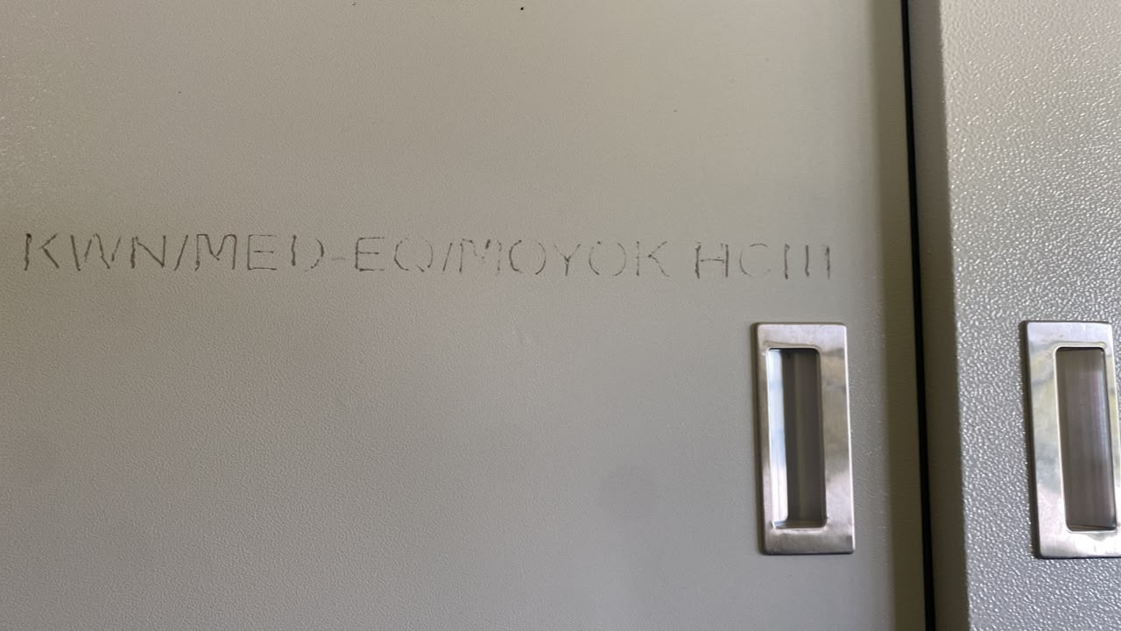
Engraving reading KING SOLOMON SEED SECONDARY SCHOOL, without a UgIFT marking, on furniture at King Solomon Seed Secondary School, Kagadi District | Engraving reading KWN/MED-EQ/MOYOK HCIII on a steel cupboard at Moyok Health Centre III, Kween District
- Financial analysis/ valuation
Overall, the 226,280 229,024 assets asset verified records across the different institutions had contain a an available recorded value of UGX 971,615,425,138. 996,812,628,890. Basing Cost on is the available straight-line for 227,938 records and missing for 1,086. Available accumulated depreciation policy is UGX 165,185,197,307 and the dates of deployment for the different assets, the computed net book value was is UGX 808,621,845,836 as 595,801,587,531 at 30 September 2026. 2026; The net recorded book value remains unavailable for 23,016 records. Recorded values vary by classification institution, with MDAs at UGX 31,822,306,095, 32,054,743,836, Blood regional Banks blood banks UGX 1,451,584,715, 1,503,720,926, Seed Secondary Schools schools UGX 678,247,549,426 700,242,561,371 and Health health Centers centres UGX 259,662,849,164 260,692,452,291. as The indicated table in below also includes hospital and other local-government records. These columns cover different populations; the table financial 2. appendix reconciles the assets with complete accounting information.
Table 2: Overall Recorded asset value and net book value
Asset category and coverage | Recorded cost | Accumulated depreciation | Net book value | NBV / cost
Schools  145,256 records; NBV 130,449/145,256 | 700,242.561* | 104,574.530* | 394,241.709* | 79.0%
Health centres  63,432 records; NBV 55,604/63,432 | 260,692.452* | 39,211.095* | 189,403.577* | 82.8%
Ministries and agencies  16,663 records; NBV 16,567/16,663 | 32,054.744* | 19,787.511* | 10,265.925* | 34.2%
Hospitals on LG books  3,067 records; NBV 2,795/3,067 | 1,888.015* | 778.948* | 912.033* | 53.9%
Regional blood banks  602 records; NBV 589/602 | 1,503.721* | 553.689* | 826.632* | 59.9%
Other LG locations  4 records; NBV 4/4 | 431.136 | 279.424 | 151.712 | 35.2%
Amounts are in UGX million, rounded to three decimals. * Available amounts only; one or more amounts are missing or pending calculation. NBV coverage is given for each category. NBV/cost compares complete accounting records and does not measure physical condition. n/a means a comparable ratio is unavailable.

3.2 National level Ministries and Agencies results
- Overall Asset availability at Ministries and Agencies
The exercise verified 16,668 assets of the different categories across all the thirteen Thirteen Ministries and agencies. agencies account for 16,663 assets. In terms of categorization, the these exercise comprise verified 15,136 15,192 ICT equipment items, including desktop computers, laptops, tablets, tablets and Uninterruptible Power Supply (UPS), (UPS) 76 units; Vehicles 77 transport items; 99 furniture and motorcycles, fittings; 99 48 Furniture other classified assets; 1,235 items outside fixed-asset classification; and fittings 12 unclassified entries. Fifteen MDAs were covered by the exercise; LGFC and 1,357 MoPS small reported equipment receiving including no shredders, UgIFT binders, projectors among others. assets.
By location, institution, most MDA assets (64.7%) (94.6%) were are at attributed to MoES, MoWE and MAAIF while MAAIF. PPDA was found with only has five assets assets, including comprising three Lenovo think ThinkPad pad Laptops, laptops, one HP Laser LaserJet Jet Color Printer printer and one Samsung Galaxy tablet tablet, as indicated in the figure 4 below. Assets attributed to MDAs are excluded from the school and health-centre totals to avoid double counting.
Figure 4: UgFT Assets available held at by each ministries of and the verified MDAs agencies
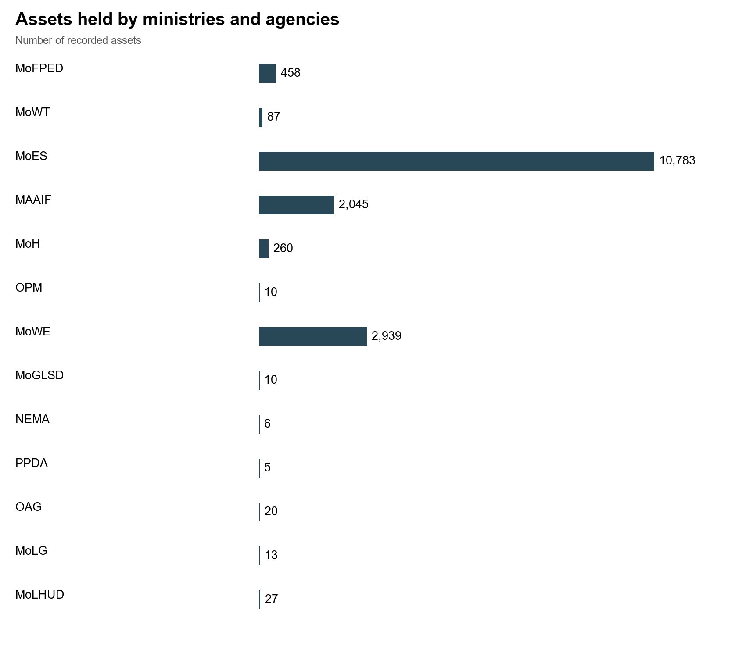
- MDA asset Condition and functionality
At MDA level, apart 16,643 from assets Ministry (99.9%) of are Health classified that as had functional and in use. The remaining 20 (0.1%) are classified as faulty: sixteen at MoWT, one double at cabin boarded off MoH and three broken laptops at the Office of the Prime minister, the rest of the assets 16,664 (99.9%) were in good condition and were in use. Minister. The Ministry of Education and Sports holds accounts for 10,783 of these assets, mainly TELA handsets and tablets and were tablets, all reported as in use at the different schools across the country. use. LGFC and MoPS indicated that they never had received no UgIFT assets. Faulty items require individual assessment before a decision on repair or disposal.
- Asset marking and Identification
At MDA level, there were 15,401 movable assets, 4,925 of which the 4,843 (31.4%) were engraved with 4,730 16,663 assets (30.7%) (29.6%) bearing have the identifiers containing UgIFT marking. or Majority UGFT, of while assets 120 10,558 (0.7%) (68.6%) have were another not identifier. engraved. The majority, 11,618 (69.7%), have no usable identifier. The figure 5 below shows the identification status coverage across MDAs. The method of the physical assets marking at still the requires different MDAs. confirmation.
Figure 5: Asset marking and Identification at MDAs
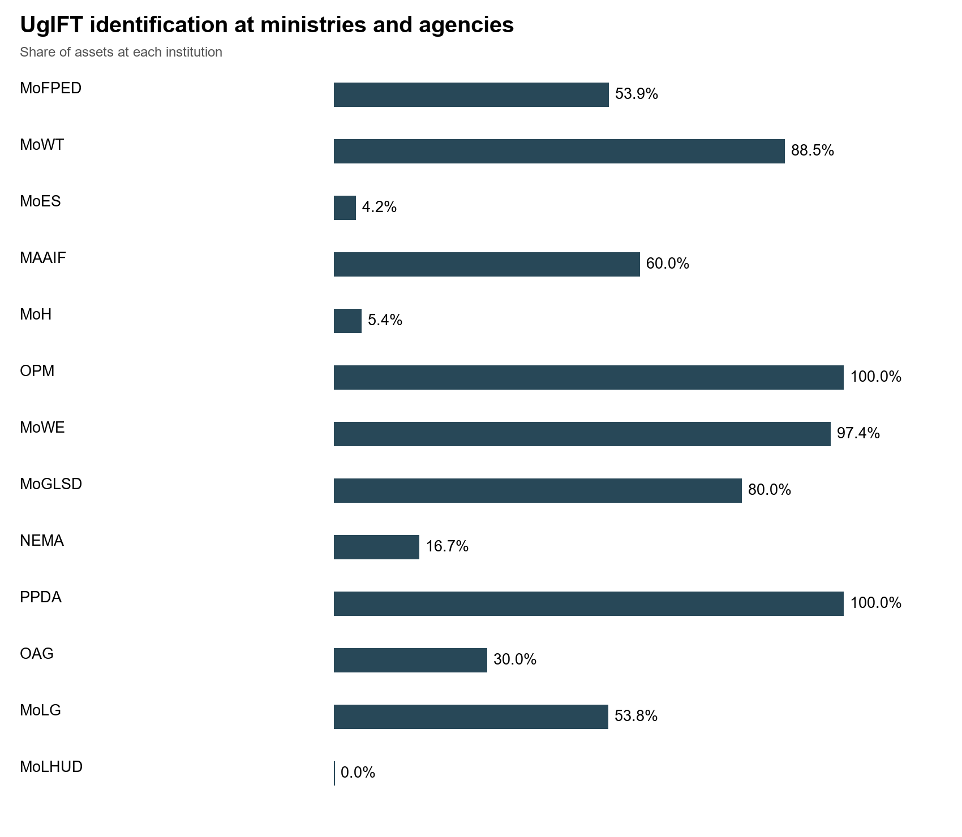
- Financial analysis/ valuation
Financial value of assets: recorded costs total UGX 32,054,743,836 across 16,651 of 16,663 records. Accumulated depreciation totals UGX 19,787,511,232 and net book value totals UGX 10,265,924,979 at 30 September 2026. Net book value remains unavailable for 96 records. The table below gives the category breakdown and identifies any unavailable amounts.

3.3 MDA specific results

3.3.1 Ministry of Finance, Planning and Economic Development
Asset availability: The ministry keeps a UgIFT asset register and the consolidated register for all MDAs that received UgIFT assets. A total of 458 assets were are verified attributed at to the ministry MoFPED, including 217 230 ICT items, 122 other assets, 99 furniture and fittings fittings, 21 transport items, 37 other classified assets, 65 outside fixed-asset classification and 20 six transport unclassified assets. entries. The main items were include office chairs and desks, desktop computers, tablets and 20 Toyota Hilux double cabin double-cabin pickups.
Condition and functionality: All 458 assets (100.0%) were are working classified as functional and in use, use. Reports of damaged equipment and none losses was are broken discussed down. below.
Reports described spoilt keyboards and UPS units, computers that freeze and laptop losses. The affected quantities and individual assets were not specified, so the number of broken or lost items could not be established. The asset manager should identify the affected items and reconcile the damage and loss reports.
Marking and identification: A Of total the of 458 272 assets, assets 247 (76.0%) (53.9%) were have engraved identifiers containing UgIFT or UGFT, 35 (7.6%) have another identifier and 86 176 (24.0%) were not engraved. 252 assets were found to (38.4%) have the no usable identifier. Registration numbers and other identifiers are distinguished from UgIFT marking. markings. It Physical was engraving also still noted requires that the 20 double cabin pickups, did not have the UgFT labelling but were identified by their registration numbers only. confirmation.
Financial Value of assets: The recorded value of the ministry's ministry’s UgIFT assets is UGX 5,615,661,760. 6,204,318,000. Cost is available for 456 of 458 records. Accumulated depreciation is UGX 4,312,193,629 and net book value is UGX 1,785,677,771 at 30 September 2026. Net book value remains unavailable for 20 records; the figures sum only available amounts. The table below gives the category breakdown.
Table 3: Recorded costs and available accounting values at MoFPED
Asset category and coverage | Recorded cost | Accumulated depreciation | Net book value | NBV / cost
ICT equipment  230 records; NBV 216/230 | 1,350.105 | 1,011.732* | 238.731* | 19.1%
Furniture and fittings  99 records; NBV 99/99 | 137.037 | 96.069 | 40.968 | 29.9%
Outside fixed-asset classification  65 records; NBV 65/65 | 6.564 | 0.000 | 0.000 | n/a
Other classified assets  37 records; NBV 36/37 | 159.987* | 158.377* | 1.610* | 1.0%
Transport equipment  21 records; NBV 20/21 | 4,550.385* | 3,046.016* | 1,504.369* | 33.1%
Unclassified  6 records; NBV 2/6 | 0.240 | 0.000* | 0.000* | n/a
Amounts are in UGX million, rounded to three decimals. * Available amounts only; one or more amounts are missing or pending calculation. NBV coverage is given for each category. NBV/cost compares complete accounting records and does not measure physical condition. n/a means a comparable ratio is unavailable.

3.3.2 Ministry of Works and Transport
Asset availability: The Ministry did not provide a UgIFT Asset asset Register. register Physical during verification the at fieldwork. MoWT A identified total 88 of 87 assets are attributed to MoWT, of which 63 69 are classified as ICT items equipment, were one mainly as Lenovo transport equipment, sixteen outside fixed-asset classification and one unclassified. Items include desktop computers, monitors, uninterruptible power supply (UPS) UPS units, video-conferencing equipment equipment, printers and HP Color LaserJet printers; photocopiers, one Toyota Hilux pickup; pickup and 24 sixteen other keyboards. assets. Desktop system units and their components are listed separately and should not be counted again as combined computer sets. The 24 unclassified records entry grouped is under titled other assets comprised 16 keyboards, four Dell OptiPlex 7090 desktop system units, two Lenovo Think Book notebooks, and two records without usable asset descriptions (entered as 'Ministry Ministry of Local Government' Government and 'PPDA'), requires as presented in Figure 6. clarification.
Figure 6: Assets verified Asset categories at MoWT
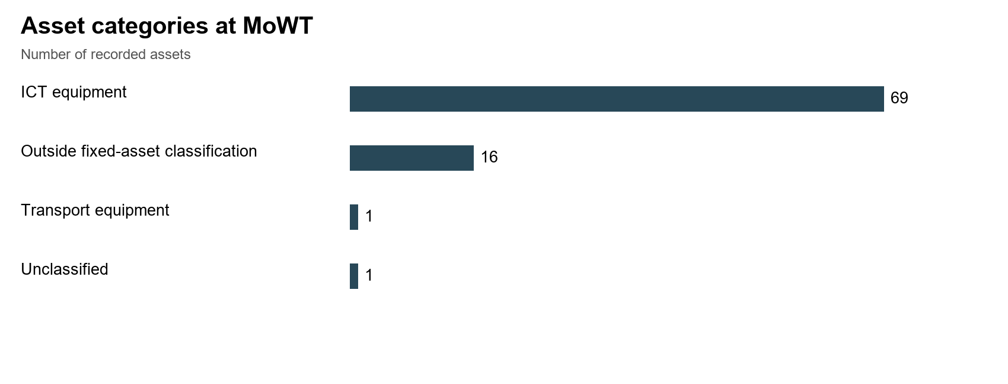
Condition and functionality: All Of the 88 87 assets assets, were 71 verified (81.6%) found are working classified as functional and in use; use, none while was sixteen broken (18.4%) down. are classified as faulty and not in use.
Marking and Identification: Of the 88 verified 87 assets, 63 77 (71.6%) (88.5%) were have engraved identifiers with 62 having the containing UgIFT marking or while; UGFT, 25 two (28.4%) (2.3%) were have not another engraved. identifier and eight (9.2%) have no usable identifier.
Financial Value of assets: The recorded value was established as UGX 340,968,220 455,932,376. as Cost presented is in available Table for 3. 86 of 87 records. Accumulated depreciation is UGX 326,484,882 and net book value is UGX 115,311,494 at 30 September 2026. Net book value remains unavailable for 19 records; the figures sum only available amounts. The table below gives the category breakdown.
Table 3: 4: MoWT asset values by category
Asset category and coverage | Recorded cost | Accumulated depreciation | Net book value | NBV / cost
ICT equipment  69 records; NBV 51/69 | 259.914 | 137.001* | 108.778* | 44.3%
Outside fixed-asset classification  16 records; NBV 16/16 | 0.000 | 0.000 | 0.000 | n/a
Transport equipment  1 records; NBV 1/1 | 196.018 | 189.484 | 6.534 | 3.3%
Unclassified  1 records; NBV 0/1 | Unavailable | Unavailable | Unavailable | n/a
Amounts are in UGX million, rounded to three decimals. * Available amounts only; one or more amounts are missing or pending calculation. NBV coverage is given for each category. NBV/cost compares complete accounting records and does not measure physical condition. n/a means a comparable ratio is unavailable.

3.3.3 Ministry of Education and Sports
Asset availability: The verification at the Ministry of Education and Sports (MoES) established accounts that the ministry had for 10,783 assets. All the are assets classified are as ICT equipment and these include 9,324 TELA handsets, 1,001 tablets (976 of them inspection tablets), 456 laptops, a photocopier and a printer. The breakdown of these assets is shown below in in the figure 46c. below. Teacher, Effectiveness and Learner Achievement (TELA) TELA is the system, system financed by UgIFT, UgIFT that the ministry uses to monitor attendance and performance in schools; schools. the The handsets and inspection tablets are deployed in local governments and remain MoES assets.
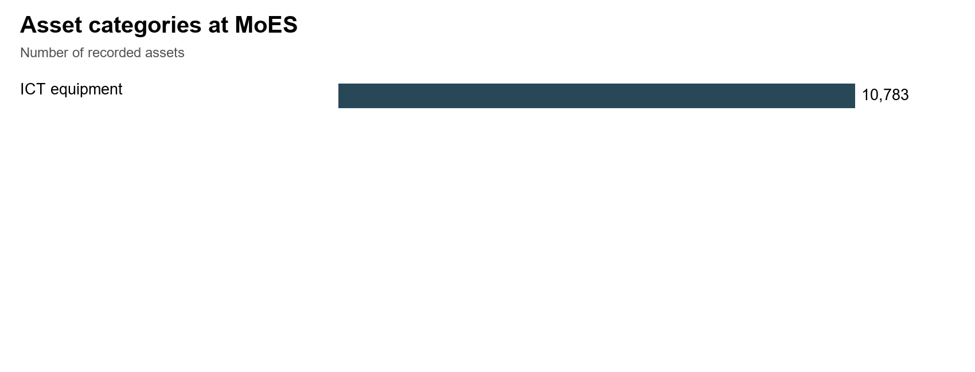
Figure 46c: 7: Assets verified Asset categories at MoES
All the 10,783 assets (100.0%) are in classified good as working condition functional and in use. use, All including all 456 laptops. Their identification status is shown separately in the 456 following laptops are in good condition, properly engraved and in use. table.
Table 12b: 5: Condition and use of assets at MoES
Condition | Records | Share
Functional | 10,783 | 100.0%
Faulty | 0 | 0.0%
Total | 10,783 | 100.0%
Marking and Identification: Of the verified 10,783 assets, 458 (4.2%) were have engraved, identifiers all with the containing UgIFT marking, or UGFT, while 10,325 (95.8%) were have not no engraved. usable None identifier. of The the handset handsets and or tablet tablets identifiers carries are an unavailable, engravement so mark. their physical engraving status requires confirmation.
Table 12c: 6: Engravement status of assets Recorded tag content at MoES
Identification | Records | Share of all records
Tag contains UgIFT or UGFT | 458 | 4.2%
Other identifier | 0 | 0.0%
No usable tag recorded | 10,325 | 95.8%
Financial Value of assets: The recorded value is UGX 14,760,581,751, 14,925,128,359, the highest among the MDAs. Accumulated depreciation is UGX 10,607,476,704 and net book value is UGX 4,317,651,655 at 30 September 2026. The table below gives the category breakdown.
Table 7: Recorded costs and available accounting values at MoES
Asset category and coverage | Recorded cost | Accumulated depreciation | Net book value | NBV / cost
ICT equipment  10,783 records; NBV 10,783/10,783 | 14,925.128 | 10,607.477 | 4,317.652 | 28.9%
Amounts are in UGX million, rounded to three decimals. * Available amounts only; one or more amounts are missing or pending calculation. NBV coverage is given for each category. NBV/cost compares complete accounting records and does not measure physical condition. n/a means a comparable ratio is unavailable.

3.3.4 Ministry of Agriculture, Animal Industry and Fisheries
Asset availability: The A team total verified of UgIFT 2,045 assets at are attributed to the Ministry of Agriculture, Animal Industry and Fisheries (MAAIF) (MAAIF). These include 1,236 ICT items, two transport items and established 807 that others, it comprising held 797 2,045 outside assets. fixed-asset These classification, included five 1,206 other ICT classified equipment, 2 vehicles assets and 837 five others. unclassified entries. The ICT items were mainly include 819 tablets, 211 computers (162 desktops desktop CPUs and 49 laptops), 149 monitors and 15 21 printers. The breakdown of the assets mentioned above is shown in the figure 46d. below.
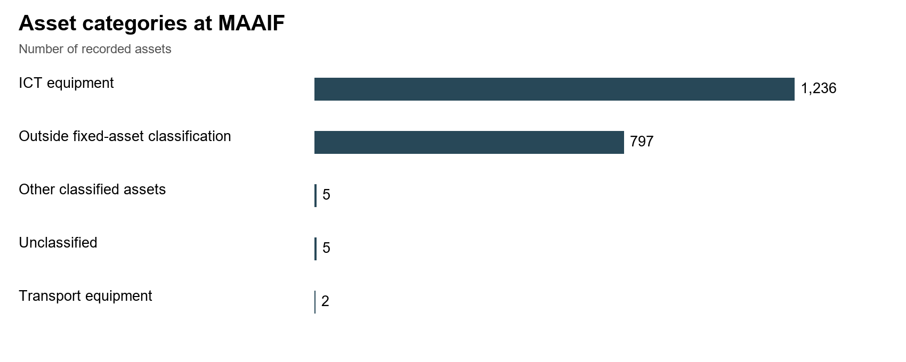
Figure 46d: 8: Assets Asset categories verified: at MAAIF
All 2,045 assets (100.0%) are in classified good as condition functional and in use. use, All including the 211 computers and 819 tablets tablets. are Their in identification good status condition, is properly reported engraved and in use. separately.
Table 12d: 8: Condition and use of assets at MAAIF
Condition | Records | Share
Functional | 2,045 | 100.0%
Faulty | 0 | 0.0%
Total | 2,045 | 100.0%
Marking and Identification: Of the 1,227 verified 2,045 assets, 1,204 1,228 (98.1%) (60.0%) are have engraved, identifiers 1,200 containing (97.8%) UgIFT with or UGFT, four (0.2%) have another identifier and 813 (39.8%) have no usable identifier. The percentages cover the UgIFT full marking, ministry and asset 23 population, (1.9%) including were non-capitalized not engraved, among them two drones, a handheld global positioning system (GPS) unit and a projector. The laptops and printers had the UgIFT engraving. items.
Table 12e: 9: Engravement status of verified assets Recorded tag content at MAAIF
Identification | Records | Share of all records
Tag contains UgIFT or UGFT | 1,228 | 60.0%
Other identifier | 4 | 0.2%
No usable tag recorded | 813 | 39.8%
Financial Value of assets: The recorded value was UGX 1,844,366,458. 2,856,556,593. Cost is available for 2,043 of 2,045 records. Accumulated depreciation is UGX 1,380,059,505 and net book value is UGX 1,403,429,899 at 30 September 2026. Net book value remains unavailable for 7 records; the figures sum only available amounts. The table below gives the category breakdown.
Table 10: Recorded costs and available accounting values at MAAIF
Asset category and coverage | Recorded cost | Accumulated depreciation | Net book value | NBV / cost
ICT equipment  1,236 records; NBV 1,234/1,236 | 2,278.449* | 952.109* | 1,326.341* | 58.2%
Outside fixed-asset classification  797 records; NBV 797/797 | 72.467 | 0.000 | 0.000 | n/a
Other classified assets  5 records; NBV 5/5 | 8.000 | 5.467 | 2.533 | 31.7%
Unclassified  5 records; NBV 0/5 | 0.600 | Unavailable | Unavailable | n/a
Transport equipment  2 records; NBV 2/2 | 497.040 | 422.484 | 74.556 | 15.0%
Amounts are in UGX million, rounded to three decimals. * Available amounts only; one or more amounts are missing or pending calculation. NBV coverage is given for each category. NBV/cost compares complete accounting records and does not measure physical condition. n/a means a comparable ratio is unavailable.

3.3.5 Ministry of Health
The verification at the MoH did not find the Ugift Asset Register but relied on the listing provided by the Ministry of Finance, Planning and Economic Development.
Asset availability: A total of 264 260 assets were are verified. attributed to MoH. Of the these, 264 31 assets, are 39 classified were as ICT equipment equipment, (laptops 25 as transport equipment, six as other classified assets and photocopiers), 198 25 outside assets fixed-asset were transport assets (motor vehicles and motor cycles) and 200(Electronic shredders and Heavy duty Binders) were other assets classification, as indicated in Figure the 46e. figure below. Binding machines, shredders, helmet accessories and power items are detailed below.
The Ministry of Health’s other items include two heavy-duty binding machines, two CC20240 paper shredders and 12 entries described as Accessories (12-Helmets). All 12 helmet entries share asset number UGIFT-217204, so the identity and quantity of the helmets require confirmation. The reported total of six power items remains unreconciled. Three have been traced to Kyamwinula Health Centre III under Tororo Municipal Council: one power bank and two regulators (UGIFT-118553–UGIFT-118555). These are already included in the health-centre total. These items are also associated with TASO or RHITES E, so their attribution to UgIFT requires confirmation. The other three power items have not been identified.
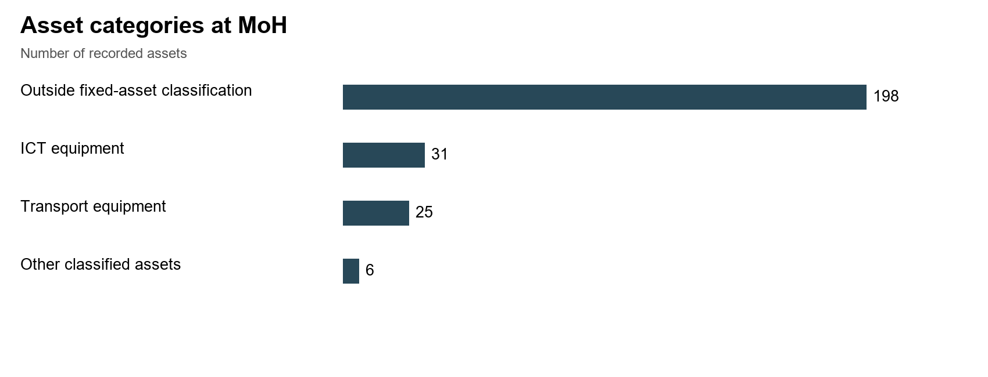
Figure 46e: 9: Assets verified Asset categories at MoH
Condition and functionality: The A total of 259 assets in (99.6%) good are working classified condition as were 263 (99.6%). Among those in good condition functional and in use use. were One 26 double-cabin computers pickup (2 is desktops classified as faulty and 24 laptops), Shredders and heavy duty bidders. Only one asset ie a pick-up double cabin was not in good working condition and had been boarded off. use.
Marking and Identification: Out of the 73 movable 260 assets, 41(56%) fourteen were (5.4%) engraved have while identifiers 32 (44%) were not engraved. There were 14 (19%) assets that were properly engraved with containing UgIFT marks or UGFT, eighteen (6.9%) have another identifier and serial 228 numbers. (87.7%) have no usable identifier.
Financial Value of assets: The MoH assets had a recorded value of UGX 953,859,009. 1,186,689,609. Accumulated depreciation is UGX 441,202,460 and net book value is UGX 384,551,313 at 30 September 2026. Net book value remains unavailable for 1 record; the figures sum only available amounts. The table below gives the category breakdown.
Table 11: Recorded costs and available accounting values at MoH
Asset category and coverage | Recorded cost | Accumulated depreciation | Net book value | NBV / cost
Outside fixed-asset classification  198 records; NBV 198/198 | 175.368 | 0.000 | 0.000 | n/a
ICT equipment  31 records; NBV 31/31 | 211.927 | 109.806 | 102.122 | 48.2%
Transport equipment  25 records; NBV 24/25 | 789.136 | 326.267* | 277.300* | 45.9%
Other classified assets  6 records; NBV 6/6 | 10.259 | 5.129 | 5.129 | 50.0%
Amounts are in UGX million, rounded to three decimals. * Available amounts only; one or more amounts are missing or pending calculation. NBV coverage is given for each category. NBV/cost compares complete accounting records and does not measure physical condition. n/a means a comparable ratio is unavailable.

3.3.6 Office of the Prime Minister
The Assets Register for the Office of the Prime Minister was not obtained and no list of assets was provided. The verification relied on the listing obtained from the Ministry of Finance, Planning and Economic Development.
Asset availability: The Office of the Prime Minister received has 10 assets which were all ten HP laptop computers computers, as shown in Figure the 46f. figure below.
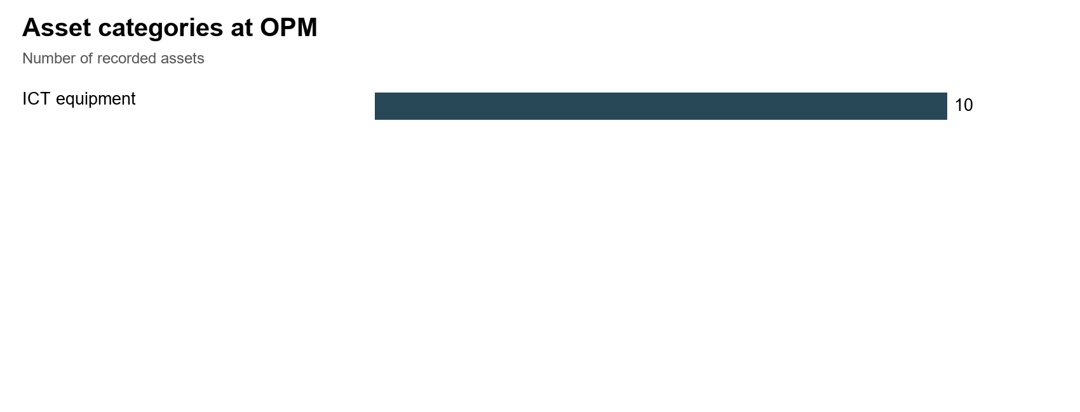
Figure 46f: 10: Assets Asset categories verified: at OPM
Condition and functionality: Seven assets laptops (70.0%) were are in classified good as working condition functional and in use. Three (30.0%) were are damaged, classified as faulty and out not of in use.
Marking and identification: All the 10 ten laptops were (100.0%) properly have engraved identifiers with the containing UgIFT markings. or UGFT.
Financial Value of assets: The recorded value of these computers in OPM was UGX 53,535,300. Accumulated depreciation is UGX 48,181,770 and net book value is UGX 5,353,530 at 30 September 2026. The table below gives the category breakdown.
Table 12: Recorded costs and available accounting values at OPM
Asset category and coverage | Recorded cost | Accumulated depreciation | Net book value | NBV / cost
ICT equipment  10 records; NBV 10/10 | 53.535 | 48.182 | 5.354 | 10.0%
Amounts are in UGX million, rounded to three decimals. * Available amounts only; one or more amounts are missing or pending calculation. NBV coverage is given for each category. NBV/cost compares complete accounting records and does not measure physical condition. n/a means a comparable ratio is unavailable.

3.3.7 1.1.1 Ministry of Water and Environment
Asset availability: The Asset Verification at the Ministry of Water and Environment found out that the ministry keeps kept a general asset register which does did not conform to IFMS IFMIS Standards. standards. The A register total recorded of 2,939 assets, assets all are attributed to the ministry, of which 2,782 are classified as ICT equipment. equipment and 157 outside fixed-asset classification. The verified items assets received by the Ministry were include 2,368 tablets out tablets, of which 2,344 were of are Euron type, tablets; 188 computers Computers and with related their monitors, keyboards and UPS unit units; of 31 which laptops; 31were and laptops. sixteen The Ministry also received 16 real time real-time kinematic GPS machines. Computer components are counted separately and should not be added again as complete computer sets.
However, other Other assets were include identified 157 which keyboards, included157 seven keyboards survey recorded units with described Dell OptiPlex computers, 7 airborne as ground-penetrating radar units, equipment, 3 three Samsung Galaxy Tab S9 tablets, 2 two Lenovo ThinkBook notebooks, 1 one Kyocera heavy-duty copier, photocopier, 1 one Huawei 65-inch infrared screen and 1 one separately described UPS unit. These descriptions are already included in the ministry total; they are not additional assets to add to it.
Asset condition and functionality: The findings further indicated that all All 2,939 assets (100.0%) were are classified as functional and in good working condition and non were broken down. use.
Marking and Identification: The Of ministry the received ministry’s a total of 2939 2,939 assets, 2,782 2,864 verified (97.4%) assets, have 2,740 identifiers (98.5%) were engraved, 2,707 (97.3%) with the containing UgIFT marking, or UGFT, 33 (1.1%) have another identifier and 42 (1.5%) (1.4%) were have not no engraved. usable identifier.
Financial Value of the assets: The recorded value was UGX 5,993,100,537. 5,029,981,561. Cost is available for 2,932 of 2,939 records. Accumulated depreciation is UGX 2,092,642,121 and net book value is UGX 1,535,627,440 at 30 September 2026. Net book value remains unavailable for 43 records; the figures sum only available amounts. The table below gives the category breakdown.
Table 13: Recorded costs and available accounting values at MoWE
Asset category and coverage | Recorded cost | Accumulated depreciation | Net book value | NBV / cost
ICT equipment  2,782 records; NBV 2,739/2,782 | 3,773.982* | 2,092.642* | 1,535.627* | 42.3%
Outside fixed-asset classification  157 records; NBV 157/157 | 1,256.000 | 0.000 | 0.000 | n/a
Amounts are in UGX million, rounded to three decimals. * Available amounts only; one or more amounts are missing or pending calculation. NBV coverage is given for each category. NBV/cost compares complete accounting records and does not measure physical condition. n/a means a comparable ratio is unavailable.

3.3.8 Ministry of Gender, Labour and Social Development
Asset availability: The Asset Verification at the Ministry of Gender, Labour and Social Development found out that the ministry keeps kept a UgIFT asset register which with had 10 UgIFT ten assets. These comprised comprise of 8 eight Lenovo ThinkPad computers, Laptops, including four ThinkBook laptops, and 2 two Samsung Tablets. tablets. Figure The 46h figure below presents the their UgIFT assets verified for MoGLSD. classification.
Asset condition and functionality: The All findings further indicate that all the verified UgIFT ten assets were (100.0%) in are good classified working as condition functional and in use.
Marking and Identification: A total of Eight Lenovo ThinkPad Laptops computers (80.0%) were have properly identifiers engraved with the containing UgIFT markings or and UGFT. the The Two two Samsung Tablets tablets (20.0%) were have not no engraved. usable identifier.
Financial Value of the assets: The findings pointed indicate out that the a recorded value to be of UGX 20,120,000. 46,180,000. Accumulated depreciation is UGX 13,260,000 and net book value is UGX 14,860,000 at 30 September 2026. Net book value remains unavailable for 4 records; the figures sum only available amounts. The table below gives the category breakdown.
Table 14: Recorded costs and available accounting values at MoGLSD
Asset category and coverage | Recorded cost | Accumulated depreciation | Net book value | NBV / cost
ICT equipment  10 records; NBV 6/10 | 46.180 | 13.260* | 14.860* | 52.8%
Amounts are in UGX million, rounded to three decimals. * Available amounts only; one or more amounts are missing or pending calculation. NBV coverage is given for each category. NBV/cost compares complete accounting records and does not measure physical condition. n/a means a comparable ratio is unavailable.
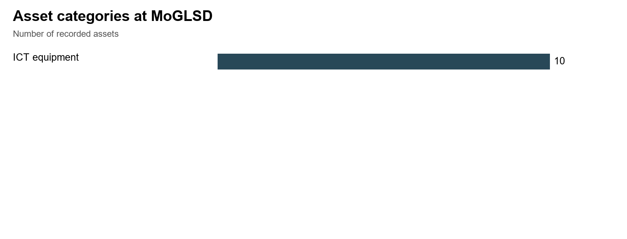
Figure 46h: 11: Assets Asset categories verified: at MoGLSD

3.3.9 National Environment Management Authority
Asset availability:
National Environment Management Authority (NEMA) had has 6 six ICT items; assets: 4 four laptops, computers, a printer and a heavy-duty photocopier.
Condition and functionality: All 6 six assets (100.0%) were are working classified as functional and in use.
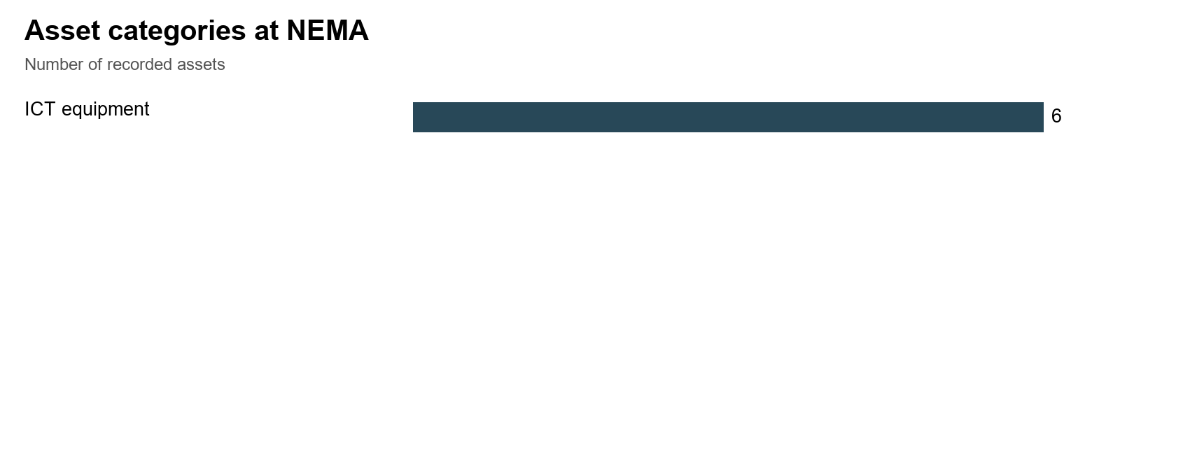
Figure 46i: 12: Assets Asset categories verified: at NEMA
Asset marking and identification:
One The (16.7%) heavy-duty ie photocopier (16.7% of the heavy assets) duty has photocopier an was identifier engraved containing UgIFT or UGFT, while the other 5 five assets (83.3%) were have not no engraved. usable identifier.
Financial value of Assets: The recorded value is UGX 27,324,409. 46,824,409. Accumulated depreciation is UGX 32,841,273 and net book value is UGX 13,983,136 at 30 September 2026. The table below gives the category breakdown.
Table 15: Recorded costs and available accounting values at NEMA
Asset category and coverage | Recorded cost | Accumulated depreciation | Net book value | NBV / cost
ICT equipment  6 records; NBV 6/6 | 46.824 | 32.841 | 13.983 | 29.9%
Amounts are in UGX million, rounded to three decimals. * Available amounts only; one or more amounts are missing or pending calculation. NBV coverage is given for each category. NBV/cost compares complete accounting records and does not measure physical condition. n/a means a comparable ratio is unavailable.

3.3.10 Public Procurement and Disposal of Public Assets Authority
Public Procurement and Disposal of Public Assets Authority (PPDA) did not provide a Ugift Asset Register. The verification relied on the information obtained from the Ministry of Finance, Planning and Economic Development.
Asset availability: A PPDA total has of five 5 assets: assets were verified in PPDA; these were 3 three Lenovo ThinkPad laptops, a Samsung Galaxy tablet and an HP printer printer, as indicated in Figure the 46j. figure below.
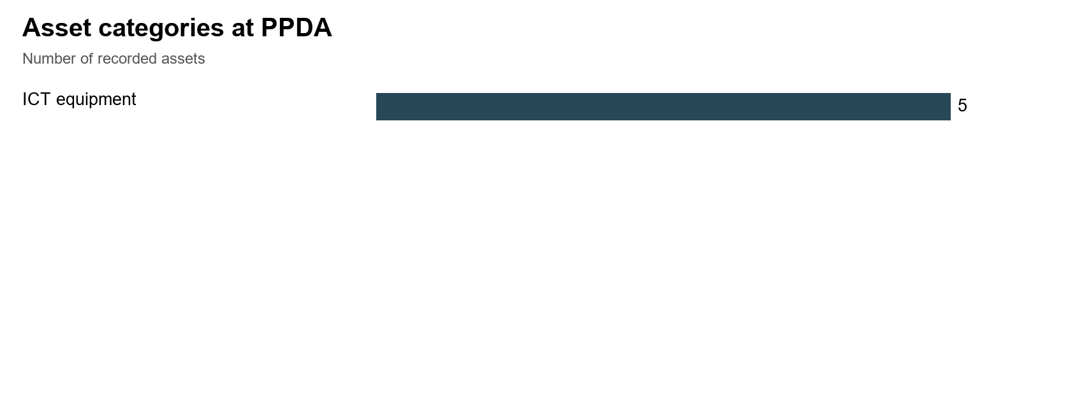
Figure 46j: 13: Assets verified Asset categories at PPDA
Asset condition and functionality: All the 5 five assets were (100.0%) in are good classified working as condition functional and in use.
Asset marking and identification: All the five laptops, assets tablets have and identifiers printer were properly engraved with the containing UgIFT marking. or UGFT.
Financial Value of assets: The MF register does not state a recorded cost or is UGX 30,153,500 for these assets. Accumulated depreciation is UGX 13,066,516 and net book value for is these UGX assets. 17,086,984 at 30 September 2026. The table below gives the category breakdown.
Table 16: Recorded costs and available accounting values at PPDA
Asset category and coverage | Recorded cost | Accumulated depreciation | Net book value | NBV / cost
ICT equipment  5 records; NBV 5/5 | 30.154 | 13.067 | 17.087 | 56.7%
Amounts are in UGX million, rounded to three decimals. * Available amounts only; one or more amounts are missing or pending calculation. NBV coverage is given for each category. NBV/cost compares complete accounting records and does not measure physical condition. n/a means a comparable ratio is unavailable.

3.3.11 Office of the Auditor General (OAG)
Asset availability: Evidence gathered during the verification confirmed that OAG had did no not have a UgIFT asset register rather but provided a list which indicated 20 assets; 18 of which twenty were assets: eighteen ICT items (16 (sixteen laptops and 2 two printers) and 2 pickup two vehicles. The above information is depicted in the figure 46k. below.
Asset condition and functionality: All 20 twenty assets (100.0%) were are in classified good as condition functional and in use.
Asset marking and Identification: Six assets (30.0%) were have properly identifiers engraved containing with UgIFT or UGFT and fourteen (70.0%) have other identifiers, including the UgIFT markings and 14 (70.0%) were not properly engraved with UgIFT markings. The engravement was carrying the office's office’s own asset code codes or and vehicle registration number numbers. for The the method two of pickups. physical marking requires confirmation.
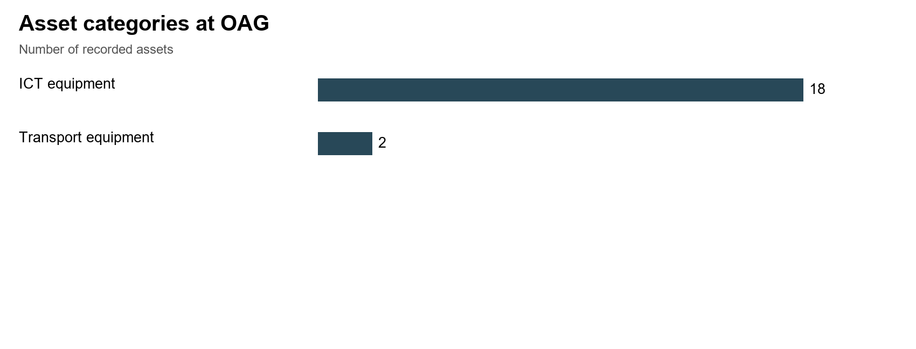
Figure 46k: 14: Assets verified Asset categories at OAG
Financial value of Assets: The recorded value of the assets were worth is UGX 228,773,680. 388,773,680. Accumulated depreciation is UGX 111,591,545 and net book value is UGX 277,182,135 at 30 September 2026. The table below gives the category breakdown.
Table 17: Recorded costs and available accounting values at OAG
Asset category and coverage | Recorded cost | Accumulated depreciation | Net book value | NBV / cost
ICT equipment  18 records; NBV 18/18 | 228.774 | 71.592 | 157.182 | 68.7%
Transport equipment  2 records; NBV 2/2 | 160.000 | 40.000 | 120.000 | 75.0%
Amounts are in UGX million, rounded to three decimals. * Available amounts only; one or more amounts are missing or pending calculation. NBV coverage is given for each category. NBV/cost compares complete accounting records and does not measure physical condition. n/a means a comparable ratio is unavailable.

3.3.12 Ministry of Local Government
Asset availability: The asset verification at the Ministry of Local Government (MoLG) found that the ministry kept a UgIFT asset register and with had thirteen 13 assets. UgIFT These assets; comprise one double-cabin pickup vehicle and 12 twelve ICT items. The ICT assets items comprised include of 6 computers, 4 six computer peripherals entries, four laptops and 2 two photocopier entries, one described as heavy duty duty. photocopiers. The Figure figure 46l below presents the UgIFT asset assets verified for MoLG. breakdown.
The two photocopier entries share the identifier UGIFT-MOLG/PHC/23-01. Their identity requires reconciliation to establish whether they are two separate items. Computer components are counted separately in the figure.
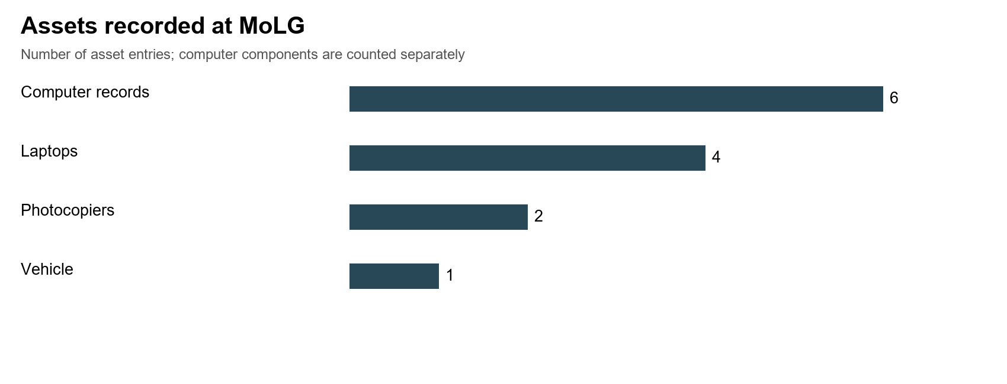
Figure 46l: 15: Assets verified recorded at MoLG
Asset condition and functionality: The All findings thirteen further indicate that all 13 assets (100.0%) verified are UgIFT classified assets as were in good condition functional and in use.
Asset marking and identification: Out of the 13 thirteen assets, eight (61.5%) were have engraved a while usable identifier and five (38.5%) were do not. Of the eight assets identified that assets, were seven engraved, have 7 identifiers (53.8%) were engraved with a containing UgIFT markings or while UGFT (53.8% of all assets) and one was has not. another In identifier terms of ICT equipment which formed the bulk of assets, 3 (50.0%) were engraved and 3 (50.0%) were not. (7.7%).
Financial Value of assets: The findings pointed indicate out the a recorded value to be of UGX 31,114,879. 343,320,450. Accumulated depreciation is UGX 284,670,827 and net book value is UGX 54,649,623 at 30 September 2026. Net book value remains unavailable for 1 record; the figures sum only available amounts. The table below gives the category breakdown.
Table 18: Recorded costs and available accounting values at MoLG
Asset category and coverage | Recorded cost | Accumulated depreciation | Net book value | NBV / cost
ICT equipment  12 records; NBV 11/12 | 94.800 | 36.151* | 54.650* | 60.2%
Transport equipment  1 records; NBV 1/1 | 248.520 | 248.520 | 0.000 | 0.0%
Amounts are in UGX million, rounded to three decimals. * Available amounts only; one or more amounts are missing or pending calculation. NBV coverage is given for each category. NBV/cost compares complete accounting records and does not measure physical condition. n/a means a comparable ratio is unavailable.

3.3.13 Ministry of Lands, Housing and Urban Development
Asset availability: The MoLHUD findings accounts from the verification exercise indicate that MoLH &UD had for 27 UgIFT assets, assets. These include comprising 25 Honda motorcycles and 2 two other entries assets described (Helmets). as Accessories (12-Helmets). The quantity of individual helmets requires confirmation and has not been multiplied by twelve.
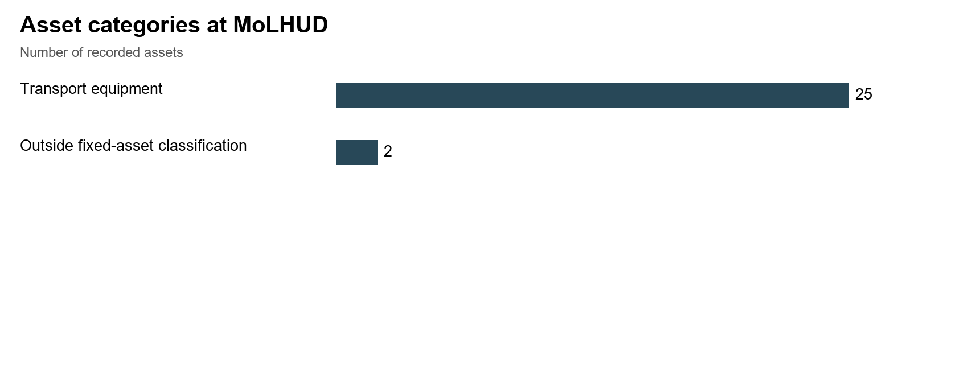
Figure 46m: 16: Assets verified Asset categories at MoLHUD
Additionally, the fieldwork account records that the ministry received survey equipment and other motorcycles that it gave out to local governments. Recorded ownership and custody should be reconciled through issue and receipt documents so that the same item is not counted in both ministry and local-government totals.
Asset condition and functionality: All the 27 27 assets (100.0%) were are in classified good as condition functional and in use, and none was broken down. use.
Asset marking and Identification: All None of the 27 (100.0%) assets were has not an engraved identifier with containing UgIFT markings. or It UGFT. was Thirteen also noted that the motorcycles did not (48.1%) have the another UgFT identifier labelling and but fourteen were (51.9%) identified have by no their usable identifier. Vehicle registration numbers details only. are distinguished from programme markings.
Financial Value of assets: The findings further indicate the a recorded value to be of UGX 597,549,997. 487,349,999. Accumulated depreciation is UGX 123,840,000 and net book value is UGX 340,559,999 at 30 September 2026. Net book value remains unavailable for 1 record; the figures sum only available amounts. The table below gives the category breakdown.
Table 19: Recorded costs and available accounting values at MoLHUD
Asset category and coverage | Recorded cost | Accumulated depreciation | Net book value | NBV / cost
Transport equipment  25 records; NBV 24/25 | 483.750 | 123.840* | 340.560* | 73.3%
Outside fixed-asset classification  2 records; NBV 2/2 | 3.600 | 0.000 | 0.000 | n/a
Amounts are in UGX million, rounded to three decimals. * Available amounts only; one or more amounts are missing or pending calculation. NBV coverage is given for each category. NBV/cost compares complete accounting records and does not measure physical condition. n/a means a comparable ratio is unavailable.

3.4 Results from blood banks
UgIFT financed the construction of the Arua and Hoima regional blood banks, which were completed and commissioned, banks and the rehabilitation of Soroti Regional Blood Bank. The three Blood Banks operate under Uganda Blood Transfusion Services (UBTS) and were verified. covered by the verification exercise. Completion and commissioning should be confirmed from the relevant certificates.
Asset availability: The blood banks held a total of UgFT asset base of 626 fixed assets inclusive of the Assets at the Uganda Blood transfusion services. The exercise verified all assets at the three regional blood banks as account follows. for 602 assets: 324 at Arua Regional Blood Bank Bank, held 163 277 assets, at Hoima Regional Blood Bank had and 119 115 and at Soroti Regional Blood Bank Bank. had This 115 subtotal assets. excludes assets assigned to other institutions or locations.
Asset Condition and functionality
Assets at the regional blood banks were are generally classified as functional and in good use: working 578 condition. assets Only (96.0%) Arua have regional that bloodbank status. had All six 24 broken assets assets. classified as faulty (4.0%) are at Arua. Each requires assessment to establish whether repair or replacement is appropriate.
Marking and Identification
Of 605 the movable 602 regional blood-bank assets, 43 (7.1%) were engraved and 562 (92.9%) were not engraved. 26 (4.3%) carried have the identifiers containing UgIFT marking or UGFT, 50 (8.3%) have another identifier and 17 526 (2.8%) (87.4%) carried have another no marking usable only. identifier. Figure Physical 59 engraving shows still the requires position. Table 25 sets out the counts. confirmation.
Financial aspects
Recorded value was UGX 1,451,584,715 1,503,720,926 and net book value at 30 September 2026 was UGX 937,479,171. 826,632,084. Accumulated depreciation was UGX 514,105,544. 553,688,842. These are available amounts for 589 of the 602 regional blood-bank records; thirteen have unavailable cost and net book value. The columns should not be subtracted without matching their recognition treatment and available inputs.
Table 26: 20: Recorded value and net book value: Blood banks
Asset category and coverage | Recorded cost | Accumulated depreciation | Net book value | NBV / cost
Arua Regional Blood Bank  324 records; NBV 311/324 | 1,153.115* | 472.399* | 557.316* | 54.1%
Hoima Regional Blood Bank  163 records; NBV 163/163 | 312.991 | 48.561 | 264.430 | 84.5%
Soroti Regional Blood Bank  115 records; NBV 115/115 | 37.615 | 32.729 | 4.886 | 13.0%
Amounts are in UGX million, rounded to three decimals. * Available amounts only; one or more amounts are missing or pending calculation. NBV coverage is given for each category. NBV/cost compares complete accounting records and does not measure physical condition. n/a means a comparable ratio is unavailable.

3.4.1 Arua Regional Blood Bank
Arua Regional Blood Bank accounts for 324 assets. Of these, 300 (92.6%) are classified as functional and in use, while 24 (7.4%) are classified as faulty and not in use. The faulty items require individual assessment for repair or replacement.
Marking and identification: Twenty-six assets (8.0%) have identifiers containing UgIFT or UGFT, 48 (14.8%) have another identifier and 250 (77.2%) have no usable identifier. Physical engraving still requires confirmation.
Financial value of assets: recorded costs total UGX 1,153,114,971 across 311 of 324 records. Accumulated depreciation totals UGX 472,399,460 and net book value totals UGX 557,315,511 at 30 September 2026. Net book value remains unavailable for 13 records. The table below gives the category breakdown and identifies any unavailable amounts.
Table 21: Asset categories at Arua Regional Blood Bank
Asset category and coverage | Recorded cost | Accumulated depreciation | Net book value | NBV / cost
Medical, laboratory and research appliances  182 records; NBV 171/182 | 57.612* | 41.213* | 16.400* | 28.5%
Furniture and fittings  65 records; NBV 63/65 | 192.104* | 99.390* | 92.715* | 48.3%
ICT equipment  41 records; NBV 41/41 | 91.478 | 41.308 | 50.170 | 54.8%
Other classified assets  21 records; NBV 21/21 | 261.024 | 142.271 | 118.753 | 45.5%
Outside fixed-asset classification  11 records; NBV 11/11 | 123.400 | 0.000 | 0.000 | n/a
Transport equipment  3 records; NBV 3/3 | 240.000 | 124.000 | 116.000 | 48.3%
Buildings and structures  1 records; NBV 1/1 | 187.496 | 24.218 | 163.278 | 87.1%
Amounts are in UGX million, rounded to three decimals. * Available amounts only; one or more amounts are missing or pending calculation. NBV coverage is given for each category. NBV/cost compares complete accounting records and does not measure physical condition. n/a means a comparable ratio is unavailable.

3.4.2 Hoima Regional Blood Bank
Hoima Regional Blood Bank accounts for 163 assets, all classified as functional and in use (100.0%).
Marking and identification: No asset has an identifier containing UgIFT or UGFT. Two assets (1.2%) have other identifiers and 161 (98.8%) have no usable identifier. Physical engraving still requires confirmation.
Financial value of assets: recorded costs total UGX 312,990,807 across 163 of 163 records. Accumulated depreciation totals UGX 48,560,694 and net book value totals UGX 264,430,113 at 30 September 2026. All records have a calculated net book value. The table below gives the category breakdown and identifies any unavailable amounts.
Table 22: Asset categories at Hoima Regional Blood Bank
Asset category and coverage | Recorded cost | Accumulated depreciation | Net book value | NBV / cost
Medical, laboratory and research appliances  152 records; NBV 152/152 | 54.192 | 37.973 | 16.219 | 29.9%
Other classified assets  6 records; NBV 6/6 | 6.840 | 3.544 | 3.296 | 48.2%
Furniture and fittings  4 records; NBV 4/4 | 0.520 | 0.338 | 0.182 | 34.9%
Buildings and structures  1 records; NBV 1/1 | 251.439 | 6.705 | 244.734 | 97.3%
Amounts are in UGX million, rounded to three decimals. * Available amounts only; one or more amounts are missing or pending calculation. NBV coverage is given for each category. NBV/cost compares complete accounting records and does not measure physical condition. n/a means a comparable ratio is unavailable.

3.4.3 Soroti Regional Blood Bank
Soroti Regional Blood Bank accounts for 115 assets, all classified as functional and in use (100.0%).
Marking and identification: None of the 115 assets has a usable identifier. Physical engraving still requires confirmation.
Financial value of assets: recorded costs total UGX 37,615,148 across 115 of 115 records. Accumulated depreciation totals UGX 32,728,688 and net book value totals UGX 4,886,460 at 30 September 2026. All records have a calculated net book value. The table below gives the category breakdown and identifies any unavailable amounts.
Table 23: Asset categories at Soroti Regional Blood Bank
Asset category and coverage | Recorded cost | Accumulated depreciation | Net book value | NBV / cost
Medical, laboratory and research appliances  103 records; NBV 103/103 | 32.599 | 28.131 | 4.468 | 13.7%
ICT equipment  8 records; NBV 8/8 | 4.416 | 4.048 | 0.368 | 8.3%
Furniture and fittings  4 records; NBV 4/4 | 0.600 | 0.550 | 0.050 | 8.3%
Amounts are in UGX million, rounded to three decimals. * Available amounts only; one or more amounts are missing or pending calculation. NBV coverage is given for each category. NBV/cost compares complete accounting records and does not measure physical condition. n/a means a comparable ratio is unavailable.
The photos below show some of the asets assets documented during the field visits.
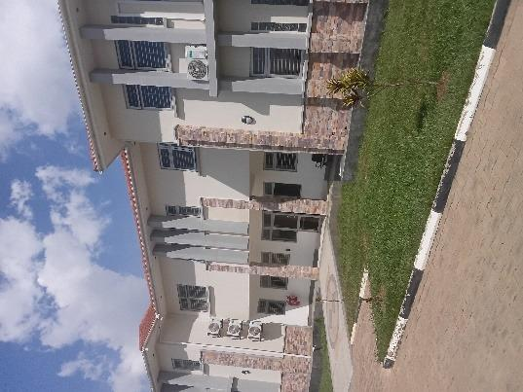 | 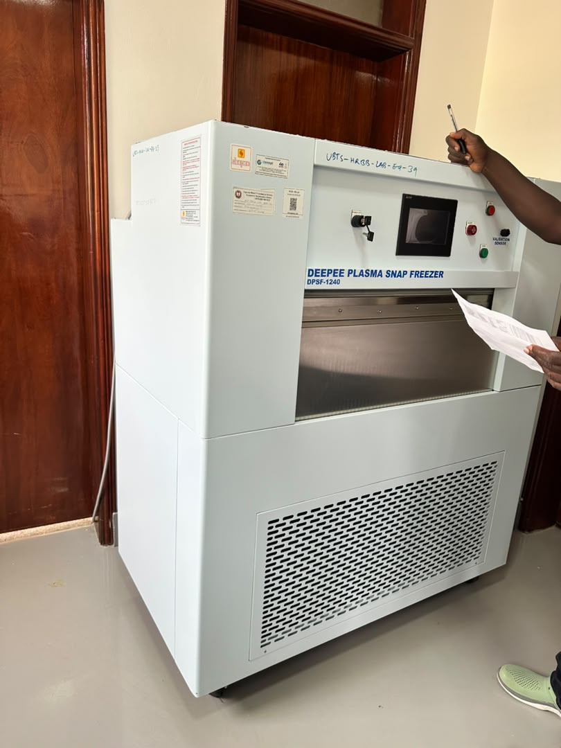
Completed blood bank Blood-bank building at Arua Regional Blood Bank, Arua City | Soroti Plasma snap freezer at Hoima Regional Blood bank Bank, Hoima City.
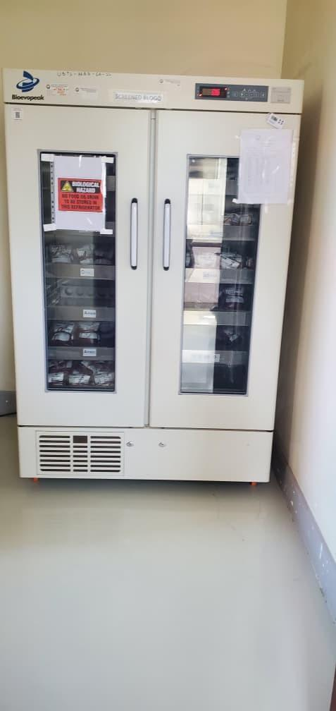 | 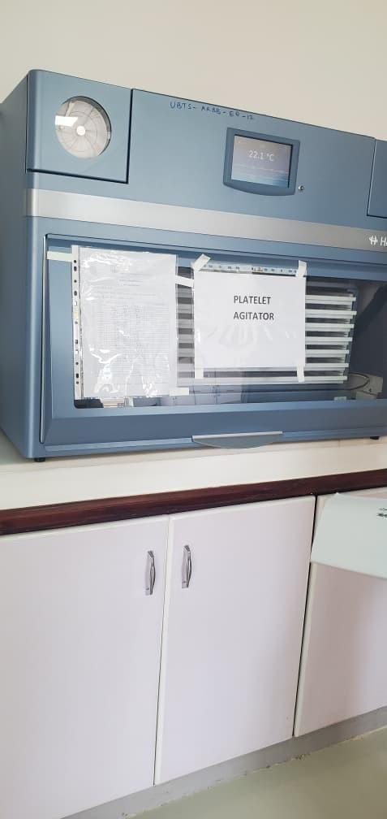
Blood bank refrigerator at Arua Regional Blood Bank, Arua City | Platelet agitator at Arua Regional Blood Bank, Arua City
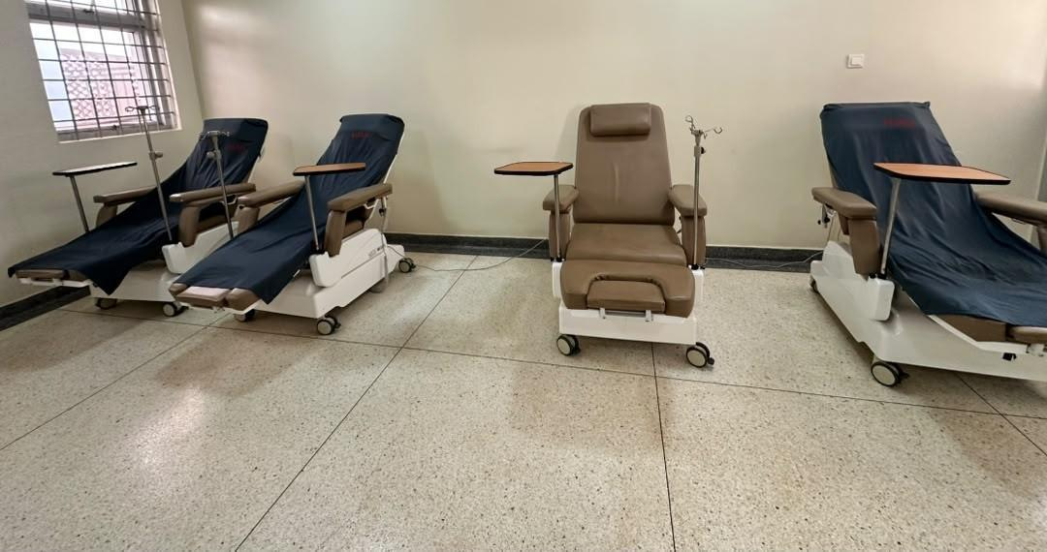 | 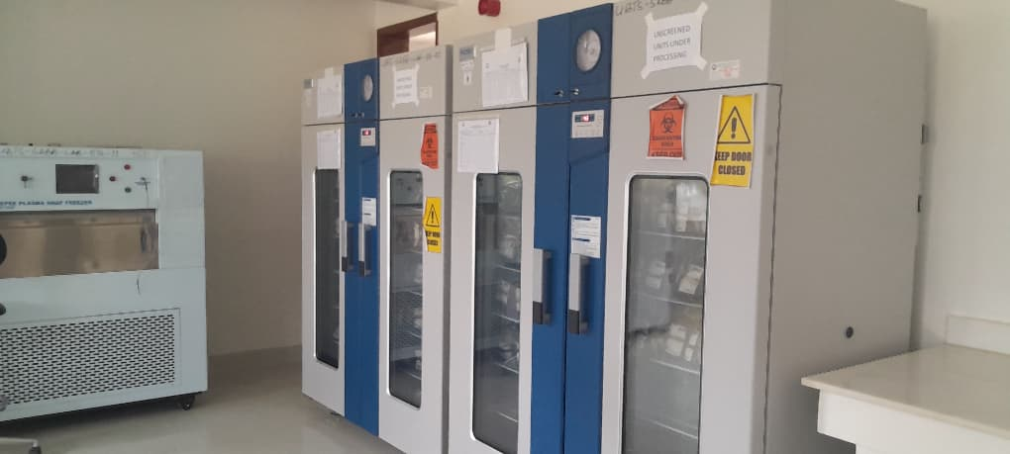
Donor couches in the donor room at Hoima Regional Blood Bank, Hoima City | Blood Blood-bank bank refrigerators refrigerator and plasma snap freezer at Soroti Regional Blood bank Bank.
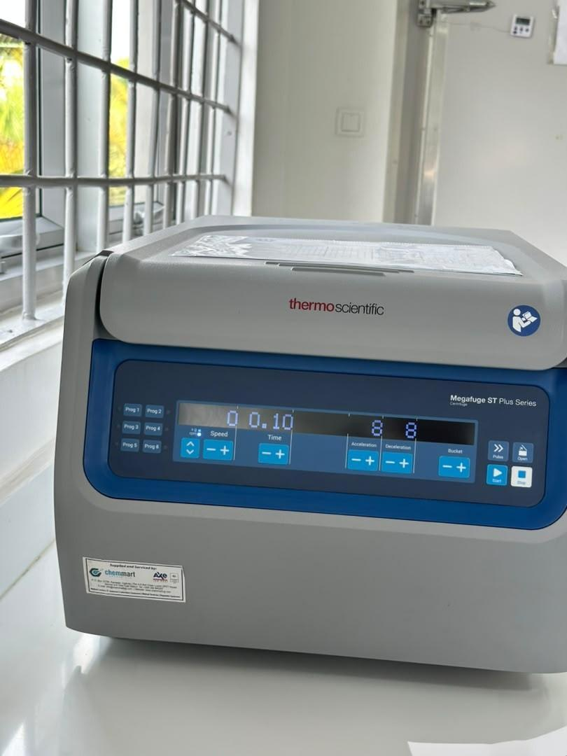 | 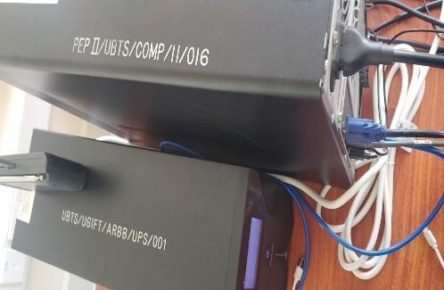
Benchtop centrifuge at Hoima Regional Blood Bank, Hoima City | Markings PEP II/UBTS/COMP/11/016 and UBTS/UGIFT/ARBB/UPS/001 on uninterruptible power supplies at Arua Regional Blood Bank, Arua City

3.5 Local Government level results
The asset programme verification list exercise at the LG level covered all the 176 LGs across the country with contains 629 UgIFT distinct facilities facility that received support from UgIFT programme entries, of which 371 590 have supporting returns and 39 have discrepancies requiring reconciliation. Health centres account for 63,432 assets and schools for 145,256. A further 3,067 assets are Health attributed Centres to hospitals and 258 four to other local-government locations. These asset totals are Seed reported Secondary separately Schools. A from total the number of 208,975 facilities assets were verified, of which 63,599 were for Health Centres and 145,376 were for Seed Secondary Schools across all LGs. Of the 208,975 assets, 195,503 (93.6%) were in good condition and in use while 3,119 (1.5%) were not in use. 3,382 were broken assets. The details are presented in sections 3.3 (Health Centres) and 3.4 (Seed Secondary Schools). covered.

3.6 Health Centres

3.6.1 Availability of the assets
The Health verification centres findings account indicate for that health facilities received 63,599 63,432 assets across the different categories categories, which include; including clinical and laboratory equipment, clinical furniture, maternity ward equipment, ICT equipment, buildings, land and other movable items. assets. The Consumables total are includes excluded. items Table outside 13 fixed-asset classification and Figure assets 47 whose receipt or valuation remains unresolved. The table and figure below present the their assets by category. classification.
Table 13: 24: Availability of assets in Health Centres
Asset category | Records | Share
Medical, laboratory and research appliances | 36,721 | 57.9%
Furniture and fittings | 15,671 | 24.7%
Outside fixed-asset classification | 7,746 | 12.2%
Buildings and structures | 2,260 | 3.6%
Other classified assets | 537 | 0.8%
ICT equipment | 424 | 0.7%
Unclassified | 64 | 0.1%
Transport equipment | 5 | 0.0%
Land | 4 | 0.0%
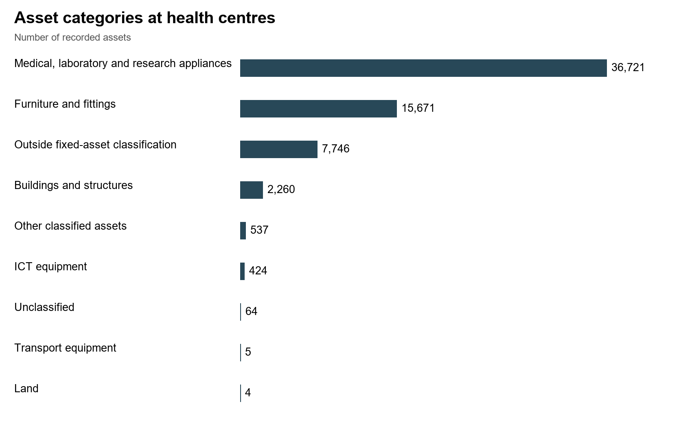
Figure 47: 17: Assets Asset categories at verified: Health health centres

3.6.2 Asset condition and functionality
The findings indicate that of Of the 63,599 63,432 health centre health-centre assets, 60,547 57,759 (95.2%) (91.1%) were are classified as functional and in good use, condition, while 57,918 5,673 (91.1%) (8.9%) were are in classified use as faulty and 2,629 (4.1%) were in store. A further 660 (1.0%) were broken and 2,392 (3.8%) were not in use use. The figure and table below set out these classifications. Separate totals for other usable reasons. ICT equipment had the lowest share items in good store, condition broken at 89.3%. Figure 48 items and Table other 14 reasons present for the non-use condition could of not the be assets. established.
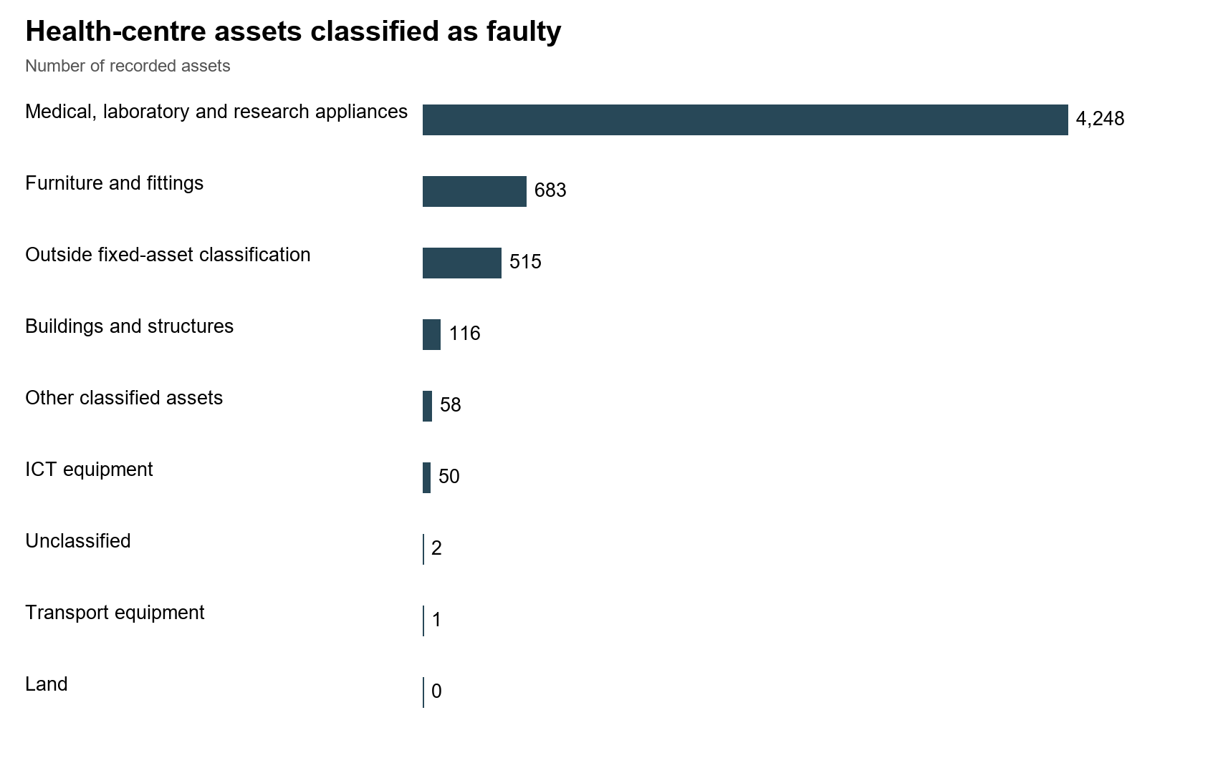
Figure 48: 18: Condition of assets: Health centres
Table 14: 25: Condition of assets: Health centres
Asset category | Records | Functional | Faulty
Medical, laboratory and research appliances | 36,721 | 32,473 | 4,248
Furniture and fittings | 15,671 | 14,988 | 683
Outside fixed-asset classification | 7,746 | 7,231 | 515
Buildings and structures | 2,260 | 2,144 | 116
Other classified assets | 537 | 479 | 58
ICT equipment | 424 | 374 | 50
Unclassified | 64 | 62 | 2
Transport equipment | 5 | 4 | 1
Land | 4 | 4 | 0
Of The the field 2,392 records (3.8%) describe health-centre health centre assets that were not in use for other reasons, included including those that were items not delivered to the facility (still in stores at LGs), idle, items had with missing parts, lacked equipment awaiting power, not rooms/wards required or at installation, the facility, rooms/ wards for installation of the equipment, assets held at another facility, awaiting installation, lost/missing facility and equipment unused because staff were not trained or no specialist was available to operate the it. equipment. Examples include a wall-mounted blood pressure machine at Butawata Health Centre III (Mubende District) recorded as not functional; a wheelchair at Aarapoo Health Centre III (Serere District) that had not been delivered; a patient screen at Ayer Health Centre III (Kole District) that was on the delivery note but not seen; a paediatric bed at Okwerodot Health Centre III (Kole District) supplied without a mattress; and an autoclave machine at Anamwany Health Centre III (Amolatar District) left unused for lack of electricity. electricity and its cable.
In Health terms centres account for 2,260 entries classified as buildings and structures. Some items require reclassification, so this total does not establish the number of buildings, separate they buildings. Four land entries are categorised associated into with two health i.e. centres; residential the (482) land appendix gives their identifiers, locations and non-residential buildings (1,043). Residential buildings are staff houses and other buildings described as residential. Table 15 and Figure 49 depict the building categories. costs.
Table 15: 26: Health Health-centre records classified Centre as Buildings buildings and structures
Recorded building classification | Records
BUILDINGS OTHER THAN DWELLINGS / NON RESIDENTIAL BUILDINGS | 1,402
DWELLINGS / RESIDENTIAL BUILDINGS | 487
STRUCTURES / OTHER STRUCTURES | 364
STRUCTURES / WATER SUPPLY SYSTEMS | 7

3.6.3 Asset marking and Identification
Of the 63,599 63,432 assets health-centre in assets, Health 3,824 Centres; (6.0%) 62,071 have are identifiers movable containing assets UgIFT of or which UGFT, 9,446 5,717 (15.2%) (9.0%) were have engraved another identifier and 52,625 53,891 (84.8%) (85.0%) were not engraved. It was noted that 3,817 (6.1%) carried the UgIFT identifiers and 5,629 (9.1%) carried other modes of marking with have no UgIFT usable identifiers identifier, as depicted in Figure the 49 figure and Table table 16. below. These percentages cover all asset categories. Engraving is assessed separately from the identification of buildings and land.
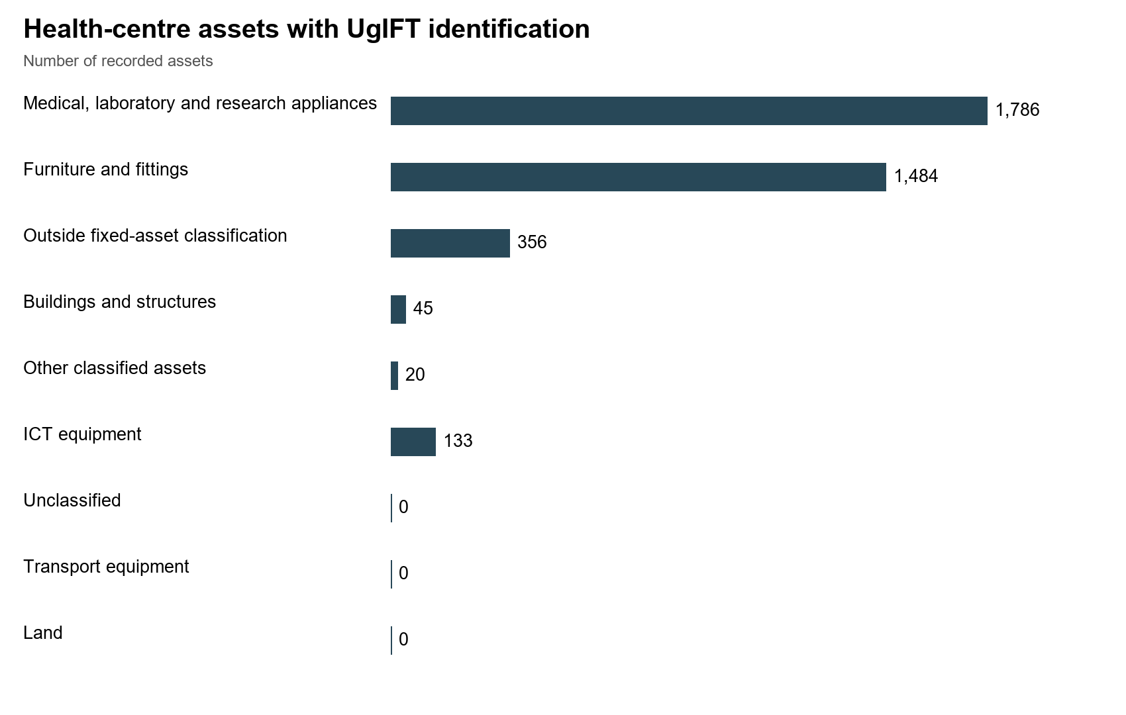
Figure 49: 19: Engraving of movable assets: Health centres Health-centre records with UgIFT tag text
Table 16: 27: Identification of assets at Health centres
Asset category | Records | UgIFT text | Other identifier | No usable tag
Medical, laboratory and research appliances | 36,721 | 1,786 | 2,826 | 32,109
Furniture and fittings | 15,671 | 1,484 | 1,888 | 12,299
Outside fixed-asset classification | 7,746 | 356 | 689 | 6,701
Buildings and structures | 2,260 | 45 | 179 | 2,036
Other classified assets | 537 | 20 | 43 | 474
ICT equipment | 424 | 133 | 32 | 259
Unclassified | 64 | 0 | 54 | 10
Transport equipment | 5 | 0 | 4 | 1
Land | 4 | 0 | 2 | 2
Financial Value of assets: The findings indicate that the recorded value of health-centre assets was UGX 259,662,759,164 260,692,452,291 and the net book value was UGX 218,378,252,366, 189,403,577,197, while accumulated depreciation was UGX 41,291,769,808 as 39,211,094,700 at 30 September 2026. Table Cost 17 is available for 63,183 of 63,432 records; net book value remains unavailable for 7,828. The table below gives the recorded value and net book value. value, with coverage shown because the columns do not cover identical populations.
Table 17: 28: Recorded and net book values at Health centres
Asset category and coverage | Recorded cost | Accumulated depreciation | Net book value | NBV / cost
Medical, laboratory and research appliances  36,721 records; NBV 31,185/36,721 | 39,592.633* | 14,080.055* | 18,715.685* | 57.1%
Furniture and fittings  15,671 records; NBV 13,869/15,671 | 15,109.270* | 5,764.153* | 6,584.582* | 53.3%
Outside fixed-asset classification  7,746 records; NBV 7,746/7,746 | 479.803 | 0.000 | 0.000 | n/a
Buildings and structures  2,260 records; NBV 2,027/2,260 | 203,954.138* | 18,304.241* | 163,802.803* | 89.9%
Other classified assets  537 records; NBV 468/537 | 347.206* | 172.492* | 133.099* | 43.6%
ICT equipment  424 records; NBV 244/424 | 929.345* | 825.749* | 85.256* | 9.4%
Unclassified  64 records; NBV 56/64 | 134.958* | 0.971* | 0.485* | 33.3%
Transport equipment  5 records; NBV 5/5 | 75.100 | 63.433 | 11.667 | 15.5%
Land  4 records; NBV 4/4 | 70.000 | 0.000 | 70.000 | 100.0%
Amounts are in UGX million, rounded to three decimals. * Available amounts only; one or more amounts are missing or pending calculation. NBV coverage is given for each category. NBV/cost compares complete accounting records and does not measure physical condition. n/a means a comparable ratio is unavailable.
Recorded value is the cost in the verification records. Net For CAPITALIZED or CIP records with all required amounts available, net book value is that cost less accumulated depreciation to 30 September 2026, 2026 and is not taken below zero. The cost, depreciation and net book value totals cover different records. Pending calculations and costs treated as expenses or not recognized as assets must therefore be separated before comparing the totals.
The photos below show some of the health facilities that documented are during complete the field visits.
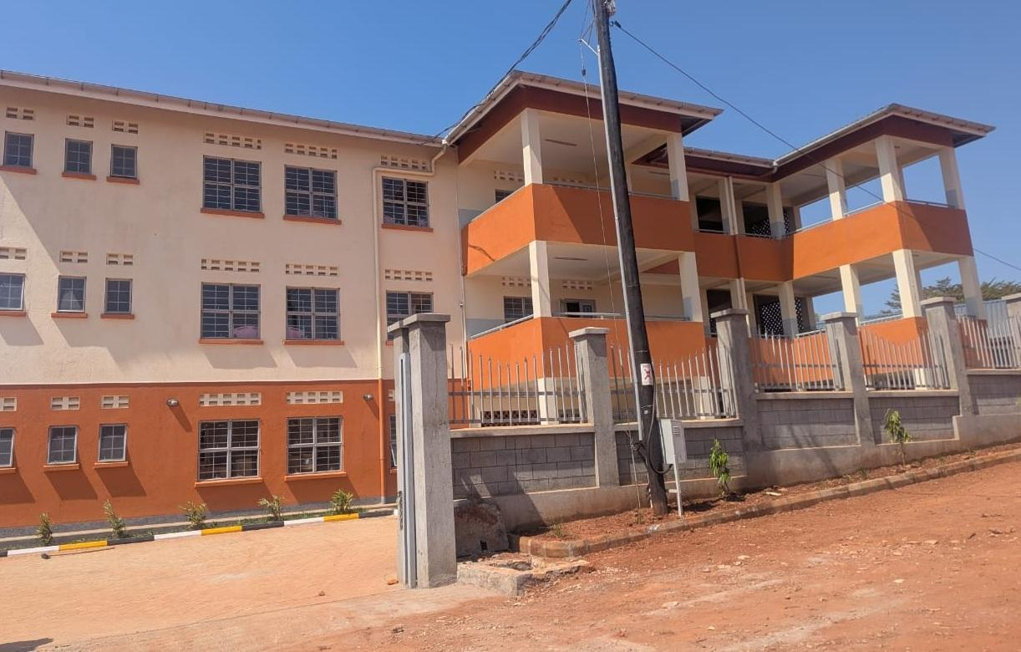  Figure 89: 20: Health centre building at Kibiri HC III, Makindye-Ssabagabo Municipal Council (Buganda) |  |  | 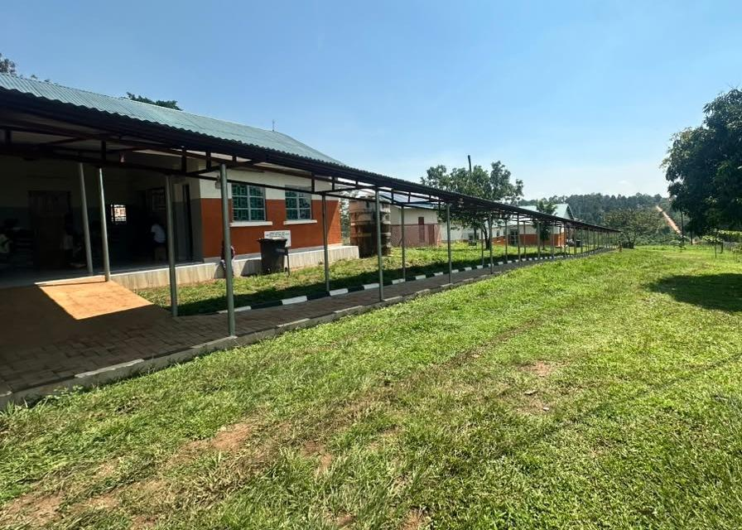  Figure 90: 21: Health centre buildings and covered walkway at Kihuukya HC III, Hoima City (Bunyoro)
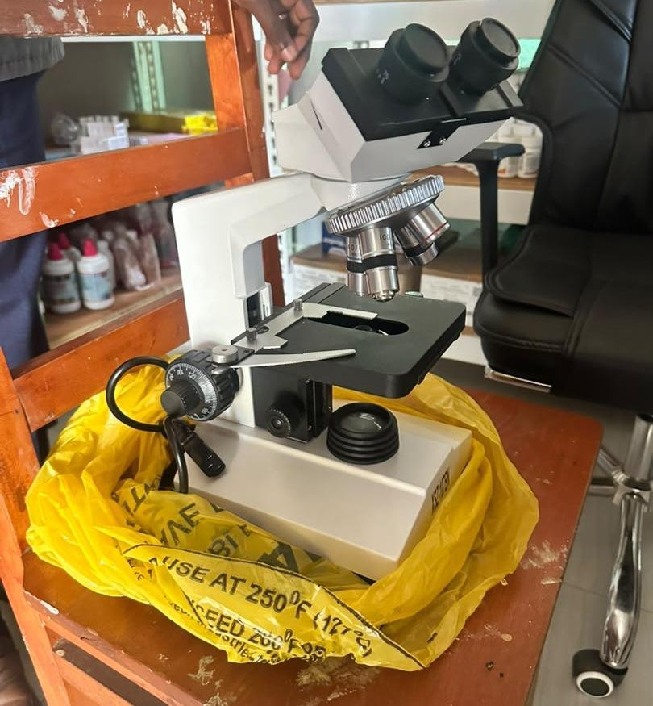  Figure 91: 22: Binocular microscope at Kihuukya HC III, Hoima City (Bunyoro) |  | 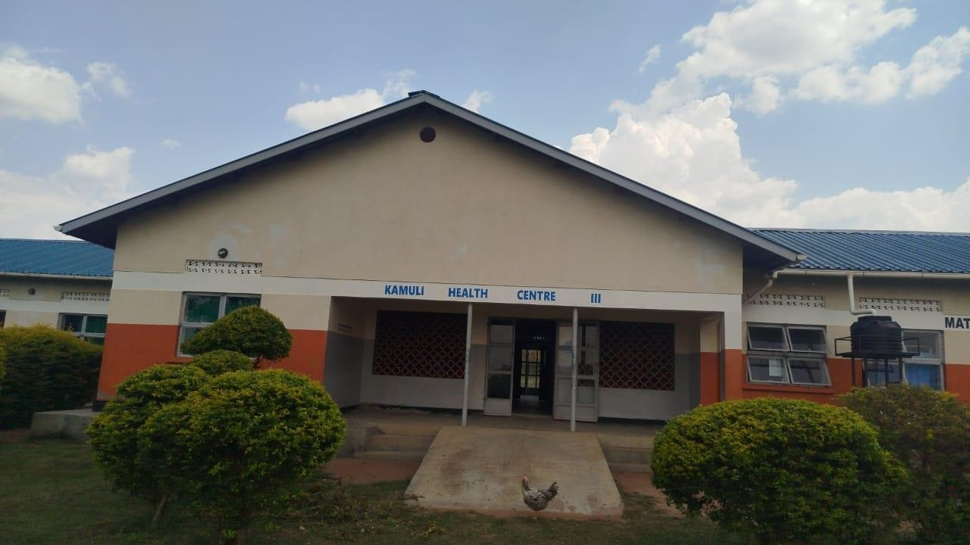  Figure 93: 23: Maternity block entrance and access ramp at Kamuli HC III, Tororo District (Bukedi)
The photos below show some of the facilities that are were Incomplete incomplete at the time of the field visits.
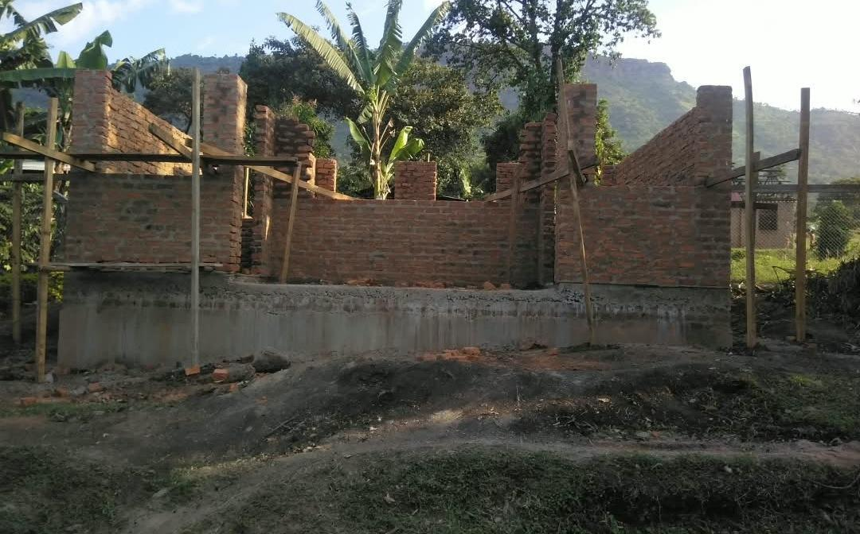
Figure 81: 24: Unfinished laboratory building at Simu Pondo Health a Centre health centre, III, Sironko District (Bugisu)
The following three photographs show different views of Benet Health Centre III in Kween District. At the field visit on 27 August 2026, staff quarters were incomplete, another structure awaited completion and handover, and equipment was still in store.
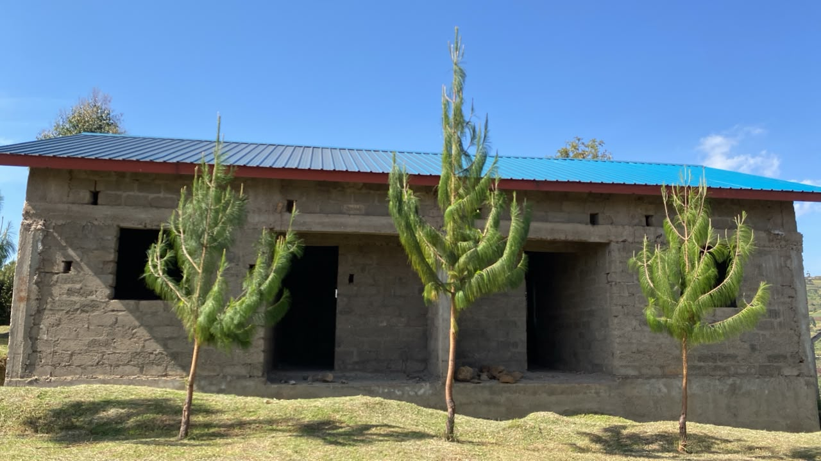 | 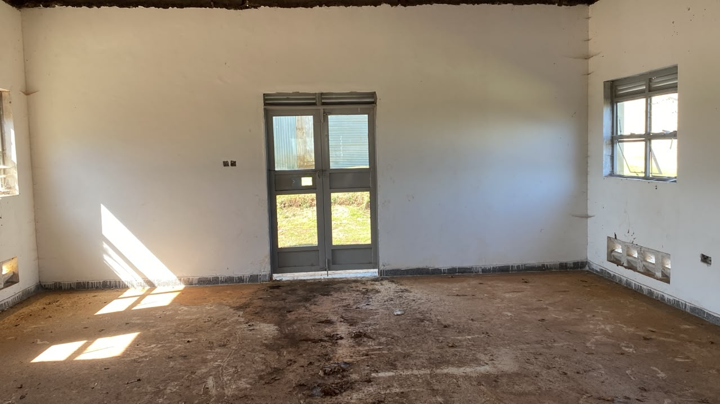
Figure 25: Incomplete staff quarters at Benet Health Centre III, Kween District. Field visit 27 August 2026. | Figure 26: Interior awaiting completion at Benet Health Centre III, Kween District. Field visit 27 August 2026.
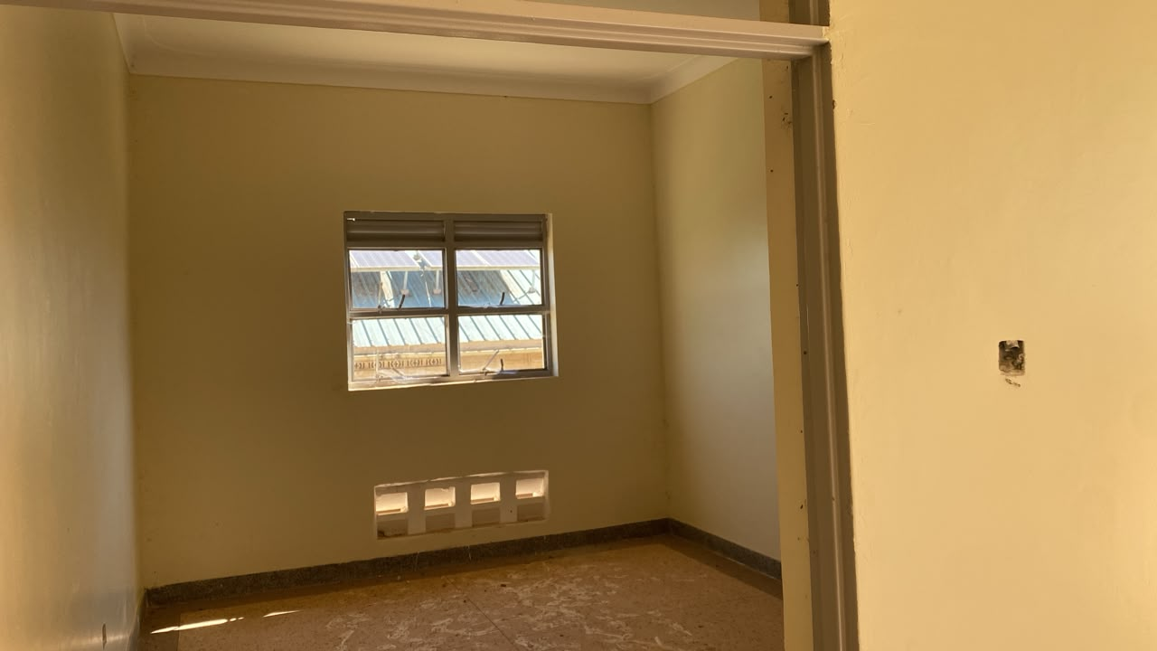
Figure 27: A further unfinished room at Benet Health Centre III, Kween District. Field visit 27 August 2026.

3.7 Seed Secondary Schools

3.7.1 Availability of the assets
The findings showed that the Seed Secondary Schools received account 145,376 for assets 145,256 assets, covering the following categories; School school buildings, Water water facilities, School furniture, Computers computers and related equipment such as monitors, UPS units and keyboards, ICT equipment including; keyboards; printers, photocopiers, cameras and projectors projectors; and other school assets items, such including laboratory equipment. The table below presents their classification. The total includes schools whose status as laboratory UgIFT items, seed-secondary-school electrical beneficiaries items, remains plant to and be machinery and sports equipment. Table 18 presents the details. confirmed.
Table 18: 29: Availability of recorded school assets at Seed Secondary Schools
Asset category | Records | Share
Furniture and fittings | 107,792 | 74.2%
ICT equipment | 12,036 | 8.3%
Outside fixed-asset classification | 9,081 | 6.3%
Buildings and structures | 7,505 | 5.2%
Medical, laboratory and research appliances | 5,604 | 3.9%
Other classified assets | 2,716 | 1.9%
Unclassified | 500 | 0.3%
Land | 14 | 0.0%
Transport equipment | 8 | 0.0%

3.7.2 Asset condition and functionality
Out of 145,376 145,256 assets; school 138,075 assets, (95.0%) 137,465 were (94.6%) are classified as functional and in good use. condition. Of those in good condition, 137,585 were in use and 490 were in store. The verification A further established 7,791 that (5.4%) 2,722 are (1.9%) classified were as broken faulty while 4,579 (3.1%) were and not in use use. The table below indicates their condition. The reasons for other non-use reasons. include Table physical 19 faults, indicates storage the and Asset incomplete condition. installation; these require separate follow-up.
Table 19: 30: Condition of assets: Seed secondary schools recorded school assets
Asset category | Records | Functional | Faulty
Furniture and fittings | 107,792 | 102,521 | 5,271
ICT equipment | 12,036 | 10,404 | 1,632
Outside fixed-asset classification | 9,081 | 8,692 | 389
Buildings and structures | 7,505 | 7,220 | 285
Medical, laboratory and research appliances | 5,604 | 5,498 | 106
Other classified assets | 2,716 | 2,623 | 93
Unclassified | 500 | 485 | 15
Land | 14 | 14 | 0
Transport equipment | 8 | 8 | 0
Good condition is assets in use plus assets in store. Broken assets are counted on their own, including broken assets found in store. Other assets are Items not in use for require another individual reason. The four condition columns sum assessment to assets establish verified whether installation, repair, replacement or disposal is appropriate. A faulty classification alone does not establish that an item is beyond repair.
School furniture (desks, and fittings, including desks, tables, chairs, shelves and stools) stools, is form the largest category with 109,646 107,792 assets. Of these, 104,233 102,521 were are in classified good as conditions functional and in use use, while 2,455 5,271 were are broken. classified Computers as and faulty. related A equipment total had of 8,777 10,404 ICT items are reported as in use. Faulty items require assessment before any disposal decision.

3.7.3 Asset marking and Identification
Of the 138,671 145,256 movable school assets, 35,121 13,478 (25.3%) (9.3%) were have engraved identifiers where as 103,550 (74.7%) were not engraved. 14,861 (10.7%) carried the containing UgIFT markings or UGFT and 20,260 22,123 (14.6%) (15.2%) carried have other another markings identifier, while 109,655 (75.5%) have no usable identifier, as shown in Table the 20. table below. These percentages describe identification coverage; physical engraving still requires confirmation.
Table 20: 31: Identification Recorded tag of content for school assets at Seed Secondary Schools
Asset category | Records | UgIFT text | Other identifier | No usable tag
Furniture and fittings | 107,792 | 12,985 | 18,503 | 76,304
ICT equipment | 12,036 | 315 | 2,426 | 9,295
Outside fixed-asset classification | 9,081 | 0 | 452 | 8,629
Buildings and structures | 7,505 | 40 | 391 | 7,074
Medical, laboratory and research appliances | 5,604 | 121 | 242 | 5,241
Other classified assets | 2,716 | 17 | 96 | 2,603
Unclassified | 500 | 0 | 10 | 490
Land | 14 | 0 | 2 | 12
Transport equipment | 8 | 0 | 1 | 7
Movable assets exclude buildings, structures and land. Properly The engraved table means the distinguishes UgIFT marking. or A UGFT dash identifiers, means other the identifiers assets and items with no usable identifier. Buildings, structures and land are identified through property and site records rather than engraving. documentation.

3.8 3.7.4 Financial Value value of school assets
The recorded value was UGX 678,247,549,426, 700,242,561,371, the net book value was UGX 576,704,905,370 394,241,708,595 and accumulated depreciation was UGX 101,549,907,057 as 104,574,530,246 at 30 September 2026 2026, as shown in Table the 21. table below. Cost is available for 144,445 of the 145,256 school records; net book value remains unavailable for 14,807. The figures sum available amounts and should not be reconciled across unmatched populations.
Table 21: 32: Recorded value and net book value: Seed secondary schools financial values for school assets
Asset category and coverage | Recorded cost | Accumulated depreciation | Net book value | NBV / cost
Furniture and fittings  107,792 records; NBV 97,305/107,792 | 22,612.957* | 11,733.742* | 7,406.367* | 38.7%
ICT equipment  12,036 records; NBV 10,345/12,036 | 29,669.809* | 15,836.227* | 9,584.916* | 37.7%
Outside fixed-asset classification  9,081 records; NBV 9,081/9,081 | 40,839.592 | 0.000 | 0.000 | n/a
Buildings and structures  7,505 records; NBV 5,977/7,505 | 601,004.483* | 74,561.320* | 374,906.543* | 83.4%
Medical, laboratory and research appliances  5,604 records; NBV 5,259/5,604 | 1,455.366* | 864.426* | 511.352* | 37.2%
Other classified assets  2,716 records; NBV 2,448/2,716 | 2,488.189* | 1,037.888* | 1,224.696* | 54.1%
Unclassified  500 records; NBV 16/500 | 610.010* | 33.415* | 141.245* | 80.9%
Land  14 records; NBV 13/14 | 110.029* | 0.000* | 110.029* | 100.0%
Transport equipment  8 records; NBV 5/8 | 1,452.127 | 507.511* | 356.561* | 41.3%
Amounts are in UGX million, rounded to three decimals. * Available amounts only; one or more amounts are missing or pending calculation. NBV coverage is given for each category. NBV/cost compares complete accounting records and does not measure physical condition. n/a means a comparable ratio is unavailable.
Recorded value is the cost in the verification records. Net For CAPITALIZED or CIP records with all required amounts available, net book value is that cost less accumulated depreciation to 30 September 2026. The financial reconciliation appendix explains which records can be compared and which amounts remain unavailable.

3.9 Completion Status of Facilities
The verification programme established that there were a number of facilities that were either completed or not completed. Table 27 list provides the details. construction baseline. Outstanding works and handover have been identified at specific facilities. Baseline completion labels and the current findings describe different matters and should be read separately.
Table 27: 33: Programme-list facilities verified, completed Programme list construction baseline and documented outstanding providing services works
Measure | Health centres | Schools | Total
Programme-list entries | 371 | 258 | 629
Complete on the programme list | 352 | 195 | 547
Ongoing on the programme list | 19 | 63 | 82
Documented incomplete works | 13 | 57 | 70
Documented handover or commissioning outstanding only | 2 | 11 | 13
Counts Programme-list completion labels and outstanding-work findings may concern the same facilities and must not be added together. The outstanding-work counts are facilities. documented Verified and accounted for through reconciliation are percentages of the programme list; the other percentages are of verified facilities. minimums.
Table The 27 programme indicates list recorded 547 facilities as complete and 82 as ongoing before verification. The current evidence identifies at least 70 programme-list entries with incomplete works and another 13 with handover or commissioning outstanding. Some facilities were already serving patients or learners while these matters remained open. A building recorded as functional does not, by itself, establish that works every were contracted completed structure at was 475 complete of or formally handed over. The appendix lists the verified documented facilities cases (80.5%) and while their works were not complete at 115 (19.5%). Eighty-eight schools (36.2%) were still under construction or not yet handed over by the contractor compared to 27 (7.8%) in case of health facilities. evidence.
The photos below show some of the school facilities that documented are during complete the field visits.
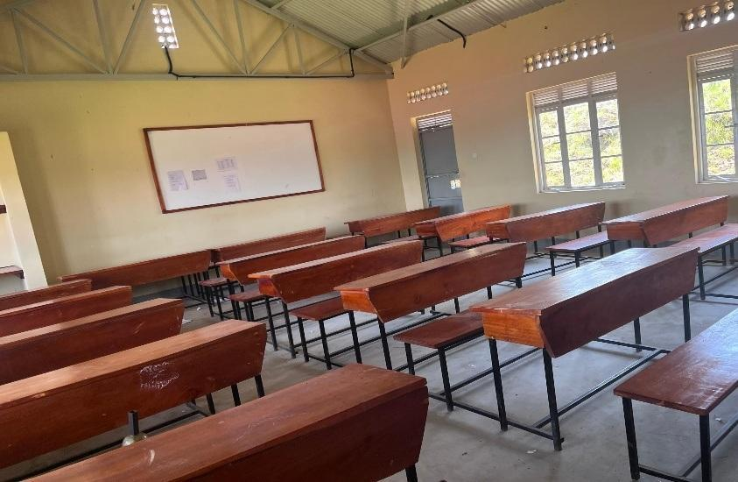  Figure 94: 28: Classroom furnished with desks and a whiteboard at Gyagenda Memorial Seed Secondary School, Kalangala District (Buganda) | 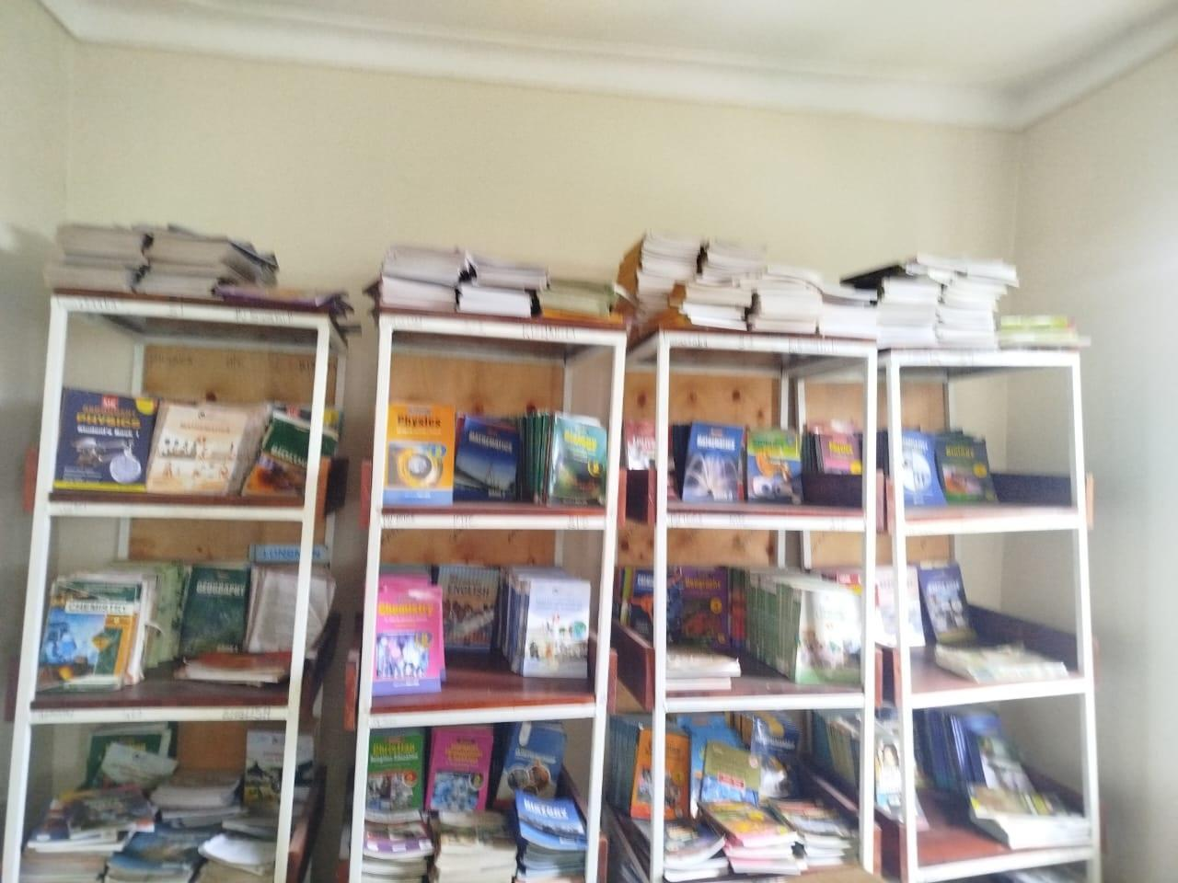  Figure 95: 29: Books displayed on library shelves at Sibanga Seed School, Manafwa District (Bugisu) | 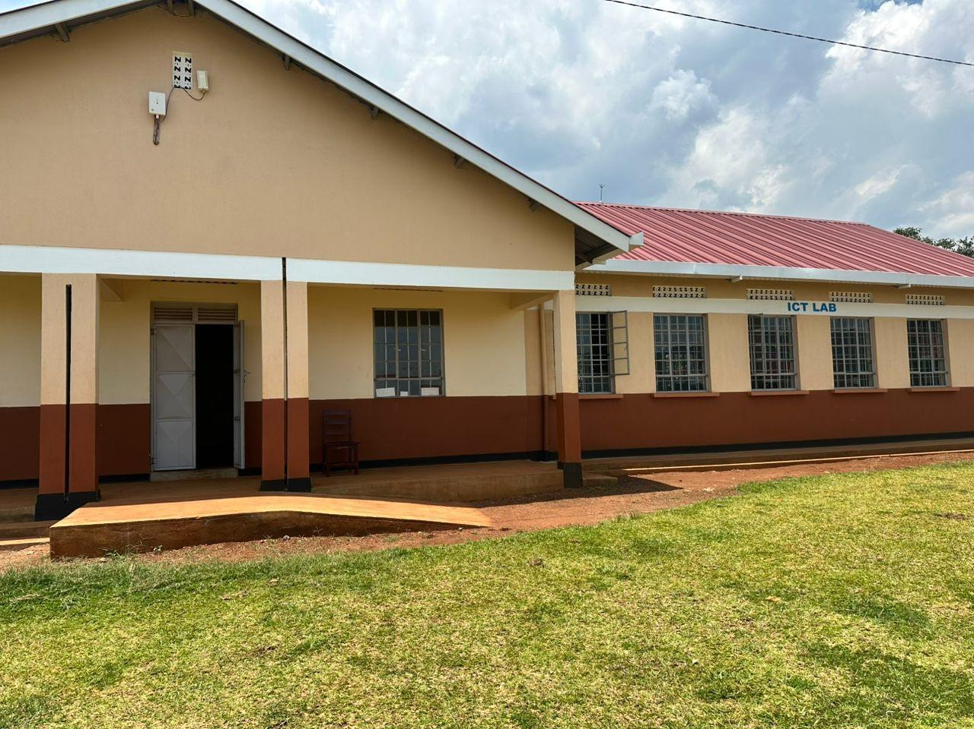  Figure 96: 30: ICT laboratory block and entrance ramp at Sisiyi Seed Secondary School, Bulambuli District (Bugisu)
The photos below show some of the facilities that are still under construction
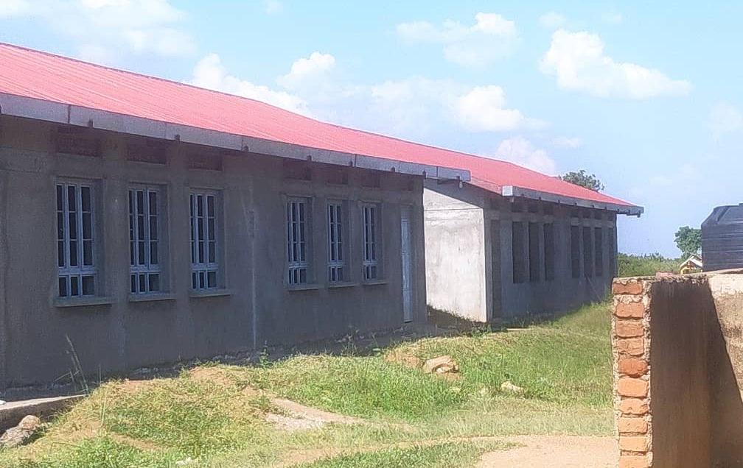  Figure 74: 31: Unfinished school block at Got Apwoyo Seed Secondary School, Nwoya District (Acholi) |  |  |  |  |  | 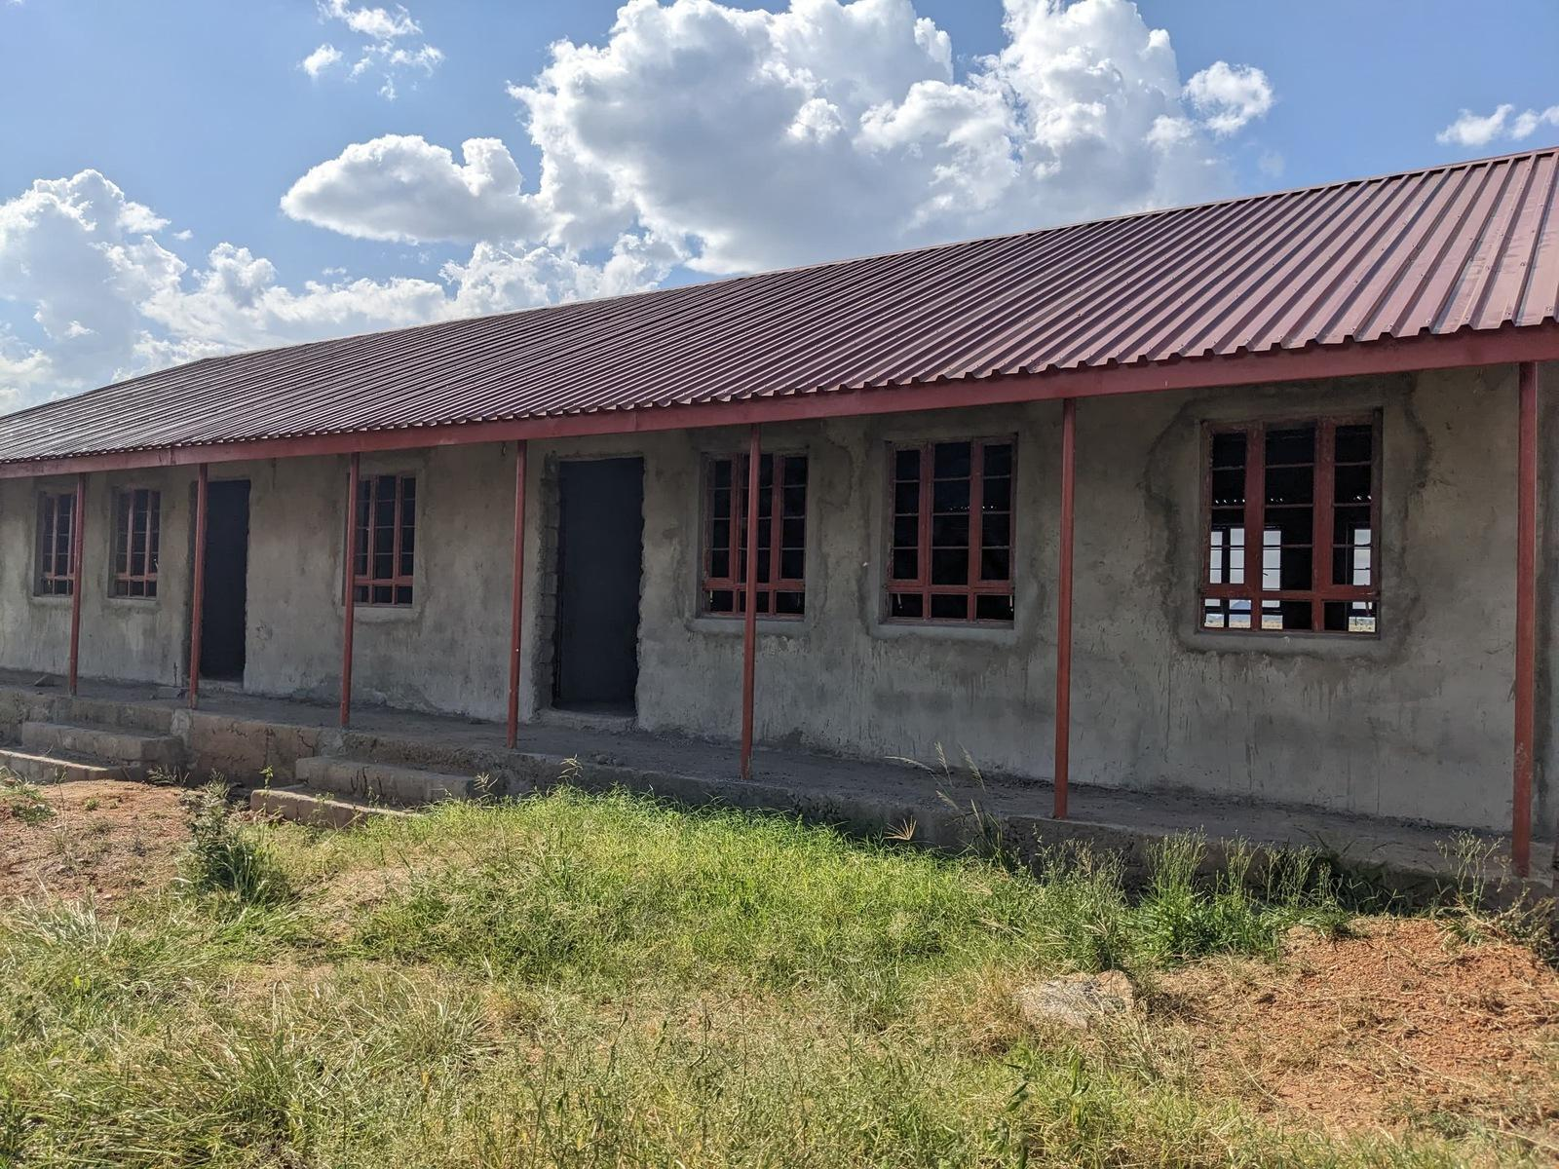  Figure 75: 32: Unfinished classroom block at Sidok Seed Secondary School, Kaabong District (Karamoja)
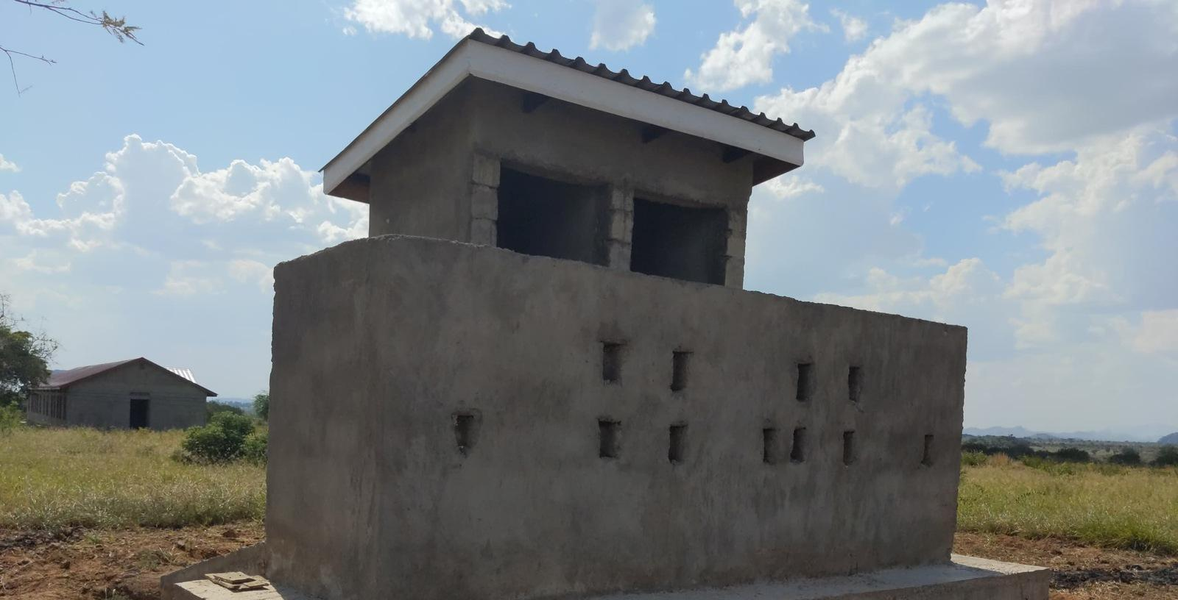  Figure 76: 33: Latrine block under construction at Sidok Seed Secondary School, Kaabong District (Karamoja) |  |  |  |  | 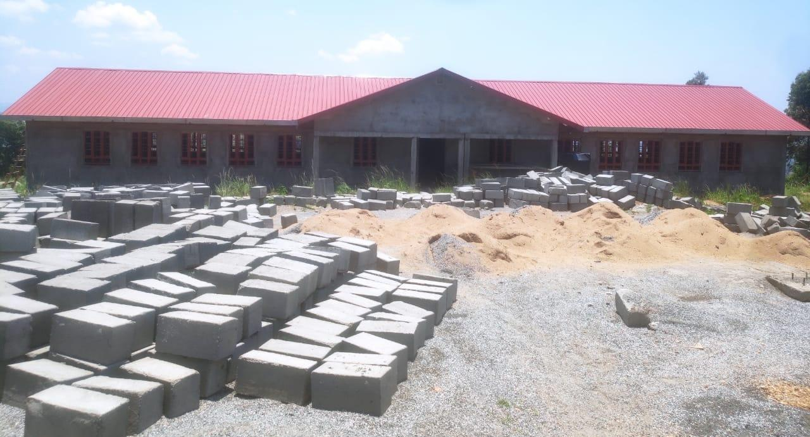  Figure 77: 34: Building works and construction materials at Ndhew Seed Secondary School, Nebbi District (West Nile)
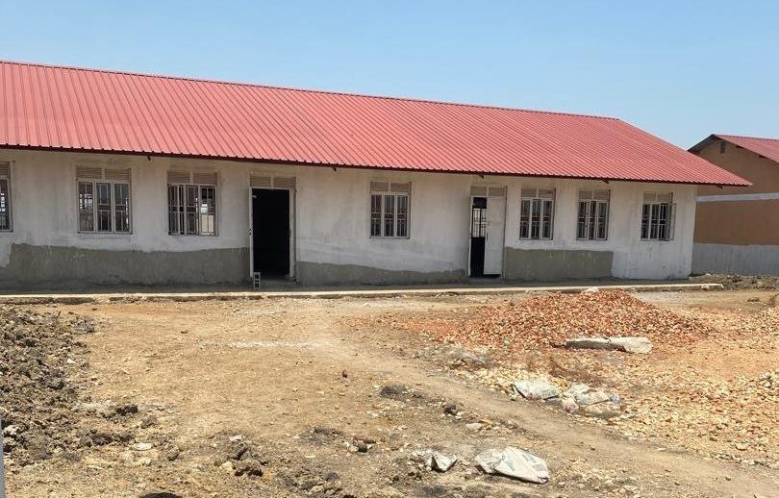  Figure 78: 35: School block awaiting completion at Butungama Seed Secondary School, Ntoroko District (Tooro) | 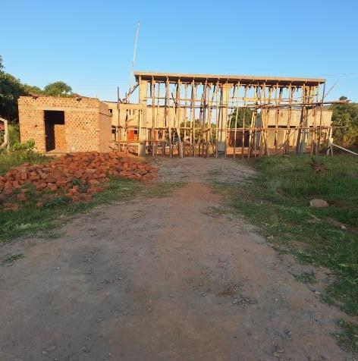  Figure 79: 36: Building works at a seed secondary school, Kiboga District (Buganda) |  |  |  |  |  | 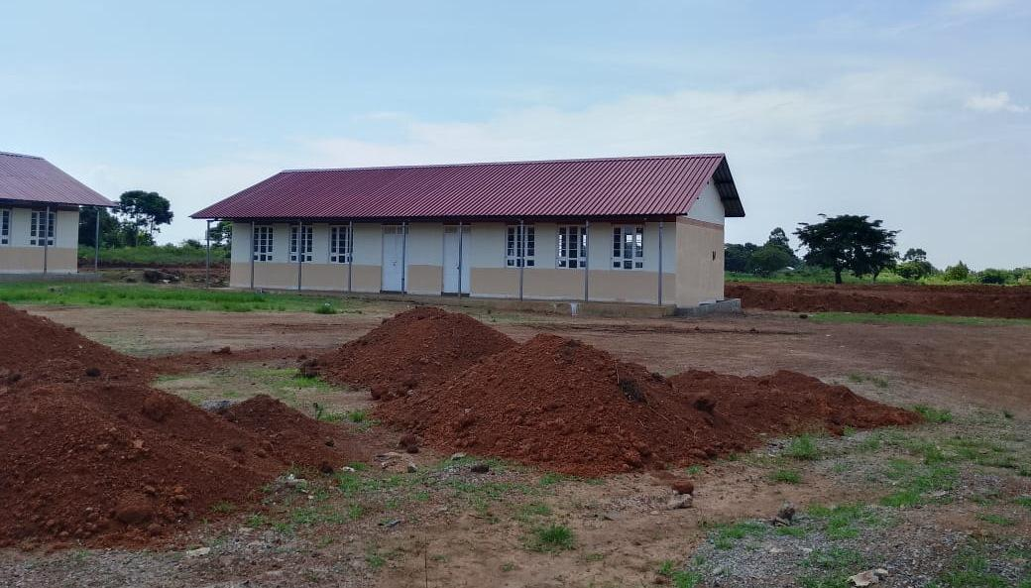  Figure 80: 37: Classroom block with earthworks in the foreground at Kihungya Seed Secondary School, Buliisa District (Bunyoro)
 |  | 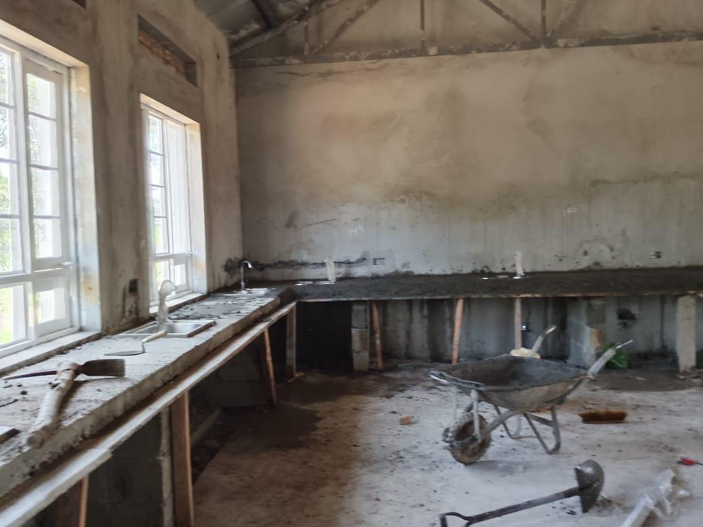  Figure 82: 38: Biology laboratory under construction at a seed secondary school, Buliisa District (Bunyoro) |  |  |  |  |  | 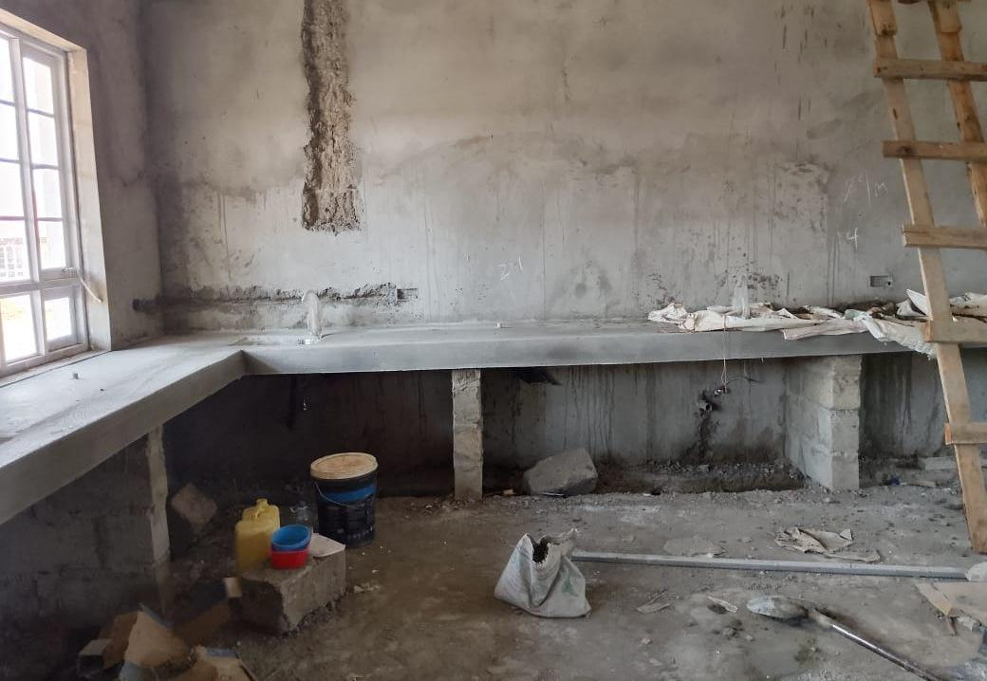  Figure 83: 39: Unfinished laboratory interior at Kihungya Seed Secondary School, Buliisa District (Bunyoro)
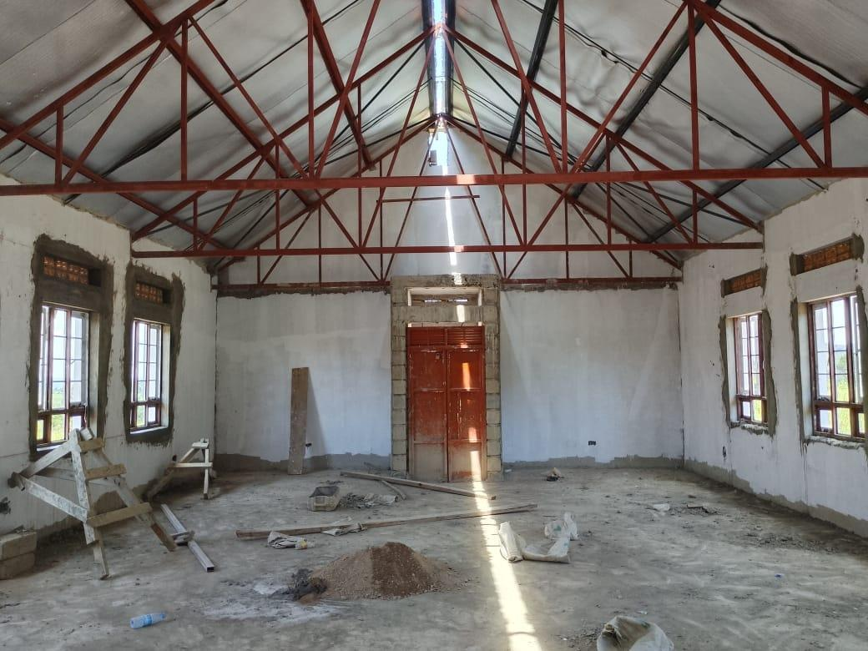  Figure 84: 40: Library interior under construction at Kihungya Seed Secondary School, Buliisa District (Bunyoro) |  |  | 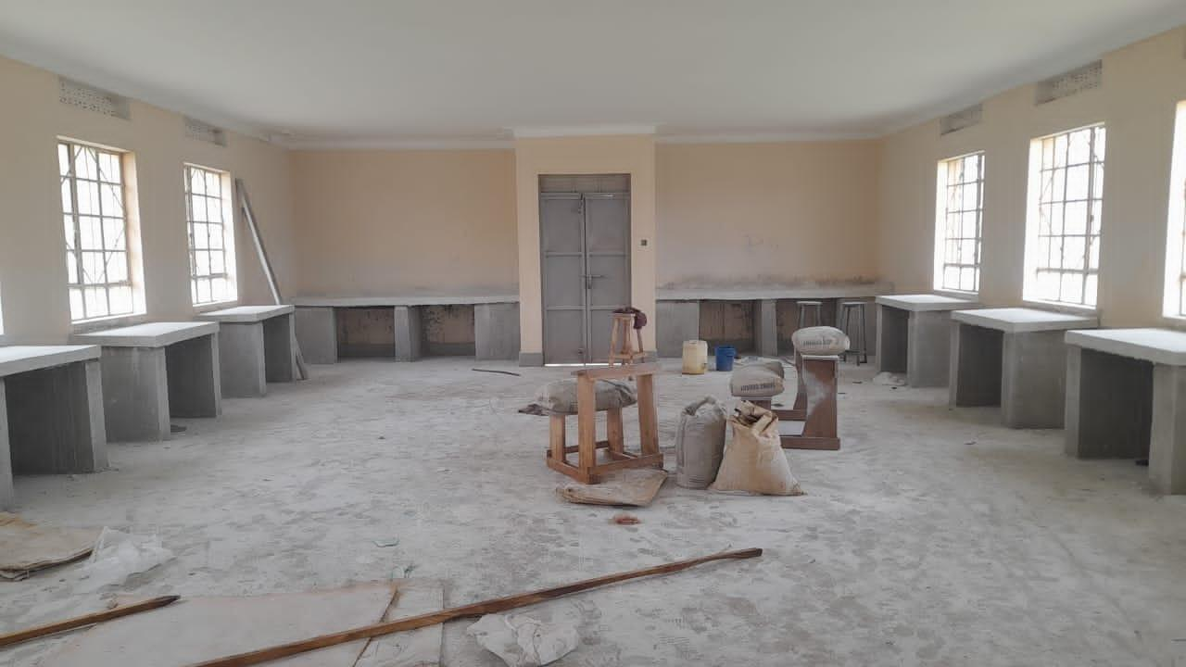  Figure 85: 41: ICT laboratory interior under construction at Kitawoi Seed Secondary School, Kween District (Sebei)
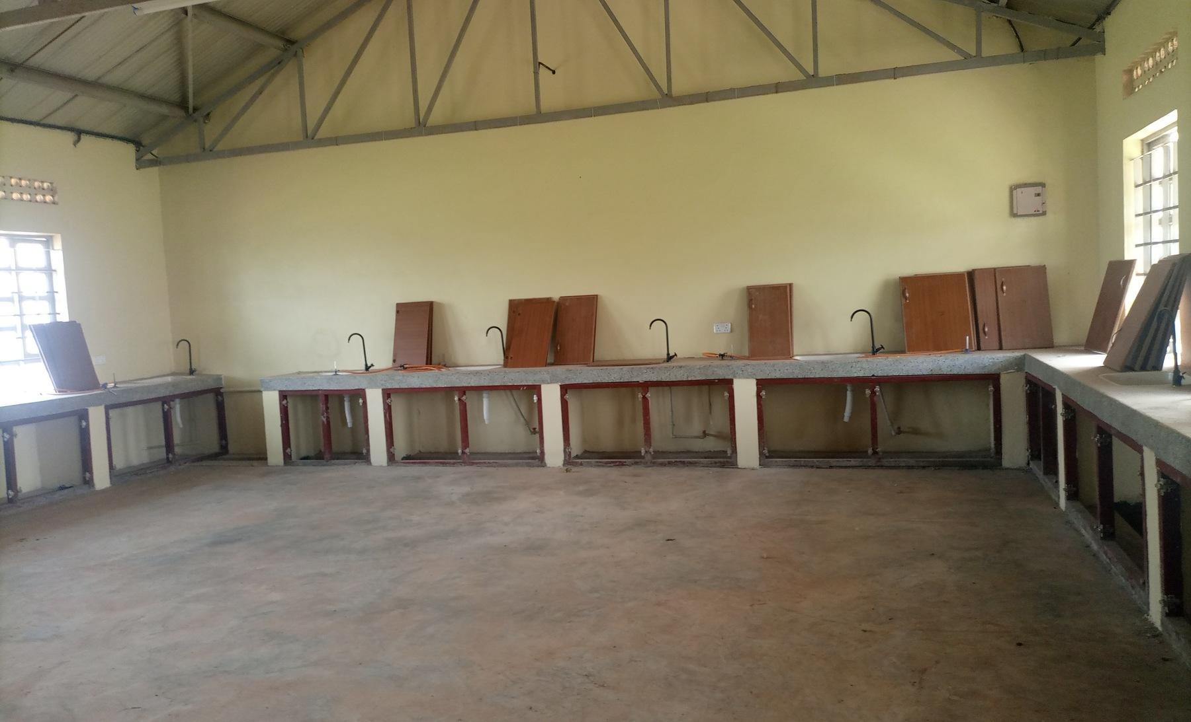  Figure 86: 42: Laboratory benches with cupboard doors not yet fitted, in a science laboratory block recorded as under construction, at King Solomon Seed Secondary School, Kagadi District (Bunyoro) |  |  |  | 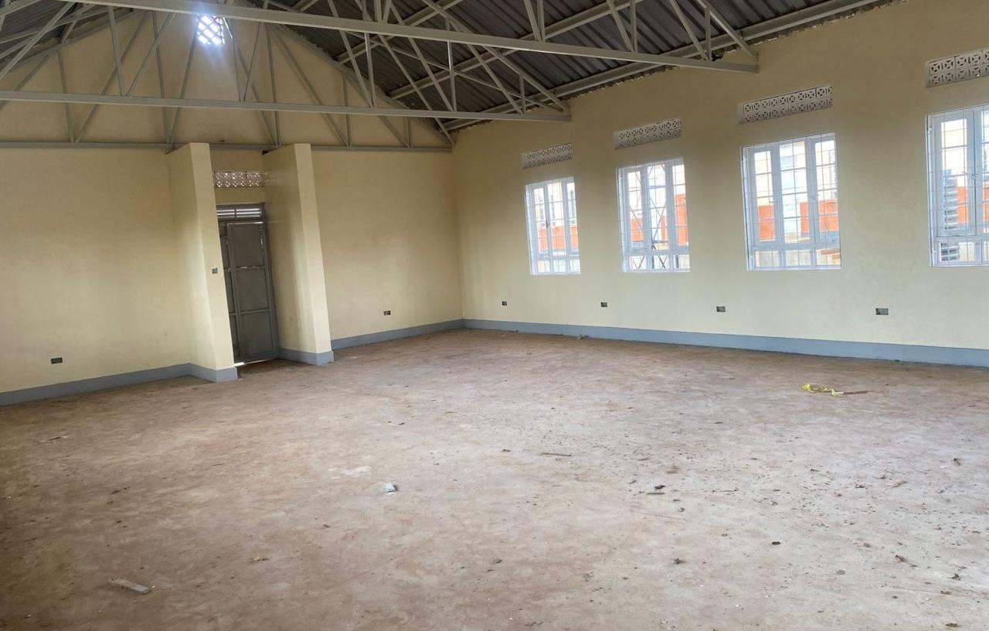  Figure 87: 43: Empty computer laboratory at Kaptum Seed Secondary School, Kween District (Sebei), where the buildings had not been handed over and no ICT equipment had been received

3.10 Field Observations,

3.11 Location and Name changes
The verification exercise established that there were mismatches between information from the programme list reconciliation and what was found on the ground. It was found that out of contains 629 facilities distinct verified, entries. Supporting facility-specific or consolidated material accounts for 590 (93.8%) entries matched properly with the programme list as obtained from the MoFPED. A total of (93.8%); 39 facilities (6.2%) had remain inconsistencies in with exception the categories. programme list which included; i) those operating under different names; ii) facilities found on the programme list but did not benefit from the programme; and iii) Renamed facilities that were are found already on matched ground are not added to have those benefited 39. from The table and appendix list the programme 39 but exceptions were by not outcome included on the and programme list. These inconsistencies were accounted for through reconciliation. Table 29 provides the details. identifier.
Table 29: 34: Inconsistencies between the programme list and the facilities found Programme-list entries requiring separate reconciliation
Outcome | Health centres | Schools | Total
Reported absent or not constructed | 7 | 3 | 10
Outside UgIFT beneficiary scope | 2 | 1 | 3
Exists but no UgIFT assets reported | 2 | 3 | 5
UgIFT assets relocated | 2 | 1 | 3
Represented by another programme entry | 2 | 0 | 2
Follow-up without a separate on-site asset return | 9 | 7 | 16
Total exceptions | 24 | 15 | 39
Counts These 39 administrative exceptions are distinct programme-list facilities. entries: HC means 24 health centre; centres SSS and means 15 Seed schools. Secondary They School. are not a count of all name differences. Renamed facilities with usable returns can remain within the evidence-supported group. The full exception roster is appended; unresolved identity questions, including Kagganda and Mbirizi, require separate review.

3.12 3.7 UgIFT support to service delivery
Of the 284 health health-centre centres, responses 237 included (83.5%) in the analysis, 238 (83.8%) reported at least one benefit from the UgIFT support. Improved maternity and delivery services were reported by 117 (41.2%), and 51 (18.0%) reported more or safer births at the facility. Improved antenatal, immunisation, laboratory or other specific services were reported by 89 (31.3%), improved access to care or shorter distances by 70 71 (24.6%) (25.0%) and more patients attending by 60 61 (21.1%). (21.5%). More than half, 163 164 (57.4%), (57.7%), linked better services to the equipment and furniture supplied.
Of the 193 seed school schools, responses included in the analysis, 144 (74.6%) reported at least one benefit. A better learning environment, with classrooms, furniture and libraries, was reported by 74 (38.3%), and improved access to secondary education or shorter distances by 59 (30.6%). Practical science or ICT teaching improved at 39 schools (20.2%), and 37 (19.2%) reported higher enrolment. Forty schools (20.7%) also reported jobs and local economic benefits around the school. Figure The 88 figure below compares the selected benefits most often reported by the two types of facility.
Percentages use 284 health-centre and 193 school responses. A facility could report several benefits. These are respondents' accounts of service changes; the exercise did not measure a causal effect. The school response attributed to Kagganda Health Centre was excluded because its identity was not confirmed.
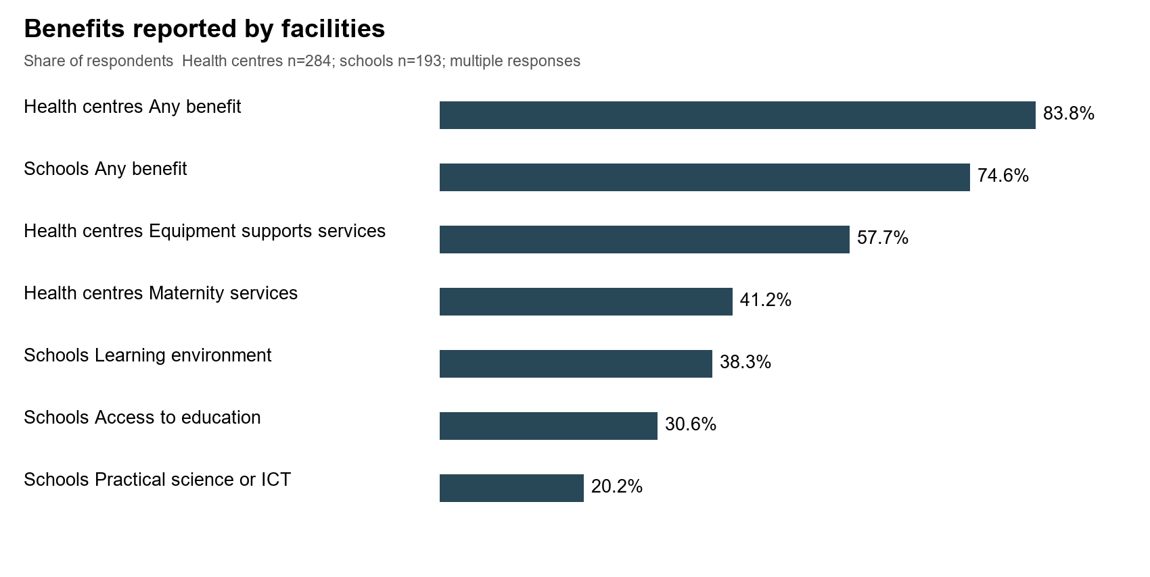
Figure 88: Programme 44: Benefits reported by responding facilities

3.12.1 3.7.2 Gaps and Challenges
The main gaps identified by the facilities include; include the following. Counts are based on 477 facility responses; a gap was counted when the respondent described a challenge or requested a remedy. Percentages use all respondents unless a facility type is specified; categories overlap.
- Insufficient Power power supply which was reported by 200 201 facilities (42.1%), including 44.4% of which 44.0% were health centres centre respondents and 38.9% were of schools; school respondents.
- Inadequate Staffing staffing which was reported by 32.3% 32.1% of the facilities, facilities (153 of 477).
- Inadequate space or infrastructure reported by 31.7% of the facilities (151 of 477).
- Insecurity or absence of fencing reported by 27.3% 27.0% of the facilities, facilities (129 of 477).
- Limited maintenance support was raised by 22.2% of the facilities, facilities (106 of 477).
- Inadequate staff houses reported by 22.0% of the facilities (105 of 477).
- Poor water supply reported by 20.1% of the facilities. facilities (96 of 477).
- inadequate Inadequate training of staff to operate the equipment reported by 28.9% of the health centres, centres (82 of 284) and 1.6% of schools (3 of 193).
- Incomplete or delayed works works, handover or commissioning reported by 28.0% of seed schools schools. (54 of 193) and 10.2% of health centres (29 of 284).
- Equipment not installed, not assembled or delivered incomplete was raised by 17.6% 84 of facilities the facilities. (17.6%).
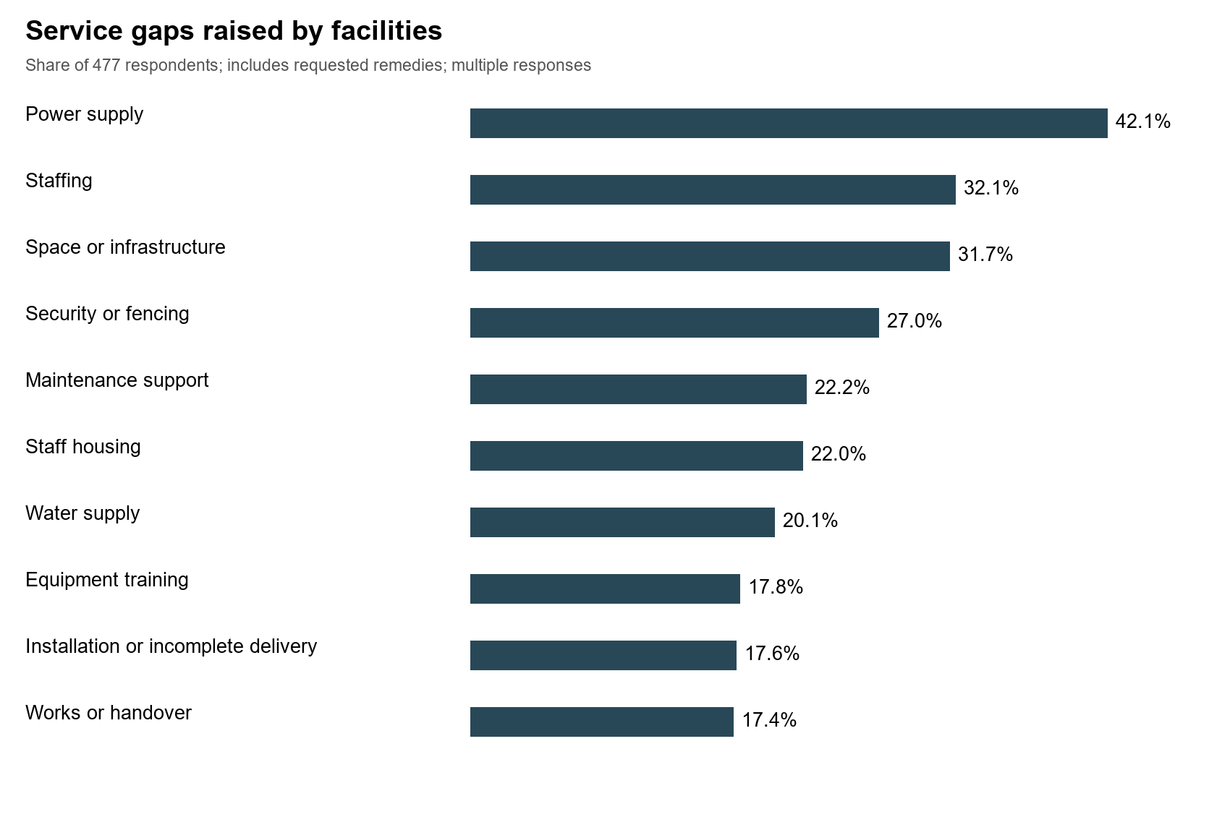
Figure 97: 45: Service gaps raised by and responding challenges facilities

4 Asset management

4.1 Maintenance and repairs
Maintenance keeps UgIFT assets working for the services they were bought to support. Most of the verified assets are furniture, clinical equipment and computers in daily use at health centres and seed schools, where wear and breakage are to be expected. Routine checks, a record of faults and a dependable route for repair decide whether a broken item returns to use quickly or stays out of service. During the verification, each facility was asked how it maintains, repairs, services or replaces UgIFT assets and whether it keeps a regular record of their functionality or breakdown.
Repair arrangements. Of the 469 facilities that described their maintenance arrangements, 260 (55.4%) met repairs at facility level, from their own funds or with their own staff. Health centres named Primary Health Care funds (94 of 278, 33.8%), while schools named the capitation or Universal Secondary Education grant, parents' contributions or the school budget (52 of 191, 27.2%). Busaale Health Centre III in Kayunga used Primary Health Care funds for repairs, and Kagumba Seed Secondary School in Kamuli had repaired broken furniture during the second term. A facility could describe more than one arrangement.
Support from outside the facility was cited by 151 152 facilities (32.2%): (32.4%): district offices, mainly the District Health Officer, 84 85 (17.9%); (18.1%); regional referral hospital workshops or national teams 52 (11.1%); hired technicians and artisans 27 (5.8%); and contractors or suppliers under defects liability, guarantee or warranty 12 (2.6%). Major medical equipment repairs depended on this support. Todora Health Centre III in Nwoya worked through the District Health Officer and the Gulu Regional Referral Hospital technical team, Avogera Health Centre III in Buliisa received support from Hoima Regional Referral Hospital, and Bundimulangya Health Centre III in Bundibugyo obtained a team through the District Health Officer.
In all, 97 facilities (20.7%), 59 of them schools, had not yet needed maintenance because the assets were new, not yet handed over or the buildings were still under construction, and 36 (7.7%) reported no repair arrangement, with broken items set aside or not repaired. Funds for maintenance and repair were reported as insufficient, particularly for major repairs, by 32 of the 505 facilities that described maintenance or challenges (6.3%). At Kyankaramata Health Centre III in Kyenjojo, Primary Health Care funds met minor repairs, but the cost of major repairs was a constraint.
Figure The 98 figure below compares these reported arrangements maintenance at health centres and seed schools. arrangements. Health centres relied more on outside technical support (41.0% (41.4% of health health-centre centres respondents against 19.4% of schools), school respondents), while schools more often had not yet needed maintenance (30.9% against 13.7%).
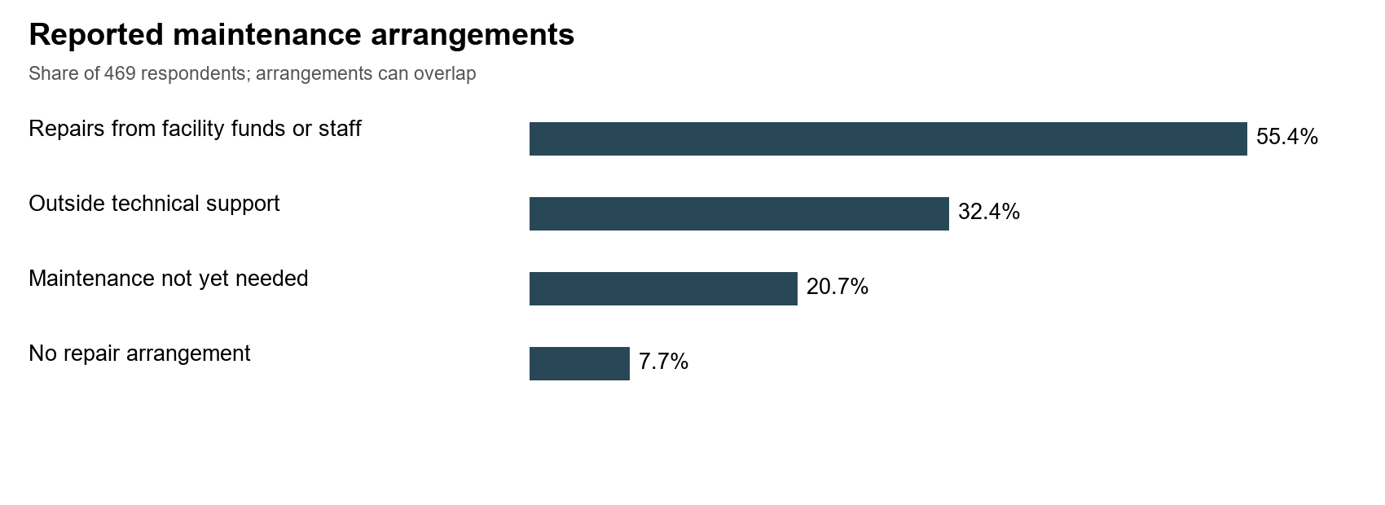
Figure 98: 46: Most Maintenance arrangements reported by facilities met repairs from their own funds or staff
Frequency. Few facilities worked to a fixed maintenance interval. Of the 494 programme-list facilities that described how they maintain UgIFT assets or check their condition, 50 (10.1%) did so at a fixed interval. Of these 50, 14 (28.0%) worked annually, 11 (22.0%) monthly, 10 (20.0%) quarterly, 9 (18.0%) every school term, 3 (6.0%) twice a year and 3 (6.0%) weekly or daily, as Figure the 99 figure below shows. A further 18 facilities (3.6%) described routine or scheduled servicing without a set interval, mostly scheduled visits by regional referral hospital maintenance teams, and 62 61 (12.6%) (12.3%) repaired items as the need arose. Ngwedo Seed Secondary School in Buliisa engaged a caretaker every month and used the Directorate of Industrial Training for furniture repairs, while Busaale reviewed asset condition every quarter.
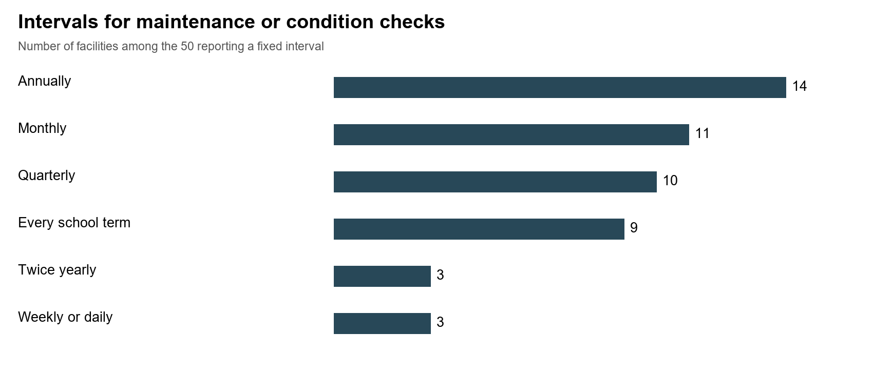
Figure 99: 47: Annual, Fixed intervals reported for monthly maintenance and or quarterly condition checks were the most common stated intervals
Records. Of the 463 facilities that with answered, classifiable responses, 318 (68.7%) kept a regular record of asset functionality or breakdowns, 36 (7.8%) kept a partial or informal record, 80 (17.3%) kept none and 29 (6.3%) had not yet started because the assets were new or the facility was not yet operating. Of the 478 facilities that with answered, classifiable responses, 355 (74.3%) held a record of the UgIFT assets they received, 40 (8.4%) held a partial record, such as delivery notes only or a general register that does not identify UgIFT items, and 83 (17.4%) held none. Kagumba Health Centre III in Kamuli kept an asset condition book, a simple practice that other facilities can adopt. The denominators differ because some replies were missing or could not be classified.

4.2 2.2 Obsolete and Unserviceable Assets
Two wall-mounted aneroid blood-pressure machines at Nyanja Health Centre III, UGIFT-012842 and UGIFT-012843, were reported as spoilt, beyond repair and requiring replacement. Disposal approval or completion has not been confirmed.
A certified inventory of obsolete assets and an approved disposal schedule have not been established. Faulty equipment should be assessed individually for repair, replacement or disposal.

4.3 2.3 Missing and Unrecorded Assets
Assets reported stolen, items not received, equipment with missing accessories and items that could not be accessed during the visit require different follow-up. These circumstances cannot be combined into a single count of losses.
For example, the incubator at Buwembe Health Centre III (UGIFT-114904) and the ENT instrument set at Rubingo Health Centre III (UGIFT-188911) were reported not received. The wheelchair at Bukimanayi Health Centre III (UGIFT-115669) was not seen, and the officer in charge could not confirm whether it had been redistributed. Check delivery and transfer records before concluding that these assets were lost.
At Paloga Seed Secondary School, two monitors were reported stolen, while the others remained in use. At Bukiiro Seed Secondary School, accounts of 16 system units conflict: they were described as both present and functional and as stolen. Their status requires confirmation. At Ogur Seed Secondary School, furniture in locked rooms could not be verified because keys were unavailable; this is an access limitation, not evidence of loss.
The number of assets omitted from facility registers has not been established. A missing local asset register, an inaccessible item and a stolen asset should remain separate findings. Further examples and the required checks are set out in the asset reconciliation appendix.

5 Recommendations
Recommendation. Facility managers and school governing bodies should keep the local and regional repair arrangements that already work and adopt a fixed routine: a condition check at least every school term in schools and every quarter in health centres, and a full count of UgIFT assets each year. Each facility should keep a condition book or fault list naming each item requiring action, the responsible person and the agreed completion date; the 36 facilities with no repair arrangement and the 80 with no functionality or breakdown record should set these up first.
District health and education offices should review unresolved repairs each quarter and arrange technical assistance, and regional referral hospital workshops should include UgIFT equipment in their scheduled visits. Annual maintenance plans should separate minor repairs from major repairs such that the minor repairs be met from Primary Health Care funds or school grants, while major repairs can be handled through district or national funding.
Recommendation. Facility managers, district health and education officers, engineers and technical teams should prioritise unsafe furniture, electrical concerns and failed equipment needed for essential services. Withdraw unsafe items, obtain technical assessments and verify safe operation after repair. The Assets broken recorded down as and faulty or not functional assets should be assessed in order of their effect on care and teaching, beginning with clinical equipment and the school furniture that makes up most of the broken down assets; furniture; items beyond economic repair should receive a formal disposal decision. At national level, the Office of the Prime Minister should decide on repair or replacement of its three damaged laptops laptops, recorded as not functional, and Uganda Blood Transfusion Services (UBTS) should decide on repair or replace replacement of the six broken blood pressure machines recorded as not functional at Arua Regional Blood Bank. Keep damaged assets separate from usable assets awaiting installation so that each receives the appropriate action.
Recommendation. LG Accounting Officers, engineers, health and education officers and contractors should coordinate outstanding buildings, utilities, furniture and equipment through site-specific completion plans for each of the 115 83 documented facilities with works or handover outstanding, starting comprising 70 with the incomplete 22 works of and them 13 that awaiting were handover not or yet commissioning. providing These services. 83 cases are a documented minimum. Installation should follow confirmation that rooms, power, water and security are ready. Stored assets described as new or in good condition should be issued to the rooms where they are needed, and each asset waiting for power or installation should have a named date for connection and testing. Protect services already operating during construction. There should be complete testing and signing off before handover or closing each action.
Recommendation. District health officers, facility managers, suppliers and regional technical teams should provide practical training for staff who use specialist equipment, starting with the health centres that linked idle equipment to a lack of skills, including oxygen equipment users, for example, at Bubago and Sop Sop and staff requiring orientation at Avogera. Handover should include a demonstration, basic maintenance guidance and a named route for technical support. Future supply contracts should make on-site demonstration to the staff who will use the equipment, equipment a condition of acceptance acceptance, and staffing reviews should take account of the equipment each health centre now holds.
Recommendation. Institution asset managers and LG finance, health and education officers should engrave all the verified assets with apply UgIFT markings where physically appropriate and confirm their asset locations and custodians. Assets carrying another marking only should receive the programme identifier at their next check. check, while retaining serials and vehicle registration details. Resolve the continuing allocation of equipment equipment, e.g for example at Todora, Paraa and Masafu Masafu, through signed transfer or receipt documentation, bring assets held at district stores to their facilities once rooms are ready, and complete delivery of the items still with suppliers. suppliers before recording them as received or in service.
The Ministry of Works and Transport should retain the completed its tracing record records and keep the confirmed custodians and locations current. Losses Suspected losses should be reported and investigated under through the asset-specific public finance rules, records, and every facility should hold a list of the UgIFT assets it received, showing each item, its engraving identifier and its custodian. Distinguish delivered assets from planned supplies, missing components and assets temporarily held elsewhere. Maintain site, ownership and handover records for buildings and land.
Recommendation. The Ministry of Finance, Planning and Economic Development, with the Ministry of Health, the Ministry of Education and Sports and the local governments concerned, should approve a corrected programme list after rectifying the inconsistencies. The corrected list should then guide decisions wherever planned locations differed from what teams found.

5.1 Actions to address the reported service gaps
Gap | Responsible officers | Action | Evidence of completion
Power | LG engineers and facility managers | Assess electrical loads and complete safe grid or suitable alternative supply before testing and issuing idle equipment. | Connection and electrical test records
Staffing | District service authorities and sector ministries | Match staffing needs to operating rooms and equipment; deploy qualified staff through approved staffing and budget processes. | Approved deployment and duty rosters
Space | LG engineers and sector departments | Inspect room suitability, identify overcrowded services and sequence building completion or adaptations around service needs. | Room allocation and completion records
Security | Accounting Officers and facility governing bodies | Prioritise vulnerable stores and ICT rooms; provide secure storage, access controls and risk-based fencing. | Security inspection and custodian logs
Maintenance | Facility managers and district technical teams | Set funded maintenance schedules, record faults and escalate major repairs to the responsible workshop or supplier. | Fault register and closed repair orders
Staff housing | LG planners, engineers and sector departments | Identify housing constraints affecting attendance; complete contracted quarters and plan additional accommodation where justified. | Occupancy and outstanding-work schedules
Water | District water officers and facility managers | Restore reliable water and test storage, supply and sanitation connections before putting dependent equipment into use. | Water availability and system test records
Training | Sector technical teams and suppliers | Demonstrate operation, safety and basic care to named users; confirm competence and provide a support contact. | Training attendance and competency sign-off
Works | Accounting Officers, engineers and contractors | Agree site-specific defects and completion lists, milestones and handover requirements; verify each closure on site. | Inspection certificates and signed handover
Installation and delivery | Procurement units, suppliers and facility managers | Reconcile delivery notes, obtain missing parts, install equipment in ready rooms and complete acceptance tests. | Delivery reconciliation and acceptance tests

Annexures Appendices

Appendix A Financial reconciliation and valuation limitations
The financial reporting date is 30 September 2026. Year-to-date depreciation covers 1 July to 30 September 2026. Amounts below are in Uganda shillings, rounded to the nearest shilling after the totals are calculated. Only available amounts are added; blank cells and entries marked Pending calculation are not treated as zero. Each record has one unit, so no further quantity multiplier is applied.
Financial measure | Available records | Unavailable records | Available total UGX
Recorded cost | 227,938 | 1,086 | 996,812,628,890
Accumulated depreciation | 206,012 | 23,012 | 165,185,197,307
Year-to-date depreciation | 206,012 | 23,012 | 10,793,939,755
Net book value | 206,008 | 23,016 | 595,801,587,531
The cost, depreciation and net book value totals do not all cover the same records. A direct comparison is possible for 180,730 records classified CAPITALIZED or construction in progress (CIP), where all three amounts are available. Their recorded cost of UGX 760,986,784,838 less accumulated depreciation of UGX 165,185,197,307 gives net book value of UGX 595,801,587,531. For this group, net book value is 78.3% of cost. This is the share of recorded cost that has not been depreciated; it does not measure physical condition, service performance or market value.
Reconciliation of available amounts | UGX
Available recorded cost, all accounting treatments | 996,812,628,890
Less known costs on records whose NBV remains unavailable | 190,742,908,682
Less positive recorded costs on expensed or non-recognized treatments | 45,082,935,370
Recorded cost of the assets with complete accounting information | 760,986,784,838
Less accumulated depreciation of those assets | 165,185,197,307
Net book value of those assets | 595,801,587,531
There are 21,978 records with a known cost but no calculated net book value. A further 5,336 records have positive costs but are treated as expenses or are not recognized as assets under the accounting treatment applied. Their costs must be excluded from the comparison above. This explains why subtracting all available depreciation from the full recorded cost does not give the reported net book value.

Extent of existing cost estimates
Basis of recorded cost | Records | Recorded cost UGX
Comparable assets within the same government | 26,922 | 122,474,661,776
Comparable assets in other governments | 139,671 | 699,262,256,528
Other available costs | 61,345 | 175,075,710,586
Total available costs | 227,938 | 996,812,628,890
Costs for 166,593 items were estimated by comparison with other assets, totalling UGX 821,736,918,304, or 82.44% of available recorded cost. These estimates require supporting valuation evidence. The other available costs also require acquisition or valuation records before they can be accepted as verified amounts. Costs remain missing for a further 1,086 items.
Construction in progress requires particular care. Of 298 CIP records, 275 carry zero cost, 19 have positive cost totalling UGX 1,168,217,300 and four have missing cost. The reported CIP balance is therefore not a measure of the full value of unfinished works or the amount required to finish them. These are asset records, not 298 distinct incomplete facilities.
Depreciation includes the service month and is limited to cost less salvage value. Year-to-date depreciation is the increase in accumulated depreciation since the start of the financial year. All recorded salvage values are zero. The underlying dates and cost evidence require confirmation before the balances can be treated as verified amounts.
There are 23,154 fully depreciated items, including 22,161 still marked in use. These assets need a review of their condition and remaining useful life. A zero net book value alone is not a reason to regard an asset as failed, disposed of or due for replacement. The financial tables use the existing accounting classifications. Errors, such as diagnostic equipment classified as buildings, need supporting evidence and correction before category totals can be used as physical inventories.

Appendix B Service date exceptions and supporting evidence
The cases below illustrate service-date problems and the decisions required. They are examples rather than a complete list of all date exceptions. Asset references and facility names are provided to support follow-up.
Asset reference | Location and service date | Finding and action
UGIFT-217326 | UNSPECIFIED  2009-08-20 | Source records purchase timing but leaves service date blank. Purchase does not establish commissioning.
UGIFT-010050 | Nkokonjeru Health Centre III  2012-03-01 | Service field absent or blank. No supported replacement date established.
UGIFT-010342 | Bukatube Health Centre III  2016-05-01 | Source records purchase timing but leaves service date blank. Purchase does not establish commissioning.
UGIFT-044388 | Maaji Seed Secondary School  2014-06-24 | Source records purchase timing but leaves service date blank. Purchase does not establish commissioning.
UGIFT-050677 | Labongo Amida Seed Secondary School  2014-01-01 | Service field absent or blank. No supported replacement date established.
UGIFT-114049 | Sikuda Seed Secondary School  2012-07-13 | Source states 13/7/2012 and Sikuda Primary School. Confirm legacy status, funding and school attribution.
UGIFT-118560 | Kyamwinula Health Centre III  2012-03-01 | Service field absent or blank. No supported replacement date established.
UGIFT-179828 | Makokoto Seed Secondary School  2014-01-01 | Service field absent or blank. No supported replacement date established.
UGIFT-196249 | Nyamarwa Seed Secondary School  2014-01-01 | Service field absent or blank. No supported replacement date established.
UGIFT-197564 | Namungo Seed Secondary School  2014-01-01 | Service field absent or blank. No supported replacement date established.
The shared 1 January 2014 value covers 260 wooden-chair records at Labongo Amida, 266 at Makokoto, 303 at Nyamarwa and 203 at Namungo. The original returns for these groups provide no service date. The sampled Kyamwinula source likewise lacks a service-date field and provides no full date to justify the stated date of 1 March 2012. The sampled Nkokonjeru return expressly states that receipt or service timing was not recorded. The dates therefore remain unresolved; the source material does not support replacement dates.

Rules for an approved register correction
Enter a full calendar date only when the evidence shows when the identified asset became available for use. Keep the source’s original wording and level of detail in the supporting record. A month, year, financial year or commissioning status must not be entered as though it were a full date.
Leave the date field blank in the corrected register where a full date cannot be supported. Record the reason, original value and source reference separately. Keep any work-in-progress or undelivered status visible even when the date is blank.
Where the source supports an early date, establish whether the asset predates UgIFT or has been assigned to the wrong beneficiary or programme. Do not simply move the year forward or remove the asset from the register. Record the approved decision about its ownership and programme assignment.
Before approving changes, compare purchase and service dates, check repeated entries and confirm which physical units they describe. A date may be applied to a whole batch only where the documents identify both the batch and the relevant event. Similar item names or dates at another facility are not sufficient evidence.
For each approved change, record the original and revised values, supporting evidence, decision, responsible officer and review date. Recalculate depreciation, net book value and any recoverable amount based on net book value. Retain independently supported recoverable amounts separately. Check the resulting balances and outstanding exceptions before migration to IFMIS.

Appendix C Definitions used in the analysis
The definitions below explain how quantities, condition and financial values are presented. Unresolved receipt, ownership and classification matters are included in the relevant schedules for follow-up.
Term | Meaning in this report
Asset quantities | Each entry represents one recorded unit. Totals include capitalized, expensed and unresolved entries; receipt and ownership exceptions require confirmation.
Institution and location | Assets are grouped by the institution and beneficiary to which they are attributed. Transfers, substitutions and uncertain programme assignments require reconciliation.
Asset categories | The categories describe the existing accounting classification. Known errors require correction before the categories can be treated as confirmed physical inventories.
Recorded cost | The available cost in Uganda shillings. Some amounts are estimates. A missing amount remains unresolved and is distinguished from a recorded zero.
Service and purchase dates | The service date is when the asset became available for use. The purchase date is a separate event and does not establish the service date.
Useful life and salvage value | Useful life is the period used for depreciation. Salvage value is the amount expected to remain at the end of that period. Neither determines when an asset physically fails.
Depreciation | Accumulated depreciation is the cost allocated over the asset’s accounting life to date. Year-to-date depreciation covers 1 July to 30 September 2026. Pending calculations remain unavailable.
Net book value | Recorded cost less accumulated depreciation for assets recognized for accounting purposes. Comparisons use the same records with all required amounts available.
Recoverable amount | An independently supported recoverable amount must be distinguished from a value based on net book value. The latter does not constitute an independent impairment valuation.
Asset identification | Asset references, programme markings, serial numbers and vehicle registrations help establish identity. Shared identifiers and missing markings require physical and custody checks.
Condition and use | Functional and Faulty are the two reported condition classes. Reasons for non-use are examined separately to determine whether installation, repair, replacement or disposal is appropriate.
Complete accounting information | Assets classified CAPITALIZED or construction in progress, with cost, accumulated depreciation and net book value all available. These provide the basis for direct financial reconciliation.
The analysis distinguishes the thirteen asset-holding MDAs, the three regional blood banks, health centres, schools, hospitals and other local-government locations. Institution totals, programme-list facilities and interview respondents represent different populations and should not be used interchangeably.
Asset numbers are missing for 1,923 entries, while 34 state Not engraved. Three linked asset-number entries disagree: one at Birembo Health Centre III and two at Namungo Seed Secondary School. There are also 355 repeated asset-number values and 323 repeated serial-number values within individual institution books. Quantities and supporting records should be checked before any assets are counted as duplicates.

Principal references
Programme chronology: World Bank UgIFT Additional Financing programme paper, section I, paragraph 1, printed page 1.
Accounting policy context: Government of Uganda Asset Accounting Policies and Guidelines 2023, sections 3.3.5.2, 5.5, 5.7 and 5.9; pages 49, 67 and 68.
Field photographs and reports describe conditions at the time of the visits. Photographs alone cannot confirm functionality, completion, programme ownership or current condition.

Appendix D Programme list exception roster
The 39 entries below explain gaps or differences between the programme list and the available asset returns. Reported absence is not an independent finding that a facility does not exist. A receiving facility already on the list is counted once.
ID | Programme-list entry and LG | Outcome
H205 | Olok HC II  Pader | Reported absent or not constructed
H190 | Alik HCII  Lira | Reported absent or not constructed
H197 | Acimi HC II  Oyam | Reported absent or not constructed
H195 | Acokara HCII  Oyam | Reported absent or not constructed
H200 | Ariba HC II  Oyam | Reported absent or not constructed
H070 | Busia Eastern Division  Busia MC | Reported absent or not constructed
S010 | Eastern Division  Tororo MC | Reported absent or not constructed
S012 | Central Division  Jinja City | Reported absent or not constructed
S216 | Kishangara seed school  Ibanda | Reported absent or not constructed
H010 | Butoloogo HC II  Kasanda | Reported absent or not constructed
H193 | Alira HCII  Oyam | Outside UgIFT scope
H086 | Buyinda HC II  Kaliro | Outside UgIFT scope
S237 | Kiziranfumbi Seed School  Kikuube | Outside UgIFT scope
H149 | Pandwong HC II  Kitgum MC | No UgIFT assets reported
S214 | Bumbaire Seed School  Bushenyi | No UgIFT assets reported
S215 | Kyamuhunga  Bushenyi | No UgIFT assets reported
S221 | Kashenshero  Mitooma | No UgIFT assets reported
H282 | Rwamujojo HC II  Sheema MC | No UgIFT assets reported
H231 | Alangi  Zombo | Assets relocated
H233 | Ther-uru HC II  Zombo | Assets relocated
S208 | Abanga  Zombo | Assets relocated
H213 | Loinya HC II  Maracha | Already represented elsewhere
H054 | Bussi HC II  Wakiso | Already represented elsewhere
H044 | Butalangu HC II  Nakaseke | Follow-up without on-site return
H043 | Semuto HC II  Nakaseke | Follow-up without on-site return
S087 | Kikamulo  Nakaseke | Follow-up without on-site return
S088 | Nakaseke Seed School  Nakaseke | Follow-up without on-site return
H045 | Kiralamba HC II  Nakasongola | Follow-up without on-site return
S089 | Nakitoma  Nakasongola | Follow-up without on-site return
H370 | Kyondo HC II  Bundibugyo | Follow-up without on-site return
H373 | Kabingo HCII  Kasese | Follow-up without on-site return
H048 | Kyera HCII  Sembabule | Follow-up without on-site return
H047 | Ntete HCII  Sembabule | Follow-up without on-site return
H031 | Kyabakuza HCII  Masaka | Follow-up without on-site return
S059 | Kichwamba  Kabarole | Follow-up without on-site return
S058 | Karago TC  Fort-Portal City | Follow-up without on-site return
S004 | Ngoma  Nakaseke | Follow-up without on-site return
S080 | Lwengo Seed School  Lwengo | Follow-up without on-site return
H227 | Lodonga TC  Yumbe | Follow-up without on-site return

Appendix E Documented outstanding works and handover
This schedule lists the 70 facilities with documented incomplete works and the 13 additional facilities awaiting handover or commissioning. It is a minimum list of documented cases, not a certification of the remaining facilities. A facility may operate while a block or ancillary structure remains unfinished.
ID | Facility and LG | Outstanding matter
H145 | Omot Health Centre III  Agago | Incomplete works
H112 | Bukibologoto Health Centre III  Bulambuli | Incomplete works
H181 | Adagmon Health Centre III  Dokolo | Incomplete works
H008 | Mamba Health Centre III  Gomba | Incomplete ancillary works
H009 | Ngomamene Health Centre III  Gomba | Incomplete ancillary works
H312 | Maregamo Health Centre III  Kisoro | Incomplete works
H152 | Moyok Health Centre III  Kween | Handover or commissioning
H155 | Kaptum Health Centre III  Kween | Incomplete works
H156 | Benet Health Centre III  Kween | Incomplete works
H356 | Mutungo Health Centre III  Makindye-Ssabagabo MC | Incomplete ancillary works
H366 | Lama Health Centre III  Moyo | Incomplete works
H355 | Matugga Health Centre III  Nansana MC | Incomplete ancillary works
H367 | Tekulu Health Centre III  Omoro | Incomplete works
H368 | Abwoch Health Centre III  Omoro | Incomplete works
H228 | Amanyiri Health Centre III  Yumbe | Handover or commissioning
S141 | Alerek Seed Secondary School  Abim | Handover or commissioning
S021 | Kotomor Seed Secondary School  Agago | Incomplete works
S022 | Lamiyo Seed Secondary School  Agago | Incomplete works
S027 | Akwon Seed Secondary School  Amolatar | Incomplete works
S145 | Looro Seed Secondary School  Amudat | Incomplete works
S157 | Asamuk Seed Secondary School  Amuria | Incomplete works
S024 | Amuru Town Seed Secondary School  Amuru | Handover or commissioning
S030 | St Peters Aroi Seed Secondary School  Arua | Incomplete works
S005 | Kakule Seed Secondary School  Budaka | Handover or commissioning
S007 | Bushiribo Seed Secondary School  Bududa | Incomplete works
S011 | Mpiita Seed Secondary School  Bugweri | Incomplete works
S014 | Senendet Seed Secondary School  Bukwo | Incomplete works
S046 | Kihungya Seed Secondary School  Buliisa | Incomplete works
S054 | Burondo Seed Secondary School  Bundibugyo | Incomplete works
S055 | Kabango Seed Secondary School  Bundibugyo | Incomplete works
S250 | Kisuba Seed Secondary School  Bundibugyo | Incomplete works
S056 | Katugunda Seed Secondary School  Bunyangabu | Incomplete works
S057 | Nsuura Seed Secondary School  Bunyangabu | Incomplete works
S096 | Sikuda Seed Secondary School  Busia | Handover or commissioning
S009 | Muhula Seed Secondary School  Butaleja | Incomplete works
S025 | Patiko Seed Secondary School  Gulu | Incomplete works
S230 | Kidukuru Seed Secondary School  Hoima | Handover or commissioning
S019 | Sidok Seed Secondary School  Kaabong | Incomplete works
S159 | Aperikira Seed Secondary School  Kaberamaido | Incomplete ancillary works
S047 | Burora Seed Secondary School  Kagadi | Handover or commissioning
S048 | King Solomon Seed Secondary School  Kagadi | Incomplete works
S049 | Kitegwa Community Seed Secondary School  Kagadi | Incomplete works
S232 | St Catherine Kicucura Seed Secondary School  Kagadi | Incomplete works
S060 | Bwesumbu Seed Secondary School  Kasese | Incomplete works
S001 | Lwamata Town Council Seed Secondary School  Kiboga | Incomplete works
S050 | Kyangwali Seed Secondary School  Kikuube | Handover or commissioning
S040 | Lake Mburo Seed Secondary School  Kiruhura | Incomplete works
S051 | Kigumba Town Seed Secondary School  Kiryandongo | Incomplete works
S254 | Kanara Seed Secondary School  Kitagwenda | Handover or commissioning
S149 | Rengen Seed Secondary School  Kotido | Incomplete works
S164 | Kumi Seed Secondary School  Kumi | Incomplete ancillary works
S131 | Kaptum Seed Secondary School  Kween | Incomplete works
S132 | Kitawoi Seed Secondary School  Kween | Incomplete works
S133 | Moyok Seed Secondary School  Kween | Incomplete works
S075 | Ntwetwe Seed Secondary School  Kyankwanzi | Incomplete works
S256 | Rwentuha Seed Secondary School  Kyegegwa | Incomplete works
S061 | Kyarusozi Seed Secondary School  Kyenjojo | Incomplete works
S257 | Kigaraale Seed Secondary School  Kyenjojo | Incomplete works
S258 | Kyembogo Seed Secondary School  Kyenjojo | Incomplete works
S026 | Padibe Seed Secondary School  Lamwo | Incomplete works
S015 | Butta Seed Secondary School  Manafwa | Incomplete works
S016 | Sisuni Seed Secondary School  Manafwa | Incomplete works
S135 | Khabutoola Seed Secondary School  Manafwa | Incomplete works
S136 | Sibanga Seed Secondary School  Manafwa | Handover or commissioning
S151 | Rupa Seed Secondary School  Moroto | Incomplete ancillary works
S200 | Dufile Seed Secondary School  Moyo | Incomplete works
S085 | Kigando Seed Secondary School  Mubende | Incomplete works
S020 | Moruita Seed Secondary School  Nakapiripirit | Incomplete works
S153 | Nakapiripirit Seed Secondary School  Nakapiripirit | Incomplete works
S018 | Mukuto Seed Secondary School  Namisindwa | Incomplete works
S154 | Iriiri Seed Secondary School  Napak | Handover or commissioning
S033 | Mamba Seed Secondary School  Nebbi | Incomplete works
S034 | Ndhew Seed Secondary School  Nebbi | Incomplete works
S201 | Atego Seed Secondary School  Nebbi | Incomplete works
S062 | Butungama Seed Secondary School  Ntoroko | Incomplete works
S063 | Kibuuku Seed Secondary School  Ntoroko | Incomplete ancillary works
S035 | Got Apwoyo Seed Secondary School  Nwoya | Incomplete works
S028 | Okum Seed Secondary School  Otuke | Incomplete works
S102 | Olok Seed Secondary School  Pallisa | Incomplete ancillary works
S170 | Kamuda Seed Secondary School  Soroti | Incomplete works
S105 | Malaba Seed Secondary School  Tororo | Handover or commissioning
S209 | Atyak Seed Secondary School  Zombo | Incomplete works
S210 | Kango Seed Secondary School  Zombo | Incomplete ancillary works
Two additional locations outside this programme-list schedule, have outstanding works or commissioning: Bukuuku Community Seed Secondary School has staff quarters and a kitchen under construction; Kibuzigye Seed Secondary School has a kitchen recorded as completed and operational but not yet commissioned. Their programme-list attribution requires reconciliation.

Appendix F Facility interview scope and denominators
The interview analysis counts each programme-list facility once per topic. Multiple returns for a facility are reconciled before analysis. Answers about another institution, statements that do not answer the question and unclassifiable replies are excluded from the relevant denominator. The Mbirizi school response attributed to Kagganda Health Centre is excluded from health-centre analysis pending correction of the identity. Receiving-facility responses are linked to the appropriate programme entry.
Measure | Health centres | Schools | Total
Service benefits and challenges | 284 | 193 | 477
Maintenance arrangements | 278 | 191 | 469
Maintenance or condition-check frequency | 294 | 200 | 494
Classified functionality or breakdown records | 282 | 181 | 463
Classified records of assets received | 281 | 197 | 478
A benefit or challenge percentage uses the respondents to that question, not all 629 programme-list entries. Topic categories overlap. The broader challenge measure includes both an explicitly described problem and a request for its remedy; it should not be confused with the narrower count of explicit complaints. The 50 fixed-interval responses combine maintenance and condition-check information. Forty-four facility responses share wording with another return, so the findings should be read as accounts reported by facilities, rather than independent measurements of impact.

Appendix G Asset reconciliation examples
The cases below require delivery, custody or condition checks. They do not provide a national total of losses or disposals. Where a report concerns a batch of equipment, the affected items still need to be identified.
Facility and item | Asset reference | Finding and action
Kijuna Health Centre III  Oxygen Therapy Apparatus, Mininum 45L cylinder | UGIFT-003939 | Oxygen therapy apparatus lacks regulators/accessories. This concerns missing parts, not the whole asset.
Nyanja Health Centre III  B.P. Machine (Aneroid wall mounted) | UGIFT-012842 | Two machines, UGIFT-012842 and UGIFT-012843, were reported beyond repair. Disposal approval remains unconfirmed.
Paloga Seed Secondary School  Desktop Computer | UGIFT-052080 | Two monitors were reported stolen, while the others remained in use. Confirm which items were affected.
Ogur Seed Secondary School  Desks | UGIFT-057485 | Furniture in locked rooms could not be verified because keys were unavailable. Confirm its location and condition.
Buwembe Health Centre III  Incubator | UGIFT-114904 | Incubator reported not received. Check delivery records before concluding that it was lost.
Bukimanayi Health Centre III  Wheel Chair | UGIFT-115669 | Wheelchair not seen; possible redistribution unconfirmed. Establish its location.
Ikumbya Seed Secondary School  Desktop Computer | UGIFT-140448 | Reported quantities: 29 received, 12 verified, 10 stolen and two faulty. Reconcile receipt, transfer and loss records.
Kitojo Health Centre III  Microscope Binocular | UGIFT-150498 | Microscope reportedly not received although status says Functional. Resolve the contradiction.
Bukiiro Seed Secondary School  System Unit | UGIFT-159973 | Accounts of 16 system units conflict: described as both present and functional and as stolen. Confirm their status.
Rubingo Health Centre III  Instrument set, ENT Basic for HCIII | UGIFT-188911 | ENT instrument set reportedly not received. Reconcile supplier and facility receipt records.

Appendix H Photographic schedule
The photographs illustrate facilities, equipment and outstanding works at the time of the visits. They should be read alongside the findings on condition, use and completion. A photograph alone does not establish that equipment was functional or that a facility was ready for handover.
Facility | Photographic subject
Majanji Health Centre III | Delivery bed with a torn mattress cover at a health centre, Busia District (Bukedi).
Lungulu Seed Secondary School | Boxed computers and related equipment in a seed school store, Nwoya District (Acholi).
Malaba Seed School | UgIFT identification on a desk at a seed school, Tororo District (Bukedi).
Got Apwoyo Seed Secondary School | Unfinished school block at Got Apwoyo Seed Secondary School, Nwoya District (Acholi).
Lwamata Town Council Seed Secondary School | Building works at a seed secondary school, Kiboga District (Buganda).
Butungama Seed Secondary School | School block awaiting completion at Butungama Seed Secondary School, Ntoroko District (Tooro).
Bukibologoto Health Centre II | Cracked health centre block above collapsed ground, Bulambuli District (Bugisu).
Bundege Health Centre III | Stained and peeling ceiling at a health centre, Sironko District (Bugisu).
Napak Seed Secondary School | Stacked desks, chairs and stools at a seed secondary school, Napak District (Karamoja).
Butungama Seed Secondary School | Laboratory stools and other school furniture in storage, Ntoroko District (Tooro).
Kibiri Health Centre III | Boxed pulse oximeters at a health centre, Makindye-Ssabagabo Municipal Council (Buganda).
Ndhew Seed Secondary School | Building works and construction materials at Ndhew Seed Secondary School, Nebbi District (West Nile).
Simu Pondo Health Centre III | Unfinished laboratory building at a health centre, Sironko District (Bugisu).
Namboko Seed Secondary School | Broken desk frame at a seed secondary school, Namisindwa District (Bugisu).
Sibanga Seed School | Books displayed on library shelves at Sibanga Seed School, Manafwa District (Bugisu).
Kamuli HC III | Maternity block entrance and access ramp at Kamuli HC III, Tororo District (Bukedi).
Kyabasara Health Centre III | Hospital beds and screens stacked in storage at a health centre, Kagadi District (Bunyoro).
Kihungya Seed Secondary School | Biology laboratory under construction at a seed secondary school, Buliisa District (Bunyoro).
Older Butiaba Health Centre III facility | Flood-affected older health facility at Butiaba, Buliisa District (Bunyoro).
Kaptum Seed Secondary School | Empty computer laboratory at a seed secondary school, Kween District (Sebei).
Kalemungole HC III | Programme engraving on a weighing scale at Kalemungole HC III, Moroto District (Karamoja).
Kalemungole HC III | Wheelchair with programme marking at Kalemungole HC III, Moroto District (Karamoja).
Sidok Seed Secondary School | Unfinished classroom block at Sidok Seed Secondary School, Kaabong District (Karamoja).
Sidok Seed Secondary School | Latrine block under construction at Sidok Seed Secondary School, Kaabong District (Karamoja).
Kihungya Seed Secondary School | Unfinished laboratory interior at Kihungya Seed Secondary School, Buliisa District (Bunyoro).
Kihungya Seed Secondary School | Library interior under construction at Kihungya Seed Secondary School, Buliisa District (Bunyoro).
King Solomon Seed Secondary School | School engraving on wooden furniture at King Solomon Seed Secondary School, Kagadi District (Bunyoro).
King Solomon Seed Secondary School | Boxed projector and other equipment at King Solomon Seed Secondary School, Kagadi District (Bunyoro).
Budde Seed Secondary School | Programme and school engraving on a chair at Budde Seed Secondary School, Butambala District (Buganda).
Sisiyi Seed Secondary School | ICT laboratory block and entrance ramp at Sisiyi Seed Secondary School, Bulambuli District (Bugisu).
Majanji HC III | Pedal suction unit in packaging at Majanji HC III, Busia District (Bukedi).
Bumufuni Seed Secondary School | Computer sets stacked in a store at Bumufuni Seed Secondary School, Bulambuli District (Bugisu).
Kitawoi Seed Secondary School | ICT laboratory interior under construction at Kitawoi Seed Secondary School, Kween District (Sebei).
Moyok HC III | Institutional engraving on equipment at Moyok HC III, Kween District (Sebei).
Kibiri HC III | Health centre building at Kibiri HC III, Makindye-Ssabagabo Municipal Council (Buganda).
Gyagenda Memorial Seed Secondary School | Classroom furnished with desks and a whiteboard at Gyagenda Memorial Seed Secondary School, Kalangala District (Buganda).
Kihungya Seed Secondary School | Classroom block with earthworks in the foreground at Kihungya Seed Secondary School, Buliisa District (Bunyoro).
Kihuukya HC III | Health centre buildings and covered walkway at Kihuukya HC III, Hoima City (Bunyoro).
Kihuukya HC III | Binocular microscope at Kihuukya HC III, Hoima City (Bunyoro).
King Solomon Seed Secondary School | Laboratory benches with cupboard doors detached at King Solomon Seed Secondary School, Kagadi District (Bunyoro).
Iriiri Seed Secondary School | Computer and library block interior with furniture and stored items at Iriiri Seed Secondary School, Napak District (Karamoja).
Kamoru HC III | Microscope bearing local facility identification at Kamoru HC III, Kotido District (Karamoja).
Aperikira Seed Secondary School | Engraving reading APESSS MOES/UGIFT/KABE/SPLRS/2023-24/001 on a desk at Aperikira Seed Secondary School, Kaberamaido District (Teso)
Arua Regional Blood Bank | Completed blood bank building at Arua Regional Blood Bank, Arua City (West Nile)
Arua Regional Blood Bank | Markings PEP II/UBTS/COMP/11/016 and UBTS/UGIFT/ARBB/UPS/001 on uninterruptible power supplies at Arua Regional Blood Bank, Arua City (West Nile)
Hoima Regional Blood Bank | Donor couches in the donor room at Hoima Regional Blood Bank, Hoima City (Bunyoro)
Hoima Regional Blood Bank | Benchtop centrifuge at Hoima Regional Blood Bank, Hoima City (Bunyoro)
Arua Regional Blood Bank | Blood bank refrigerator at Arua Regional Blood Bank, Arua City (West Nile)
Arua Regional Blood Bank | Platelet agitator at Arua Regional Blood Bank, Arua City (West Nile)
Benet Health Centre III | Incomplete staff quarters at Benet Health Centre III, Kween District. Field visit 27 August 2026.
Benet Health Centre III | Interior awaiting completion at Benet Health Centre III, Kween District. Field visit 27 August 2026.
Benet Health Centre III | A further unfinished room at Benet Health Centre III, Kween District. Field visit 27 August 2026.
Hoima Regional Blood Bank | Freezer at Hoima Regional Blood Bank.
Soroti Regional Blood Bank | Refrigerators at Soroti Regional Blood Bank.

Appendix I Land records and ownership evidence
Eighteen entries are classified as land, including four at health centres. Ownership, area, tenure and valuation require supporting documents. The table lists these entries for follow-up by the responsible institutions.
Asset reference | Location | Item | Cost UGX m | Available evidence
UGIFT-119332 | Kyamwinula Health Centre III | Land | 20.000 | Functional.
UGIFT-128460 | Sop Sop Health Centre III | 70X300M | 20.000 | Functional. Good and In Use.
UGIFT-177218 | Luwube Muslim Seed Secondary School | Land | Unavailable | Functional.
UGIFT-183077 | Kigorobya Seed Secondary School | Land | 0.912 | Functional. Only a partial service date is available; the exact date requires confirmation.
UGIFT-183078 | Kigorobya Seed Secondary School | Land | 0.912 | Functional. Only a partial service date is available; the exact date requires confirmation.
UGIFT-183079 | Kigorobya Seed Secondary School | Land | 0.912 | Functional. Only a partial service date is available; the exact date requires confirmation.
UGIFT-183080 | Kigorobya Seed Secondary School | Land | 0.912 | Functional. Only a partial service date is available; the exact date requires confirmation.
UGIFT-183081 | Kigorobya Seed Secondary School | Land | 0.912 | Functional. Only a partial service date is available; the exact date requires confirmation.
UGIFT-183082 | Kigorobya Seed Secondary School | Land | 0.912 | Functional. Only a partial service date is available; the exact date requires confirmation.
UGIFT-183083 | Kigorobya Seed Secondary School | Land | 0.912 | Functional. Only a partial service date is available; the exact date requires confirmation.
UGIFT-183084 | Kigorobya Seed Secondary School | Land | 0.912 | Functional. Only a partial service date is available; the exact date requires confirmation.
UGIFT-183085 | Kigorobya Seed Secondary School | Land | 0.912 | Functional. Only a partial service date is available; the exact date requires confirmation.
UGIFT-183086 | Kigorobya Seed Secondary School | Land | 0.912 | Functional. Only a partial service date is available; the exact date requires confirmation.
UGIFT-183087 | Kigorobya Seed Secondary School | Land | 0.912 | Functional. Only a partial service date is available; the exact date requires confirmation.
M161436 | Kabweri Seed Secondary School | School Land | 50.000 | Functional.
M161488 | Nalubembe Health Centre III | Hospital Land | 15.000 | Functional.
M183485 | Kasasira Seed Secondary School | School Land | 50.000 | Functional.
M183544 | Kabweri Health Centre III | Hospital Land | 15.000 | Functional.
Costs include nil amounts and estimates.

Appendix J Additional assets and classification checks
Hospitals on local-government books: 3,067 records. These are included in the report total and shown separately from health centres and schools.
Asset category and coverage | Recorded cost | Accumulated depreciation | Net book value | NBV / cost
Medical, laboratory and research appliances  2,843 records; NBV 2,632/2,843 | 1,436.617 | 738.099* | 546.884* | 42.6%
Outside fixed-asset classification  145 records; NBV 145/145 | 1.000 | 0.000 | 0.000 | n/a
Furniture and fittings  68 records; NBV 10/68 | 52.427 | 3.696* | 7.832* | 67.9%
Buildings and structures  6 records; NBV 4/6 | 396.408 | 35.986* | 356.923* | 90.8%
Other classified assets  3 records; NBV 3/3 | 1.010 | 0.662 | 0.348 | 34.5%
ICT equipment  2 records; NBV 1/2 | 0.552* | 0.506* | 0.046* | 8.3%
Amounts are in UGX million, rounded to three decimals. * Available amounts only; one or more amounts are missing or pending calculation. NBV coverage is given for each category. NBV/cost compares complete accounting records and does not measure physical condition. n/a means a comparable ratio is unavailable.
Other local-government or unassigned locations: 4 records. These are included in the report total and shown separately from health centres and schools.
Asset category and coverage | Recorded cost | Accumulated depreciation | Net book value | NBV / cost
Transport equipment  4 records; NBV 4/4 | 431.136 | 279.424 | 151.712 | 35.2%
Amounts are in UGX million, rounded to three decimals. * Available amounts only; one or more amounts are missing or pending calculation. NBV coverage is given for each category. NBV/cost compares complete accounting records and does not measure physical condition. n/a means a comparable ratio is unavailable.
Review the classification of diagnostic sets listed under buildings and structures. Confirm item descriptions, account mapping, ownership and useful life before migration to IFMIS.

Appendix K Financial analysis by asset type
The following tables present financial values by asset type for each ministry, regional blood bank, health centres and schools. They separate laptops, printers, furniture, medical equipment and other items while retaining the full institution totals. Recorded costs, accumulated depreciation and net book values agree with the broader financial analysis in the report.
Items are grouped by their descriptions, with accounting categories used where the description is insufficient. Each record represents one unit. A desktop-computer description may refer to a system unit or an incomplete set; separately listed monitors, CPUs, keyboards and mice are therefore shown as components. Accessories and supplies are included even where they are not recognized as fixed assets. Unclear descriptions are reported separately. Some descriptions differ from their accounting categories: for example, Van de Graaff generators and strip cups classified as transport are grouped here as laboratory items. Their accounting classifications require correction.
Amounts are in UGX million at 30 September 2026, rounded to three decimals. An asterisk means the total includes available amounts only; Unavailable means none of the amounts for that measure can be calculated. NBV coverage shows how many records have a net book value. The NBV/cost ratio uses only CAPITALIZED or CIP records with cost, depreciation and net book value all available. It shows the share of cost not yet depreciated, not physical condition or market value. n/a means there is no positive cost on that comparable basis.

MoFPED
Asset type and coverage | Recorded cost | Accumulated depreciation | Net book value | NBV / cost
Computer components: monitors, CPUs, keyboards and mice  70 records; NBV 66/70 | 338.617 | 284.293* | 54.084* | 16.0%
Chairs and seats  69 records; NBV 69/69 | 92.869 | 59.383 | 33.486 | 36.1%
Other records outside fixed-asset classes  54 records; NBV 54/54 | 6.564 | 0.000 | 0.000 | n/a
Laptops and notebooks  40 records; NBV 34/40 | 261.360 | 150.858* | 55.542* | 26.9%
Software and licences  31 records; NBV 30/31 | 147.147* | 147.147* | 0.000* | 0.0%
Desktop and unspecified computer records  26 records; NBV 26/26 | 135.854 | 123.120 | 12.734 | 9.4%
UPS systems  25 records; NBV 25/25 | 30.723 | 19.554 | 11.168 | 36.4%
Desks and benches  21 records; NBV 21/21 | 32.238 | 26.346 | 5.891 | 18.3%
Vehicles and other transport  21 records; NBV 20/21 | 4,550.385* | 3,046.016* | 1,504.369* | 33.1%
Tablets  17 records; NBV 17/17 | 39.244 | 26.163 | 13.081 | 33.3%
Printers and photocopiers  15 records; NBV 13/15 | 234.901 | 156.781* | 52.077* | 24.9%
Digital phones and TELA handsets  14 records; NBV 14/14 | 10.290 | 10.290 | 0.000 | 0.0%
Projectors  14 records; NBV 14/14 | 124.300 | 124.300 | 0.000 | 0.0%
Servers and network equipment  10 records; NBV 10/10 | 70.000 | 60.667 | 9.333 | 13.3%
Cabinets, cupboards and shelves  9 records; NBV 9/9 | 11.930 | 10.339 | 1.591 | 13.3%
Other records classified as ICT  9 records; NBV 9/9 | 32.317 | 32.262 | 0.054 | 0.2%
Accessories and protective items  6 records; NBV 0/6 | 18.640 | Unavailable | Unavailable | n/a
Paper shredders and binding machines  3 records; NBV 3/3 | 10.800 | 9.360 | 1.440 | 13.3%
Water dispensers  3 records; NBV 3/3 | 2.040 | 1.870 | 0.170 | 8.3%
Audio-visual, survey and other ICT equipment  1 record; NBV 1/1 | 54.100 | 23.443 | 30.657 | 56.7%
Total  458 records; NBV 438/458 | 6,204.318* | 4,312.194* | 1,785.678* | 29.3%
Amounts in UGX million. * Available amounts only. NBV/cost compares the same complete records.

MoWT
Asset type and coverage | Recorded cost | Accumulated depreciation | Net book value | NBV / cost
Computer components: monitors, CPUs, keyboards and mice  48 records; NBV 40/48 | 62.259 | 23.859* | 31.200* | 56.7%
UPS systems  14 records; NBV 10/14 | 13.076 | 5.001* | 6.539* | 56.7%
Desktop and unspecified computer records  8 records; NBV 4/8 | 22.016 | 15.961* | 2.455* | 13.3%
Printers and photocopiers  8 records; NBV 6/8 | 67.483 | 50.979* | 14.704* | 22.4%
Laptops and notebooks  5 records; NBV 5/5 | 40.080 | 17.368 | 22.712 | 56.7%
Audio-visual, survey and other ICT equipment  1 record; NBV 1/1 | 54.100 | 23.443 | 30.657 | 56.7%
Other or insufficiently described items  1 record; NBV 0/1 | Unavailable | Unavailable | Unavailable | n/a
Tablets  1 record; NBV 1/1 | 0.900 | 0.390 | 0.510 | 56.7%
Vehicles and other transport  1 record; NBV 1/1 | 196.018 | 189.484 | 6.534 | 3.3%
Total  87 records; NBV 68/87 | 455.932* | 326.485* | 115.311* | 26.1%
Amounts in UGX million. * Available amounts only. NBV/cost compares the same complete records.

MoES
Asset type and coverage | Recorded cost | Accumulated depreciation | Net book value | NBV / cost
Digital phones and TELA handsets  9,324 records; NBV 9,324/9,324 | 10,847.924 | 7,774.569 | 3,073.355 | 28.3%
Tablets  1,001 records; NBV 1,001/1,001 | 1,995.347 | 1,591.326 | 404.021 | 20.2%
Laptops and notebooks  456 records; NBV 456/456 | 2,043.788 | 1,206.684 | 837.104 | 41.0%
Printers and photocopiers  2 records; NBV 2/2 | 38.070 | 34.897 | 3.172 | 8.3%
Total  10,783 records; NBV 10,783/10,783 | 14,925.128 | 10,607.477 | 4,317.652 | 28.9%
Amounts in UGX million. * Available amounts only. NBV/cost compares the same complete records.

MAAIF
Asset type and coverage | Recorded cost | Accumulated depreciation | Net book value | NBV / cost
Tablets  819 records; NBV 819/819 | 623.689 | 429.317 | 194.373 | 31.2%
Accessories and protective items  784 records; NBV 778/784 | 306.274* | 82.589* | 163.388* | 66.4%
Computer components: monitors, CPUs, keyboards and mice  340 records; NBV 340/340 | 823.828 | 247.120 | 576.612 | 70.0%
Laptops and notebooks  49 records; NBV 49/49 | 481.164 | 158.325 | 322.839 | 67.1%
Printers and photocopiers  21 records; NBV 21/21 | 72.534 | 21.760 | 50.774 | 70.0%
Printer supplies and consumables  15 records; NBV 15/15 | 12.674 | 0.000 | 0.000 | n/a
Software and licences  5 records; NBV 5/5 | 8.000 | 5.467 | 2.533 | 31.7%
Other records classified as ICT  4 records; NBV 4/4 | 20.992 | 6.298 | 14.694 | 70.0%
Vehicles and other transport  4 records; NBV 4/4 | 500.040 | 425.034 | 75.006 | 15.0%
Audio-visual, survey and other ICT equipment  3 records; NBV 2/3 | 3.829* | 1.149* | 2.680* | 70.0%
Projectors  1 record; NBV 1/1 | 3.532 | 3.002 | 0.530 | 15.0%
Total  2,045 records; NBV 2,038/2,045 | 2,856.557* | 1,380.060* | 1,403.430* | 50.4%
Amounts in UGX million. * Available amounts only. NBV/cost compares the same complete records.

MoH
Asset type and coverage | Recorded cost | Accumulated depreciation | Net book value | NBV / cost
Accessories and protective items  148 records; NBV 148/148 | 134.418 | 0.000 | 0.000 | n/a
Printer supplies and consumables  50 records; NBV 50/50 | 40.950 | 0.000 | 0.000 | n/a
Laptops and notebooks  23 records; NBV 23/23 | 137.277 | 72.714 | 64.563 | 47.0%
Motorcycles  23 records; NBV 23/23 | 418.000 | 202.556 | 215.444 | 51.5%
Printers and photocopiers  6 records; NBV 6/6 | 67.278 | 33.406 | 33.872 | 50.3%
Paper shredders and binding machines  4 records; NBV 4/4 | 4.831 | 2.415 | 2.415 | 50.0%
Servers and network equipment  4 records; NBV 4/4 | 12.800 | 6.400 | 6.400 | 50.0%
Vehicles and other transport  2 records; NBV 1/2 | 371.136 | 123.712* | 61.856* | 33.3%
Total  260 records; NBV 259/260 | 1,186.690 | 441.202* | 384.551* | 46.6%
Amounts in UGX million. * Available amounts only. NBV/cost compares the same complete records.

OPM
Asset type and coverage | Recorded cost | Accumulated depreciation | Net book value | NBV / cost
Laptops and notebooks  10 records; NBV 10/10 | 53.535 | 48.182 | 5.354 | 10.0%
Total  10 records; NBV 10/10 | 53.535 | 48.182 | 5.354 | 10.0%
Amounts in UGX million. * Available amounts only. NBV/cost compares the same complete records.

MoWE
Asset type and coverage | Recorded cost | Accumulated depreciation | Net book value | NBV / cost
Tablets  2,368 records; NBV 2,348/2,368 | 1,453.253 | 764.511* | 551.862* | 41.9%
Computer components: monitors, CPUs, keyboards and mice  320 records; NBV 320/320 | 2,583.075 | 763.466 | 563.609 | 42.5%
UPS systems  166 records; NBV 166/166 | 372.850 | 215.868 | 156.982 | 42.1%
Laptops and notebooks  31 records; NBV 31/31 | 298.532 | 179.917 | 118.615 | 39.7%
Audio-visual, survey and other ICT equipment  27 records; NBV 4/27 | 116.932* | 54.943* | 53.157* | 49.2%
Printers and photocopiers  16 records; NBV 16/16 | 117.205 | 65.334 | 51.870 | 44.3%
Projectors  5 records; NBV 5/5 | 56.552 | 32.989 | 23.563 | 41.7%
Servers and network equipment  4 records; NBV 4/4 | 12.400 | 7.233 | 5.167 | 41.7%
Other records classified as ICT  2 records; NBV 2/2 | 19.183 | 8.380 | 10.803 | 56.3%
Total  2,939 records; NBV 2,896/2,939 | 5,029.982* | 2,092.642* | 1,535.627* | 42.3%
Amounts in UGX million. * Available amounts only. NBV/cost compares the same complete records.

MoGLSD
Asset type and coverage | Recorded cost | Accumulated depreciation | Net book value | NBV / cost
Laptops and notebooks  8 records; NBV 6/8 | 36.120 | 13.260* | 14.860* | 52.8%
Tablets  2 records; NBV 0/2 | 10.060 | Unavailable | Unavailable | n/a
Total  10 records; NBV 6/10 | 46.180 | 13.260* | 14.860* | 52.8%
Amounts in UGX million. * Available amounts only. NBV/cost compares the same complete records.

NEMA
Asset type and coverage | Recorded cost | Accumulated depreciation | Net book value | NBV / cost
Desktop and unspecified computer records  4 records; NBV 4/4 | 16.000 | 12.000 | 4.000 | 25.0%
Printers and photocopiers  2 records; NBV 2/2 | 30.824 | 20.841 | 9.983 | 32.4%
Total  6 records; NBV 6/6 | 46.824 | 32.841 | 13.983 | 29.9%
Amounts in UGX million. * Available amounts only. NBV/cost compares the same complete records.

PPDA
Asset type and coverage | Recorded cost | Accumulated depreciation | Net book value | NBV / cost
Laptops and notebooks  3 records; NBV 3/3 | 27.630 | 11.973 | 15.657 | 56.7%
Printers and photocopiers  1 record; NBV 1/1 | 1.825 | 0.791 | 1.034 | 56.7%
Tablets  1 record; NBV 1/1 | 0.699 | 0.303 | 0.396 | 56.7%
Total  5 records; NBV 5/5 | 30.154 | 13.067 | 17.087 | 56.7%
Amounts in UGX million. * Available amounts only. NBV/cost compares the same complete records.

OAG
Asset type and coverage | Recorded cost | Accumulated depreciation | Net book value | NBV / cost
Laptops and notebooks  16 records; NBV 16/16 | 188.795 | 61.597 | 127.198 | 67.4%
Printers and photocopiers  2 records; NBV 2/2 | 39.978 | 9.995 | 29.984 | 75.0%
Vehicles and other transport  2 records; NBV 2/2 | 160.000 | 40.000 | 120.000 | 75.0%
Total  20 records; NBV 20/20 | 388.774 | 111.592 | 277.182 | 71.3%
Amounts in UGX million. * Available amounts only. NBV/cost compares the same complete records.

MoLG
Asset type and coverage | Recorded cost | Accumulated depreciation | Net book value | NBV / cost
Computer components: monitors, CPUs, keyboards and mice  4 records; NBV 3/4 | 16.000 | 3.400* | 8.600* | 71.7%
Laptops and notebooks  4 records; NBV 4/4 | 39.134 | 10.173 | 28.961 | 74.0%
Desktop and unspecified computer records  2 records; NBV 2/2 | 8.000 | 1.467 | 6.533 | 81.7%
Printers and photocopiers  2 records; NBV 2/2 | 31.667 | 21.111 | 10.556 | 33.3%
Vehicles and other transport  1 record; NBV 1/1 | 248.520 | 248.520 | 0.000 | 0.0%
Total  13 records; NBV 12/13 | 343.320 | 284.671* | 54.650* | 16.1%
Amounts in UGX million. * Available amounts only. NBV/cost compares the same complete records.

MoLHUD
Asset type and coverage | Recorded cost | Accumulated depreciation | Net book value | NBV / cost
Motorcycles  25 records; NBV 24/25 | 483.750 | 123.840* | 340.560* | 73.3%
Accessories and protective items  2 records; NBV 2/2 | 3.600 | 0.000 | 0.000 | n/a
Total  27 records; NBV 26/27 | 487.350 | 123.840* | 340.560* | 73.3%
Amounts in UGX million. * Available amounts only. NBV/cost compares the same complete records.

Arua Regional Blood Bank
Asset type and coverage | Recorded cost | Accumulated depreciation | Net book value | NBV / cost
Laboratory and blood-processing equipment  48 records; NBV 48/48 | 13.809 | 11.009 | 2.800 | 20.3%
Refrigerators, freezers and cold storage  32 records; NBV 32/32 | 10.807 | 8.304 | 2.503 | 23.2%
Power, water and other service equipment  30 records; NBV 29/30 | 389.062* | 145.262* | 120.399* | 45.3%
Other records classified as medical or laboratory  29 records; NBV 20/29 | 6.487* | 4.812* | 1.675* | 25.8%
Scales and balances  24 records; NBV 24/24 | 8.332 | 5.908 | 2.424 | 29.1%
Beds, cots, mattresses and couches  21 records; NBV 21/21 | 7.850 | 5.394 | 2.455 | 31.3%
Desktop and unspecified computer records  17 records; NBV 17/17 | 48.150 | 17.438 | 30.712 | 63.8%
Other furniture and fittings  16 records; NBV 16/16 | 3.100 | 1.602 | 1.498 | 48.3%
Cabinets, cupboards and shelves  15 records; NBV 15/15 | 7.840 | 3.799 | 4.041 | 51.5%
Other medical and laboratory items  14 records; NBV 13/14 | 4.191* | 2.305* | 1.886* | 45.0%
Other records outside fixed-asset classes  9 records; NBV 9/9 | 0.000 | 0.000 | 0.000 | n/a
Tables  8 records; NBV 8/8 | 6.800 | 3.513 | 3.287 | 48.3%
Blood-pressure equipment  7 records; NBV 7/7 | 2.034 | 0.811 | 1.224 | 60.2%
Laptops and notebooks  7 records; NBV 7/7 | 3.864 | 3.321 | 0.543 | 14.0%
Chairs and seats  6 records; NBV 6/6 | 2.676 | 1.350 | 1.326 | 49.5%
Sterilization, disinfection and waste items  5 records; NBV 5/5 | 1.817 | 0.968 | 0.849 | 46.7%
Microscopes  4 records; NBV 4/4 | 1.432 | 1.026 | 0.406 | 28.3%
Other records classified as ICT  4 records; NBV 4/4 | 5.964 | 3.081 | 2.883 | 48.3%
Servers and network equipment  4 records; NBV 4/4 | 13.600 | 6.177 | 7.423 | 54.6%
Desks and benches  3 records; NBV 3/3 | 1.500 | 0.775 | 0.725 | 48.3%
Other records classified as furniture  3 records; NBV 3/3 | 168.468 | 87.042 | 81.426 | 48.3%
Printers and photocopiers  3 records; NBV 3/3 | 7.552 | 3.552 | 4.000 | 53.0%
UPS systems  3 records; NBV 3/3 | 1.656 | 1.076 | 0.580 | 35.0%
Vehicles and other transport  3 records; NBV 3/3 | 240.000 | 124.000 | 116.000 | 48.3%
Accessories and protective items  2 records; NBV 0/2 | Unavailable | Unavailable | Unavailable | n/a
Audio-visual, survey and other ICT equipment  2 records; NBV 2/2 | 4.860 | 4.455 | 0.405 | 8.3%
Patient support and clinical furniture  2 records; NBV 2/2 | 0.716 | 0.370 | 0.346 | 48.3%
Other records classified as buildings  1 record; NBV 1/1 | 187.496 | 24.218 | 163.278 | 87.1%
Projectors  1 record; NBV 1/1 | 2.982 | 0.795 | 2.187 | 73.3%
Stools  1 record; NBV 1/1 | 0.070 | 0.036 | 0.034 | 48.3%
Total  324 records; NBV 311/324 | 1,153.115* | 472.399* | 557.316* | 54.1%
Amounts in UGX million. * Available amounts only. NBV/cost compares the same complete records.

Hoima Regional Blood Bank
Asset type and coverage | Recorded cost | Accumulated depreciation | Net book value | NBV / cost
Laboratory and blood-processing equipment  60 records; NBV 60/60 | 21.211 | 14.837 | 6.374 | 30.1%
Scales and balances  30 records; NBV 30/30 | 9.790 | 7.213 | 2.577 | 26.3%
Refrigerators, freezers and cold storage  28 records; NBV 28/28 | 10.986 | 7.117 | 3.869 | 35.2%
Power, water and other service equipment  14 records; NBV 14/14 | 8.864 | 5.534 | 3.330 | 37.6%
Beds, cots, mattresses and couches  12 records; NBV 12/12 | 4.463 | 3.124 | 1.339 | 30.0%
Patient support and clinical furniture  6 records; NBV 6/6 | 2.147 | 1.503 | 0.644 | 30.0%
Sterilization, disinfection and waste items  6 records; NBV 6/6 | 2.189 | 1.533 | 0.657 | 30.0%
Other records classified as medical or laboratory  3 records; NBV 3/3 | 1.116 | 0.781 | 0.335 | 30.0%
Other furniture and fittings  2 records; NBV 2/2 | 0.716 | 0.191 | 0.525 | 73.3%
Cabinets, cupboards and shelves  1 record; NBV 1/1 | 251.439 | 6.705 | 244.734 | 97.3%
Stools  1 record; NBV 1/1 | 0.070 | 0.023 | 0.047 | 66.7%
Total  163 records; NBV 163/163 | 312.991 | 48.561 | 264.430 | 84.5%
Amounts in UGX million. * Available amounts only. NBV/cost compares the same complete records.

Soroti Regional Blood Bank
Asset type and coverage | Recorded cost | Accumulated depreciation | Net book value | NBV / cost
Other medical and laboratory items  38 records; NBV 38/38 | 12.549 | 11.503 | 1.046 | 8.3%
Laboratory and blood-processing equipment  18 records; NBV 18/18 | 4.235 | 3.882 | 0.353 | 8.3%
Scales and balances  15 records; NBV 15/15 | 4.595 | 2.693 | 1.902 | 41.4%
Refrigerators, freezers and cold storage  14 records; NBV 14/14 | 4.295 | 3.937 | 0.358 | 8.3%
Beds, cots, mattresses and couches  12 records; NBV 12/12 | 4.463 | 4.091 | 0.372 | 8.3%
Blood-pressure equipment  8 records; NBV 8/8 | 4.416 | 4.048 | 0.368 | 8.3%
Patient support and clinical furniture  4 records; NBV 4/4 | 1.432 | 1.312 | 0.119 | 8.3%
Other records classified as medical or laboratory  3 records; NBV 3/3 | 1.074 | 0.984 | 0.089 | 8.3%
Power, water and other service equipment  2 records; NBV 2/2 | 0.200 | 0.183 | 0.017 | 8.3%
Sterilization, disinfection and waste items  1 record; NBV 1/1 | 0.358 | 0.095 | 0.262 | 73.3%
Total  115 records; NBV 115/115 | 37.615 | 32.729 | 4.886 | 13.0%
Amounts in UGX million. * Available amounts only. NBV/cost compares the same complete records.

Health centres
Asset type and coverage | Recorded cost | Accumulated depreciation | Net book value | NBV / cost
Other medical and laboratory items  12,797 records; NBV 11,017/12,797 | 12,859.916* | 4,227.785* | 6,523.271* | 60.7%
Beds, cots, mattresses and couches  7,473 records; NBV 6,400/7,473 | 13,138.484 | 4,799.540* | 5,751.624* | 54.5%
Patient support and clinical furniture  6,895 records; NBV 5,826/6,895 | 3,843.920 | 1,425.673* | 1,822.683* | 56.1%
Resuscitation, oxygen and suction equipment  5,014 records; NBV 4,375/5,014 | 8,004.034* | 3,102.561* | 3,749.447* | 54.7%
Sterilization, disinfection and waste items  4,719 records; NBV 4,658/4,719 | 564.976 | 166.216* | 174.780* | 51.3%
Cabinets, cupboards and shelves  4,144 records; NBV 3,615/4,144 | 3,374.608 | 1,295.940* | 1,614.235* | 55.5%
Other records classified as medical or laboratory  3,762 records; NBV 3,295/3,762 | 5,956.768* | 1,682.465* | 2,613.657* | 60.8%
Chairs and seats  2,959 records; NBV 2,695/2,959 | 1,121.407 | 544.232* | 467.327* | 46.2%
Desks and benches  2,439 records; NBV 2,233/2,439 | 898.270 | 387.384* | 404.560* | 51.1%
Other records outside fixed-asset classes  1,887 records; NBV 1,887/1,887 | 43.771 | 0.000 | 0.000 | n/a
Scales and balances  1,838 records; NBV 1,557/1,838 | 927.968* | 370.819* | 391.460* | 51.4%
Power, water and other service equipment  1,719 records; NBV 1,491/1,719 | 1,205.043* | 531.372* | 501.107* | 48.5%
Accessories and protective items  1,511 records; NBV 1,110/1,511 | 299.405 | 86.303* | 91.401* | 51.4%
Buildings, components and site infrastructure  1,319 records; NBV 1,177/1,319 | 192,676.460* | 16,224.082* | 154,922.816* | 90.5%
Blood-pressure equipment  1,297 records; NBV 1,114/1,297 | 422.750 | 178.413* | 185.553* | 51.0%
Stools  739 records; NBV 666/739 | 255.022 | 117.896* | 106.699* | 47.5%
Laboratory and blood-processing equipment  600 records; NBV 524/600 | 1,125.611* | 426.348* | 557.458* | 56.7%
Refrigerators, freezers and cold storage  592 records; NBV 508/592 | 1,980.863 | 677.673* | 988.100* | 59.3%
Microscopes  395 records; NBV 338/395 | 696.639 | 271.695* | 330.860* | 54.9%
Tables  308 records; NBV 308/308 | 60.226 | 52.862 | 7.364 | 12.2%
Audio-visual, survey and other ICT equipment  243 records; NBV 64/243 | 122.539* | 47.904* | 56.261* | 54.0%
Other records classified as buildings  242 records; NBV 226/242 | 9,605.390* | 1,690.046* | 7,701.724* | 82.0%
Other records classified as furniture  193 records; NBV 186/193 | 36.816* | 20.369* | 16.448* | 44.7%
Other or insufficiently described items  82 records; NBV 72/82 | 460.850* | 32.003* | 295.445* | 90.2%
Servers and network equipment  72 records; NBV 72/72 | 559.039 | 559.039 | 0.000 | 0.0%
Other furniture and fittings  45 records; NBV 45/45 | 1.580 | 1.002 | 0.578 | 36.6%
Computer components: monitors, CPUs, keyboards and mice  33 records; NBV 33/33 | 73.079 | 52.195 | 20.884 | 28.6%
Desktop and unspecified computer records  32 records; NBV 32/32 | 16.136 | 12.097 | 4.039 | 25.0%
Printers and photocopiers  28 records; NBV 28/28 | 95.870 | 95.802 | 0.069 | 0.1%
UPS systems  21 records; NBV 21/21 | 29.400 | 29.400 | 0.000 | 0.0%
Other records classified as ICT  16 records; NBV 14/16 | 37.619* | 27.633* | 9.986* | 26.5%
Land records  6 records; NBV 5/6 | 104.905 | 0.896* | 74.104* | 98.8%
Laptops and notebooks  3 records; NBV 3/3 | 8.073 | 4.478 | 3.596 | 44.5%
Motorcycles  3 records; NBV 3/3 | 74.000 | 62.333 | 11.667 | 15.8%
Projectors  3 records; NBV 3/3 | 9.765 | 5.391 | 4.374 | 44.8%
Other records classified as transport  2 records; NBV 2/2 | 1.100 | 1.100 | 0.000 | 0.0%
Digital phones and TELA handsets  1 record; NBV 1/1 | 0.150 | 0.150 | 0.000 | 0.0%
Total  63,432 records; NBV 55,604/63,432 | 260,692.452* | 39,211.095* | 189,403.577* | 82.8%
Amounts in UGX million. * Available amounts only. NBV/cost compares the same complete records.

Schools
Asset type and coverage | Recorded cost | Accumulated depreciation | Net book value | NBV / cost
Chairs and seats  37,948 records; NBV 32,808/37,948 | 32,414.137 | 6,082.224* | 24,913.392* | 80.4%
Stools  25,504 records; NBV 24,573/25,504 | 4,186.113 | 1,306.123* | 2,739.639* | 67.7%
Desks and benches  22,358 records; NBV 20,177/22,358 | 18,803.478 | 2,710.851* | 6,873.881* | 71.7%
Tables  16,472 records; NBV 14,157/16,472 | 32,313.571 | 4,749.847* | 26,531.642* | 84.8%
Other medical and laboratory items  5,509 records; NBV 5,265/5,509 | 33,128.711* | 8,368.224* | 19,661.304* | 70.1%
Buildings, components and site infrastructure  4,782 records; NBV 4,034/4,782 | 345,990.827* | 38,130.369* | 187,574.763* | 83.1%
Other records classified as medical or laboratory  4,356 records; NBV 4,043/4,356 | 1,152.670* | 657.041* | 430.864* | 39.6%
Desktop and unspecified computer records  3,769 records; NBV 3,270/3,769 | 12,010.788 | 6,417.939* | 3,751.758* | 36.9%
Computer components: monitors, CPUs, keyboards and mice  3,231 records; NBV 2,844/3,231 | 7,933.239 | 4,018.894* | 2,782.603* | 40.9%
Other records outside fixed-asset classes  3,226 records; NBV 3,226/3,226 | 111.014 | 0.000 | 0.000 | n/a
Cabinets, cupboards and shelves  3,077 records; NBV 2,878/3,077 | 3,678.681 | 784.281* | 2,773.997* | 78.0%
UPS systems  2,916 records; NBV 2,544/2,916 | 3,131.398 | 1,745.665* | 951.050* | 35.3%
Other records classified as furniture  2,697 records; NBV 2,440/2,697 | 577.819* | 253.127* | 173.344* | 40.6%
Power, water and other service equipment  2,500 records; NBV 2,405/2,500 | 1,599.132* | 694.524* | 644.366* | 48.1%
Books, stationery and other supplies  1,374 records; NBV 1,374/1,374 | 40,624.635 | 0.135 | 0.315 | 70.0%
Other records classified as buildings  1,222 records; NBV 999/1,222 | 127,813.514* | 23,815.406* | 86,027.617* | 78.3%
Servers and network equipment  1,189 records; NBV 1,086/1,189 | 3,252.573* | 1,662.756* | 1,162.473* | 41.1%
Other or insufficiently described items  870 records; NBV 317/870 | 26,803.085* | 980.915* | 25,378.016* | 96.3%
Other records classified as ICT  509 records; NBV 443/509 | 1,603.073* | 723.534* | 677.750* | 48.4%
Audio-visual, survey and other ICT equipment  460 records; NBV 377/460 | 1,257.649* | 730.112* | 348.377* | 32.3%
Other furniture and fittings  400 records; NBV 398/400 | 47.534* | 25.823* | 21.361* | 45.3%
Projectors  287 records; NBV 243/287 | 790.656 | 300.143* | 340.593* | 53.2%
Printers and photocopiers  240 records; NBV 199/240 | 704.566 | 288.316* | 306.530* | 51.5%
Scales and balances  136 records; NBV 134/136 | 43.697* | 25.916* | 17.423* | 40.2%
Accessories and protective items  74 records; NBV 73/74 | 67.756* | 58.137* | 9.619* | 14.2%
Microscopes  59 records; NBV 54/59 | 23.834 | 15.110* | 3.814* | 20.2%
Beds, cots, mattresses and couches  52 records; NBV 52/52 | 13.000 | 11.556 | 1.444 | 11.1%
Land records  14 records; NBV 13/14 | 110.029* | 0.000* | 110.029* | 100.0%
Laptops and notebooks  9 records; NBV 7/9 | 34.413 | 11.854* | 19.159* | 61.8%
Refrigerators, freezers and cold storage  7 records; NBV 7/7 | 2.823 | 2.567 | 0.256 | 9.1%
Software and licences  2 records; NBV 2/2 | 9.810 | 1.635 | 8.175 | 83.3%
Sterilization, disinfection and waste items  2 records; NBV 2/2 | 0.200 | 0.178 | 0.022 | 11.1%
Blood-pressure equipment  1 record; NBV 1/1 | 0.321 | 0.086 | 0.235 | 73.3%
Laboratory and blood-processing equipment  1 record; NBV 1/1 | 0.300 | 0.000 | 0.000 | n/a
Patient support and clinical furniture  1 record; NBV 1/1 | 0.375 | 0.000 | 0.000 | n/a
Printer supplies and consumables  1 record; NBV 1/1 | 6.784 | 1.131 | 5.654 | 83.3%
Tablets  1 record; NBV 1/1 | 0.358 | 0.113 | 0.245 | 68.3%
Total  145,256 records; NBV 130,449/145,256 | 700,242.561* | 104,574.530* | 394,241.709* | 79.0%
Amounts in UGX million. * Available amounts only. NBV/cost compares the same complete records.

The four land entries relate to Kyamwinula Health Centre III (UGIFT-119332), Sop Sop Health Centre III (UGIFT-128460), Nalubembe Health Centre III (M161488) and Kabweri Health Centre III (M183544). Dimensions are stated only for Sop Sop, at 70 × 300 metres. The land appendix provides costs and further details. Title and tenure require confirmation.

