Table 1: High-value UgIFT assets recorded faulty or broken during verification
Seed Secondary Schools | Health Centres
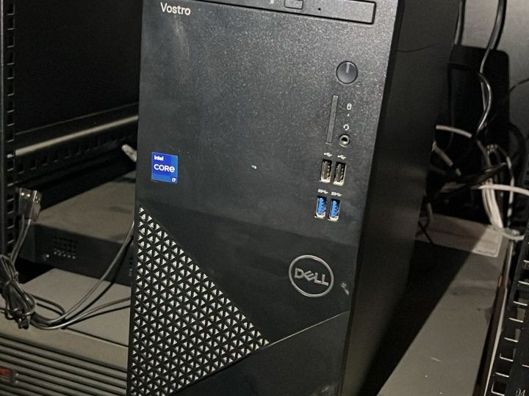  Server processor (UGX 7.0 million), recorded faulty and not in use, at Namboko Seed Secondary School, Namisindwa District | 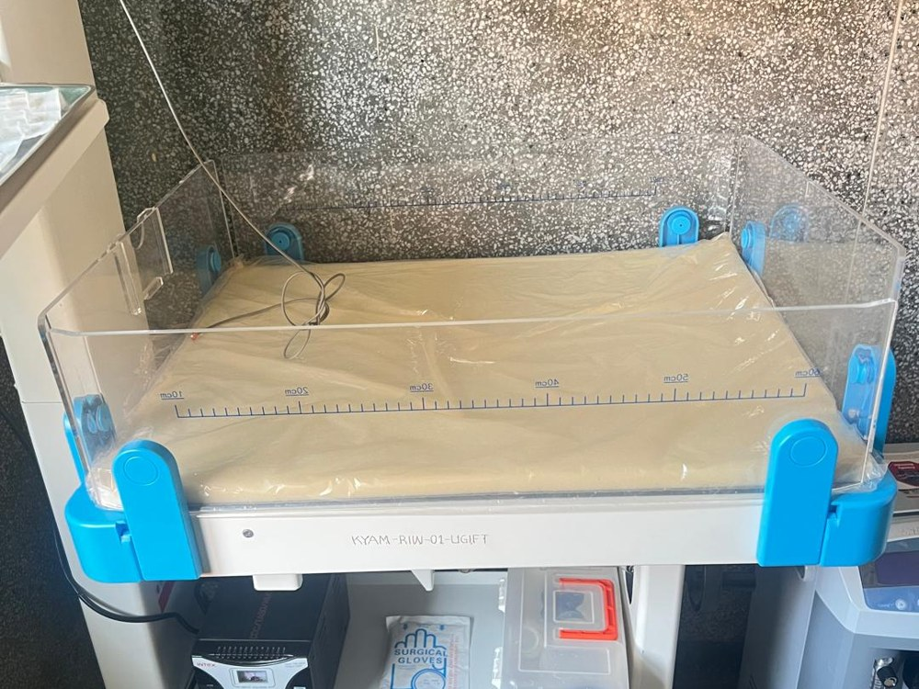  Radiant infant warmer (UGX 16.8 million) at Kyamwinula HC III, Tororo Municipal Council; one of the 2 warmers is out of use after its power stabiliser burnt
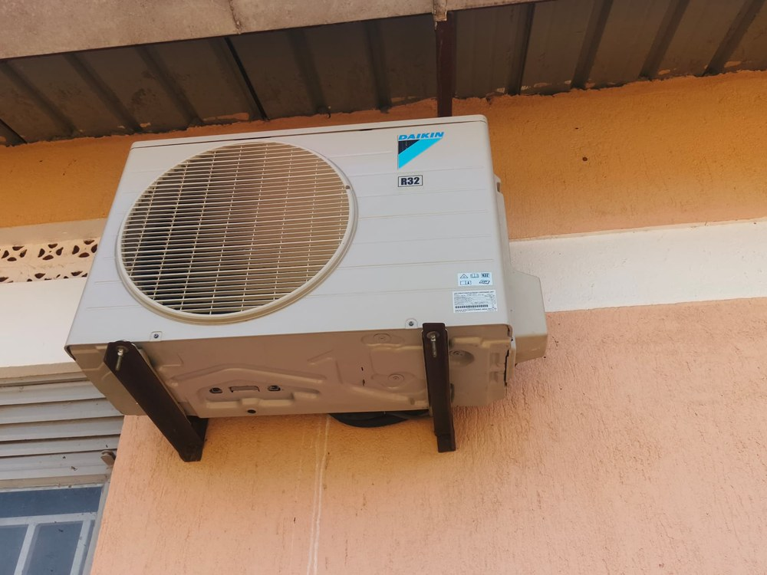  Air conditioner (UGX 6.8 million), recorded faulty and not in use, at Panyangara Seed Secondary School, Kotido District | 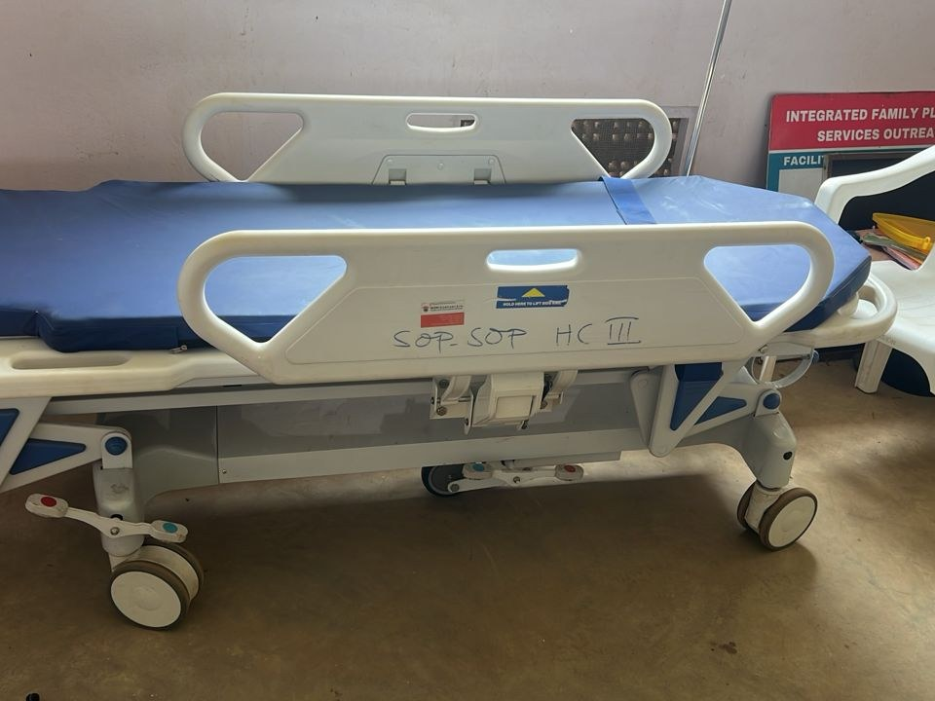  Patient trolley (UGX 2.4 million), recorded faulty and not in use, at Sop Sop HC III, Tororo District
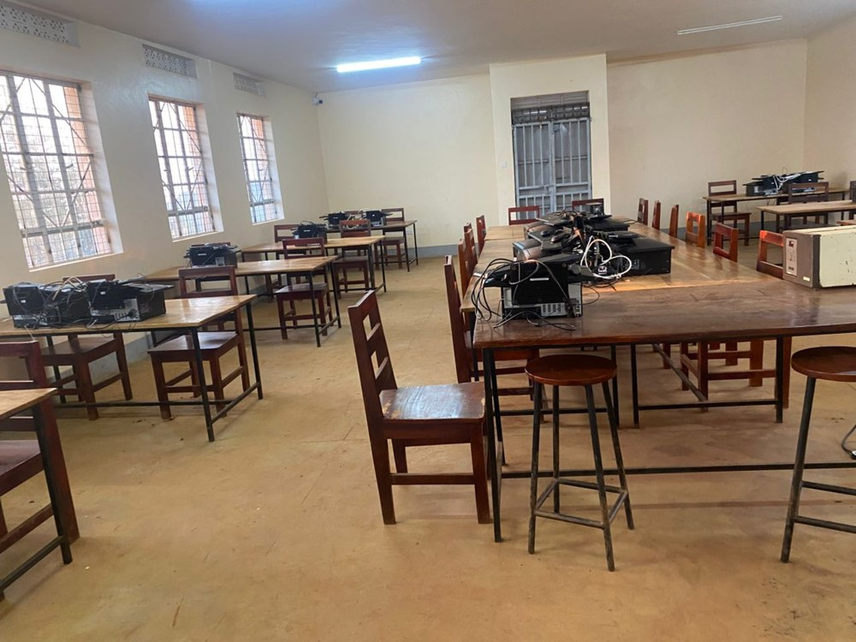  ICT laboratory where all 28 desktop computers (UGX 3.5 million each) are recorded faulty, Kabeywa Seed Secondary School, Kapchorwa District | 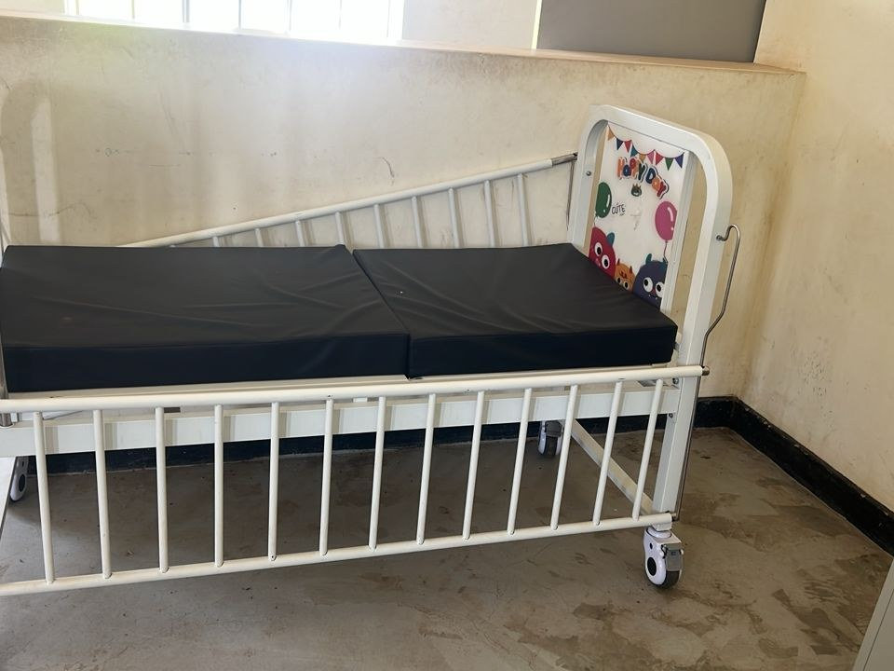  Broken paediatric patient bed (UGX 1.05 million) at Sop Sop HC III, Tororo District
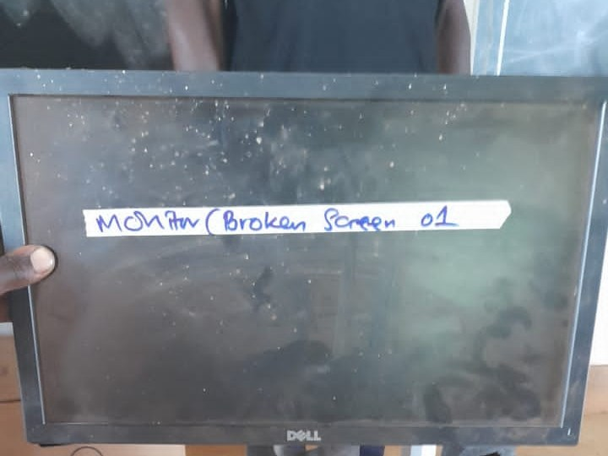  Desktop computer monitor with a broken screen, one of 3 desktops recorded spoilt, at Kitawoi Seed Secondary School, Kween District | 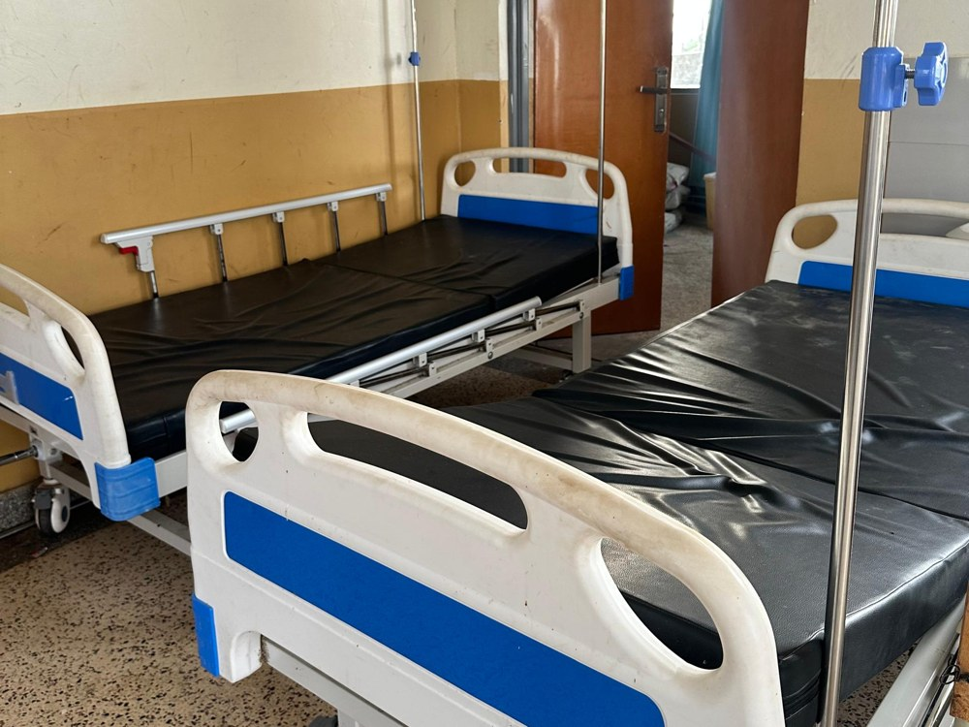  Adult patient bed, one of 2 recorded broken and not in use, at Butiaba HC III, Buliisa District
Source: Field verification photographs; values and condition from the UgIFT asset register and field returns

