Pictures for Assets Verified in Ministry of Health
 | 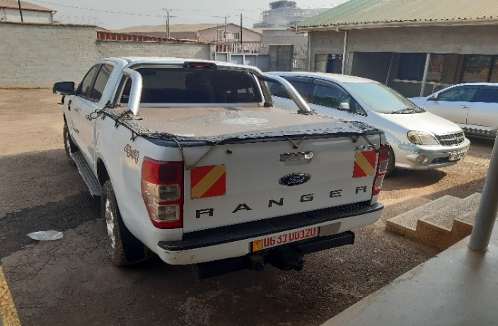 | 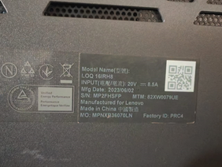
 | UG 3100120 | Laptop serial No. MP2FHSFP
 | 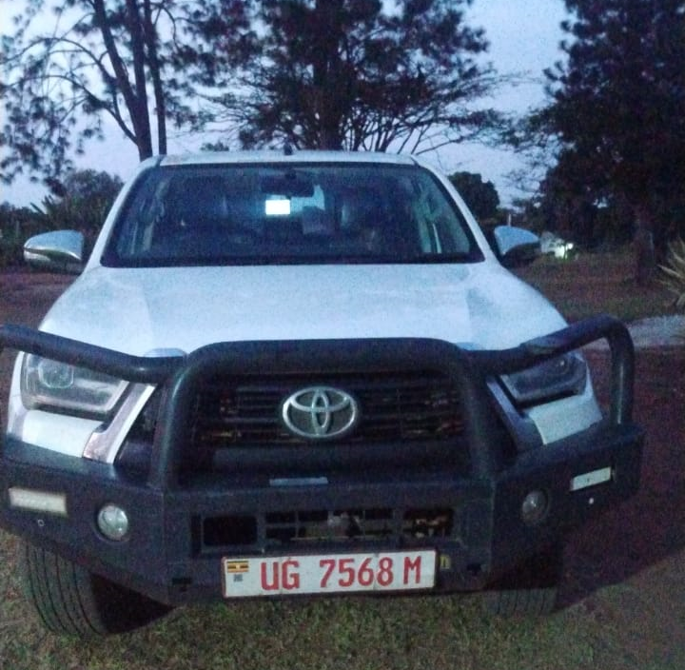 | 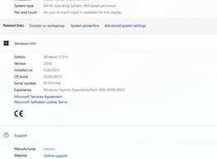
 | UG 7568M | Laptop Screen serial No. PF3TGYSW
 | 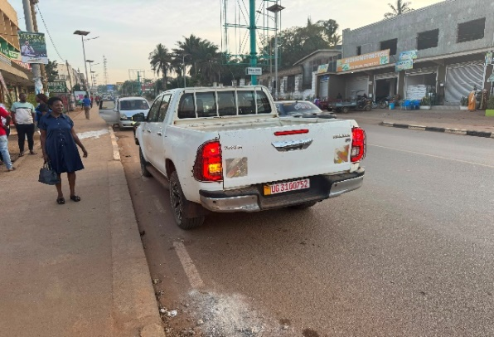 | 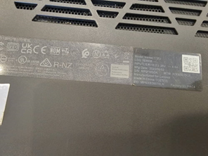
 | UG 3100752 | Laptop serial No. MP2FHSGK
1 | 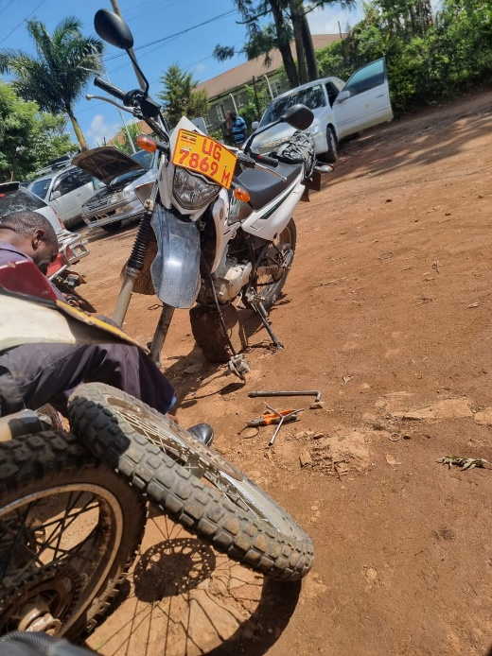 | 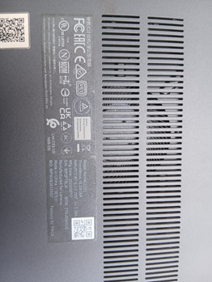
 | UG 7869M | Laptop serial No. MP2PT9LN
2 | 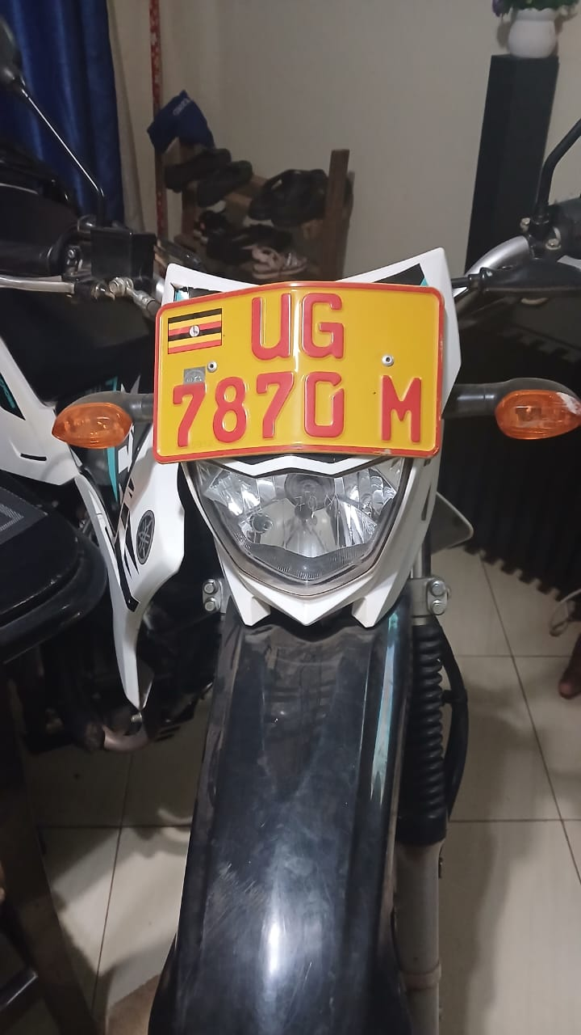 | 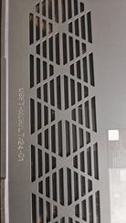
 | UG 7870M | Laptop UGIT/MOH/LT/24-01
3 | 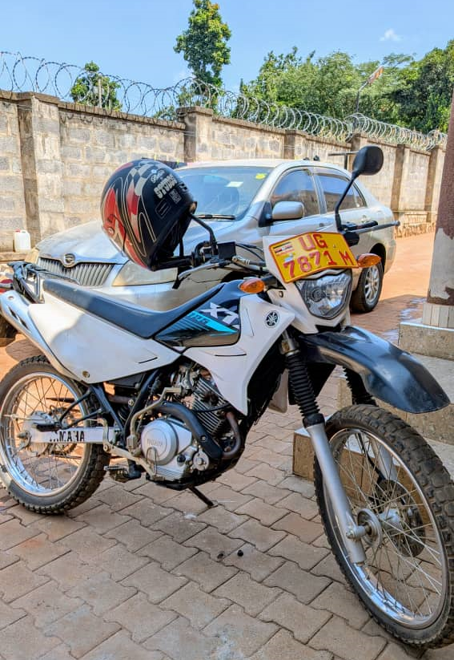 | 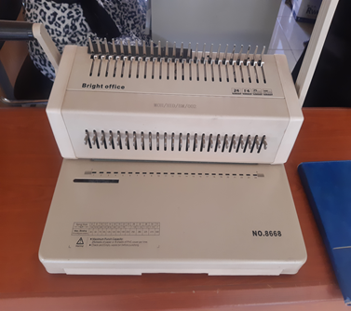
 | UG 7871M | Heavy duty Binder
4 | 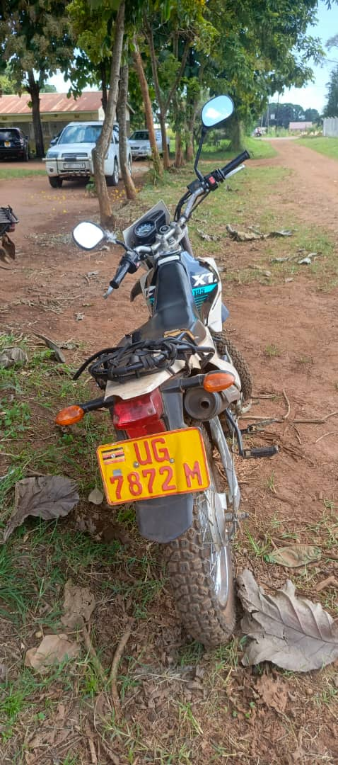 | 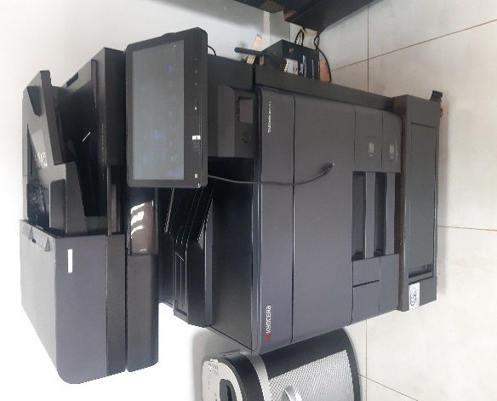
 | UG 7872M | Heavy Duty Printer/Photocopier – Taskalfa 4053ci
5 | 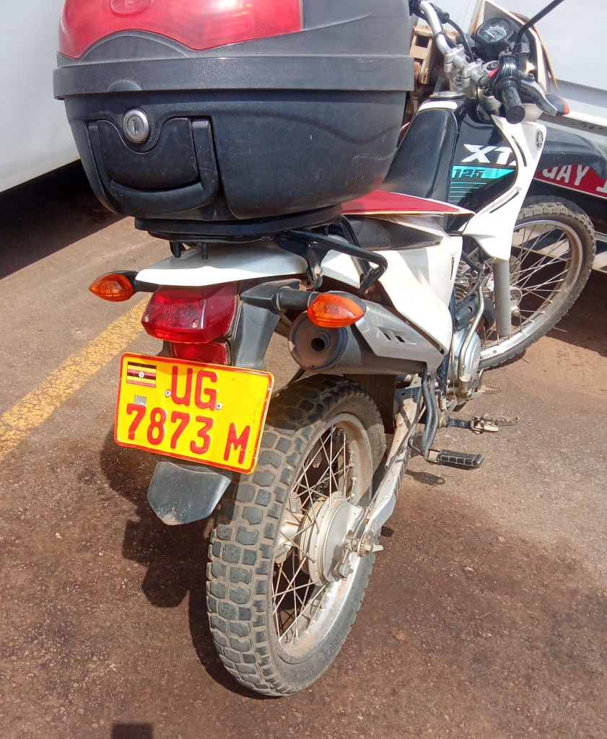 | 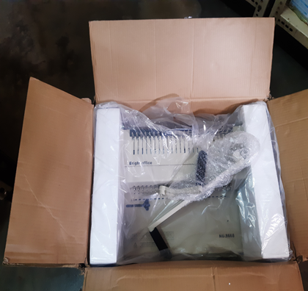
 | UG 7873M | Another Heavy Duty Binder in Store not yet in Use
6 | 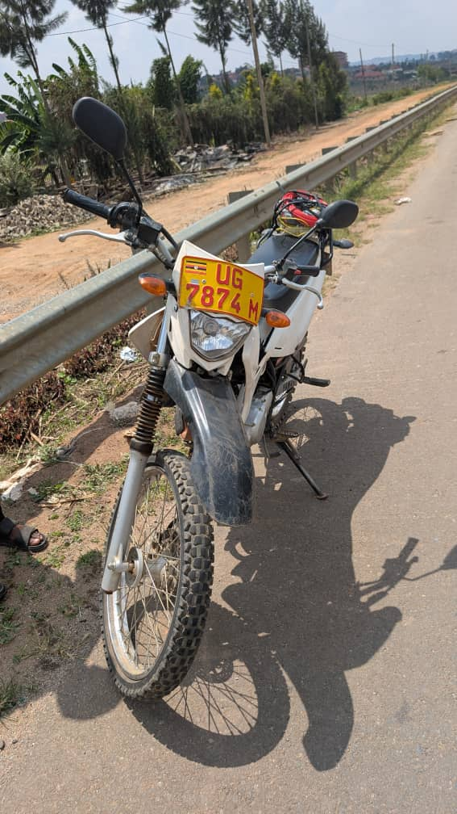 | 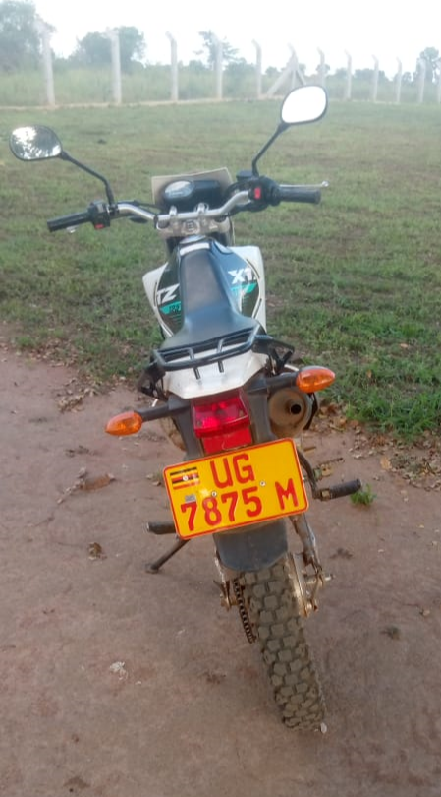
 | UG 7874M | UG 7875M
8 | 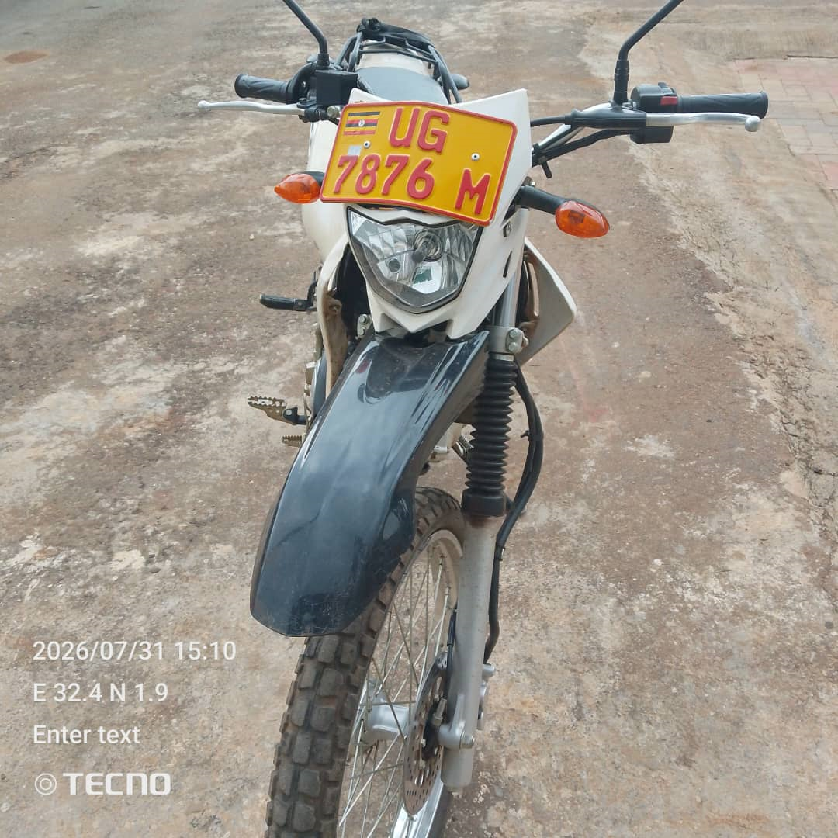 | 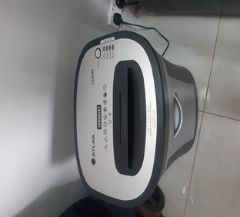
 | UG 7876M | Paper Shredder MOH/HID/BM/002

