

ASSET VERIFICATION AND RECORDING TOOL KIT


Plot 31, Bukoto Street
P.O Box 7657, Kampala, Uganda
+256 (0) 39 2000216/0772525235
email: cpa@cpa.ug

www.cpa.com

August to September 2026

VERIFICATION DETAILS

NAME OF THE REGION: | WESTERN
SUB-REGION: | TOORO
Name of Local Government | KYENJONJO
VERIFIER PARTICULARS
Full name | JALIYAH BALUUBU
Contact/ email and Telephone | Jaliahb45@gmail.com  0794775877
Supervisor/ Sub team leader
Name | Prof: MBONIGABA DEPAUL
Contact | 0788483159
Date of submission | 06/09/2026

HEALTH CENTRES
INFORMANT INTERVIEW/DISCUSSION GUIDE (INCHARGE OR RESPONSIBLE PERSON)

Name of Health Centre:

1a | Does the Facility have a record of all assets provided under UgIFT.  (Obtain a record and verify if it has the costs and numbers supplied
1b | If Not ask how many were supplied and when.

2 | How does this facility Maintain (repair/service/replace) the assets provided under Ugift

3 | Does the facility take regular record about functionality/ or breakdown of the assets provided?

4 | How has the UgIFT support helped in service delivery in the area, any issues, challenges and any recommendations for better program implementation.

PROCEED TO VERIFICATION AFTER THIS DISCUSSION

Health centre checklist

NAME OF LG
NAME OF HEALTH FACILITY

Equipment/ Item | Department | Asset Number | Item  Description | Life in Months | Tag Number ( engrave no.) | Date Of Purchase | Date Placed In Service | Recoverable cost | Cost | Acc Dep Cost | Net Book Value | Ytd Deprn | Equipment status | Remarks

SCHOOL VERIFICATION CHECKLIST

SCHOOL INTERVIEW/DISCUSSION GUIDE

Name of school: NYAKASORA SEED SECONDARY SECONDARY SCHOOL

1a | Does the Facility have a record of all assets provided under UgIFT.  (Obtain a record and verify if it has the costs and numbers supplied | NOT APPLICABLE
1b | If Not ask how many were supplied and when.

2 | How does this facility Maintain (repair/service/replace) the assets provided under Ugift

The school is still under the construction phase

3 | Does the facility take regular record about functionality/ or breakdown of the assets provided?  Nonfunctional/ working, and reasons for non-functionality. | Not fully

NOT APPLICABLE

4 | How has the UgIFT support helped in service delivery in the area, any issues, challenges and any recommendations for better program implementation.

NOT APPLICABLE

PROCEED TO VERIFICATION AFTER THIS DISCUSSION

SCHOOL FURNITURE
(School Desks, Office chairs, Laboratory stools, Book shelves)

Name of SCHOOL KYARUSOZI SEED SECONDARY SCHOOL

Equipment/ Item | Department | Asset Number | Item  Description | Life in Months | Tag Number ( engrave no.) | Date Of Pur | Date Placed In Service | Recoverable cost | Cost | Acc Dep Cost | Net Book Value | Ytd Deprn | Equipment status | Remarks
School deasks | Education |  | Wooden varnished desks |  | Not engraved | l |  |  |  |  |  |  | Not functioning | 120 desks still in the finishing phase
Lockable shelves | Education |  | Wooden varnished |  | Not engraved |  |  |  |  |  |  |  | Not functional | 34 shelves in the finishing pahse
blackboards | Education |  | Teaching blackboards |  | Not engraved |  |  |  |  |  |  |  | Functional but not yet operational | School is still in construction phase
Laboratory stools | Education |  | Well varnished stools |  | Not engraved |  |  |  |  |  |  |  | Not functional | 124 stools in the finishing stage
tables | Education |  | Well vanished wooden tables |  | Not engraved |  |  |  |  |  |  |  | Not functional | 120 tables in the final stages
Chairs | Education |  | Well varnished wooden chairs |  | Not engraved |  |  |  |  |  |  |  | Not Functional | 180 chairs in the finishing phase

ICT ITEMS TO VERIFY
(Desktop Computer, Server Processor, Network Switch 24 Port, Multipurpose Printer, UPS, Projector, Air Conditioners, Server, CCTV Camera)

Name of LG KYENJONJO

Name of SCHOOL KYARUSOZI SEED SECONDARY SCHOOL

Equipment/ Item | Department | Asset Number | Item  Description | Life in Months | Tag Number ( engrave no.) | Date Of Pur | Date Placed In Service | Recoverable cost | Cost | Acc Dep Cost | Net Book Value | Ytd Deprn | Equipment status | Remarks

BUILDINGS TO VERIFY
(Non- Residential and Residential, Kitchen, Toilets/Pit latrine Water tanks, Fences etc.)

Name of LG KYENJONJO
Name of SCHOOL KYARUSOZI SEED SECONDARY SCHOOL

Equipment/ Item | Department | Asset Number | Item  Description | Life in Months | Tag Number ( engrave no.) | Date Of Pur | Date Placed In Service | Recoverable cost | Cost | Acc Dep Cost | Net Book Value | Ytd Deprn | Equipment status | Remarks
Water tanks | education |  | A black tank of 5000lts, 3000ltrs and 10000 |  | Not engraved |  |  |  |  |  |  |  | functional | In good shape and in use
Staff toilets | Education |  | Well built 1 block of 2 stances and a bathroom |  | Not engraved |  |  |  |  |  |  |  | functional | Not yet in use
Staff quarters | Education |  | 2 blocks of two units of two rooms |  | Not engraved |  |  |  |  |  |  |  | Functioning | Construction still in progress
Student toilets | Education |  | 2 blocks of respective gender boys and girls of 5 stances with a dressing room on the girls’ block |  | Not engraved |  |  |  |  |  |  |  | Fully functioning | Not fully in use
Kitchen | Education |  | 2 blocks of 2 rooms |  | Not engraved |  |  |  |  |  |  |  | Not unctional | Not in use
Student Laboratory | Education |  | I block of 2 rooms |  | Not engraved |  |  |  |  |  |  |  | Not yet functional l | In use
Computer lab | education |  | I block of 2 rooms with a library |  | Not engraved |  |  |  |  |  |  |  | Not yet f functional | Not in use
Multi purpose hall | Education |  | I block of 2 entrances |  | Not engraved |  |  |  |  |  |  |  | Not yet functional | Not in use
Staff quarters toilets | Education |  | 2 blocks of two stances and a bathroom |  | Not engraved |  |  |  |  |  |  |  | Functional | not in use
Staff quarters kitchen | Education |  | 3 blocks of 2 units |  | Not engraved |  |  |  |  |  |  |  | Functional | Not in use
classrooms | Education |  | 3 blocks of two classes |  | Not engraved |  |  |  |  |  |  |  | Functional | In use
Play ground | Education |  |  |  | Not engraved |  |  |  |  |  |  |  | Not yet functional | Still incomplete

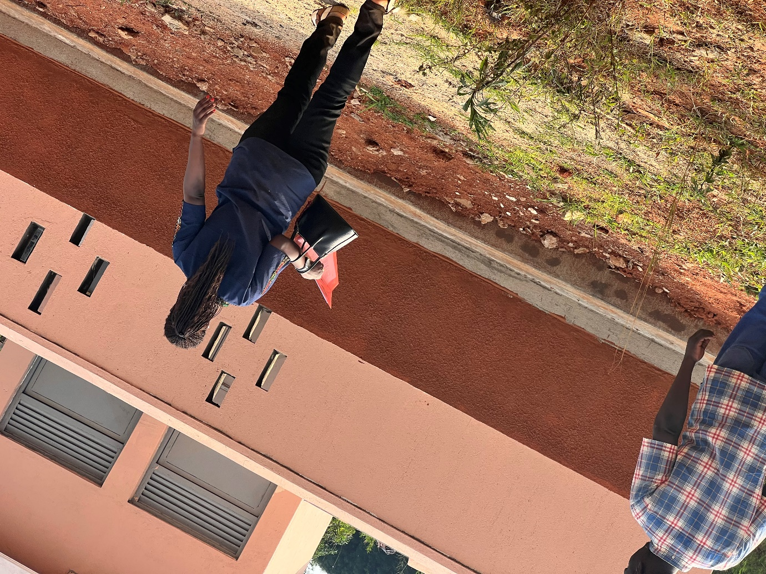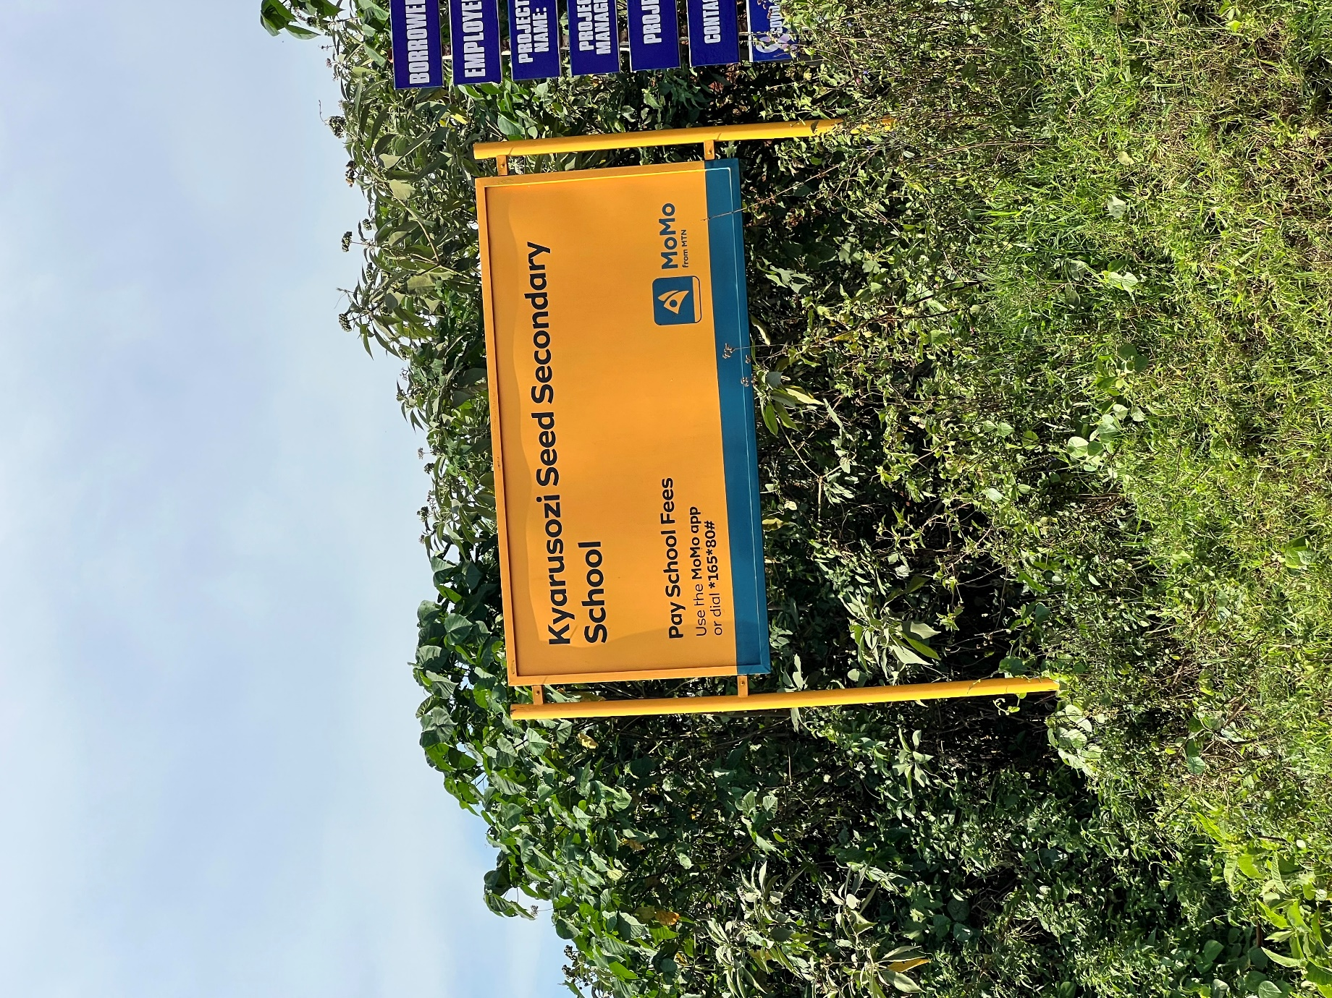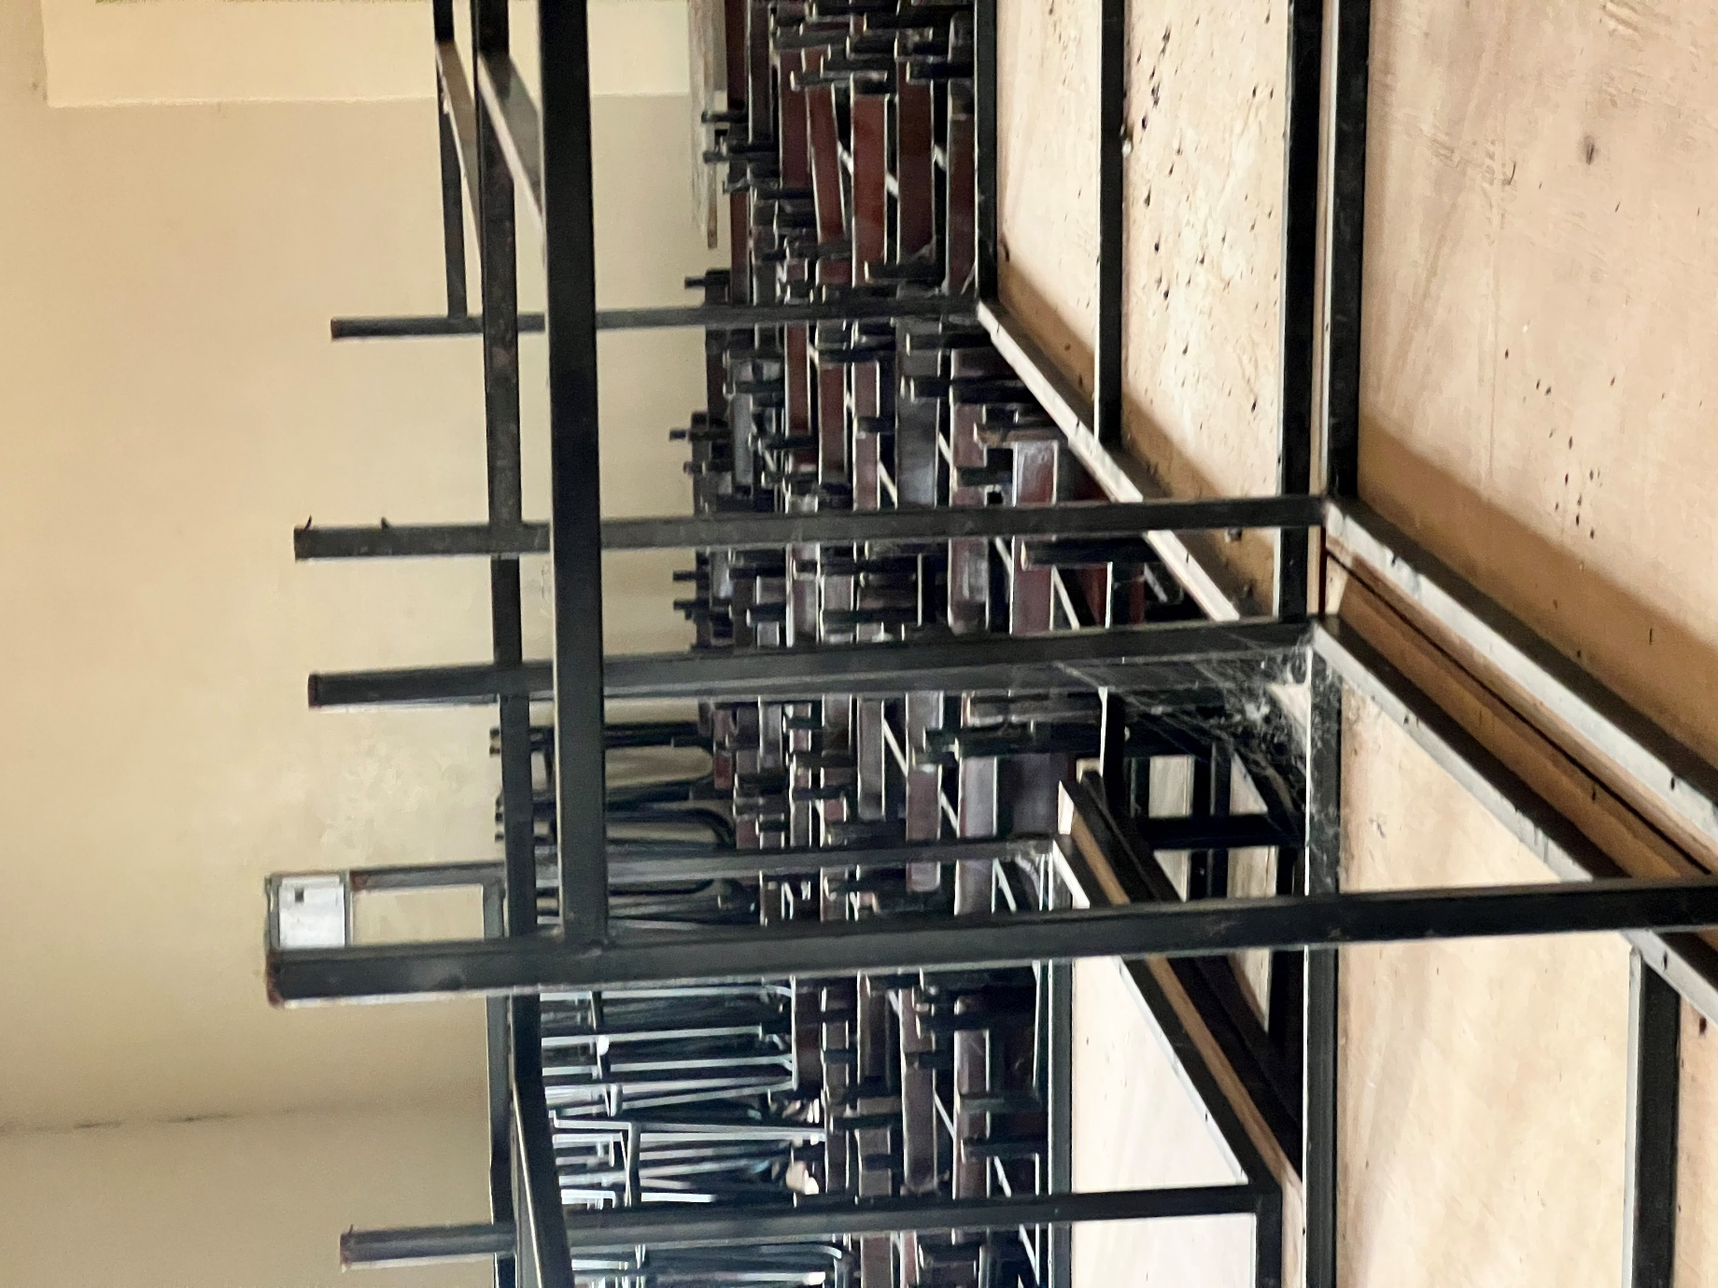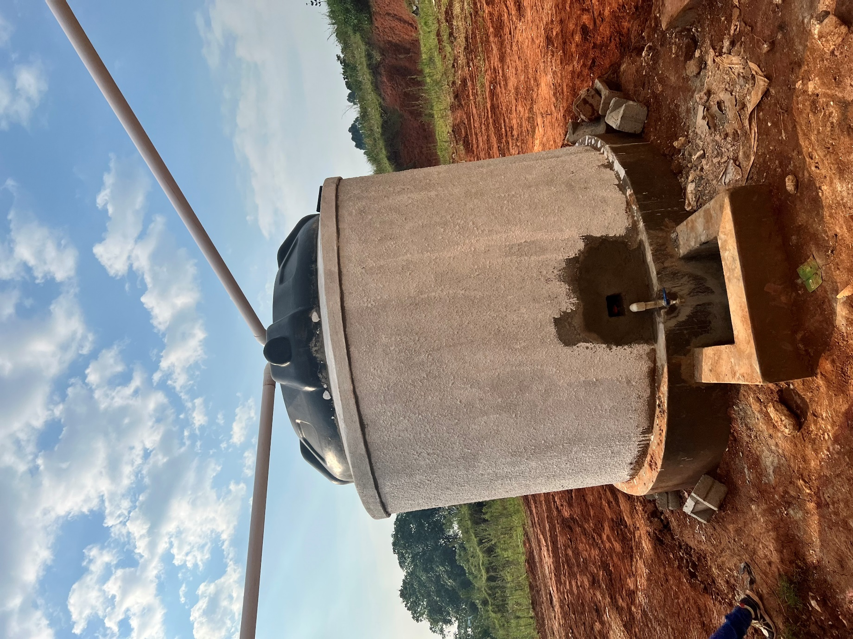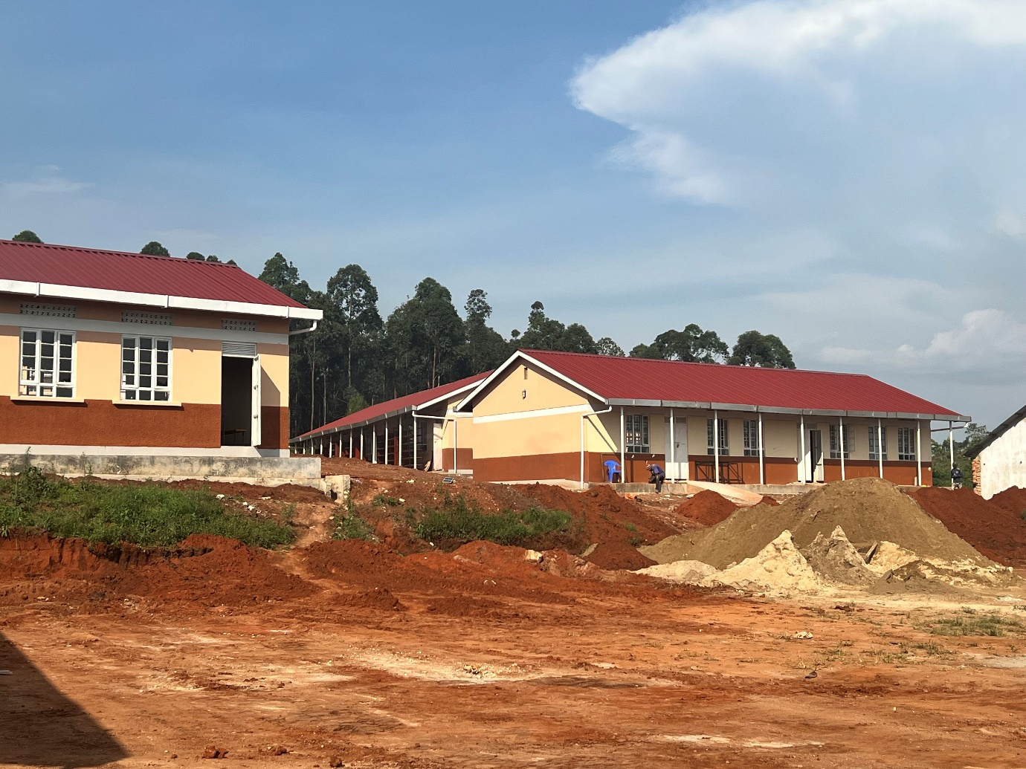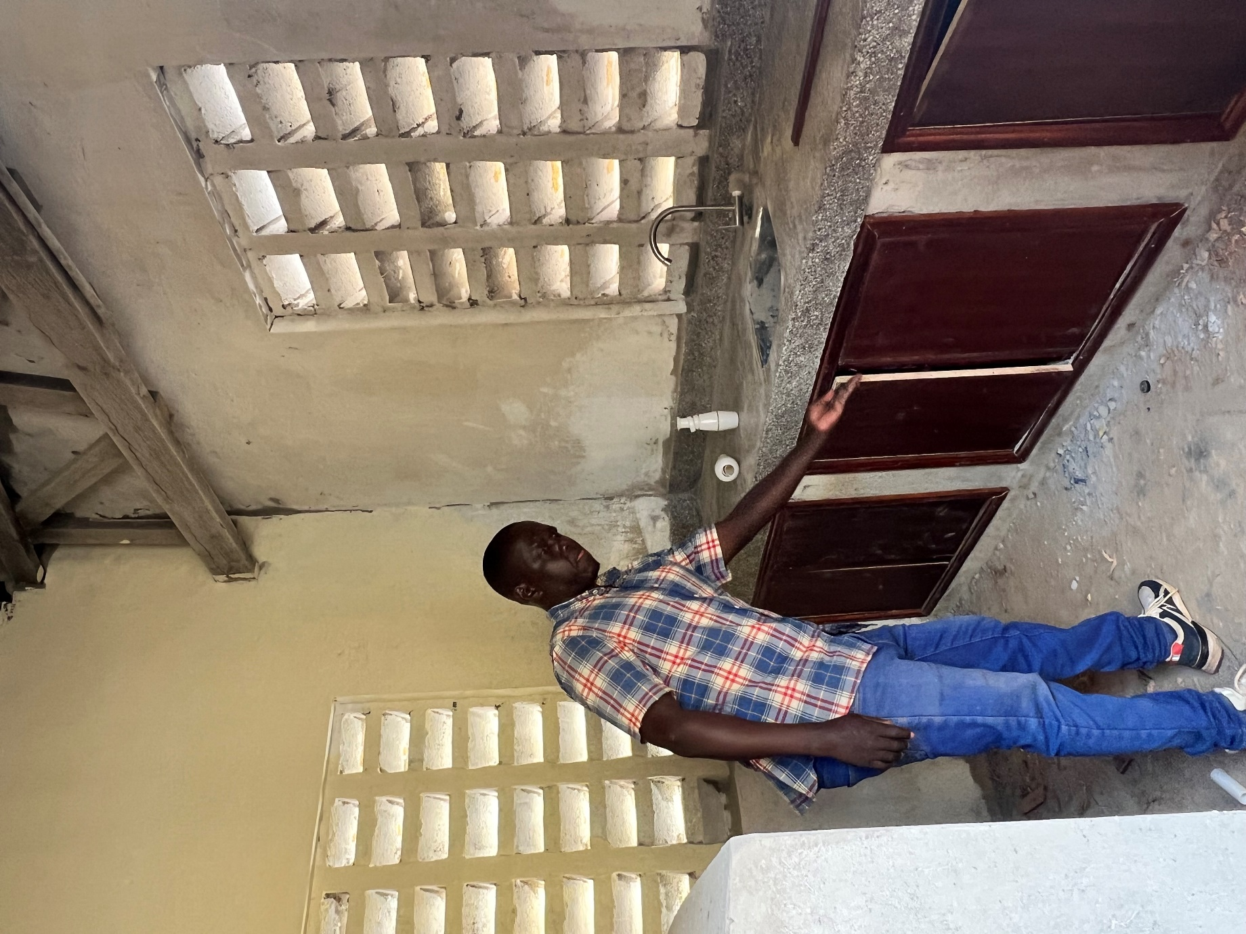
Student latrines
Unfinished tables
Water tanks
Classrooms and unfinished play ground
Inside the science laboratory

