

ASSET VERIFICATION AND RECORDING TOOL KIT


Plot 31, Bukoto Street
P.O Box 7657, Kampala, Uganda
+256 (0) 39 2000216/0772525235
email: cpa@cpa.ug

www.cpa.com

August to September 2026

VERIFICATION DETAILS

NAME OF THE REGION: | CENTRAL
SUB-REGION: | BUGANDA
Name of Local Government | MUBENDE
VERIFIER PARTICULARS
Full name | JALIYAH BALUUBU
Contact/ email and Telephone | Jaliahb45@gmail.com  0794775877
Supervisor/ Sub team leader
Name | Prof: MBONIGABA DEPAUL
Contact | 0788483159
Date of submission | 06/09/2026

HEALTH CENTRES
INFORMANT INTERVIEW/DISCUSSION GUIDE (INCHARGE OR RESPONSIBLE PERSON)

Name of Health Centre:

1a | Does the Facility have a record of all assets provided under UgIFT.  (Obtain a record and verify if it has the costs and numbers supplied
1b | If Not ask how many were supplied and when.

2 | How does this facility Maintain (repair/service/replace) the assets provided under Ugift

3 | Does the facility take regular record about functionality/ or breakdown of the assets provided?

4 | How has the UgIFT support helped in service delivery in the area, any issues, challenges and any recommendations for better program implementation.

PROCEED TO VERIFICATION AFTER THIS DISCUSSION

Health centre checklist

NAME OF LG
NAME OF HEALTH FACILITY

Equipment/ Item | Department | Asset Number | Item  Description | Life in Months | Tag Number ( engrave no.) | Date Of Purchase | Date Placed In Service | Recoverable cost | Cost | Acc Dep Cost | Net Book Value | Ytd Deprn | Equipment status | Remarks

SCHOOL VERIFICATION CHECKLIST

SCHOOL INTERVIEW/DISCUSSION GUIDE

Name of school: RUYONZA SEED SECONDARY SECONDARY SCHOOL

1a | Does the Facility have a record of all assets provided under UgIFT.  (Obtain a record and verify if it has the costs and numbers supplied | yes
1b | If Not ask how many were supplied and when.

2 | How does this facility Maintain (repair/service/replace) the assets provided under Ugift

The school has a portion off the school budget to handle damage emergencies

3 | Does the facility take regular record about functionality/ or breakdown of the assets provided?  Nonfunctional/ working, and reasons for non-functionality. | Not applicable

NOT APPLICABLE as most of the assets have not been fully handed over to the school administration

4 | How has the UgIFT support helped in service delivery in the area, any issues, challenges and any recommendations for better program implementation.

UGIFT program has improved, promoted and eased the teaching of both the science and computer subjects.

The incharge said that most of the assets are still at the district headquarters like the computers, CCTVs because of no power supply at the school.

The incharge recommended that the contractor should quicken up with the installation of power supply so as to get hold of the assets to ensure the
Smooth runnin.

PROCEED TO VERIFICATION AFTER THIS DISCUSSION

SCHOOL FURNITURE
(School Desks, Office chairs, Laboratory stools, Book shelves)

Name of SCHOOL RUYONZA SEED SECONDARY SCHOOL

Equipment/ Item | Department | Asset Number | Item  Description | Life in Months | Tag Number ( engrave no.) | Date Of Pur | Date Placed In Service | Recoverable cost | Cost | Acc Dep Cost | Net Book Value | Ytd Deprn | Equipment status | Remarks
School desks | Education |  | Wooden varnished desks |  | Not engraved |  |  |  |  |  |  |  | Functional | 120 desks functional
Book shelves | Education |  | Wooden varnished incomplete shelves |  | Not engraved |  |  |  |  |  |  |  | Functional | 11 incomplete shelves
Laboratory Tables | Education |  | Varnished wooden tables |  | Not engraved |  |  |  |  |  |  |  | Functional | 31 functional tables
Laboratory stools | Education |  | Well varnished wooden stools |  | Not engraved |  |  |  |  |  |  |  | Functional | 85 functional stools and 5 of them damaged waiting for repair
Computer chairs | education |  | Varnished wooden chairs |  | Not engraved |  |  |  |  |  |  |  | Functional | 130 functional chairs with 5 damaged chairs waiting for repair
Computer tables | Education |  | Varnished wooden tables |  | Not engraved |  |  |  |  |  |  |  | Functional | 19 functional tables
Computer shelves | Education |  | Varnished wooden shelves |  | Not engraved |  |  |  |  |  |  |  | Functional | 2 functional shelves already in use

ICT ITEMS TO VERIFY
(Desktop Computer, Server Processor, Network Switch 24 Port, Multipurpose Printer, UPS, Projector, Air Conditioners, Server, CCTV Camera)

Name of LG MUBENDE

Name of SCHOOL KIGANDO SEED SECONDARY SCHOOL

Equipment/ Item | Department | Asset Number | Item  Description | Life in Months | Tag Number ( engrave no.) | Date Of Pur | Date Placed In Service | Recoverable cost | Cost | Acc Dep Cost | Net Book Value | Ytd Deprn | Equipment status | Remarks
 |  |  | r

BUILDINGS TO VERIFY
(Non- Residential and Residential, Kitchen, Toilets/Pit latrine Water tanks, Fences etc.)

Name of LG MUBENDE
Name of SCHOOL KIGANDO SEED SECONDARY SCHOOL

Equipment/ Item | Department | Asset Number | Item  Description | Life in Months | Tag Number ( engrave no.) | Date Of Pur | Date Placed In Service | Recoverable cost | Cost | Acc Dep Cost | Net Book Value | Ytd Deprn | Equipment status | Remarks
Water tanks | education |  | Water tanks of 5000, 10000, and 3000ltrs |  | Not engraved |  |  |  |  |  |  |  | Not functional | The tanks are cracked and the water cant supply water bacause there's no electricity in the entire scgool
Staff toilets | Education |  | Well built 1 block of 2 stances and a bathroom |  |  |  |  |  |  |  |  |  | functional | Fully functioning and in good shape
Staff quarters | Education |  | 3 blocks of two units of two rooms |  |  |  |  |  |  |  |  |  | Functioning | Functional
Student toilets | Education |  | 2 blocks of respective gender boys and girls of 5 stances with a dressing room on the girls’ block |  |  |  |  |  |  |  |  |  | Fully functioning | Good shape and already in use
Kitchen | Education |  | 2 blocks of 2 rooms |  |  |  |  |  |  |  |  |  | Functional | In use
Student Laboratory | Education |  | I block of 2 rooms |  |  |  |  |  |  |  |  |  | Functional l | In use
Computer lab | education |  | I block of 2 rooms with a library |  |  |  |  |  |  |  |  |  | Functional | In use
Multi purpose hall | Education |  | I block of 2 entrances |  |  |  |  |  |  |  |  |  | Functional | In use
Staff quarters toilets | Education |  | 3 blocks of two stances and a bathroom |  |  |  |  |  |  |  |  |  | Functional | In use
Staff quarters kitchen | Education |  | 3 blocks of 2 units |  |  |  |  |  |  |  |  |  | Functional | In use
classrooms | Education |  | 3 blocks of two classes |  |  |  |  |  |  |  |  |  | Functional | In use
Water tanks | education |  | 5000, 3000, and 10000 ltrs |  |  |  |  |  |  |  |  |  | Functional | In use
Sports field | Education |  |  |  |  |  |  |  |  |  |  |  | Functional | Still incomplete
Administration block | Education |  | I block 2rooms |  |  |  |  |  |  |  |  |  | Functional | Functional
Fire extinguishers | Education |  | Fire extinguishers |  |  |  |  |  |  |  |  |  | Functional | 11 functional
Speakers | Education |  | Speakers |  |  |  |  |  |  |  |  |  | Functional | 3 functioning

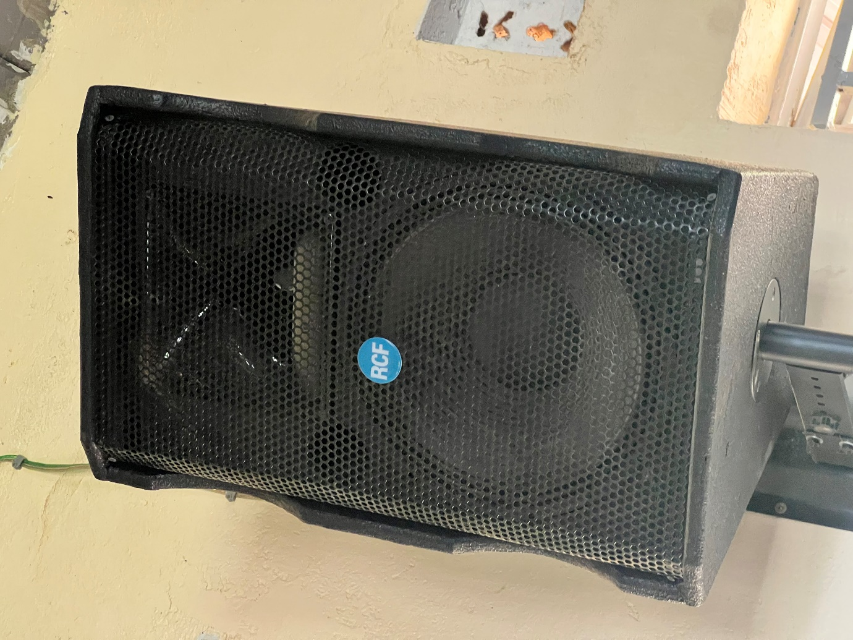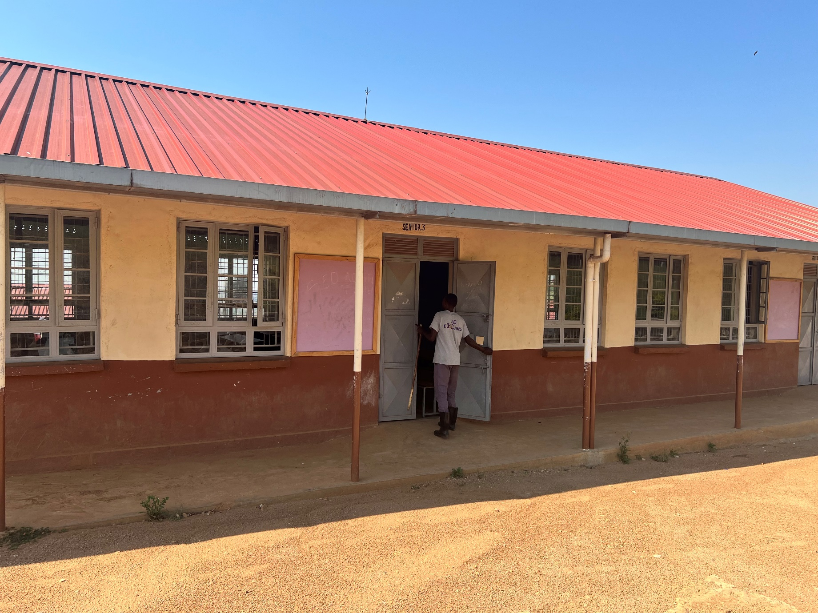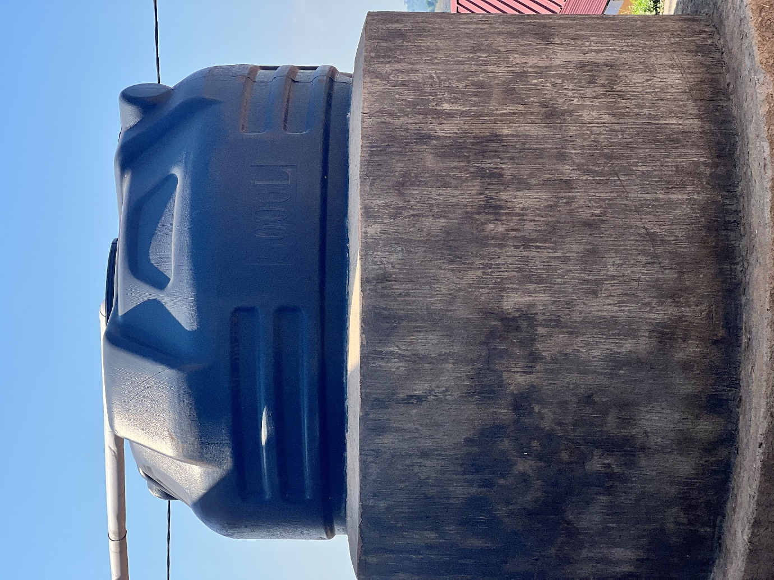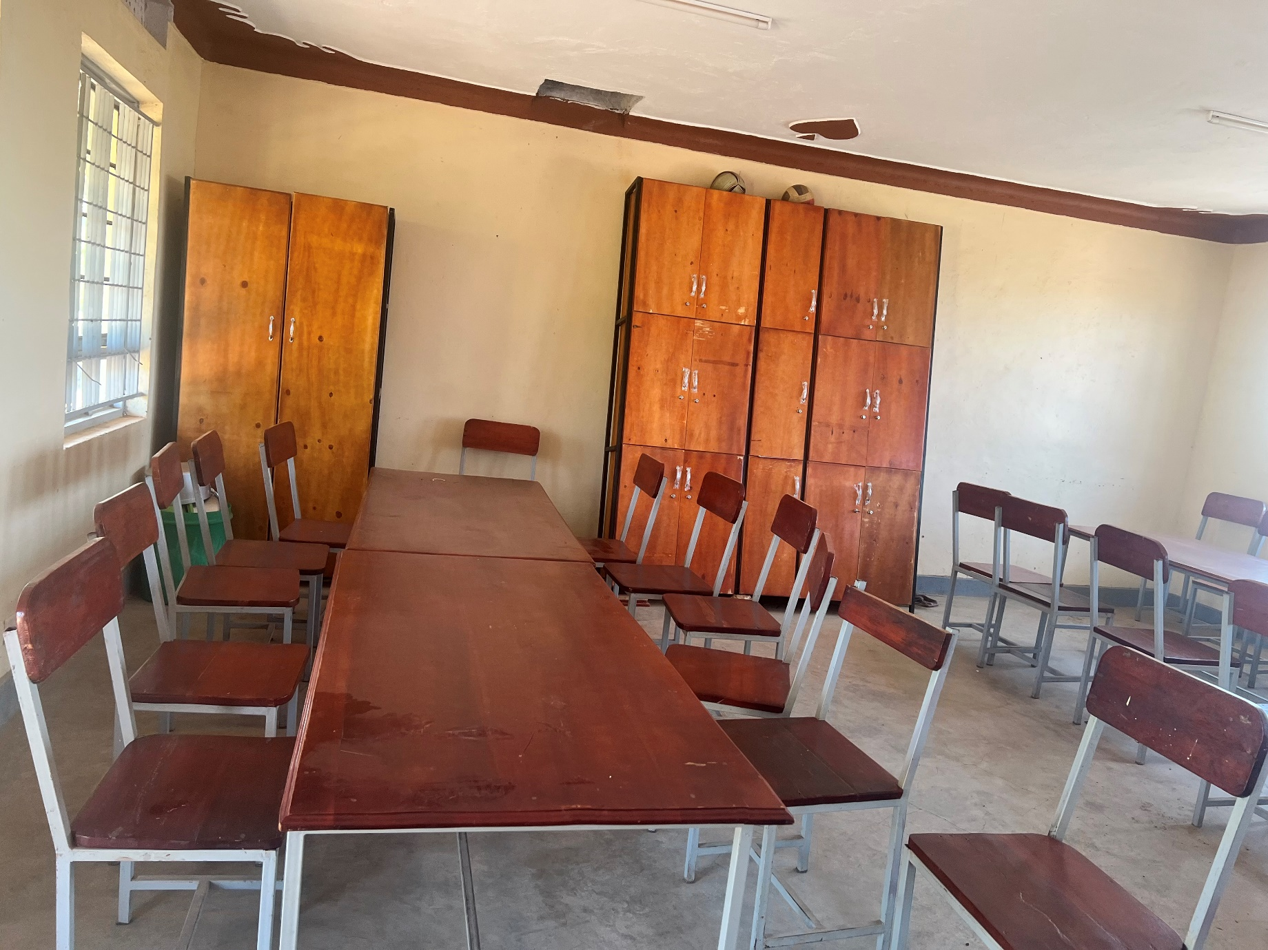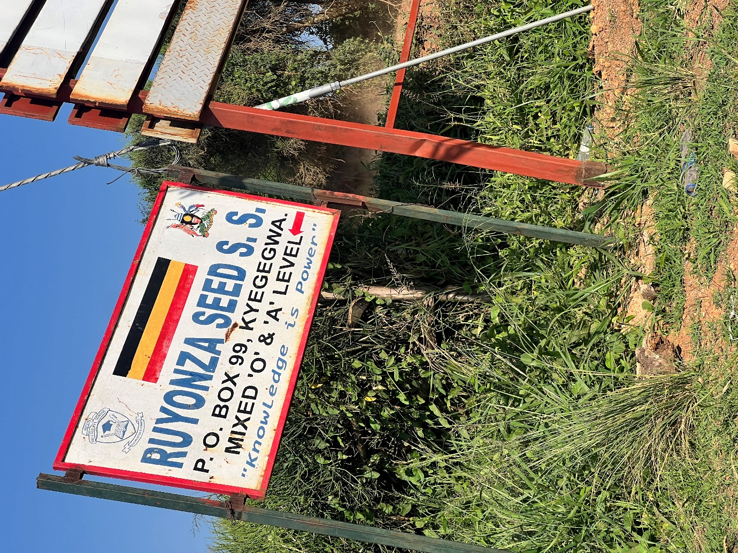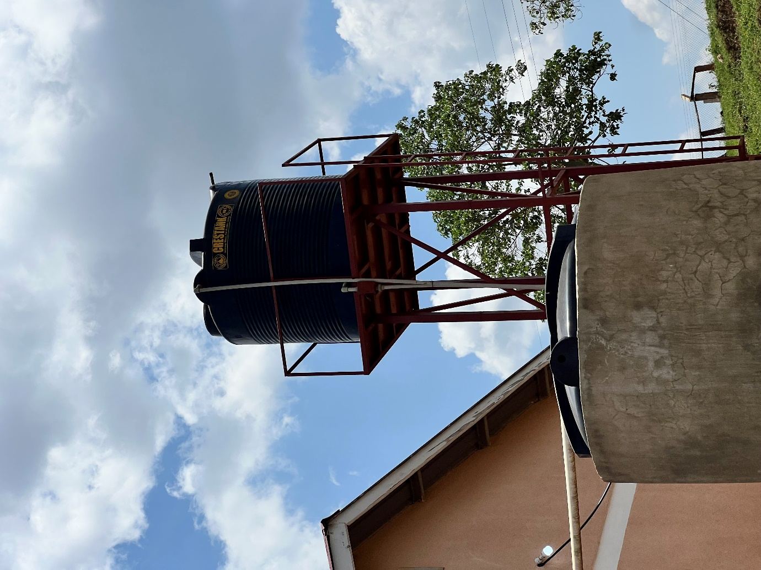
speaker
classrooms
Water tank
Desks, chairs and book shelves.

